Knocking-out the brassinosteroid-biosynthesis genes DWARF1 or DWARF4 produces upright canopy architecture in wheat
Manpartik S. Gill, Andrew L. Phillips, Danuše Tarkowská, John Addy, Nicolas Virlet, John Foulkes, Stephen Pearce, Stephen G. Thomas, Peter Hedden

Additional file 1
Figure S1: DWF1 and DWF4 homoeologues and mutant alleles used in this study.
Figure S2: Phenotypic characterization of all combinatorial dwf1 and dwf4 mutants under glasshouse conditions.
Figure S3: Phenotype of Cadenza and dwf1-abd mutant at the tillering stage in the field.
Figure S4: High throughput phenotyping of dwf1-abd mutant under Field Scanalyzer.
Figure S5: Expression of DWF1 genes in wheat variety ‘Azhurnaya’.
Figure S6: Expression of DWF4 and DWF11 genes in wheat variety ‘Azhurnaya’.
Table S1: Homoeologue-specific primers designed to amplify fragments around the deleterious mutations in TaDWF1 and TaDWF4 genes.
Table S2: KASP primers designed to differentiate the mutant and wild type allele in segregating DWF1 and DWF4 populations.
Table S3: BR levels (pg/mg DW) in dwf1-abd and dwf4-abd mutants and controls.
Figure S1: DWF1 and DWF4 homoeologues and mutant alleles used in this study. (A) TaDWF1 gene indicating the position of nonsense mutations in the three homoeologues (red arrows) (B) Structure of the TaDWF1 protein showing conserved domains and the predicted TaDWF1 proteins encoded by the mutant alleles. (C) TaDWF4 gene indicating the position of nonsense mutations in the three homoeologues (red arrows) (D) Structure of the TaDWF4 protein showing conserved domains and the predicted TaDWF4 proteins encoded by the mutant alleles. Position of nonsense mutations identified from the Cadenza TILLING population are indicated. * = stop codon. Produced using Biorender.com.
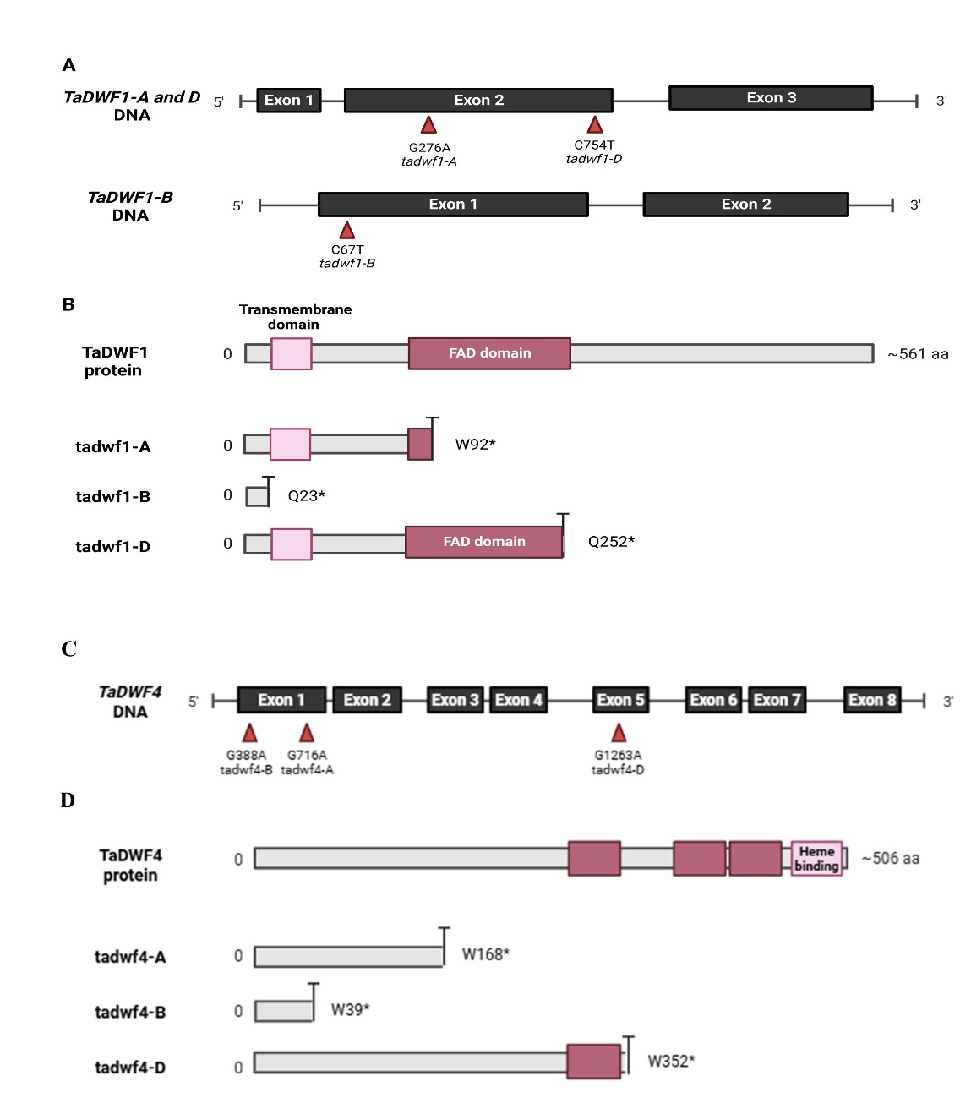

Figure S2: Phenotypic characterization of all combinatorial dwf1 and dwf4 mutants under glasshouse conditions. (A) Flag Leaf Angle (FLA) at 22 days post anthesis and (B) Final plant height of tadwf1 combinatorial mutants along with Cadenza (n = 4). (C) FLA at anthesis and (D) Final plant height of tadwf4 combinatorial mutants along with Cadenza (n = 4). Different letters indicate significant differences between genotypes (obtained from Fisher’s unprotected LSD test).
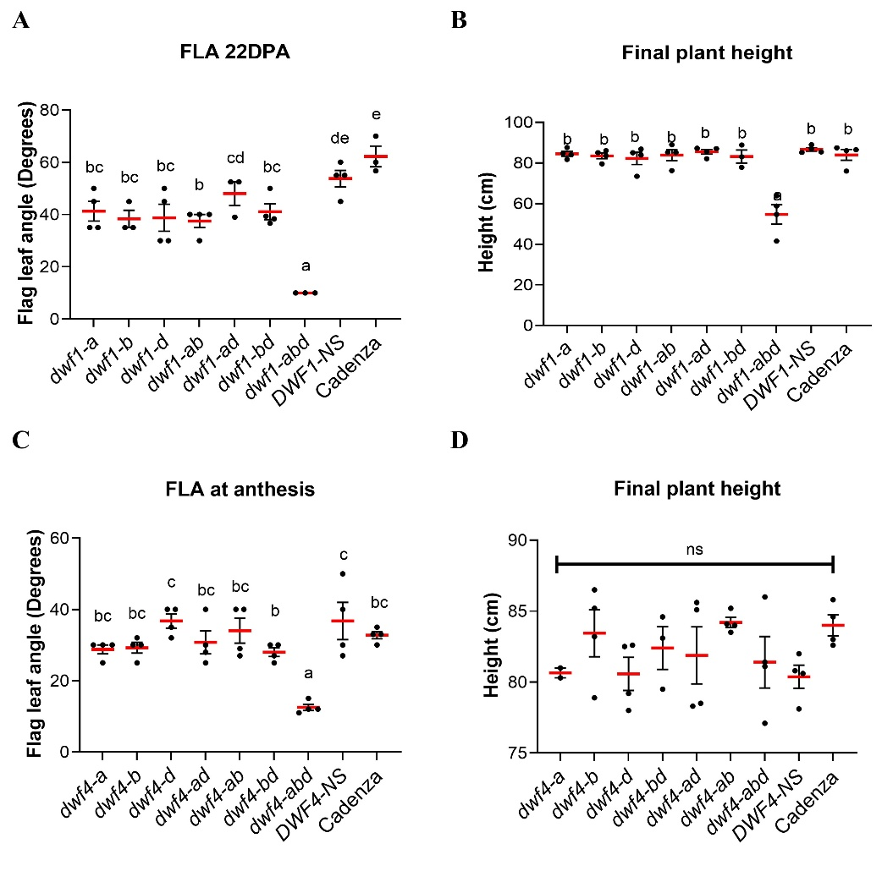
Figure S3: Phenotype of Cadenza and dwf1-abd mutant at the tillering stage in the field. The images show 1 m² plots of Cadenza and the dwf1-abd mutant at the tillering stage (GS25). The row to row and plant to plant spacing was the same in each plot.
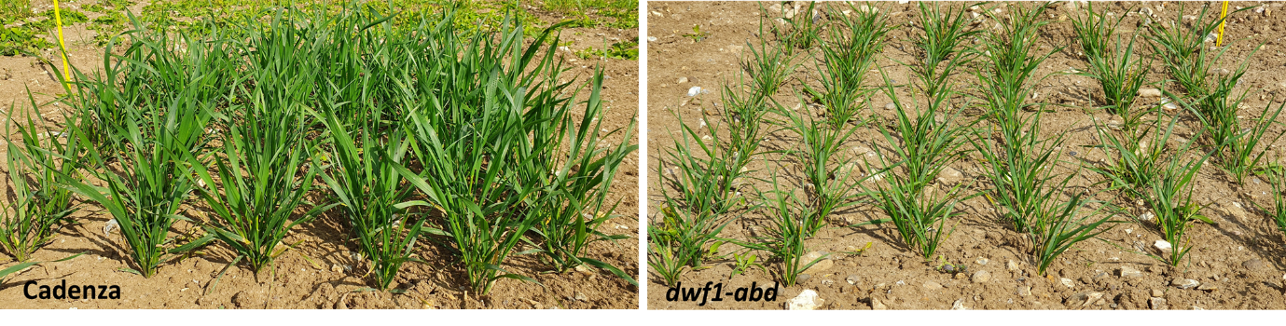
Figure S4: High throughput phenotyping of the dwf1-abd mutant under the Field Scanalyzer. RGB images of dwf1-abd (A) and Cadenza (B) at GS69 under the Field Scanalyzer during 2020-21. The left panel shows the original image and the right panel shows the segmented RGB image. RGB images showing highlighted spikes in red in dwf1-abd (C) and Cadenza (D) at GS69. These images were used to estimate spike density (number of spikes/m²).
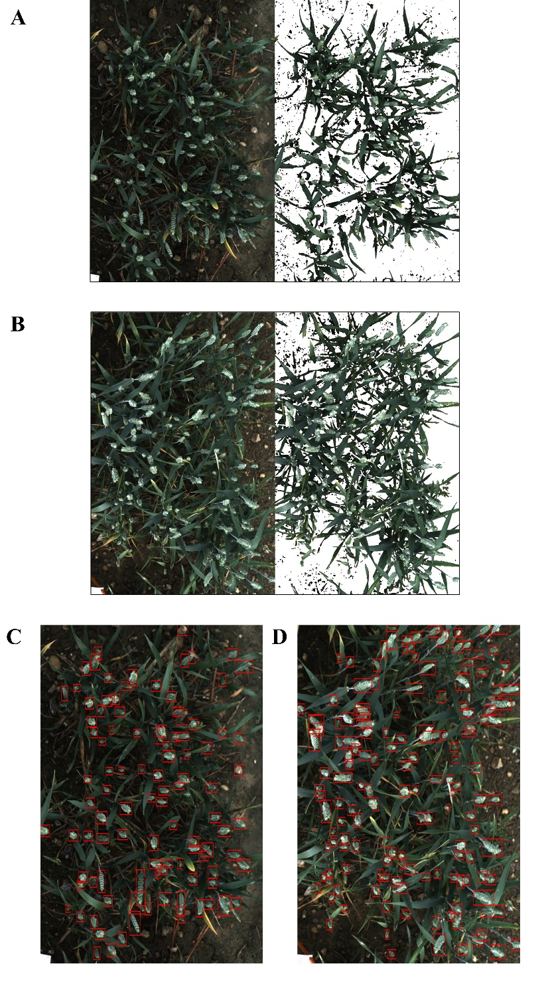
Figure S5: Expression of DWF1 in wheat cultivar ‘Azhurnaya’. The organ expression profile is shown as transcripts per million (TPM) for the TaDWF1 homoeologues. The data were obtained from https://www.wheat-expression.com/.
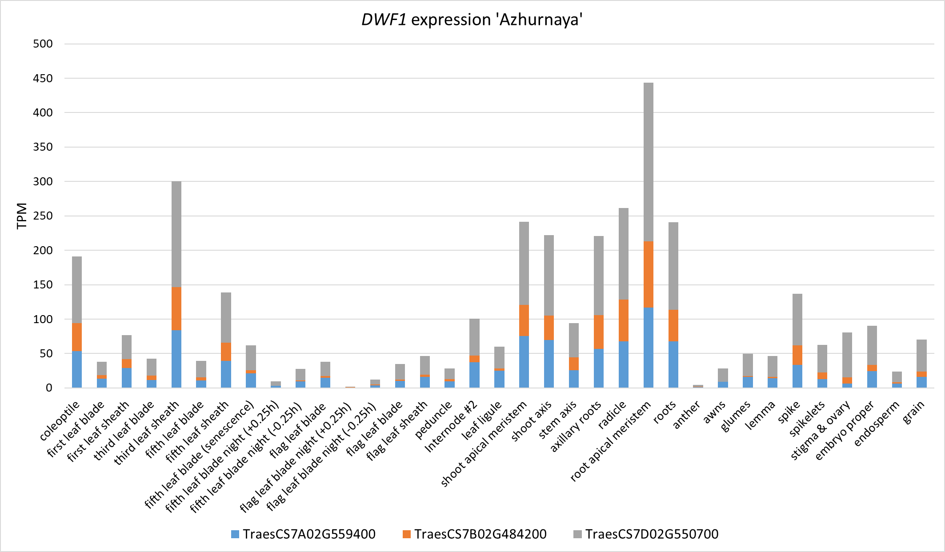
Figure S6: Expression of DWF4 and DWF11 in wheat cultivar ‘Azhurnaya’. The organ expression profiles are shown as transcripts per million (TPM) for TaDWF4 and TaDWF11 homoeologues. The data were obtained from https://www.wheat-expression.com/.
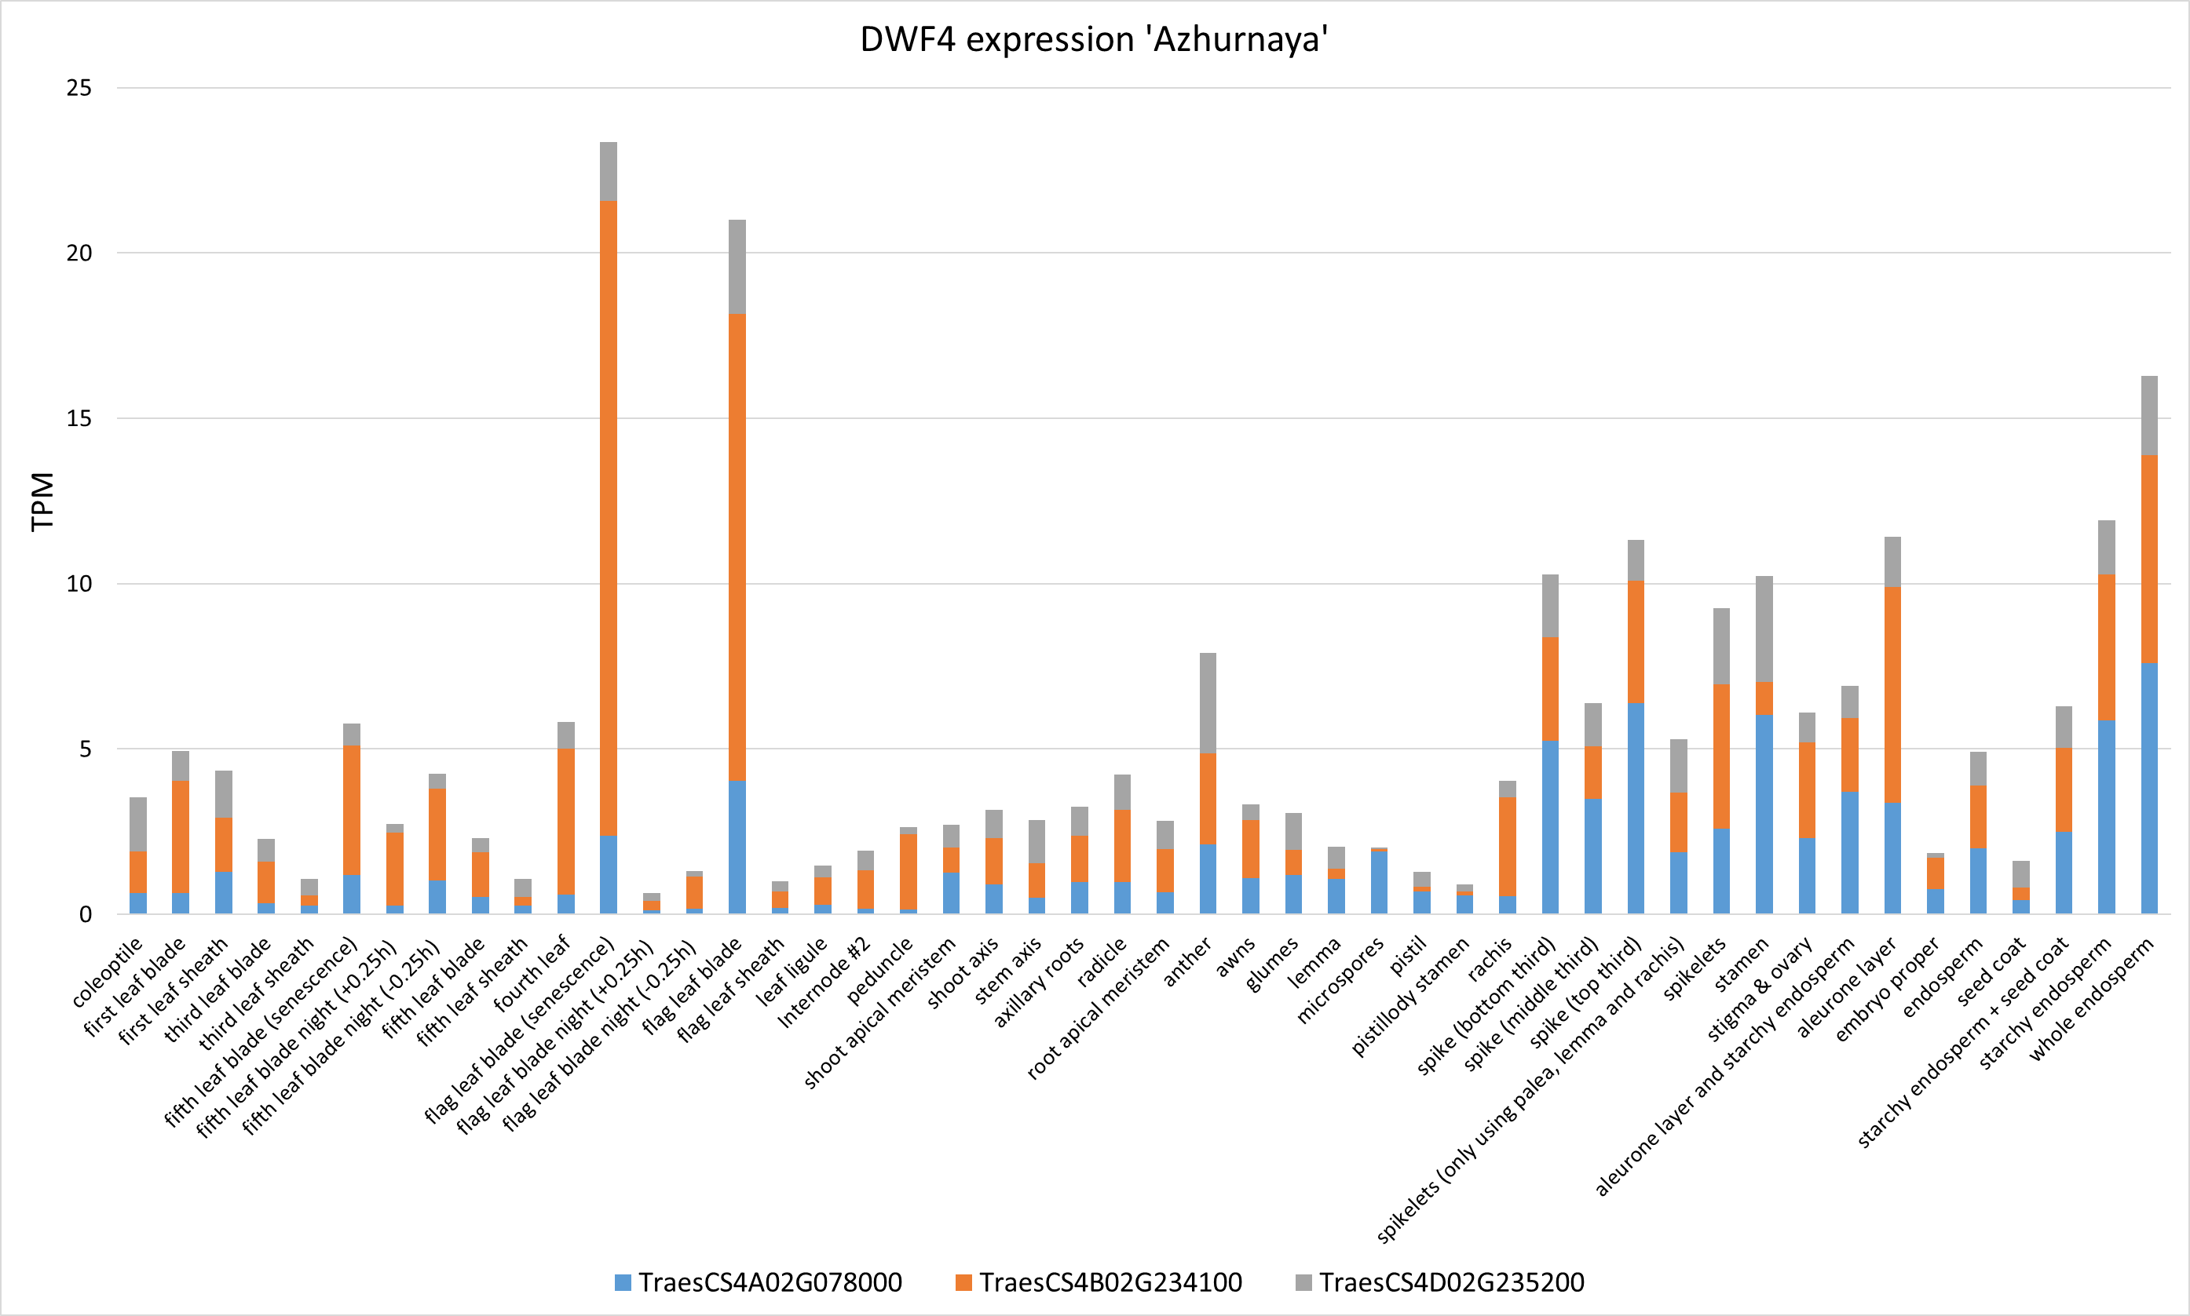
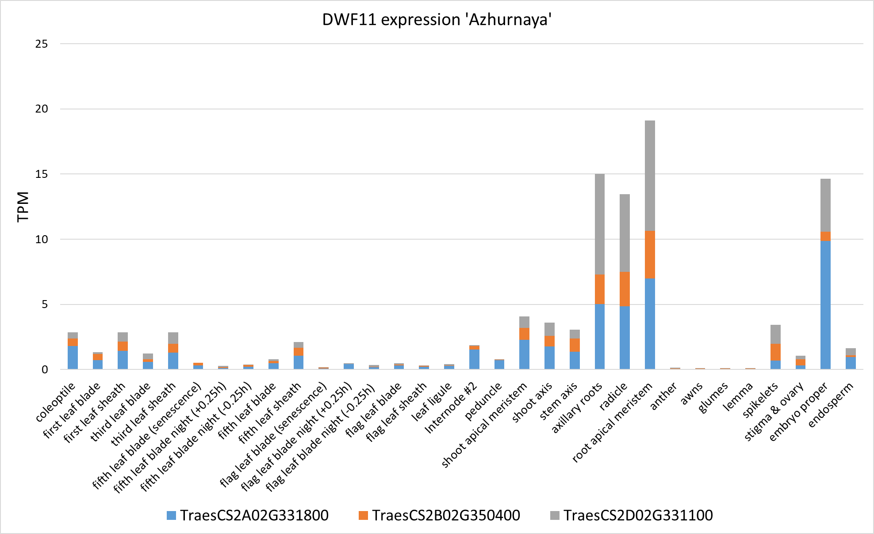

Table S1: Homoeologue-specific primers designed to amplify fragments around the deleterious mutations in DWF1 and DWF4. The primer sequences, fragment lengths and Tm (℃) are listed.
Gene | Forward primer (5' - 3') | Reverse primer (5' - 3') | Amplicon length (bp) | Tm (°C)
DWF1-A | ATGTGGTCCGCCATGAAGTCC | TCGACCTCGAAGTGCCTGACG | 188 | 66
DWF1-B | TCAGCTAACATCTCTTTGTACA | TCACGACCTTCTGCACGTTC | 265 | 60
DWF1-D | TCAGCTAACATCTCTTTGTACT | TGGGGATGAGCTTGATCTCA | 745 | 60
DWF4-A | TCAGTACAGGCATGCGAGCAG | CGCGGACACCACCCCCTTCAT | 660 | 66
DWF4-B | TCTCTCTCTCTCCAACCCATCATC | CGCATGCCTGTACTGATGTATA | 403 | 62
DWF4-D | GATCTGTGCTAAACTAGACACT | ACGCATATATCTTGCACTGAT | 293 | 62

Table S2: KASP primers designed to differentiate between the mutant and wild-type alleles in segregating DWF1 and DWF4 populations. Tail sequences GAAGGTGACCAAGTTCATGCT (FAM) and GAAGGTCGGAGTCAACGGATT (HEX) were added to the 5’ end of the forward primers to differentiate mutant (MT) and wild-type (WT) alleles, respectively. The nucleotide distinguishing wild-type and mutant alleles is in bold.
Gene | Forward Primer (5' - 3') (MT) | Forward Primer (5' - 3') (WT) | Common primer (5’ -3’)
DWF1-A | CACGTTGCGCATGCCGACGGCGATT | CACGTTGCGCATGCCGACGGCGATC | ACCCCAAGAAGGACGGCCTC
DWF1-B | ACGAGGATCCATCGGAACTA | ACGAGGATCCATCGGAACTG | CGACCAAAGAGGAAGAAGGTC
DWF1-D | GGAACCCGAGAGTGCCCTA | GGAACCCGAGAGTGCCCTG | CGAGTACTCCGACCTCTTCTA
DWF4-A | GGCGGCATCCTTGGCAAATA | GGCGGCATCCTTGGCAAATG | CTGAGGAAGTTGAGGGAGATGG
DWF4-B | TTCGTCCGGCCGCTCCACT | TTCGTCCGGCCGCTCCACC | CATCCTCCTGGCCCTGCTCA
DWF4-D | AACCATCTCTTTGTAGTCTTCT | AACCATCTCTTTGTAGTCTTCC | ATGGAAATATTGACAGTGAATCCA

 |  | dwf1-abd | DWF1-NS | dwf4-abd | DWF4-NS | Cadenza | p-value | SED | LSD at 5%
BR content (pg/mg DW) | CR | 6.23 ± 0.43**** | 759.05 ± 67.02 | 721.78 ± 61.77* | 811.45 ± 21.46 | 603.61 ± 55.63 | <.001 | 42.165 | 89.872
BR content (pg/mg DW) | CN | 1.27 ± 0.34**** | 16.56 ± 0.78 | 18.99 ± 0.81 | 19.28 ± 0.94 | 17.51 ± 1.84 | <.001 | 0.868 | 1.85
BR content (pg/mg DW) | 6-oxoCN | 0.22 ± 0.03*** | 0.82 ± 0.12 | 0.72 ± 0.12 | 0.78 ± 0.19 | 0.79 ± 0.17 | <.001 | 0.112 | 0.239
BR content (pg/mg DW) | 6-deoxoCT | 4.11 ± 0.43* | 4.71 ± 0.33 | 4.81 ± 0.12**** | 3.19 ± 0.47 | 3.46 ± 0.10 | <.001 | 0.27 | 0.575
BR content (pg/mg DW) | 6-deoxoTY | 40.00 ± 5.20 | 33.41 ± 1.98 | 36.24 ± 3.80**** | 16.09 ± 1.45 | 38.88 ± 5.57 | <.001 | 3.238 | 6.903
BR content (pg/mg DW) | TY | 0.0002 ± 0.0001** | 0.0004 ± 0.0001 | 0.0005 ± 0.0000 | 0.0005 ± 0.0002 | 0.0006 ± 0.0001 | 0.002 | 0.000078 | 0.00016
BR content (pg/mg DW) | CS | 0.0015 ± 0.0008** | 0.0005 ± 0.0001 | 0.0010 ± 0.0002 | 0.0003 ± 0.0001 | 0.0008 ± 0.0003 | 0.015 | 0.00031 | 0.00067
BR content (pg/mg DW) | BL | 0.021 ± 0.003**** | 0.006 ± 0.003 | 0.017 ± 0.003** | 0.009 ± 0.002 | 0.014 ± 0.002 | <.001 | 0.0025 | 0.0054
BR content (pg/mg DW) | DS | 0.0015 ± 0.0006 | 0.0009 ± 0.001 | 0.0004 ± 0.0003 | 0.0006 ± 0.0004 | 0.0004 ± 0.0002 | 0.018 | 0.0003 | 0.0006
Table S3: BR levels (pg/mg DW) in dwf1-abd and dwf4-abd mutants and controls. Mean values (pg/mg DW) ± SD are shown for the dwf1-abd and dwf4-abd mutants along with the DWF1-NS, DWF4-NS and Cadenza controls at the seedling stage. The data were analysed using one-way ANOVA which yielded p-values, SED, and LSD at 5% level of significance. Fisher’s unprotected LSD test was performed for multiple pair-wise comparisons. P values *0.05>P>0.01, **0.01>P>0.001, ****0.0001>P>0.00001 (obtained from Fisher’s unprotected test)

