Supplementary Material

Tab. S1 Selection of the Czech measurement sites presented in the study.
Station name | Measurement | Longitude | Latitude | Altitude [m a. s. l.]
České Budějovice | PM₁₀ | 48° 59´ 3.791" N | 14° 27´ 56.462" E | 383
Hradec Králové - Brněnská | PM₁₀ | 50° 11´ 43.304" N | 15° 50´ 46.955" E | 232
Klatovy - soud | PM₁₀ | 49° 24´ 2.189" N | 13° 17´ 12.924" E | 394
Košetice | PM₁₀ | 49° 34´ 24.221" N | 15° 4´ 49.002" E | 535
Kuchařovice | PM₁₀, Ceilometer | 48° 52´ 52.879" N | 16° 5´ 8.942" E | 324
Mošnov | Ceilometer, SODAR-RASS | 49° 41´ 29.583" N | 18° 6´ 47.485" E | 253
Olomouc - Hejčín | PM₁₀ | 49° 36´ 5.268" N | 17° 14´ 17.064" E | 224
Ostrava -Poruba | PM₁₀ | 49° 49´ 31.060" N | 18° 9´ 33.390" E | 242
Plzeň | PM₁₀, Ceilometer | 49° 46´ 7.017" N | 13° 25´ 24.171" E | 348
Prague - Karlín | PM₁₀ | 50° 5´ 39.258" N | 14° 26´ 31.376" E | 203
Prague - Libuš | Sounding, Ceilometer | 50° 0´ 26.299" N | 14° 26´ 45.360" E | 301
Prostějov | Sounding | 49° 27´ 8.280" N | 17° 8´ 5.401" E | 215
Studénka | PM₁₀ | 49° 43´ 15.369" N | 18° 5´ 21.501" E | 231
Tušimice | PM₁₀ | 50° 22´ 35.713" N | 13° 19´ 39.441" E | 322
Ústí nad Labem | PM₁₀ | 50° 41´ 0.690" N | 14° 2´ 28.302" E | 367

Text S1 Saharan dust events frequency estimation 2018–2024
The SD events are natural phenomena caused by the transport of mineral dust from the Sahara Desert across the continents [37]. The SD events frequency passing through the Czech Republic was estimated according to the Daily Dust product developed by the World Meteorological Organization (WMO) Barcelona Dust Regional Center that coordinates the research of the WMO Sand and Dust Storms Warning Advisory and Assessment System (WMO SDS-WAS) in Northern Africa, the Middle East, and Europe. Daily Dust Products is an interactive tool for daily dust forecasting that employs several useful functions for analyses. Our analyses were used for SD event estimation of the Aerosol atmospheric depth (AOD) parameter at 550 nm and multimodel setting [38]. AOD represents the light extinction of solar beam caused by dust (aerosol) in the atmospheric column [39, 40]. The daily dust product AOD scale varies from 0 to more than 6.4. A potential SD event was counted when AOD was higher than 0.2, and more than half of the area of the Czech Republic was covered by this layer in the interactive tool (Fig. S1).
SD event frequency analysis was investigated from 2018 to 2024 (2557 days). Only 50 days were marked as days with potential SD events; details are listed in Tab. S2. During these 50 days, a similar impact of SD on air quality was not recorded, as during the study period from 28 March to 1 April, 2024.
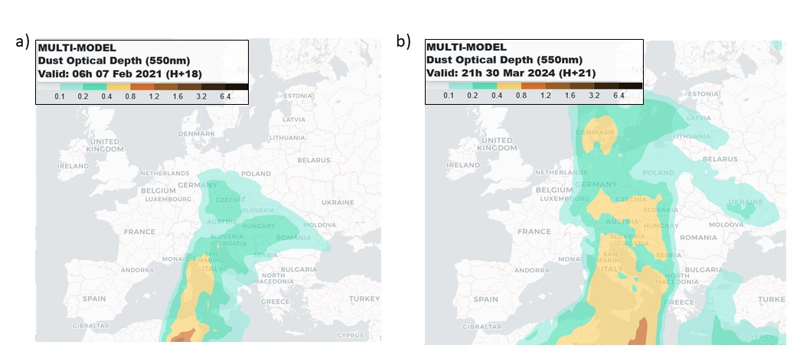

Fig. S1 Numerical dust forecast maps vizualize AOD values during SD events, February 7 2021 (on the left), March 30, 2024 (on the right).

Tab. S2 Potential number of days with Saharan dust events, 2018–2024.
2018 | 2019 | 2020 | 2021 | 2022 | 2023 | 2024
4 | 6 | 0 | 11 | 5 | 6 | 18

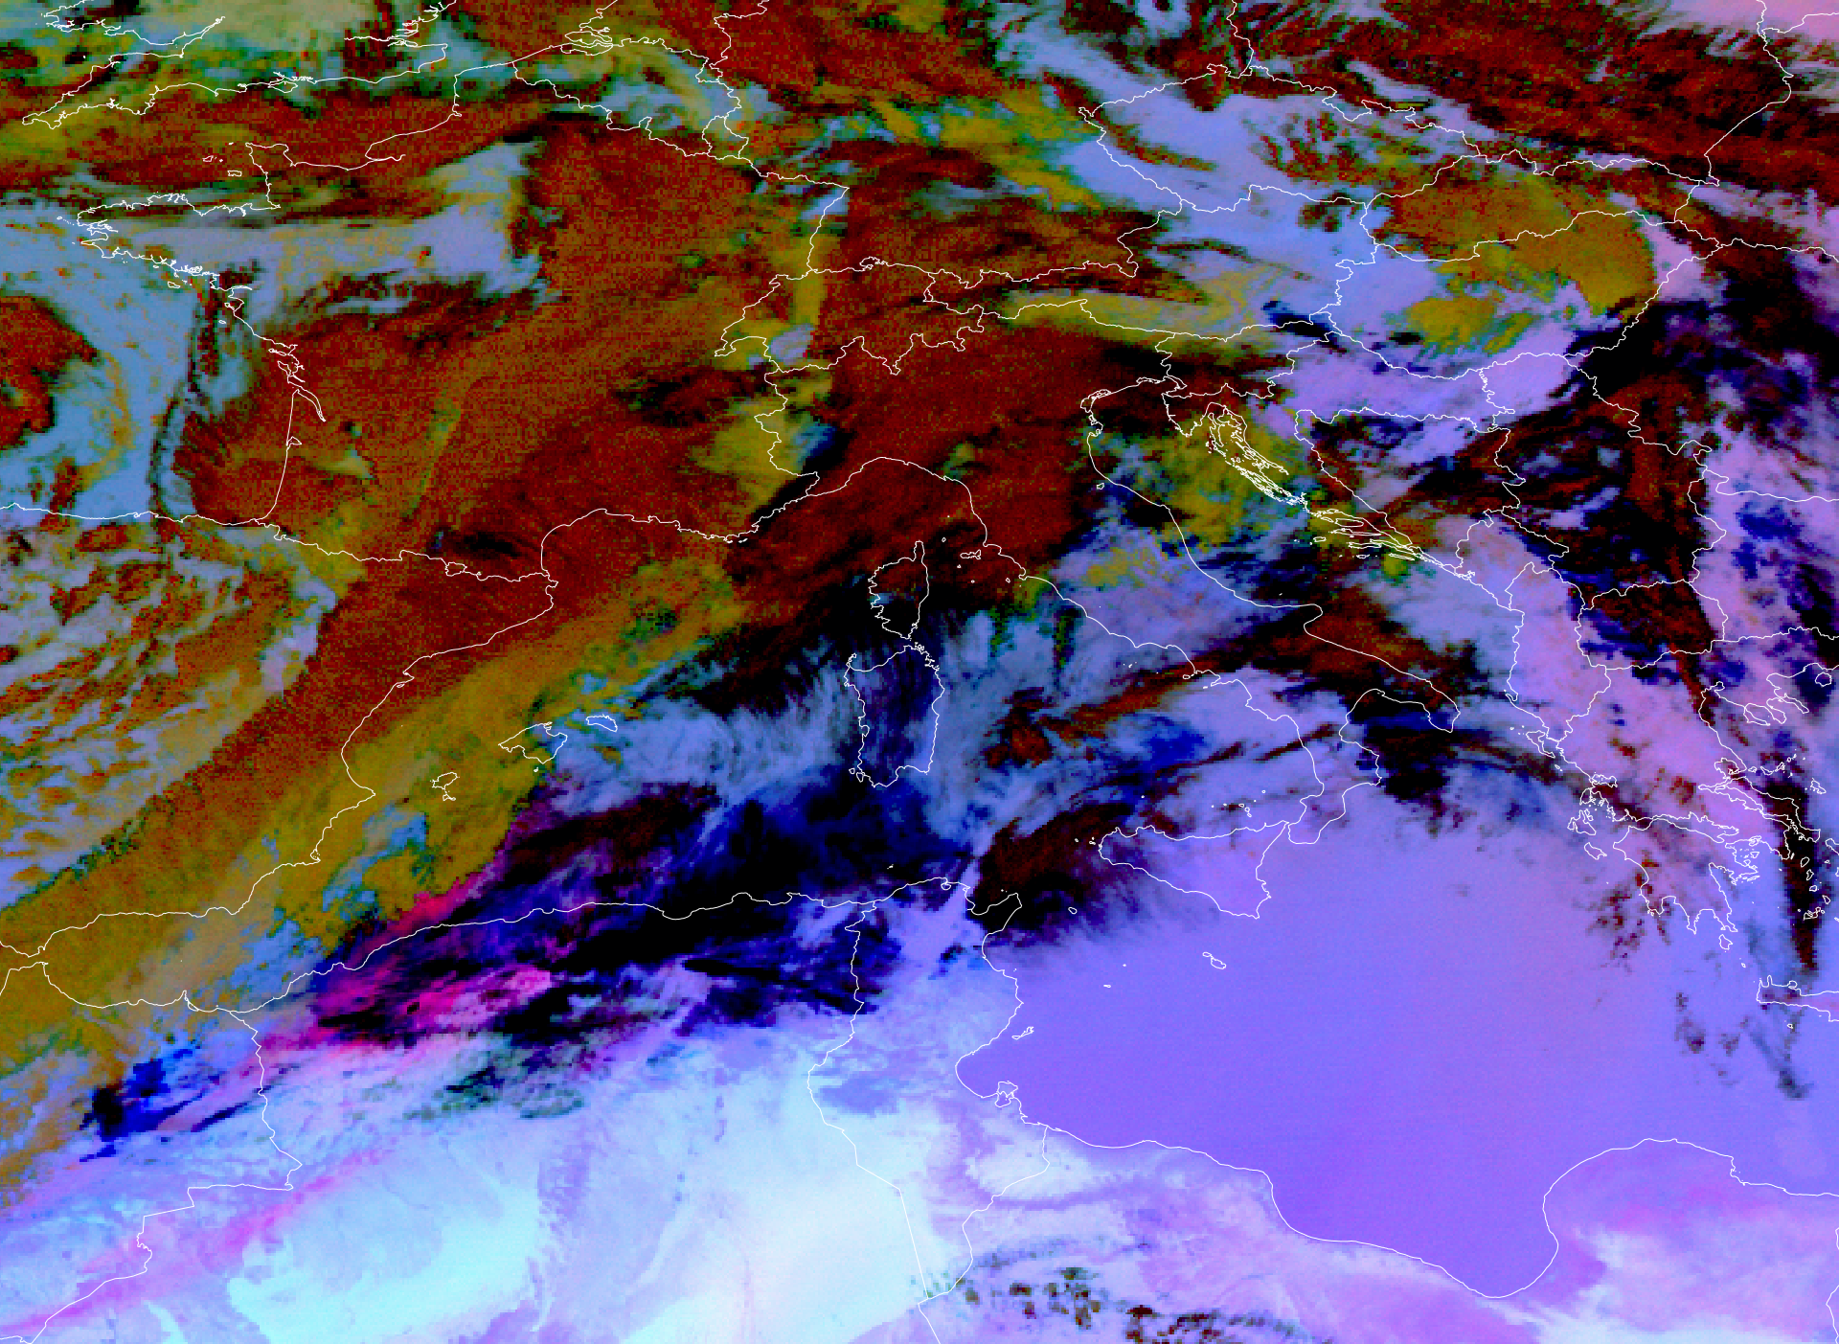
Fig. S2 DUST RGB image, May 31, 2024, 6:30 UTC
The third plume is propagating from the Hautes Plaines towards Central Europe. Another, rather thin belt of Saharan dust extends from Libya to the north/northeast, affecting basically all of Eastern Europe. (Thin dust layers are not visible on this product. The dust plume is bright pink.)

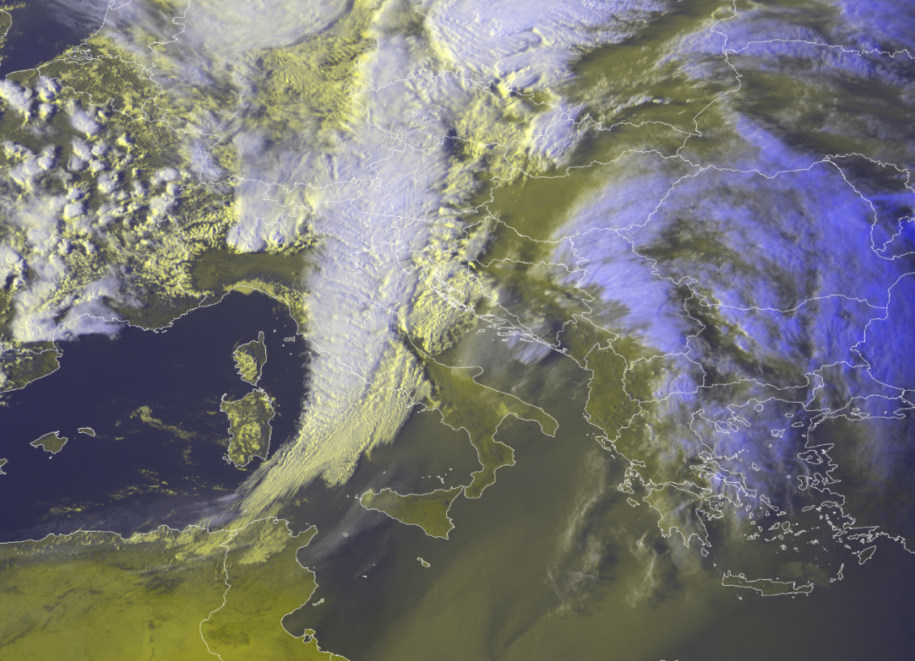
Fig. S3 HRV (high resolution visible) image, April 1, 2024 16:00 UTC.
Thinner dust plumes covered all of Eastern Europe and most of the Central Europe. With the third plume we can again observea belt of Saharan dust stretching from Algeria towards north/north east. (The dust plume is appears as yellowish "veil".)

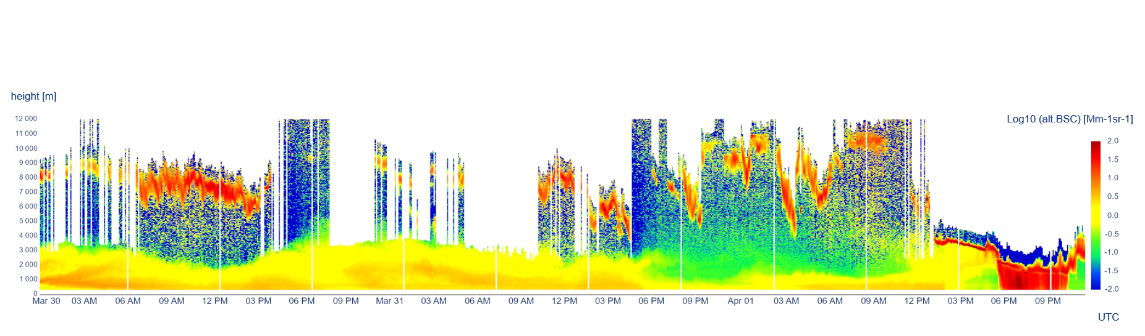

Fig. S4 Visualization of ceilometer data at the Kuchařovice site, March 30 – April 1, 2024 (Figure download date September 09, 2024. Currently the ceilometer data can be downloaded from [27] in a different color scale and resolution, see chapter "Potential links between meteorological conditions and PM₁₀ concentrations".)

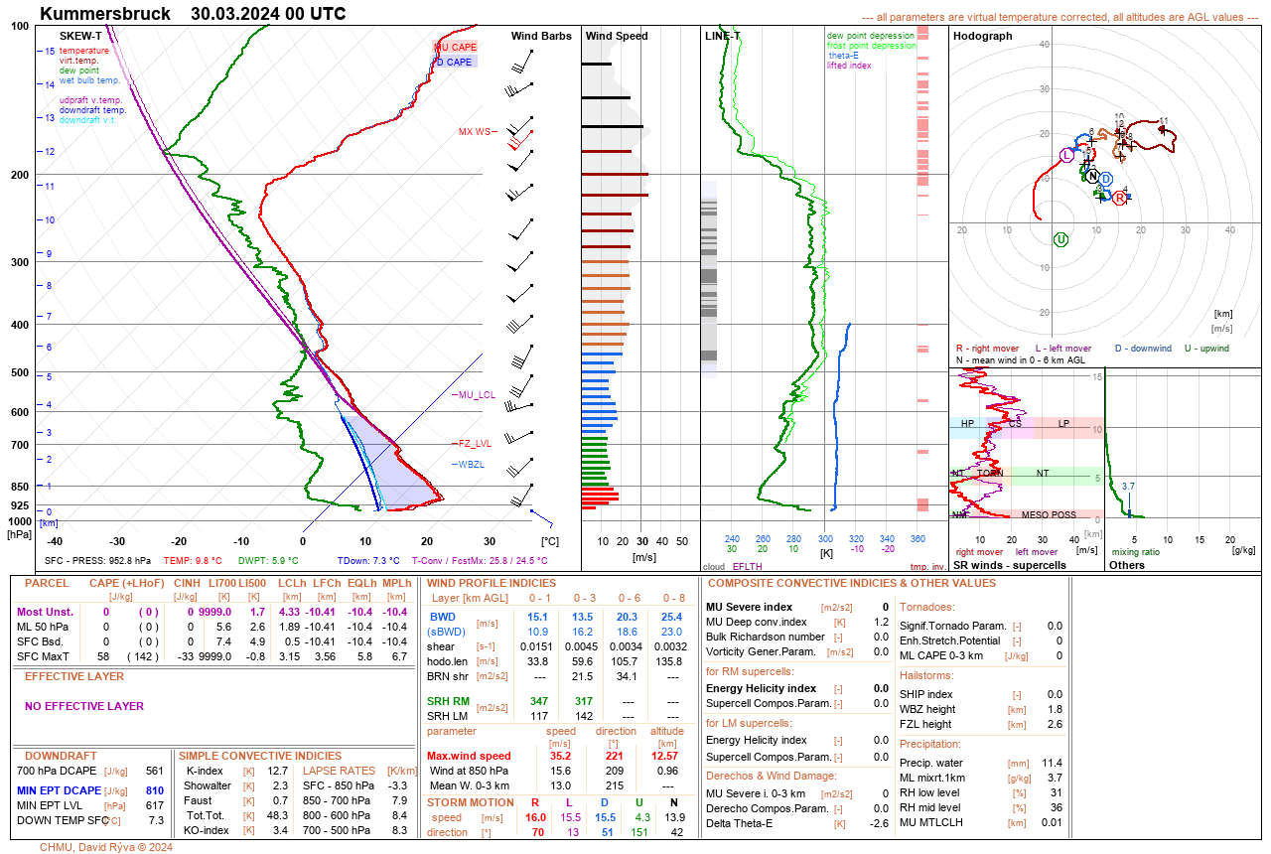
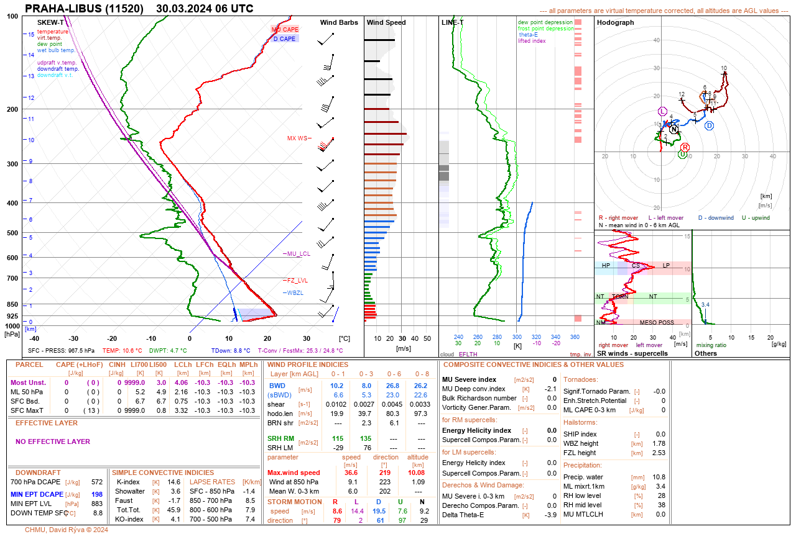
Fig. S5 Sounding, Kümmersbruck, March 30, 2024, 00:00 UTC
Fig. S6 Sounding, Prague, March 30, 2024, 06:00 UTC
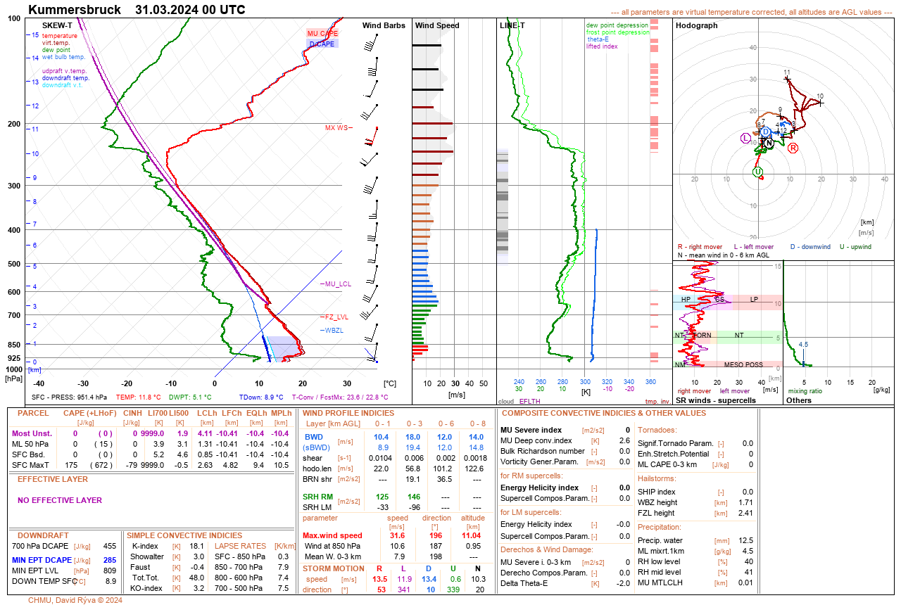
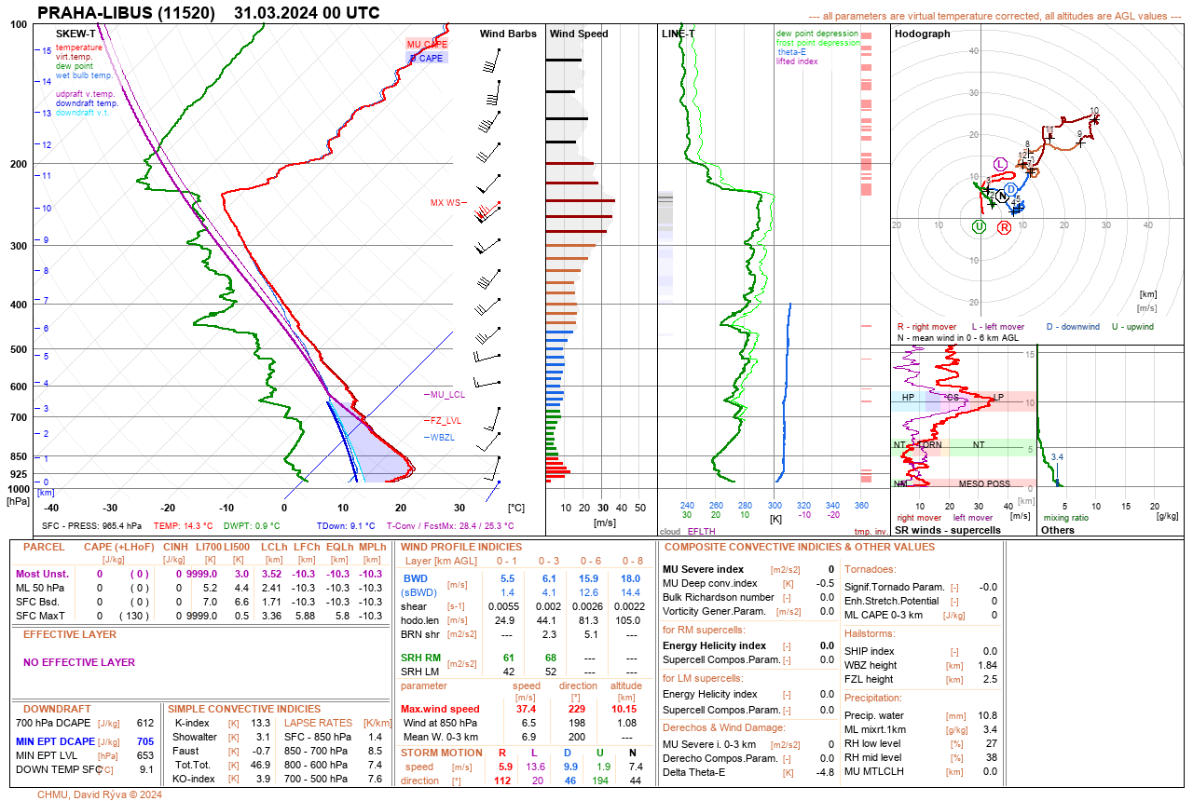
Fig. S7 Sounding, Kümmersbruck, March 31, 2024, 00:00 UTC

Fig. S8 Sounding, Prague, March 31, 2024, 00:00 UTC
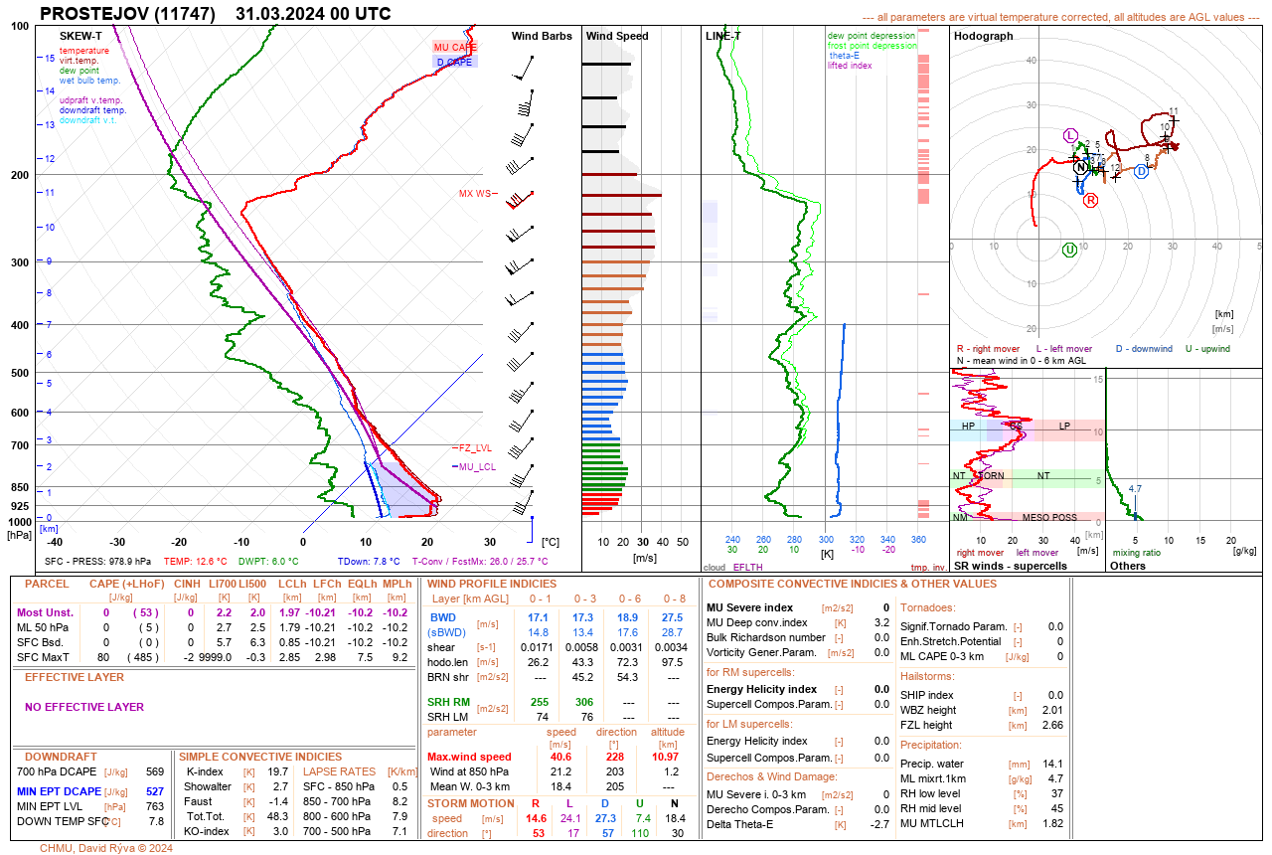
Fig. S9 Sounding, Prostějov, March 31, 2024, 00:00 UTC
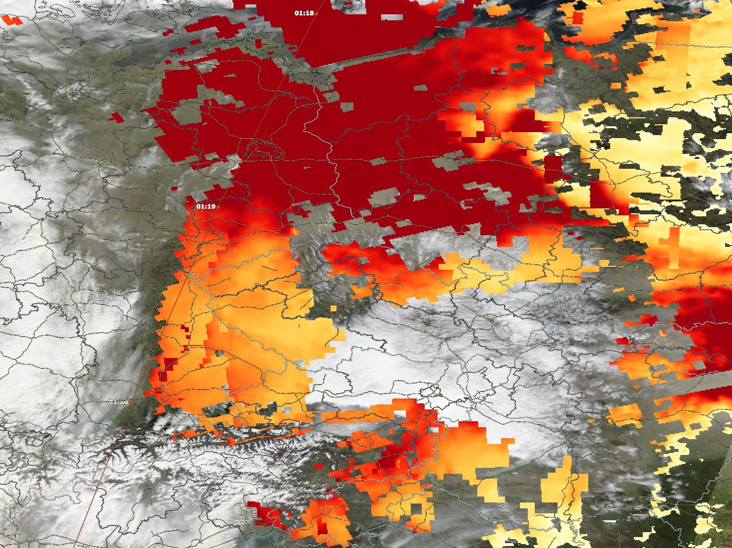

Fig. S10 Aqua-MODIS, aerosol optical depth imagery from March 30, 2024 over the Czech Republic.
(There are quite a lot of cirrus clouds, although they exhibit characteristics of DIBS cirrus clouds. The dark red colour indicates high values of aerosol optical depth.)

