Supplement of “A Preliminary Attempt on Decadal Prediction of the East Asian Summer Monsoon”

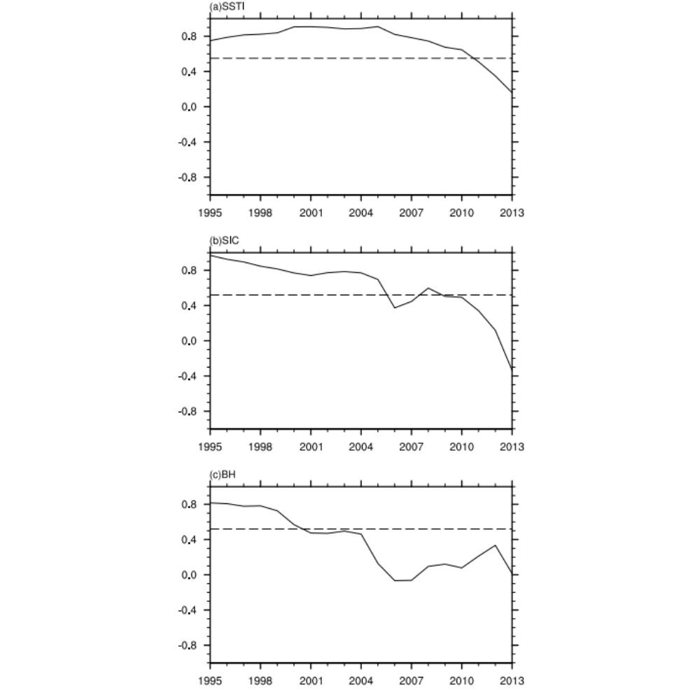
Fig. S1 11-year running correlation between DI_EASMI during 1990–2018 and leading DI of predictors (a SSTI, b SIC, c BH). The dotted line is at the 90% confidence level by the student’s t-test, and the effective sample numbers are 9, 10, and 10, respectively
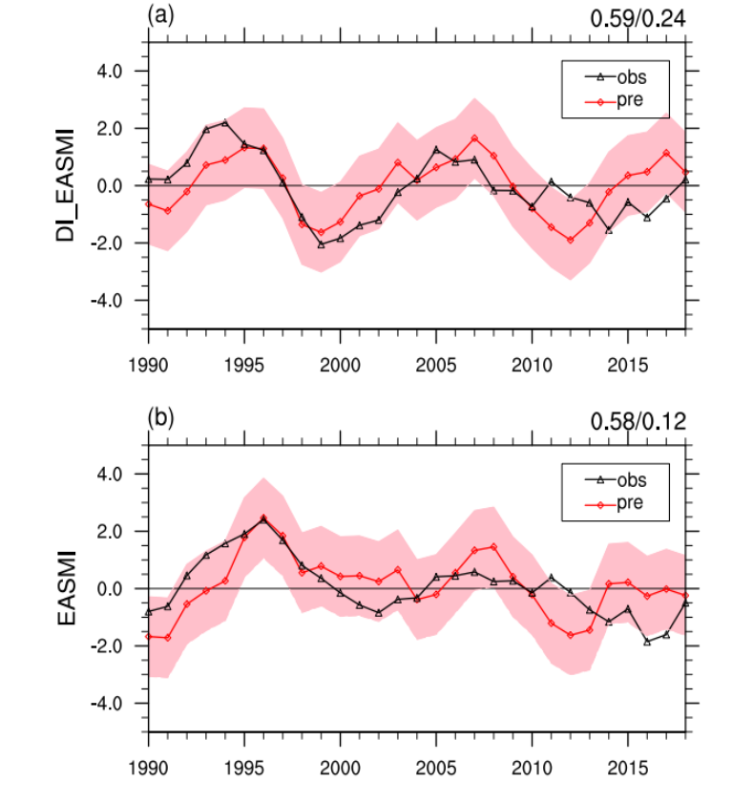
Fig. S2 Predictions of a DI_EASMI and b EASMI of the cross validation during 1990–2018 (the light pink shading indicates the 95% confidence interval of the prediction. The value in the upper right corner is the correlation coefficient/MSSS between observations and predictions)

