Table 1. Receiver operating characteristic (ROC) curve & confusion matrix (logistic regression)
ROC Curve | Confusion Matrix
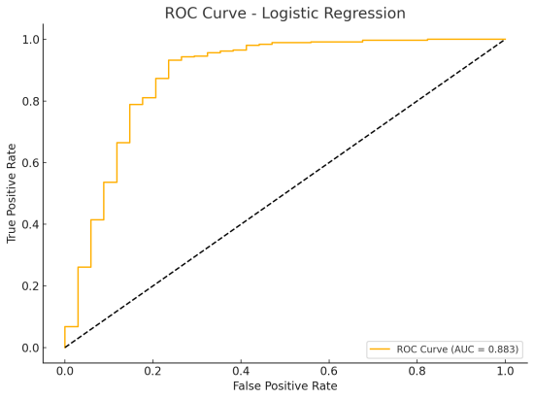 | 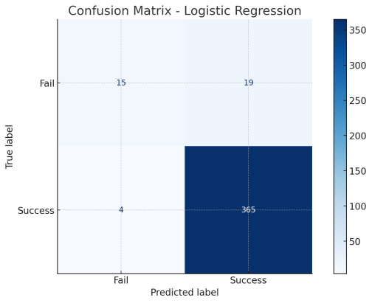

Table 2. Logistic Regression
Input variables | Coefficient | Odds ratio | S.D. | z-value | p-value
Const | -2.94 | 0.05 | 1.45 | -2.03 | 0.04
Age | 0.01 | 1.01 | 0.02 | 0.59 | 0.56
Gender (female) | -0.01 | 0.99 | 0.53 | -0.01 | 0.99
Location (upper) | 2.28 | 9.81 | 0.57 | 4.01 | 0.00
Location (middle) | 0.94 | 2.56 | 0.89 | 1.05 | 0.29
Location (pelvis) | 1.87 | 6.47 | 0.74 | 2.51 | 0.01
Volume | 0.00 | 1.00 | 0.00 | 0.71 | 0.48
HU | -0.01 | 0.99 | 0.00 | -4.07 | 0.00
SHI | 0.02 | 1.02 | 0.00 | 5.89 | 0.00
SSD | 0.03 | 1.03 | 0.01 | 2.53 | 0.01
Total ESWL energy | 0.00 | 1.00 | 0.00 | -0.64 | 0.52
Total ESWL energy/HU | 0.01 | 1.01 | 0.01 | 0.78 | 0.44
Total ESWL energy/SSD | 0.00 | 1.00 | 0.00 | 0.78 | 0.43
Total ESWL Energy/Volume | 0.00 | 1.00 | 0.00 | -4.51 | 0.00
Note: The values for sex and stone location are mutually exclusive categorical variables, which can lead to multicollinearity. To address this, we set ‘male’ for sex and ‘lower’ for stone location as reference categories, and their coefficients were excluded from the regression analysis results.

Table 3. ROC curve & confusion matrix (random forest)
ROC Curve | Confusion Matrix
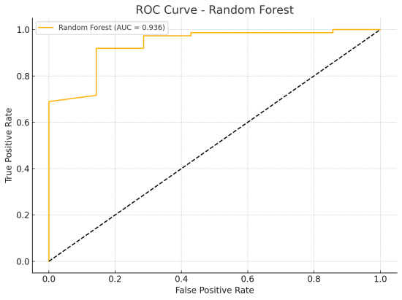 | 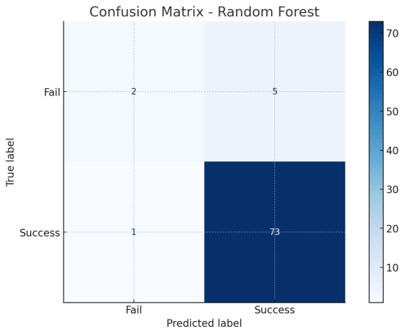

Table 4. ROC curve & confusion matrix (decision tree)
ROC Curve | Confusion Matrix
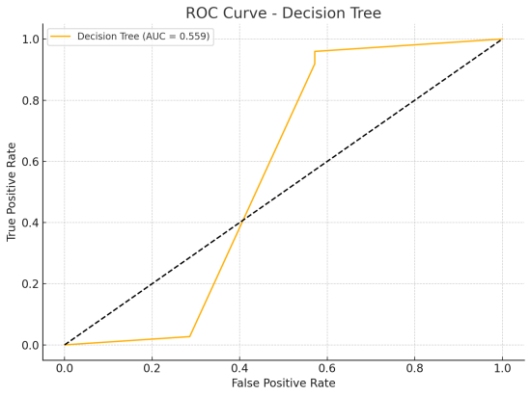 | 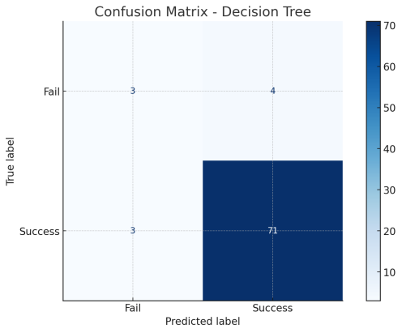

Table 5. Summary of model performance and key predictive features
Model | Accuracy | Sensitivity | Specificity | AUC | Key Features
Logistic Regression | 0.943 | 0.989 | 0.441 | 0.883 | SHI, HU, SSD,  Location (Pelvis, Upper), Total ESWL Energy/Volume
Random Forest | 0.926 | 0.986 | 0.286 | 0.936 | Volume, SHI, HU
Decision Tree | 0.914 | 0.959 | 0.429 | 0.559 | Volume, SHI, HU

