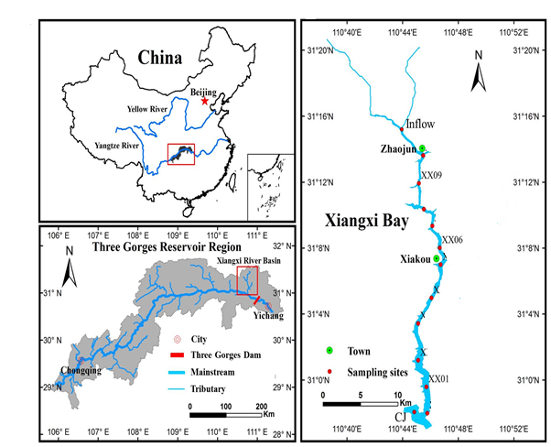
Fig.S1. The Xiangxi Bay (XXB) in Xiakou Town, Xingsha County, Hubei Province, China. The summer sampling for the spatial biomass production were conducted at points; XX01 (mouth), XX06 (confluence), and XX09 (mainstream) which are typical representatives of the XXB characteristics. Samples were all returned to the point XX06 where the bioassay experiments were deployed. Other samplings across the seasons were conducted in XX06.

