Antonie van Leeuwenhoek
Supplementary Material

Sulfuriroseicoccus oceanibius gen. nov., sp. nov., a representative of the phylum Verrucomicrobia with the special cytoplasmic membrane, and proposal of Sulfuriroseicoccaceae fam. nov.

Xi Feng¹, Qi-Yun Liang¹, Qi-Hang Zou¹, Meng-Qi Ye¹, and Zong-Jun Du^{1,2*}

¹Marine College, Shandong University, Weihai, Shandong, 264209, PR China
²State Key Laboratory of Microbial Technology, Shandong University, Qingdao, Shandong, 266237, PR China

Author for correspondence:
Zong-Jun Du, Email: duzongjun@sdu.edu.cn
Tel and Fax: +86-631-5688303

Fig. S1. Cell morphology of strain T37 at different growth periods.

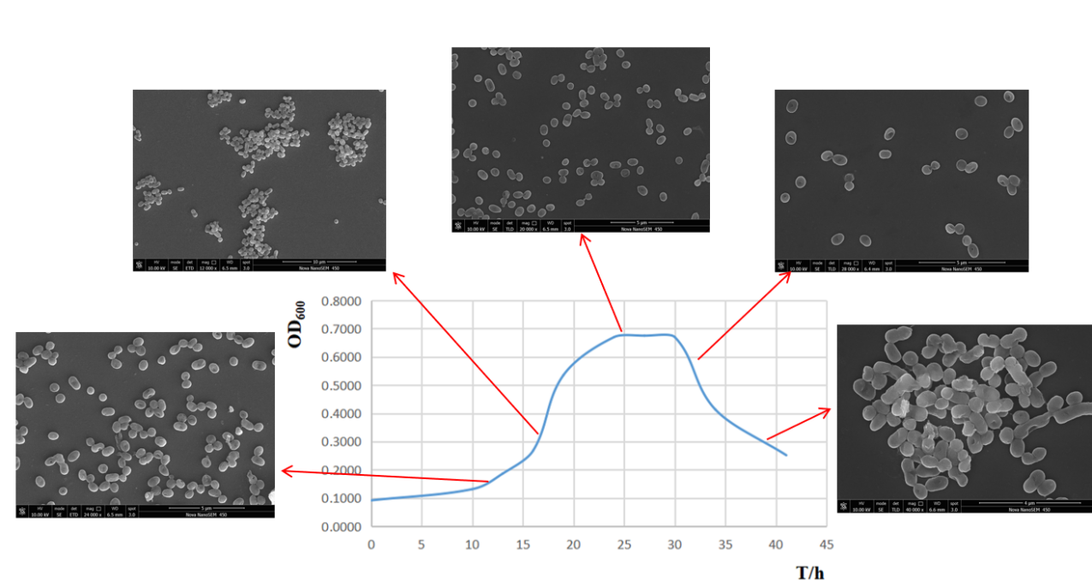

Fig. S2. Two-dimensional TLC showing the polar lipids of the strain T37^{T}.
a. phosphomolybdic acid; b. molybdenum blue; c. ninhydrin
DPG, diphosphatidylglycerol；PGL, phosphoglycolipids; PI, phosphatidylinositol; PE, phosphatidylethanolamine; PL, unidentified phospholipid; PG, phosphatidylglycerol; PC, phosphatidylcholine; AL, aminolipid; L, unidentified lipid.

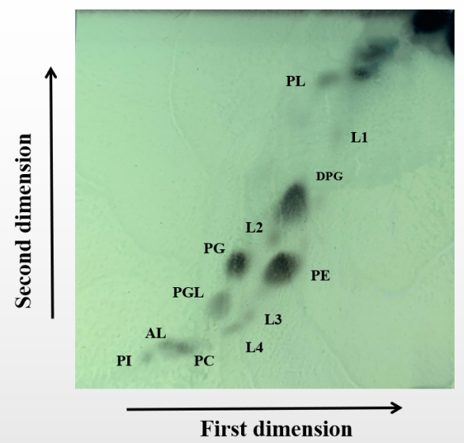
b
a
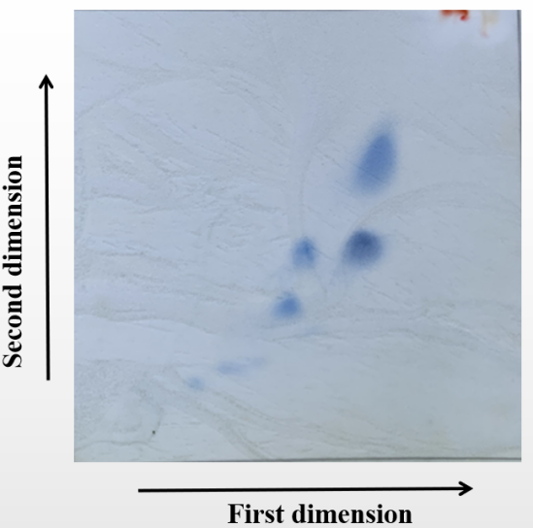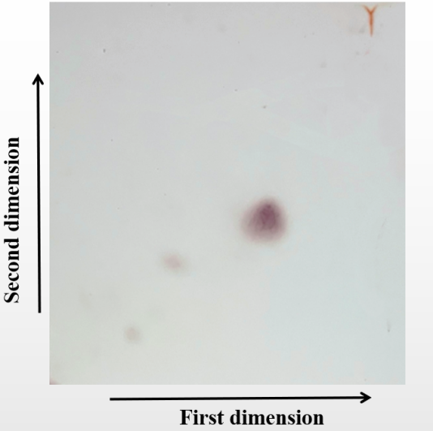
c

Fig. S3. Number of genes associated with the COG categories of coding proteins in the genome of strain T37^{T}.
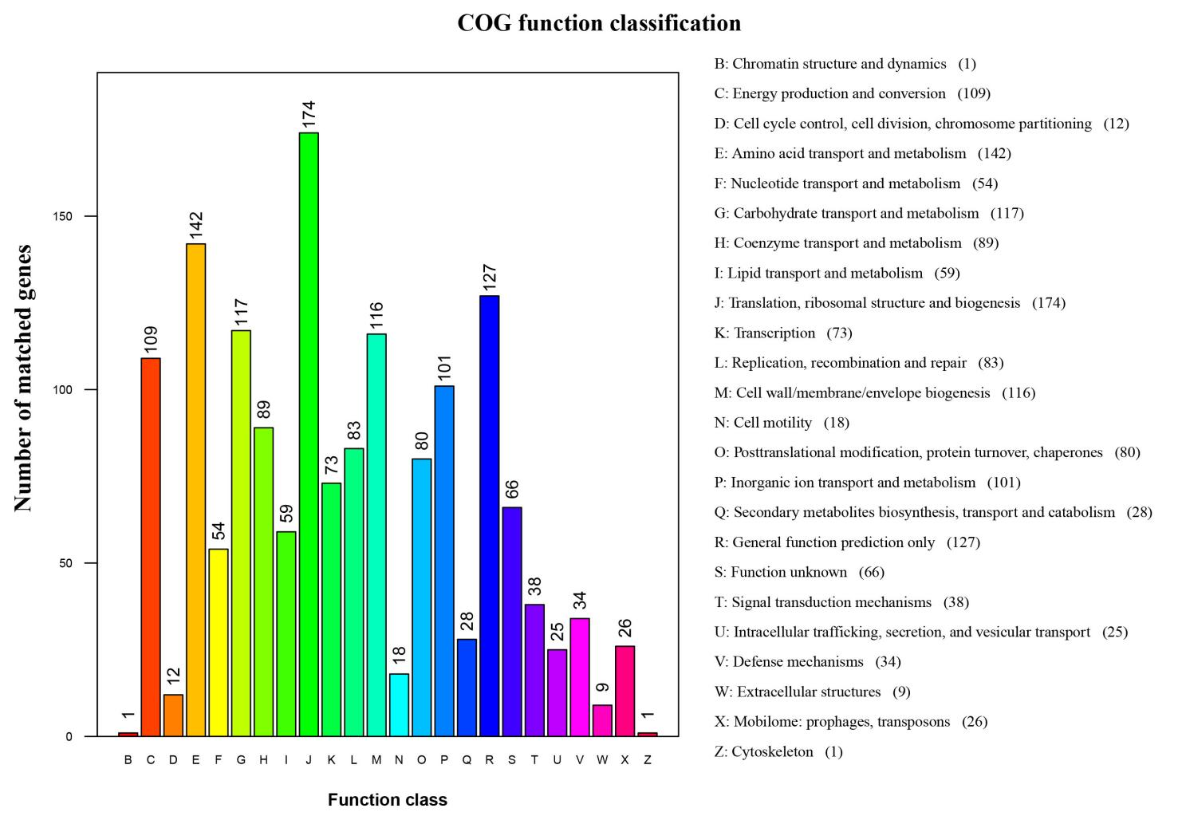

Fig. S4. Number of genes associated with the CAZy in the genome of strain T37^{T}.
CAZy, Carbohydrate-Active enZYmes Database; GH, Glycoside Hydrolases; GT, GlycosylTransferases; PL, Polysaccharide Lyases; CE, Carbohydrate Esterases; AA, Auxiliary Activities; CBM, Carbohydrate-Binding Modules.
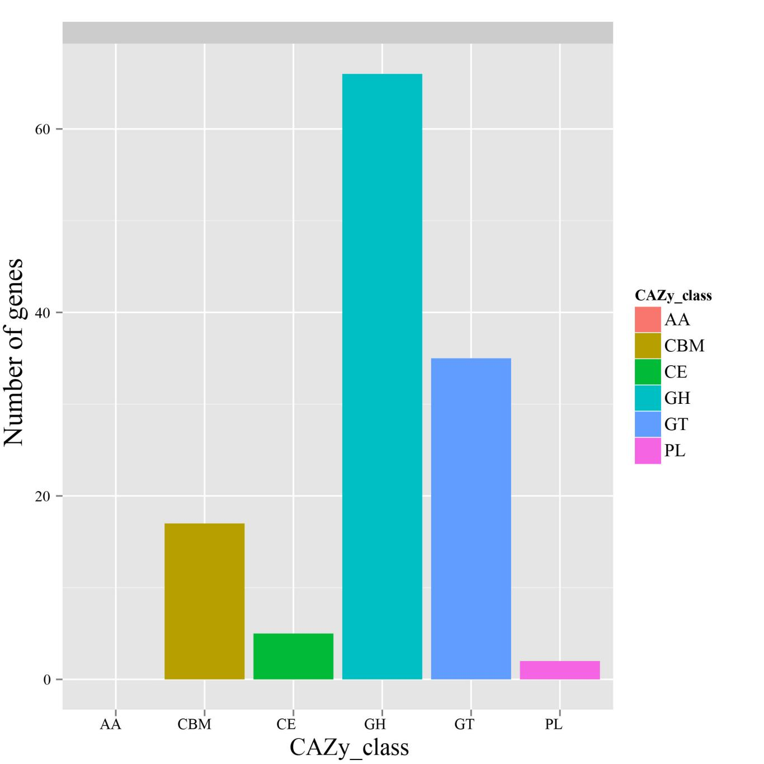

Fig. S5. Number of genes associated with the TCDB of coding proteins in the genome of strain T37^{T}.
TCDB, Transporter Classification Database.
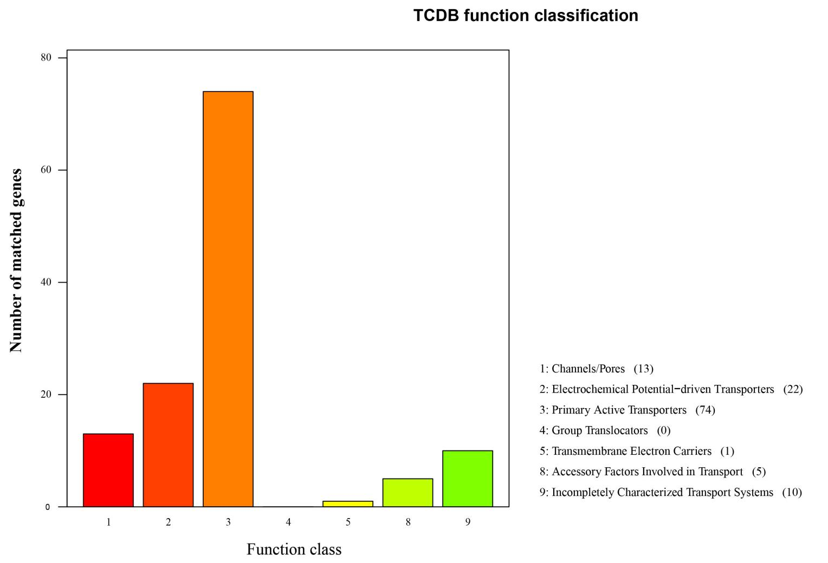

Table S1. The genome sequence comparisons between strain T37^{T} and phylogenetically related taxa.
Species | AAI (%) | POCP (%) | OrthoANIu value (%) | dDDH (%)* | Genome (Mbp) | G+C (%) | GenBank accession
Akkermansia muciniphila ATCC BAA-835 | 56.1 | 29.1 | 66.5 | 23.3 | 2.5 | 55.8 | NC_010655.1
Brevifollis gellanilyticus NBRC 108608 | 56.0 | 22.9 | 66.9 | 20.4 | 7.7 | 59.9 | GCA_007992435
Haloferula rosea KCTC 22201 | 58.2 | 35.8 | 69.2 | 20.2 | 4.7 | 60.9 | JAENII000000000
Luteolibacter pohnpeiensis KCTC 22041 | 57.9 | 28.6 | 68.0 | 21.5 | 4.7 | 53.6 | JAENIJ000000000
Persicirhabdus sediminis KCTC 22039 | 57.7 | 35.0 | 67.5 | 22.5 | 4.7 | 49.2 | JAENIM000000000
Phragmitibacter flavus MG-N-17 | 56.3 | 25.9 | 67.6 | 20.3 | 5.9 | 56.9 | GCA_005780165
Prosthecobacter fusiformis ATCC 25309 | 56.1 | 25.9 | 67.6 | 20.8 | 5.8 | 56.7 | SOCA00000000
Roseibacillus ishigakijimensis KCTC 12986 | 57.5 | 32.6 | 68.0 | 25.0 | 4.4 | 59.3 | JAENIO000000000
Roseimicrobium gellanilyticum DSM 25532 | 56.2 | 22.4 | 66.8 | 18.1 | 7.9 | 59.7 | GCA_003315205
Rubritalea marina DSM 17716 | 58.1 | 36.7 | 68.3 | 24.6 | 2.9 | 51.6 | ARJP00000000
Verrucomicrobium spinosum DSM 4136 | 56.3 | 22.5 | 67.4 | 22.9 | 8.2 | 60.3 | GCA_000172155
*identities / HSP length

