Table S1 The proximate and ultimate analysis of three types of AC
Sample | Proximate analysis (ad, wt%) |  |  |  | Ultimate analysis (ad, wt%)
Sample | moisture | volatile | ash | fixed carbon | C | H | O* | N | S
AC₁ | 6.74 | 6.48 | 6.38 | 80.40 | 78.53 | 4.27 | 2.86 | 0.92 | 0.39
AC₂ | 6.57 | 7.92 | 10.93 | 74.88 | 72.93 | 5.01 | 1.98 | 1.03 | 1.55
AC₃ | 6.42 | 13.52 | 12.99 | 67.07 | 67.51 | 5.96 | 3.57 | 1.12 | 2.43
*-calculated by difference

Figure S1 Flow chart of catalyst preparation through solid-phase method

Figure S2 Schematic diagram of experimental setup for testing catalyst performance

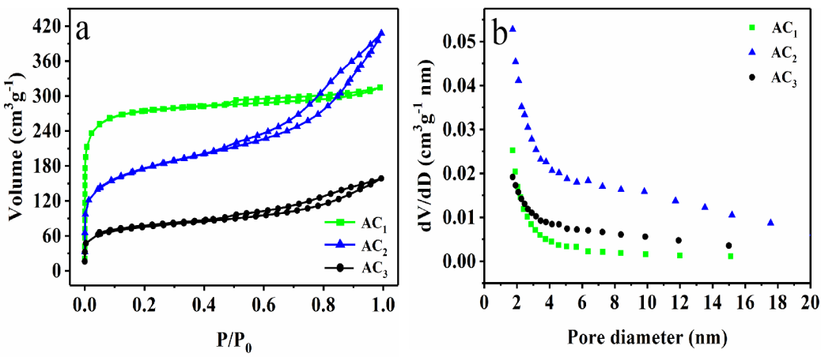
Figure S3 Nitrogen adsorption-desorption isotherms and pore size of AC

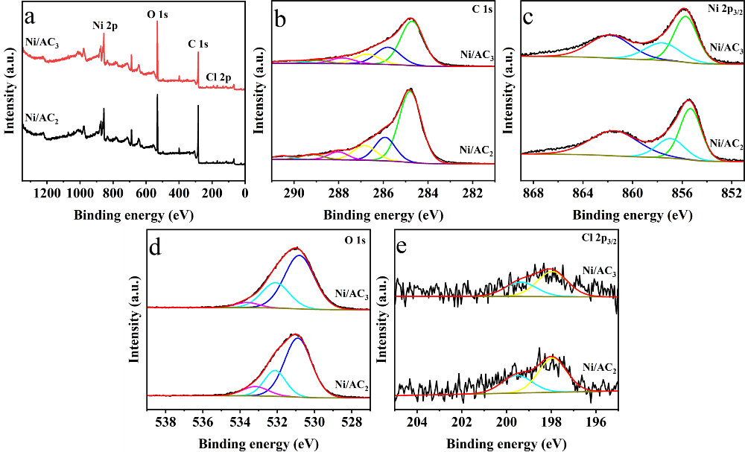
Figure S4 High-resolution XPS spectra of Ni/AC₂ and Ni/AC₃: a) Ni/AC₂ and Ni/AC₃; b) C 1s; c) Ni 2p_{3/2}; d) O 1s e) Cl 2p_{3/2}

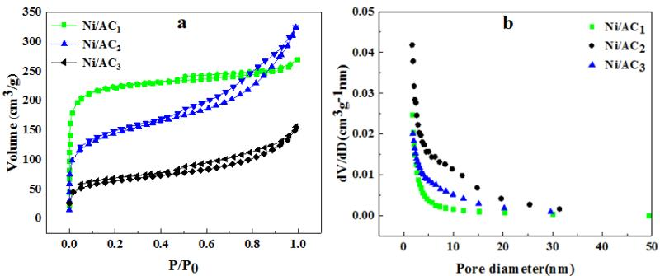
Figure S5 Nitrogen adsorption-desorption isotherms and pore sizes of the Ni/AC catalysts

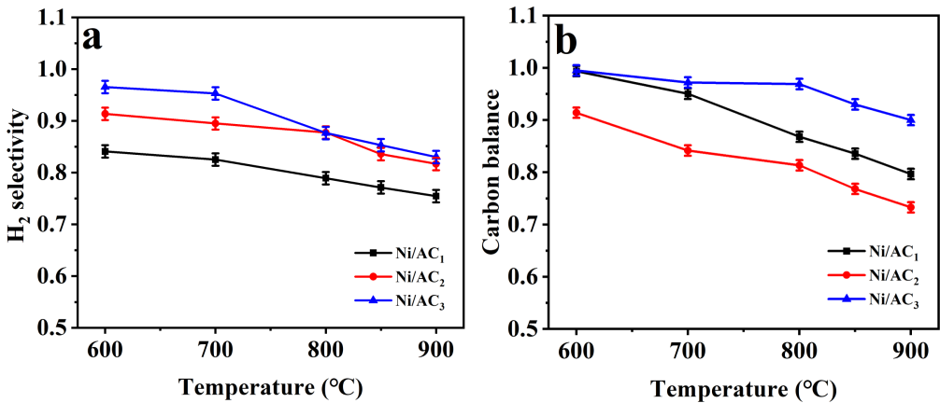
Figure S6 H₂ selectivity and carbon balance curves of Ni/AC on DRM at different temperatures:
a) H₂ selectivity; b) carbon balance

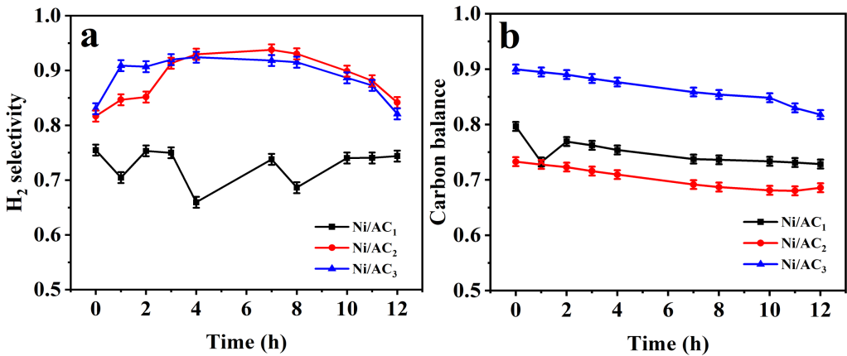
Figure S7 H₂ selectivity and carbon balance curves of Ni/AC at 900 °C:
a) H₂ selectivity; b) carbon balance

