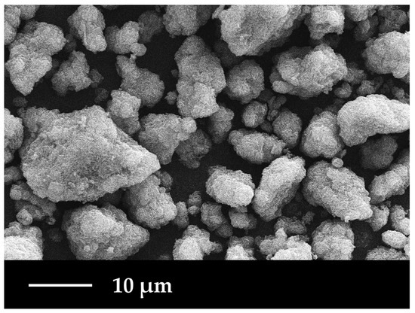  Figure 1: chalcopyrite 1 | 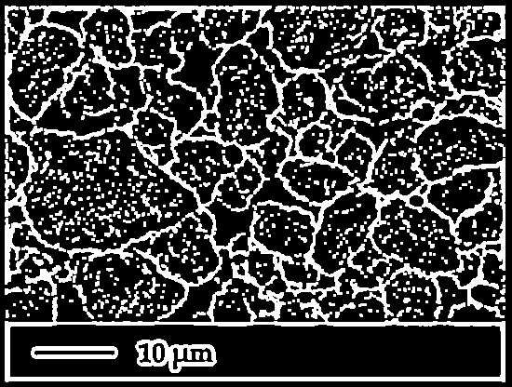  Figure 2: chalcopyrite 1
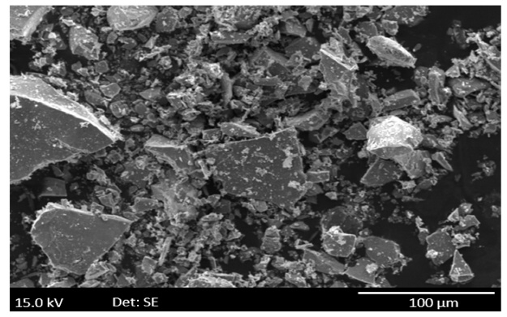  Figure 3: chalcopyrite 2 | 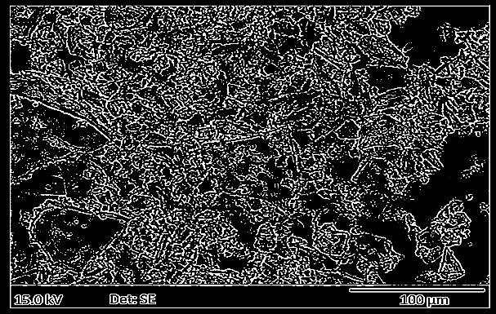  Figure 4: chalcopyrite 2
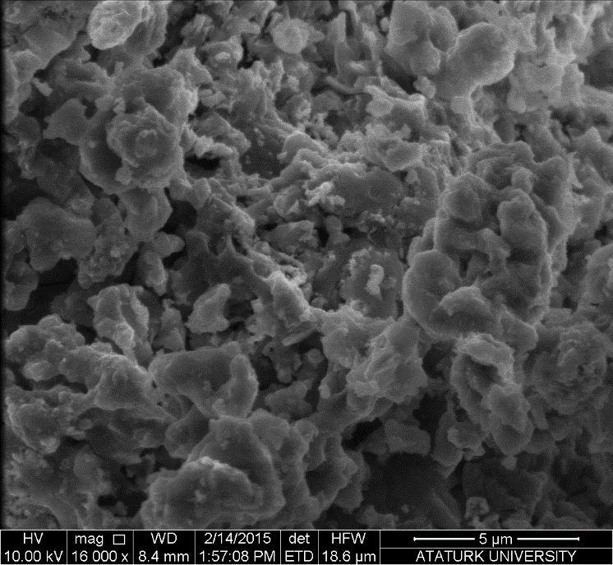  Figure 5: chalcopyrite 3 | 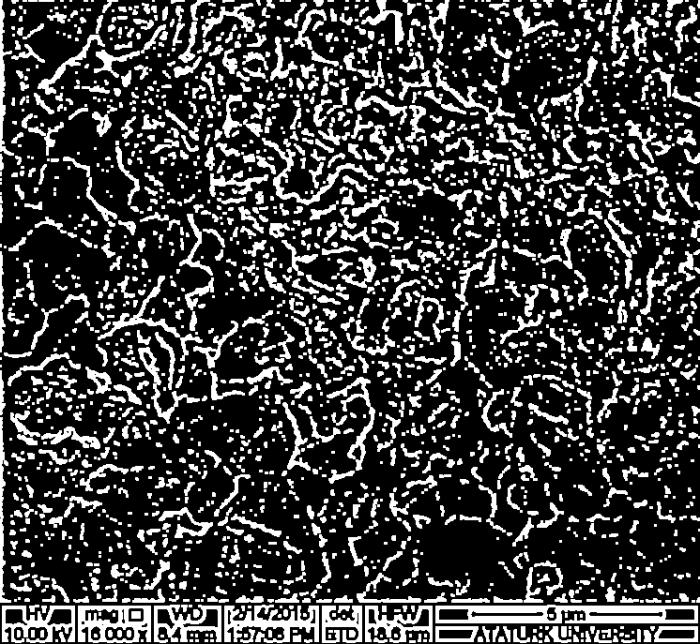  Figure 6: chalcopyrite 3
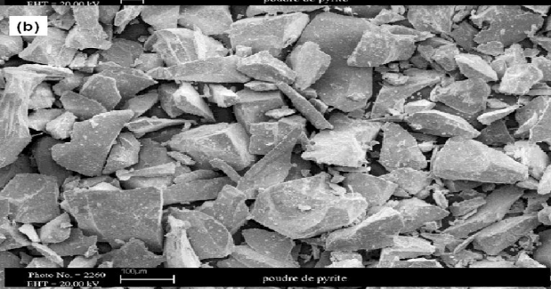  Figure 7: pyrite 1 | 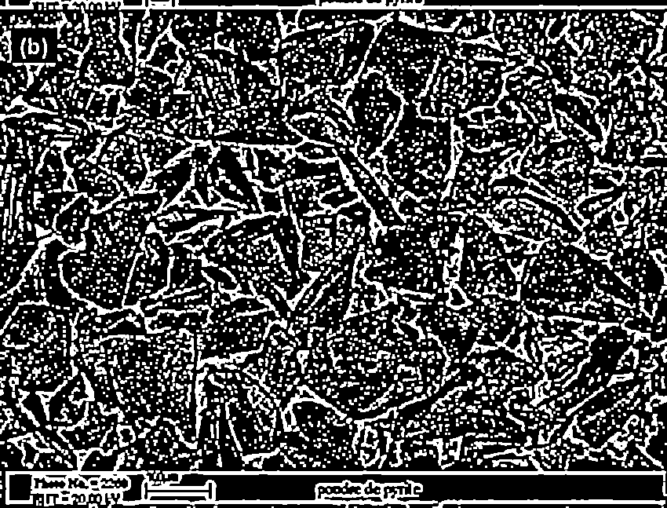  Figure 8: pyrite 1

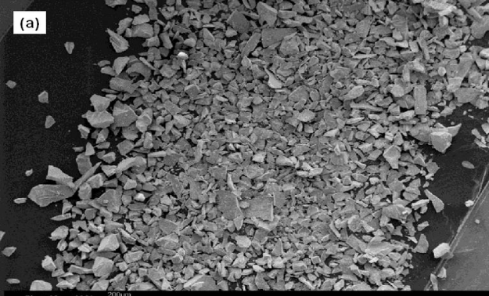  Figure 9: pyrite 2 | 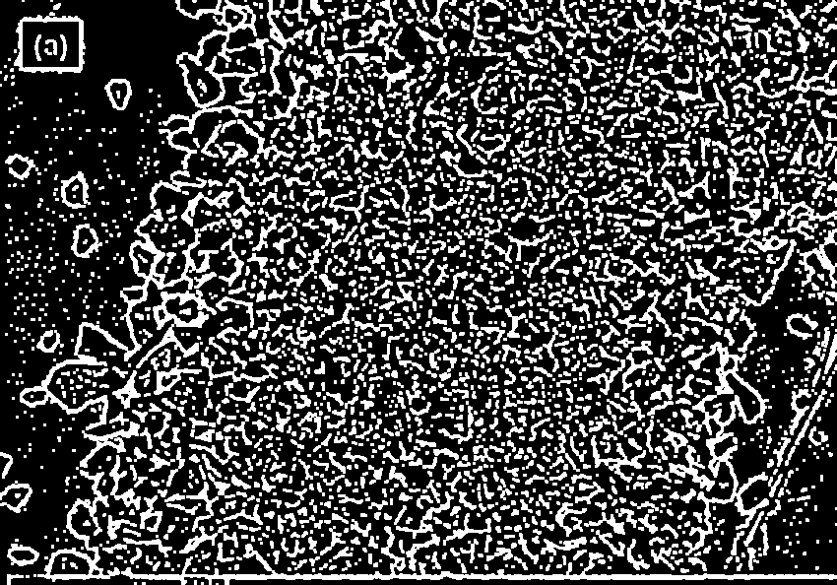  Figure 10: pyrite 2
Table 1:Raw vs. Processed SEM Images

Table 2: Liberation Analysis Results from Image Processing
Sample | Total Grains | Grain Area (pixels) | Image Area (pixels) | Liberation (%)
Chalcopyrite1 | 1,076 | 105,638 | 228,800 | 46.17
Chalcopyrite2 | 5,837 | 876,433 | 4,121,920 | 21.26
Chalcopyrite3 | 2,223 | 127,014 | 512,502 | 24.78
Pyrite1 | 2,888 | 168,731 | 549,950 | 30.68
Pyrite2 | 2,573 | 143,481 | 504,900 | 28.42

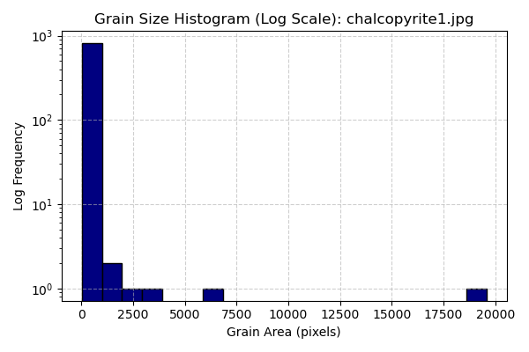

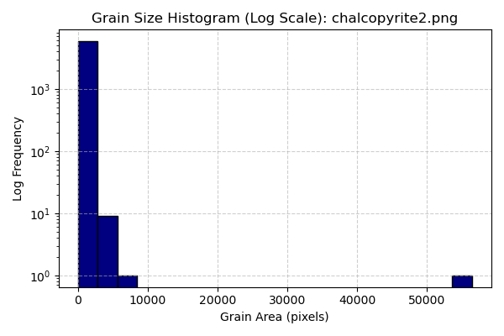
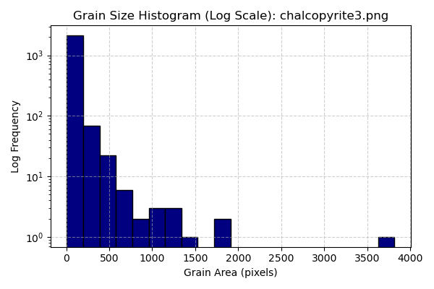
Table 3: Individual Grain Size Histograms for chalcopyrite’s

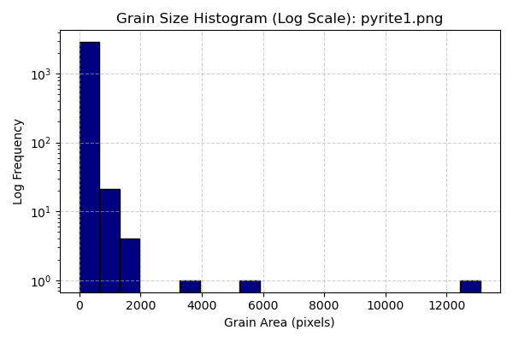

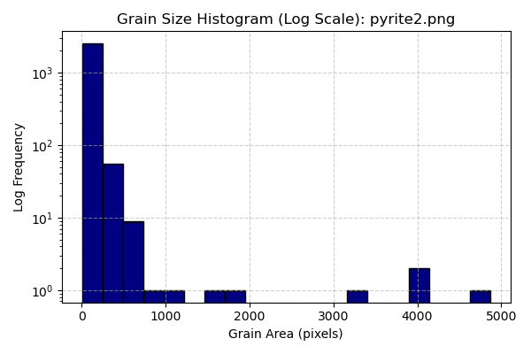

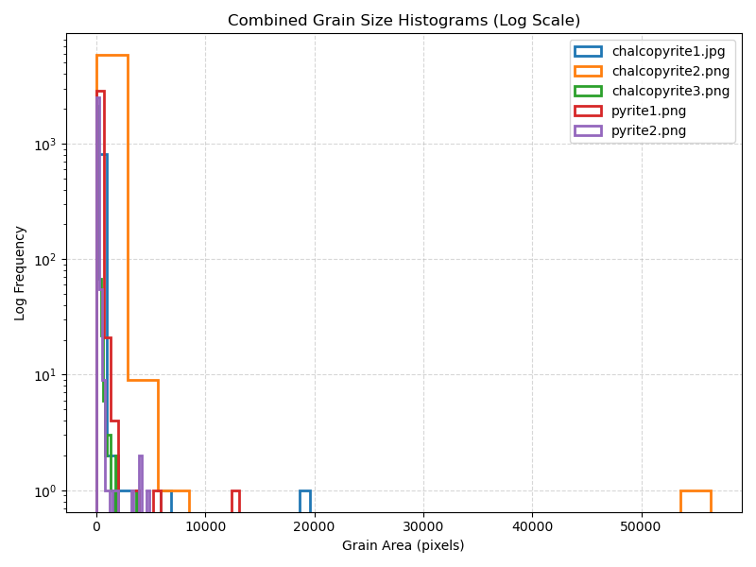
Table 4: Individual Grain Size Histograms for Pyrite's and Combined Histogram

