Supplementary Text

Construction of Anabaena-pZR2099 strain:
A 2090bp fragment (alr0267 ORF along with its native promoter region) was PCRed from genomic DNA of Anabaena 7120 using the primers ZR1230+ZR1231 and cloned into pTOPO2.1 vector to produce pZR2071; Then BamHI +XmaI to obtain the 2090bp fragment from pZR2071 and ligate the 2090bp fragment into BamHI+XmaI digested pSMC232-GFP vector to produce pZR2099.The PCR verified pZR2099 was transformed into Anabaena sp. PCC 7120 to construct Anabaena-pZR2099 strain through a conjugation method [1]. The details of construction of pZR2099 are described visually below. 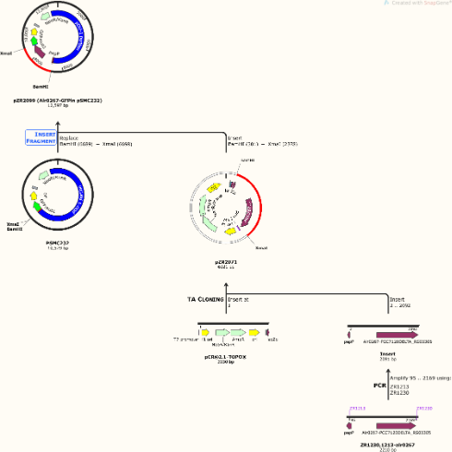
.

1. Elhai, J.a.W., C. P., Conjugal transfer of DNA to cyanobacteria. Methods Enzymol., 1988. 167: p. 747-754.

Supplemental Figure

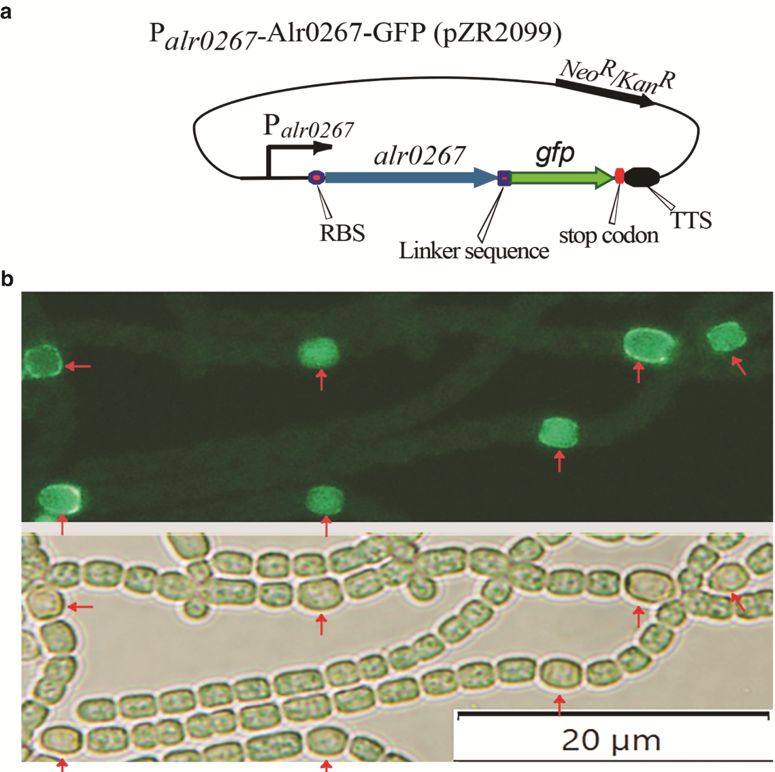
Supplemental Figure 1: alr0267 GFP fusion proteins localize to the walls in heterocysts in diazotrophic conditions.
Supplementary Tables

Available as attachments.

