Supplementary Materials

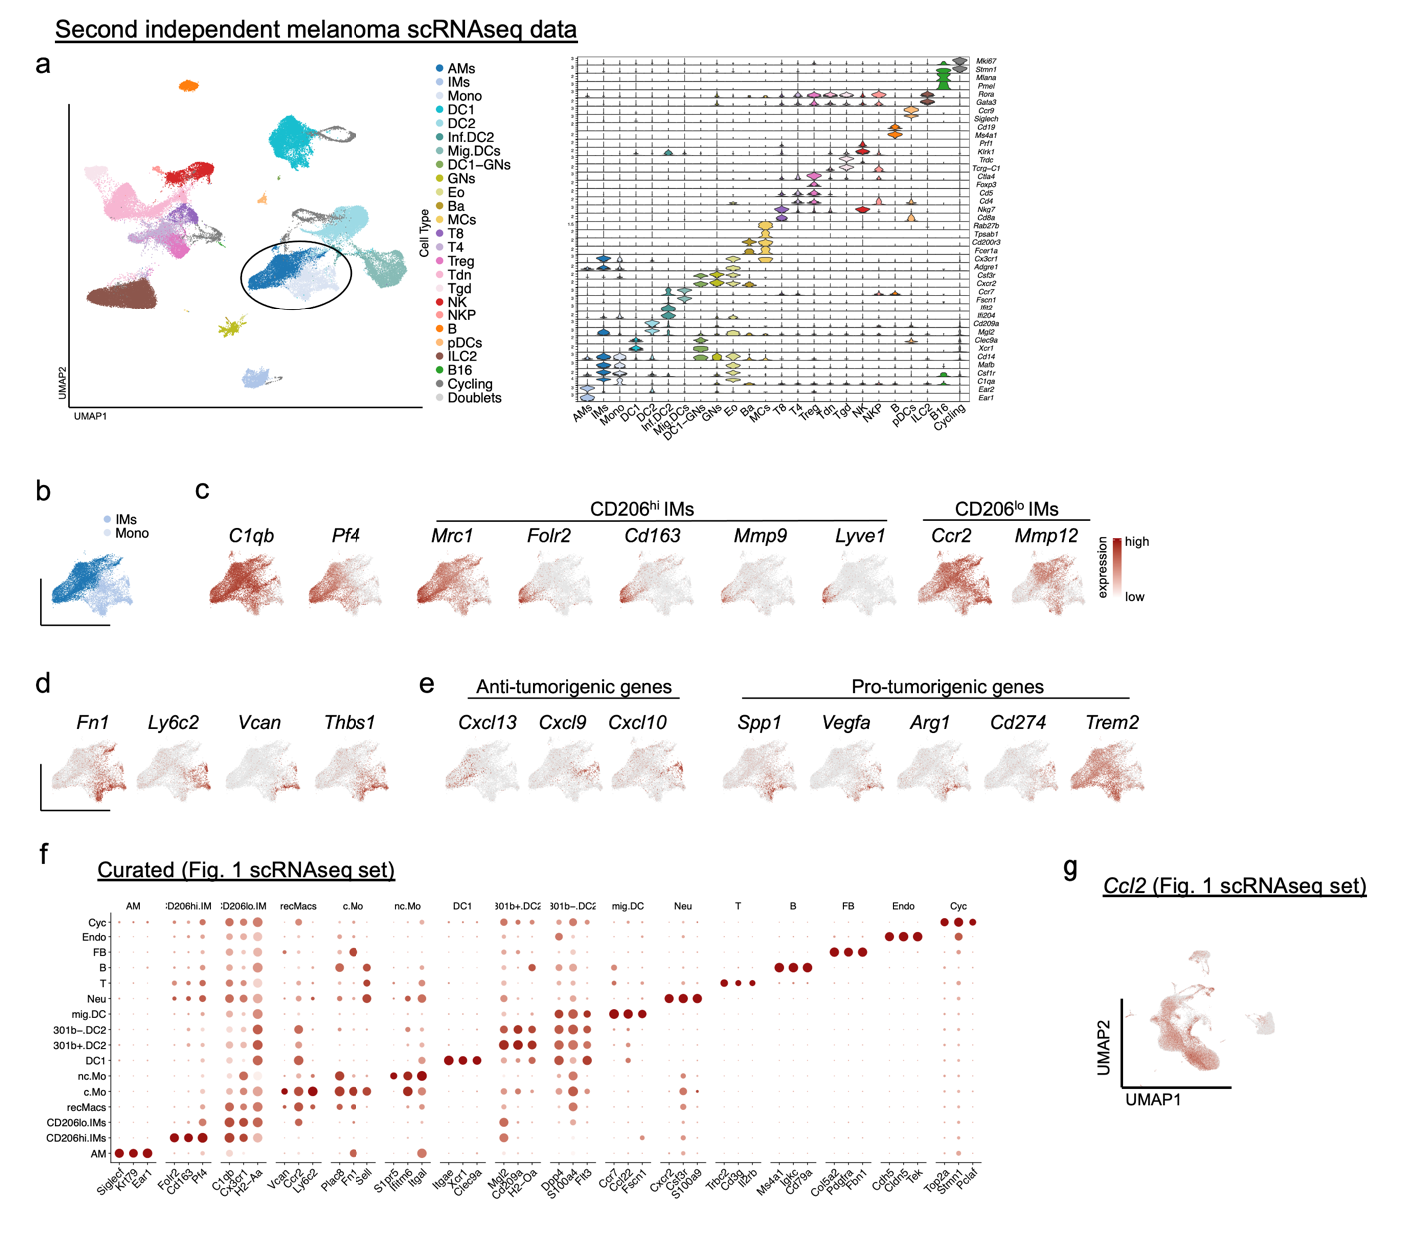

Supplementary Figure 1. Pulmonary melanoma scRNA-seq identifies gene expression in IMs and recMacs
(a) UMAP of extravascular immune cells isolated from the lungs of melanoma burdened C57BL/6 mice. Key signature genes defined the unbiased clusters. Alveolar macrophages, AMs; interstitial macrophages, IMs, recruited macrophages/monocytes, recMacs; dendritic cells, DC1, DC2; inflammatory DC, inf.DC2; migratory DCs, mig.DCs, neutrophils, GNs; eosinophils, Eo; basophils, Ba; mast cells, MCs; CD8 T cells, T8; CD4 T cell, T4; regulatory T cells, Treg; double negative T cells, Tdn; gamma delta T cells, Tgd; natural killer progenitor, NKP; B cells, B; plasmacytoid DCs, pDCs; innate lymphocytes ILC2, B16F10, B16 (b-e) UMAP of IMs and recMacs. (c) Feature plots show the expression of C1qb and Pf4, key IM signature genes. Additional feature plots depict CD206^{hi} IM expression for Folr2, Cd163, Mmp9, and Lyve1, and CD206^{lo} IM expression for Ccr2 and Mmp12. (d) Feature plots show recMacs expression for Fn1, Ly6c2, Vcan, and Thbs1. (e) Feature plots display the expression of protumorigenic genes Spp1, Vegfa, Vcan, Arg1, and Cd274 by recMacs, and antitumorigenic chemokines Cxcl13, Cxcl9, and Cxcl10 by IMs. Trem2 is expressed by both recMacs and IMs. (f) Dot plot shows the expression of curated genes in 16 immune cell populations from Figure 1. (g) Feature plot showing the expression of Ccl2.

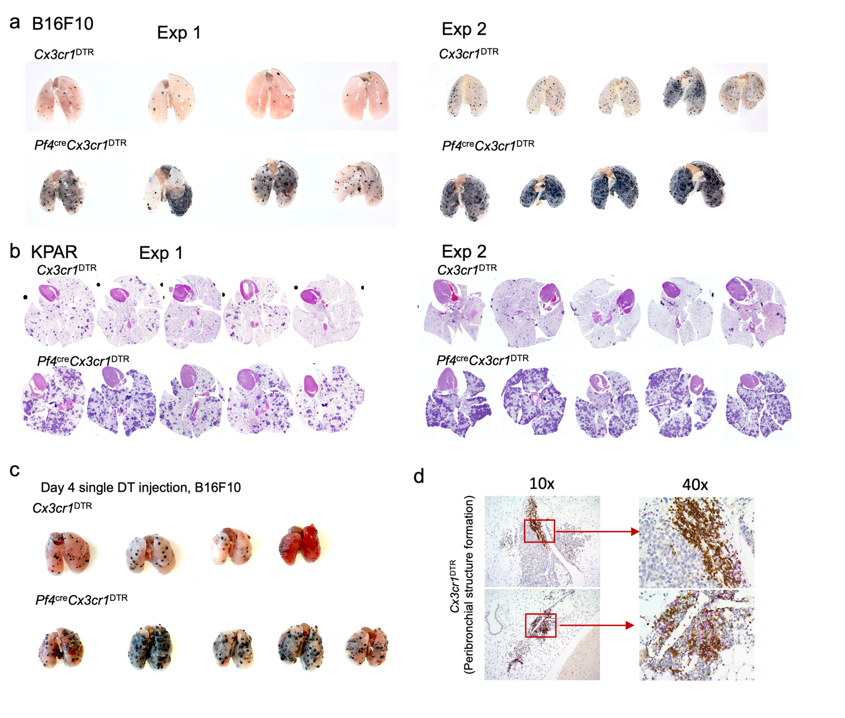

Supplementary Figure 2. CD206^{hi} IMs contribute to anti-tumor immunity.

(a) Images of tumor-burdened lungs from Cx3cr1^{DTR} and Pf4^{cre}Cx3cr1^{DTR} mice harvested on day 16 after intravenous injection of melanoma cells. Two out of four independent experiments illustrated. (b) Hematoxylin and eosin-stained lung sections from Cx3cr1^{DTR} and Pf4^{cre}Cx3cr1^{DTR} mice harvested on day 16 after injection of KPAR1.3 adenocarcinoma cells. Two out of four independent experiments illustrated. (c) Images of tumor-burdened lungs from Cx3cr1^{DTR} and Pf4^{cre}Cx3cr1^{DTR} mice harvested on day 16 after intravenous injection of melanoma cells and a single DT injection on Day 4. One of two independent experiments illustrated. (d) Representative IHC sections stained for B220 (brown) and CD3e (purple), showing peribronchial lymphocytes infiltration in melanoma burdened Cx3cr1^{DTR} mice.
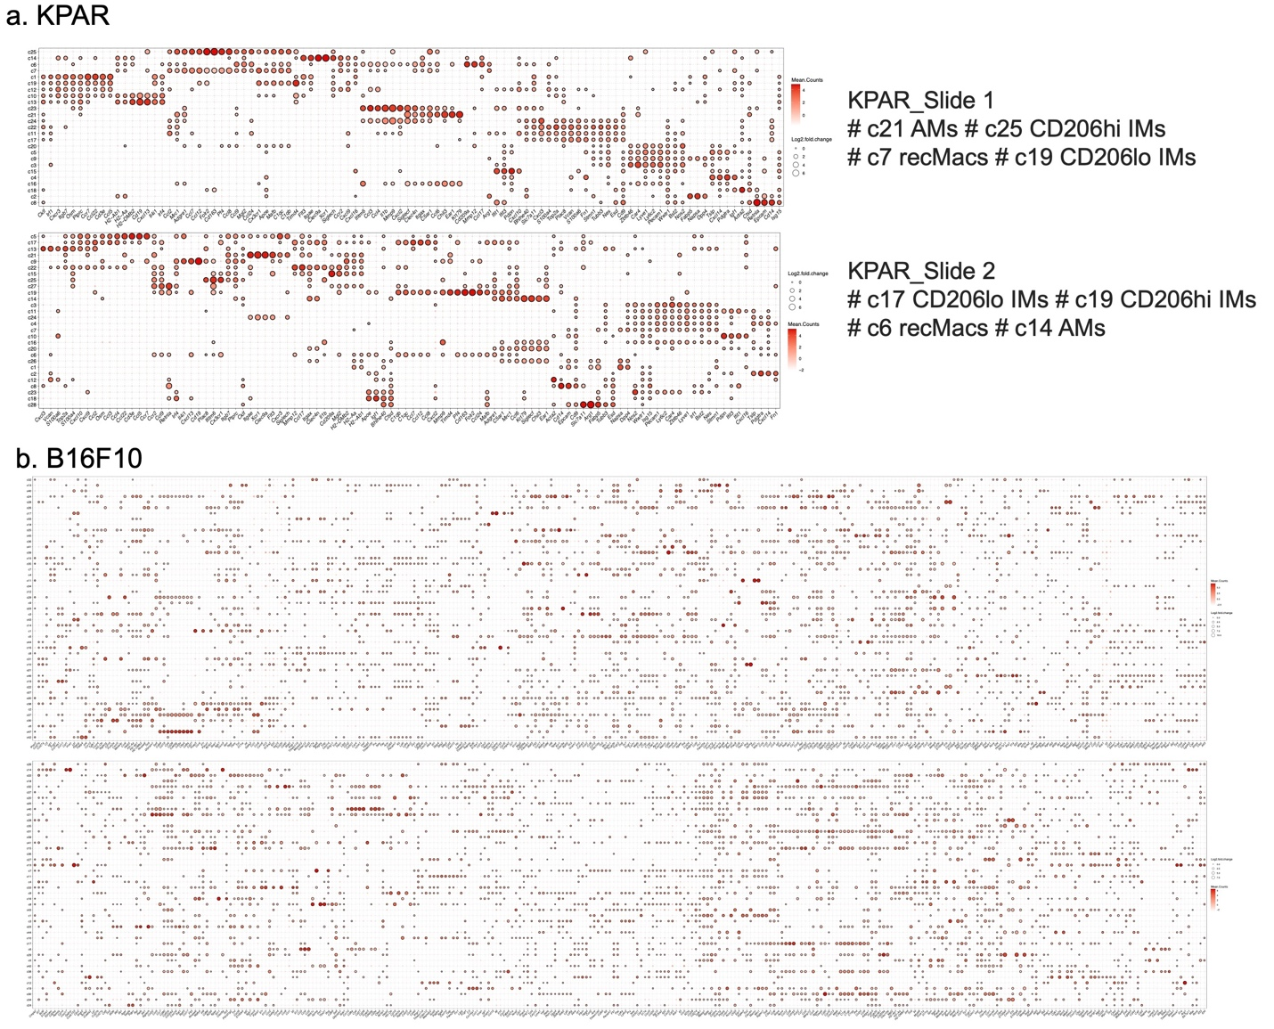

Supplementary Figure 3 Spatial transcriptomics cluster analysis using the entire gene panel.

Cluster defining gene panels used for Xenium Spatial Transcriptomic. Genes used were for identification of immune cell types, myeloid cell differentiation, chemokines, and stromal components. Four tumor bearing lungs were examined: (a) two for adenocarcinoma and (b) two for melanoma.

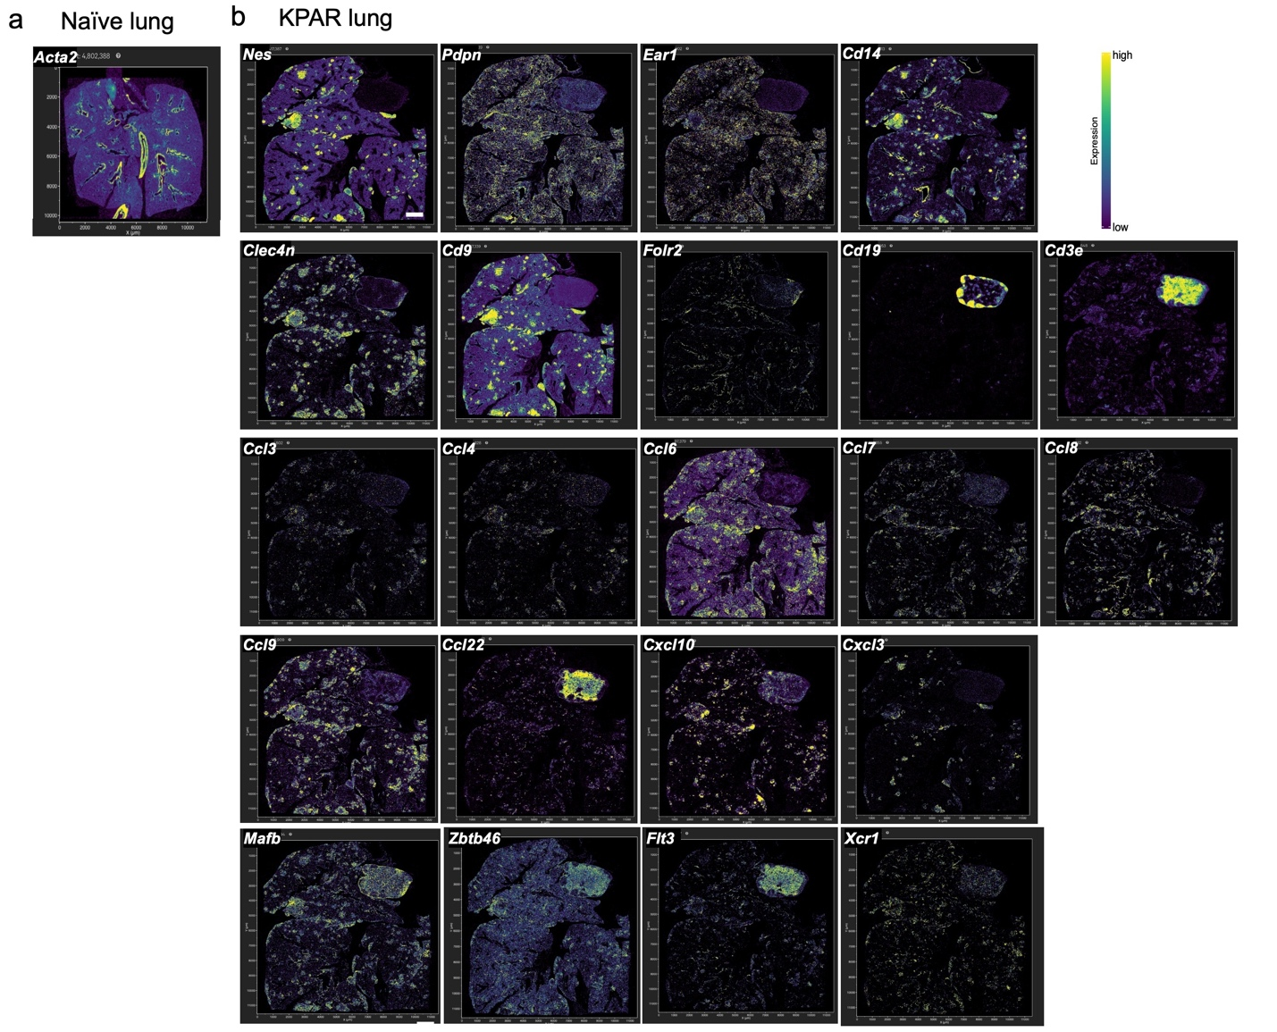

Supplementary Figure 4. Spatial transcriptomics of adenocarcinoma displays high abundance of recMac and IMs with distinct chemokine patterns in TME.

(a) Spatial expression of the Acta2 (actin) in the lungs of a naïve mouse. (b) Spatial expression of various genes in different compartments of the lung on day 16 post-KPAR1.3 injection, including: nerves (Nes), lymphatic vessels (Pdpn), alveolar macrophages (Ear1), monocyte/macrophage markers (Cd14), recruited macrophages (Cd9, Clec4n), CD206⁺ IMs (Folr2), B cells (Cd19), T cells (CD3e), chemokines (Ccl3, Ccl4, Ccl6, Ccl7, Ccl8, Ccl9, Ccl22, Cxcl10, Cxcl3). Macrophages: Mafb and Dendritic cells (DCs): Zbtb46, Flt3, Xcr1.

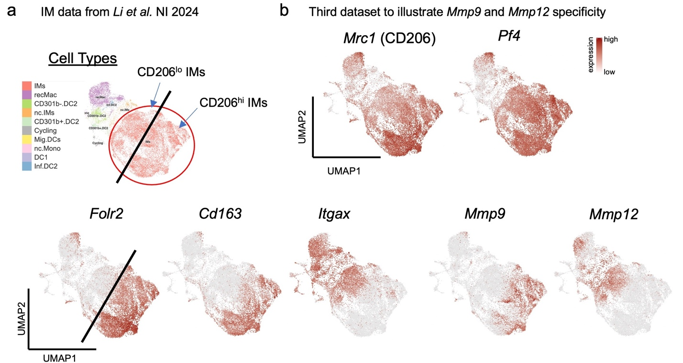

Supplementary Figure 5. Spatial transcriptomics and scRNA-seq identifies gene expression in IMs and recMacs
(a) GSE225664 (mouse pulmonary cells under homeostasis and LPS stimulation) on the left, cell type identification of various myeloid populations, including IMs, non-classical IMs, recMacs, non-classical monocytes, DC1, CD301b⁻ DC2, CD301b⁺ DC2, inflammatory DC2, migratory DCs, and cycling cells. (b) Feature plots showing the expression of Mrc1 (CD206) and Pf4 in IMs. Black line illustrates CD206^{lo} IMs from Folr2⁺CD206^{hi} IMs. In addition to the expression of Folr2, Cd163, and Mmp9 in CD206^{hi} IMs, whereas Itgax and Mmp12 are expressed in CD206^{lo} IMs.

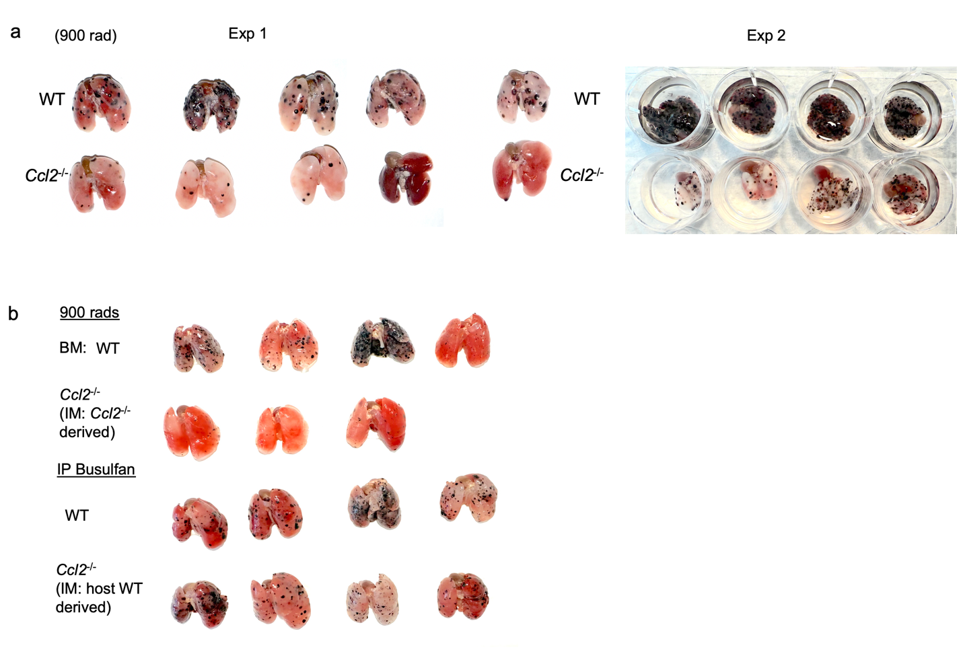

Supplementary Figure 6. Ccl2 expression by IMs is critical for recMac recruitment.
(a) Images of lungs from lethally irradiated BM chimeric WT.2 and Ccl2⁻/⁻ mice, single dose of 900 rads. Lungs harvested on day 16 post-B16F10 melanoma cell injection. Two out of three independent experiments illustrated. (b) Four groups of mice (Lethally irradiated, IMs are WT-derived and Ccl2^{-/-} derived versus Busulfan-treated: IMs are WT-derived and WT-derived) were injected with B16F10 melanoma cells and examined for tumor growth. Represented one out of two independent experiments.

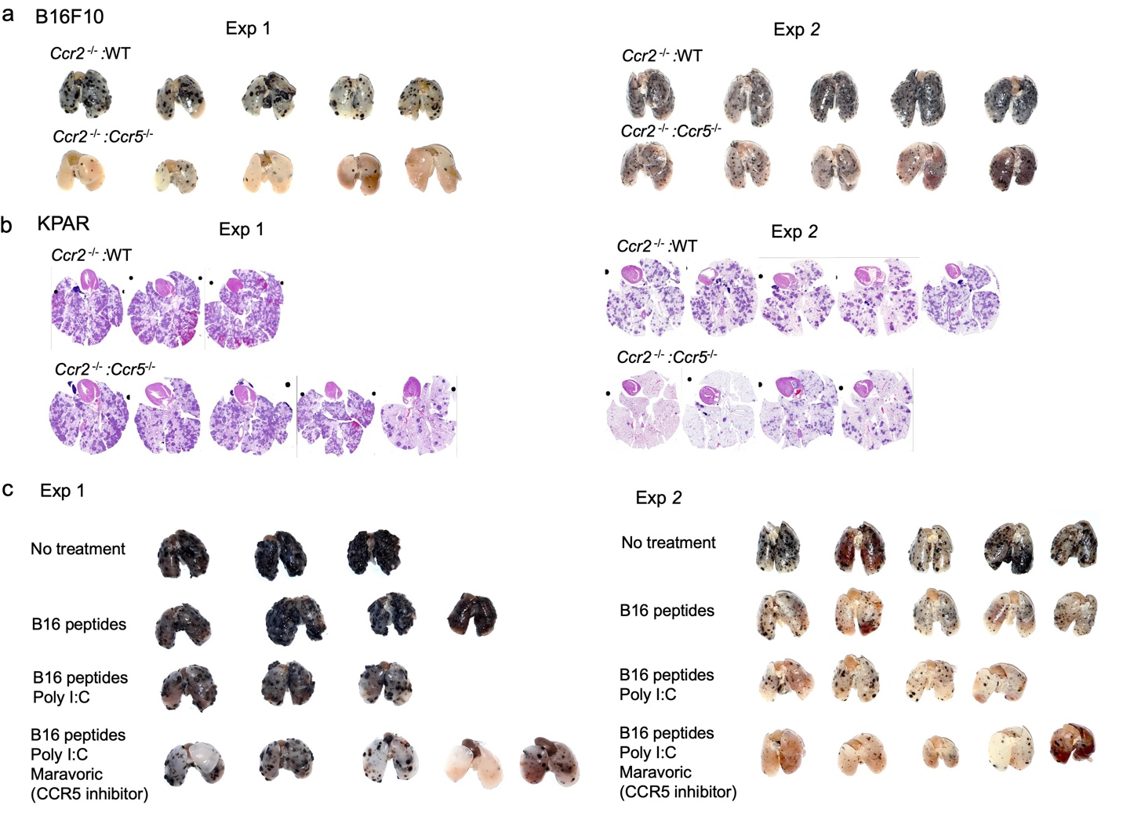

Supplementary Figure 6. Inhibiting antigen-bearing moDCs during a prophylactic neoantigen vaccine enhances anti-tumor immunity.
(a) Lungs from BM chimeric (80:20) Ccr2⁻/⁻:WT.1 and Ccr2⁻/⁻:Ccr5⁻/⁻mice: Harvested on day 16 post-B16F10 melanoma cell injection. Two out three independent experiments are represented. (b) Hematoxylin and eosin-stained lung sections from BM chimeric Ccr2⁻/⁻:WT.1 and Ccr2⁻/⁻:Ccr5⁻/⁻ mice, harvested on day 16 post-KPAR1.3 adenocarcinoma cell injection. Two independent experiments are represented. (c) Lungs from prophylactic treatment of PBS, tumor peptides only, tumor peptides +Poly I:C, and tumor peptide +Poly I:C +Maraviroc (CCR5 inhibitor)-treated mice. Two independent experiments are represented.

