Appendix 1: Detailed description of changes to DCE instrument and introductory script during pretesting
 | Issue Identified | Action
Cycle 1: Spanish
V1-V3 | Attribute labels too wordy | Shortened attribute labels
N = 6 | Level descriptions too wordy | Shortened level descriptions
 | Participants interpreted all attributes after “Verbal communication” to be asking about preference for type of interpreter | Moved “Verbal communication” attribute from first to last in choice sets
 | Confusion over who people represented in levels of “Verbal communication” | Labeled people in “Verbal communication” level pictures
 | Difficult to tell from preference stated for three example choice sets presented if elicitation was occurring | Revised test choice sets to better detect choices that were not internally consistent
Cycle 2: Spanish and Haitian Creole
V4 | Difficulty grasping the task of comparing alternative profiles (instead of individual levels) | Placed box around all levels for Option A and all levels for Option B
N=4 | Level description “Nurse and me” not understood as lack of family involvement | Changed level description to “Without family”
Cycle 3: Haitian Creole
V5-6 | Confusion over who people represented in “Family involvement" levels | Labeled people in “Family involvement” level pictures
N = 4 | Participants interpreted level description of “audio recorded” as not being in their preferred language | Modified level description to read “audio recorded in my language”
 | Misunderstanding that “Family involvement” referred desire for family to be updated during hospital course | Revised label description of attribute “Family involvement" to add focus on discharge teaching only
 | Ongoing difficulty with elicitation | Developed “warm up” DCE for V7
Cycle 4: Spanish and Haitian Creole
V7 | Understanding tradeoffs through “warm up” DCE | Modified introductory script to highlight tradeoffs demonstrated through “warm up” DCE
N=7 | Confusion over changing actors for photos | Photos revised to have same actor as patient, nurse, family, and in-person interpreter
Final DCE materials (V8) for Phase 5 pilot testing
DCE = discrete choice experiment, N = number of cognitive interviews performed with that version of DCE materials, V = DCE materials version

Appendix 2: Evolution of working of attribute and level descriptions
 | Version One | Version Three | Version Eight
Attribute 1 | Way to overcome language barrier | Verbal communication | Verbal communication
Level 1 | The nurse who reviews by discharge information uses a professional interpreter by phone | Phone interpreter | Phone interpreter
Level 2 | The nurse who reviews by discharge information uses a professional interpreter by video | Video interpreter | Video interpreter
Level 3 | The nurse who reviews by discharge information uses a professional interpreter in person | In person interpreter | In person interpreter
Level 4 | The nurse who reviews by discharge information speaks Spanish/Haitian Creole fluently | Nurse who speaks my language | Nurse who speaks my language
Attribute 2 | Participants in discharge teaching | People present | Family participation when the nurse reviews discharge instructions
Level 1 | The nurse reviews my discharge paperwork with me alone | Just me | Without family
Level 2 | My family is present when the nurse reviews my discharge paperwork | Family in person | Family in person
Level 3 | The nurse reviews my discharge paperwork with me and calls my family by phone | Family by phone | Family by phone
Attribute 3 | Record of discharge teaching | Written instructions | Form of discharge instructions
Level 1 | The documents that explain how to take care of myself at home, including my medication list, are written in English | In English | Written in English
Level 2 | The documents that explain how to take care of myself at home, including my medication list, are written in Spanish/Haitian Creole | In my language | Written in my language
Level 3 | Someone who speaks Spanish reads the documents that explain how to take care of myself at home and audio records them on a record that I can listen to at home | Recorded | Audio recorded in my language
Attribute 4  (Version 2) | Follow up after discharge | Follow up after discharge | Phone follow up after discharge
Level 1 | A nurse from the hospital calls me a few days after discharge to review my discharge information | Nurse from the hospital | Nurse from the hospital
Level 2 | A nurse from my primary care office calls me a few days after discharge to see how I am doing | Nurse from my primary care doctor’s office | Nurse from my primary care doctor’s office
Level 3 | A number I can call to speak with a nurse from the hospital in case I have questions | A number I can call | A number I can call
DCE = discrete choice experiment

Appendix 3: Comparison of version 1 (A) to version 8 (B) level descriptions for “Verbal communication” attribute

A) B)

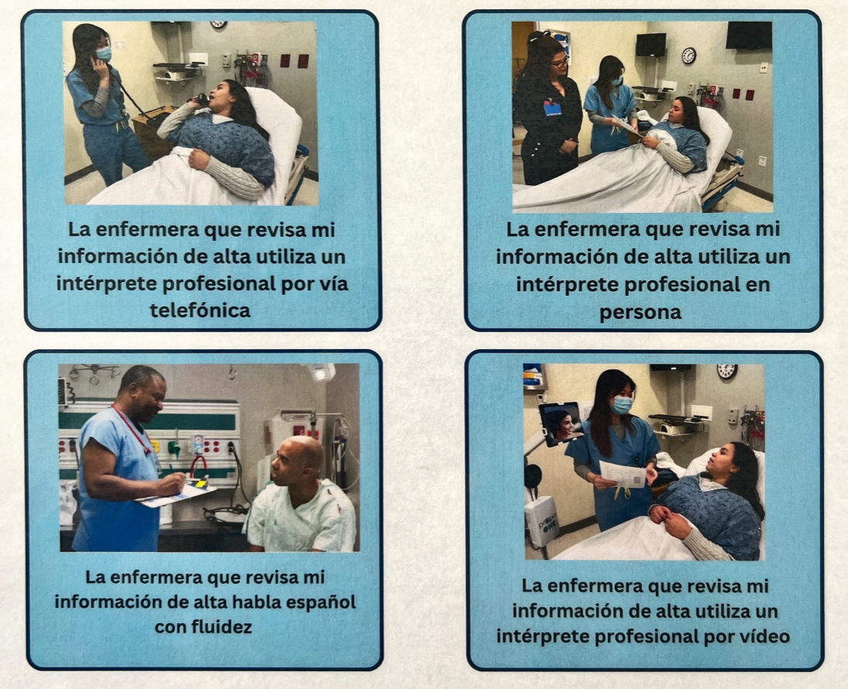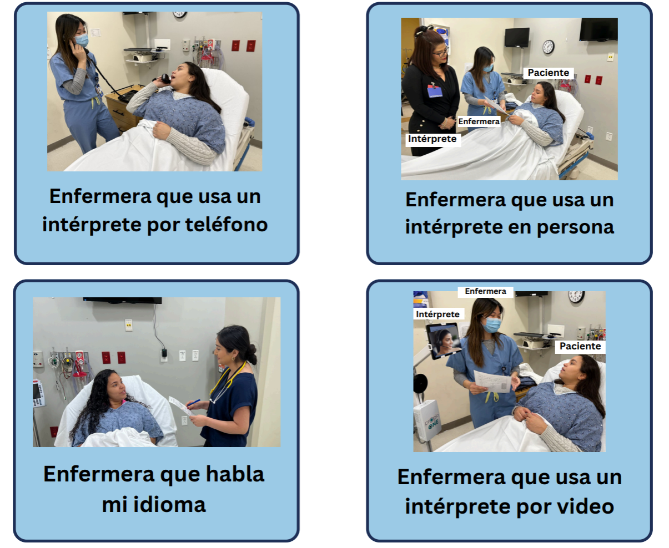

Appendix 4: Example of warm up discrete choice experiment to help participants understand elicitation

