Figure S1. A: Unigene annotated statistical result Upset graph; B: NR annotation statistics; C: GO annotation statistics D: KEGG annotation statistics.

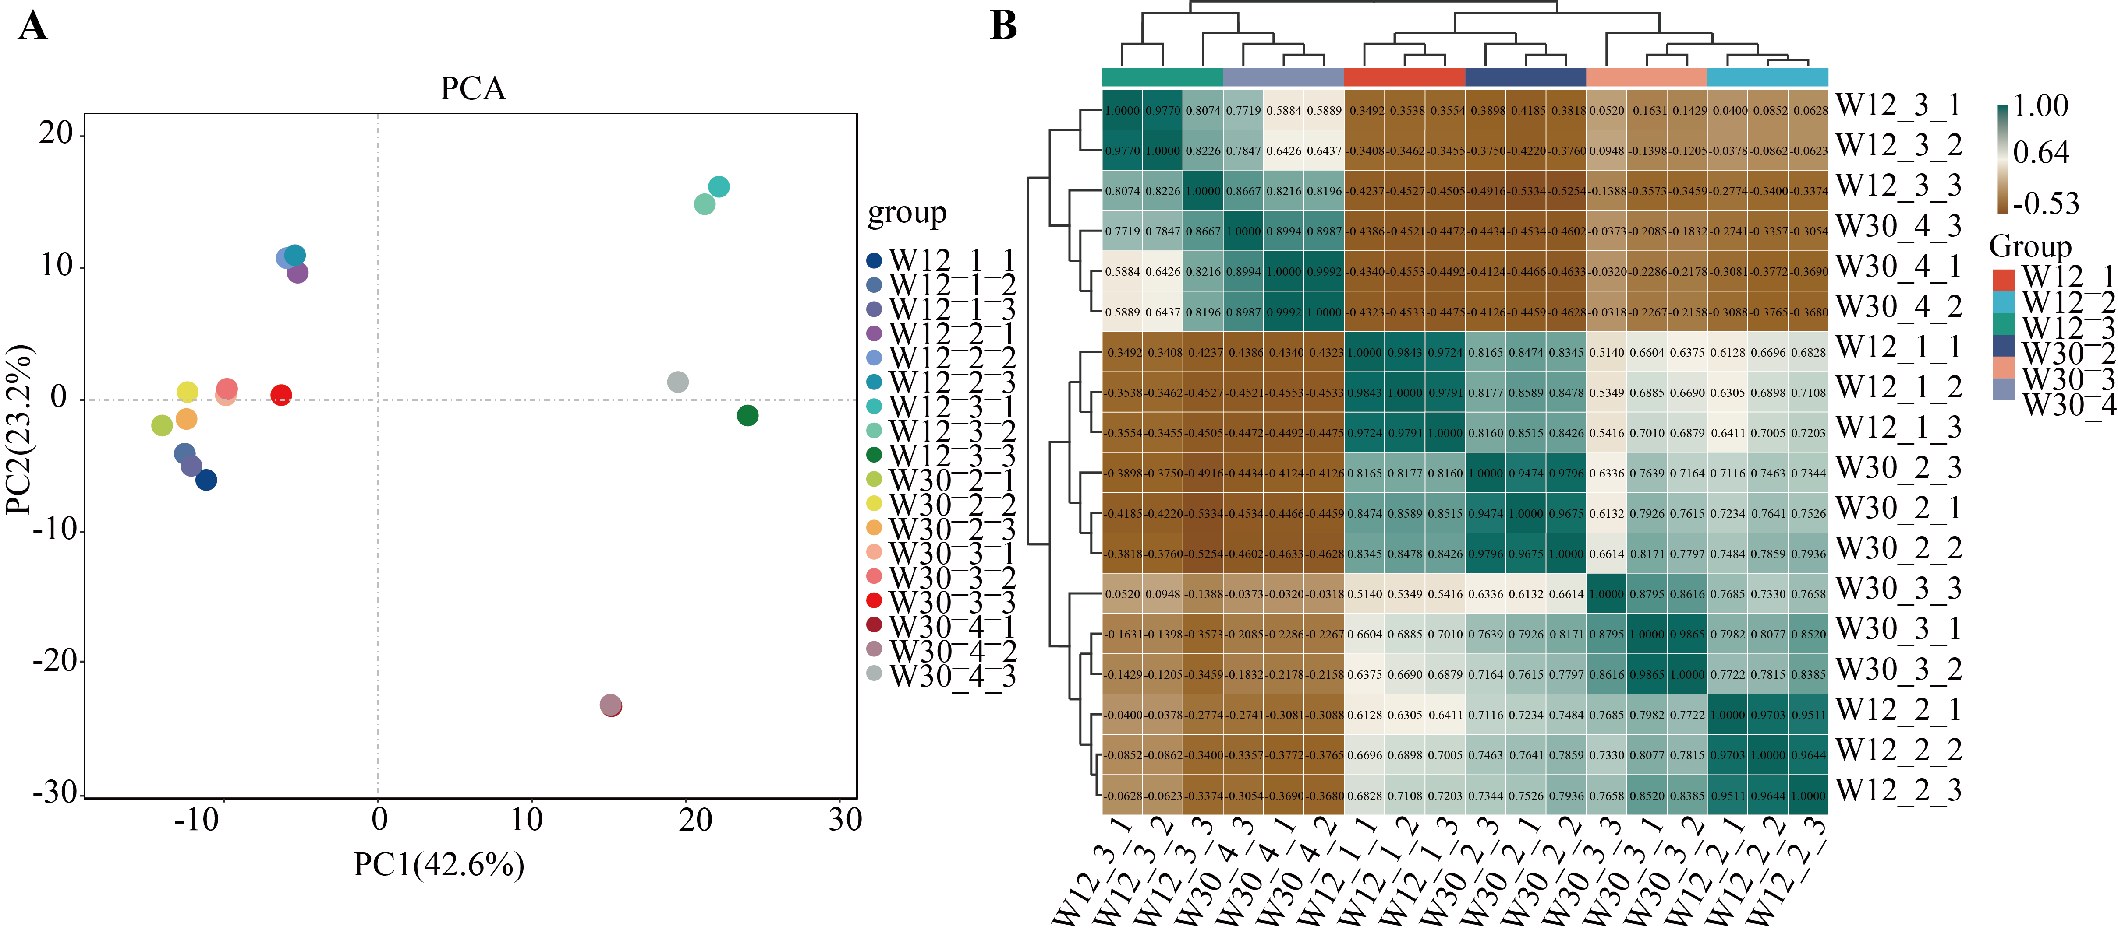
Figure S2. A: PCA analysis B: Sample correlation test.
Note: The left and top sides show the sample clustering situation. The right and bottom sides in the figure show the sample names. Squares of different colors represent the correlation levels of the two samples.

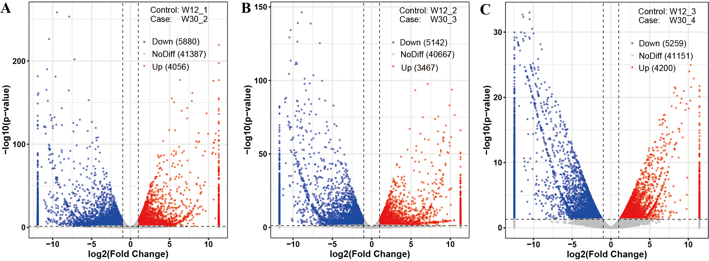
Figure S3. Volcano map of differentially expressed genes
Note: Volcano graph: The horizontal coordinate is log2FoldChange, and the vertical coordinate is -log10 (p-value). The two vertical dotted lines in the figure represent a 2x expression difference threshold; the dashed line indicates the P-value=0.05 threshold. The red dots represent the up-regulated genes in this group, the blue dots represent the down-regulated genes in this group, and the gray dots represent the non-significantly differentially expressed genes.

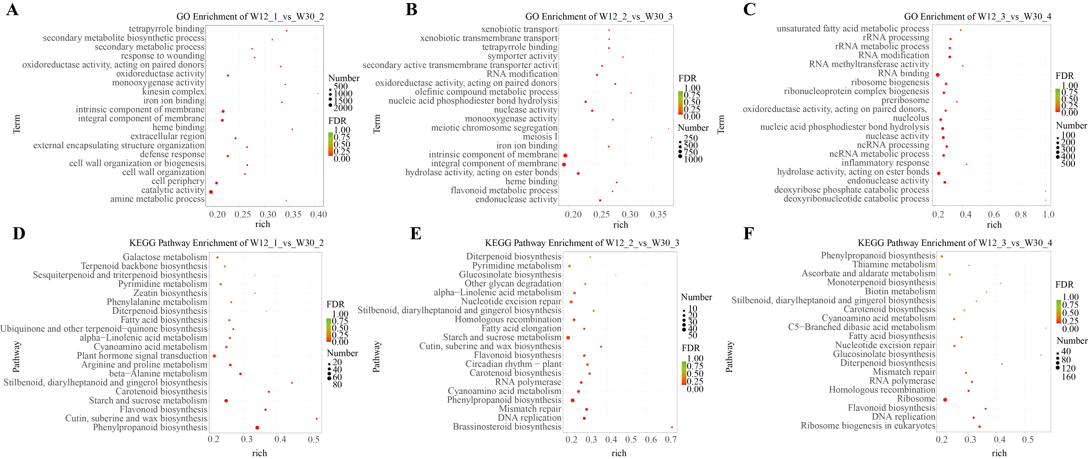
Figure S4. A-C: GO enrichment analysis bubble chart; D-F: KEGG enrichment analysis.

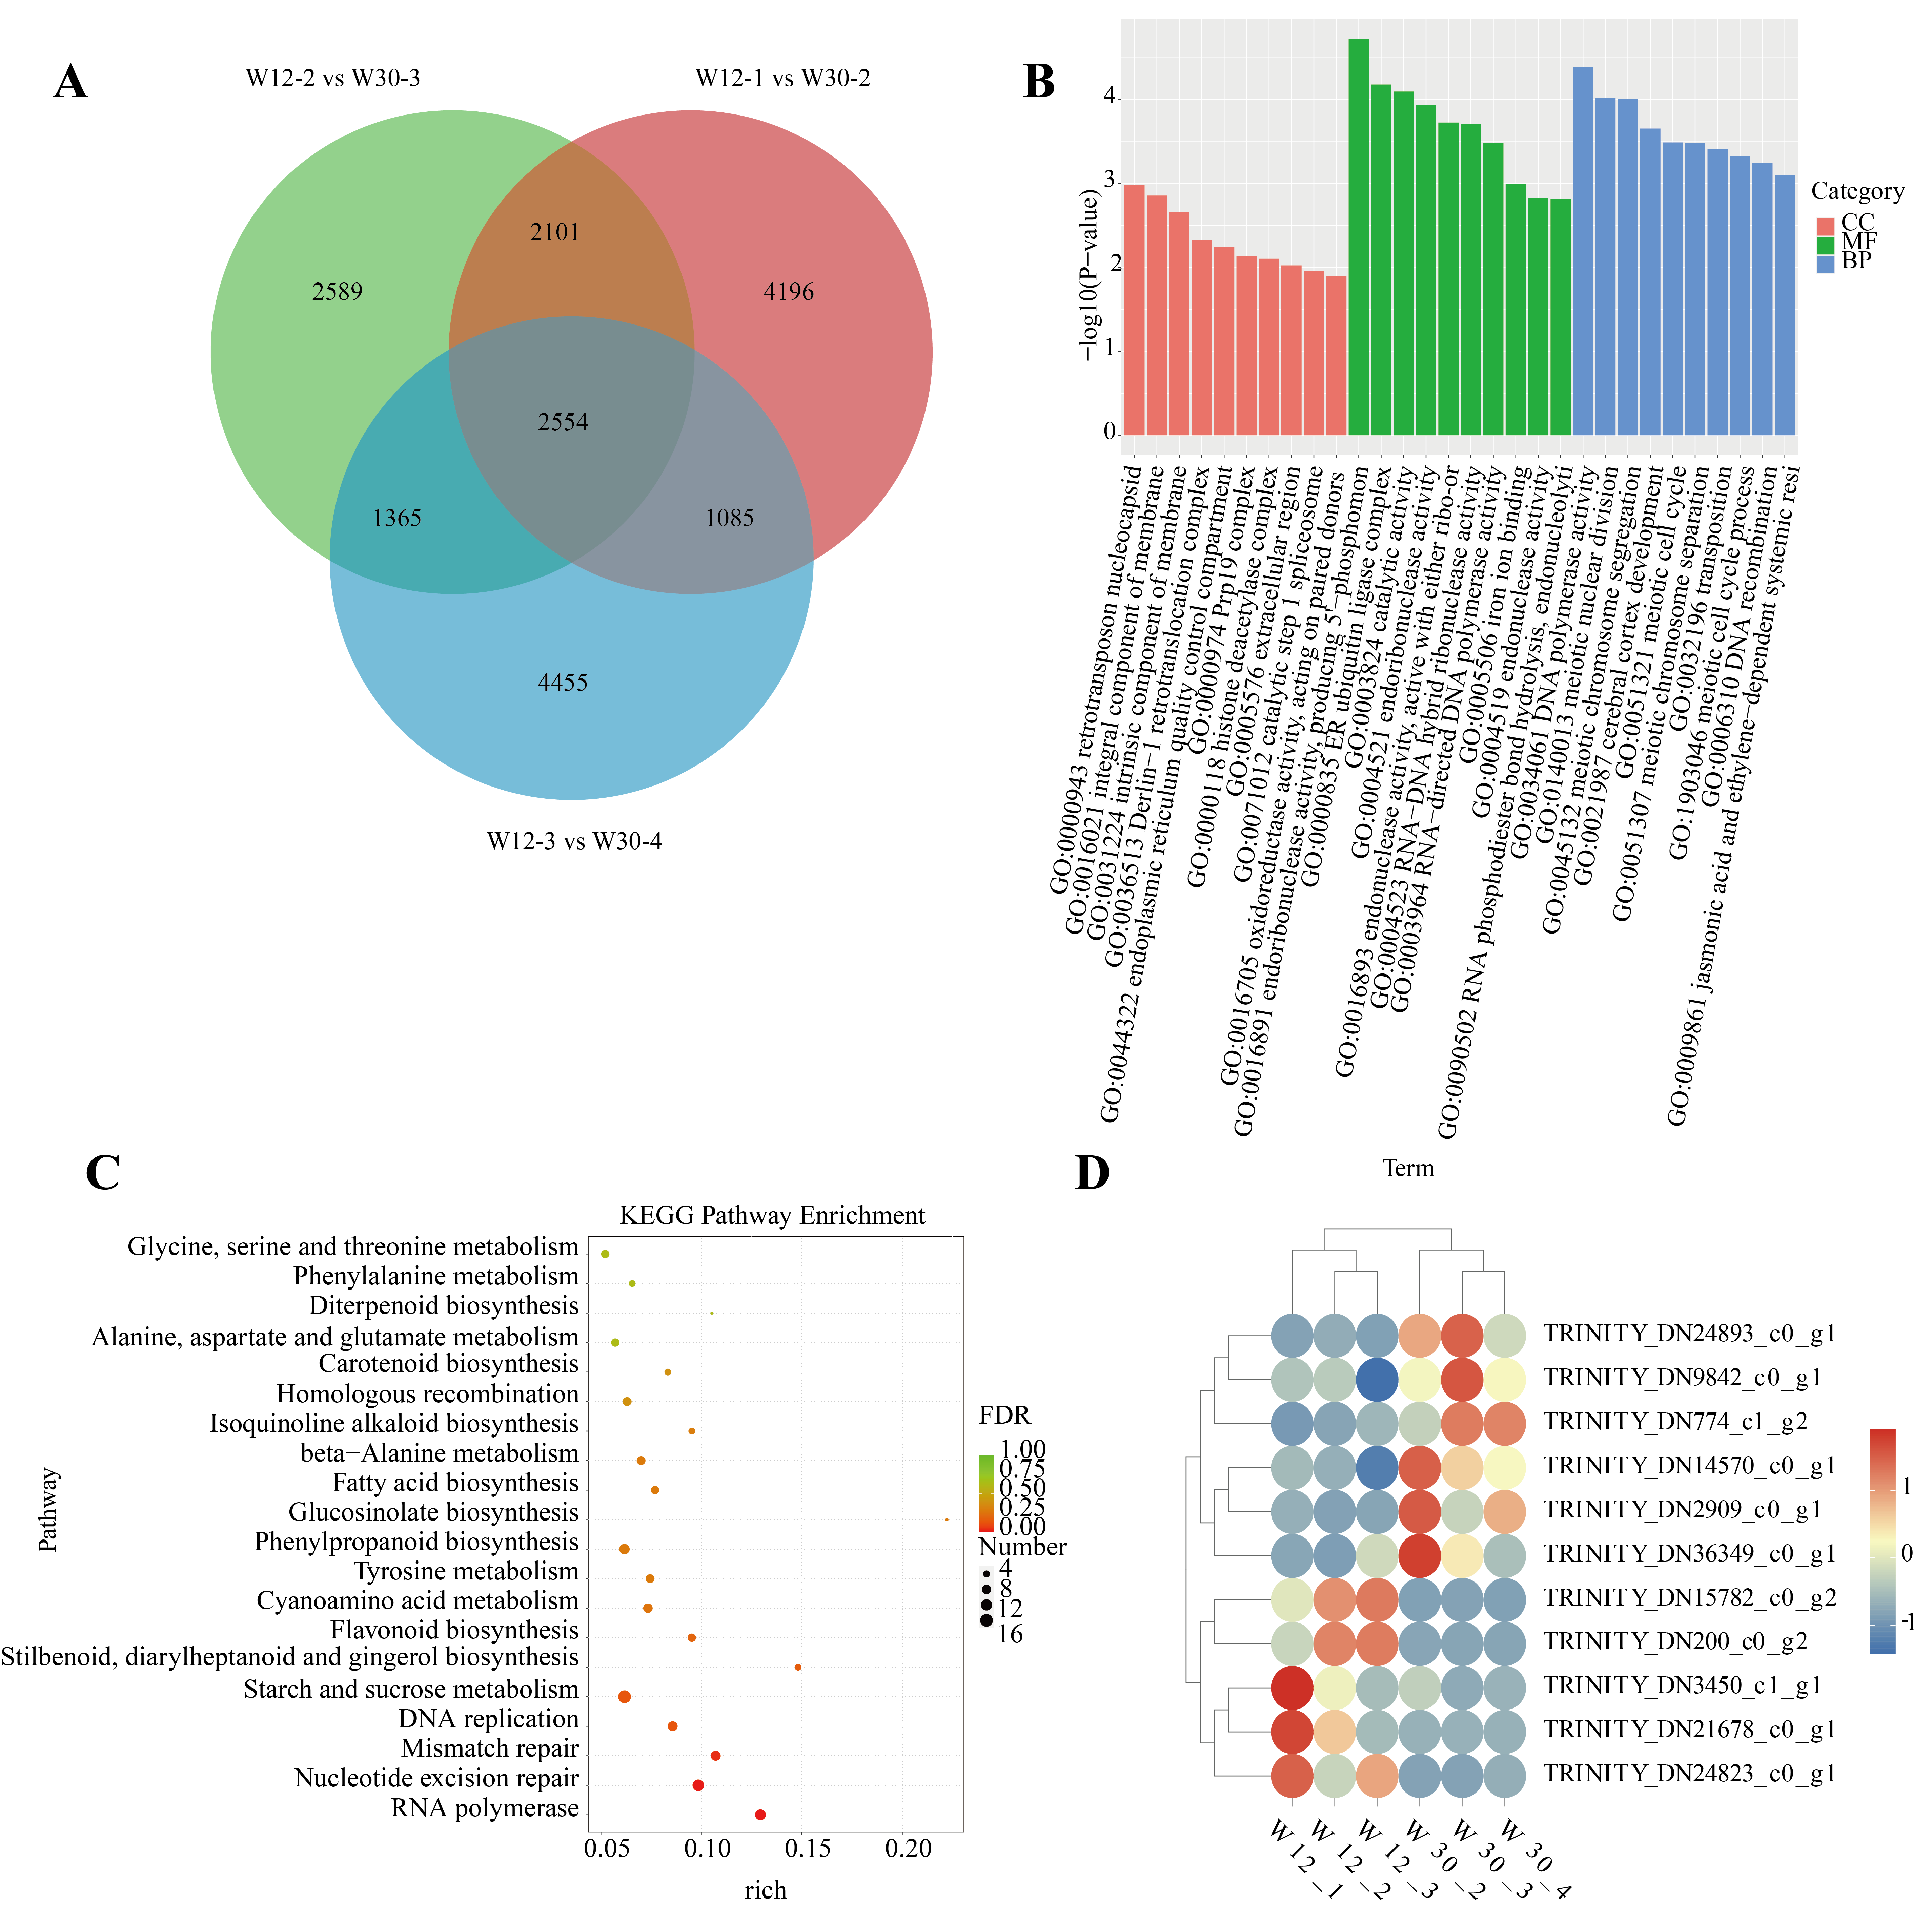
Figure S5. A: Venn diagram of differentially expressed genes; B: Conduct GO enrichment analysis on common genes; C: Conduct KEGG enrichment analysis on common genes; D: Heat map of differential gene expression.
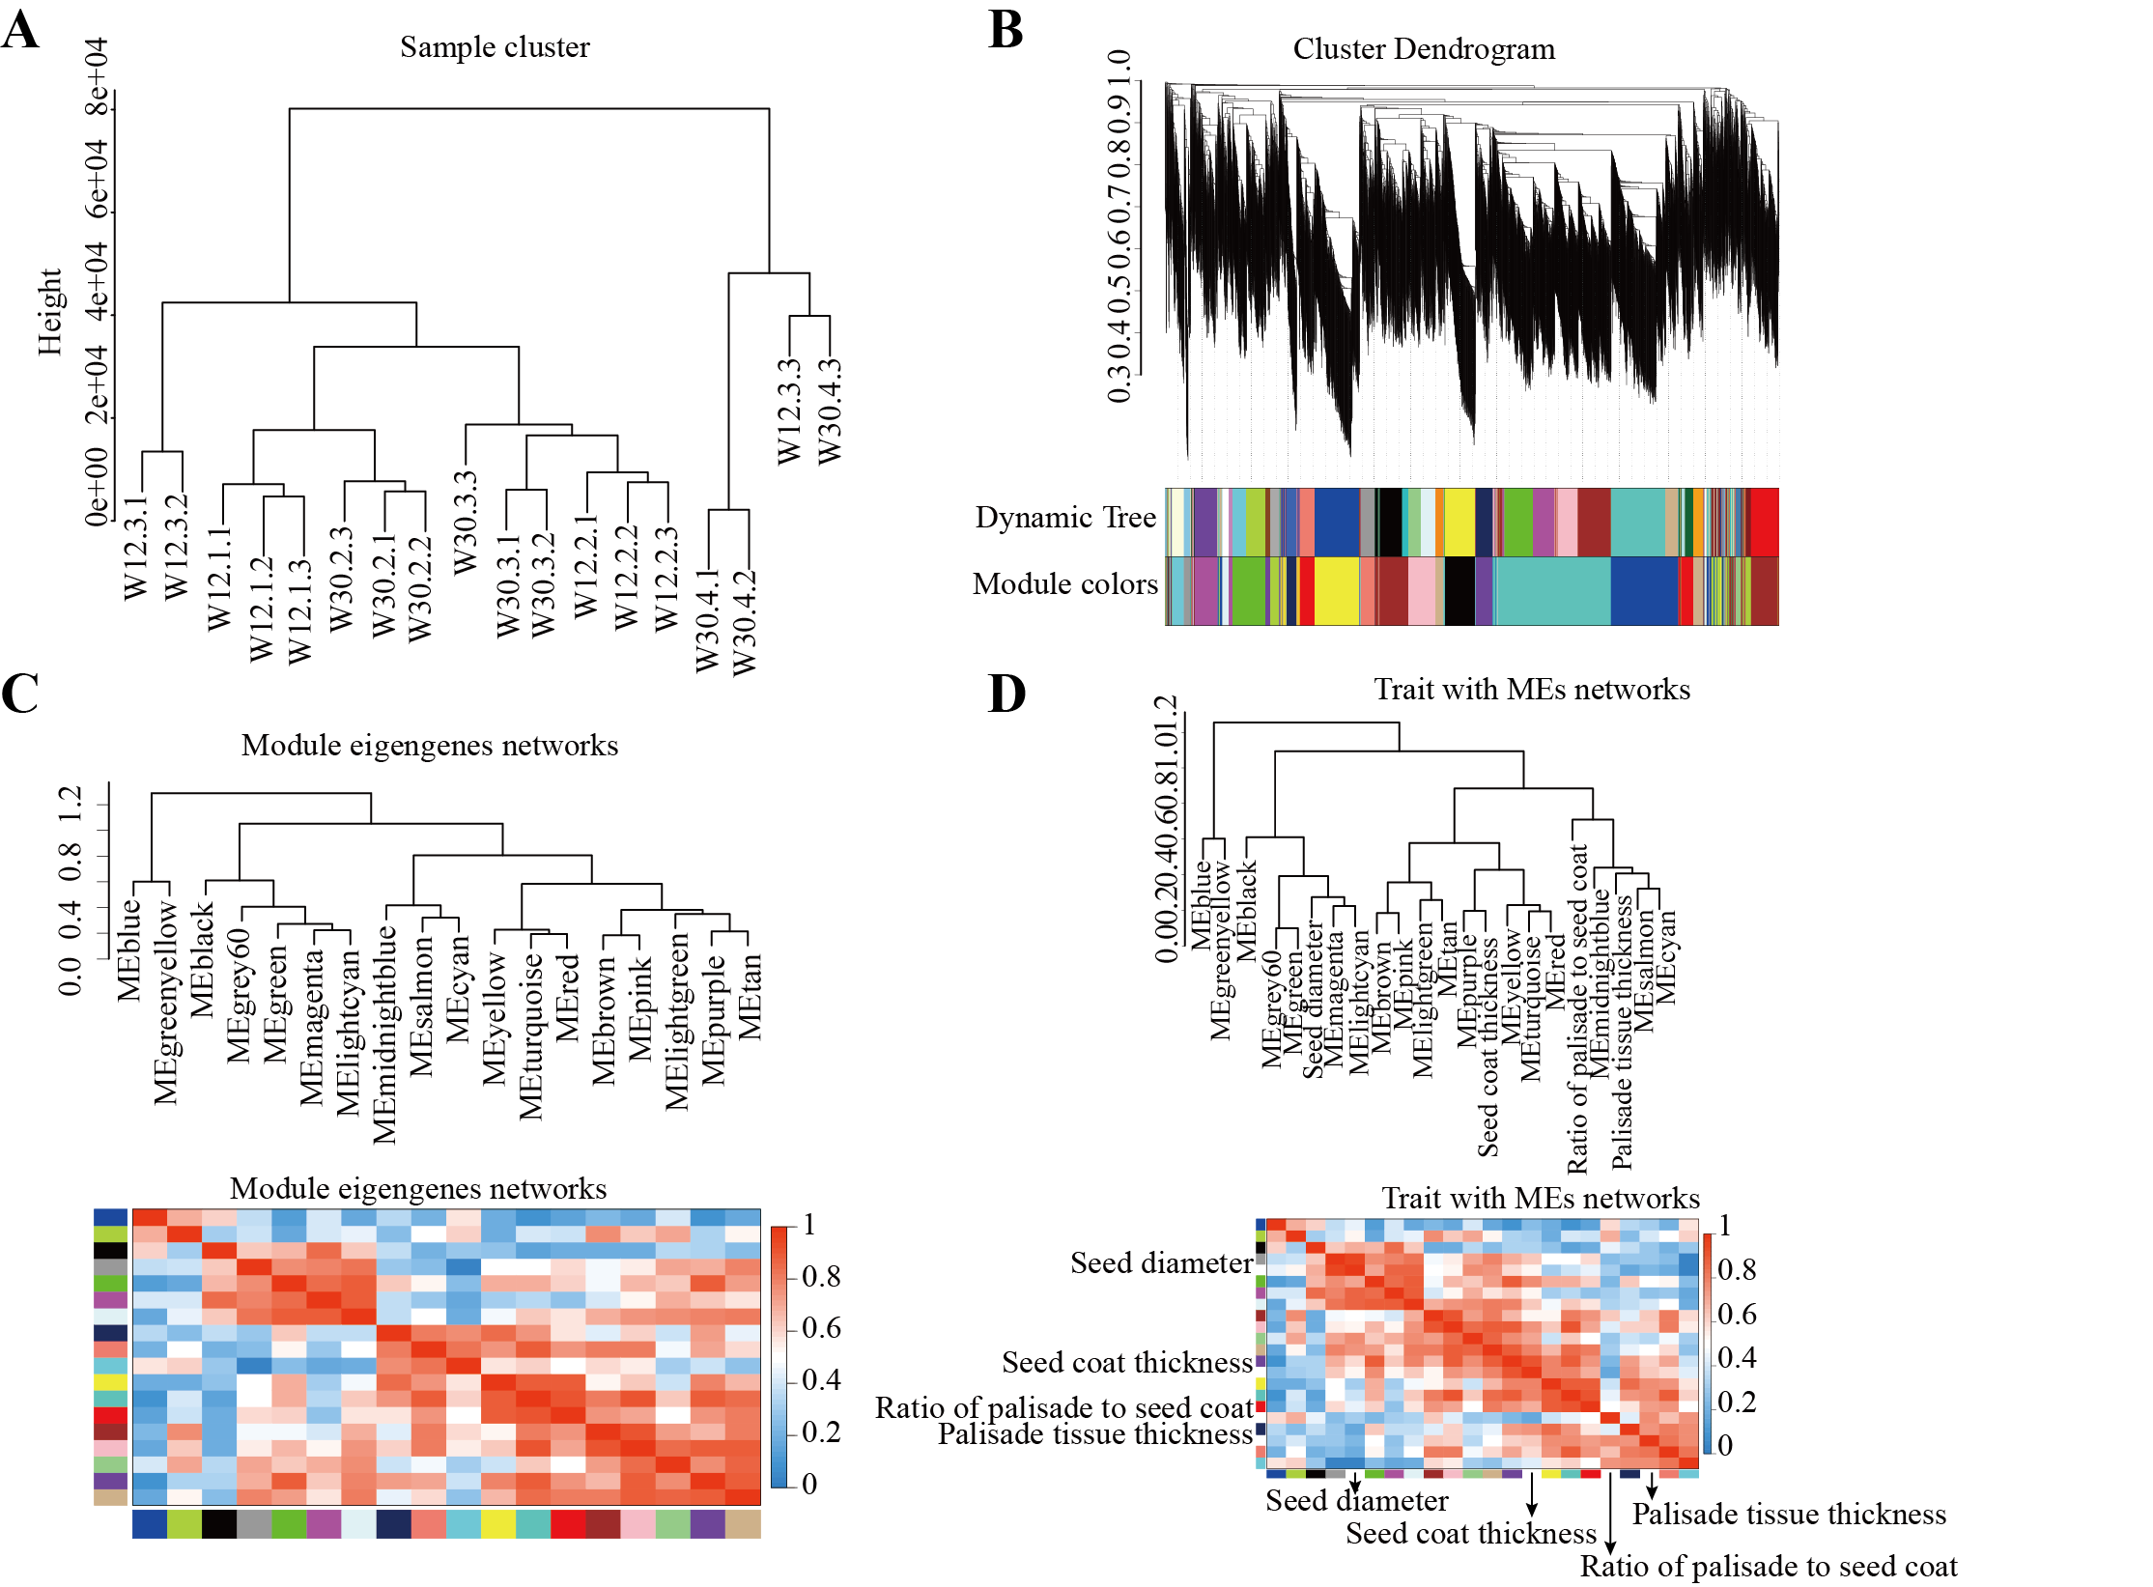
Figure S6. WGCNA analysis

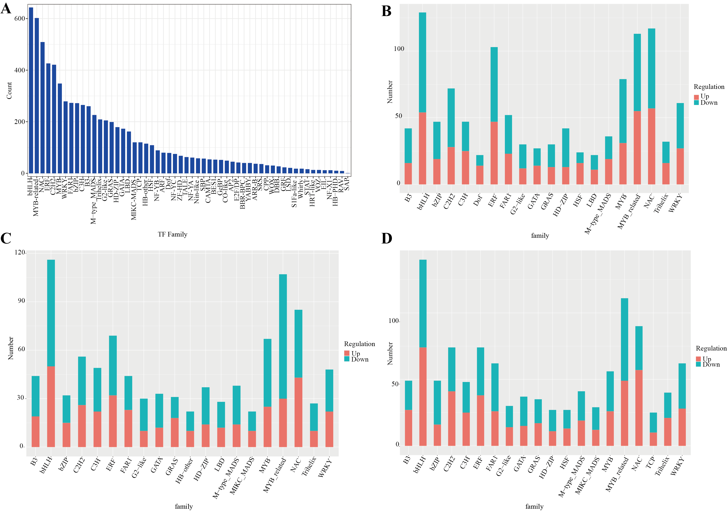
Figure S7. A: Family statistics chart of transcription factors; B-D: Bar chart of Differential Transcription factors.
Note: The horizontal axis represents different transcription factor families, and the vertical axis represents the number of genes falling into that transcription factor family.

