Data capture of a potential centrally-implemented system for national surveillance of bloodstream infections in England, 2023-2024 - supplementary material
SUPPLEMENTARY METHODS
Following Data Capture System (DCS) (local surveillance) practices, hospital groups that had merged or de-merged during the study period were re-coded to reflect the hospital group in March 2024 for both locally-implemented and centrally-implemented surveillance.
Additional details on data processing for centrally-implemented surveillance:
Amended laboratory-reported hospital group
As the hospital group contained within SGSS (laboratory-submitted) data is known to be incorrect in a sizeable minority of cases, we used a heuristic algorithm to amend this hospital group. Each SGSS record includes a code that denotes the collection site (e.g. specific hospital or GP practice) and also denotes the hospital group of the collection site, but the hospital group of the codes used by the laboratories is frequently inaccurate. To “correct” these data, using NHS England Hospital Episode Statistics (HES), SGSS records were linked by NHS number to inpatient admissions overlapping the specimen collection date and the predominant hospital group per collection site was assigned as that site’s amended hospital group. See [2] for further details.
Meticillin resistance status
S. aureus episodes were categorised as MRSA where any isolate within the episode was recorded as phenotypically resistant to meticillin, cefoxitin, oxacillin or flucloxacillin; and otherwise as MSSA (including where susceptibility results were missing). Presence of mecA and mecC genes could not be determined; this is inconsistently tested by laboratories (depending on local processes) and is not collected centrally within SGSS. Susceptibility testing category “I” (Susceptible, increased exposure) was considered as resistant, following the European Committee on Antimicrobial Susceptibility Testing definitions[1].
Identification of index specimen collection-relevant hospital encounters
“Temporal relevance” of linked hospital encounters was determined by proximity in days to the index specimen date, chronological precedence (with pre- preferred to post-index date), and – in the very small number of instances where this failed to select a sole encounter – alphabetically by, in turn, hospital site, treatment specialty, main specialty, admission method and patient classification.
Centrally-identified Reporting Organisation
Due to known issues with the coding of hospital group data submitted by laboratories, we assigned the responsible Reporting Organisation hierarchically: first to the acute hospital group of the linked inpatient encounter, if available; otherwise, to that of the linked ED encounter, otherwise to that of the linked outpatient encounter. If no acute hospital encounter was linked, the hospital group of the index specimen collection as reported in SGSS by the testing laboratory (and amended algorithmically according to most common hospital group by hospital site following linkage of SGSS and HES data[2]) was used where this was an acute hospital group; otherwise, the (acute) hospital group of the reporting laboratory was assigned.
Centrally-identified Source of Infection
Centrally-identified bacteraemias linked to an inpatient encounter were assigned a Source of Infection based on diagnostic codes from that encounter as mapped onto CCS categories. Bacteraemias could have multiple Sources of Infection, ie presence or absence of each category was calculated. Encounters with diagnostic codes within specific CCS categories were assigned the following Sources of Infection:
- “chest”: aspiration pneumonitis; food/vomitus; pneumonia (except that caused by tuberculosis or sexually transmitted disease); chronic obstructive pulmonary disease and bronchiectasis; cystic fibrosis, other lower respiratory disease; acute bronchitis; asthma
- “urinary”: genitourinary symptoms and ill-defined conditions; urinary tract infections; calculus of urinary tract, other diseases of kidneys and ureters, other diseases of bladder and urethra; nephritis, nephrosis, renal sclerosis, chronic renal failure
- “surgical”: complication of device, implant, or graft; complication of surgical procedures or medical care
- “other”: biliary tract disease; abdominal pain; appendicitis and other appendiceal conditions, peritonitis and intestinal abscess; diverticulosis & diverticulitis, anal and rectal conditions; intestinal obstruction without hernia; intestinal infection
- “nonspecific”: septicaemia (except in labour), shock; fever of unknown origin; bacterial infection (unspecified site)
Locally-identified Source of Infection
Locally-identified Primary Focus was mapped to a Source of Infection (Table S4).
Matching locally- and centrally-identified bacteraemias
Locally- and centrally-identified bacteraemias were matched to each other where the dates of index specimen collection were within ±13-days of each other and either the NHS number from each source was an exact match, or the date of birth from each source was an exact match and the names matched sufficiently. Names were considered to have matched sufficiently where the entirety of the forename from one case identification method was contained within the forename from the other case identification method and the same was true for surname, or the entirety of the forename from one method was contained within the surname from the other method and the same was true for the remaining name from each source (allowing for the switching of forenames and surnames).
Data-field agreement: “match” and “congruence”
We considered two forms of agreement between data-fields in locally- and centrally- implemented surveillance: exact agreement (“match”) and non-contradictory findings or agreement allowing for reasonable minor differences (“congruence”).
For the different data-fields, congruence was defined as exact match or the following:
- Forename – either the locally-identified name was contained within the centrally-identified name, or vice versa
- Surname – as for Forename
- Patient Category – locally-identified data agreed exactly with either linked inpatient, ED or outpatient encounter within ±2 days or locally-identified category is “Emergency Assessment” and centrally-identified category is “Inpatient”
- Main Specialty – any of the following:
  - locally- or centrally-identified specialty was General Surgery and the specialty from the other source was Urology; Transplant Surgery Service; Breast Surgery Service; Colorectal Surgery Service; Hepatobiliary and Pancreatic Surgery Service; Upper Gastrointestinal Surgery Service or Vascular Surgery
  - locally- or centrally-identified specialty was Paediatrics and the specialty from the other source was Paediatric Surgery; Paediatric Cardiology or Paediatric Neurology
  - locally- or centrally-identified specialty code was General Internal Medicine and the specialty from the other source was Accident & Emergency; Geriatric Medicine; or an internal medicine subspecialty (NHS specialty codes 301-410) excluding Clinical Haematology (303), Audio Vestibular Medicine (310), Paediatrics (321) and Medical Oncology (370)
  - locally- and centrally-identified specialty was either of: Ear Nose and Throat; Audio Vestibular Medicine
  - locally- and centrally-identified specialty was any of: Oral Surgery; Restorative Dentistry; Paediatric Dentistry; Orthodontics; Maxillofacial Surgery Service; Oral and Maxillofacial Surgery; Endodontics; Periodontics; Prosthodontics; Surgical Dentistry; Dental Medicine; Special Care Dentistry
  - locally- and centrally-identified specialty were any of: Ophthalmology; Medical Ophthalmology
  - locally- and centrally-identified specialty were any of: Anaesthetics; Pain Management Service; Intensive Care Medicine
  - locally- and centrally-identified specialty were any of: Medical Oncology; Clinical Oncology
  - locally- and centrally-identified specialty was any of : Obstetrics; Gynaecology; Midwifery
  - locally- and centrally-identified specialty was any of: Clinical Haematology; Haematology
- Treatment Specialty – as Main Specialty
- Source of Infection – the source derived from locally-implemented surveillance was contained within the source(s) derived from centrally-implemented surveillance (Table S4)
- On Dialysis – locally-implemented surveillance reported “True” and centrally-implemented surveillance found an ICD-10 code beginning with “Z49”, “Z992”, “N186” or “T824” within [-90,+2] days of the index specimen date in inpatient encounters linked by NHS number, or when locally-implemented surveillance reported “False” and the above was not found
- Urinary Catheter Present Last 28 Days – locally-implemented surveillance reported “True” and centrally-implemented surveillance found a procedure code beginning with “M47” within [-90,+2] days of the index specimen date in inpatient encounters linked by NHS number, or when locally-implemented surveillance reported “False” and the above was not found
- Urinary Catheter Manipulated Last 28 Days – as Urinary Catheter Present Last 28 Days
When considering agreement between data-fields of matched bacteraemias, “unknown” in locally-implemented surveillance was counted as missing data.

SUPPLEMENTARY RESULTS
Exploration of non-matching cases
Only 13 (of 2251 locally-identified and 1327 centrally-identified) non-matching records agreed on names, date of birth and pathogen but not index specimen date (closest agreeing on other fields was 16 days), 24 agreed on names, pathogen and specimen date but not date of birth, and none agreed on date of birth, pathogen and specimen date but not names. Visual inspection of unmatched records did not identify obvious errors.
Discrepancies in meticillin susceptibility
Of 859 locally-identified MRSA bacteraemias, 810 (94.3%) were also identified as MRSA using centrally-implemented surveillance. Of the remaining 49, 46 had no laboratory-reported susceptibility results in the central system, i.e. data were missing, leaving 3 genuine discrepancies. 12775/12906 (99.0%) locally-identified meticillin-susceptible (MSSA) bacteraemias were also centrally-identified as MSSA, while 131 (1.0%) were centrally-identified as MRSA. 84 (64.1%) of these 131 discrepancies were from one specific hospital group and one laboratory, with central results determined by cefoxitin resistance for all 84. However, implausibly, these 84 cases comprised all but three S. aureus bacteraemias from this hospital group, and 8.9% of all centrally-identified MRSA bacteraemias (suggesting misreporting of cefoxitin results to the central database). Among the remaining 47 apparently genuine discrepancies, only 2 were designated as meticillin resistant in central surveillance by virtue of resistance to oxacillin. (Using oxacillin to determine meticillin resistance status is no longer recommended by EUCAST but is still currently in line with UKHSA guidance[3][4].)
Differences in index specimen date
Of 71556 matched bacteraemias, 66062 (92.3%) had identical index specimen dates, 967 (1.4%) had centrally-identified index date 1 day before the locally-identified date, and 2586 (3.6%) had centrally-identified index date 1 day after the locally-identified date (1941 (2.7%) outside ±1 day). Date differences were more common in certain laboratories, and centrally-identified index dates were more often after locally-identified dates (Figure 1). One laboratory (serving two hospital groups) had >90% bacteraemias with centrally-identified index date >2 days after the locally-identified date (median 3 days (IQR 3-4) (range -2 to +8)) suggesting the central data feed may have incorrectly included result or reporting date rather than specimen collection date. 10/103 laboratories had >20% non-matching index specimen dates; excluding these laboratories, 61524/63231 (97.3%) matched bacteraemias had identical index dates, 825 (1.3%) had centrally-identified index date 1 day before the locally-identified date, and 667 (1.1%) 1 day after (215 (0.3%) outside ±1 day). The most plausible explanation for these differences is errors arising in local reporting from transcription from local records into the case reporting system.
Locally-identified and centrally-identified bacteraemias not found in respective sources
Children/adolescents (<18 years at index specimen collection) accounted for a disproportionate number of centrally-identified bacteraemias that were not matched to a locally-identified bacteraemia, and the proportion of those bacteraemias that were not linked to a hospital encounter. Among all 72883 centrally-identified bacteraemias, 1326 (1.8%) were in children/adolescents, while 236/1230 (17.7%) centrally-identified bacteraemias not matched to locally-identified bacteraemias were in children/adolescents (p<0.0001). Among unmatched centrally-identified bacteraemias with an NHS number, children/adolescents accounted for 183/1185 (15.4%) bacteraemias but 115/217 (53.0%) bacteraemias not linked to any hospital encounter (p<0.0001). In contrast, among matched centrally identified bacteraemias with an NHS number, children/adolescents accounted for 2211/70977 (3.1%) bacteraemias and 8/183 (4.4%) bacteraemias not linked to any hospital encounter (p=0.398). This suggests that centrally-identified bacteraemias in children/adolescents that are neither matched to local surveillance nor linked to a hospital encounter may more likely not be genuine cases.
Differences in Reporting Organisation
Of 135 Reporting Organisations, only one (reporting only 8 bacteraemias) had complete agreement (i.e., all locally-identified bacteraemias were identified centrally and assigned to the same Reporting Organisation, and vice versa) (Figures 3, S1). Across all pathogens, absolute differences between locally-implemented and centrally-implemented surveillance tended to increase slightly with total bacteraemias (Figure 3), but relative differences declined (Figure S1).
Congruence by data-field
Considering the nine data-fields for which linked hospital encounters were used to calculate centrally-identified fields (Figure S3A), Patient Location had >95% congruence between locally- and centrally-identified bacteraemias for 132/135 (97.8%) locally-identified Reporting Organisations; Hospital Group for 128/135 (94.8%); Hospital Site 77/135 (57.0%); Patient Category 67/135 (49.6%); Main Specialty 1/134 (0.7%); Treatment Specialty 5/134 (3.7%); Date Admitted 29/135 (21.5%); Admission Method 65/133 (48.9%); and Onset Status 124/135 (91.9%) (varying denominators as some Reporting Organisations had no locally-identified data for some fields).
Patient Category reporting for index dates with an ED attendance
The main source of the discrepancy in Patient Category was around reporting of samples obtained in ED where the patient went on to be admitted. Reporting rules suggest that in this scenario the bacteraemia should be reported as occurring in the ED, whereas among centrally-identified bacteraemias with an ED encounter on the index date (date of specimen collection) and no inpatient encounter until the following day (scenario A, Figure S4A), it was more common for many hospital groups to record this as an inpatient specimen collection (dark red in Figure S4A; right-hand side of Figure S4B; not following protocol) than an ED specimen collection (dark blue in Figure S4A; left-hand side of Figure S4B; following protocol). This (scenario A) occurred for at least one bacteraemia in 124/135 (91.9%) acute hospital groups. The locally-identified Patient Category was recorded as an inpatient specimen collection in ≥90% bacteraemias in 51 of these 124 hospital groups, and as ED specimen collection in ≥90% bacteraemias in 41/124, suggesting a strong effect of local practice (regardless of the protocol). In practice, when interpreting surveillance data, this distinction may not be of major importance, but it highlights a general issue around protocol compliance which can be avoided by using all available data in centrally-implemented surveillance.
For bacteraemias where centrally-implemented surveillance found both ED and inpatient encounters on the index date (scenario B), Reporting Organisations tended to report the same specimen collection setting as they did for scenario A (light/dark colours in Figure S4A; top right/bottom left in Figure S4B). Specifically across the 51 Reporting Organisations that recorded scenario A as an inpatient collection in ≥90% locally-identified bacteraemias, 49 had an instance of scenario B; scenario B was also recorded as inpatient specimen collection in median 99.4% locally-identified bacteraemias. In contrast, across the 41 Reporting Organisations that recorded scenario A as an ED collection in ≥90% locally-identified bacteraemias, 41 had an instance of scenario B; scenario B was recorded as an ED specimen collection in median 88.5% locally-identified bacteraemias. As only dates (and not times) are recorded in the hospital encounter data, it is impossible to be confident that samples were taken in ED rather than post-admission; however, given standard patient management, this seems highly likely.
Centrally-identified bacteraemias with no inpatient encounter on the index specimen collection date or the following day were also locally reported as inpatient specimen collections for a moderate number of bacteraemias (scenarios C and D), with the 51 hospital groups with a strong tendency to report scenario A as inpatient accounting for a substantially larger proportion of these cases than other hospital groups (lightest red).
Primary Focus/Source of Infection
53848/58743 (91.7%) matched Gram-negative bacteraemias had at least one centrally-identified Source of Infection (multiple sources were possible as encounters can contain multiple diagnoses). Retaining “nonspecific” Source of Infection only where it was the sole category, 23343/58743 (39.7%) had one source only and 30514 (51.9%) had ≥2, with only 4895 (8.3%) with none, i.e. “unknown” source (Tables S2, S3).
While bacteraemias had one sole Source of Infection in 23343/58743 (39.7%) cases (retaining “nonspecific” only where it was the sole category), a sole Source of Infection could be derived from primary diagnosis codes for 20859/58743 (35.5%) (Table S3). Among the latter, 6393/8775 (72.9%) which also had a locally identified Primary Focus were exact matches with the local surveillance-derived Source of Infection, compared with 6161/9357 (65.8%) of the former.
Congruence with centrally-identified Source of Infection varied by the assigned locally-identified Source of Infection and, more markedly, by its underlying Primary Focus (Table S4).
Renal dialysis
348/39153 (0.9%) with no centrally-identified renal dialysis had renal dialysis reported locally (Table S5). 331/921 (35.9%) with centrally-identified renal dialysis were locally reported as not receiving renal dialysis.
Recent discharge from other hospital group
As well as discharge from the Reporting Organisation, central surveillance can also identify discharge from other hospital groups (not requested for local surveillance as generally unknown). Among bacteraemias locally reported not to have been discharged from the Reporting Organisation in the last 28 days, 2631/47115 (5.6%) had a centrally identified recent discharge from a hospital group other than the Reporting Organisation; 2412 (5.1%) did not also have a centrally-identified recent Reporting Organisation discharge. Among bacteraemias with missing local data, 75/1179 (6.4%) were discharged from a different hospital group, 54 (4.6%) from a different hospital group only. In total, 6356/59579 (10.7%) matched bacteramias had a centrally-identified recent hospital discharge but were not reported as such locally. Further, using central surveillance, 876/16099 (5.4%) matched bacteraemias with a recent discharge from the Reporting Organisation also had a recent discharge from a different hospital group.
In total, for discharges from the Reporting Organisation or another hospital group, 6069/57564 (10.5%) matched bacteraemias with local data present had a discharge identified centrally but not locally.
Urinary catheters
4806/57791 (8.3%) matched Gram-negative bacteraemias had catheter-related procedure codes from hospital encounters within [-90,+2] days of the index specimen date. It was not possible to identify an optimum threshold for the number of days before the index specimen collection of procedure code presence to predict locally-reported catheter presence/manipulation (area-under-the-receiver-operating curve 0.52 and 0.50, respectively). 3239/52985 (6.1%) and 2254 (4.3%) matched Gram-negative bacteraemias with no centrally-identified catheters had urine catheter presence or manipulation reported locally, respectively; while 527/4806 (11.0%) and 669 (13.9%) matched bacteraemias with centrally-identified urine catheters were locally reported as not present or manipulated respectively (Table S7).
Congruence and missingness of acquisition-related fields by Reporting Organisation
One Reporting Organisation had 0% congruence for Source of Infection, one for Urinary Catheter Presence, and one for both urinary catheter fields. For On Dialysis, only 7/135 Reporting Organisations had <92% congruence while 108/135 had >97%. 35/135 Reporting Organisations did not submit data for Primary Focus, 9/135 for On Dialysis, 1/135 for Discharged Within 28 Days, and 51/135 and 53/135 for Urinary Catheter Present and Manipulated, respectively.

References

1. Kahlmeter, G. and European Committee on Antimicrobial Susceptibility Testing (EUCAST) Steering Committee, Redefining susceptibility testing categories S, I and R (www.eucast.org). 2019.
2. Cregan, J., et al., Case ascertainment of a potential centrally-implemented, automated system for national surveillance of healthcare-associated infections in England 2016-2023. Eurosurveillance, 2025. (in press).
3. European Committee on Antimicrobial Susceptibility Testing, EUCAST guidelines for detection of resistance mechanisms and specific resistances of clinical and/or epidemiological importance: Version 2.0. 2017, European Committee on Antimicrobial Susceptibility Testing.
4. UK Health Security Agency, Mandatory enhanced MRSA, MSSA and Gram-negative bacteraemia, and Clostridioides difficile infection surveillance (Protocol version 4.4). 2021, (https://hcaidcs.phe.org.uk/ContentManagement/LinksAndAnnouncements/HCAIDCS_Mandatory_Surveillance_Protocol_v4.4.pdf).

SUPPLEMENTARY TABLES AND FIGURES
Table S1 Completeness and agreement of specific data fields between locally-identified and centrally-identified bacteraemias
 | Completeness
Field | Local surveillance | Central surveillance | Both | Match | Congruence
Forename | 100.0% | 100.0% | 100.0% | 92.0% | 98.3%
Surname | 100.0% | 100.0% | 100.0% | 98.1% | 98.4%
Date of birth | 100.0% | 100.0% | 100.0% | 98.3% | 98.3%
Sex | 99.9% | 100.0% | 99.9% | 99.2% | 99.2%
Patient location | 100.0% | 100.0% | 100.0% | 99.3% | 99.3%
Hospital Group | 99.8% | 99.9% | 99.8% | 98.0% | 98.3%
Hospital site | 99.8% | 99.1% | 98.9% | 88.4% | 88.4%
Patient category | 99.8% | 98.3% | 98.1% | 62.5% | 92.6%
Main specialty | 96.3% | 97.8% | 94.8% | 47.0% | 78.1%
Treatment specialty | 90.8% | 97.8% | 89.8% | 53.1% | 78.9%
Date admitted | 69.4% [96.7%] | 95.9% [100.0%] | 61.6% | 77.8% | 77.8%
Admission method | 63.9% [88.2%] | 95.9% [100.0%] | 61.2% | 93.1% | 93.1%
Onset status | 100.0% | 100.0% | 100.0% | 96.5% | 96.5%
Source of infection | 40.8% | 91.7% | 37.8% | 28.2% | 76.8%
On dialysis | 56.3% | 100.0% | 56.0% | 96.8% | 98.3%
Discharged last 28 days | 99.6% | 100.0% | 99.6% | 91.9% | 91.9%
Urinary catheter present | 24.5% | 100.0% | 24.5% | 77.4% | 77.4%
Urinary catheter manipulated | 23.3% | 100.0% | 23.3% | 78.3% | 78.3%
Note: data presented visually in Figure 4. Percentages are of the total matched bacteraemias, not taking any conditionality in requirements into account. Where there is conditionality (e.g. date admitted and admission method are only required in locally-implemented surveillance if an inpatient location has been chosen, completeness given this conditionality is shown in [].

Table S2 Number of Sources of Infection in centrally-implemented surveillance
Number of Source of Infection categories | Number of cases
Number of Source of Infection categories | Main | % | Sensitivity | %
0 | 4895 | 8.3% | 4886 | 8.3%
1 | 23343 | 39.7% | 7436 | 12.7%
2 | 20101 | 34.2% | 19400 | 33.0%
3 | 8712 | 14.8% | 17830 | 30.3%
4 | 1608 | 2.7% | 7669 | 13.1%
5 | 93 | 0.2% | 1435 | 2.4%
6 | 0 | 0.0% | 87 | 0.1%
Note: sensitivity analysis including non-specific sources as well as defined sources, see Methods

Table S3 Completeness and agreement between Primary Focus in locally-implemented surveillance and Source of Infection in centrally-implemented surveillance
 | No. of cases |  |  |  |  | Congruence Type
 | Local | Central | Both | Congruent | % | Congruence Type
All Gram-negative bacteraemias | 60042 | 58743 | 57791 | - | - | -
1. with a Source of Infection (Method A) | 24285 | 53848 | 21863 | 16763 | 76.7% | *
2. with a Source of Infection (Method B) | 24285 | 53848 | 21863 | 17617 | 80.6% | *
3. with one centrally-identified  Source of Infection category only | 24285 | 23343 | 9357 | 6161 | 65.8% | **
4. with a primary diagnosis-derived centrally-identified Source of Infection category | 24285 | 20859 | 8775 | 6393 | 72.9% | **
5. "4" else "3" | 24285 | 35754 | 14506 | 9505 | 65.5% | **
*Locally-identified contained within centrally-identified
**Locally-identified exact match with centrally-identified
Note: locally-implemented surveillance can record one Primary Focus only. See Table S4 for detailed breakdown. Method A excludes and Method B includes non-specific sources.

Table S4 Detailed comparison of Primary Focus in locally-implemented surveillance and Source of Infection in centrally-implemented surveillance
Locally-identified Source of Infection | Locally-identified Primary Focus | Locally-identified Source of Infection present | Centrally-identified Source of Infection present | Centrally-identified contains locally-identified | Congruence
Abdominal | Hepatobiliary | 4349 | 4095 | 3312 | 80.9% | 75.4%
Abdominal | Gastrointestinal or intraabdominal collection (excluding hepatobiliary) | 1934 | 1775 | 1116 | 62.9% | 75.4%
Chest | Lower respiratory tract (pneumonia, VAP, bronchiectasis, EXAC COPD etc) | 1880 | 1721 | 1458 | 84.7% | 84.4%
Chest | Upper respiratory tract and ENT | 111 | 96 | 76 | 79.2% | 84.4%
Surgical | Intravascular device (including pacemaker/ ICD or CVC) | 781 | 714 | 433 | 60.6% | 61.1%
Surgical | Bone and joint (with prosthetic material) | 44 | 40 | 29 | 72.5% | 61.1%
Surgical | Cardiovascular or vascular (with prosthetic material e.g. EVAR, stent, valve, prosthetic fistula) | 41 | 38 | 22 | 57.9% | 61.1%
Urinary | Lower urinary tract | 8565 | 7994 | 6574 | 82.2% | 84.4%
Urinary | Upper urinary tract (pyelonephritis/ abscess) | 3640 | 3409 | 3114 | 91.3% | 84.4%
Urinary | Genital system (including prostate if male) | 178 | 147 | 62 | 42.2% | 84.4%
Other | Skin or soft tissue (including ulcers, cellulitis, diabetic foot infections without om) | 490 | 457 | 339 | 74.2% | 68.8%
Other | Bone and joint (no prosthetic material) | 121 | 113 | 75 | 66.4% | 68.8%
Other | Cardiovascular or vascular (without prosthetic material, including fistula infection) | 50 | 47 | 15 | 31.9% | 68.8%
Other | Central nervous system | 36 | 33 | 18 | 54.5% | 68.8%
Nonspecific* | No underlying focus of infection | 987 | 880 | 106 | 12.0% | 10.4%
Nonspecific* | No clinical signs of infection | 310 | 277 | 14 | 5.1% | 10.4%
Nonspecific** | No underlying focus of infection | 987 | 880 | 744 | 84.5% | 84.2%
Nonspecific** | No clinical signs of infection | 310 | 277 | 230 | 83.0% | 84.2%
Total |  | 23517 | 21836 | 16763 | 76.8% | *
 |  | 23517 | 21836 | 17617 | 80.7% | **
Absent | NA | 0 | 32021 | 0
 |  | 23517 | 53857
* Main
** Sensitivity
Table S5 Agreement on renal dialysis status between locally-implemented and centrally-implemented surveillance
A. Among matched bacteraemias with data present in local surveillance
 |  | Central surveillance
 |  | No (%) | Yes (%) | Total (%) | Match %
Local | No (%) | 38,805 (96.8) | 331 (0.8) | 39,136 (97.7) | 99.2
surveillance | Chronic (%) | 195 (0.5) | 525 (1.3) | 720 (1.8) | 72.9
 | Acute (%) | 153 (0.4) | 65 (0.2) | 218 (0.5) | 29.8
 | Total (%) | 39,153 (97.7) | 921 (2.3)
 | Match % | 99.1 | 64.1
B. Among matched bacteraemias with data absent in local surveillance
 |  | Central surveillance
 |  | No (%) | Yes (%)
Local | Not stated (%) | 32,172 (98.1) | 637 (1.9)
surveillance

Table S6 Agreement between locally-implemented and centrally-implemented surveillance for recent (within last 28 days) discharge from (A) the Reporting Organisation and (B) any acute hospital group
Discharged within 28 days prior to index specimen
 |  | Central surveillance
 |  | Yes RO,  No Other (%) | Yes RO,  Yes Other (%) | No RO,  Yes Other (%) | No RO,  No Other (%) | Total | Match %
Local | Yes (%) | 8,957 (15.6) | 476 (0.8) | 78 (0.1) | 938 (1.6) | 10,449 (18.2) | 90.3
surveillance | No (%) | 3,437 (6.0) | 219 (0.4) | 2,412 (4.2) | 41,047 (71.3) | 47,115 (81.8) | 92.2
 | Total (%) | 12,394 (21.5) | 695 (1.2) | 2,490 (4.3) | 41,985 (72.9)
 | Match % | 72.1 |  | 97.2
 |  | Central surveillance
 |  | Yes RO,  No Other (%) | Yes RO,  Yes Other (%) | No RO,  Yes Other (%) | No RO,  No Other (%)
Local surveillance | Not stated (%) | 213 (18.1) | 21 (1.8) | 54 (4.6) | 891 (75.6)
RO=Reporting Organisation

Table S7 Agreement between urinary catheter (A) presence and (B) manipulation in locally-implemented surveillance and procedure codes for urine catheters in centrally-implemented surveillance
A. Urinary catheter present in last 28 days
Among matched bacteraemias with data present in local surveillance
 |  | Central surveillance*
 |  | No (%) | Yes (%) | Total (%) | Match %
Local | No (%) | 9247 (65.2) | 527 (3.7) | 9774 (68.9) | 94.6
surveillance | Yes (%) | 3239 (22.8) | 1163 (8.2) | 4402 (31.1) | 26.4
 | Total (%) | 12486 (88.1) | 1690 (11.9)
 | Match % | 74.1 | 68.8
Among matched bacteraemias with data absent in local surveillance
 |  | Central surveillance*
 |  | No (%) | Yes (%)
Local | Not stated (%) | 40499 (92.9) | 3116 (8.1)
surveillance

B. Urinary catheter inserted, removed or manipulated in last 28 days
Among matched bacteraemias with data present in local surveillance
 |  | Central surveillance*
 |  | No (%) | Yes (%) | Total | Match (%)
Local | No (%) | 9681 (72.0) | 669 (5.0) | 10350 (76.9) | 93.5
surveillance | Yes (%) | 2254 (16.8) | 847 (6.3) | 3101 (23.1) | 27.3
 | Total | 9681 (88.7) | 1516 (11.3)
 | Match (%) | 81.1 | 55.9
Among matched bacteraemias with data absent in local surveillance
 |  | Central surveillance*
 |  | No (%) | Yes (%)
Local | Not stated (%) | 41050 (92.6) | 3290 (7.4)
surveillance

* "Yes" in central surveillance denotes any bacteraemia with a urinary catheter procedure code from a hospital encounter between 90 days prior to and 2 days after index specimen collection

Figure S1 Percentage of locally-identified and centrally-identified bacteraemias not found in respective sources by acute hospital group (“Reporting Organisation”)
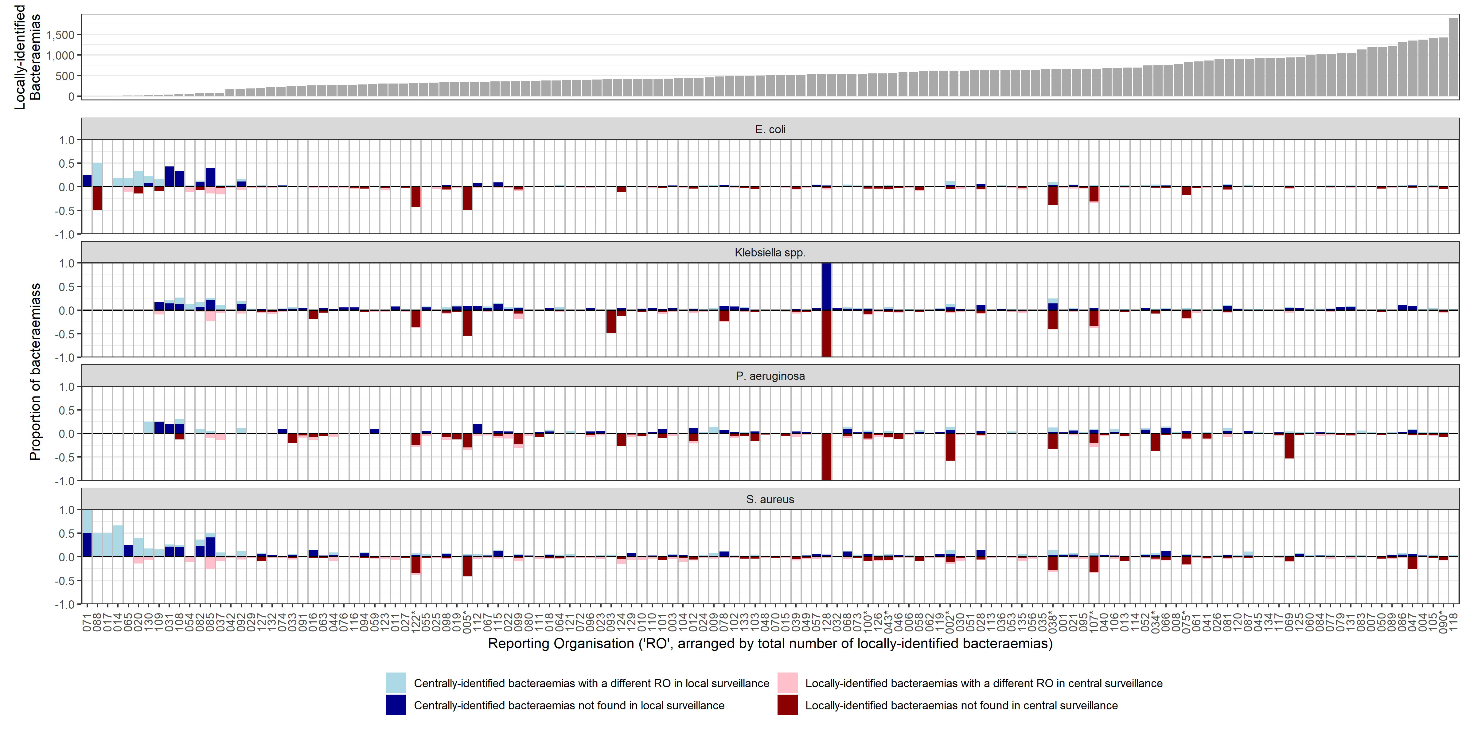
Note: blue bars represent proportion of centrally-identified bacteraemias, red bars represent proportion of locally-identified bacteraemias; see Figure 2 for absolute number of bacteraemias from that Reporting Organisation.

Figure S2 Agreement between locally-identified and centrally-identified bacteraemias by pathogen
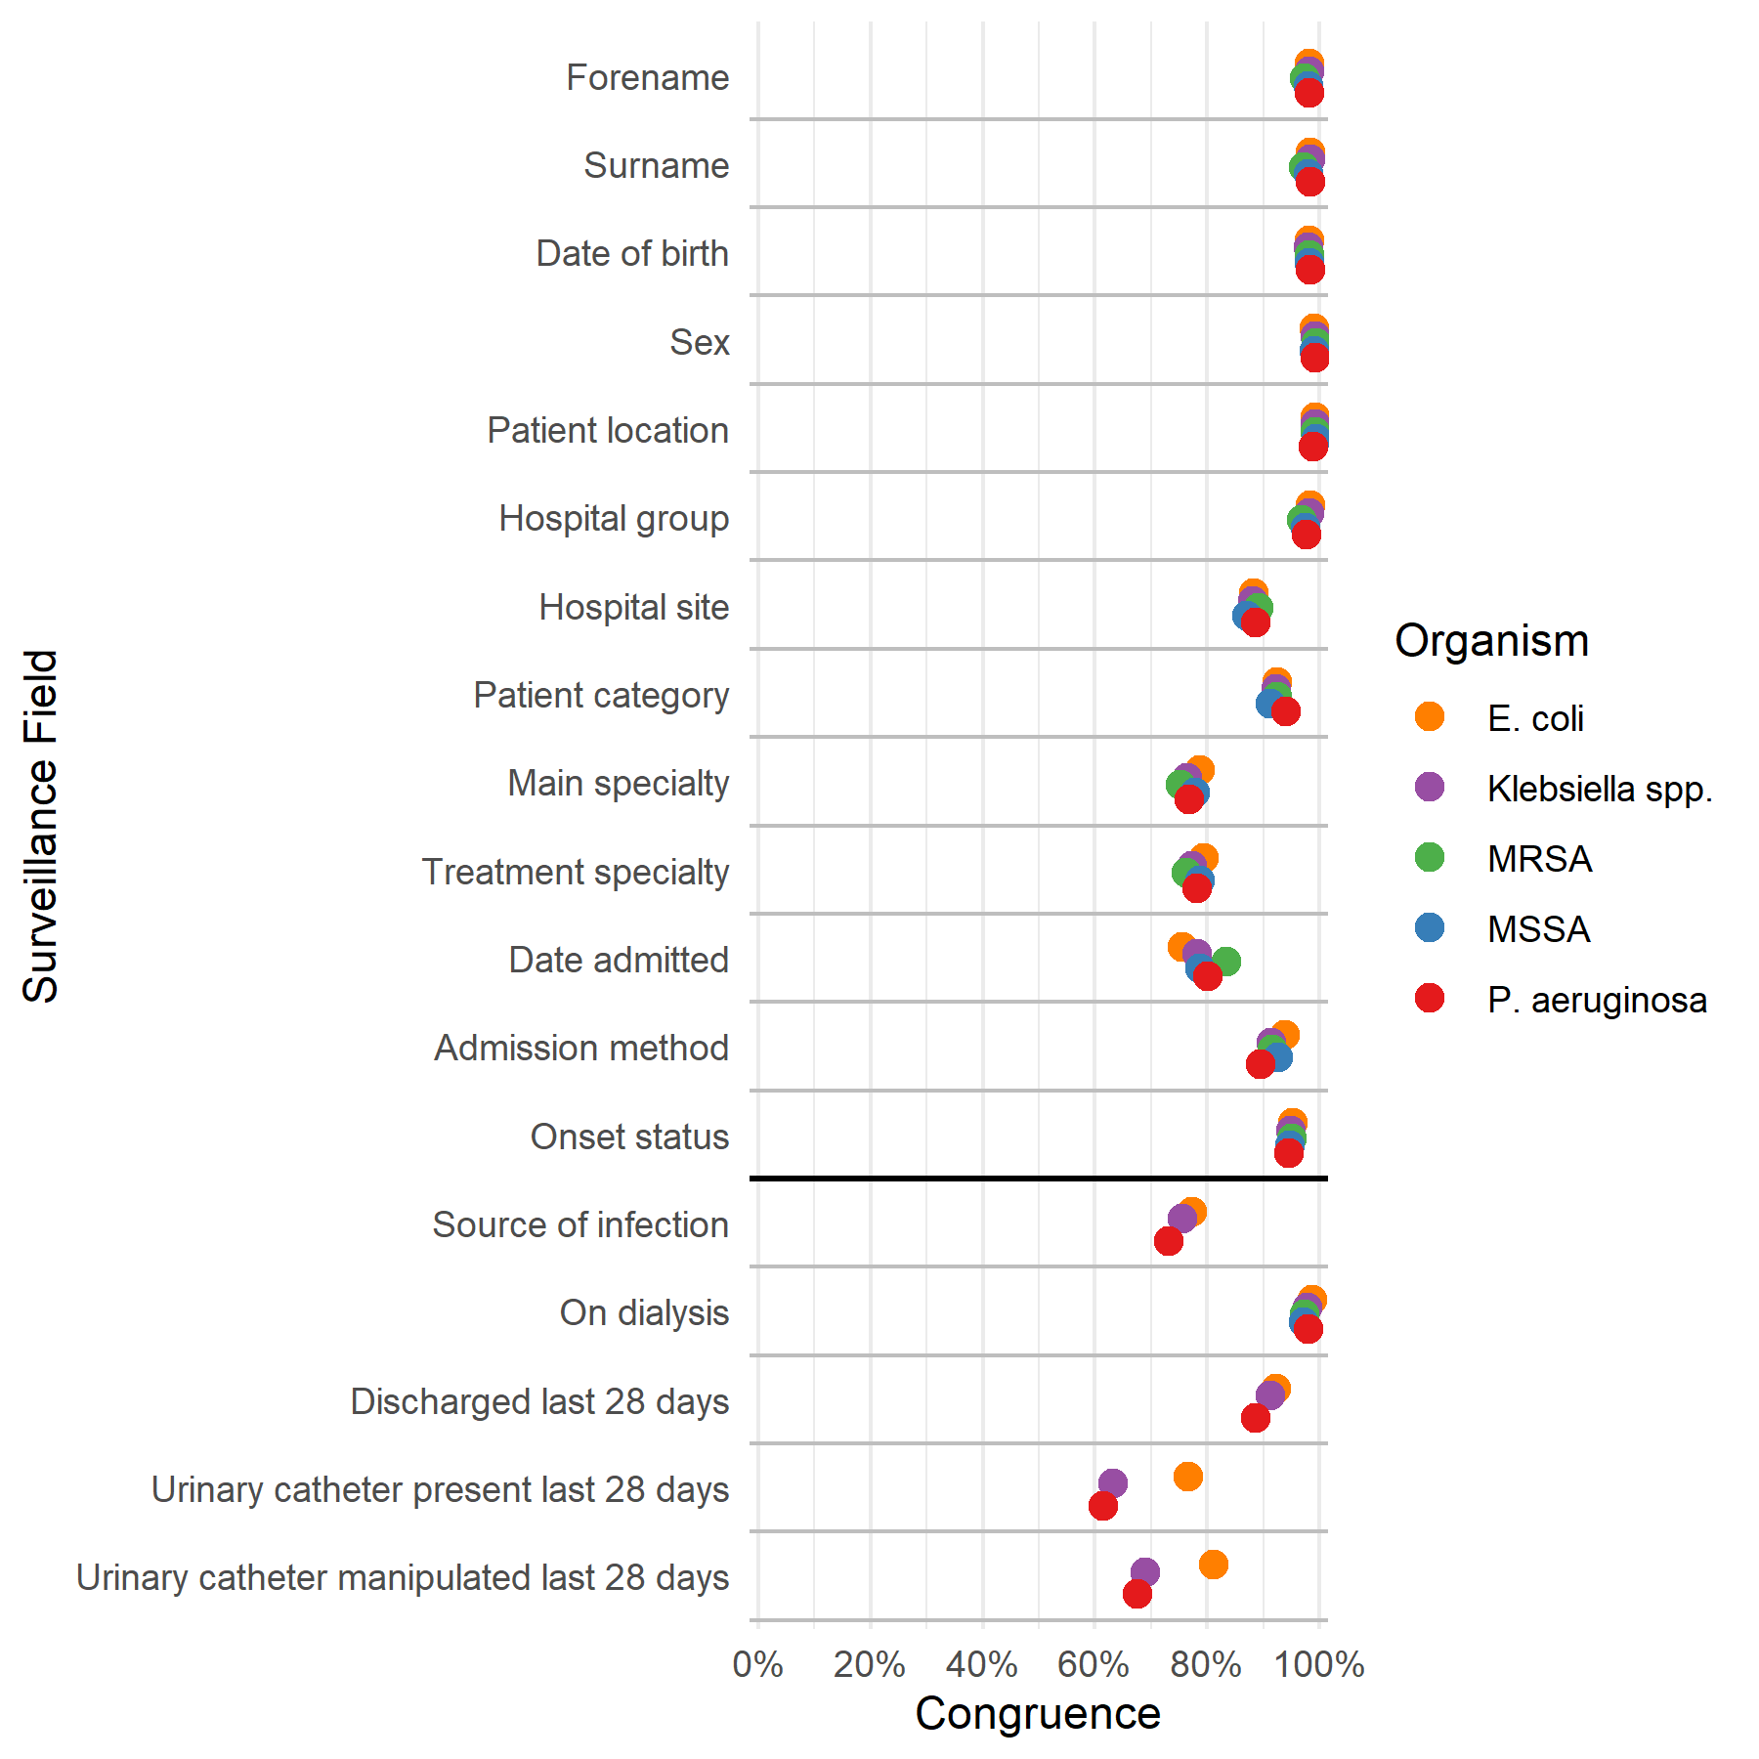
Note: higher congruence for E. coli in urinary catheter fields is due to a higher proportion of cases where both forms of surveillance return a negative (lower prevalence of urinary catheters among E. coli cases)

Figure S3 Congruence of specific data fields between locally-identified and centrally-identified bacteraemias by acute hospital group
A.
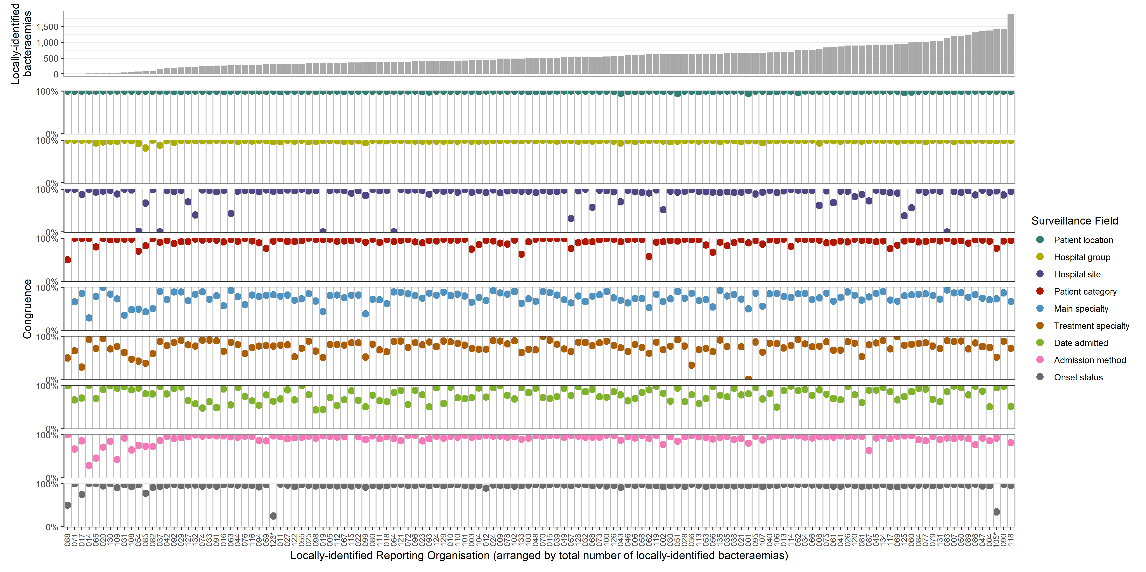

B.
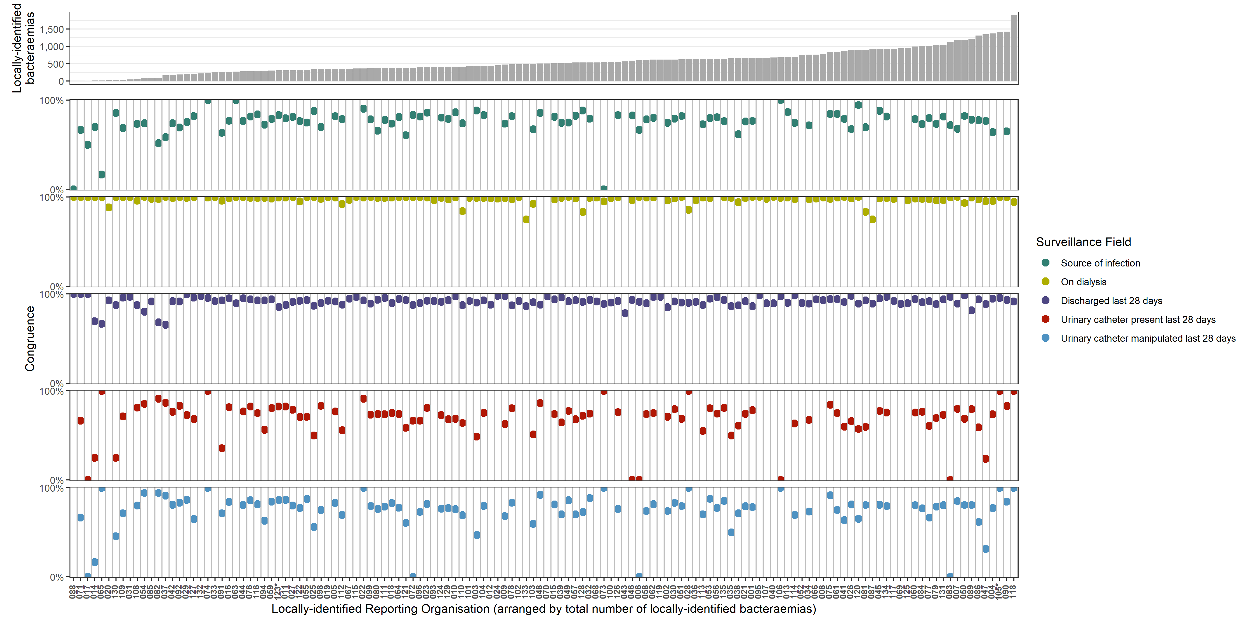

Figure S4 Among bacteraemias with an ED encounter identified from central surveillance, (A) percentages with different locally-identified Patient Categories and centrally-identified hospital encounter dates, by Reporting Organisation (B) comparison of Patient Categories where index specimen collection date was on same day as an ED encounter, and the patient was admitted as an inpatient the same or the following day
A.
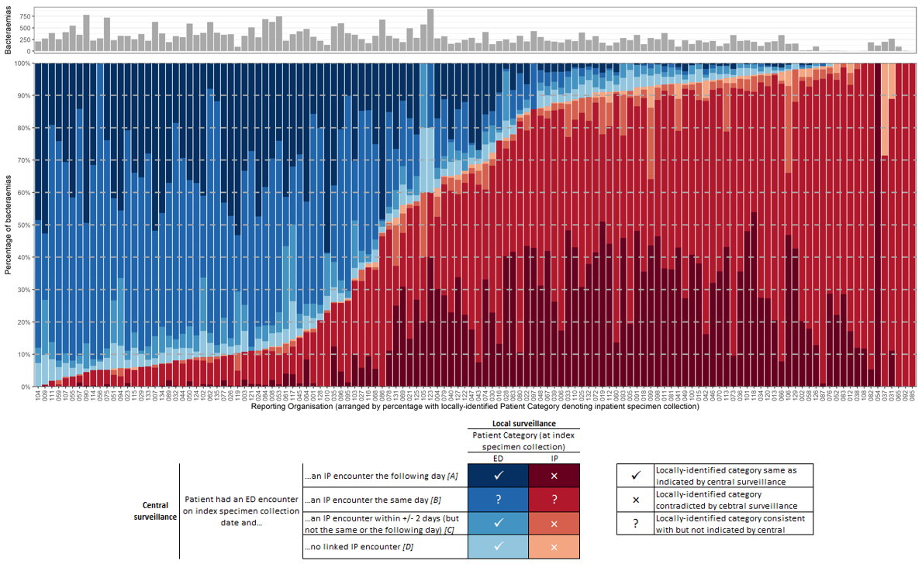
Note: using the locally-implemented surveillance protocol to determine whether locally-identified vs centrally-identified categories were correct; “IP” = inpatient
B.
