Table 5. The independent samples t-test of phosphate concentration on the shallow and deep well independent samples t-test
Phosphate |  |  | Statistic | df | p | 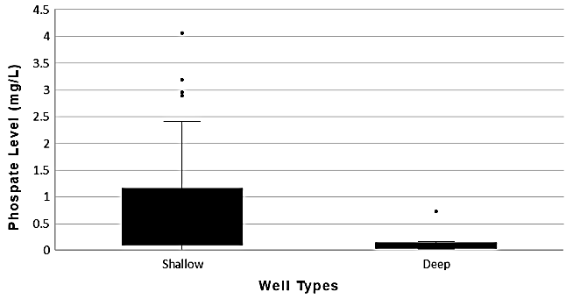
Phosphate | Student's t |  | 2.12ᵃ | 56.0 | 0.038
Phosphate | Welch’s t |  | 3.791 | 51.6 | 0.001
Group Descriptives
Phosphate | Well type | N | Mean | SD | SE
Phosphate | Shallow | 45 | 0.769 | 1.062 | 0.1583
Phosphate | Deep | 13 | 0.138 | 0.185 | 0.0513

Table 6. One Way ANOVA (Welch's) of significance phosphate concentration in administration region on the groundwater basin and descriptive analysis
Phosphate |  | F | df1 | df2 | p | 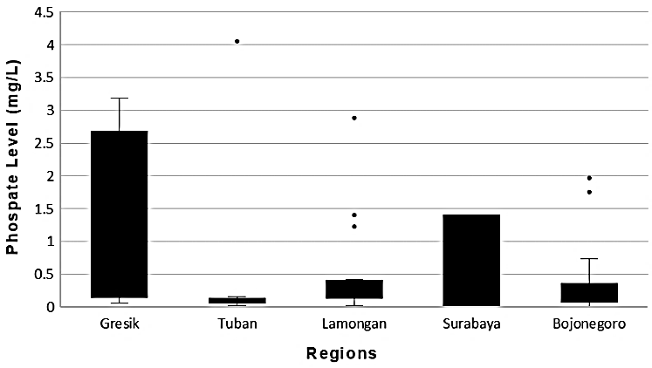
Phosphate |  | 1.02 | 4 | 12.1 | 0.435
Group Descriptive
Phosphate | Regency | N | Mean | SD | SE
Phosphate | Surabaya | 3 | 0.540 | 0.750 | 0.433
Phosphate | Gresik | 13 | 1.201 | 1.264 | 0.351
Phosphate | Lamongan | 16 | 0.523 | 0.741 | 0.185
Phosphate | Bojonegoro | 16 | 0.369 | 0.610 | 0.152
Phosphate | Tuban | 10 | 0.489 | 1.255 | 0.397

Table 7. One-way ANOVA (Welch's), differences in phosphate levels based on regional classification
 |  | F | df 1 | df 2 | p | 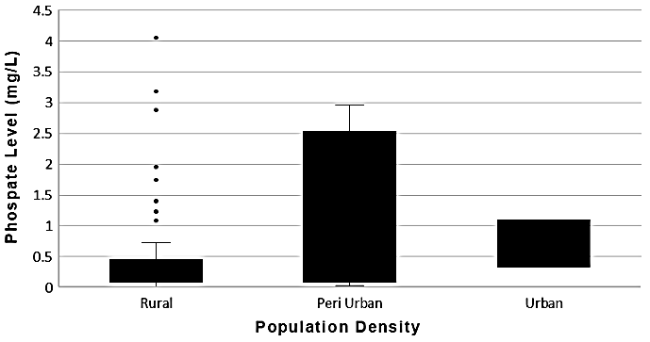
Phosphate |  | 0.566 | 2 | 2.71 | 0.623
Group Descriptives
Phosphate | Category | N | Mean | SD | SE
Phosphate | Rural | 50 | 0.558 | 0.942 | 0.133
Phosphate | Peri-Urban | 6 | 1.179 | 1.281 | 0.523
Phosphate | Urban | 2 | 0.712 | 0.541 | 0.382
Table 8. One-way ANOVA (Welch's), differences in phosphate levels based on LULC Classification
 |  | F | df 1 | df 2 | p | 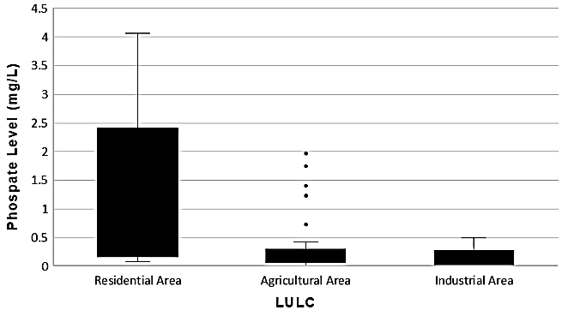
Phosphate |  | 5.479 | 2 | 23.0 | 0.011
Group Descriptives
Phosphate | Category | N | Mean | SD | SE
Phosphate | Settlement | 23 | 1.107 | 1.294 | 0.270
Phosphate | Rice Fields | 30 | 0.337 | 0.530 | 0.097
Phosphate | Industry | 5 | 0.168 | 0.200 | 0.089

