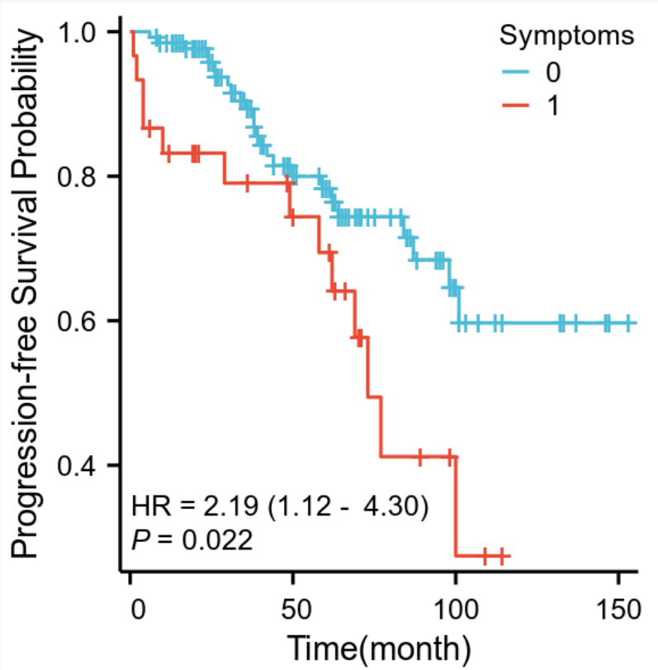  A | 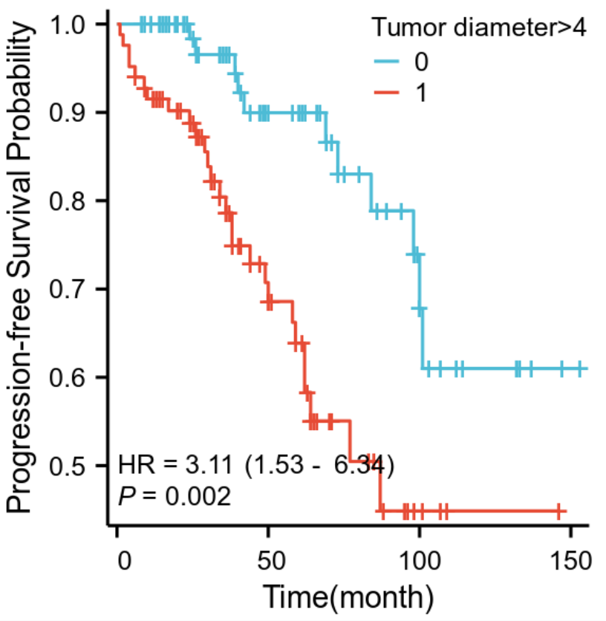  B
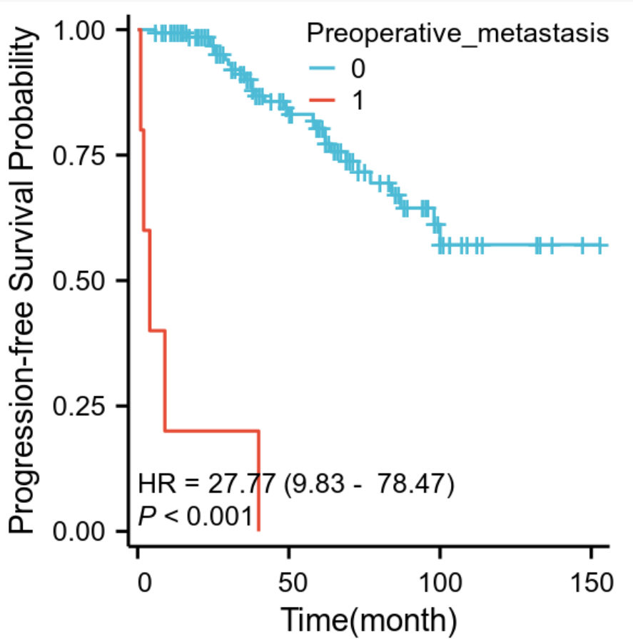  C | 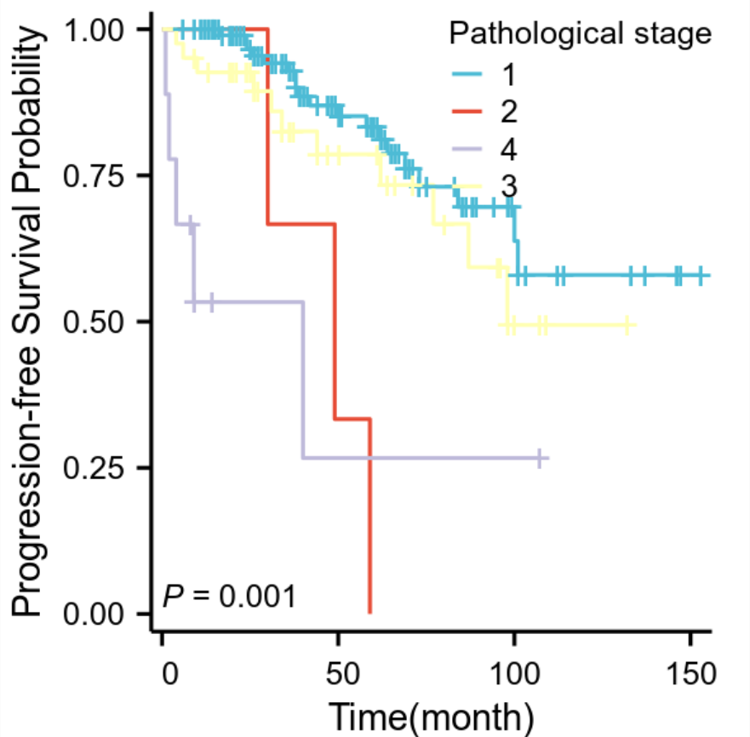  D
Supplementary Figure 1. Kaplan–Meier survival curve in PFS of elderly adults with renal cell carcinoma divided A by pathological stage, B by tumor diameter, C by preoperative metastasis and D by pathological stage
A A statistically significant difference in PFS was observed between symptomatic and asymptomatic patient groups (p=0.022). B Similarly, patients with tumor diameter >4 cm demonstrated significantly worse PFS (p=0.002). C Furthermore, patients with preoperative metastases demonstrated significantly worse PFS (p<0.001). D Lastly, a significant difference in PFS was observed among different pathological stages (p =0.001)

