Appendix:
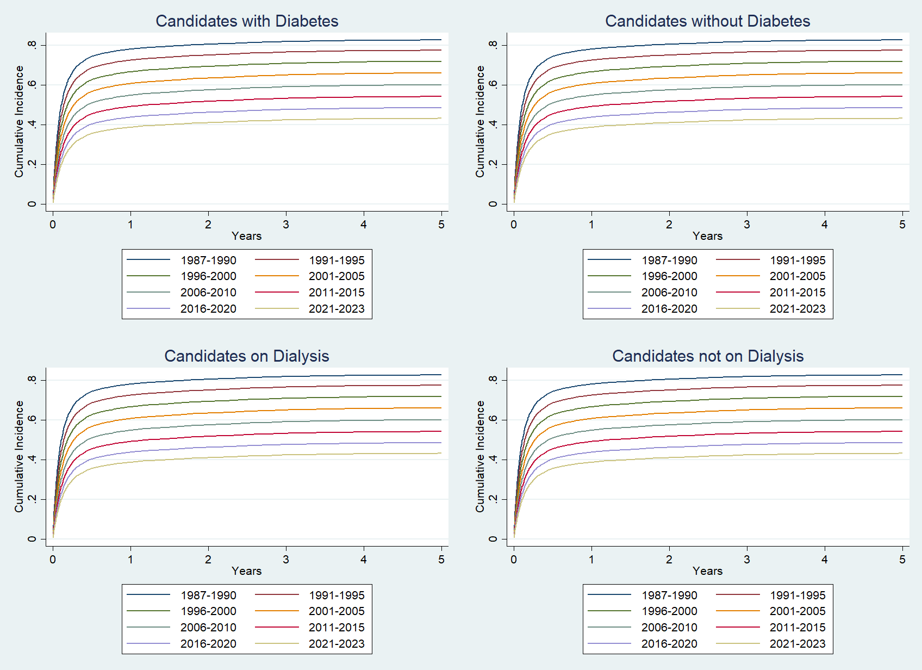Fig. 3 Estimated Cumulative Incidence Functions from Competing Risk Analysis Depicting Probability of Death on the Waiting List for Candidates with Diabetes, Candidates without Diabetes, Candidates on Dialysis, Candidates not on Dialysis
Competing outcomes were removal from the list for transplantation or due to clinical improvement.
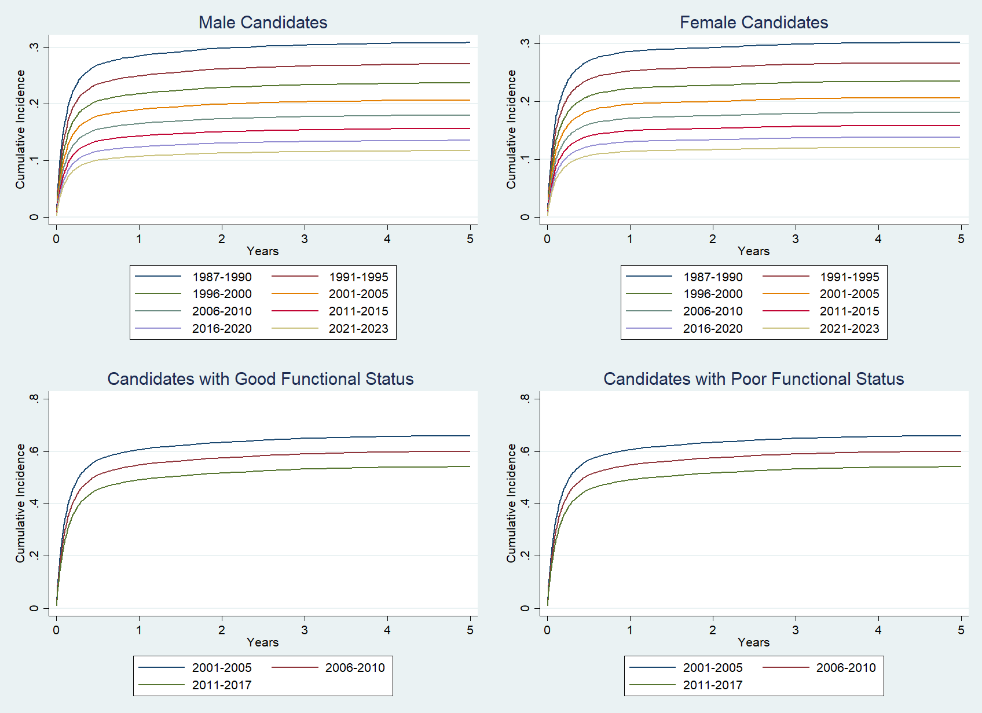Fig. 4 Estimated Cumulative Incidence Functions from Competing Risk Analysis Depicting Probability of Death on the Waiting List for Male Candidates, Female Candidates, Candidates with Good Functional Status, Candidates with Poor Functional Status
Competing outcomes were removal from the list for transplantation or due to clinical improvement.
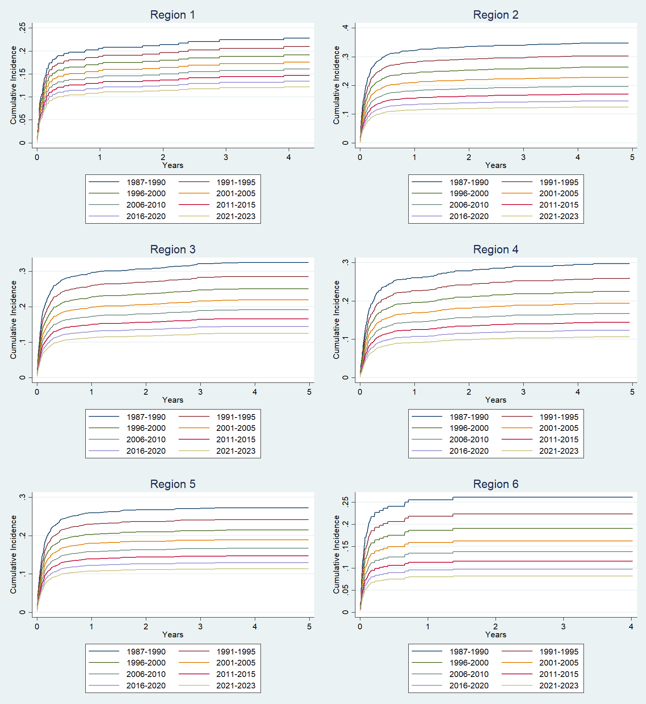Fig. 5 Estimated Cumulative Incidence Functions from Competing Risk Analysis Depicting Probability of Death on the Waiting List for regions 1-6
Competing outcomes were removal from the list for transplantation or due to clinical improvement.

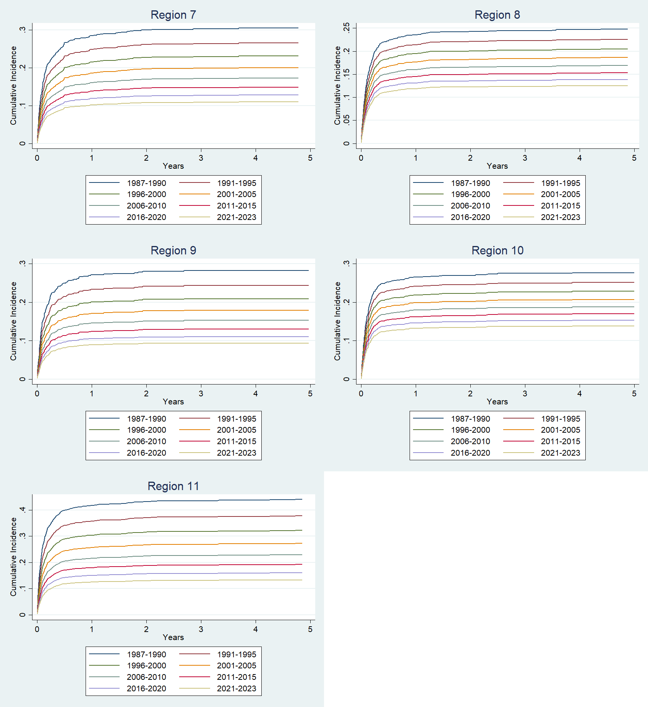 Fig. 6 Estimated Cumulative Incidence Functions from Competing Risk Analysis Depicting Probability of Death on the Waiting List for regions 7-11
Competing outcomes were removal from the list for transplantation or due to clinical improvement.

