Supplementary Information 1
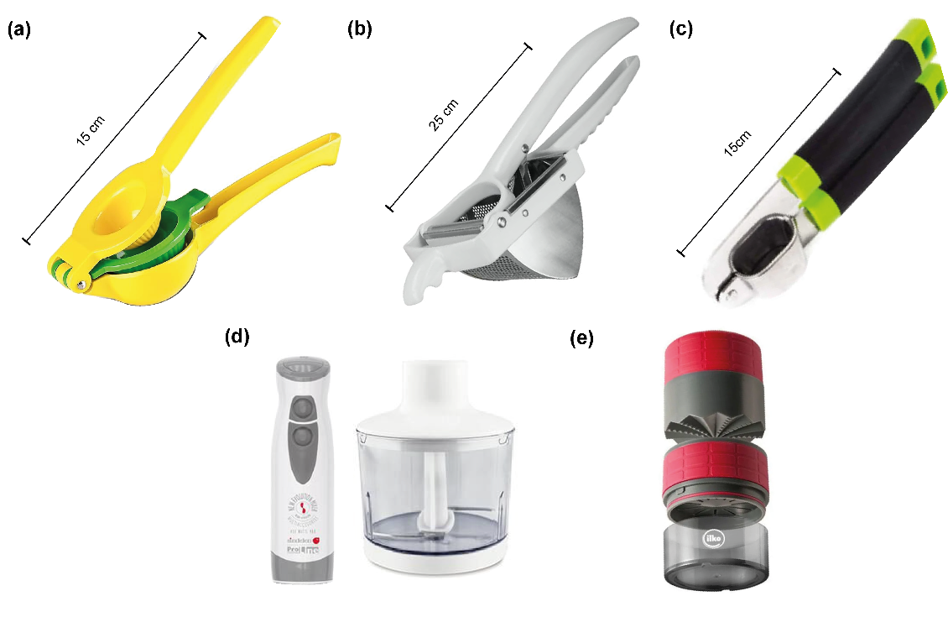
Fig. S1 Devices used for sap extraction in this study. (a) Citrus squeezer; (b) Potato press; (c) Garlic press; (d) Juicer; (e) Garlic grinder.
Table S2 Model selection metrics and variance components for sap chemical parameters across extraction methods
Parameter | χ² (EM) | p-value | Replicate SD | Residual SD | Δ AIC | LRT p-value
pH | 398.46 | < 0.001 | 0.052 | 0.062 | 210.54 | < 0.001
EC | 16.89 | 0.002 | 0.547 | 0.408 | 8.51 | 0.002
NO₃⁻ | 118.78 | < 0.001 | 9.173 | 6.204 | 85.88 | < 0.001
K⁺ | 11.85 | 0.068 | 4.638 | 3.577 | 3.72 | 0.020
°Brix | 27.26 | < 0.001 | 0.172 | 3.313 | 18.00 | < 0.001
Table S3 Sap color metrics (CIELab coordinates) across extraction methods
Method | L* (Lightness) | a* (Green-Red) | b* (Blue-Yellow)
Citrus squeezer | 77.65 | -22.16 | 67.97
Potato press | 81.57 | -22.97 | 70.81
Garlic press | 81.57 | -22.97 | 70.81
Juicer | 77.70 | -22.72 | 70.89
Garlic grinder | 87.01 | -13.66 | 42.53

