Supplemental Table 1. TB-related Mortality Trends, Overall and Stratified by Sex, 1999 to 2022.
 | Age-Adjusted Mortality Rate (per 100,000)
Year | Overall | Female | Male
1999 | 1.24 | 0.77 | 1.94
2000 | 1 | 0.67 | 1.55
2001 | 0.95 | 0.65 | 1.44
2002 | 0.89 | 0.62 | 1.38
2003 | 0.86 | 0.58 | 1.27
2004 | 0.74 | 0.52 | 1.14
2005 | 0.74 | 0.52 | 1.11
2006 | 0.69 | 0.44 | 1.08
2007 | 0.61 | 0.4 | 0.9
2008 | 0.6 | 0.43 | 0.95
2009 | 0.55 | 0.39 | 0.81
2010 | 0.54 | 0.37 | 0.82
2011 | 0.5 | 0.39 | 0.71
2012 | 0.49 | 0.39 | 0.74
2013 | 0.48 | 0.32 | 0.76
2014 | 0.45 | 0.29 | 0.71
2015 | 0.42 | 0.28 | 0.69
2016 | 0.44 | 0.31 | 0.68
2017 | 0.44 | 0.28 | 0.65
2018 | 0.44 | 0.31 | 0.74
2019 | 0.44 | 0.31 | 0.65
2020 | 0.47 | 0.34 | 0.74
2021 | 0.52 | 0.36 | 0.79
2022 | 0.45 | 0.34 | 0.7
Number of Joinpoints (Years of Joinpoint) | 2 (2001, 2014) | 3 (2007, 2012, 2015) | 1 (2011)
APC Segment-1 (95% CI) | -13.28* (-16.37 to –6.31) | -7.08* (-12.19 to –1.03) | -7.17* (-8.83 to –6.08)
APC Segment-2 (95% CI) | -5.59* (-6.62 to –1.68) | -2.47 (-9.39 to 2.52) | 0.03 (-1.49 to 2.77)
APC Segment-3 (95% CI) | 1.35 (-0.76 to 7.11) | -9.42 (-13.74 to 6.36)
APC Segment-4 (95% CI) |  | 3.69 (-5.34 to 12.63)
Average APC (AAPC) (95% CI) | -3.95* (-4.44 to –3.39) | -3.23* (-3.95 to –2.67) | -3.79* (-4.36 to –3.26)

Supplemental Figure 1. Multiple Joinpoint Model TB-related Deaths by Sex. Overall and gender stratified data regarding mortality rates related to TB between 1999 and 2022.
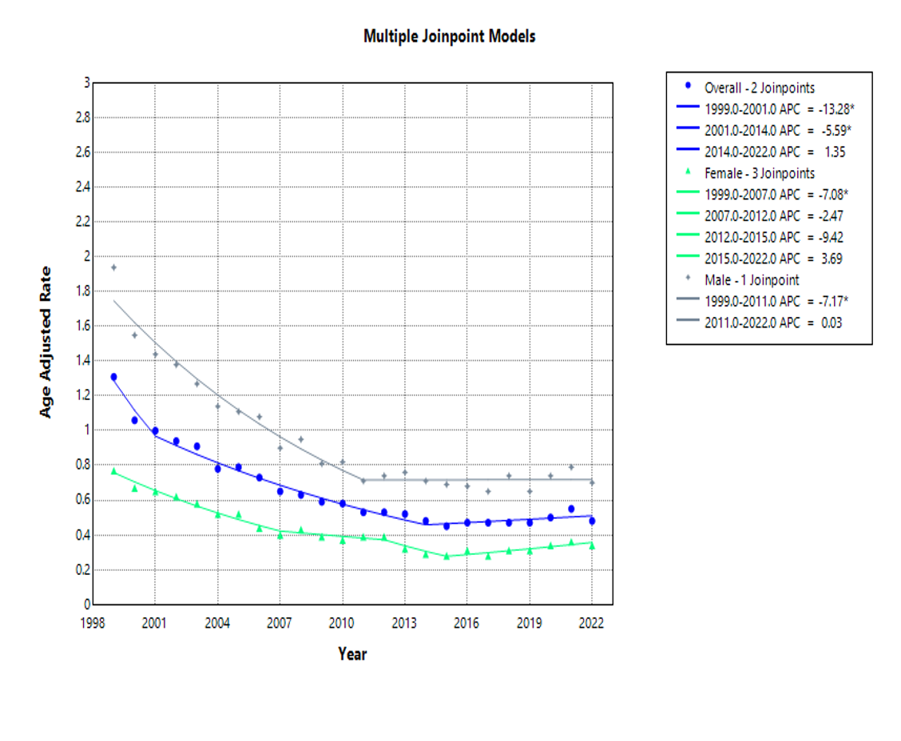Supplemental Table 2. TB-related Mortality Trends Stratified by Race, 1999 to 2022.
 | Age-Adjusted Mortality Rate (per 100,000)
Year | Asian or Pacific Islander | Black or African American | White | Hispanic or Latino
1999 | 5.35 | 3.62 | 0.78 | 2.71
2000 | 4.43 | 3.09 | 0.64 | 1.86
2001 | 3.73 | 2.66 | 0.66 | 1.9
2002 | 3.51 | 2.58 | 0.6 | 1.67
2003 | 3.37 | 2.19 | 0.54 | 1.5
2004 | 2.54 | 2.1 | 0.49 | 1.61
2005 | 3.53 | 1.88 | 0.46 | 1.5
2006 | 3.2 | 1.79 | 0.44 | 1.5
2007 | 2.45 | 1.48 | 0.36 | 1.19
2008 | 3.05 | 1.52 | 0.37 | 1.21
2009 | 2.55 | 1.22 | 0.32 | 1
2010 | 2.44 | 1.1 | 0.32 | 1.08
2011 | 2.51 | 1.13 | 0.31 | 1.02
2012 | 2.02 | 0.88 | 0.31 | 0.98
2013 | 2.09 | 0.91 | 0.3 | 0.79
2014 | 1.97 | 0.9 | 0.27 | 0.72
2015 | 2.07 | 0.68 | 0.25 | 0.71
2016 | 1.89 | 0.94 | 0.25 | 0.81
2017 | 2.01 | 0.67 | 0.27 | 0.85
2018 | 1.82 | 0.83 | 0.29 | 0.83
2019 | 2.12 | 0.7 | 0.3 | 0.61
2020 | 1.96 | 0.83 | 0.3 | 0.89
2021 | 2.27 | 0.87 | 0.37 | 0.77
2022 | 2.06 | 0.89 | 0.28 | 0.65
Number of Joinpoints (Years of Joinpoint) | 1 (2014) | 1 (2015) | 2 (2007, 2015) | 1 (2014
APC Segment-1 (95% CI) | -5.47* (-8.32 to –4.15) | -9.11* (-10.50 to –8.21) | -8.01* (-13.32 to –6.21) | -6.79* (-11.87 to –5.40)
APC Segment-2 (95% CI) | 1.09 (-1.78 to 10.34) | 2.41 (-1.74 to 14.82) | -4.89 (-6.82 to 5.70) | -0.65 (-4.16 to 12.73)
APC Segment-3 (95% CI) |  |  | 2.48 (-1.05 to 11.54)
Average APC (AAPC) (95% CI) | -3.24* (-4.08 to –2.38) | -5.75* (-6.62 to –5.04) | -3.83* (-4.40 to –3.32) | -4.70* (-5.78 to –3.79)

Supplemental Figure 2. Multiple Joinpoint Model TB-related Deaths by Race. Race-stratified data regarding mortality rates related to TB between 1999 and 2022.
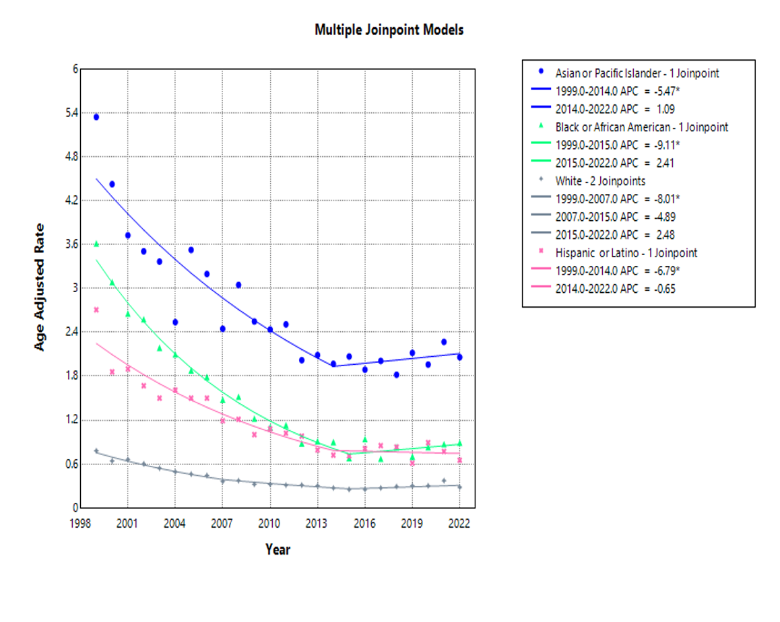Supplemental Table 3. TB-related Mortality Trends Stratified by Age, 1999 to 2022.
 | Age-Adjusted Mortality Rate (per 100,000)
Year | 35-44 years | 45-54 years | 55-64 years | 65-74 years | 75-84 years | 85+ years
1999 | 0.29 | 0.55 | 1.06 | 2 | 4.07 | 8.11
2000 | 0.21 | 0.49 | 0.78 | 1.61 | 3.85 | 5.76
2001 | 0.2 | 0.4 | 0.86 | 1.63 | 3.45 | 5.66
2002 | 0.21 | 0.39 | 0.74 | 1.59 | 3.21 | 5.38
2003 | 0.16 | 0.45 | 0.71 | 1.26 | 3.23 | 4.7
2004 | 0.2 | 0.35 | 0.58 | 1.33 | 2.46 | 4.86
2005 | 0.17 | 0.38 | 0.59 | 1.21 | 2.55 | 4.67
2006 | 0.12 | 0.39 | 0.57 | 1.12 | 2.54 | 4.27
2007 | 0.15 | 0.31 | 0.46 | 0.94 | 2.25 | 3.33
2008 | 0.13 | 0.32 | 0.5 | 1.03 | 2.12 | 4.14
2009 | 0.09 | 0.26 | 0.47 | 0.83 | 2.18 | 3.24
2010 | 0.1 | 0.25 | 0.54 | 0.9 | 1.77 | 3.51
2011 | 0.1 | 0.24 | 0.53 | 0.81 | 1.93 | 3.12
2012 | 0.07 | 0.27 | 0.48 | 0.74 | 1.74 | 3.09
2013 | 0.11 | 0.21 | 0.47 | 0.82 | 1.61 | 3.39
2014 | 0.08 | 0.2 | 0.47 | 0.67 | 1.55 | 2.99
2015 | 0.09 | 0.24 | 0.39 | 0.69 | 1.38 | 2.83
2016 | 0.11 | 0.22 | 0.5 | 0.71 | 1.42 | 2.79
2017 | 0.07 | 0.18 | 0.44 | 0.78 | 1.5 | 2.77
2018 | 0.11 | 0.21 | 0.44 | 0.72 | 1.61 | 2.78
2019 | 0.09 | 0.16 | 0.43 | 0.79 | 1.45 | 2.73
2020 | 0.12 | 0.25 | 0.54 | 0.88 | 1.51 | 2.78
2021 | 0.14 | 0.28 | 0.54 | 0.96 | 1.59 | 2.79
2022 | 0.12 | 0.22 | 0.57 | 0.84 | 1.39 | 2.34
Number of Joinpoints (Years of Joinpoint) | 1 (2012) | 1 (2017) | 2 (2007, 2019) | 1 (2014) | 1 (2014) | 2 (2001, 2011)
APC Segment-1 (95% CI) | -8.84* (-13.87 to -6.33) | -5.30* (-11.01 to -3.67) | -7.94* (-13.12 to -5.49) | -6.58* (-7.63 to -5.81) | -6.35* (-7.53 to -5.63) | -15.97* (-20.83 to -6.48)
APC Segment-2 (95% CI) | 4.00 (-0.95 to 18.73) | 5.86 (-4.01 to 29.23) | -0.93 (-6.32 to 0.66) | 4.18* (2.07 to 7.55) | 0.17 (-2.18 to 5.06) | -5.23 (-7.51 to 0.49
APC Segment-3 (95% CI) | -- | -- | 9.59* (0.78 to 21.35) | -- | -- | -2.04 (-8.97 to 5.12)
Average APC (AAPC) (95% CI) | -3.46* (-5.11 to -1.98) | - 2.98* (-4.81 to -1.86) | -2.14* (-3.02 to -1.46) |  | -4.13* (-4.73 to -3.63) | -4.72* (-5.29 to -3.95)

Supplemental Figure 3. Multiple Joinpoint Model TB-related Deaths by Age. Age-stratified data regarding mortality rates related to TB between 1999 and 2022.

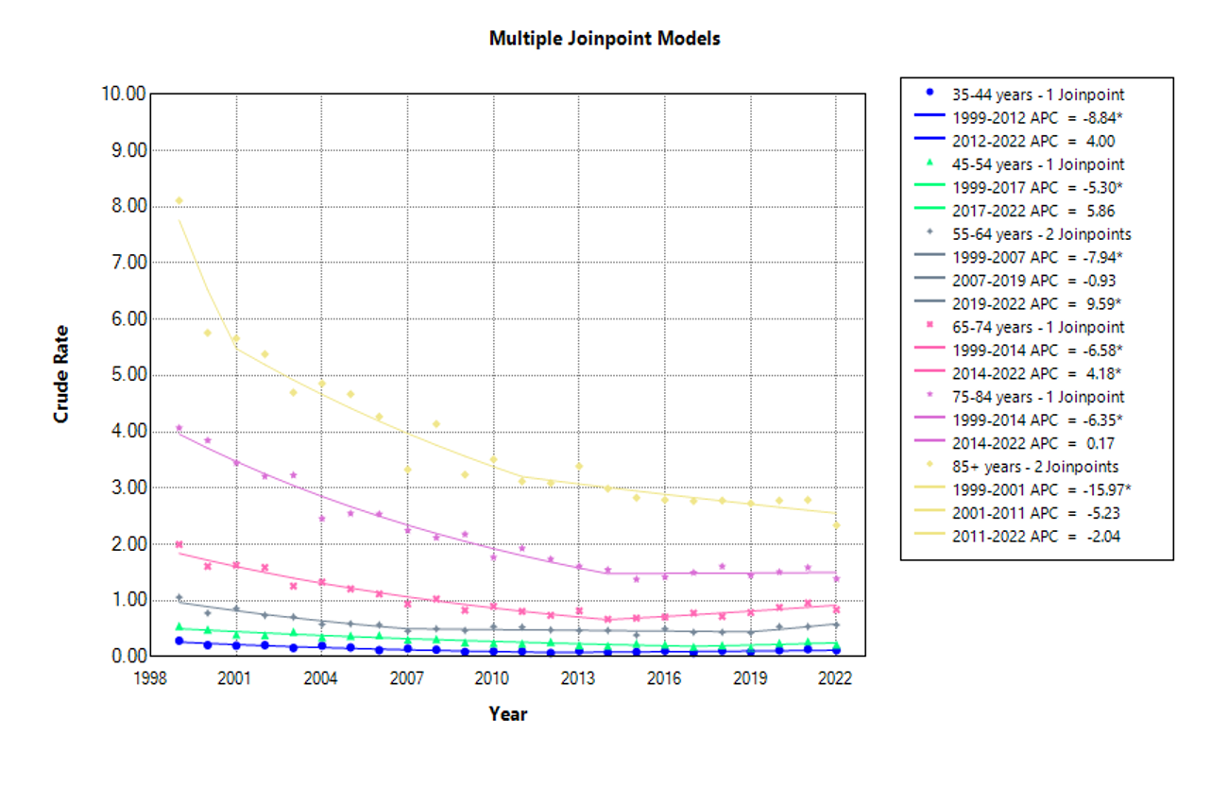
Supplemental Table 4. TB-related Mortality Trends Stratified by Region, 1999 to 2022.
 | Age-Adjusted Mortality Rate (per 100,000)
Year | Northeast | Midwest | South | West
1999 | 1.06 | 0.96 | 1.47 | 1.56
2000 | 0.9 | 0.86 | 1.24 | 1.16
2001 | 0.79 | 0.7 | 1.22 | 1.17
2002 | 0.75 | 0.67 | 1.12 | 1.18
2003 | 0.73 | 0.69 | 0.96 | 1.1
2004 | 0.57 | 0.53 | 0.95 | 1.01
2005 | 0.53 | 0.56 | 0.87 | 1.1
2006 | 0.51 | 0.49 | 0.78 | 1.12
2007 | 0.42 | 0.48 | 0.7 | 0.88
2008 | 0.53 | 0.44 | 0.69 | 0.94
2009 | 0.51 | 0.4 | 0.6 | 0.72
2010 | 0.46 | 0.39 | 0.6 | 0.8
2011 | 0.45 | 0.4 | 0.56 | 0.81
2012 | 0.37 | 0.34 | 0.55 | 0.7
2013 | 0.37 | 0.33 | 0.5 | 0.81
2014 | 0.36 | 0.42 | 0.47 | 0.66
2015 | 0.4 | 0.29 | 0.46 | 0.65
2016 | 0.4 | 0.3 | 0.47 | 0.68
2017 | 0.41 | 0.36 | 0.43 | 0.62
2018 | 0.37 | 0.43 | 0.53 | 0.65
2019 | 0.45 | 0.3 | 0.49 | 0.58
2020 | 0.47 | 0.35 | 0.54 | 0.68
2021 | 0.39 | 0.48 | 0.57 | 0.73
2022 | 0.46 | 0.37 | 0.46 | 0.65
Number of Joinpoints (Years of Joinpoint) | 2 (2005, 2014) | 1 (2012) | 3 (2009, 2017, 2020) | 1 (2015)
APC Segment-1 (95% CI) | -10.19* (-17.24 to -6.92) | -7.31* (-10.73 to -5.62) | -8.10* (-11.14 to -6.72) | -4.60* (-7.65 to -3.71)
APC Segment-2 (95% CI) | -4.00 (-7.79 to 0.58) | 2.17 (-0.86 to 11.09) | -4.09* (-9.00 to -0.43) | -3.04* (-3.91 to -2.30)
APC Segment-3 (95% CI) | 2.24 (-0.67 to 11.68) | -- | 9.14 (-4.49 to 13.28) | --
APC Segment-4 (95% CI) | -- | -- | -8.62 (-15.09 to 2.39) | --
Average APC (AAPC) (95% CI) | -3.56* (-4.23 to -2.93) | -3.30* (-4.35 to -2.353) | -4.66* (-5.23 to -4.19) | -3.04* (-3.91 to -2.29)

Supplemental Figure 4. Multiple Joinpoint Model TB-related Deaths by Region. Region-stratified data regarding mortality rates related to TB between 1999 and 2022.
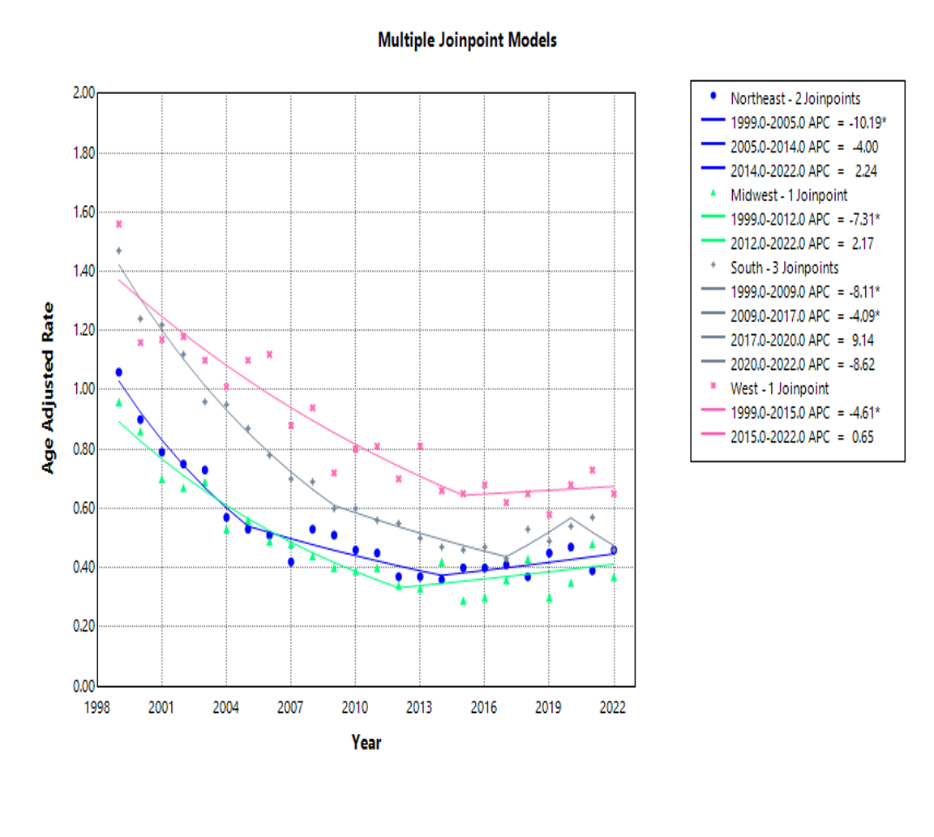
Supplemental Table 5. TB-related Mortality Trends Stratified by Urban or Rural location, 1999 to 2020.
 | Age-Adjusted Mortality Rate (per 100,000)
Year | Urban | Rural
1999 | 1.31 | 1.09
2000 | 1.05 | 0.94
2001 | 1.02 | 0.92
2002 | 0.93 | 1
2003 | 0.93 | 0.72
2004 | 0.82 | 0.65
2005 | 0.82 | 0.6
2006 | 0.75 | 0.6
2007 | 0.62 | 0.61
2008 | 0.66 | 0.55
2009 | 0.62 | 0.43
2010 | 0.56 | 0.53
2011 | 0.56 | 0.48
2012 | 0.54 | 0.46
2013 | 0.53 | 0.43
2014 | 0.49 | 0.45
2015 | 0.45 | 0.38
2016 | 0.48 | 0.43
2017 | 0.48 | 0.4
2018 | 0.48 | 0.48
2019 | 0.47 | 0.35
2020 | 0.51 | 0.47
Number of Joinpoints (Years of Joinpoint) | 2 (2001, 2015) | 1 (2009)
APC Segment-1 (95% CI) | -12.65* (-15.74 to -6.20) | -7.79* (-15.78 to -5.74)
APC Segment-2 (95% CI) | -5.39* (-6.33 to -3.44) | -1.51 (-3.92 to 8.45)
APC Segment-3 (95% CI) | 2.16 (-1.44 to 12.11) | --
Average APC (AAPC) (95% CI) | -4.37* (-4.92 to -3.78) | -4.55* (-5.65 to -3.53)

Supplemental Figure 5. Multiple Joinpoint Model TB-related Deaths by Urban vs Rural area. Urban vs. rural-stratified data regarding mortality rates related to TB between 1999 and 2020.

