Supplementary table 1
Availability of environmental control and environmental control results by participant characteristics
 | Environment sampling performed |  |  | Environment result when available
 | Yes  N = 137ª | No  N = 41ª | p-value^{b} | Mtb detected  N = 41ª | Mtb not detected  N = 96ª | p-value²
Age (yrs) | 37 (30, 47) | 36 (29, 42) | 0.6 | 40 (31, 46) | 36 (29, 48) | 0.2
Sex |  |  | >0.9 |  |  | 0.9
Female | 59 (43%) | 18 (44%) |  | 18 (44%) | 41 (43%)
Male | 78 (57%) | 23 (56%) |  | 23 (56%) | 55 (57%)
Body Mass Index | 21.3 (19.5, 25.9) | 21.8 (18.3, 24.0) | 0.7 | 22.0 (19.8, 28.2) | 21.0 (18.9, 24.8) | 0.11
Body Mass Index (kg/m²) |  |  | 0.2 |  |  | 0.12
≤18.5 | 24 (18%) | 11 (27%) |  | 4 (9.8%) | 20 (21%)
>18.5 | 113 (82%) | 30 (73%) |  | 37 (90%) | 76 (79%)
HIV status^{c} |  |  | 0.6 |  |  | 0.9
Negative | 78 (57%) | 25 (61%) |  | 23 (56%) | 55 (57%)
Positive | 59 (43%) | 16 (39%) |  | 18 (44%) | 41 (43%)
History of TB^{d} |  |  | 0.2 |  |  | 0.5
No | 94 (69%) | 24 (59%) |  | 30 (73%) | 64 (67%)
Yes | 43 (31%) | 17 (41%) |  | 11 (27%) | 32 (33%)
Smoking history |  |  | 0.4 |  |  | 0.2
Never | 61 (45%) | 23 (56%) |  | 23 (56%) | 38 (40%)
Ex-smoker | 21 (15%) | 4 (9.8%) |  | 5 (12%) | 16 (17%)
Current smoker | 55 (40%) | 14 (34%) |  | 13 (32%) | 42 (44%)
Total cough count | 82 (58, 105) | 53 (47, 83) | 0.003 | 77 (58, 104) | 82 (59, 106) | 0.9
Sputum Xpert Ultra C_{Tmin}^{e} | 19 (17, 24) | 18 (18, 20) | 0.6 | 20 (17, 26) | 18 (17, 24) | 0.5
Unavailable^{f} | 62 | 1 |  | 25 | 37
Sputum Xpert Ultra result |  |  | <0.001 |  |  | 0.3
Mtb detected | 86 (63%) | 40 (98%) |  | 23 (56%) | 63 (66%)
Mtb not detected | 51 (37%) | 1 (2.4%) |  | 18 (44%) | 33 (34%)
Sputum Xpert Ultra semi-quantitative result |  |  | <0.001 |  |  | 0.2
High | 36 (26%) | 21 (51%) |  | 6 (15%) | 30 (31%)
Medium | 11 (8.1%) | 13 (32%) |  | 4 (10%) | 7 (7.3%)
Low | 20 (15%) | 2 (4.9%) |  | 4 (10%) | 16 (17%)
Very Low | 10 (7.4%) | 4 (9.8%) |  | 4 (10%) | 6 (6.3%)
Trace | 8 (5.9%) | 0 (0%) |  | 4 (10%) | 4 (4.2%)
Negative | 51 (38%) | 1 (2.4%) |  | 18 (45%) | 33 (34%)
Missing | 1 | 0 |  | 1 | 0
Karnofsky score |  |  | 0.002 |  |  | 0.3
50 | 1 (0.7%) | 0 (0%) |  | 0 (0%) | 1 (1.0%)
60 | 5 (3.6%) | 1 (2.4%) |  | 3 (7.3%) | 2 (2.1%)
70 | 6 (4.4%) | 4 (9.8%) |  | 1 (2.4%) | 5 (5.2%)
80 | 32 (23%) | 22 (54%) |  | 6 (15%) | 26 (27%)
90 | 72 (53%) | 12 (29%) |  | 23 (56%) | 49 (51%)
100 | 21 (15%) | 2 (4.9%) |  | 8 (20%) | 13 (14%)
ªMedian (Q1, Q3); n (%)
^{b}Wilcoxon rank sum test; Pearson's Chi-squared test; Fisher's exact test
^{c}HIV = Human immunodeficiency virus
^{d}TB = tuberculosis
^{e}C_{Tmin} = Minimum cycle threshold
^{f}Unavailable C_{Tmin}= All missing C_{Tmin} values were from trace or negative sputum Ultra results

Supplementary table 2
Sputum Xpert Ultra semi-quantitative result by participant characteristics
 | Sputum Xpert Ultra semi-quantitation
 | High  N = 51ª | Medium  N = 20ª | Low  N = 18ª | Very Low  N = 10ª | Trace  N = 4ª | Negative  N = 34ª
Age (yrs) | 38 (27, 46) | 38 (32, 51) | 35 (23, 39) | 34 (29, 49) | 43 (32, 50) | 34 (30, 44)
Sex
Female | 18 (35%) | 8 (40%) | 6 (33%) | 2 (20%) | 3 (75%) | 22 (65%)
Male | 33 (65%) | 12 (60%) | 12 (67%) | 8 (80%) | 1 (25%) | 12 (35%)
Body Mass Index (kg/m²) | 21.0 (18.2, 23.9) | 20.6 (18.2, 23.3) | 21.8 (19.7, 25.1) | 20.3 (18.4, 21.4) | 19.4 (16.7, 22.8) | 24.5 (20.5, 29.8)
≤18.5 | 13 (25%) | 8 (40%) | 0 (0%) | 3 (30%) | 2 (50%) | 5 (15%)
>18.5 | 38 (75%) | 12 (60%) | 18 (100%) | 7 (70%) | 2 (50%) | 29 (85%)
HIV status^{b}
Negative | 33 (65%) | 12 (60%) | 9 (50%) | 7 (70%) | 2 (50%) | 17 (50%)
Positive | 18 (35%) | 8 (40%) | 9 (50%) | 3 (30%) | 2 (50%) | 17 (50%)
History of TB^{c}
No | 33 (65%) | 10 (50%) | 17 (94%) | 4 (40%) | 3 (75%) | 21 (62%)
Yes | 18 (35%) | 10 (50%) | 1 (5.6%) | 6 (60%) | 1 (25%) | 13 (38%)
Smoking history
Never | 21 (41%) | 8 (40%) | 12 (67%) | 2 (20%) | 2 (50%) | 16 (47%)
Ex-smoker | 11 (22%) | 1 (5.0%) | 2 (11%) | 1 (10%) | 0 (0%) | 5 (15%)
Current smoker | 19 (37%) | 11 (55%) | 4 (22%) | 7 (70%) | 2 (50%) | 13 (38%)
Total cough count | 66 (51, 102) | 67 (50, 101) | 73 (49, 107) | 87 (50, 97) | 85 (46, 108) | 75 (52, 106)
Sputum Xpert Ultra C_{Tmin}^{d} | 18 (17, 18) | 19 (19, 20) | 24 (21, 25) | 29 (29, 30) | - | -
Unavailable^{e} | 0 | 0 | 0 | 0 | 4 | 34
Sputum Xpert Ultra result
Mtb detected | 51 (100%) | 20 (100%) | 18 (100%) | 10 (100%) | 4 (100%) | 0 (0%)
Mtb not detected | 0 (0%) | 0 (0%) | 0 (0%) | 0 (0%) | 0 (0%) | 34 (100%)
Karnofsky score
50 | 1 (2.0%) | 0 (0%) | 0 (0%) | 0 (0%) | 0 (0%) | 0 (0%)
60 | 2 (3.9%) | 0 (0%) | 1 (5.6%) | 0 (0%) | 0 (0%) | 0 (0%)
70 | 5 (9.8%) | 2 (10%) | 1 (5.6%) | 0 (0%) | 0 (0%) | 1 (2.9%)
80 | 22 (43%) | 10 (50%) | 3 (17%) | 5 (50%) | 1 (25%) | 7 (21%)
90 | 21 (41%) | 7 (35%) | 11 (61%) | 4 (40%) | 2 (50%) | 16 (47%)
100 | 0 (0%) | 1 (5.0%) | 2 (11%) | 1 (10%) | 1 (25%) | 10 (29%)
Reported cough
No | 2 (3.9%) | 0 (0%) | 1 (5.6%) | 0 (0%) | 0 (0%) | 3 (8.8%)
Yes | 49 (96%) | 20 (100%) | 17 (94%) | 10 (100%) | 4 (100%) | 31 (91%)
Reported fever
No | 35 (69%) | 12 (60%) | 14 (78%) | 6 (60%) | 2 (50%) | 25 (74%)
Yes | 16 (31%) | 8 (40%) | 4 (22%) | 4 (40%) | 2 (50%) | 9 (26%)
Reported weight-loss
No | 5 (9.8%) | 3 (15%) | 3 (17%) | 1 (10%) | 2 (50%) | 17 (50%)
Yes | 46 (90%) | 17 (85%) | 15 (83%) | 9 (90%) | 2 (50%) | 17 (50%)
Reported night-sweats
No | 12 (24%) | 6 (30%) | 7 (39%) | 3 (30%) | 1 (25%) | 16 (47%)
Yes | 39 (76%) | 14 (70%) | 11 (61%) | 7 (70%) | 3 (75%) | 18 (53%)
ªMedian (Q1, Q3); n (%)
^{b}HIV = Human immunodeficiency virus
^{c}TB = tuberculosis
^{d}C_{Tmin} = Minimum cycle threshold
^{e}Unavailable = rpoB Ct values are not reported by Xpert Ultra for trace or negative results

Supplementary table 3
Aerosolized Mtb DNA detection diagnostic performance by sputum Mtb DNA burden
 | Aerosol Mtb DNA detected |  | Sensitivity^{b} |  | Specificity^{b}
 | Yes  N = 56ª | No  N = 81ª
Sputum Xpert Ultra result
Mtb detected | 48 | 55 | 46.6 (42.5, 50.7)
Mtb not detected | 8 | 26 |  |  | 76.5 (70.4, 82.5)
Sputum Xpert Ultra semi-quantitative result
High | 29 | 22 | 56.9 (51.1, 62.7)
Medium | 12 | 8 | 60.0 (50.9, 69.1)
Low | 4 | 14 | 22.2 (14.0, 30.4)
Very Low | 3 | 7 | 30.0 (17.9, 42.1)
Trace | 0 | 4 | 0 (0, 0)
Negative | 8 | 26 |  |  | 76.5 (70.4, 82.5)
ªn (%)
^{b} % (95% Confidence Interval)

Supplementary table 4
Aerosol Mtb Ultra semi-quantitative result in positive aerosol specimens
 | N = 56ª
Aerosol Xpert Ultra semi-quantitative result
High | 0 (0%)
Medium | 0 (0%)
Low | 3 (5.4%)
Very Low | 14 (25%)
Trace | 39 (70%)
ªn (%)

Supplementary table 5
Crude associations between participant characteristic and aerosolized Mtb DNA detection by sensitivity analysis cohort
 | Cohort 1  (n = 137) |  |  | Cohort 2  (n = 96) |  |  | Cohort 3  (n = 109) |  |  | Cohort 4  (n = 150)
 | RRª | 95% CIª | p-value | RRª | 95% CIª | p-value | RRª | 95% CIª | p-value | RRª | 95% CIª | p-value
Age (yrs) | 1.01 | 0.99, 1.03 | 0.3 | 1.01 | 0.99, 1.04 | 0.4 | 1.01 | 0.99, 1.03 | 0.4 | 1.01 | 0.99, 1.02 | 0.3
Sex
Female | — | — |  | — | — |  | — | — |  | — | —
Male | 1.74 | 1.09, 2.75 | 0.019 | 2.34 | 1.10, 4.99 | 0.027 | 1.57 | 0.93, 2.66 | 0.089 | 1.47 | 1.01, 2.15 | 0.045
Body Mass Index | 1.02 | 0.98, 1.06 | 0.3 | 1.02 | 0.96, 1.08 | 0.5 | 1.02 | 0.97, 1.06 | 0.5 | 1.01 | 0.98, 1.05 | 0.3
Body Mass Index (kg/m²)
≤18.5 | — | — |  | — | — |  | — | — |  | — | —
>18.5 | 0.97 | 0.60, 1.56 | 0.9 | 1.26 | 0.55, 2.92 | 0.6 | 1.43 | 0.69, 2.97 | 0.3 | 1.07 | 0.69, 1.66 | 0.8
HIV status^{b}
Negative | — | — |  | — | — |  | — | — |  | — | —
Positive | 0.78 | 0.51, 1.20 | 0.3 | 0.43 | 0.20, 0.91 | 0.027 | 0.46 | 0.25, 0.84 | 0.012 | 0.75 | 0.51, 1.10 | 0.14
History of TB^{c}
No | — | — |  | — | — |  | — | — |  | — | —
Yes | 0.92 | 0.60, 1.42 | 0.7 | 1.05 | 0.55, 2.00 | 0.9 | 0.88 | 0.52, 1.51 | 0.6 | 0.85 | 0.58, 1.25 | 0.4
Smoking history
Never | — | — |  | — | — |  | — | — |  | — | —
Ex-smoker | 1.14 | 0.64, 2.05 | 0.7 | 1.58 | 0.67, 3.76 | 0.3 | 1.11 | 0.56, 2.23 | 0.8 | 1.03 | 0.61, 1.73 | >0.9
Current smoker | 1.04 | 0.67, 1.63 | 0.9 | 1.41 | 0.68, 2.90 | 0.4 | 1.06 | 0.62, 1.80 | 0.8 | 0.97 | 0.66, 1.42 | 0.9
Total cough count | 0.99 | 0.99, 1.00 | 0.038 | 1.0 | 0.99, 1.00 | 0.3 | 1.00 | 1.0, 1.01 | 0.7 | 1.00 | 0.99, 1.00 | 0.4
Sputum Xpert Ultra C_{Tmin}^{d} | 0.95 | 0.93, 0.98 | 0.003 | 0.96 | 0.92, 1.00 | 0.031 | 0.98 | 0.95, 1.01 | 0.13 | 0.97 | 0.95, 1.00 | 0.019
Sputum Xpert Ultra result
Mtb detected | — | — |  | — | — |  | — | — |  | — | —
Mtb not detected | 0.50 | 0.26, 0.96 | 0.038 | 0.61 | 0.29, 1.28 | 0.2 | 0.75 | 0.43, 1.29 | 0.3 | 0.66 | 0.41, 1.07 | 0.093
Sputum Xpert Ultra category
≥ medium | — | — |  | — | — |  | — | — |  | — | —
≤ low | 0.38 | 0.19, 0.76 | 0.006 | 0.32 | 0.12, 0.84 | 0.021 | 0.50 | 0.25, 0.97 | 0.040 | 0.51 | 0.30, 0.87 | 0.013
negative | 0.41 | 0.21, 0.78 | 0.006 | 0.44 | 0.21, 0.92 | 0.030 | 0.59 | 0.34, 1.03 | 0.061 | 0.56 | 0.34, 0.90 | 0.018
Karnofsky score
>80 | — | — |  | — | — |  | — | — |  | — | —
≤80 | 1.44 | 0.96, 2.16 | 0.080 | 1.70 | 0.93, 3.11 | 0.084 | 1.48 | 0.93, 2.37 | 0.10 | 1.31 | 0.93, 1.85 | 0.13
Reported cough
No | — | — |  | — | — |  | — | — |  | — | —
Yes | 2.52 | 0.41, 15.5 | 0.3 | 1.54 | 0.25, 9.30 | 0.6 | 1.97 | 0.33, 11.8 | 0.5 | 2.83 | 0.46, 17.3 | 0.3
Reported fever
No | — | — |  | — | — |  | — | — |  | — | —
Yes | 0.60 | 0.35, 1.01 | 0.056 | 0.20 | 0.05, 0.79 | 0.022 | 0.37 | 0.16, 0.86 | 0.021 | 0.63 | 0.40, 0.99 | 0.046
Reported weight-loss
No | — | — |  | — | — |  | — | — |  | — | —
Yes | 1.35 | 0.77, 2.35 | 0.3 | 1.23 | 0.59, 2.56 | 0.6 | 1.12 | 0.64, 1.95 | 0.7 | 1.20 | 0.76, 1.88 | 0.4
Reported night-sweats
No | — | — |  | — | — |  | — | — |  | — | —
Yes | 1.12 | 0.72, 1.76 | 0.6 | 0.98 | 0.52, 1.85 | >0.9 | 0.87 | 0.54, 1.40 | 0.6 | 1.0 | 0.69, 1.43 | >0.9
ªRR = Risk Ratio, CI = Confidence Interval calculated with robust Standard Errors
^{b}HIV = Human immunodeficiency virus
^{c}TB = tuberculosis
^{d}C_{Tmin} = Minimum cycle threshold

Supplementary figure 1
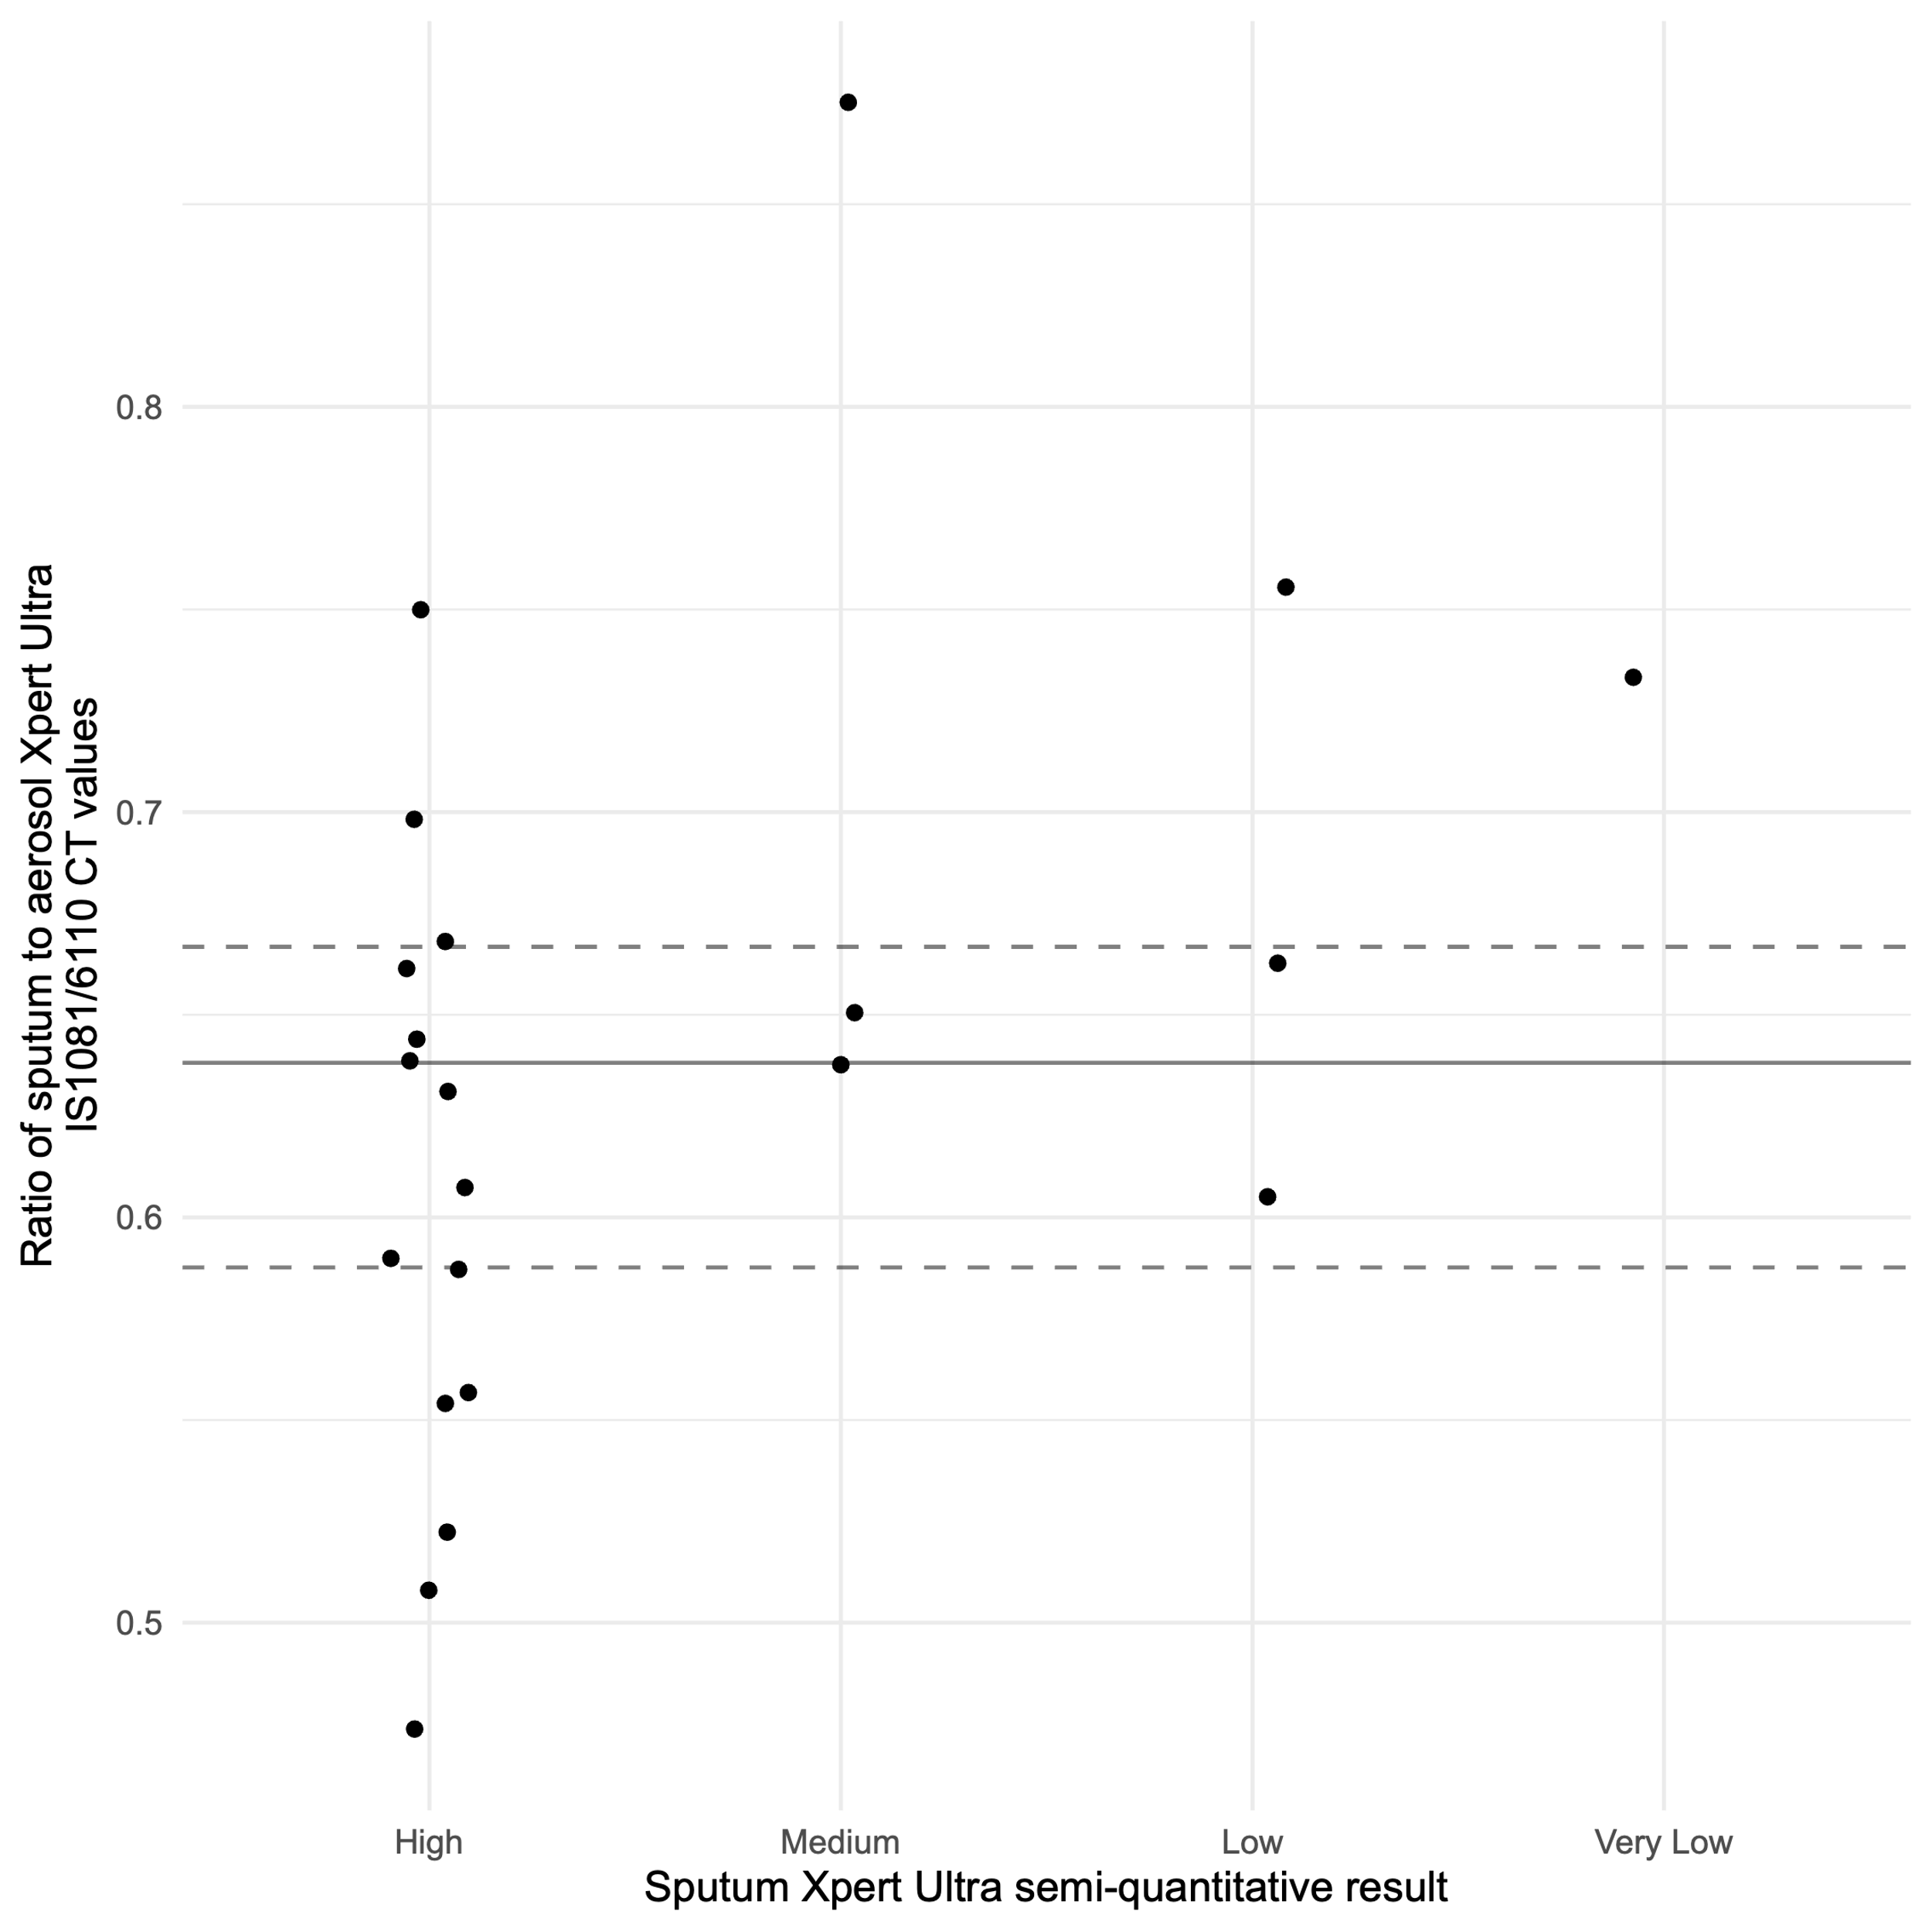
Supplementary figure 1. Comparing the ratio of sputum to aerosol Xpert Ultra IS1081/6110 C_{T} values by sputum Xpert Ultra semi-quantitative result. Ratios from participants in Cohort 2 with positive sputum and positive AMD Ultra (22/96) are shown. The median ratio (black solid line, 0.64) and the inter-quartile range (dotted line, 0.59, 0.67) are shown. The distribution of participants with ratios in the highest quartile appears evenly spread across sputum Ultra semi-quantitative grades. The top 5 ratios range between 0.87 and 0.70.

Supplementary figure 2
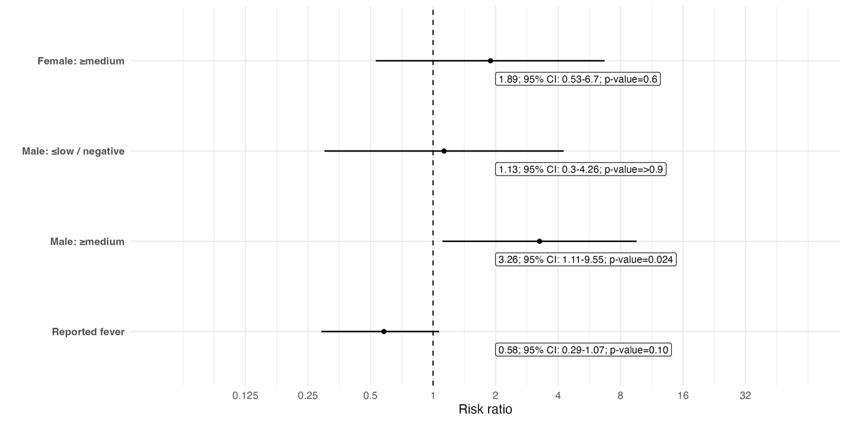
Supplementary figure 2: Forest plot showing adjusted modified Poisson regression model parameter estimates with corresponding 95% confidence intervals of participant characteristics and aerosolized M. tuberculosis DNA detection. The interaction between sex and sputum Ultra semi-quantitative result has been combined to display parameter estimates for each resulting group with the base group being women with ≤ low / negative sputum Ultra semi-quantitative result.

Supplementary figure 3
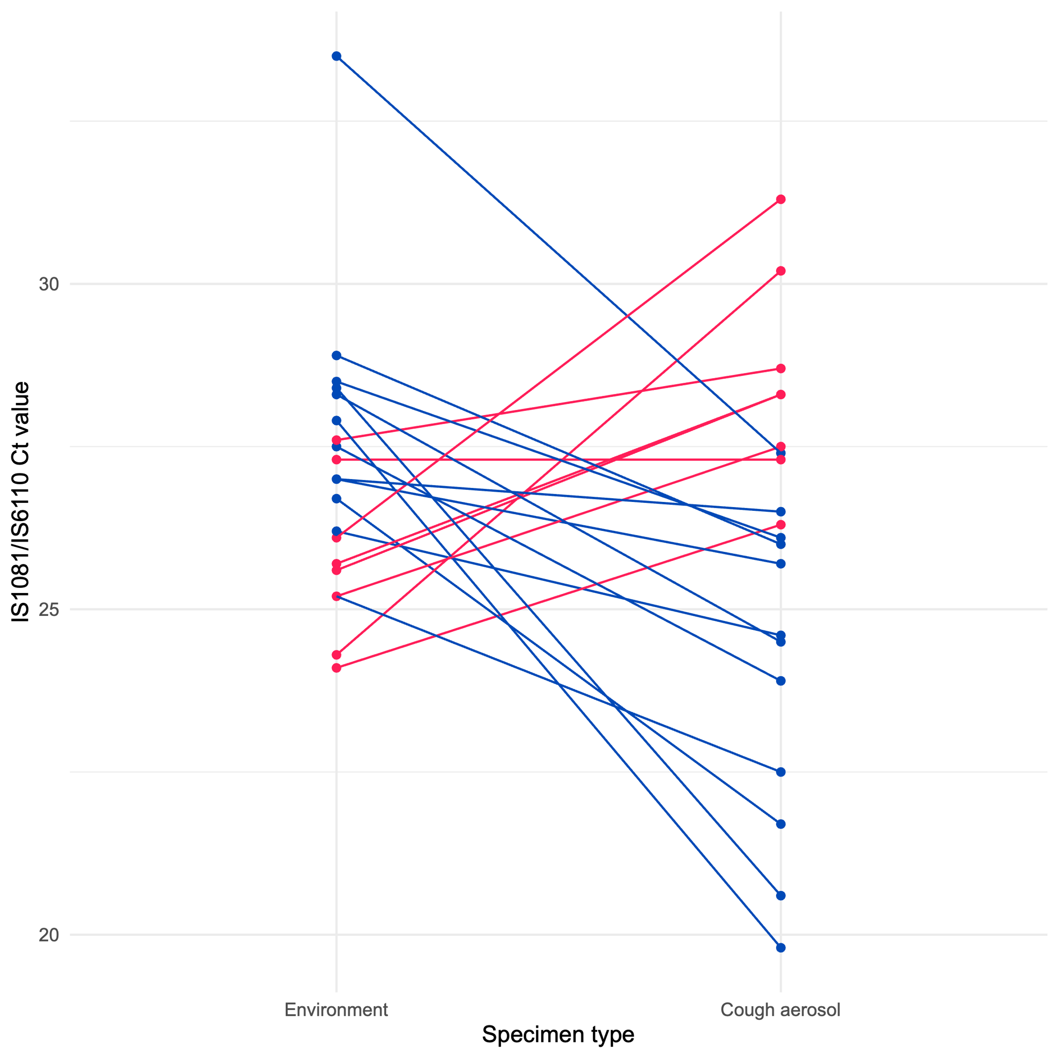
Supplementary figure 3: Grouped line plot of 21 participants with a positive environmental aerosolized M. tuberculosis DNA (AMD) result and a positive cough AMD result illustrating the difference in IS1081/IS6119 C_{T} value between the two samples. Pairs in which the cough aerosol C_{T} value is lower (13/21; 62%) (blue) than the corresponding environmental C_{T} value represent sessions where greater AMD is detected after the participant provided their cough sample suggesting cough AMD positivity.

