A GUIDELINE FOR INFECTION PREVENTION AND CONTROL IN CHILDCARE CENTERS IN NIGERIA

CHAPTER ONE
1.0 INTRODUCTION
The need to commence early childhood education and childcare centers as a result industrial revolution and modernization has resulted in the establishment of more childcare centers. Care rendered to children in childcare centers is meant to be optimal. The caregivers/teachers are expected to be well-trained before employment and periodically, not just for academic purposes, but also on infection prevention measures. This is very important since the children cared for are under the age of five years, and they are highly susceptible to any microorganism within the childcare center.
Children less than five years of age who are attending childcare centers have increased reported cases of several infections, such as acute infectious diarrhoea and upper and lower respiratory tract infections, including acute otitis media and pneumonia, as compared with age-matched children cared for at home
The safety of the childcare center is very important to be able to render an optimal service. Since infection is a common occurrence among the children, the ability to be able to manage the infection so as to prevent the transmission of the infection to other children within the center is essential.
This guideline is developed as an intervention for childcare centers as well as preschools to serve as a tool to guide caregivers in understanding the infection prevention measures, how to recognize infection, and how to manage an outbreak. The caregivers must ensure that the prevalence of infection in the childcare centers is reduced to the lowest minimum.
This is a guideline developed to guide caregivers/teachers in their day-to-day activities to ensure minimal or no infection symptoms are exhibited by both the children and the caregivers/teachers within the childcare center.
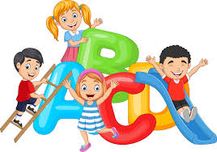
CHAPTER ONE: THE MINIMAL REQUIREMENT OF A CHILDCARE CENTER
The structure of the childcare center is expected to be designed in a special way with the following features so as to be safe for both the children and the teachers.
The layout, design, construction, and size of the premises must permit adequate maintenance, cleaning, and working spaces.
2.1 SURROUNDINGS
- Clean
- Not bushy.
- Devoid of human, animal, organic waste, and any other litter.
- Devoid of hazardous objects.
- Dry, not waterlogged.
- All wells are properly covered, locked, and secured.
- Beautiful and stimulating with flowers and plants.
- Safe Water
2.2 FENCING
- The facility should be fenced in a manner that prevents outside interference, such as rampaging animals, and prevents children from straying outside.
- Fence should be done with either concrete, mud, bamboo, raffia, corn stalk, wood, flowers, hedge, or plants.
2.3 PLAYGROUND
- Enough space for children to play (enough to take 20-25 children and two adults at a given time.
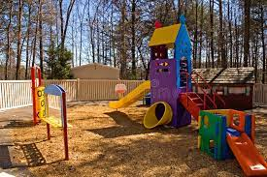
- Safe and secure.
- May have grass or sand, but not bushy or dirty.
- Not waterlogged.
- Free from dangerous objects.
2.4 CLASSROOM
- There should be solid structures that will not collapse.
- Generally, the building should not pose a danger to children.
Size
- Enough Space. The classroom (16 square meters) is for 20-25 children.
- To be well ventilated with at least two doors.
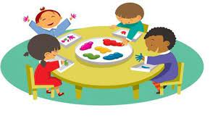
- Design should allow for free movement.
- Sitting arrangements should not be rigid like in
formal school setting but flexible and allow for play
and interaction with other children.
Flooring of the classroom: Smooth but not slippery (has to be plastered with cement or with local material, excluding cow dung and such harmful materials).
Roof: Corrugated iron sheet. Thatch, raffia, etc. (not leaking).
Ceiling: Modern ceiling boards, raffia, bamboo, wood, mats, thick cartons, etc. (not asbestos ceiling boards).
Walls: Cement blocks, bricks, mud, raffia, bamboo, etc.
Illumination: Well illuminated (children are able to see clearly in every part of the room).
Door: Wooden or iron that can be locked.
2.5 FURNITURE
- Child-sized chair (one per child) and one round table per 4 children.
- Mats, locally made beds, mattresses covered with Macintosh and Bedsheets.
- Gender-neutral IEC charts/posters/pictures. Children’s work should be on the wall.
- Cupboards, shelves, for children's items (enough to hold 25 children’s items e.g. water bottles, food, bags).
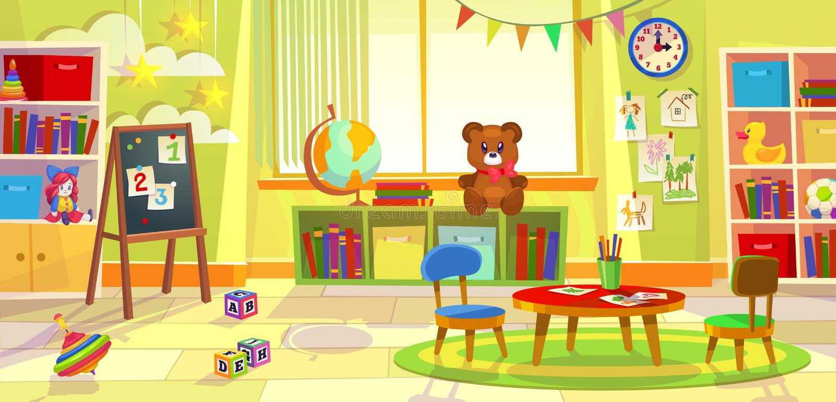
- Caregiver table and chair.
- Display table or shelf.
- Wall clock.
2.6 TOILETS
- Toilets should be available for caregivers/helpers and children, with separate toilets for girls and boys.
- Provision of sanitary facilities (each center to have potties, and ventilated improved pit latrines).
- Proper refuse disposal at the centres.
- Provision of a wash hand basin with soap and water.
2.7 SOURCE OF WATER SUPPLY
Portable water supply from
- Government water cooperatives
- Borehole
Storage of the water in a clean, covered container/tank.
Large storage capability should be cleaned monthly, while smaller storage capacity should be cleaned daily.

CHAPTER THREE: INFECTION
3.1 WHAT IS AN INFECTION?
An infection occurs when a microorganism enters
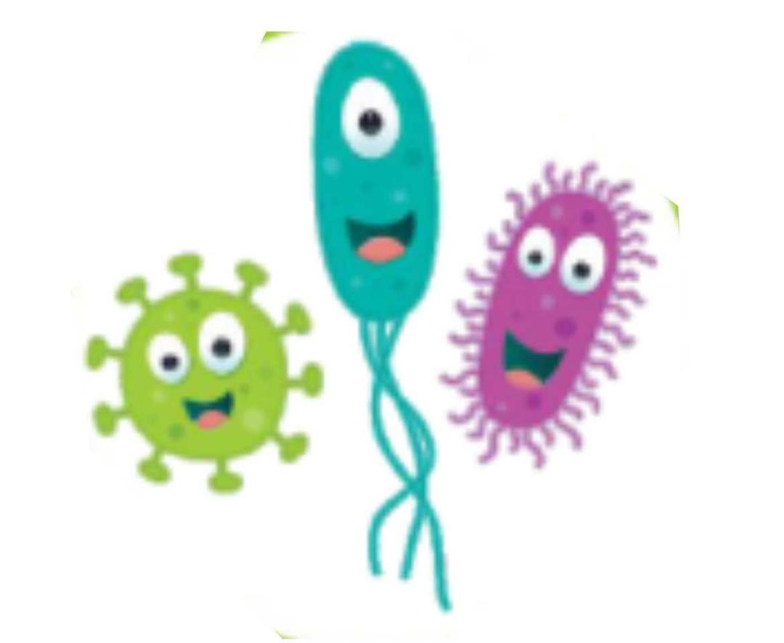
a person’s body and causes harm. The microorganism uses
the person’s body to sustain itself, reproduce, and colonize.
These infectious microscopic organisms are known as
pathogens, and they can multiply quickly. Examples of pathogens
include: bacteria, viruses, fungi, etc..

The microorganism may multiply to such an extent that it can cause illness. Infections can be apparent (i.e., the person will have an immunological reaction to the microorganism and/or will develop signs and symptoms of disease) or may be inapparent (mild with no symptoms of disease).
How an infection spreads and its effects on the human body depend on the type of pathogen. The immune system is an effective barrier against infectious agents. However, pathogens may sometimes overwhelm the immune system’s ability to fight them off. At this stage, an infection becomes harmful.
Infection in childcare is typically caused by cross-contamination among the children in a childcare center or school. This happens when different groups of children meet in a childcare environment with different health status, some exhibiting signs and symptoms of infections and some still incubating the infection.

3.2 CAUSES AND SOURCES OF INFECTIONS IN CHILDCARE CENTERS
The following are sources and causes of infections in a childcare center
- Overcrowding
- Microbial contamination of the childcare environment
- Unsanitary behaviours
- High sensitivity of young children.
- The toilet, kitchen, and playground rooms are common sites where microorganisms can be found in childcare centers
- Other common items that carry infections include nursery pillows, toys, and tables,
- The contamination of children's toys and the spread of infection to young children could be caused by poor water, sanitation, and hygiene conditions.

3.3 ROUTES OF TRANSMISSION OF INFECTIOUS DISEASES
Transmission is the process by which microorganisms spread. Infection is spread from an infected person to another person through different routes. The five basic methods by which microorganisms are transmitted are direct contact, fomites, aerosol (airborne), oral (ingestion), and vector-borne.
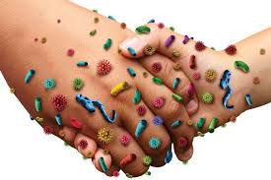
Direct contact transmission: This occurs when a person
comes into direct contact with an infected person's tissues
or fluids (blood, vomitus, saliva, etc.). Microorganisms
enter the body through mucous membranes (e.g., eyes, mouth),
open wounds and abrasions on the skin.
This is probably the most common and highest-risk route of infection transmission to man
Fomite Transmission: Fomite transmission involves
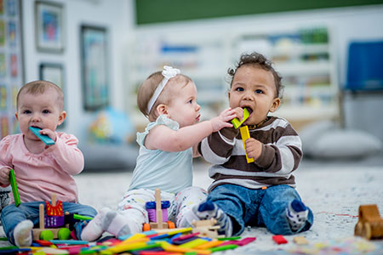
Inanimate objects contaminated by an infected
individual then come in contact with a susceptible human.
The inanimate objects are non-living objects such as bedding,
towels, toys, and barbed wire that can carry disease-causing organisms.
Aerosol (Airborne) Transmission:
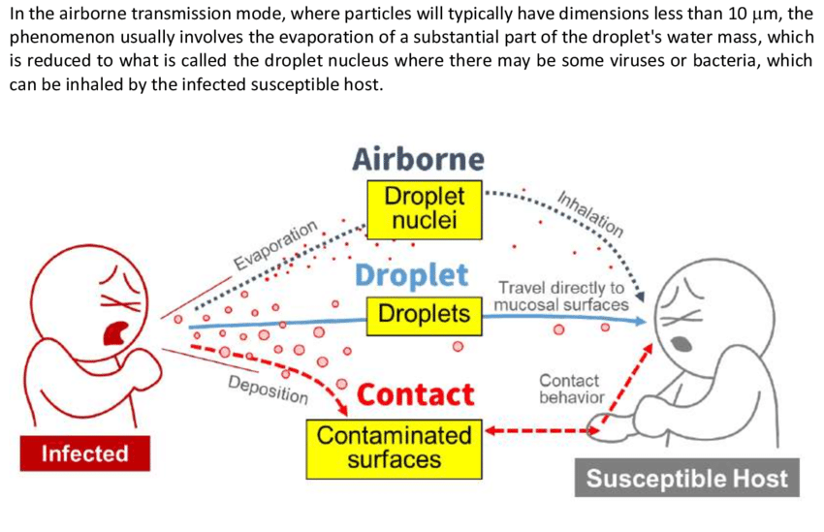

Airborne transmission occurs when infectious
agents are carried by dust or droplet nuclei
suspended in the air. Aerosol particles may be
inhaled by a susceptible host or deposited onto mucous membranes
membranes or environmental surfaces.
This can occur from breathing, coughing, sneezing, or vocalization of an infected individual.
Oral (Ingestion) Transmission: The ingestion of pathogenic
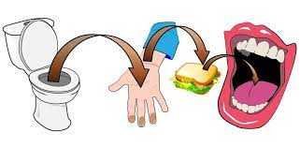
Organisms can occur from contaminated food or water as well
as by licking, eating, or chewing on contaminated objects or
surfaces. Contamination is most commonly due to exudates,
faeces, urine, or saliva.
The commonest is the faecal–oral transmission. This type
of transmission occurs when bacteria or viruses found in the
stool of one child are swallowed by another child. This is especially common in group-day-care settings, where faecal organisms are commonly found on surfaces and on the hands of providers. Usually, the contamination is invisible.

Vector-Borne Transmission: Vectors are living organisms
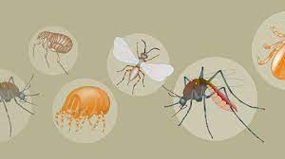
that can transfer microorganisms to other animals or
locations and include arthropod vectors
(e.g., mosquitoes, fleas, ticks) and rodents (rats).
3.4 SPREAD OF INFECTION
It is very important that you know how germs can spread so you can help stop children and staff from becoming sick. Children should be taught how germs spread and how to stop this e.g., by washing their hands.
To understand how infection spreads, there is a need to understand the chain of infection.
Chain of infection
In order for infection to occur, several events have to occur. This is often referred to as the Chain of Infection. The Figure below gives an illustration of the six links in the chain of infection. The links are listed below
- Harmful germ or Infectious Agent:
These are microorganisms that are capable of causing
a disease. These germs could be bacteria, viruses, fungi
or protozoa, they are invisible to the human naked eye to see.
- The Reservoir or source of infection: This is where the microorganism can live and thrive.
This may be a person, an animal, any object in the
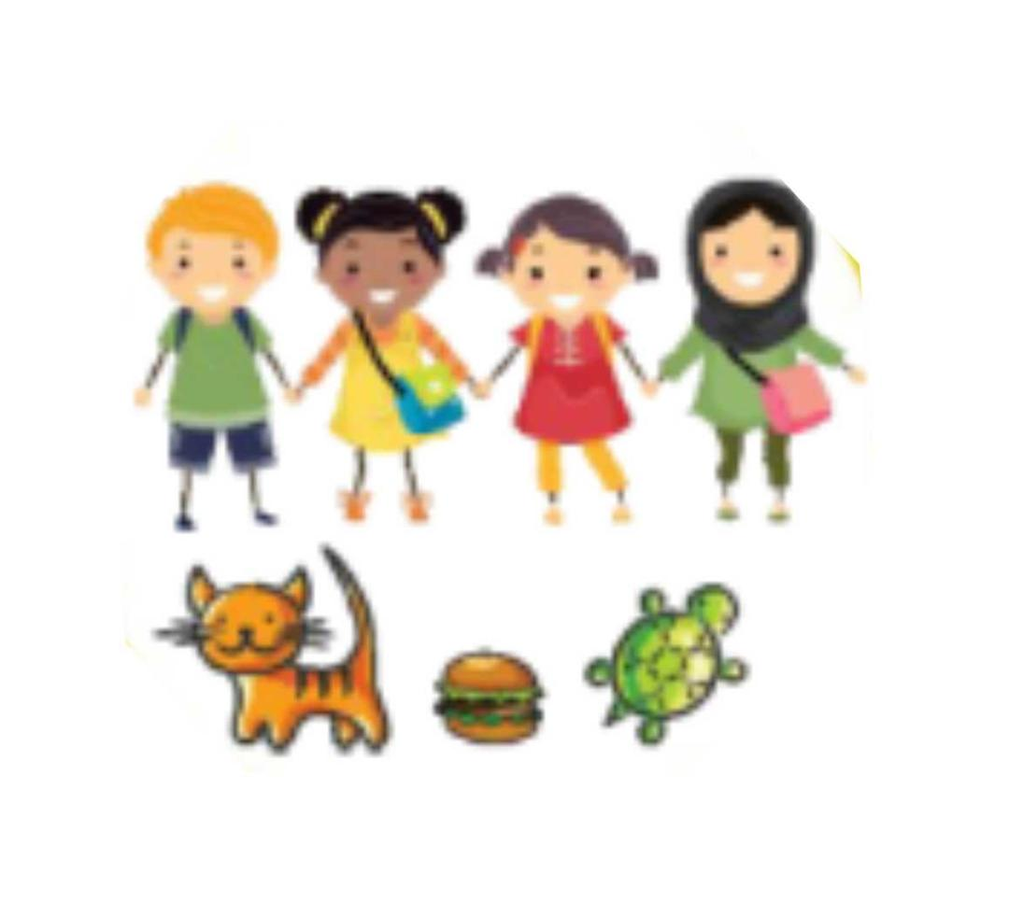
general environment, food, or water.
This is the habitat of the infection, the reservoir
may be the children, the caregivers, the toys,
animals, etc. Most human beings carry some
degree of infection while some show symptoms, some do not show.
Those who do not show any signs and symptoms are called “asymptomatic”. It is for this reason that preventive measures for infection control should be used universally in all childcare centers
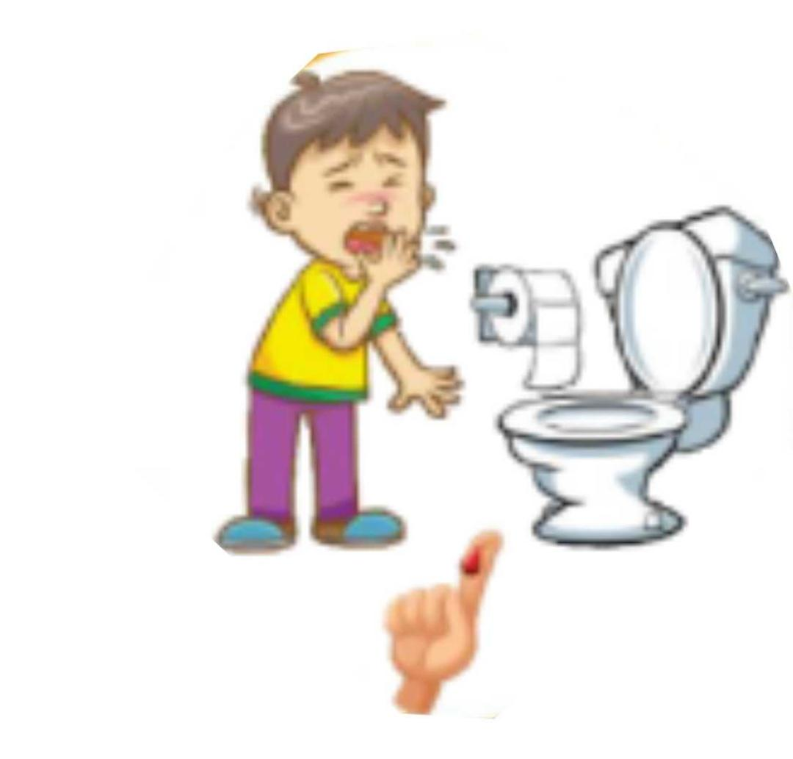
- How germs get out of the reservoir.
This describes the way the microorganism
leaves the reservoir. For example,
in the case of a person with the flu, this would
include coughing and sneezing. In the case of
someone with diarrhoea, microorganisms would be transmitted in the faeces or vomit.
- The Mode of Transmission.
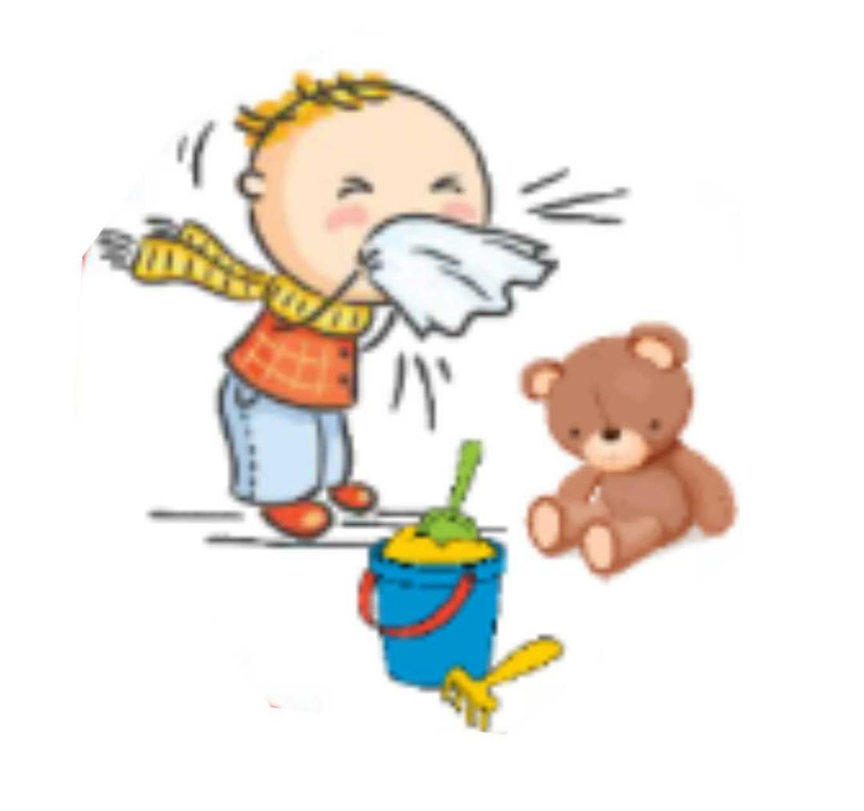
This describes how germs or microorganisms
spread from one person or place to another.
This could be via someone’s hands, on an object,
through the air, or bodily fluid contact.
- How the Germ enters another person:
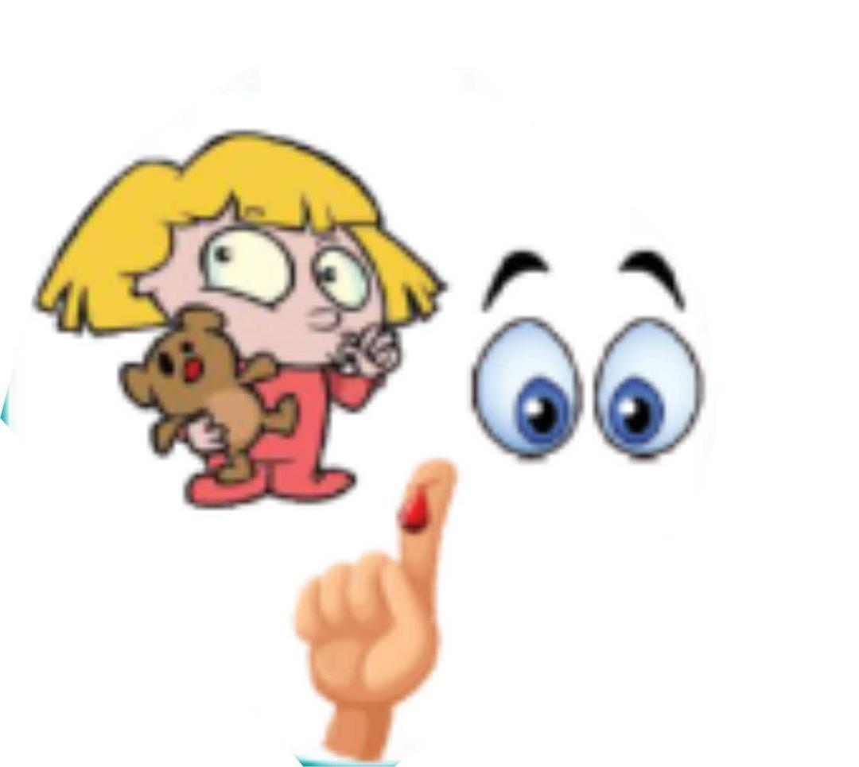
This is how the infection enters another
individual that is the new host.
This could be through a cut in the skin,
germs from coughs and sneezes can find
away in by landing on another person's eye, nose, or mouth, or through the person putting unwashed hands in their mouth or touching their eyes or nose after changing nappies or touching toys or equipment.
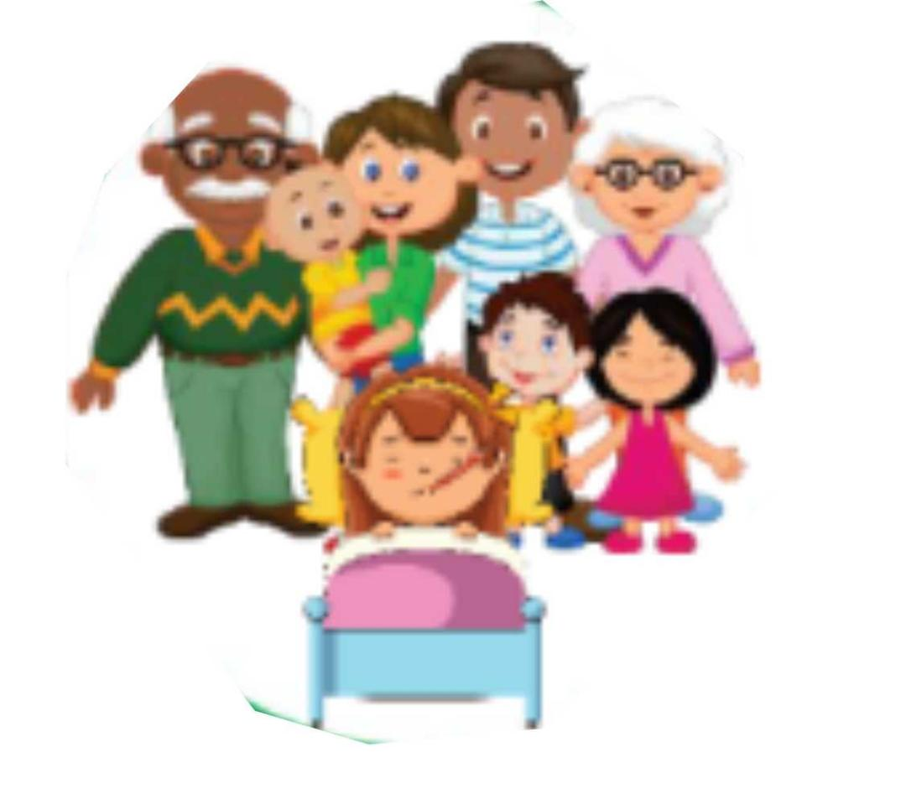
- The next sick person:
This describes the person who is vulnerable
to infection. babies and young children are more
likely to get infections because their immune
systems are still developing.
These six stages give a clearer explanation of how germs or microorganism transmits to human, so as to infect the person and how human beings could spread the infection to another person. To prevent infection, the chain needs to be broken at any stage to prevent an outbreak.

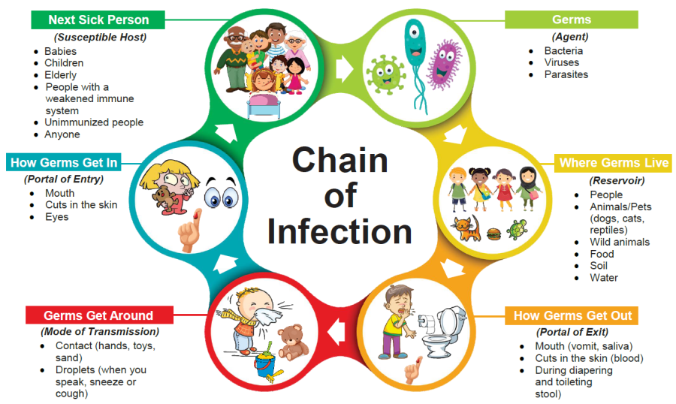

CHAPTER FOUR: INFECTION PREVENTIVE MEASURES

4.1 HAND HYGIENE
The single most effective way of preventing the spread of infection is Hand hygiene. When you practice this often, it helps to remove or destroy germs that are picked up on the hands. Germs can be picked up in lots of ways. They can be transferred onto our hands when we touch other people, animals, contaminated surfaces, food, and body fluids.
Good handwashing of children and protection of caregivers’
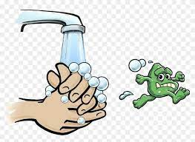
hands when wiping noses are a simple intervention
readily applicable to childcare settings, Washing
hands thoroughly, at the right time, using appropriate
facilities and products will help prevent the spread
of common infections such as colds, flu, threadworms and stomach bugs.
Children need to understand why it is important to wash their hands and be taught how to wash, rinse and dry their hands correctly.
4.1.1 Steps to Handwashing
- Wet the hands up to the wrist level with clean, running water, either warm or cold.
- Apply soap to the hands, then lather the hands evenly by rubbing them together with the soap. Also, lather the backs of your hands, between your fingers, and under your nails. Rub backward and forwards with the thumbs, fingertips, palms, and in between the fingers at each stroke.
- Hands should be properly rinsed under running water.
- Dry hands with a clean towel/paper towel or let them air dry.
- Turn off taps with the disposable paper towel that was used to dry your hands.
- To avoid contaminating freshly cleaned hands, dispose of the disposable paper towel in a garbage container using the foot pedal.

4.1.2`STEPS ON HOW TO WASH HAND ACCORDING TO WORLD HEALTH ORGANIZATION
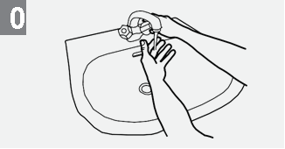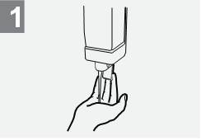
Wet hands with water; Apply enough soap to cover all
hand surfaces;
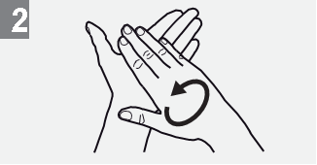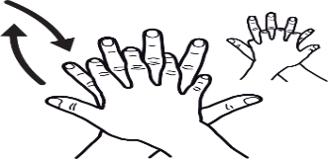

Rub hands palm to palm; Right palm over left dorsum
with interlaced fingers and vice versa;

Palm to palm with fingers interlaced; Backs of fingers to opposing
Palms with fingers interlocked;
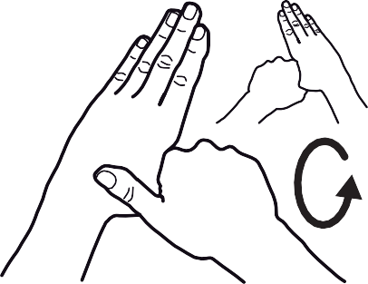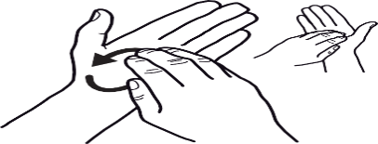

Rotational rubbing of left thumb Rotational rubbing, backwards and
clasped in right palm and forwards with clasped fingers of right
vice versa; hand in left palm and vice versa;
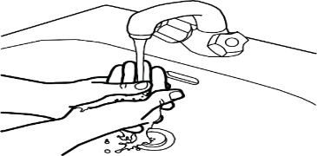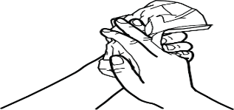

Rinse hands with water; Dry hands thoroughly with a single
use towel;

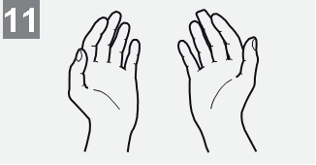

Use towel to turn off faucet; Your hands are now safe.

4.1.3 Use of Hand Sanitizer
If soap and water are not readily available, an alcohol-based hand sanitizer containing at least 60% alcohol can be used instead.
When hands are clearly unclean or oily, hand sanitizers may not be as effective. Also, hand sanitizers may not eliminate dangerous pollutants like pesticides and heavy metals from the hands
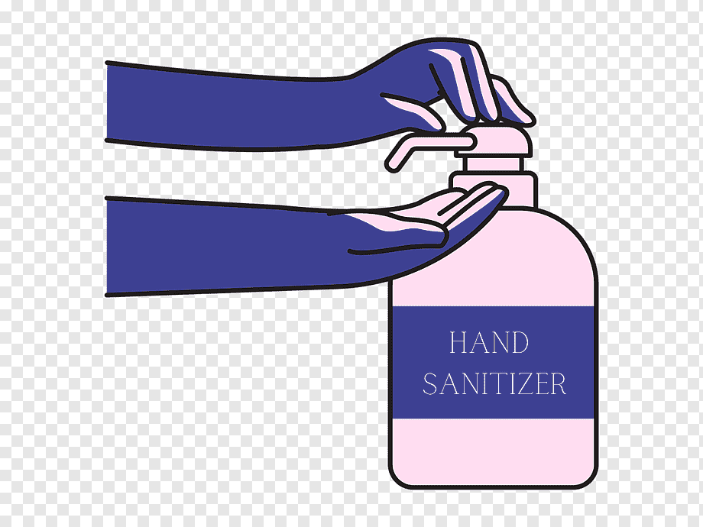
How to Use Hand Sanitizer
- Apply the gel product to the palm of one hand
(read the label to learn the correct amount).
- Rub your hands together.
- Rub the gel over all the surfaces of your hands and fingers
until your hands are dry. This should take around 20 seconds.
Hand washing should be done with soap and water as soon as it is available
The wearing of wrist jewellery (including watches), false nails, and nail products is not recommended for staff performing hand hygiene.
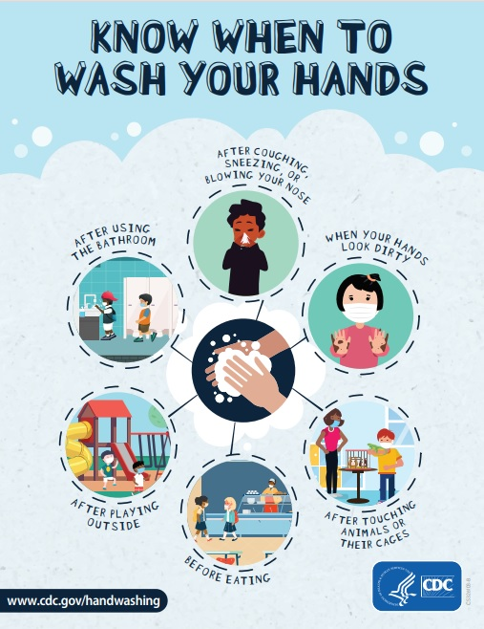
4.1.4 When should you wash your hands?
Children and caregivers should wash their hands:
- Before and after eating or handling food or drink
- After using the toilet, potty, or changing a nappy
- After blowing your nose, coughing, or sneezing
- After touching animals/pets or animal/pet waste,
equipment or bedding
- After contact with contaminated surfaces
(e.g., food-contaminated surfaces, rubbish bins, cleaning cloths).
- When returning from outside play or breaks e.g., playing with sand.

4.2 RESPIRATORY AND COUGH HYGIENE
This measure is important because germs causing respiratory infections are minute in size and can be easily transmitted between people. However, the infection can be prevented or treated by following conventional precautions, maintaining proper respiratory hygiene.
To prevent respiratory germs from spreading,
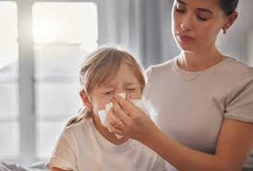
- Children and teachers should cover their mouths
and nose with a tissue when coughing and sneezing;
- Throw used tissues in the trash

- If you don’t have a tissue, cough or
sneeze into your elbow, not your hands

- Remember to immediately wash your hands after blowing the children or your nose, coughing or sneezing.

- Usage of reusable towels like cloth, handkerchiefs should be avoided

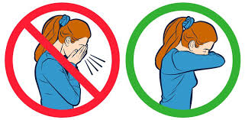
4.3 PERSONAL PROTECTIVE EQUIPMENT (PPE)
The use of personal protective equipment (PPE), facilities, and materials are required to prevent or minimize the spread of infection, illness, and disease.
Examples of PPE include aprons and gloves
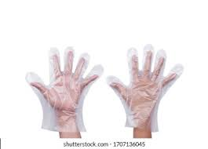
When to use PPE
- Nappy changing,
- Cleaning up vomit or blood, or
- Any activity that involves the risk of contamination.
PPE, when used appropriately, protects staff from
germs and splashing, but also protects children from
contamination from staff clothing.
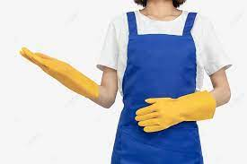
Disposable gloves are for single-use only and are not to be reused
Always wash your hands before putting on and after taking off PPE.

4.4 CLEANING AND DISINFECTING THE ENVIRONMENT
Cleaning is a process that physically removes contamination for example, faeces, and therefore also removes many micro-organisms.
Disinfection must occur after cleaning. Disinfection inactivates or kills microorganisms (germs) that may be present on surfaces and that cleaning does not remove.
4.4.1 What are the areas in the childcare centers that are of high risk?
There are many areas in childcare settings with a high risk of germs being present
- Toilets
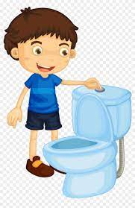
- Nappy changing areas
- Food areas/ Kitchens.
- Laundry area
- Reception area
4.4.2 How cleaning works
- Cleaning works by using detergent and water to physically remove dirt and impurities from surfaces or objects.
- Cleaning does not kill germs. Disinfection kills the germs on all surfaces
- Disinfection works by using disinfectants to kill germs on surfaces or objects.
- For a disinfectant to work properly, a dirty surface should first be cleaned with detergent and water.
- Disinfectants will not work properly without first removing the dirt and other impurities
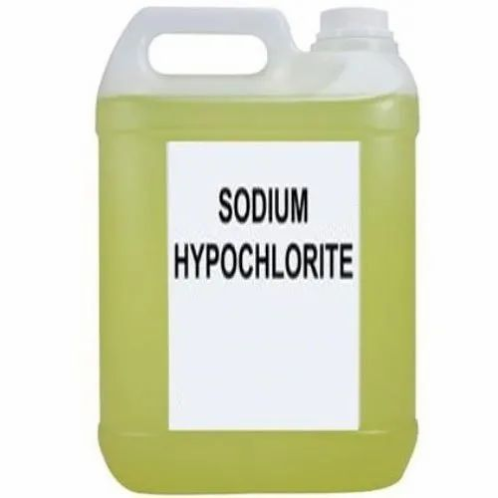
4.4.3 Common disinfectants
A common disinfectant used is bleach which is safe,
inexpensive, and effective when diluted appropriately.
Also, Concentrated chlorine can also be used.
This comes in either liquid, powder, or tablet form.
Common examples in the markets are Jik, Hypo etc…

Bleach is cheap and easy to get. A 0.1% hypochlorite solution is usually recommended; the solution of bleach and water is easy to mix and safe if handled properly.
It can be used on most surfaces, including most bathroom and food contact surfaces, but be aware that some surfaces may become discoloured or damaged by the product and alterative disinfection products may have to be used.
4.4.4 Some special areas that need cleaning
Routinely clean, sanitize, and disinfect surfaces and objects that are frequently touched, especially toys and games. This may also include cleaning objects/surfaces not ordinarily cleaned daily such as doorknobs

- Light Switches
- Classroom Sink Handles
- Countertops
- Nap Pads
- Toilet Training Potties
- Desks
- Chairs
- Playgrounds Structures

Surfaces | Dilution ratio | Strength
Excrement-soiled surfaces | 1 part bleach to 9 parts water (1:10) | Strong
General surfaces | 1 part bleach to 49 parts water (1:50) | Normal
Surfaces in contact with food/mouths | 1 part bleach to 249 parts water (1:250) | Weak

4.4.5 Steps in cleaning and disinfecting
This should be done before the children arrive at the center and should ensure that the everywhere is dry and safe before the children arrive
Step 1: Clearing; Remove dirt and debris by sweeping, scraping, wiping, or rinsing with water.
Step 2: Cleaning; this is the use of general-purpose detergent and warm water. This is done to ensure the environment is clean and safe.
Step 3: Rinsing; rinse off the dirt product of the physical cleaning
Step 4: Disinfecting: Generally, the surface should be liberally soaked/covered with disinfectant and then left in contact with the product for a certain period of time, e.g. a contact time of 30 minutes is recommended when using a bleach solution.
Step 5: Final Rinsing; After the contact time has passed, the solution can be removed using clean absorbent materials or rinsed off
Step 6: Drying; allowed to dry (air-dry or manually dried).
The summary of the steps is summarized in the table below
Step | Act | Description
1 | Clearing | Remove dirt and debris by sweeping, scraping, wiping, or rinsing with water.
2 | Cleaning | Use of a general-purpose detergent and warm water to clean
3 | Rinsing | rise off the dirt product of the cleaning
4 | Disinfecting | Disinfect to reduce/eliminate micro-organisms to safe levels.
5 | Final Rinsing; | Rinse off disinfectant (if necessary)
6 | Drying; | Allowed to dry (air-dry or manually dried).

4.4.6 Daily Cleaning and Disinfecting Routine
In the morning, prior to the children's arrival, there is a lot to do. The following is expected to be done.
- Prepare a pail of water mix with bleach (in the right proportion)
- Pack the toys away from the floor.
- Rearrange the room appropriately
- Cleaning and disinfect the Playroom/classroom with a dedicated mop
- Cleaning and disinfect the Bathroom and toilet with a dedicated mop
Within the day: it is expected that the above step 1-5 should be put in place where necessary
In Closing Up: General cleaning should be done and all waste disposed

4.4.7 Cleaning of equipment and materials
All toys and equipment must be safe for use and well-maintained to reduce the risk of spreading harmful germs.
Where possible, buy toys and equipment that can be easily cleaned.
Store toys in a clean container and don’t let children take toys into toilet areas.
Reusable equipment that has been cleaned but is not in use should be stored separately from used equipment and away from where equipment cleaning takes place.
Equipment must be cleaned;
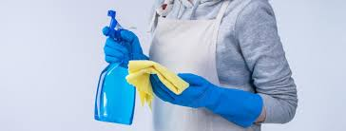
- Between use
- After blood and/body fluid contamination
- At regular intervals as part of an equipment cleaning schedule

    - Linen/Bedding/Cots
- Bed linens, Cots and mattresses must be non-absorbent and easy to clean.
- Clean and disinfect cots and mattresses at least once a week and when they are soiled.
- Designate bed linens for every child. No sharing
- Wash bedding separately from other items such as tea towels, etc.
Cleaning and disinfecting hard plastic toys
- Remove toys from the play area after use and place them in a collection box for cleaning and disinfection
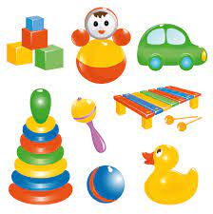
- Clean and disinfect the collection box at the same time
that toys are being cleaned and disinfected
- Clean toys in hot, soapy water prior to using a disinfectant
- Use a brush to clean crevices or hard to reach areas
- Rinse toys well under running water as soap may
neutralize the disinfectant
- Soak toys in an appropriate disinfectant for required amount of time (contact time)
- Use a solution of 10 ml (2 tsp) sodium hypochlorite
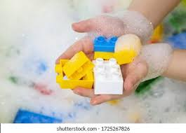
(household bleach) per 1 liter (4 cups) of water as
a disinfectant. This solution requires a contact time
of 2 minutes. Only mix bleach with water and never
with other disinfectants or cleaners
- Rinse toys with clean water to remove any
disinfectant solution
- Completely air dry toys before they are returned to use
- Keep a record of when toys were cleaned and disinfected
Cleaning and disinfecting soft, porous toys or dress up clothes

- Launder fabrics or plush toys in a washing machine
with hot water, and dry in a clothes dryer on a hot cycle
- Avoid using disinfectant products on porous surfaces

Computers/shared electronic games/video equipment
- Must be cleaned and disinfected between users with disinfectant wipes
4.4.9 How to handle soiled linen
- Linen soiled with vomit, faeces, blood or other body fluids should be treated the same as a soiled nappy.
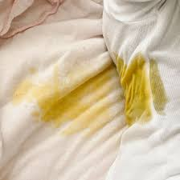
- Linen should be scraped to remove excess material,
soaked in an appropriate sanitising solution and
then washed separately using a hot-water wash.
- The linen can then be dried in the sun
- Wear gloves when handling soiled linen and
do not carry soiled linen against your clothing
take it to the laundry in a basket or linen bag.
- If linen is laundered off-site (by a commercial
company or parents/caregivers/whanau) It must be
transported in sealed containers or bags.
- Linen soiled with vomit, faeces, blood, or other body fluids must be kept separate in sealed, leak-proof, clearly marked bags.
4.4.10 Dealing with spillages of blood and body fluids
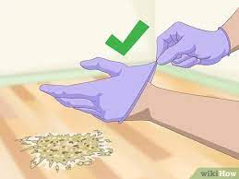
All spillages of blood and body fluids must be
cleaned immediately. The children are to be
kept away from the spill.
To clean the spill the following steps should be followed
- Put on PPE (i.e. disposable gloves and disposable apron)
- Prepare a solution of general-purpose neutral detergent;
and a solution of chloride-based disinfectant.
- Place paper towels (or kitchen roll) over the spill to soak up the spillage.
Then carefully place these into a disposable,
leak-proof plastic bag
- Use the disinfectant solution to
clean the remainder of the spillage
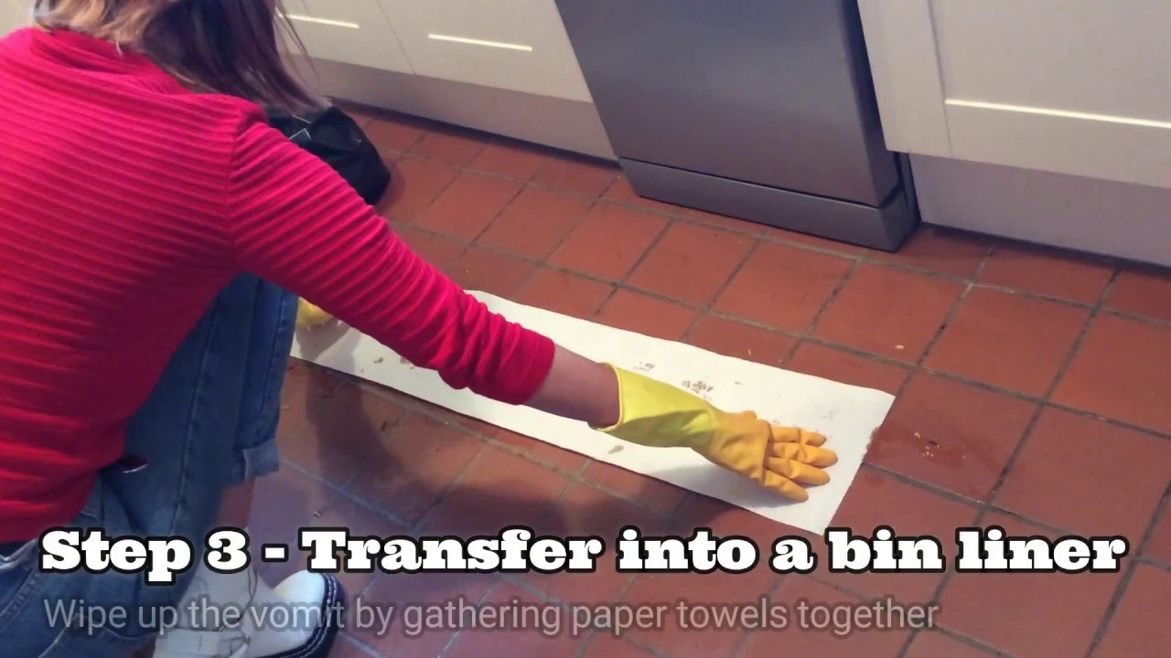
- Then wipe down the area with paper towels
(or kitchen roll) soaked in detergent solution.
- Wipe the area dry with paper towels (or kitchen roll)
- Remove PPE and put it into the plastic bag, secure
and seal the bag then place it in the waste bin
- Wash their hands with liquid soap and running water
N.B. Do not use chlorine-based disinfectants
directly onto spills of urine spillages
(this can release a chlorine gas).
Soak up urine first with paper towels before using a disinfectant solution. Always check that disinfectants are suitable for use on carpets and other soft furnishings as they may cause damage or discolouration.

4.5 FOOD HANDLING
Children spend an average of four hours in the childcare center and no doubt they will be fed, hence food hygiene has become a measure to control infection from foodborne diseases, as the children are more vulnerable
In childcare facilities, food safety is everyone's responsibility. Teachers and other personnel often come in contact with the food served to the children and should be familiar with safe food handling practices.
Food is a common way for illness to spread.
You cannot tell by looking, smelling or tasting food if harmful microorganisms are present, therefore, you must handle food safely from the time you receive it until the time you serve it.
4.5.1 Mealtime
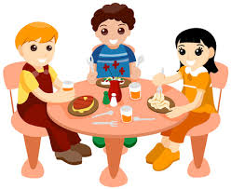
- Long day childcare centres must provide a
minimum of one meal and two snacks each day.
The primary cook or supervisor should be
a certified food handler.
- Childcare staff who diaper children cannot
work in the kitchen, nor do any food preparation
during the same shift.
- Kitchen staff who also have cleaning duties outside the kitchen cannot perform cleaning duties until after they have finished their food-handling tasks. For example, staff can prepare food in the morning and clean in the afternoon.
- Even when they don’t provide meals, childcare staff can encourage and support families to provide healthy meals for their children whilst in care.
- The mealtime atmosphere and the attitude and behaviour of childcare workers is important to the development of healthy eating practices.
- Children should be relaxed and happy when they are eating.
- Childcare workers should develop and encourage healthy eating patterns and positive attitudes to food and also supervise children’s eating.
- Children learn from others about food preferences and how to eat. Safety at mealtimes is important.

4.5.2 Self-serving of food
Children must:
- Wash their hands before eating.
- Be supervised at all times while eating.
- Use clean utensils, not their bare hands when serving food.
Other important points:
- Food should be an appropriate size and texture for the age and ability of the child so they can easily chew and swallow their food.
- Nuts and other hard foods that are difficult for young children to chew should be avoided.
- Children should not be force-fed.
- Children should be seated quietly at mealtimes.
4.5.3 Food handling for a breastfeeding child
A breastfeeding mother can pump and store human milk for bottle-feeding later.
Human milk should be brought to childcare in prepared bottles. Bottles should be clean and sanitized.
Use plastic bottles labelled BPA-free or with #1, #2, #4, or #5.
Plastic bottles are lighter weight and safer than glass bottles.
Each bottle must be clearly labelled with the infant’s full name and the date that the milk was expressed.
As a safeguard, parents may also write their child’s name directly on the plastic bottle with a permanent marker. This practice will identify the bottle in case the label comes off.
4.5.4 Handling of expressed breast milk
- Store prepared bottles in the refrigerator. Store frozen breast milk in the freezer until feeding time and then thaw it in the refrigerator or under cool, running water. Do not warm bottles on the stove, which may cause the milk to curdle.
- Wash your hands carefully with soap and water before preparing any bottle.
- Do not warm bottles in the microwave. Uneven heating may cause hot spots, which can burn a baby’s mouth. Cover all bottles during storage.
- Prepare commercial infant feedings according to instructions. Add the right amount of water to ensure that the infant gets adequate calories and nutrients.
- Throw away any breast milk or formula left in a bottle after feeding. If too much seems to be going to waste, record the amount usually used and prepare a smaller amount. You also may ask parents to save breast milk in smaller bottles.
- Clean reusable bottles and nipples thoroughly after each use. Bottles and nipples may be washed in a dishwasher in very hot water or washed by hand and boiled for five minutes before refilling.
- Fresh milk will keep for up to five (5) days, if properly refrigerated.
- Previously frozen human milk must be used within 24 hours of thawing.
4.6 DIAPERING AND TOILETING
4.6.1 Diapering location and surface
- Separate diapering area from feeding and food preparation areas.
- Use a diapering surface (solid table) that is non-absorbent and easy to clean.
- Provide a designated hand sink adjacent to diapering table.
- Provide liquid soap and paper towels in dispensers
4.6.2 Follow these steps
1. Prepare
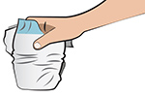
- Cover the diaper changing surface with disposable liner.
- If you will use diaper cream, dispense it onto a tissue now.
- Bring your supplies (e.g., clean diaper, wipes, diaper cream,
gloves, plastic or waterproof bag for soiled clothing, extra clothes) to the diapering area.
2. Clean Child
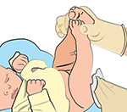
- Place the child on the diapering surface and unfasten the diaper.
- Clean the child’s diaper area with disposable wipes.
  - Always wipe front to back!
- Keep soiled diaper/clothing away from any surfaces
that cannot be easily cleaned. Securely bag soiled clothing.
3. Remove Trash
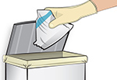
- Place used wipes in the soiled diaper.
- Discard the soiled diaper and wipes in the trash can.
- Remove and discard gloves, if used.
4. Replace the Diaper
- Slide a fresh diaper under the child.
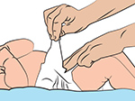
- Apply diaper cream, if needed, with a tissue or
a freshly gloved finger.
- Fasten the diaper and dress the child.

5. Wash Child’s Hands
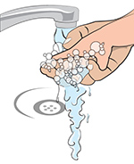
- Wash child’s hands with soap and water and
place him or her in a safe, supervised area.
6. Clean Up
- Remove the liner from the changing surface
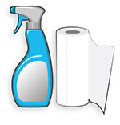
and discard in the trash can.
- Wipe up any visible soil with a damp paper
towels or a baby wipe.
- Wet the entire surface with disinfectant; make sure you read and follow the directions on the disinfecting spray, fluid or wipe.
- Choose a disinfectant appropriate for the surface material.
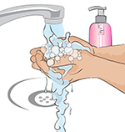
- Wash Your Hands
- Hands should be thoroughly washed
with soap and water

4.6.3 Steps for toileting or using a potty
STEPS | ACTION
 | Place the child on the clean toilet or the potty.
 | Assist the child with cleaning themselves (if necessary).
 | Wash your hands.
 | Help the child get dressed (or diapered).
 | Wash the child’s hands.
 | Put on a new pair of disposable gloves.
Clean and disinfect the toilet and toilet ring as required. If using a potty, empty the contents of potty into the toilet carefully to avoid splashing.
Clean and disinfect the potty.
 | Remove gloves and dispose in a lined waste receptacle.
 | Wash your hands.

4.7 MANAGEMENT OF WASTE
Waste created at your childcare setting should be managed as follows:
Ensure that there are lined pedal bins in each of the areas where waste is produced, e.g. food areas, nappy changing areas.
Open lidded waste bins in indoor play areas can be used for non-hazardous waste only.
Ensure waste bins are never overfilled i.e. once three-quarters full, tie them up and put them into the main waste bin.
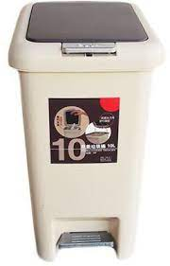
Have a schedule for emptying the bins at the end of the
day, and during the day if needed.
Keep the main waste bin in a secure area away
from play areas (ensure animals cannot get into this
area).

When collecting waste and emptying bins,
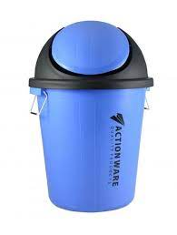
wear PPE
(i.e. disposable gloves and disposable apron).
When you are finished, remove PPE and wash your
hands with liquid soap and running water.

4.8 IMMUNIZATION OF CHILDREN AND CAREGIVERS/TEACHERS
Immunization is a cost-effective approach to preventing infection.
The close proximity of children in day care makes it a common setting for the spread of infectious diseases.
Vaccinations can be an effective way to prevent diseases like chicken pox, influenza, and pertussis from spreading to children too young to receive vaccines or to family members with compromised immune systems.
Parents are meant to ensure that their children are fully vaccinated based on the national immunization scheme.
Immunisations are essential for people who work with children to prevent the spread of vaccine-preventable diseases from staff members to children and vice versa.
The management of the school/centre should keep documentation of the staff's immunity status.
People who work with children include: Also, caregivers/teachers in CCCs are meant to be vaccinated.
The following vaccines are recommended
- Measles, mumps, rubella vaccine (MMR)
- Chickenpox (or varicella)
- Whooping cough (pertussis) vaccine (available as TdaP)
- Hepatitis B vaccine
- Seasonal influenza vaccine (annual)
Summary of recommended immunization (if not given during childhood) for people (18-65 years and older) working with children
VACCINE | SCHEDULE
Influenza | 1 dose annually
Tetanus, diphtheria and pertussis | 1 dose per adulthood and per pregnancy (16-32 weeks of gestation)
*Measles, Mumps, Rubella (MMR) | 2 doses (one month apart)
Hepatitis B | 3 doses (intervals 0, 1 and 6 months in previously unvaccinated adult)
Varicella | 2 doses (one month apart)
*For adults without evidence of immunity and / or prior disease

4.9 MANAGEMENT OF SICK CHILDREN
The goal at every childcare centre is to keep children healthy. Despite best efforts, illnesses do occur in the childcare centre or at home. If an illness is serious or there’s an outbreak, proper management will involve following policies and procedures for exclusion, reporting and communicating illnesses and outbreaks, enhanced handwashing and thorough cleaning and disinfecting. The caregivers are to be knowledgeable about the early signs of infection. At times there may be an outbreak of a disease in the childcare center
An outbreak is defined as “having two or more children or staff with an infection, caused by the same microorganism, at the same time in the same place”. However, a single case of a serious disease may also require an outbreak response, e.g. E. coli O157, diphtheria, or measles.
How Do I Know When There Is An Illness?
Child care staff play an important role in identifying early signs and symptoms of illness in children and staff.
You should observe every child for signs or symptoms of illness at the start of every day and throughout the day.
Seven signs and symptoms of illness to look for:
1.Unusual behaviour
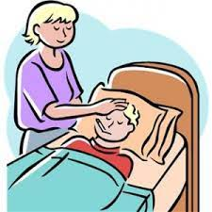
2. Runny nose, cough or difficulty breathing
3. Vomiting
4. Diarrhoea
5. Change in skin colour
6. Rash
7. Fever

What Should I Do If Children Are Sick?
Childcare centres have certain responsibilities when it comes to sick children. Child care centres are required to:
- Separate sick children from well children.
- Note symptoms of illness in the child’s record.
- Contact a parent or guardian to take the sick child home.
- Excluding, re-admitting and cohorting sick children and child care staff.
- Reporting communicable diseases and suspected outbreaks to appropriate health care agency

Steps for Exclusion
- Separate sick children from well children. Symptomatic children should be placed in the
- designated isolation area (e.g., sick room).
- Keep sick children comfortable by providing separate cots and toys. Clean and disinfect
cots and toys after use. Do not allow sick children to participate in group play activities.
- If possible, designate specific staff to care for sick children. Ideally, child care staff should not care for sick and well children at the same time.
- Contact parents to pick up sick children

Exclude a child who has any of the following symptoms

- Fever AND a combination of other symptoms (e.g., nausea, vomiting)
- Fever AND a body rash
- Diarrhoea – two or more liquid stools or a change in the normal pattern of bowel movement
- (e.g., runny, watery or bloody stools)
- Vomiting – two or more times in the last 24 hours
- Eye discharge – yellow or white
- Severe cough
- Yellowish skin or eyes, or jaundice
- Irritability, continuous crying, or requires more attention than can be provided

How to manage an Outbreak?
An outbreak is when a greater than expected number of children and child care staff have similar symptoms (e.g., fever, diarrhoea, vomiting, rash, respiratory symptoms) and are sick or absent due to illness in a given period of time.
A warning signal is when 10% of the children are sick with a similar illness.
Some diseases (e.g., measles) should be treated like an outbreak even if there is only one case. If you are unsure whether one case of an illness is an outbreak, contact the Disease Notification and Surveillance Officer of the Local Government.
Early awareness and action are critical in managing an outbreak at your childcare centre.

BIBLOGRAPHY

Adam Felman. (2020). What to know about infections
https://www.medicalnewstoday.com/articles/196271
Centers for Disease Control and Prevention. (2022). Diaper Changing Steps for Childcare Settings. https://www.cdc.gov/hygiene/childcare/childcare.html
Centers for Disease Control and Prevention. (2022). Water, Sanitation, and Environmentally Related Hygiene. https://www.cdc.gov/hygiene/personal-hygiene/coughing-sneezing.html
Center for Disease Control. (2022). When and How to Wash Your Hands: Handwashing. https://www.cdc.gov/handwashing/when-how-handwashing.html
Child Care and Early Years Act, (CCEYA). (2019). Toronto Public Health Guidance Document, , Toronto Children Services Early Learning and Care Assessment for Quality Improvement, 2014 Approved by Board of Directors
Health Protection Scotland. (2018). Infection Prevention and Control in Childcare Settings (Day Care and Childminding Settings).
Minstry of Health Singapore. (2019). Infection Prevention Guidelines for schools (Primary) and childcare centers (Third).
Nigeria Centre for Disease Control (NCDC). (2021). Guidance for Integrated Safe School Re-opening https://covid19.ncdc.gov.ng/media/files/Guidance_for_Integrated_Safe_School_Reopening_2nd_Edition.pdf
Nigeria Centre for Disease Control (NCDC). (2020). Infection Prevention And Control Recommendations During Health Care When COVID-19 is Suspected. https://covid19.ncdc.gov.ng/media/archives/IPC_RECOMMENDATIONS_DURING_HEALTHCARE_WHEN_COVID19_IS_SUSPECTED.pdf
Nigerian Educational Research and Development Council, (NERDC). (2004). NATIONAL MINIMUM STANDARD FOR EARLY CHILD CARE CENTRES IN NIGERIA.
Ottawa Public Health (2022). Cleaning and Disinfection of Toys. https://www.ottawapublichealth.ca/en/professionals-and-partners/cleaning-and-disinfection-of-toys.aspx
Peel Public Health Preventing and Managing Illnesses in Child Care Centres https://www.peelregion.ca/health/infectioncontrol/pdf/ENV-0227.pdf
Public health Agency Ireland-Northern. (2017). Infection prevention and control: Best practice advice for nurseries and childcare settings.
Seabela, M., & Dikeledi, L. (2020). Assessment of Food Safety Hazards among Day Care Centres in Mbombela, Republic of South Africa. In University of Johannesburg (South Africa) ProQuest Dissertations Publishing. University of Johannesburg.
Steve, F. (2019). Infection control 3: Use of disposable gloves and aprons. Nursing Times. https://www.nursingtimes.net/clinical-archive/infection-control/infection-control-3-use-of-disposable-gloves-and-aprons-24-06-2019/

