Extended Data

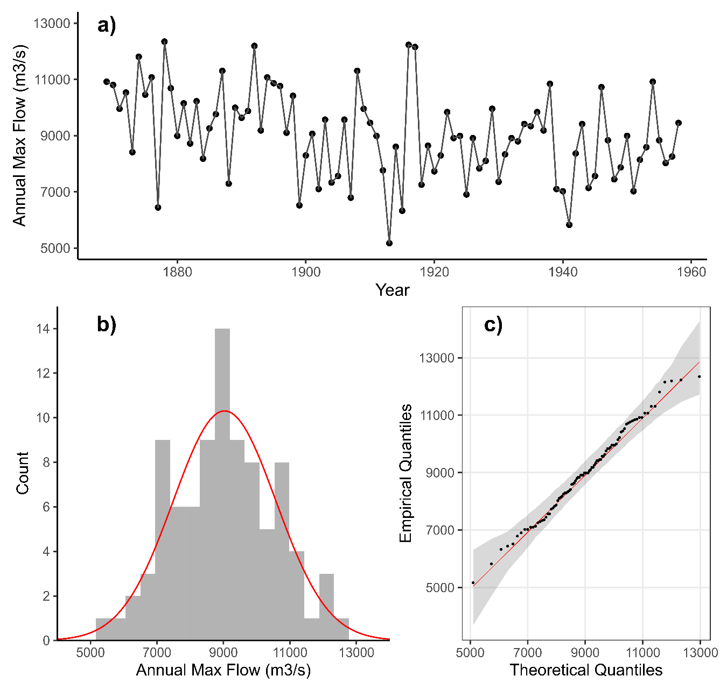
Fig. E1. Historical time series of annual flow maxima (a), developed by taking the larger value between Aswan and Dongola gauges. Annual maxima were used to fit a normal distribution (b), shown in red against observed values, shown as a grey histogram. Quantile-quantile plots (c) confirm that the normal distribution provides a good fit.

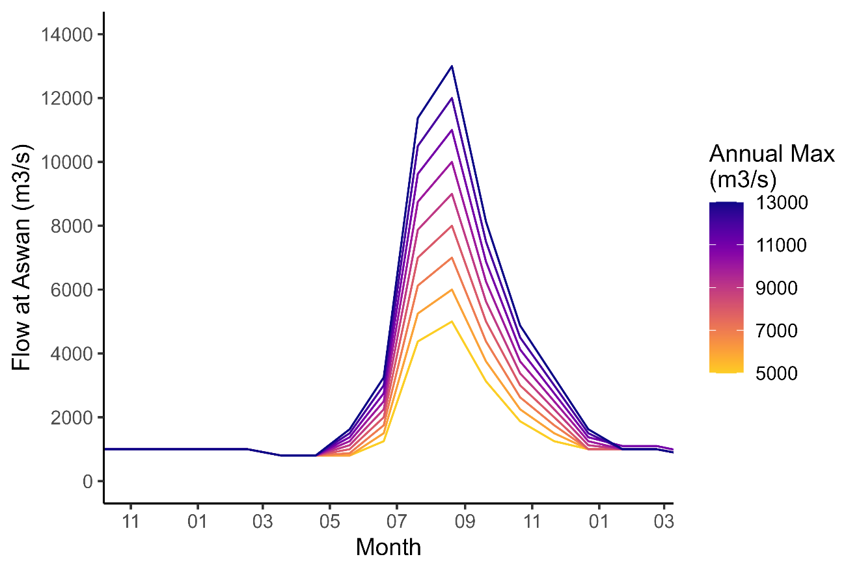
Fig. E2. Synthetic flood events used for simulation, with annual maxima ranging from 5,000 m³/s to 13,000 m³/s, represented by colors. A constant 1,000 m³/s warm up period was used to initialize the model year.

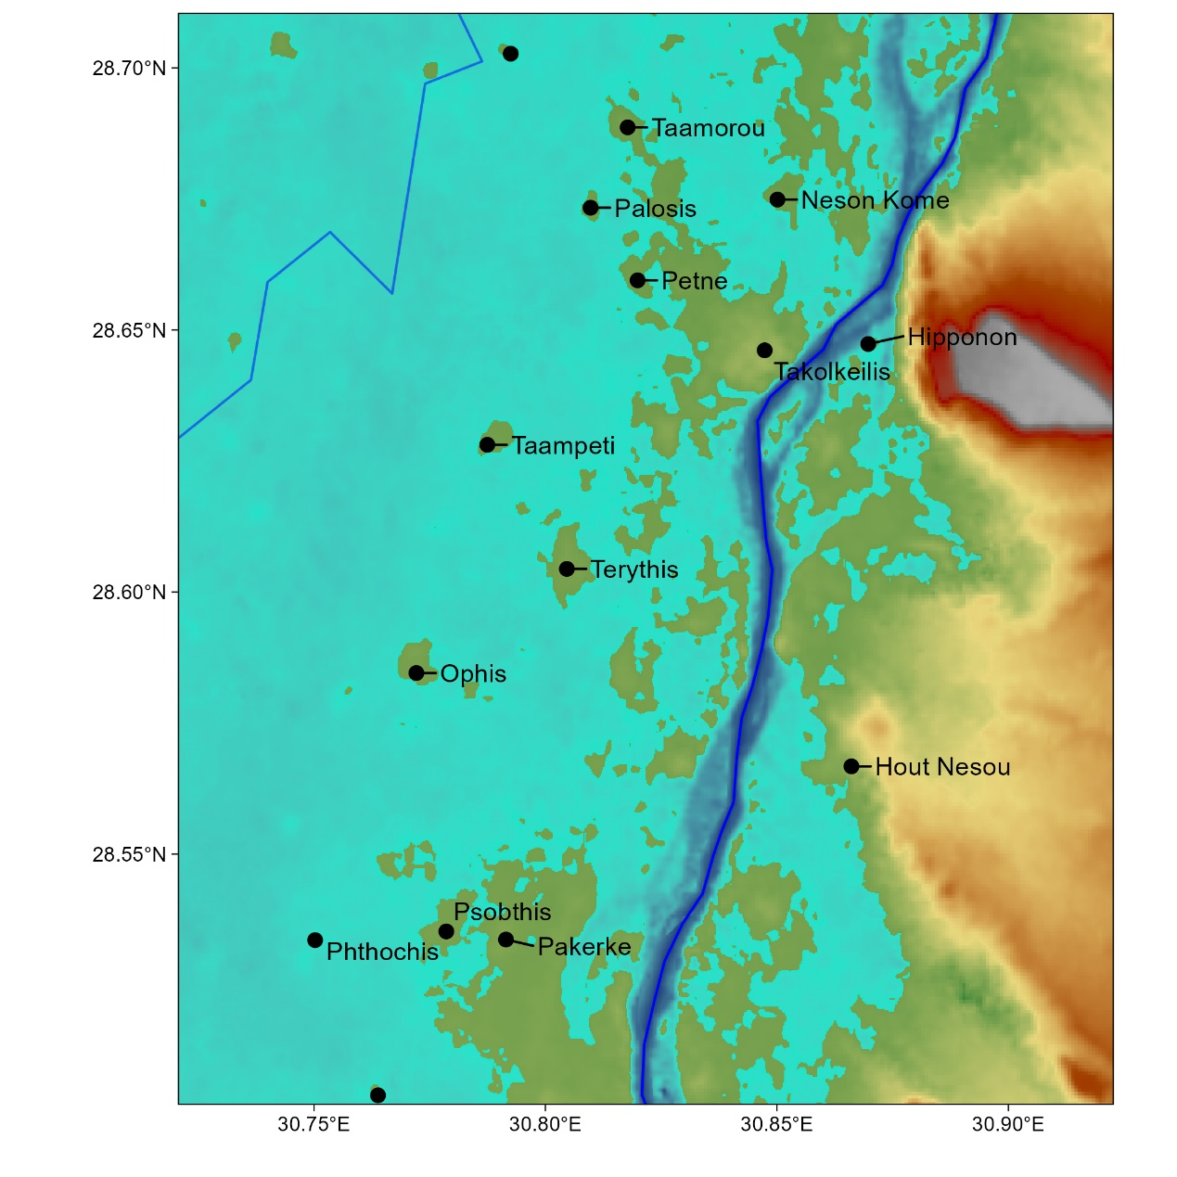
Fig. E3. Similar to Fig. 2, but showing a new location in Middle Egypt. Blue regions show the maximum flood extent associated with the simulated 9,000 m³/s seasonal peak, representing a typical year’s pre-modern flood. Most Ptolemaic-era villages, towns, and cities, shown as labeled dots, remain outside a typical flood extent.

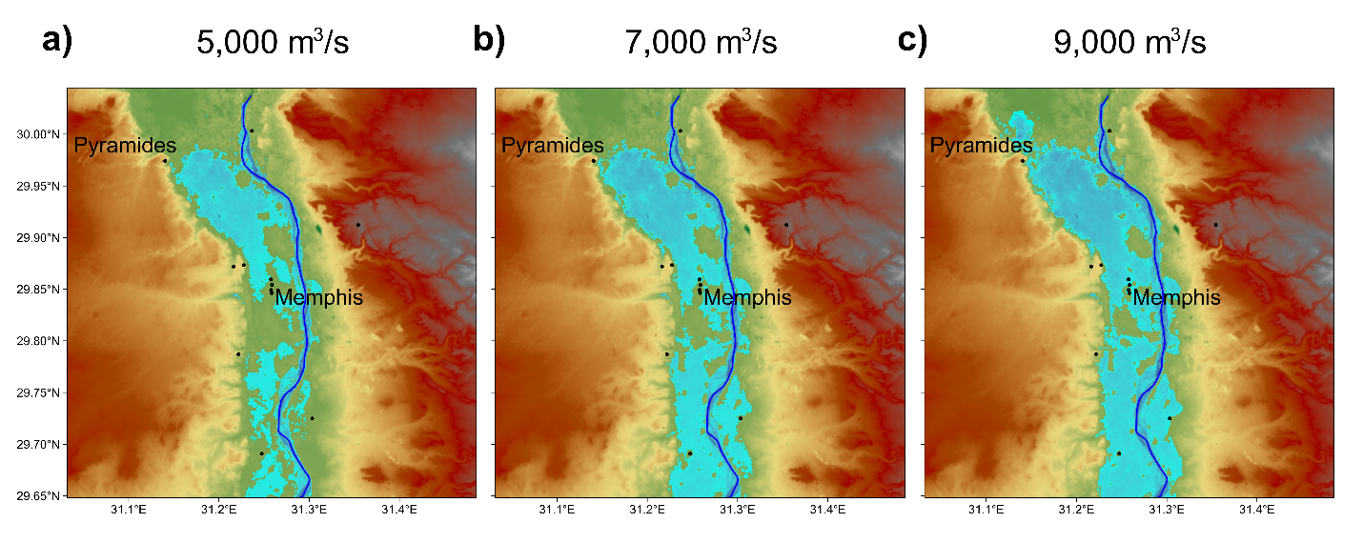
Fig. E4. Similar to Fig. 3, showing the northernmost region around Memphis.

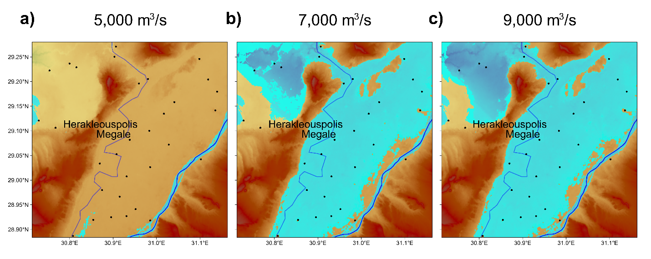
Fig. E5. Similar to Fig. 3, showing the region around Herakleouspolis Megale, near the mouth of the Fayum. Bahr Yussef is shown to the west as a blue line.

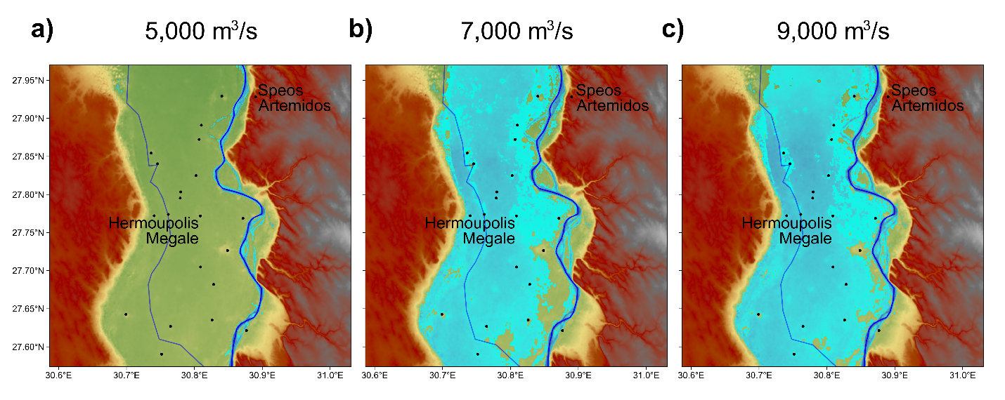
Fig. E6. Similar to Fig. 3, showing the region around Hermoupolis Megale, near the connection between the Bahr Yussef and the Nile.

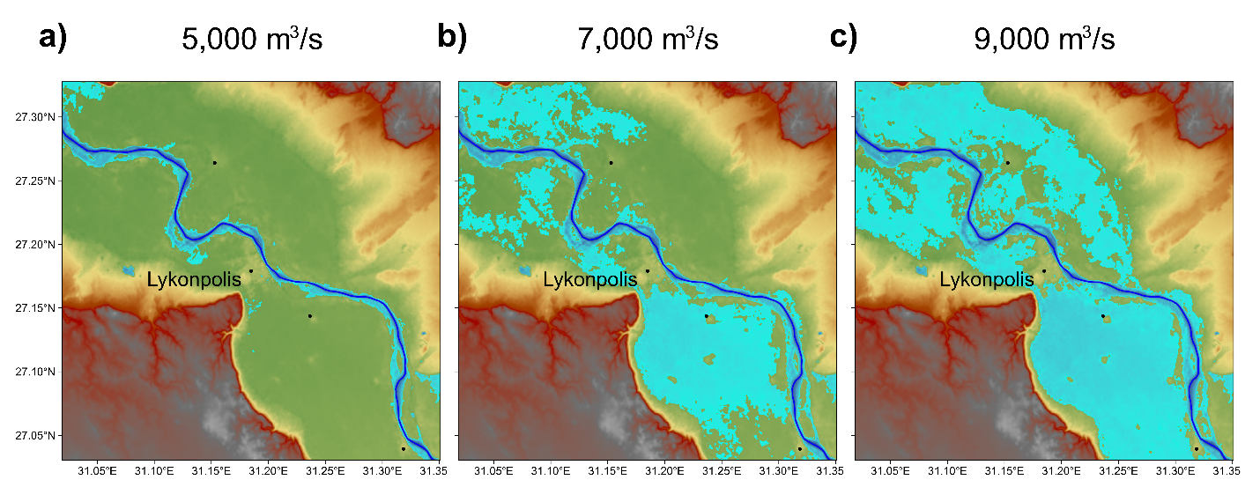
Fig. E7. Similar to Fig. 3, showing the region around Lykonpolis, modern day Asyut.

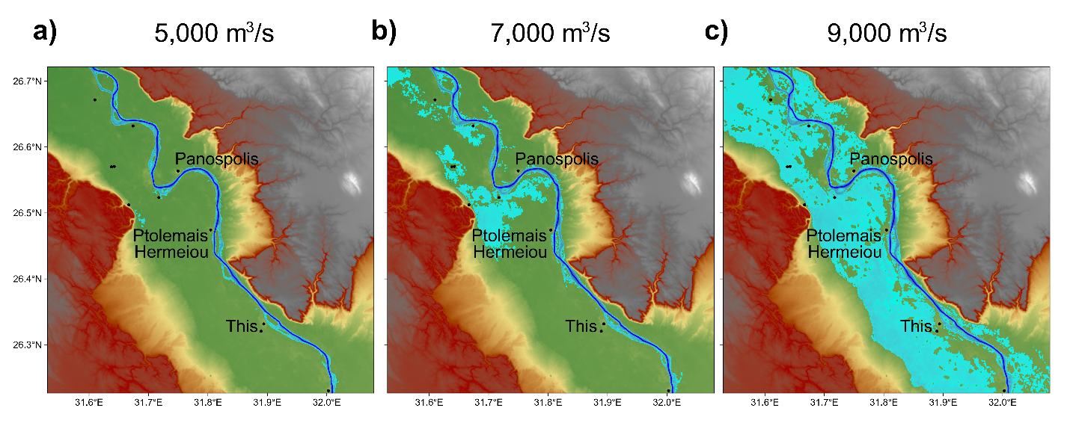
Fig. E8. Similar to Fig. 3, showing the region around Ptolemais Hermeiou, administrative capital of the Thebaid.

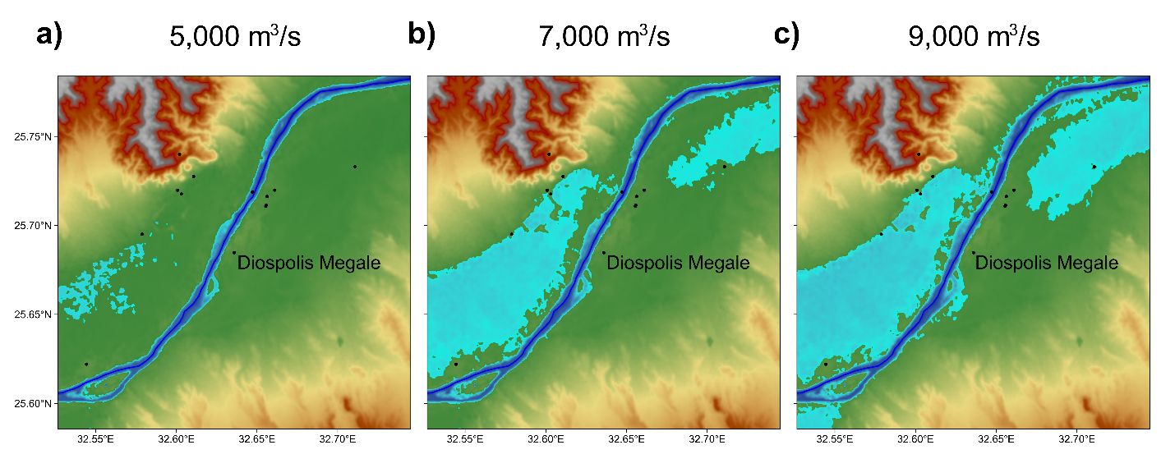
Fig. E9. Similar to Fig. 3, showing the region around Diospolis Megale, modern Thebes.
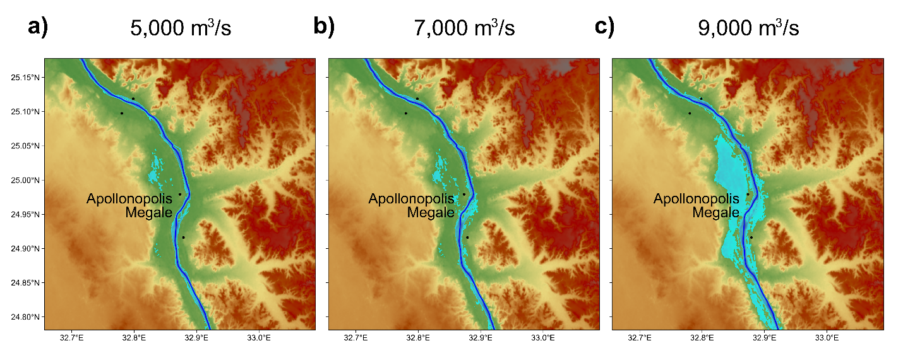
Fig. E10. Similar to Fig. 3, showing the region around Apollonopolis Megale, modern Edfu.

