Supplementary Information for

Enhanced superconductivity in the compressively strained bilayer nickelate thin films by pressure

Qing Li^{1†}, Jianping Sun^{2,3†}, Steffen Bötzel^{4†}, Mengjun Ou¹, Zhe-Ning Xiang¹, Frank Lechermann⁴, Bosen Wang^{2,3}, Yi Wang¹, Ying-Jie Zhang¹, Jinguang Cheng^{2,3*}, Ilya M. Eremin^{4*}, Hai-Hu Wen^{1*}

1. National Laboratory of Solid State Microstructures and Department of Physics, Collaborative Innovation Center of Advanced Microstructures, Nanjing University, Nanjing 210093, China.
2. Beijing National Laboratory for Condensed Matter Physics and Institute of Physics, Chinese Academy of Sciences, Beijing 100190, China.
3. School of Physical Sciences, University of Chinese Academy of Sciences, Beijing 100190, China.
4. Theoretical Physics III, Faculty of Physics and Astronomy Ruhr-University Bochum, D-44801 Bochum, Germany.
†These authors contribute equally to the work.
*Corresponding authors: jgcheng@iphy.ac.cn, Ilya.Eremin@ruhr-uni-bochum.de, hhwen@nju.edu.cn

CONTENTS

Supplementary Figure 1 Temperature dependent resistivity for an LSP₃₂₇ thin film (S5) under various magnetic fields applied along the c-axis.
Supplementary Figure 2 Magnetic field dependent Hall resistance (R_{xy}) at different temperatures for an LSP₃₂₇ thin film (S6) at ambient pressure.
Supplementary Figure 3 Pressure dependent R(T) curves for S2 in PCC.
Supplementary Figure 4 Pressure dependence of the exponent n that derived from the fitting to the R(T) data of S1and S2 with the formula $R(T)=R_{0}+AT^{n}$ in the temperature region from T_{c} to 100 K.
Supplementary Figure 5 Temperature dependence of resistance and Hall effect measurement for S6.
Supplementary Figure 6 Raw data of Hall Resistance and temperature dependent coefficient at different pressure.
Supplementary Figure 7 Temperature dependence of resistance of S4 under different pressures.
Supplementary Figure 8 DFT results by using different c lattice constants.
Supplementary Figure 9 Theoretical evolution of the spin fluctuations upon pressure with a doping of 0.1 holes per Ni atom.
Supplementary Figure 10 Theoretical evolution of the spin fluctuations upon pressure with a doping of 0.2 holes per Ni atom.

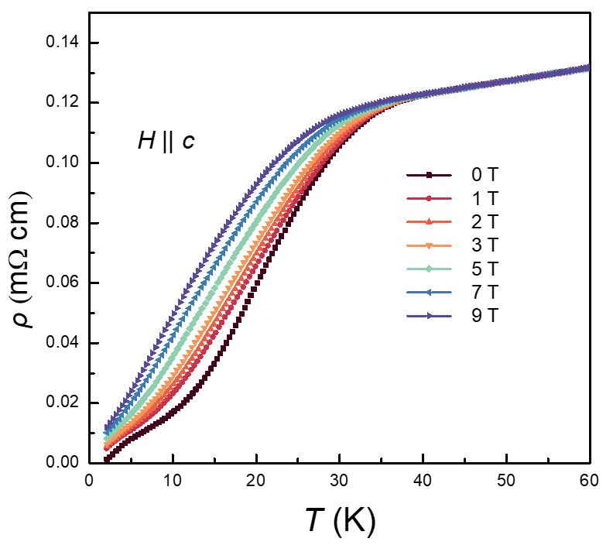
Supplementary Figure 1. Temperature dependent resistivity for an LSP₃₂₇ thin film (S5) under various magnetic fields applied along the c-axis.

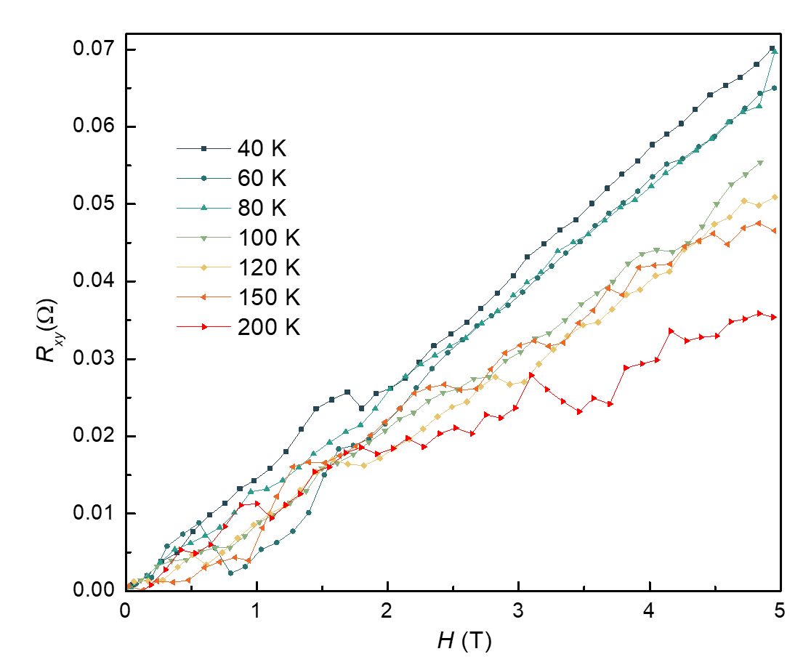
Supplementary Figure 2. Magnetic field dependent Hall resistance (R_{xy}) at different temperatures for an LSP₃₂₇ thin film (S6) at ambient pressure.

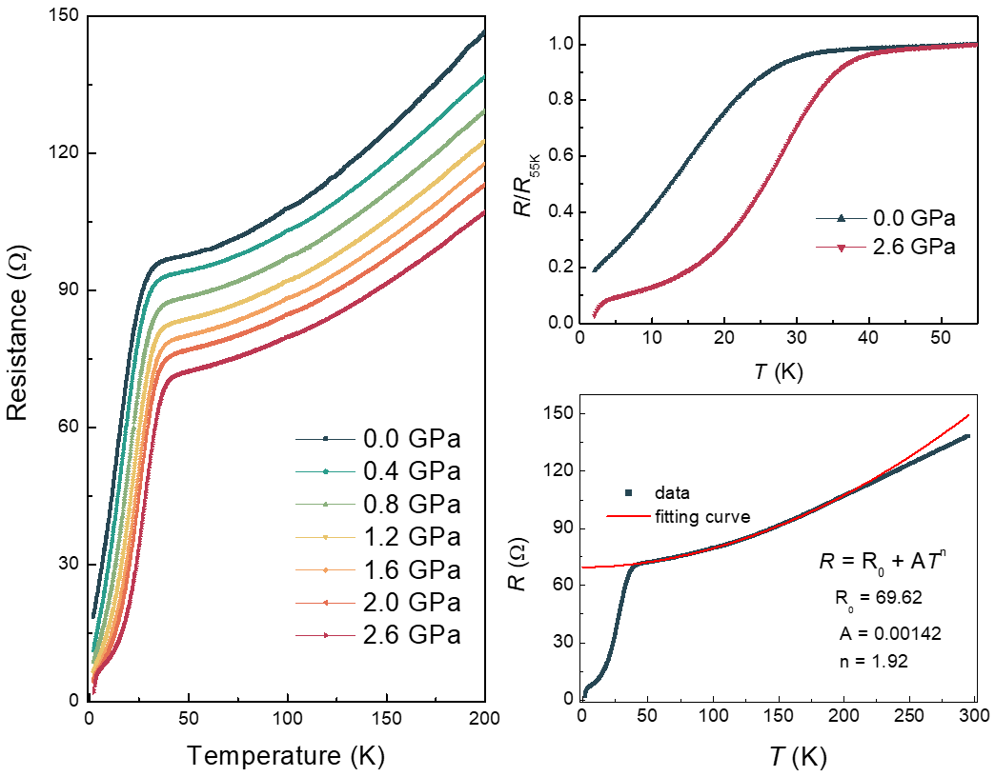
Supplementary Figure 3. Pressure dependent R(T) curves for S2 in PCC. a Temperature dependence of resistance of another LSP₃₂₇ thin film (S2) under various pressures a up to 2.6 GPa with Daphne 7373 as the PTM. b Normalized R/R_{55K}(T) curves in the temperature region from 2 to 55 K at 0 and 2.6 GPa. The superconducting transition temperature is clearly enhanced under pressures. c The R(T) curve of LSP₃₂₇ at 2.6 GPa. The temperature dependent resistance from T_{c} to 100 K can be well fitted by the equation $R(T)=R_{0}+AT^{n}$ with n = 1.92. With temperature above 200 K, the fitting curve deviates clearly from the experimental data.

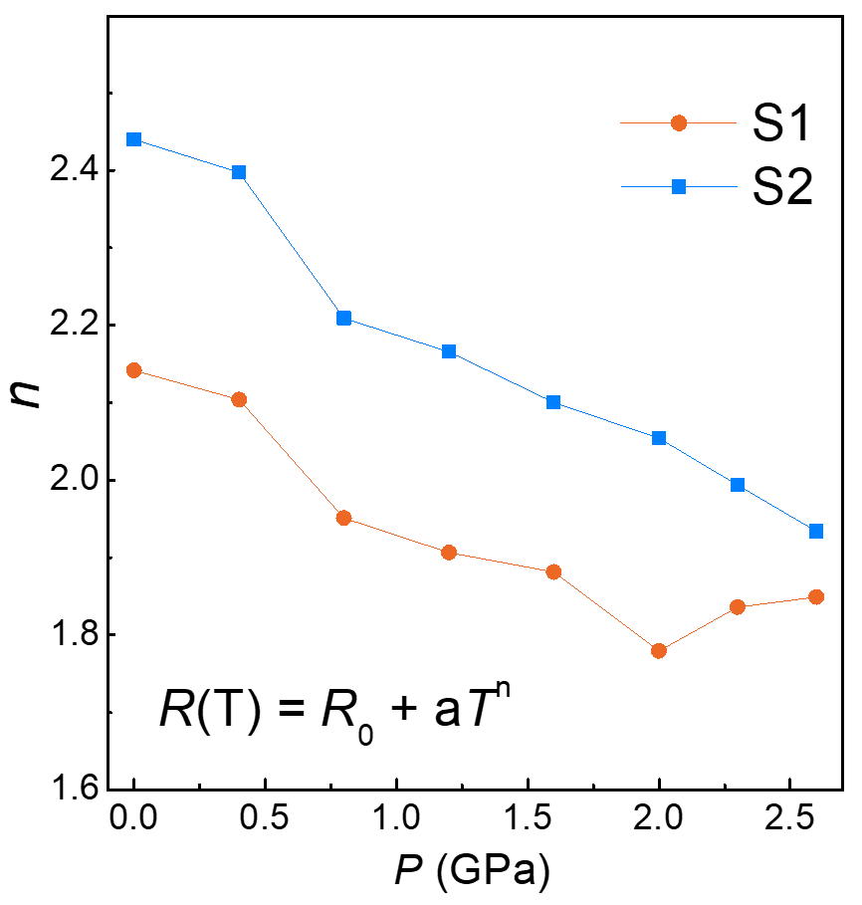
Supplementary Figure 4. Pressure dependence of the exponent n that derived from the fitting to the R(T) data of S1and S2 with the formula $R(T)=R_{0}+AT^{n}$ in the temperature region from T_{c} to 100 K. As the pressure increases, the n value gradually decreases.

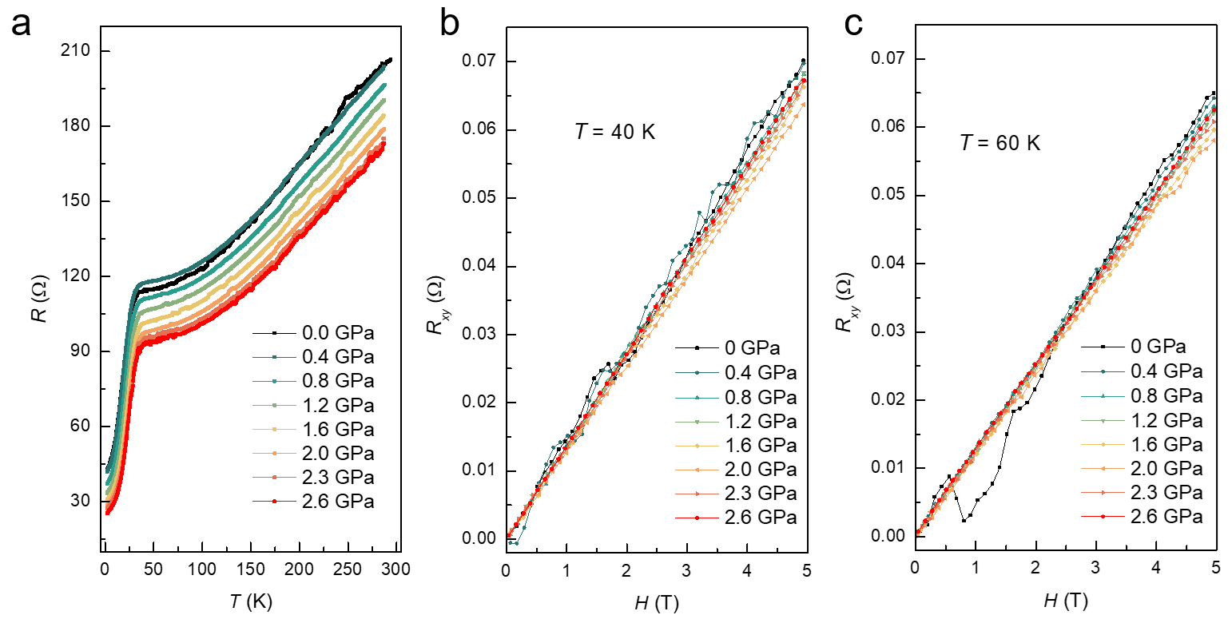
Supplementary Figure 5. Temperature dependence of resistance and Hall effect measurement for S6. a Temperature dependence of resistance of another LSP₃₂₇ thin film (S6) under various pressures up to 2.6 GPa. b, c Magnetic field dependent Hall resistance (R_{xy}) under pressures at 40 and 60 K, respectively. the slop of Hall resistance versus magnetic field curves at 2.3 and 2.6 K show some abnormal increases, which may be caused by the solidification of PTM Daphne 7373 above 2.2 GPa.
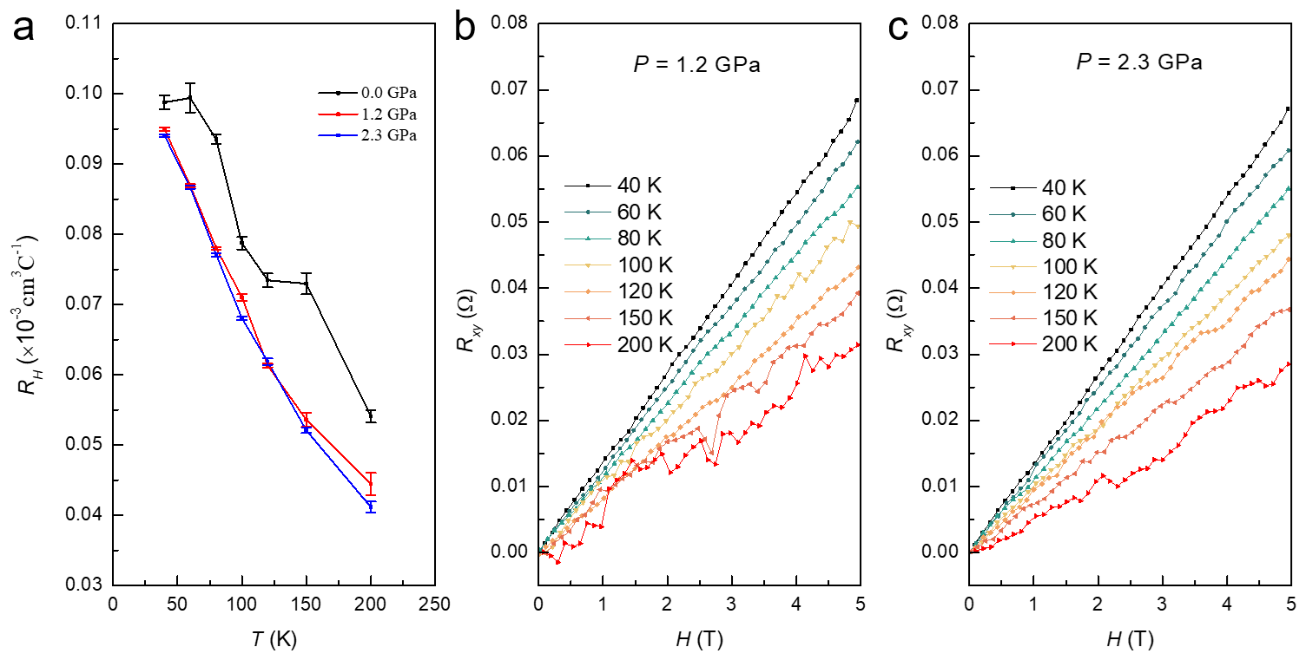
Supplementary Figure 6. Raw data of Hall Resistance and temperature dependent coefficient at different pressure. a The evolution of Hall coefficients (R_{H}) under different temperature under various pressures. b, c Magnetic field dependent Hall resistance (R_{xy}) under different temperatures at 1.2 and 2.3 GPa, respectively. Under high pressures, the R_{H} still shows clear temperature dependence and the charge carrier is hole type in the whole temperature region we measured.

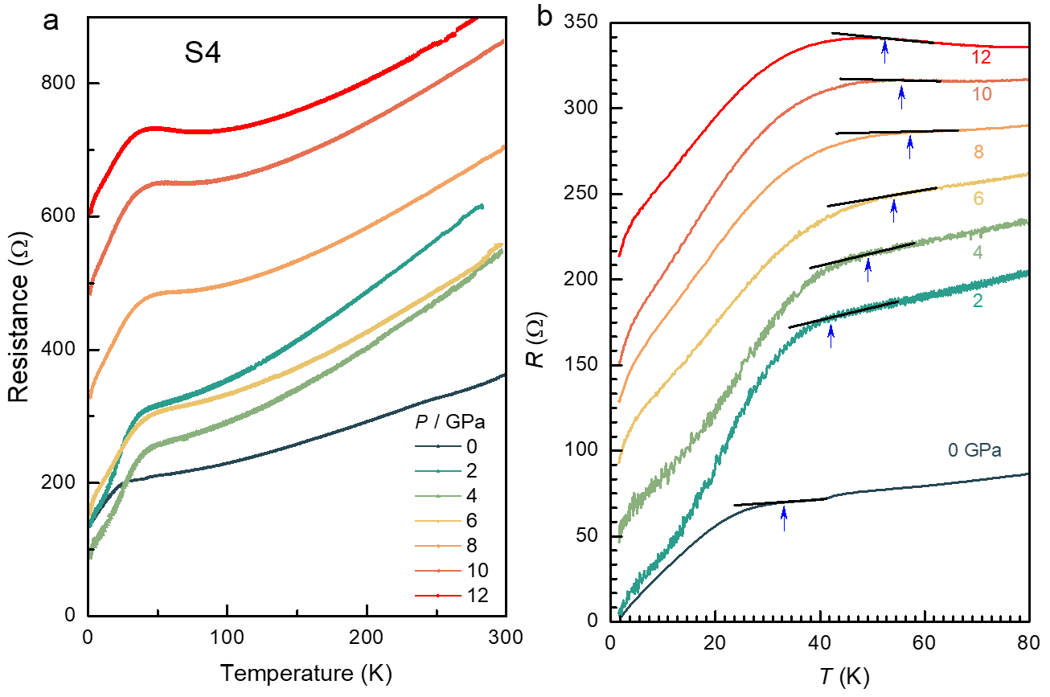
Supplementary Figure 7. Temperature dependence of resistance of S4 under different pressures. a Temperature dependence of resistance R(T) of a LSP₃₂₇ thin film (S4) under various pressures up to 12 GPa with Daphne 7373 as PTM. b The enlarged view of R(T) curves below 80 K for S4, respectively. To illustrate the variation of the superconducting transition temperatures with pressure more clearly, the R(T) curves in b have been vertically shifted. The T_{c}^{onset} (up-pointing arrow) was determined as the temperature where resistance starts to deviate from the extrapolated normal-state behavior.
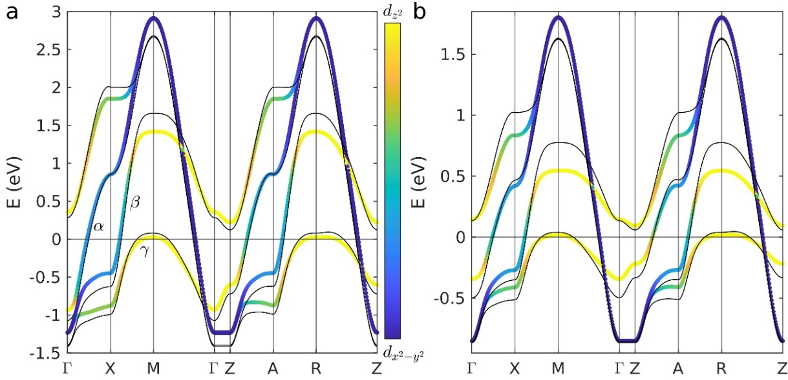
Supplementary Figure 8. DFT results by using different c lattice constants. Calculated DFT (a) and slave-boson renormalized (b) band structures for the two-orbital bilayer model for ambient pressure shown with color scheme visualizing the orbital content and for $Δc/c_{0}$= 5% shown as black line.

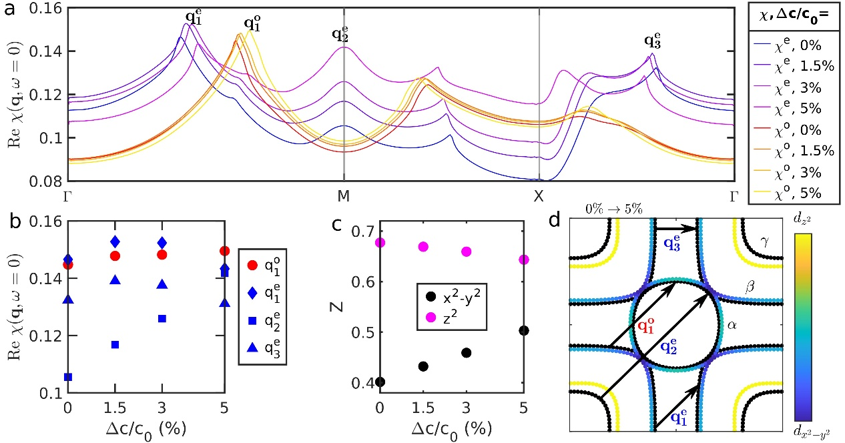
Supplementary Figure 9. Theoretical evolution of the spin fluctuations upon pressure. Same as Figure 5 but for a doping of 0.1 holes per Ni atom.

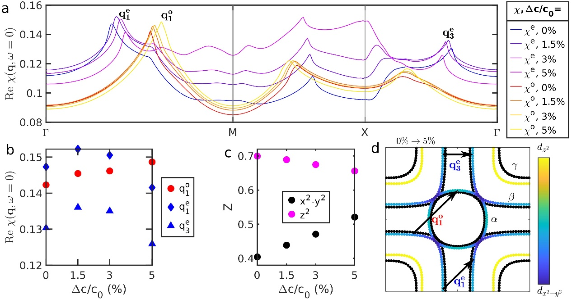
Supplementary Figure 10. Theoretical evolution of the spin fluctuations upon pressure. Same as Figure 5 but for a doping of 0.2 holes per Ni atom.

