Supplementary Table 1: Percentage changes in cervical cancer incidence among women of all ages in India and its states over the period 1990 to 2019.
State | Percentage Changes in Cervical Cancer Incidence
State | 1990-2000 | 2000-10 | 2010-19 | 1990-2019
Andhra Pradesh | -11.45 | -14.79 | -8.21 | -30.74
Arunachal Pradesh | -16.54 | -4.13 | -7.47 | -25.96
Assam | 5.98 | -16.37 | -6.59 | -17.22
Bihar | -6.86 | -1.81 | -5.68 | -13.73
Chhattisgarh | -11.65 | -4.09 | -7.69 | -21.78
Delhi | -14.99 | -26.98 | -12.40 | -45.62
Goa | -13.91 | -10.33 | -10.59 | -30.98
Gujarat | -23.27 | -3.08 | 14.07 | -15.17
Haryana | -4.80 | -15.85 | 4.23 | -16.49
Himachal Pradesh | -19.72 | -30.87 | -6.92 | -48.34
Jammu & Kashmir and Ladakh | -12.83 | -1.59 | -1.27 | -15.31
Jharkhand | -28.47 | -16.75 | -16.40 | -50.22
Karnataka | -8.96 | -17.48 | 22.11 | -8.26
Kerala | -2.85 | -19.44 | -6.35 | -26.71
Madhya Pradesh | -6.01 | -12.94 | -0.21 | -18.34
Maharashtra | -6.31 | -23.86 | 22.16 | -12.85
Manipur | -13.18 | -3.15 | -6.58 | -21.45
Meghalaya | -15.50 | -10.06 | -6.39 | -28.85
Mizoram | -10.54 | -0.93 | -10.24 | -20.45
Nagaland | -15.88 | -10.64 | -6.39 | -29.63
Odisha | -5.16 | -15.98 | -13.84 | -31.35
Other Union Territories | -14.44 | -15.43 | -9.48 | -34.50
Punjab | -1.57 | -19.68 | 11.45 | -11.89
Rajasthan | -1.23 | -21.83 | 30.02 | 0.38
Sikkim | -15.15 | -5.46 | -14.84 | -31.69
Tamil Nadu | -8.59 | -23.64 | -7.76 | -35.61
Telangana | -15.24 | -12.10 | -11.21 | -33.85
Tripura | -15.22 | -11.28 | -8.41 | -31.10
Uttar Pradesh | -9.76 | -17.36 | 23.62 | -7.82
Uttarakhand | -7.50 | -11.54 | -14.80 | -30.28
West Bengal | 2.67 | -28.57 | -3.29 | -29.08
India | -8.86 | -17.88 | 5.12 | -21.32

Supplementary Table 2: Percentage changes in cervical cancer mortality among women of all ages in India and its states over the period 1990 to 2019.
State | Percentage Changes in Cervical Cancer Mortality
State | 1990_2000 | 2000_2010 | 2010_19 | 1990_2019
Andhra Pradesh | -14.30 | -21.35 | -11.59 | -40.41
Arunachal Pradesh | -18.56 | -11.04 | -10.52 | -35.18
Assam | 4.15 | -18.01 | -13.34 | -26.01
Bihar | -8.66 | -10.14 | -8.38 | -24.80
Chhattisgarh | -12.74 | -8.42 | -8.96 | -27.25
Delhi | -15.98 | -30.62 | -16.51 | -51.33
Goa | -16.05 | -19.90 | -14.74 | -42.67
Gujarat | -27.00 | -11.98 | 7.29 | -31.06
Haryana | -7.93 | -19.46 | -0.80 | -26.44
Himachal Pradesh | -21.63 | -33.02 | -11.18 | -53.37
Jammu & Kashmir and Ladakh | -14.49 | -9.08 | -5.15 | -26.26
Jharkhand | -30.42 | -22.99 | -18.19 | -56.16
Karnataka | -12.76 | -19.24 | 15.00 | -18.98
Kerala | -8.41 | -28.02 | -12.06 | -42.03
Madhya Pradesh | -8.25 | -16.83 | -4.93 | -27.45
Maharashtra | -9.81 | -29.26 | 14.83 | -26.73
Manipur | -13.52 | -8.27 | -8.62 | -27.51
Meghalaya | -17.02 | -14.42 | -8.00 | -34.66
Mizoram | -12.76 | -6.23 | -11.31 | -27.45
Nagaland | -17.09 | -16.27 | -7.86 | -36.03
Odisha | -5.80 | -21.20 | -17.01 | -38.40
Other Union Territories | -14.84 | -21.76 | -12.18 | -41.49
Punjab | -4.66 | -24.60 | 6.33 | -23.56
Rajasthan | -5.92 | -28.62 | 23.10 | -17.34
Sikkim | -16.71 | -12.61 | -18.14 | -40.41
Tamil Nadu | -10.17 | -27.35 | -14.50 | -44.20
Telangana | -16.69 | -20.08 | -17.21 | -44.88
Tripura | -17.77 | -15.59 | -10.17 | -37.65
Uttar Pradesh | -12.19 | -22.45 | 18.14 | -19.56
Uttarakhand | -8.46 | -18.27 | -18.69 | -39.16
West Bengal | -1.94 | -33.83 | -10.57 | -41.97
India | -11.56 | -23.05 | -0.48 | -32.27

Supplementary Figure 1: Trends in age standardized cervical cancer Incidence rate using joinpoint regression analysis acrossstates of India
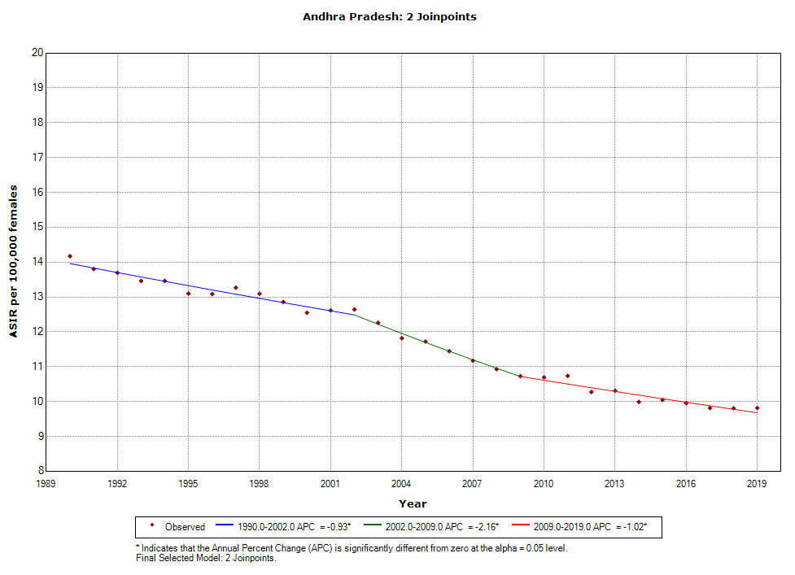 | 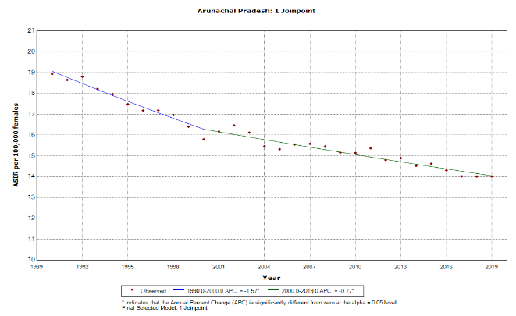 | 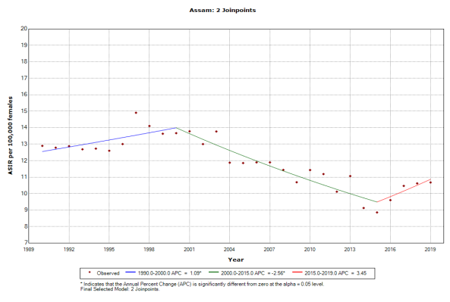
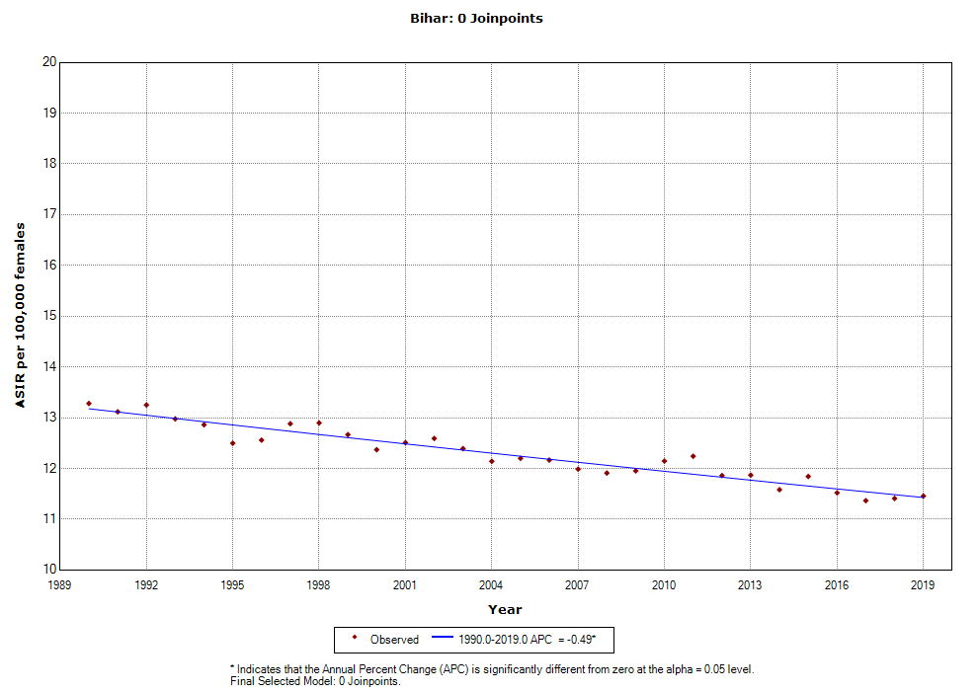 | 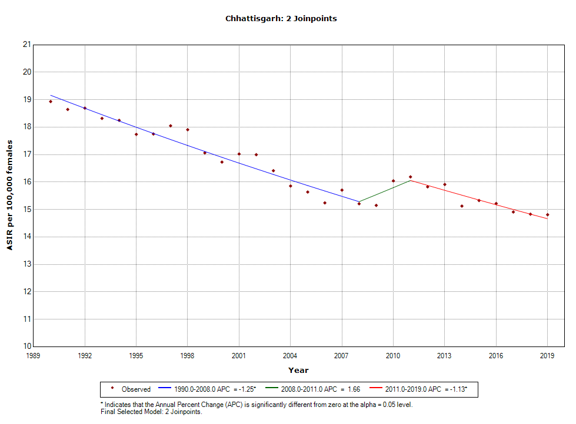 | 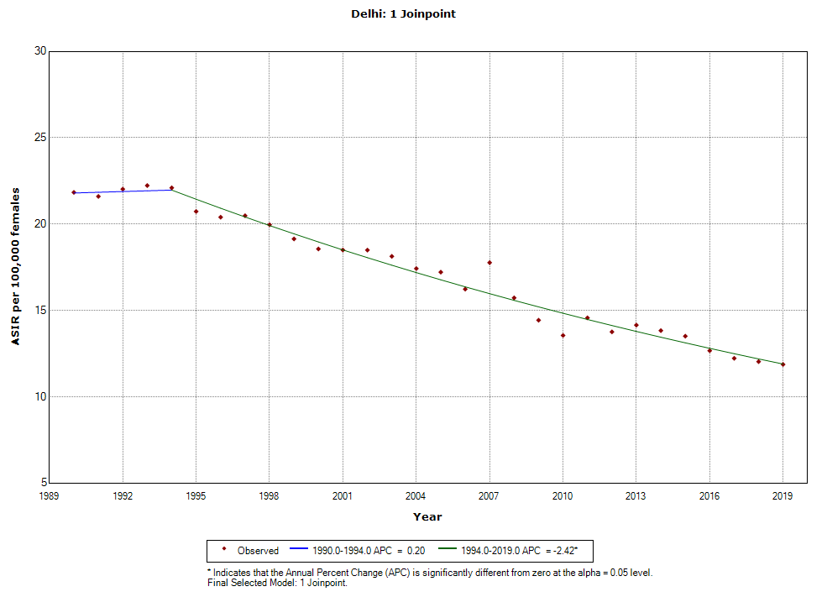
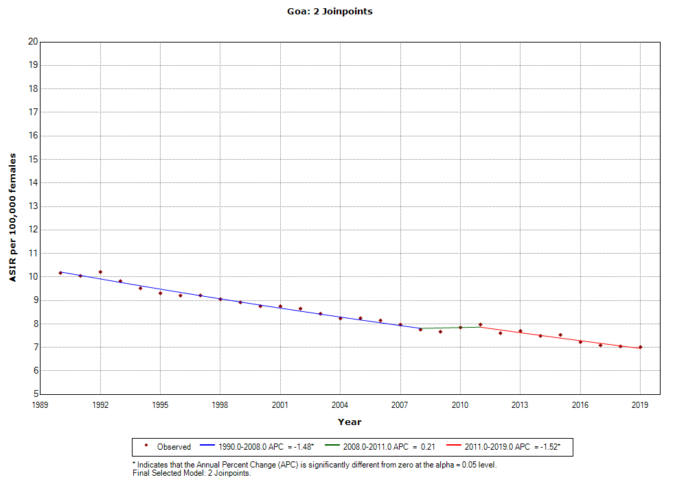 | 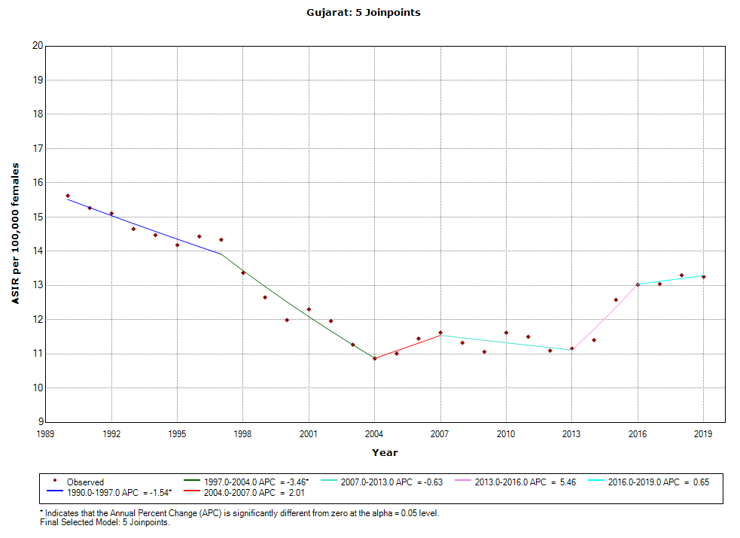 | 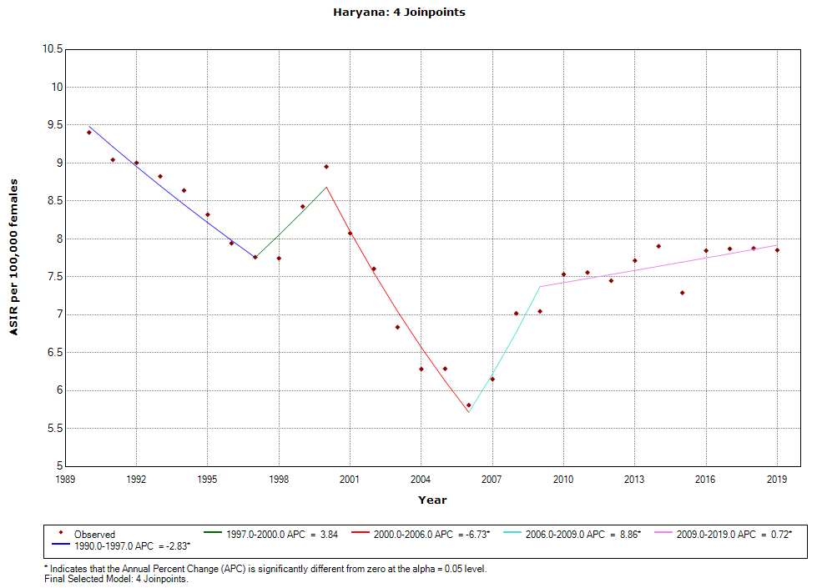
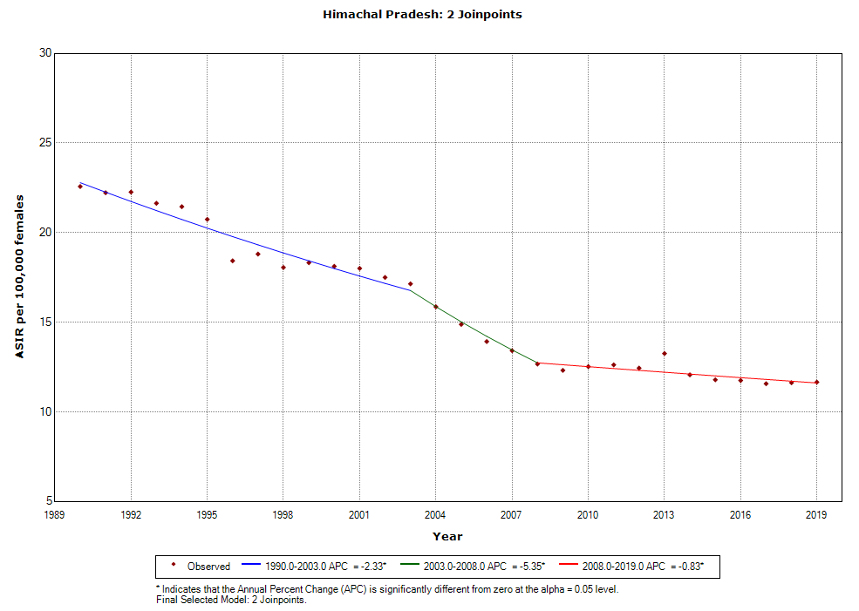 | 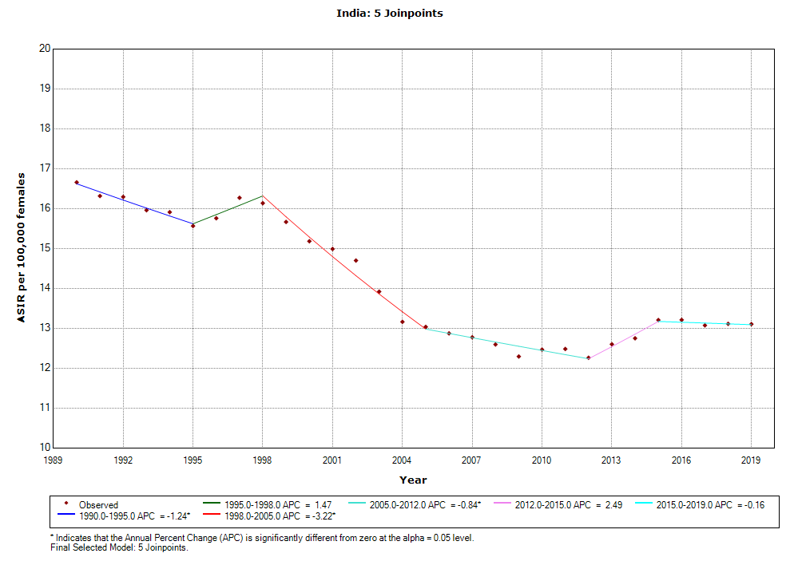 | 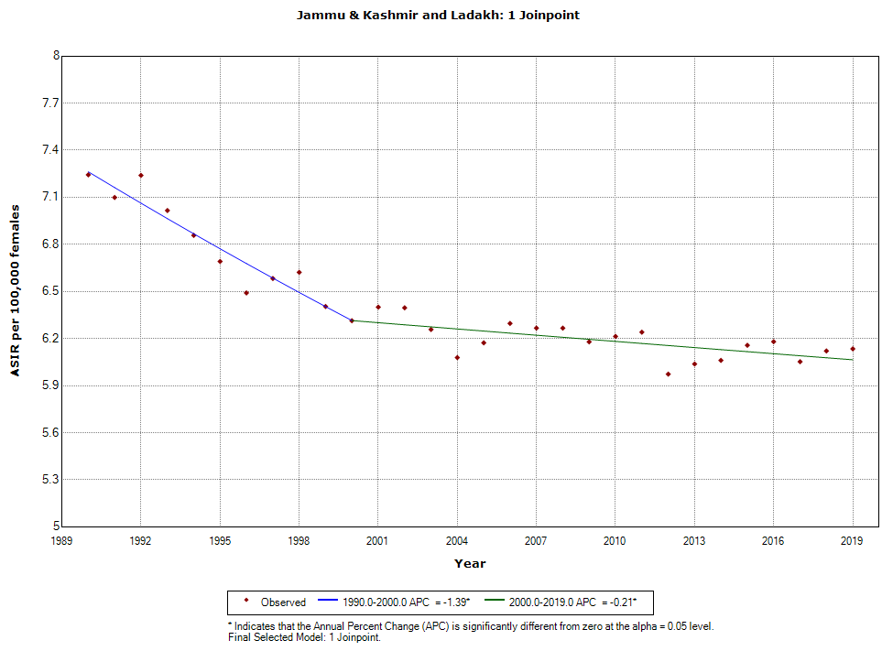
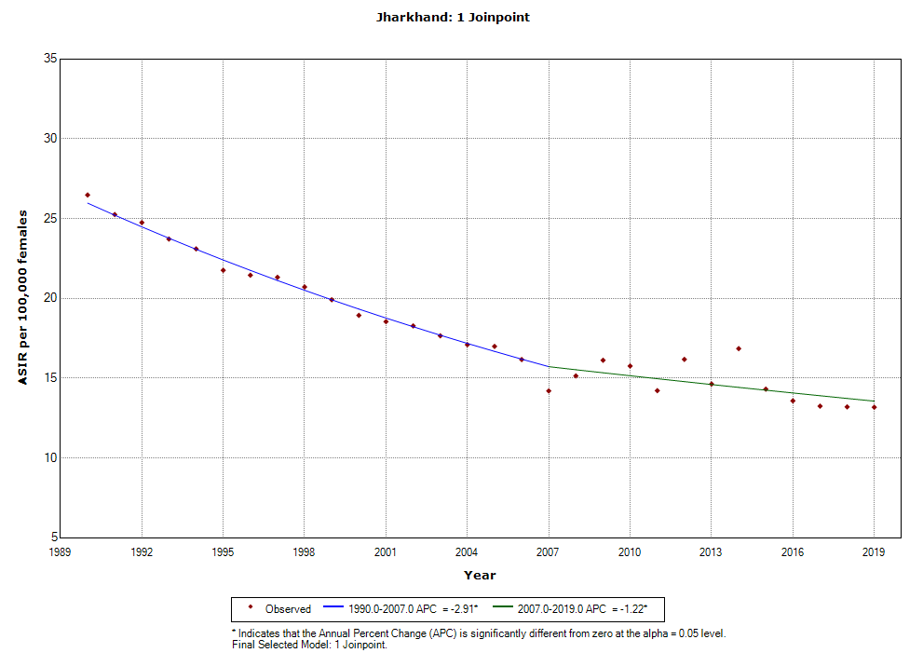 | 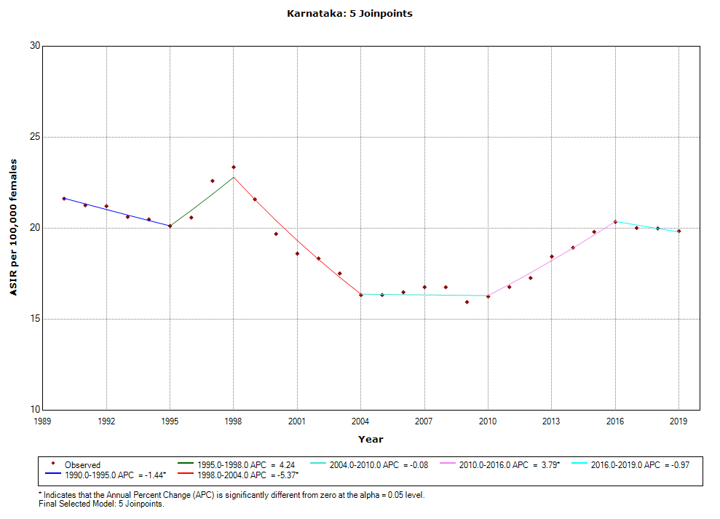 | 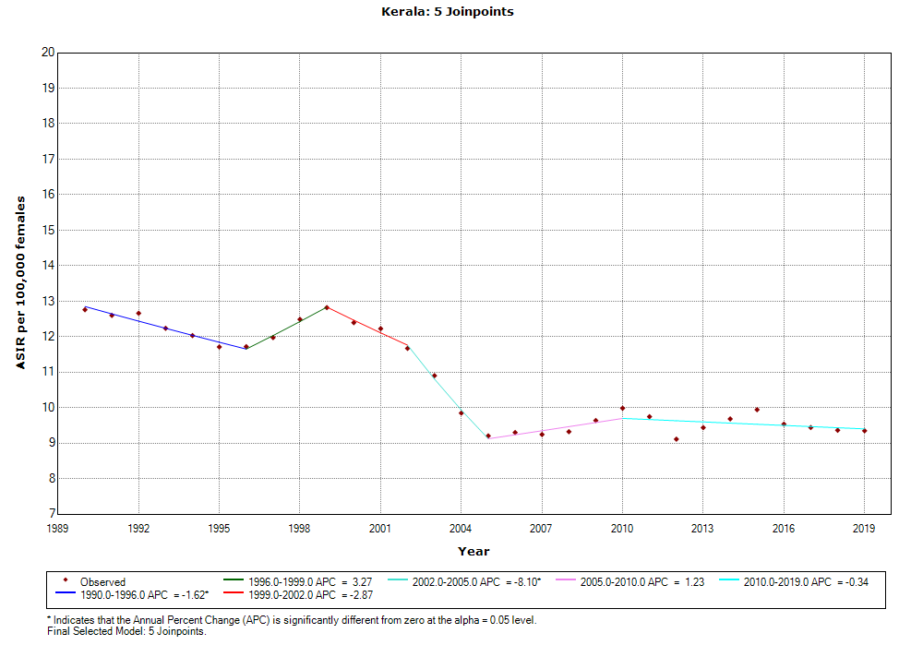
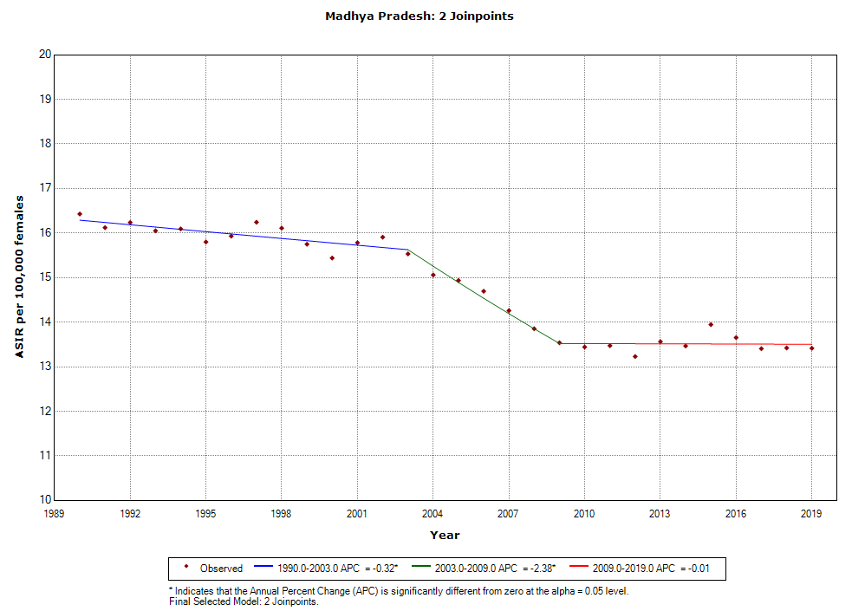 | 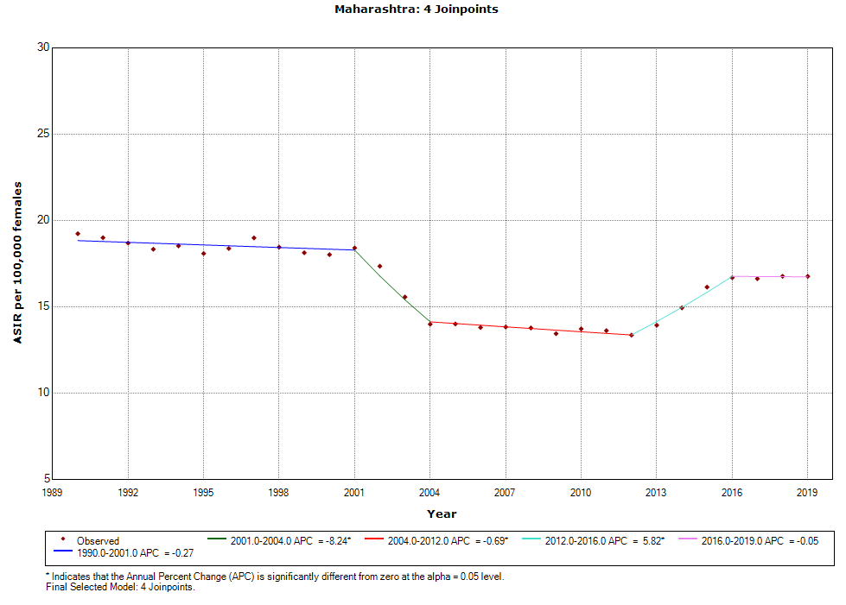 | 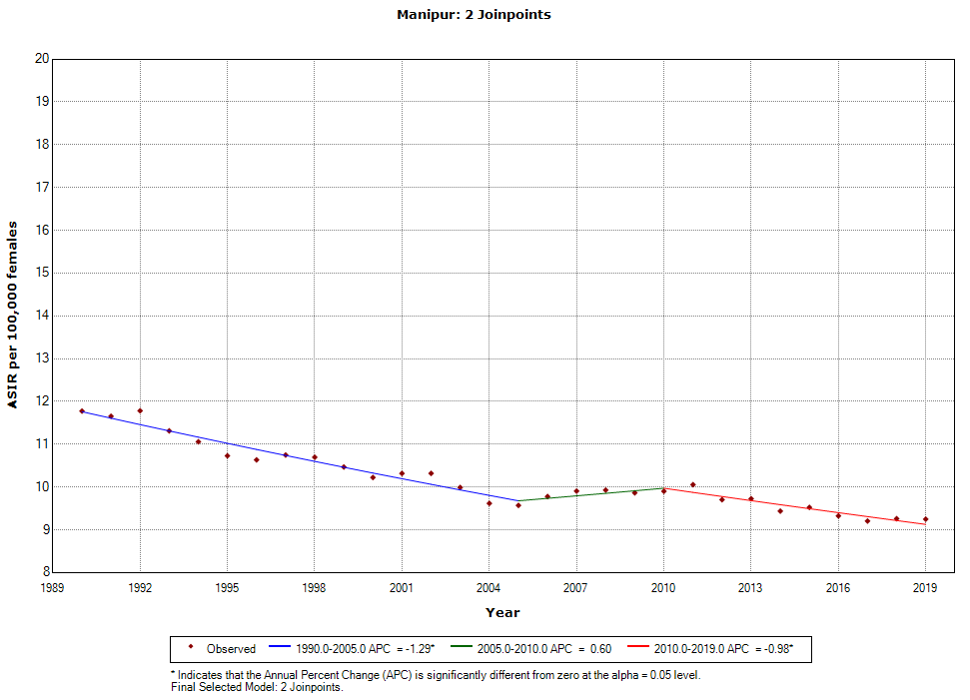
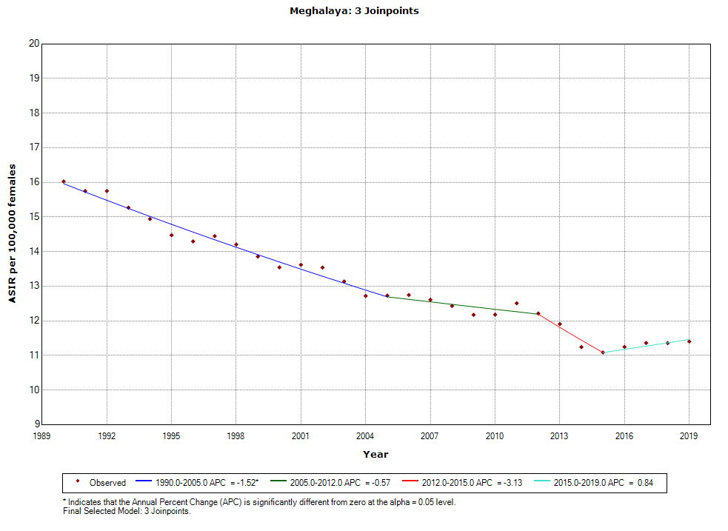 | 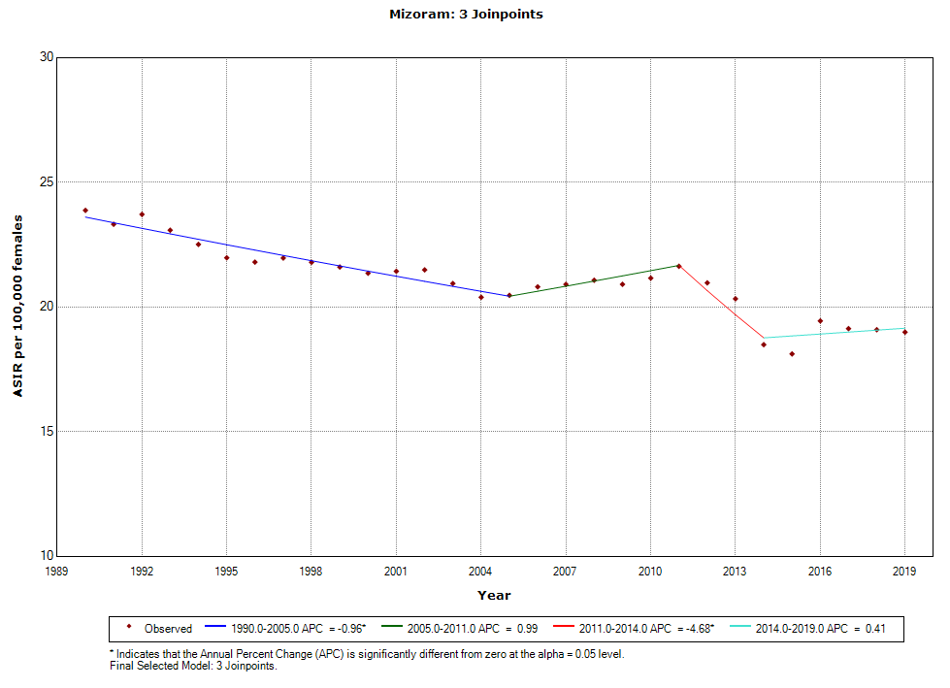 | 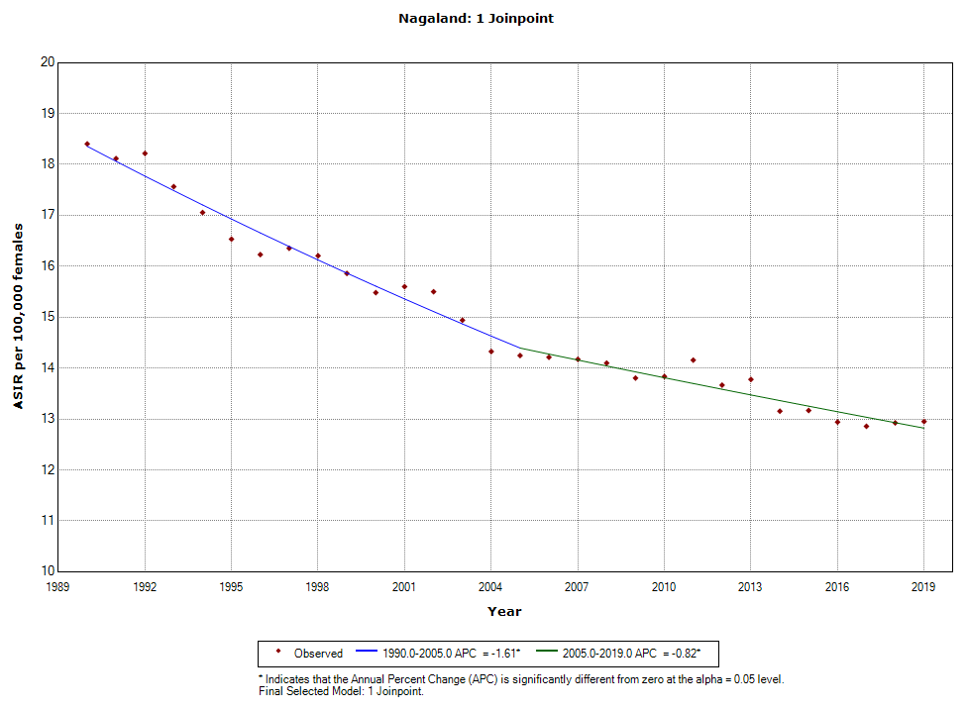
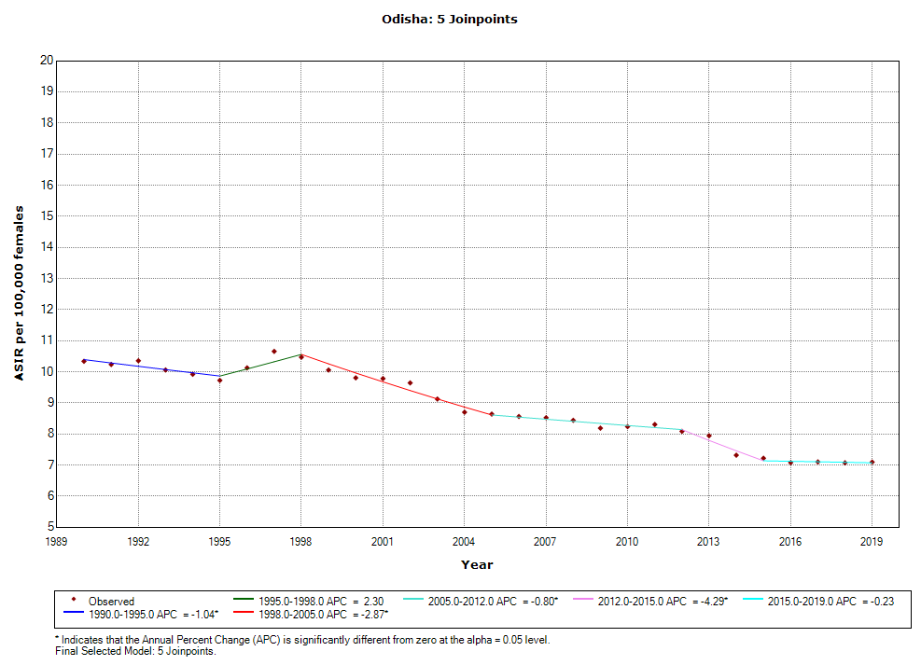 | 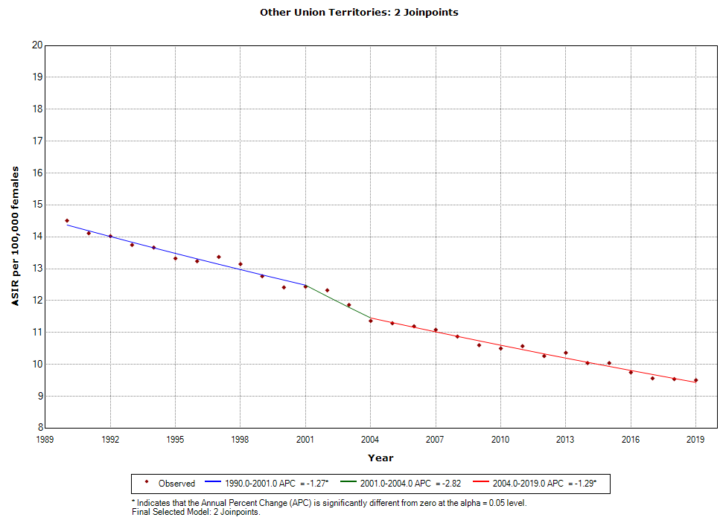 | 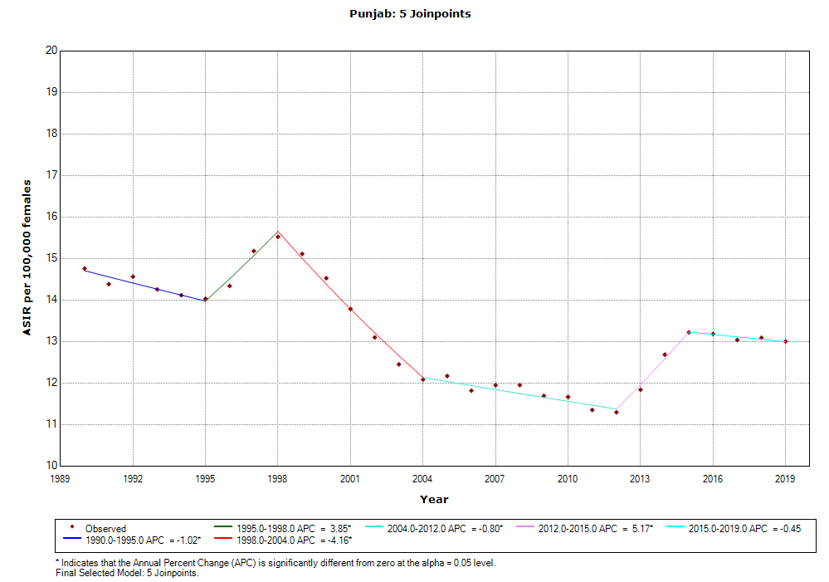
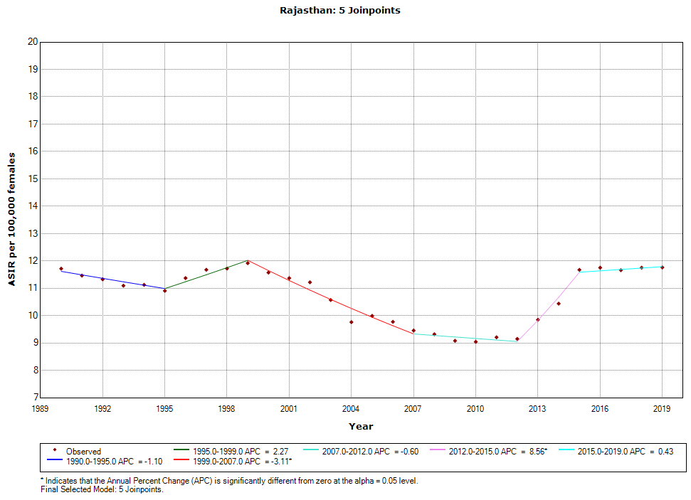 | 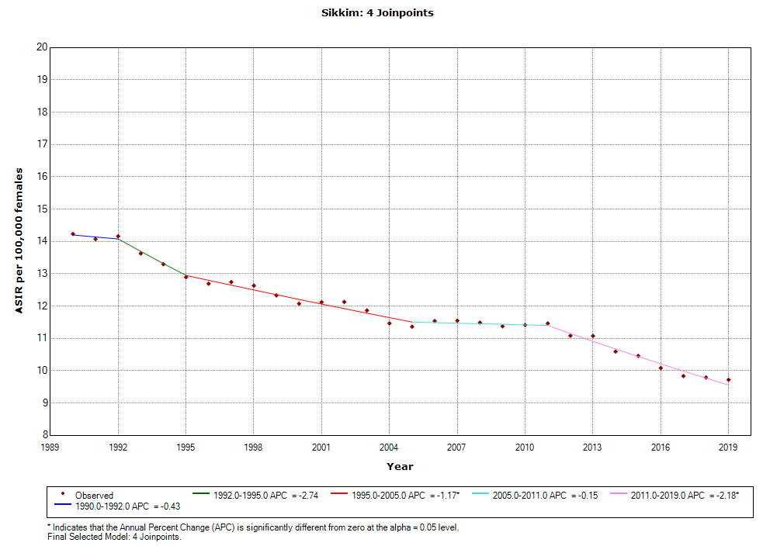 | 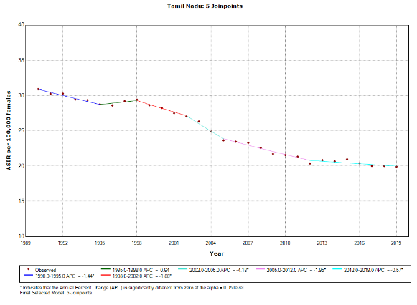
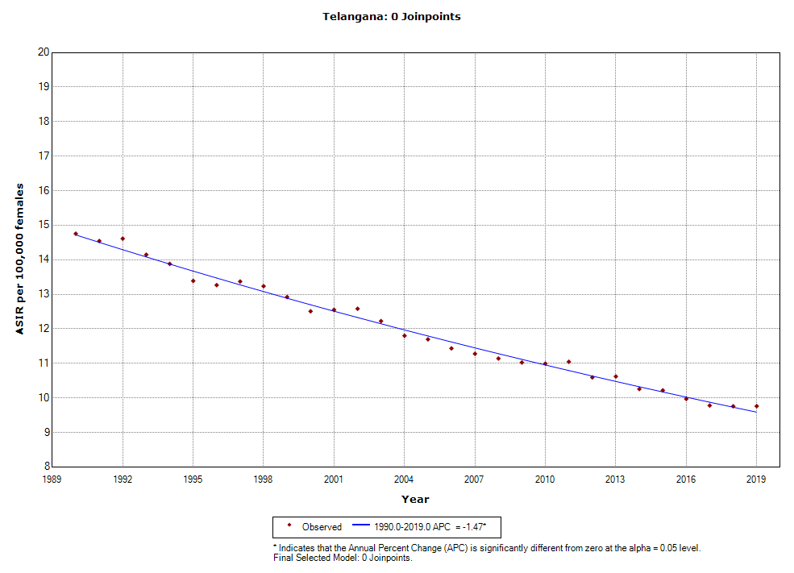 | 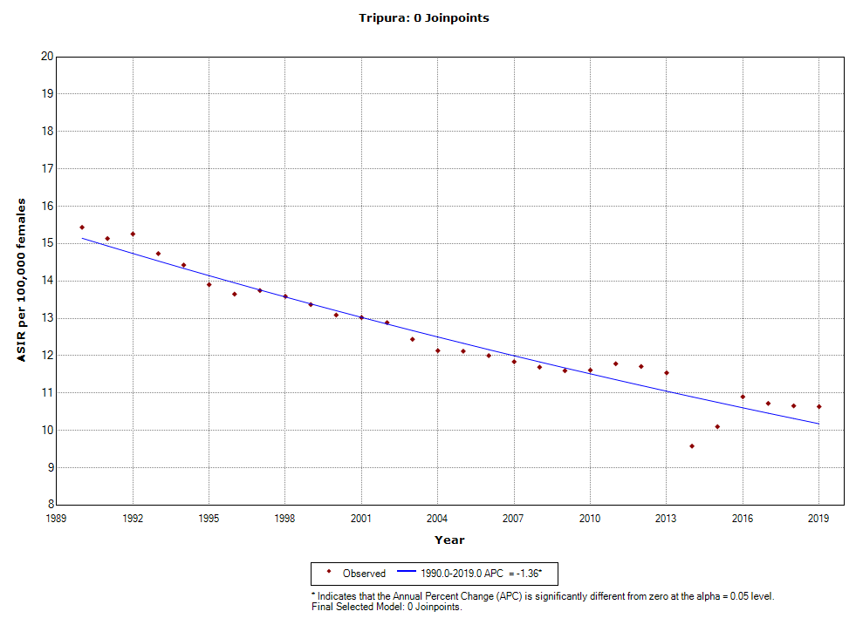 | 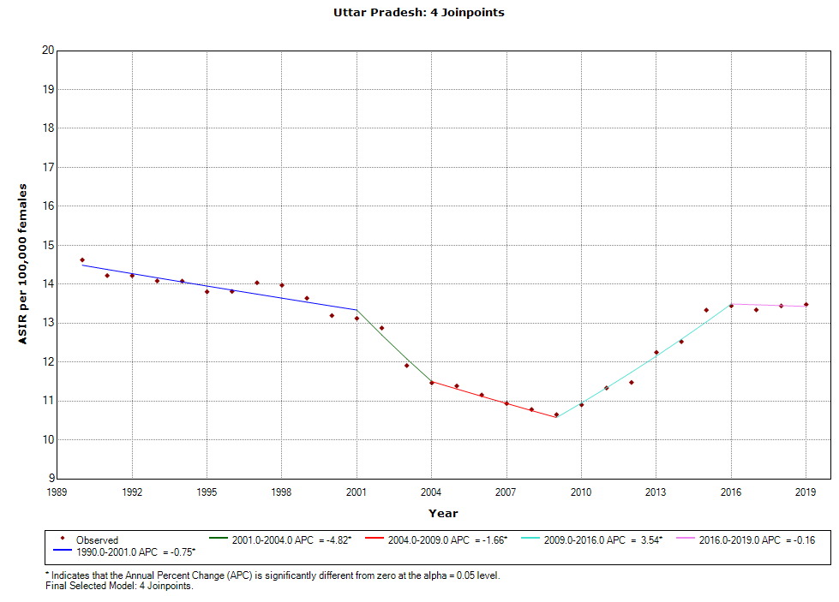
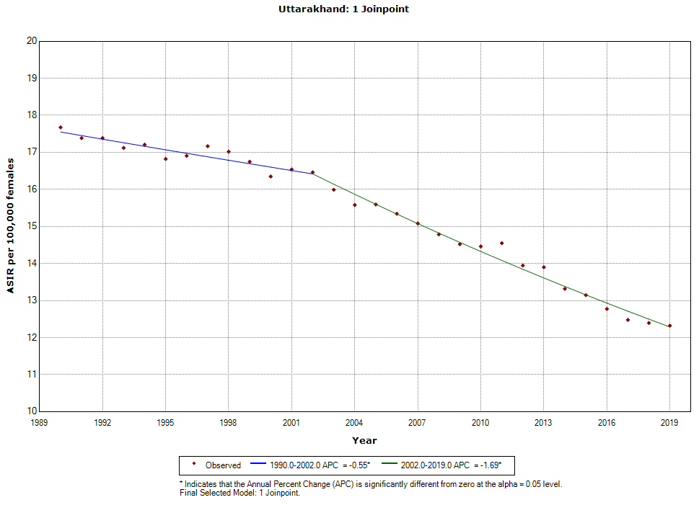 | 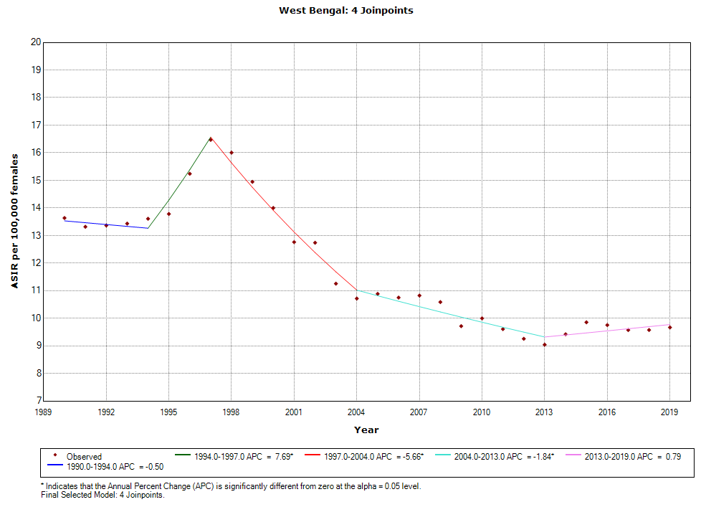
Supplementary Figure 2: Trends in age standardized mortality rate of cervical cancer using joinpoint regression analysis across states of India
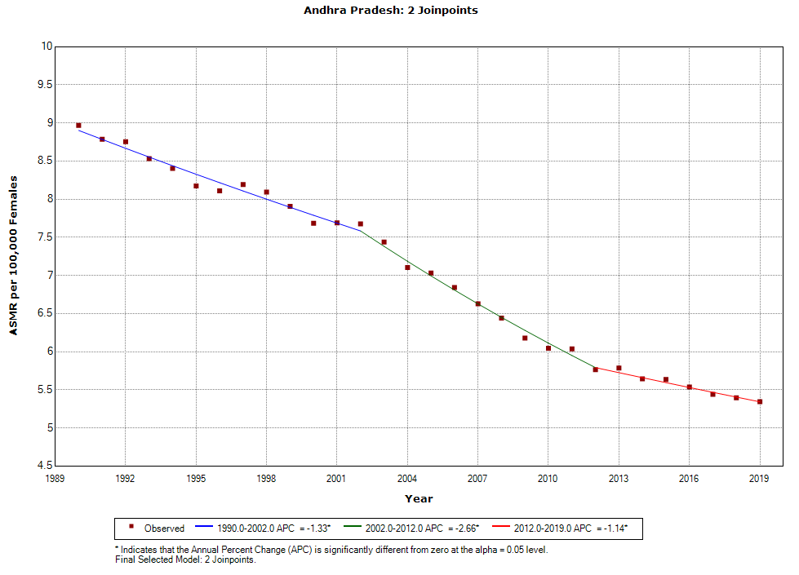 | 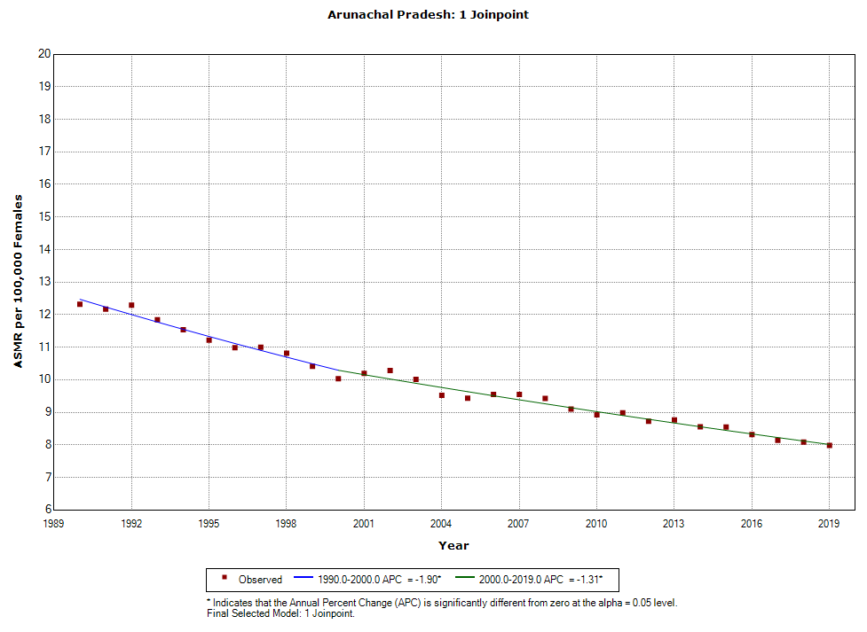 | 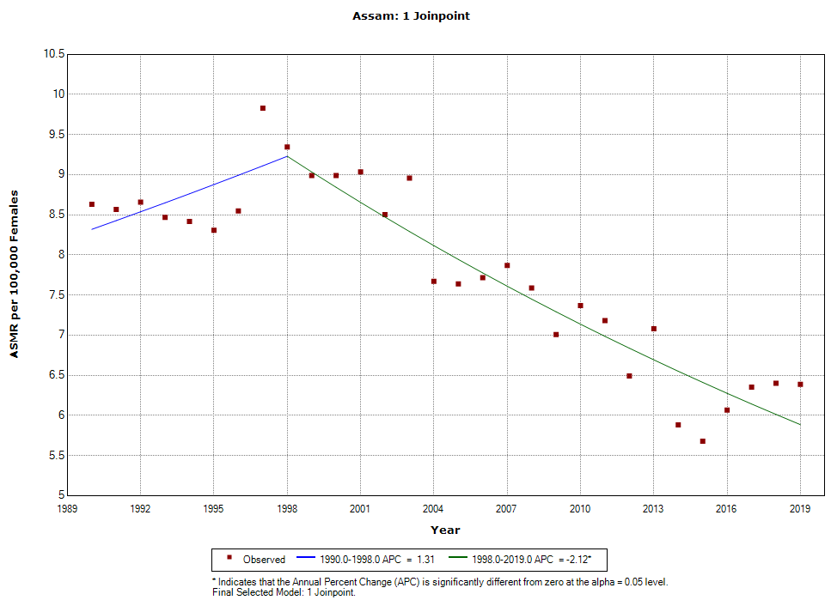
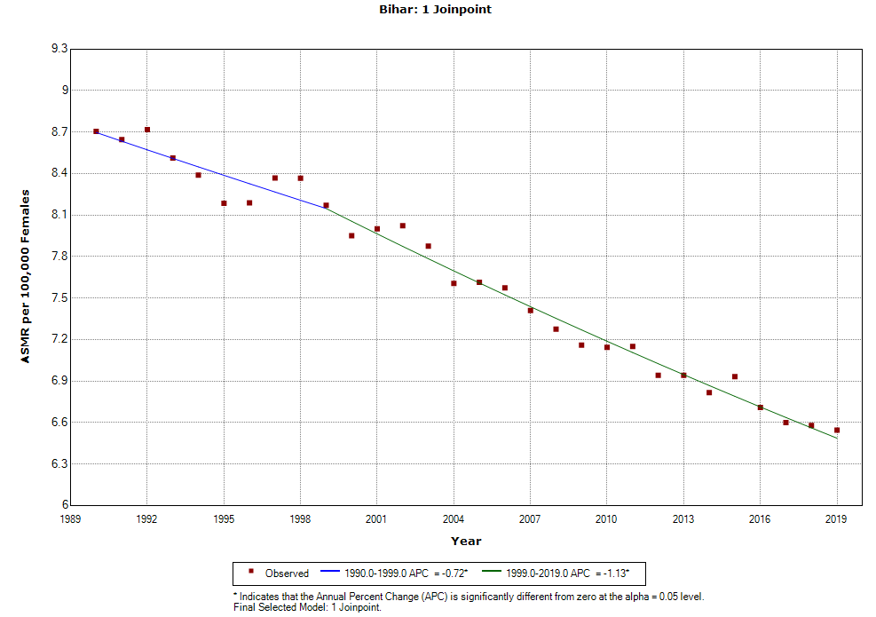 | 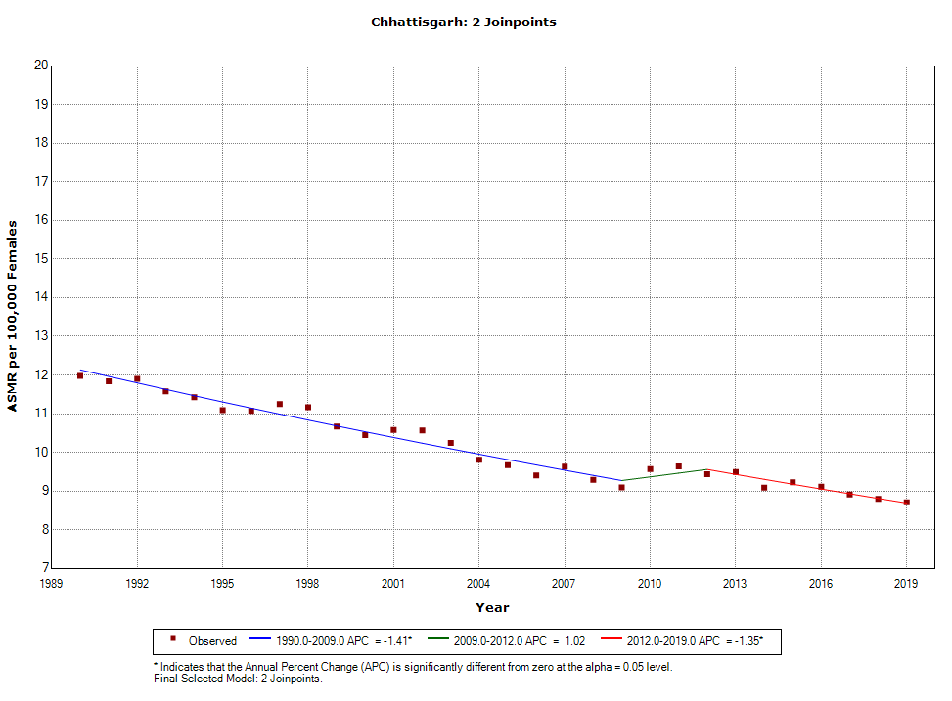 | 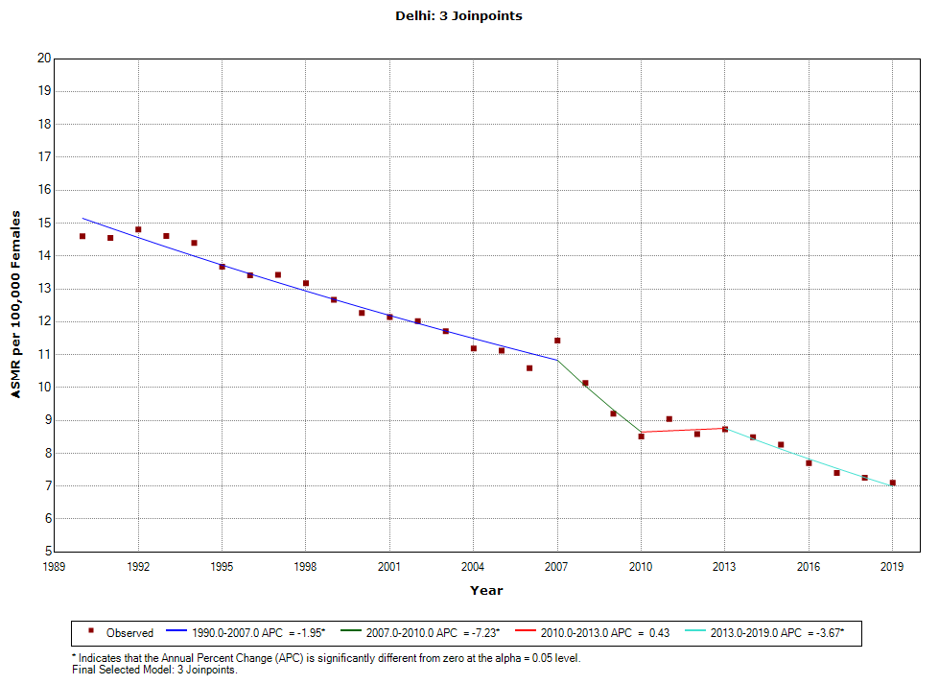
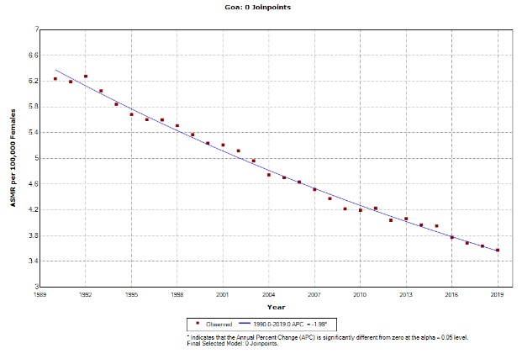 | 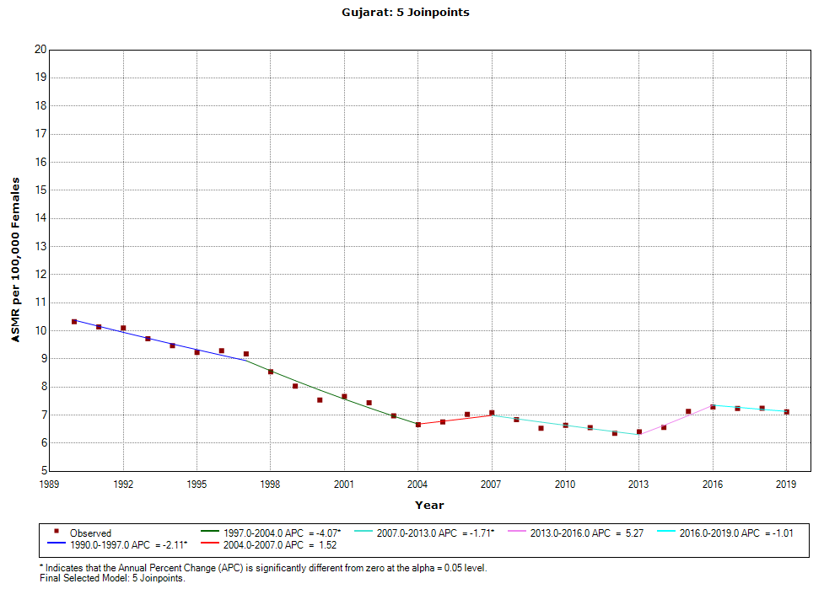 | 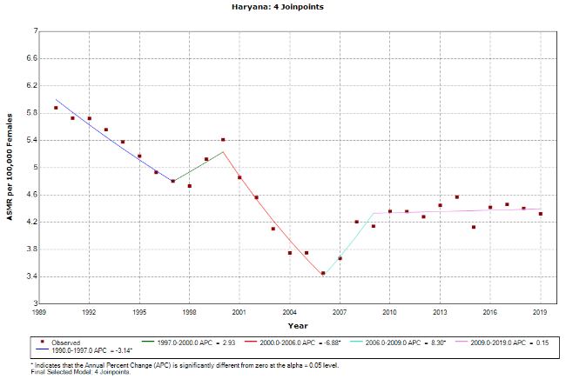
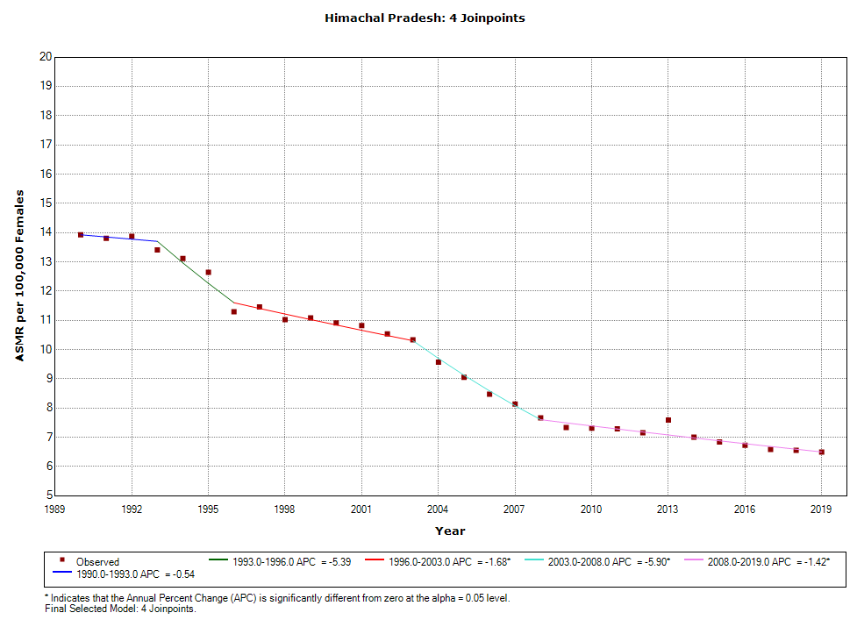 | 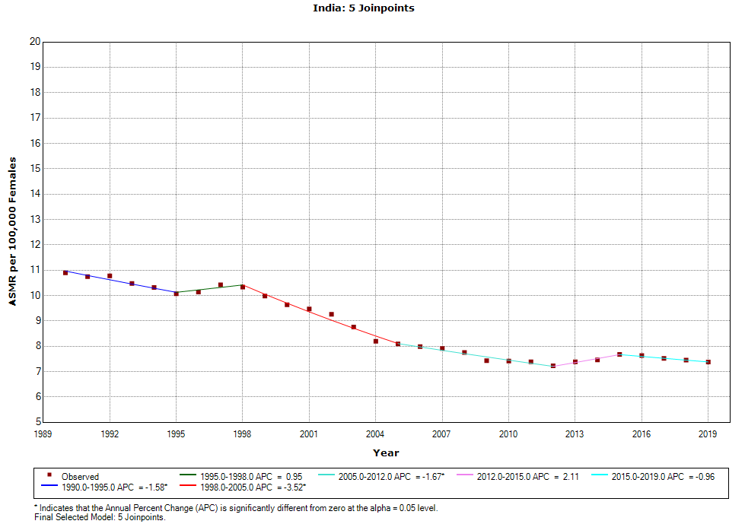 | 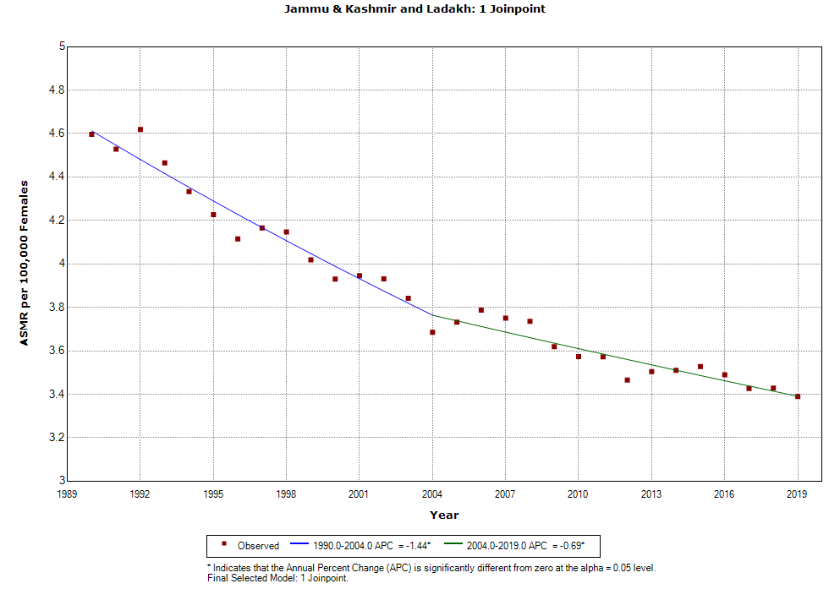
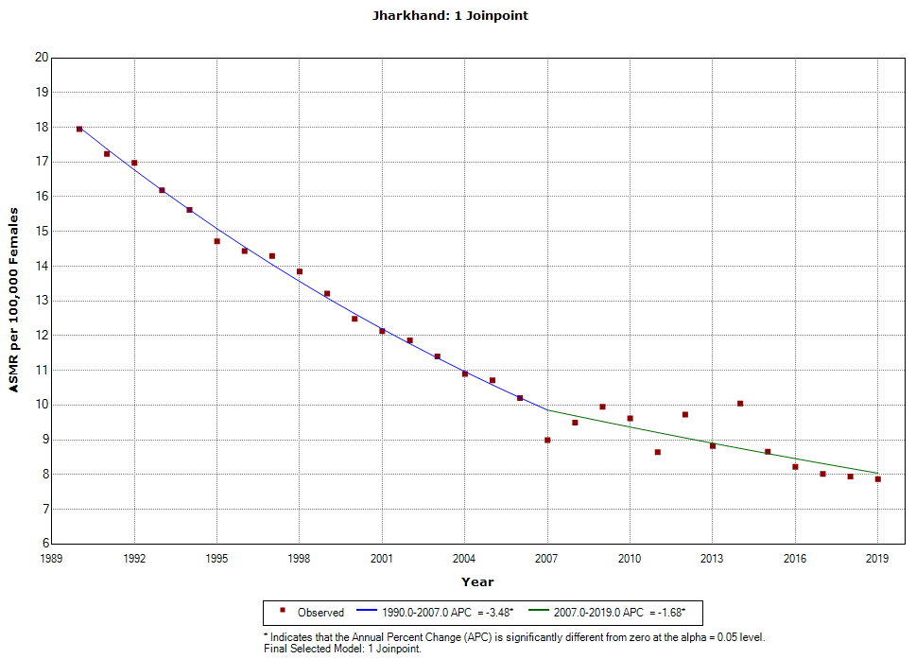 | 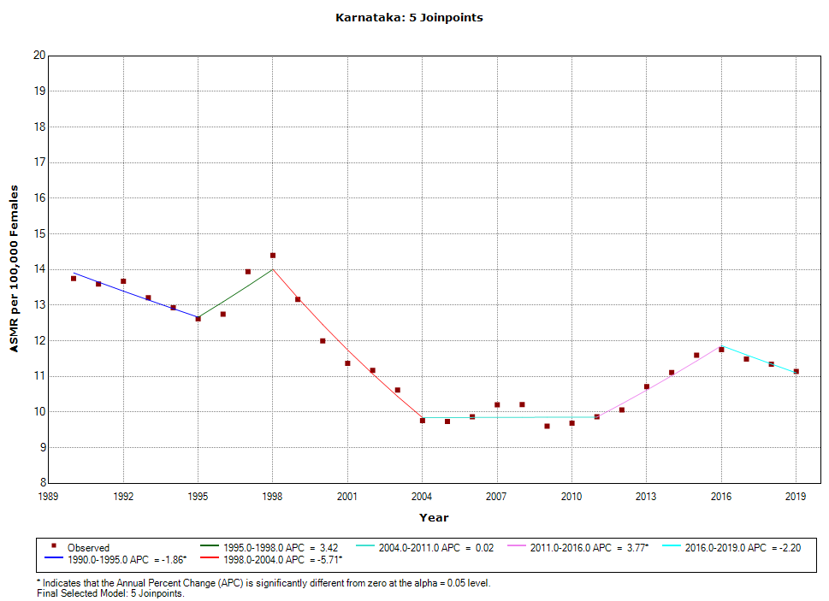 | 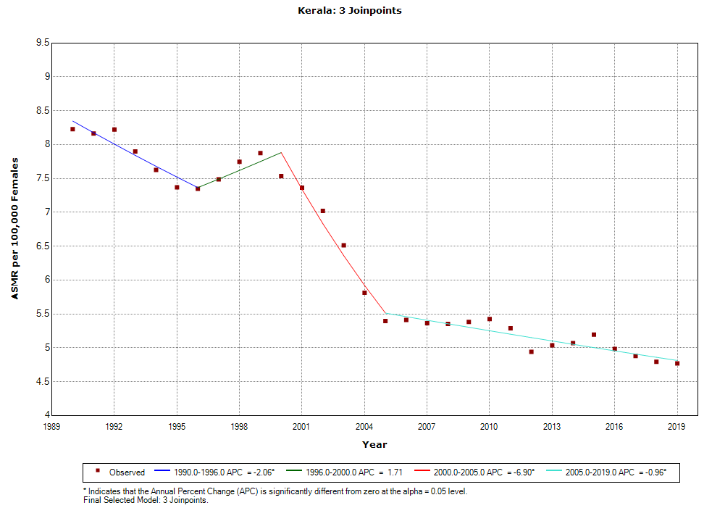
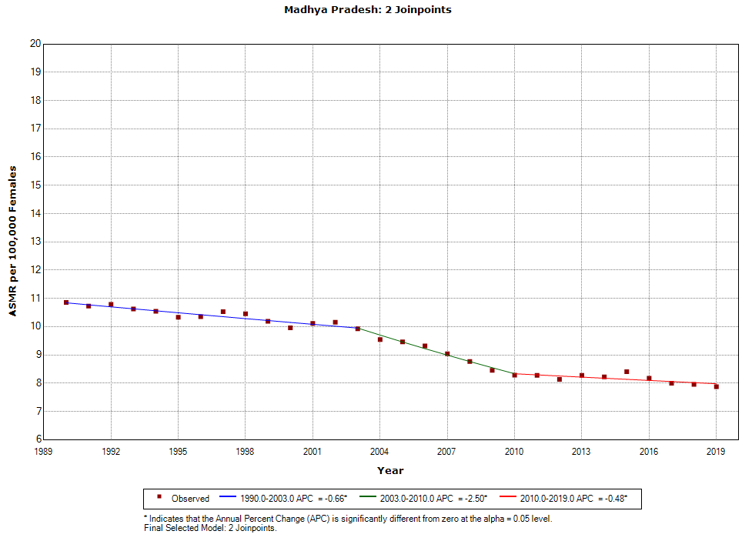 | 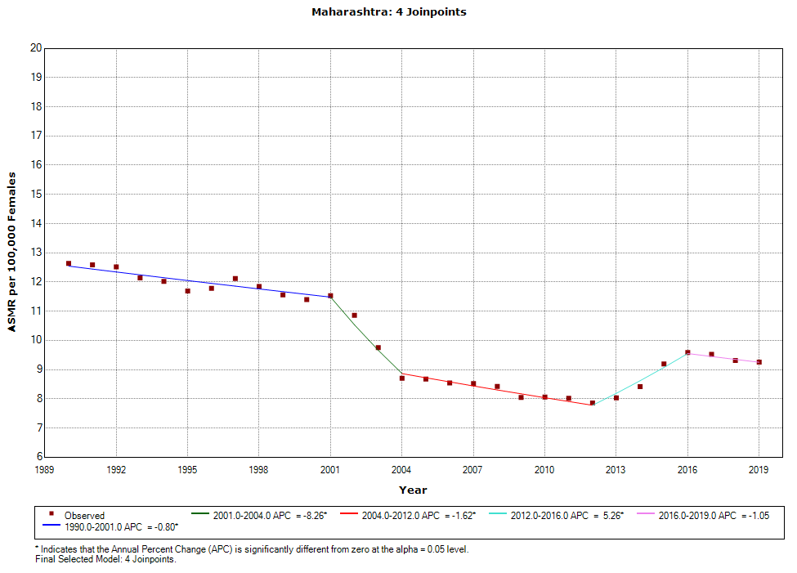 | 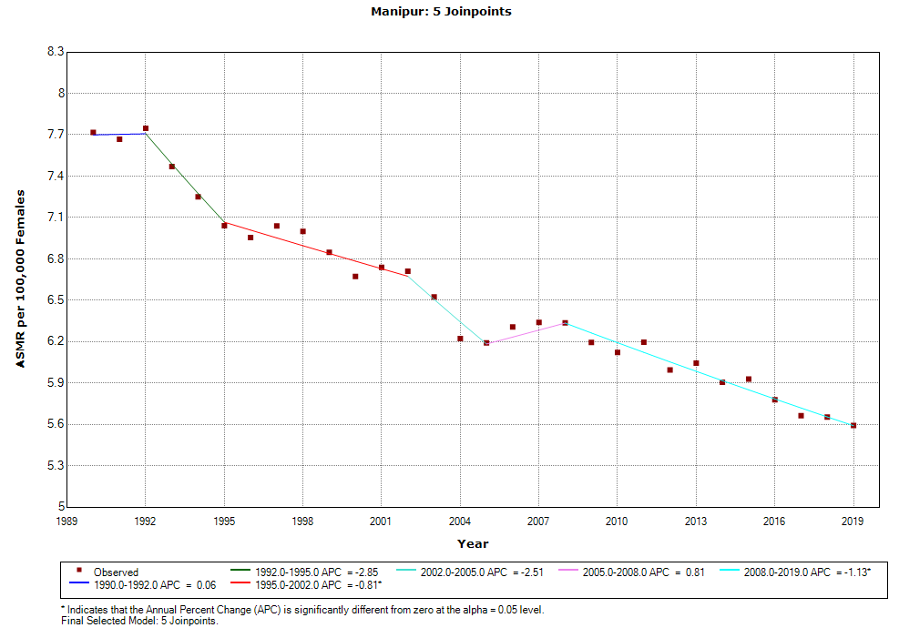
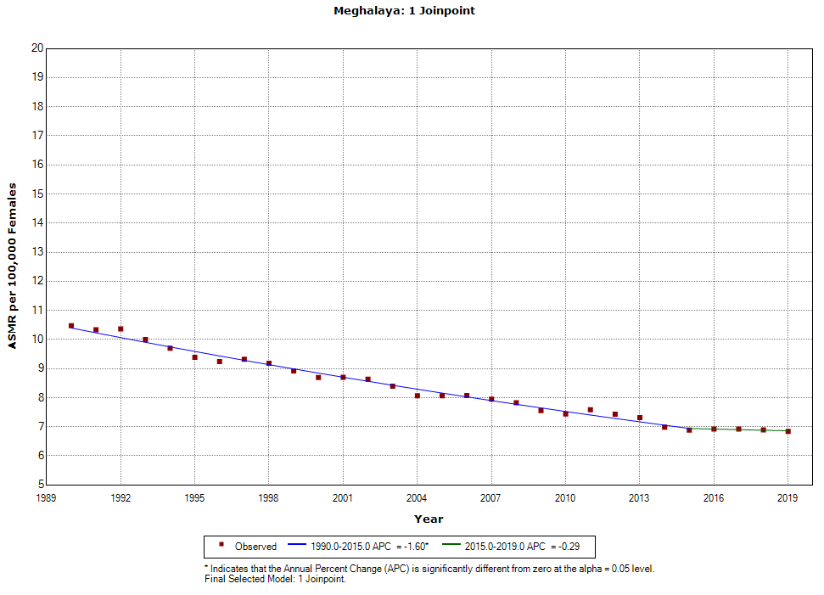 | 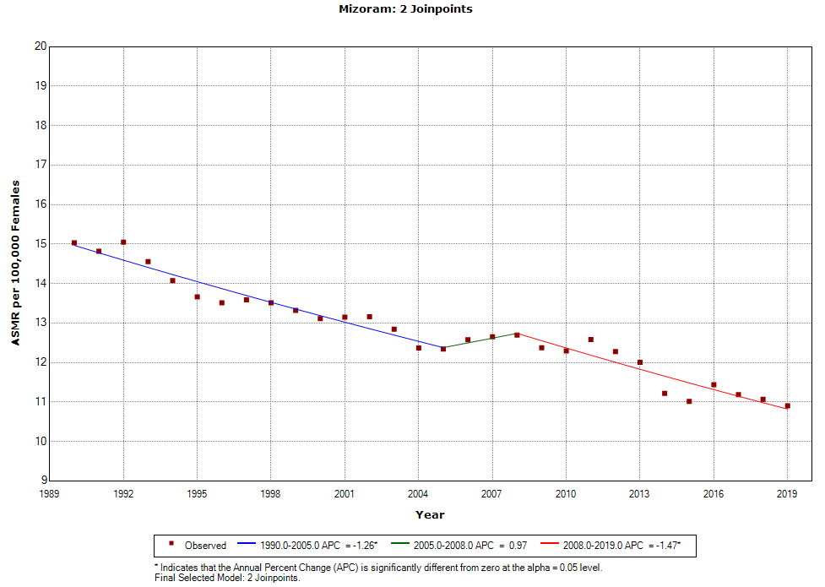 | 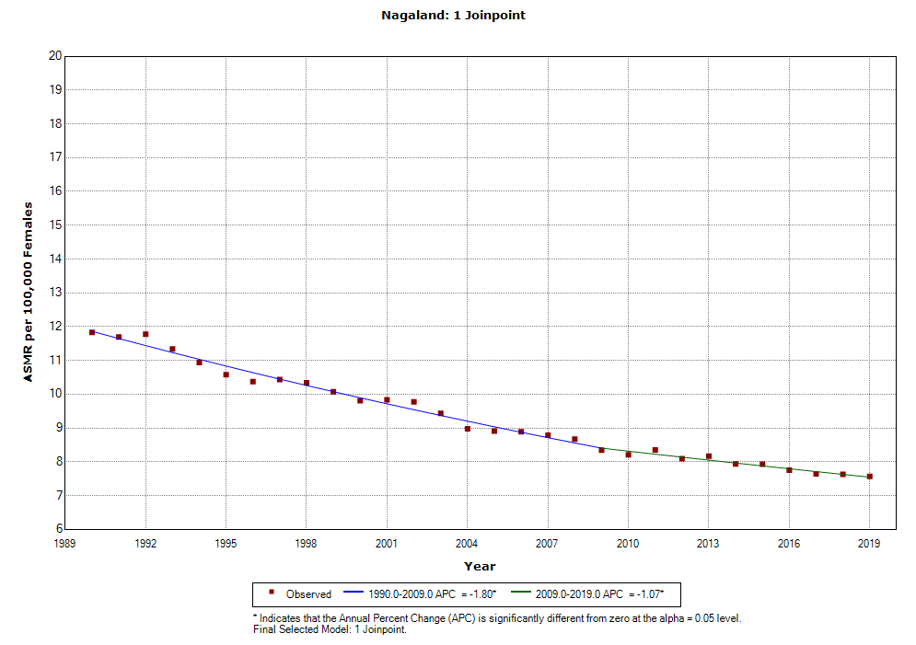
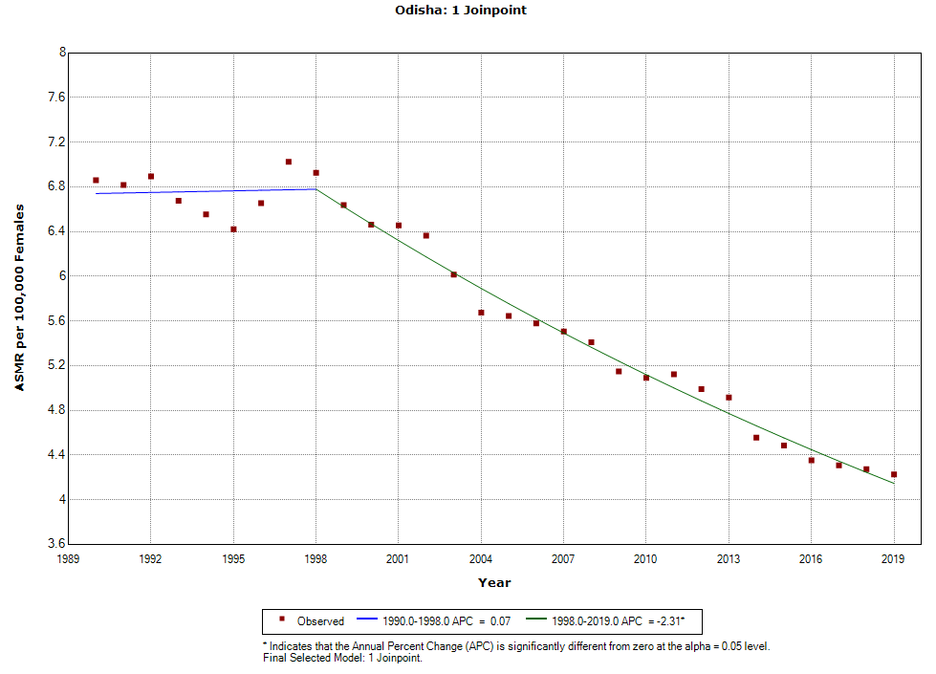 | 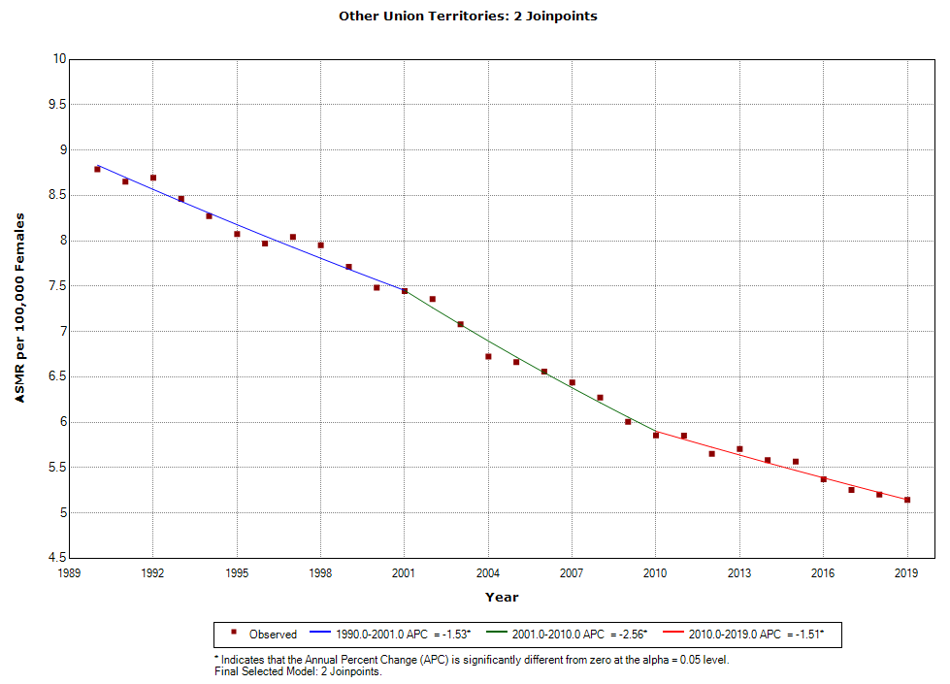 | 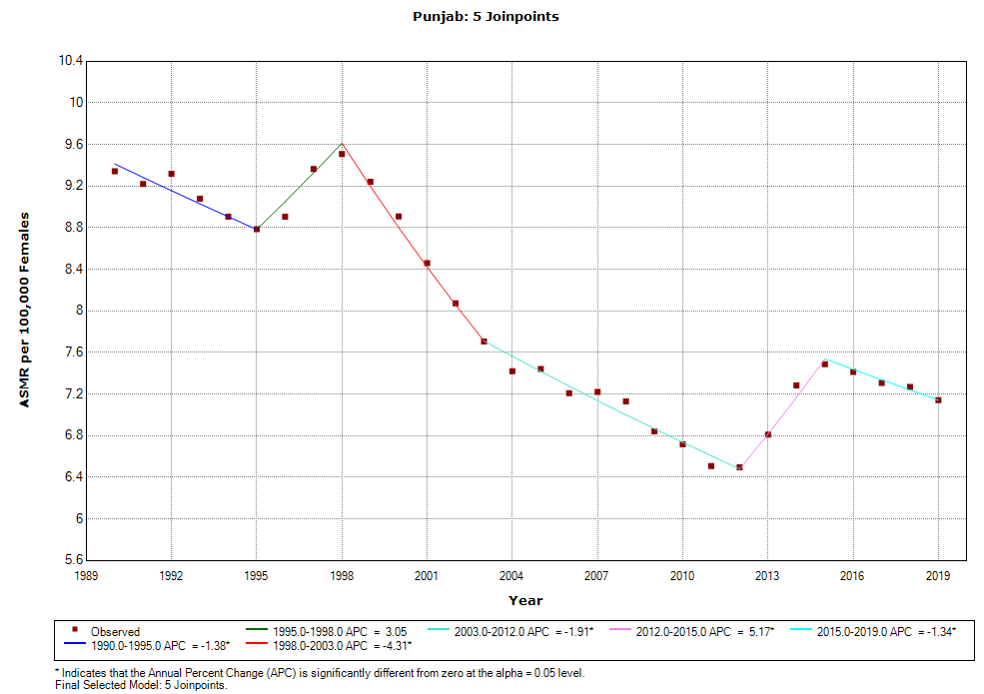
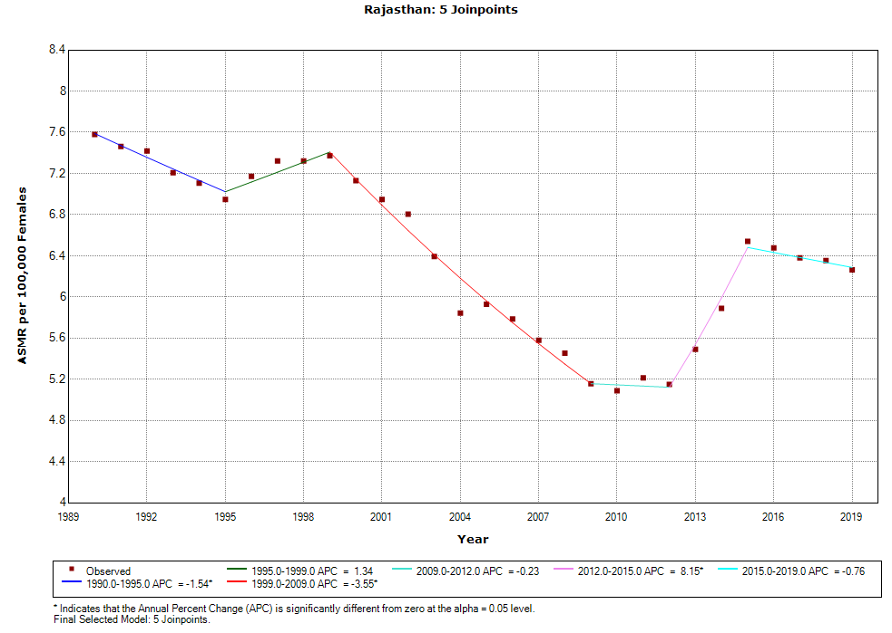 | 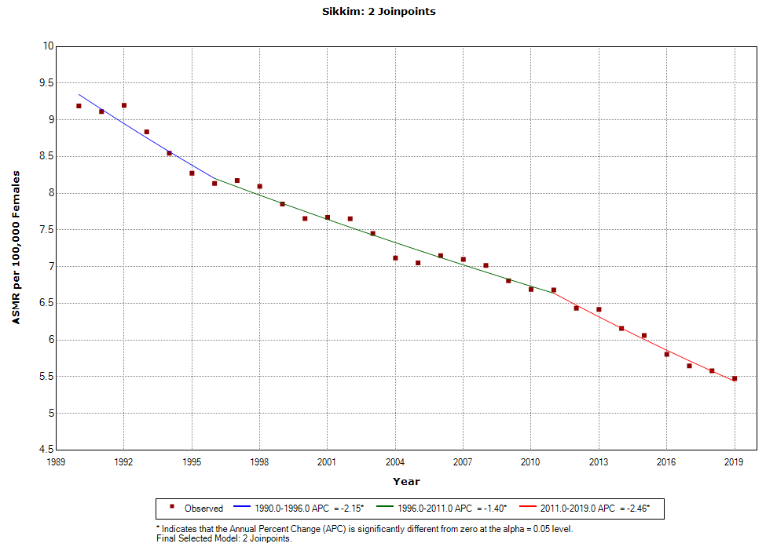 | 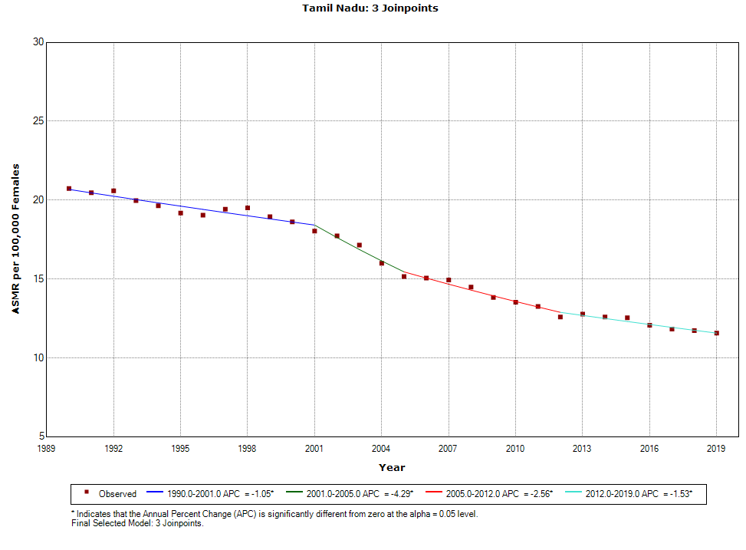
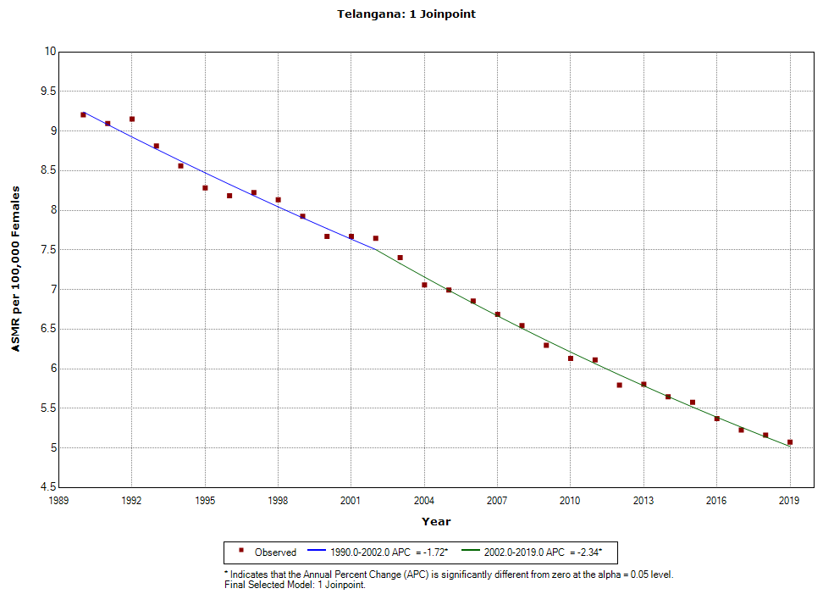 | 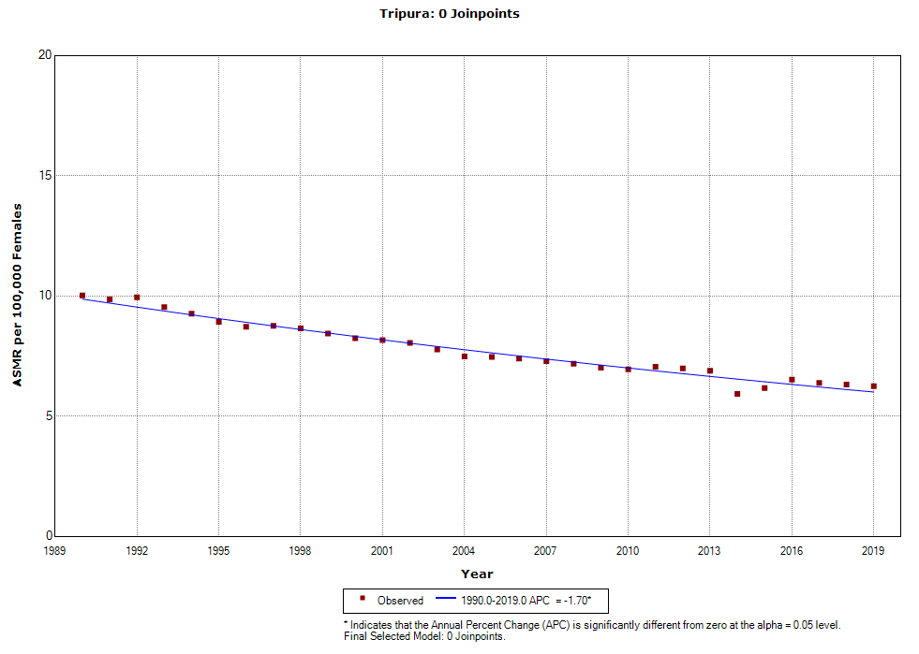 | 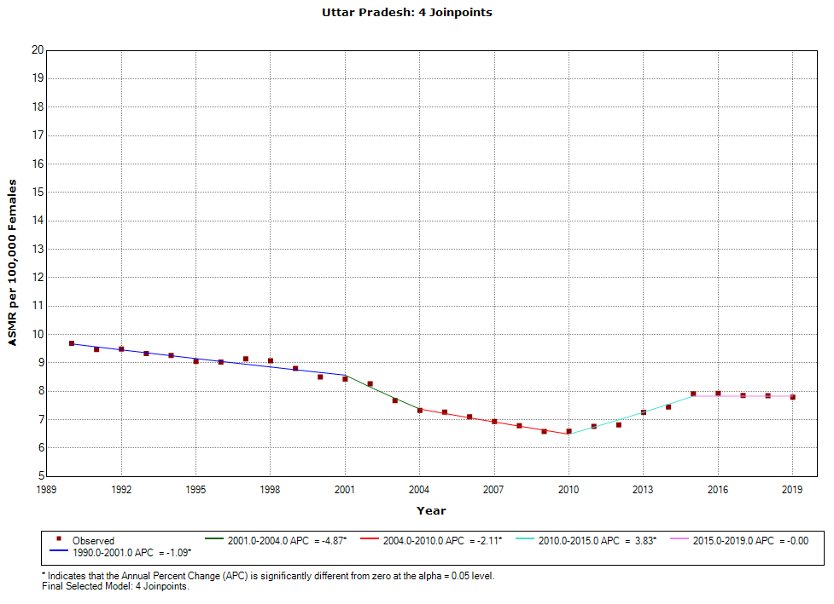
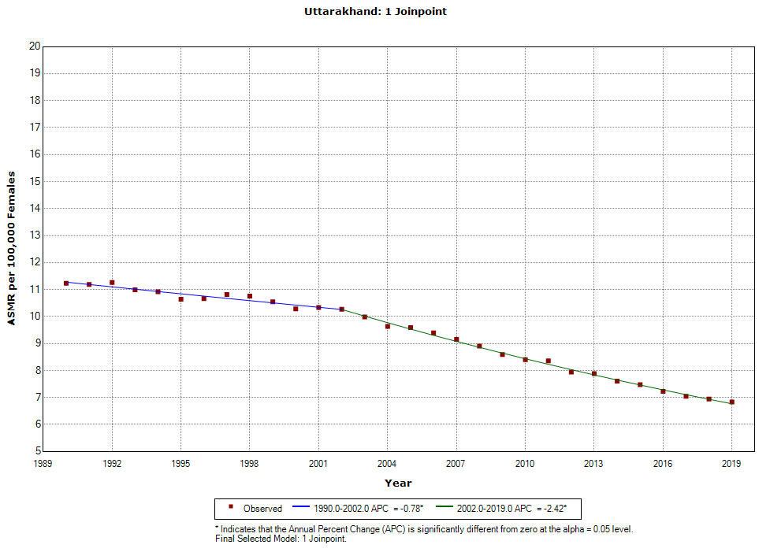 | 