Supplementary materials

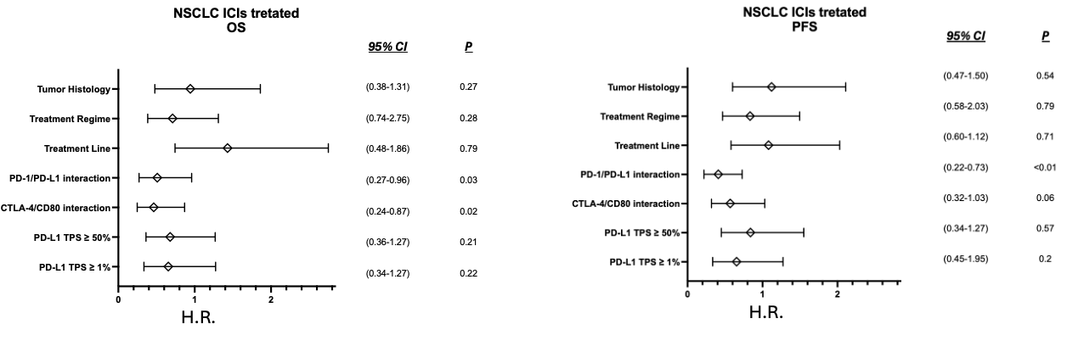
Table S1. Forest plot of OS and TPS showing the hazard ratio and 95% CI of a cohort of 67 NSCLC patients treated with immunotherapy depending on tumor histology (adenocarcinoma vs SCC), treatment regime (monotherapy vs combination with chemotherapy), line of treatment (First line vs Second line), PD-1//PD-L1 interaction (high vs low), CTLA-4/CD80 interaction (high vs low), PD-L1 TPS ³ 50% (positive vs negative) and PD-L1 TPS ³ 1% (positive vs negative).

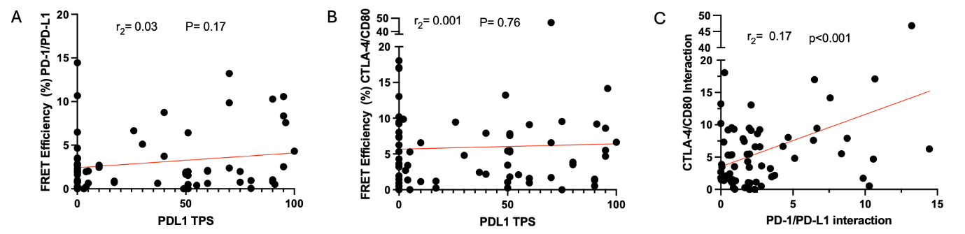Figure S1: Correlation between CTLA-4/CD80 FRET eff., PD-1/PD-L1 FRET eff. and PD-L1 TPS in ICI-treated NSCLC patients. The plots from 67 patients shows no correlation between PD-1/PD-L1 FRET efficiency and PD-L1 TPS (r_{s}=0.03, P=0.17) (A) and CTLA-4/CD80 FRET eff. and PD-L1 TPS (r=0.001, P=0.76) (B). A significant linear correlation exists between CTLA-4/CD80 FRET eff. and PD-1/PD-L1 FRET eff. (r_{s} = 0.18, P<0.001) (C).

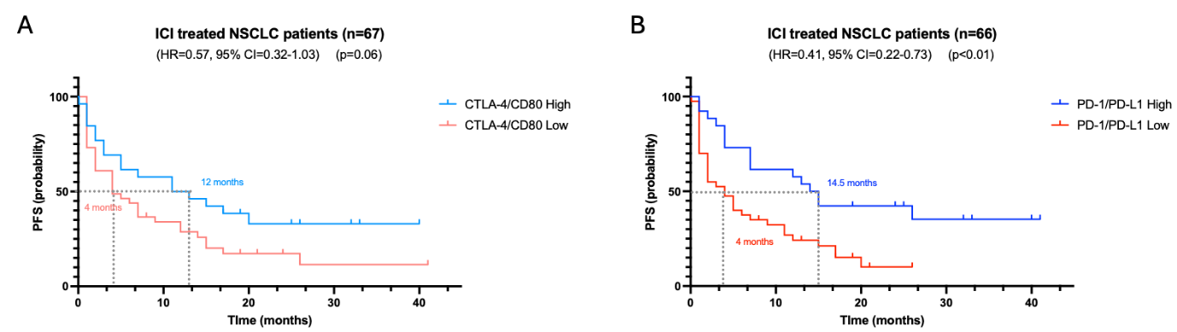Figure S2: High CLTA-4/CD80 and PD-1/PD-L1 interaction status better predict PFS outcomes to ICI treatment in lung NSCLC patients (n=67). The PFS of each patient was analyzed according to the calculated FRET efficiency for both CTLA-4/CD80 and PD-1/PD-L1 interactions (A). The cutoff value applied to stratified patients based on CTLA-4/CD80 interaction was 6.41%. Kaplan-Meier survival graph indicates a trend of better response in patients with a higher FRET efficiency (light blue line) compared to patients with lower FRET efficiency (orange line), with median PFS of 12 months and 5 months, respectively (P=0.06; HR=0.57, 95% CI=0.32-1.07) (B) For PD-1/PD-L1 interaction, a cutoff value of 2.13 was applied. A highly significant higher PFS time (P<0.01; HR=0.40, 95% CI=0.22-0.73) was observed in high FRET patients (blue line) compared to the remaining patients with a lower FRET efficiency (red line) (median progression of 14.4 months versus 4 months).

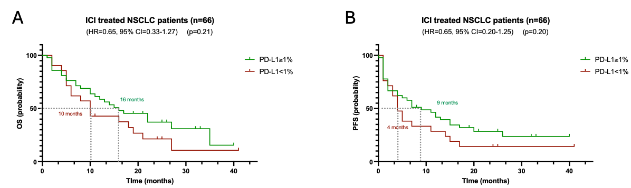
Figure S3: PD-L1 TPS is not a good predictor of response to ICI treatment in NSCLC (n=66). The overall survival (OS) and progression free survival (PFS) of a cohort of NSCLC patients (n=66) was unblinded and examined. Patient were analyzed and stratified by their PD-L1 expression scores (TPS) (high (≥1% PD-L1) vs. low (< 1% PD-L1) TPS scores) (C) the difference in OS was not significant (P value =0.21; HR=0.65, 95% CI=0.33-1.27) with a median OS of 16 months versus 10 months respectively. Similarly, the analysis in D confirmed the lack of significant difference in PFS between the patients stratified by the PD-L1 scores (median of 9 months versus 4 months free progression) (P=0.20; HR=0.65, 95% CI=0.20-1.25).

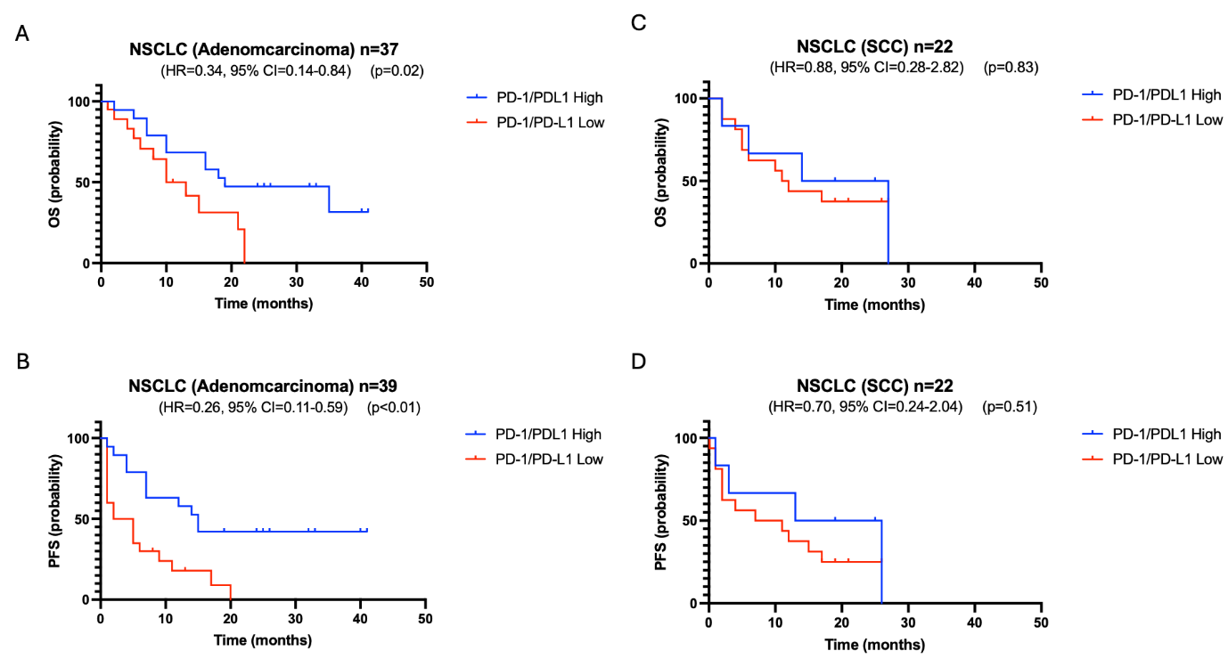

Figure S4: High PD-1/PD-L1 interaction status better predict response to ICI treatment in lung adenocarcinoma patients (n=37) than in SCC patients. (n=22). The OS of each patient was analyzed according to the calculated FRET efficiency (A). The cutoff value applied to stratified patients was 2.13127%. Kaplan-Meier survival graph indicates significant differences in OS between adenocarcinoma patients with a higher FRET efficiency (blue line) and patients with lower FRET efficiency (red line) (P=0.02; HR=0.34; 95% CI=0.14-0.84)). Moreover, the PFS of each patient (C) further corroborates the higher predictive value to response to treatment of PD-1/PD-L1 interaction in adenocarcinoma patients treated with ICI (P<0.01; HR=0.26; 95% CI=0.11-0.59). In SCC patients (B) the difference in OS between patients with high and low PD-1/PD-L1 interaction was not significant (P value =0.83; HR=0.88, 95% CI=0.28-2.82) Similarly, the PFS analysis of SCC patients stratified by the PD-L1 scores do not show statistically significant differences (P=051; HR=0.70, 95% CI=0.24-2.02).

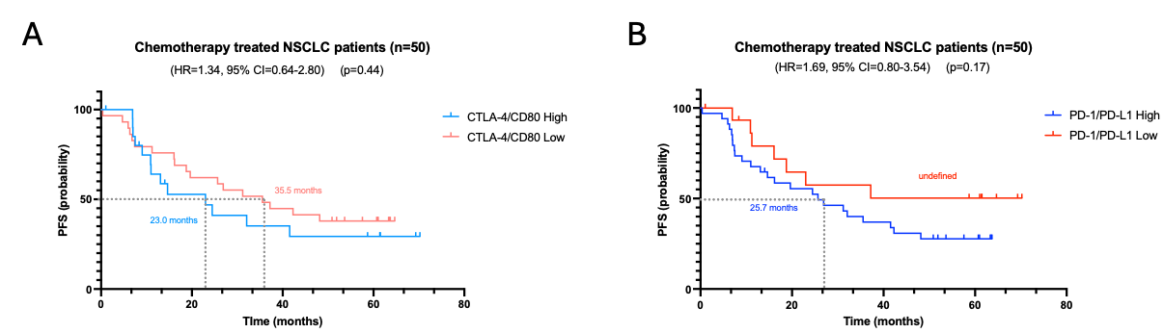
Figure S5. Neither CTLA-4/CD80 nor PD-1/PD-L1 interaction status is predictive of response to chemotherapy treatment in lung adenocarcinoma patients (n=49). The PFS of each patient was analyzed according to the calculated FRET efficiency (A). For CTLA-4/CD80 interaction, the cutoff value applied to stratified patients was 6.41%. Kaplan-Meier survival graph indicates no significant differences in PFS between patients with a higher FRET efficiency (light blue line) and patients with lower FRET efficiency (orange line) (High FRET efficiency vs Low FRET efficiency median PFS 23.0 months vs 35.5 months; P=0.44; HR=1.34; 95% CI=0.64-2.80). (B) For PD-1/PD-L1 interaction, the cutoff value applied to stratified patients was 2.13%. This grouping was determined based on previous studies ¹⁹. Kaplan-Meier survival graph indicates no significant differences in PFS between patients with a higher FRET efficiency (blue line) and patients with lower FRET efficiency (red line). High FRET efficiency vs Low FRET efficiency median PFS undefined vs 25.7 months (P=0.17; HR=1.69; 95% CI=0.80-3.54).

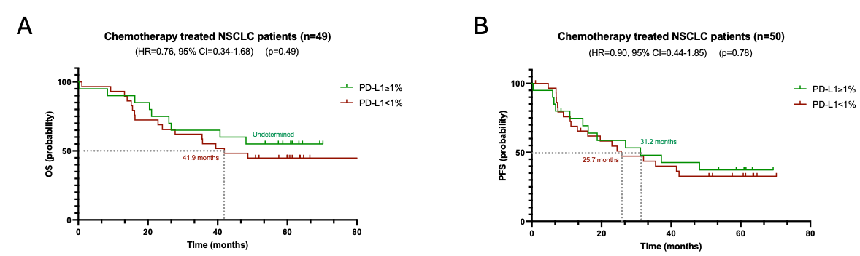
Figure S6. PD-L1 expression is not predictive of response to chemotherapy treatment in lung adenocarcinoma patients (n=49). The overall survival (OS) and progression free survival (PFS) of a cohort of adenocarcinoma patients (n=50) was analyzed based on PD-L1 expression. Patient were analyzed and stratified by their PD-L1 expression scores (TPS) (high (≥1% PD-L1) vs. low (< 1% PD-L1) TPS scores) (A) the difference in OS was not significant (P =0.49; HR=0.76, 95% CI=0.34-1.68) with a median OS of undetermined and 41.9 months respectively. Similarly, a lack of significant difference in PFS between the patients stratified by the PD-L1 scores (median of 9 months versus 4 months free progression) (P=0.78; HR=0.90, 95% CI=0.44-1.85) was observed (B).

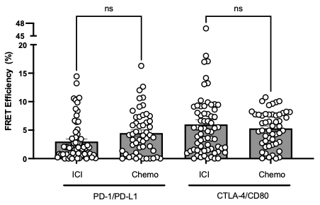

Figure S7: FRET efficiencies for PD-1/PD-L1 and CTLA-4/CD80 interaction in immune-checkpoint blockade therapy and chemotherapy treated samples. Each dot represents mean FRET efficiency for each patient analyzed. No statistically significant differences were observed between patients treated with ICIs and chemotherapy (Mean PD-1/PD-L1 FRET eff. in ICI vs Chemo 3.00% and 4.49%, P=0.20; meanCTLA-4/CD80 FRET eff. in ICI vs Chemo 6.00 vs 5.31; P>0.99; Kruskal-Wallis test).

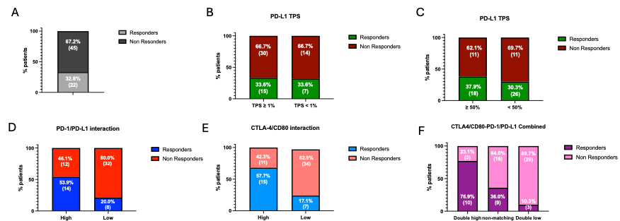
Figure S8. Percentage of responders (OS ≥ 18 months) and non-responders (OS<18 months) in the whole cohort of ICI treated NSCLC patients (A), PD-L1 TPS lower and higher that 1% patients (B), PD-L1 TPS lower and higher than 50% patients (C), in PD-1/PD-L1 high and low patients (D), CTLA-4/CD80 high and low (E) and in patients classified by the level of interaction of both PD-1/PD-L1 and CLTA-4/CD80 in combination.

