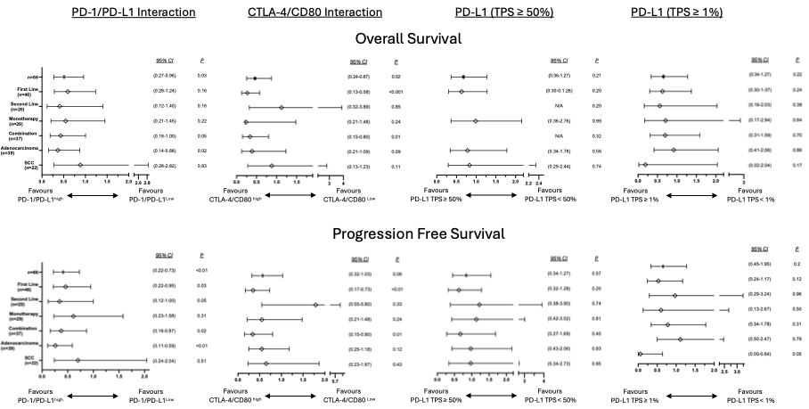
Table 1. Forest plot of OS (top) and PFS (bottom) showing the hazard ratio and 95% CI for each biomarker’s combinations analyzed in the different subgroups of patients based on the line of treatment (first and second line), treatment regime (monotherapy and in combination with chemotherapy) and tumor histology (adenocarcinoma and SCC).

