Supplementary Information
PfAgo-mediated a rapid and visual detection assay for PCV3 based on recombinase-aided amplification

Xi-Meng Chen^{a♀}, Tao Wang ^{a♀}, Xian-Qin Jiao^{a,b,c♀}, Hong-bo Cuiª, Jia-qi Zhangª, Lan-Lan Zheng^{a,b,c}, Ping-Li Wang ^{a,b,c*}, Hong-Ying Chen^{a,b,c*}, Shi-Jie Ma^{a,b,c*}
ªCollege of Veterinary Medicine, Henan Agricultural University, Zhengdong New District Longzi Lake 15#, Zhengzhou450046, PR China.
^{b}Henan Province Key Laboratory for Animal Food Pathogens Surveillance, Zhengzhou 450046, PR China.
^{c}Ministry of Education Key Laboratory for Animal Pathogens and Biosafety, Zhengzhou450046, PR China.

♀Xi-Meng Chen, Tao Wang and Xian-Qin Jiao contributed equally to this work.
*Corresponding author: Hong-Ying Chen, E-mail: chhy927@163.com, Ping-Li Wang, wplhnnd@henau.edu.cn and Shi-jie Ma, E-mail: participate2006@126.com. Mailing address: College of Veterinary Medicine, Henan Agricultural University, Zhengdong New District Longzi Lake#15, 450046 Zhengzhou, Henan Province, People’s Republic of China. Tel: +86 371 55369208; fax: +86 371 55369208

Supplementary Figure Legends

Figure S1. Comparison of the 25 PCV3 Cap gene and the location of three sets of RAA primers on them.
Figure S2. Western blot analysis of the expressed PfAgo protein.
Figure S3. Fluorescence background values at different probe concentrations.
Figure S4. The full uncropped Gels image of the for the best RAA primers of three pairs primers.
Figure S5. The full uncropped Gels image of the for different RAA incubation temperatures (37°C, 38°C, 39°C, 40°C, 41°C, and 42°C).
Figure S6. The full uncropped Gels image of the for different RAA incubation times (10, 20 and 30min).
Figure S7. The full uncropped Gels image of the for screening suitable single gDNA.
Figure S8. The full uncropped Blot image of the SDS-PAGE of the expressed PfAgo protein.
Figure S9. The full uncropped Western Blot image of the expressed PfAgo protein.

Supplementary Table Legends
Table S1. The sequences of primers, gDNAs, and probe utilized in this work.

Figure S1. Comparison of the 25 PCV3 Cap gene and the location of three sets of RAA primers on them.

Figure S2. Western blot analysis of the expressed PfAgo protein, with mouse anti-6 X His tag antibody as the primary antibody and goat anti-mouse IgG antibody as the secondary antibody. The unit of the numbers was kDa. Lane M: Marker.

Figure S3. Fluorescence background values ​​at different probe concentrations, which were subtracted in the experiment of optimizing the probe concentration.

Figure S4. The full uncropped Gels image of the for the best RAA primers of three pairs primers.
Figure S5. The full uncropped Gels image of the for different RAA incubation temperatures (37°C, 38°C, 39°C, 40°C, 41°C, and 42°C).

Figure S6. The full uncropped Gels image of the for different RAA incubation times (10, 20 and 30min).
Figure S7. The full uncropped Gels image of the for screening suitable single gDNA.
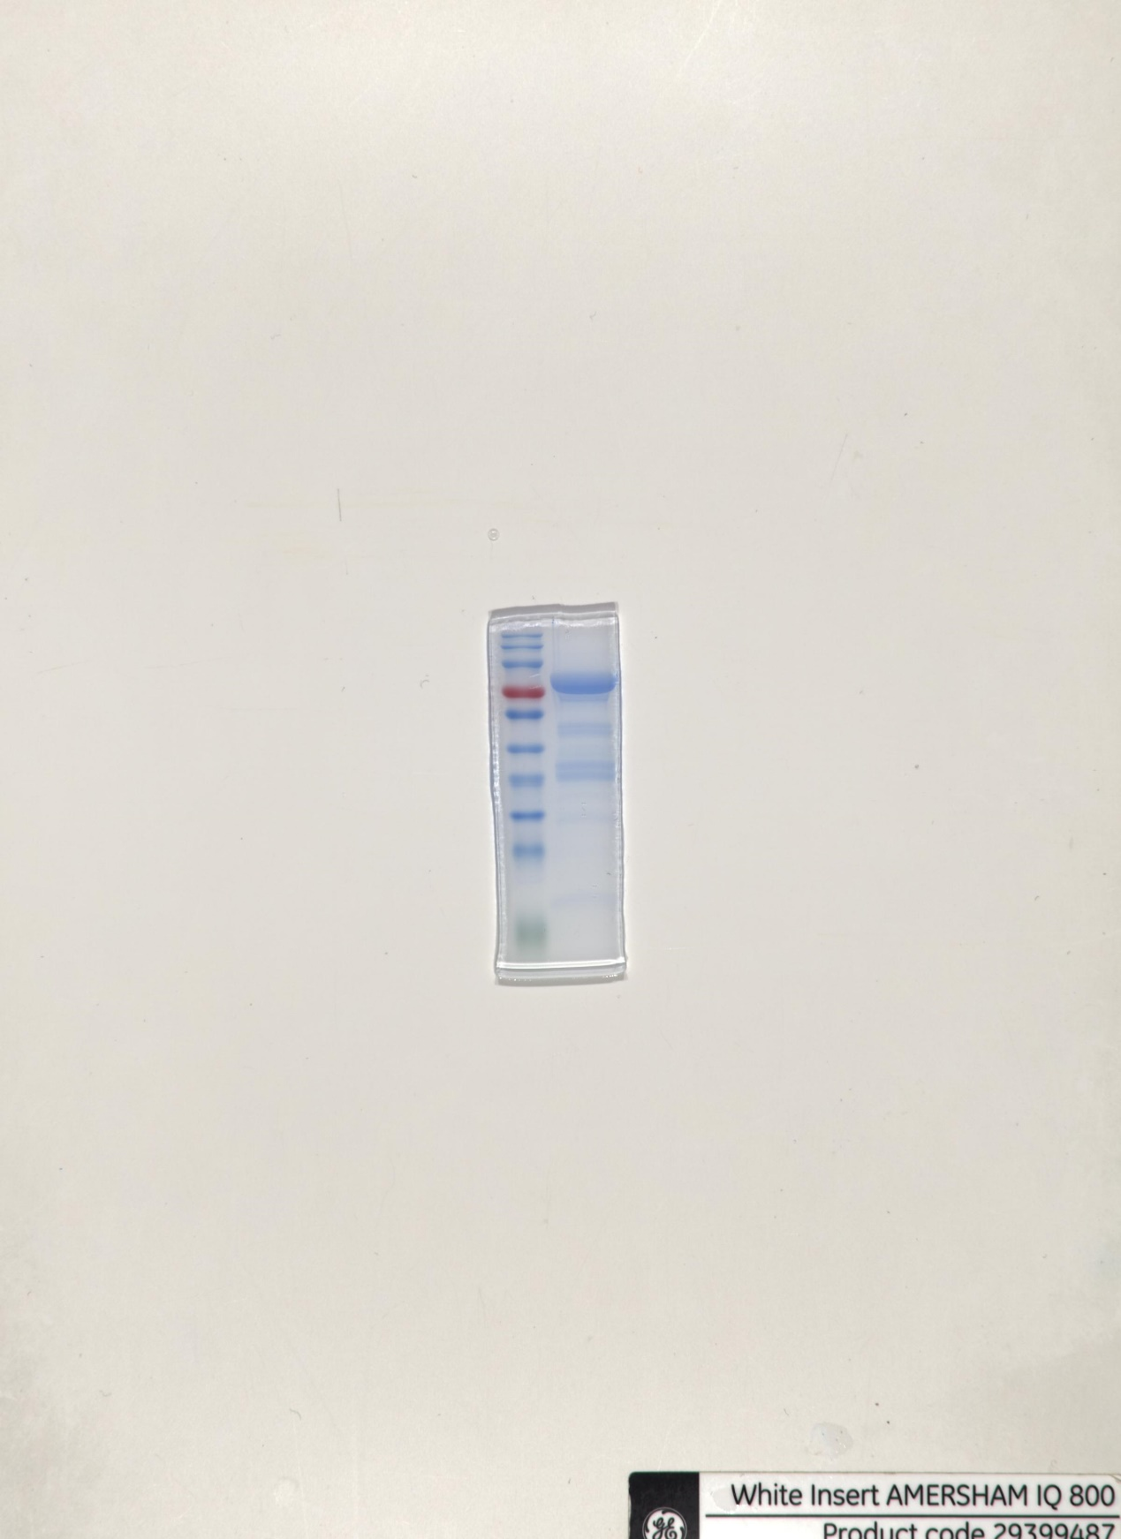
Figure S8. The full uncropped Blot image of the SDS-PAGE of the expressed PfAgo protein.

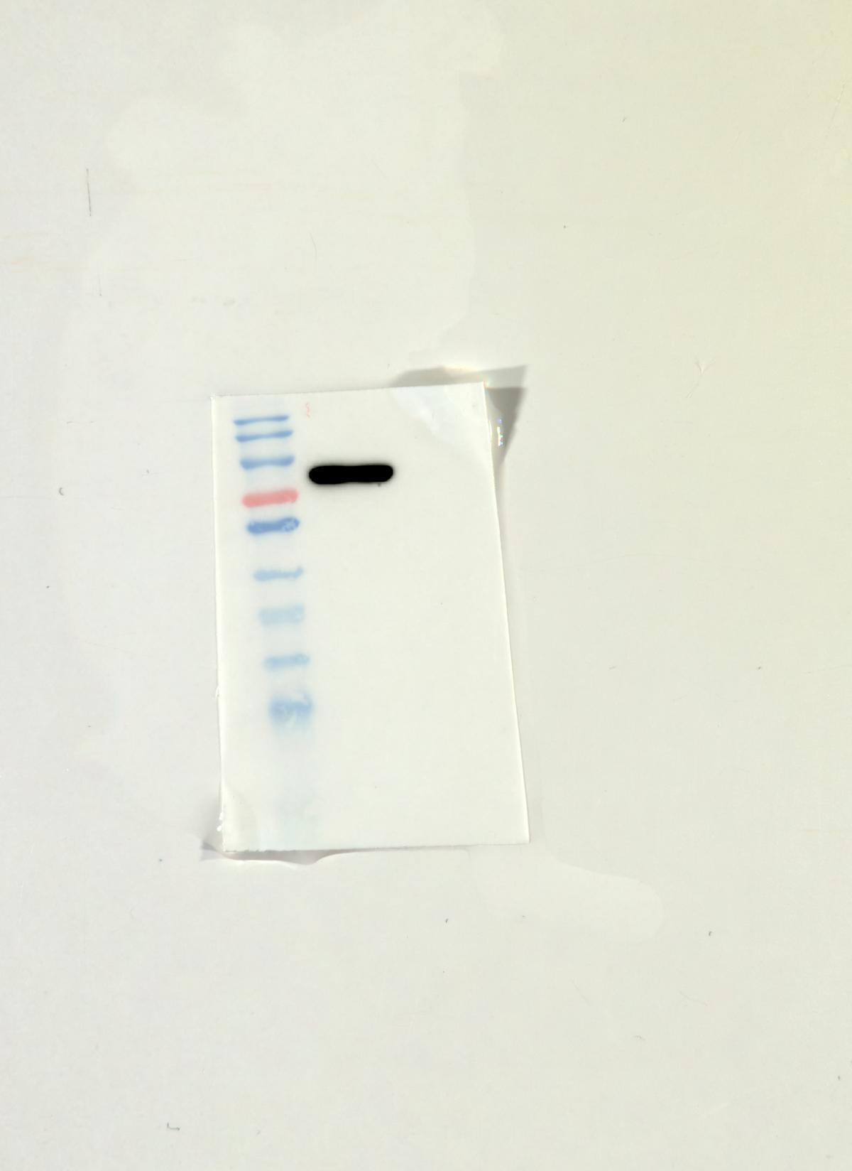
Figure S9. The full uncropped Western Blot image of the expressed PfAgo protein.

Table S1 The sequences of primers, gDNAs, and probe utilized in this work.
Name | Nucleotide sequence (5’-3’) | Product size
PCV3-F | TTAGAGAACGGACTTGTAAC | 645
PCV3-R | ATGAGACACAGAGCTATATT | 645
RAA-F1 | TATTCATTAGGAGGCCCACAGCTGGCACAT | 205
RAA-R1 | GGAGAAATTACAGGGCTGAGTGTAACTTTCATC | 205
RAA-F2 | TATTCATTAGGAGGCCCACAGCTGGCACAT | 203
RAA-R2 | AGAAATTACAGGGCTGAGTGTAACTTTCATCTTTAGT | 203
RAA-F3 | TTTGTTTGCTGAGCCGGAGAAATTACAGGG | 269
RAA-R3 | CGCCCAAGGAGACGACGACGCCACAGAAGG | 269
gDNA1 | PHO-TAATGAAGTGGTTGGC
gDNA2 | PHO-AGTGGTTGGCGTGCCA
gDNA3 | PHO-ATGAAGTGGTTGGCGT
gDNA4 | PHO-TCGTTTAGGCGGGTAATGA
gDNA5 | PHO-GTTTAGGCGGGTAATG
gDNA6 | PHO-TTTAGGCGGGTAATGA
Probe Ⅰ | 5'-6-FAM-GGGTAATGAAGTGGTTGGC-BHQ1-3'
Probe Ⅱ | 5'-6-FAM-GTAATGAAGTGGTTGGC-BHQ1-3'
Probe Ⅱ-lfd | 5'-6-FAM-GTAATGAAGTGGTTGGC-Biotin-3'
Note: The ones selected for use in the final test are highlighted in bold in the table.

