Figure S1. Leave-one-out analysis for identified associations between air pollutants and lifestyle factors with metabolic syndrome.
Figure S2. The forest plots of the identified associations between air pollutants and lifestyle factors with metabolic syndrome.
Figure S3. The scatter plots of the identified associations between air pollutants and lifestyle factors with metabolic syndrome.
Figure S4. The funnel plots of the identified associations between air pollutants and lifestyle factors with metabolic syndrome.
Figure S5. Leave-one-out analysis for identified associations between air pollutants and lifestyle factors with hypertension.
Figure S6. The forest plots for identified associations between air pollutants and lifestyle factors with hypertension.
Figure S7. The scatter plots of the identified associations between air pollutants and lifestyle factors with hypertension.
Figure S8. The funnel plots of the identified associations between air pollutants and lifestyle factors with hypertension.
Figure S9. Leave-one-out analysis for identified associations between air pollutants and lifestyle factors with waist circumference.
Figure S10. The forest plots for identified associations between air pollutants and lifestyle factors with waist circumference.
Figure S11. The scatter plots of the identified associations between air pollutants and lifestyle factors with waist circumference.
Figure S12. The funnel plots of the identified associations between air pollutants and lifestyle factors with waist circumference.
Figure S13. Leave-one-out analysis for identified associations between air pollutants and lifestyle factors with HDL cholesterol.
Figure S14. The forest plots for identified associations between air pollutants and lifestyle factors with HDL cholesterol.
Figure S15. The scatter plots of the identified associations between air pollutants and lifestyle factors with HDL cholesterol.
Figure S16. The funnel plots of the identified associations between air pollutants and lifestyle factors with HDL cholesterol.
Figure S17. Leave-one-out analysis for identified associations between air pollutants and lifestyle factors with triglycerides.
Figure S18. The forest plots for identified associations between air pollutants and lifestyle factors with triglycerides.
Figure S19. The scatter plots of the identified associations between air pollutants and lifestyle factors with triglycerides.
Figure S20. The funnel plots of the identified associations between air pollutants and lifestyle factors with triglycerides.
Figure S21. Leave-one-out analysis for identified associations between alcoholic drinks per week and fasting glucose.
Figure S22. The forest plots for identified associations between alcoholic drinks per week and fasting glucose.
Figure S23. The scatter plots of the identified associations between alcoholic drinks per week and fasting glucose.
Figure S24. The funnel plots of the identified associations between alcoholic drinks per week and fasting glucose.

A.PM_{2.5} on metabolic syndrome B.NO_{X} on metabolic syndrome C. Leisure screen time on metabolic syndrome
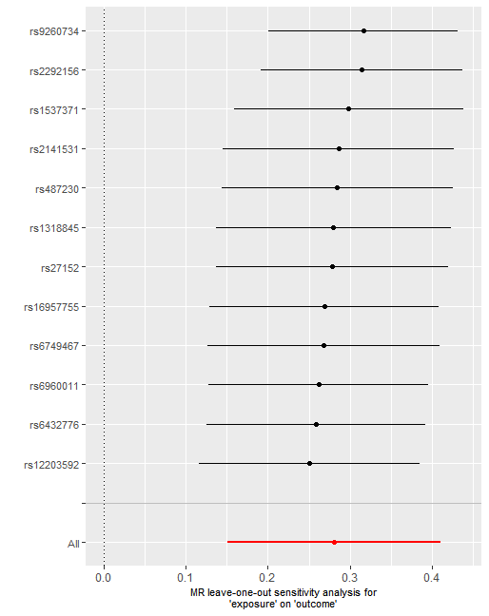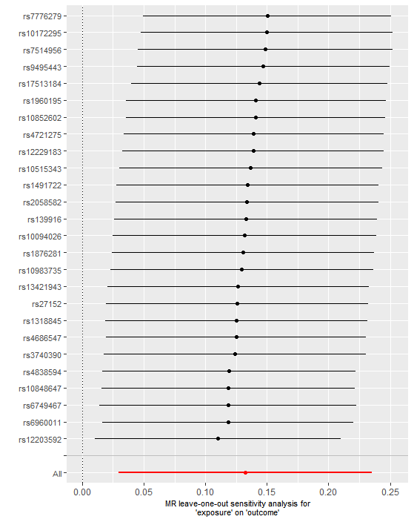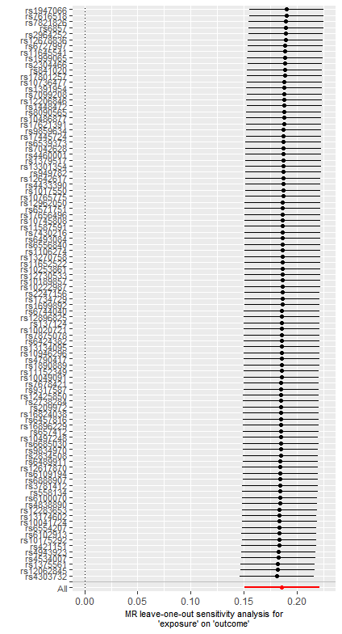
D.MVPA on metabolic syndrome E. smoking initiation on metabolic syndrome F. Coffee intake on metabolic syndrome
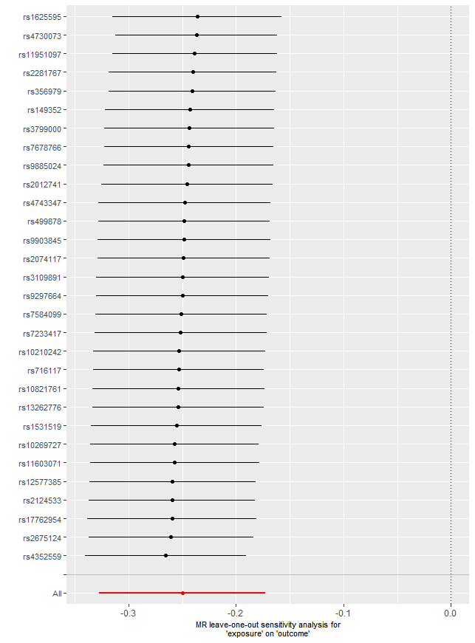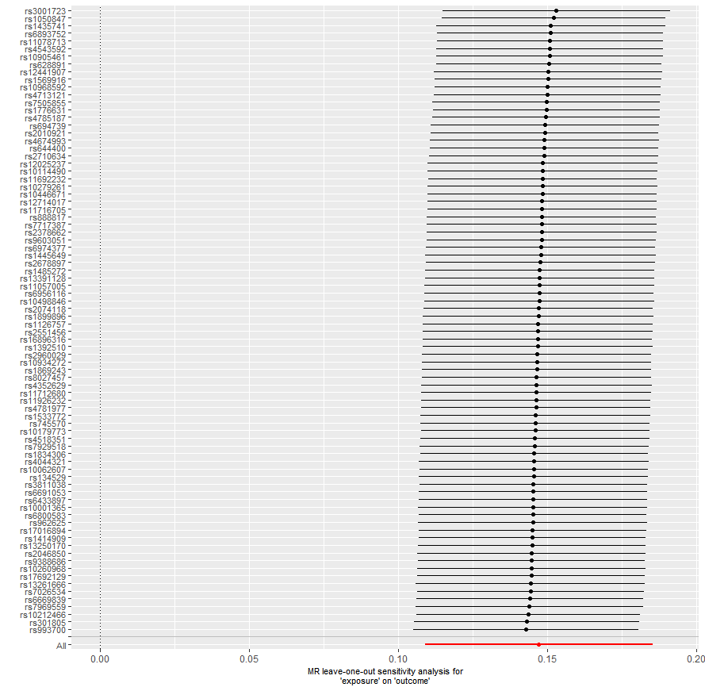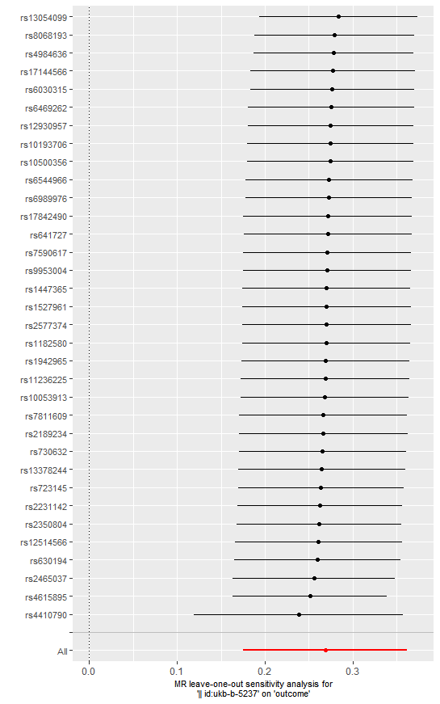
Figure S1. Leave-one-out analysis for identified associations between air pollutants and lifestyle factors with metabolic syndrome.
A.PM_{2.5} on metabolic syndrome B.NO_{X} on metabolic syndrome C. Leisure screen time on metabolic syndrome
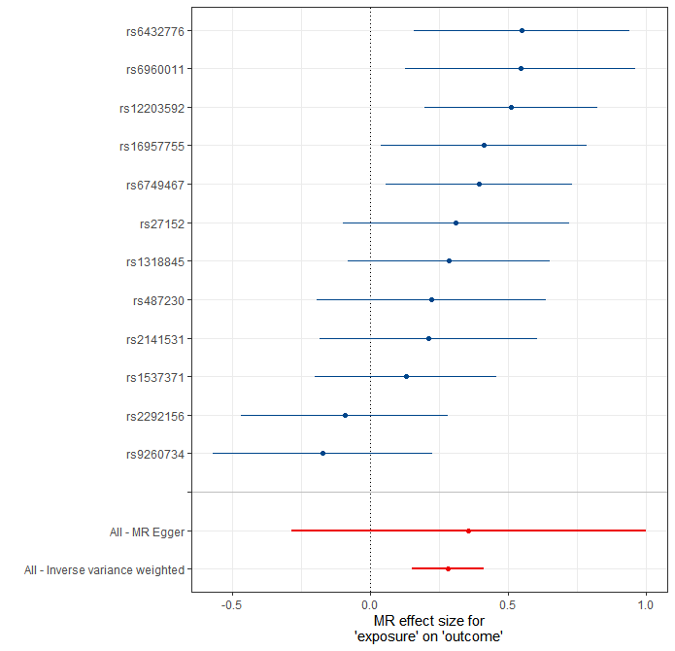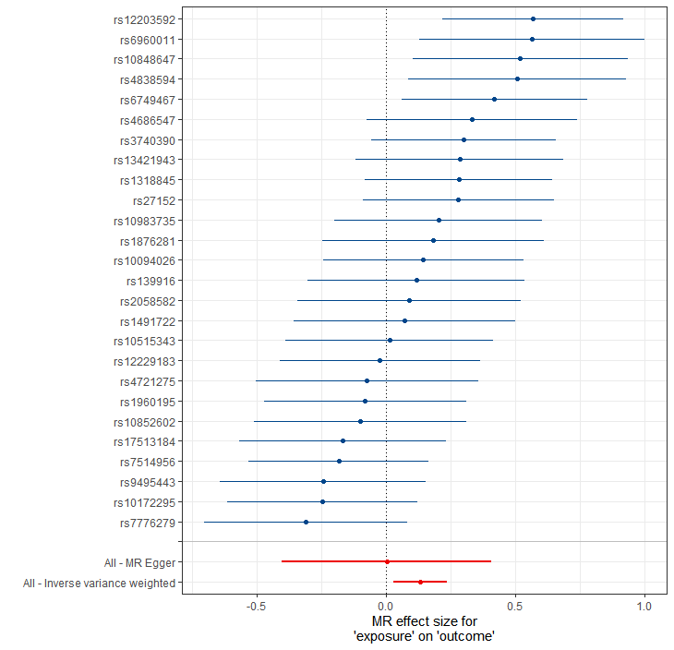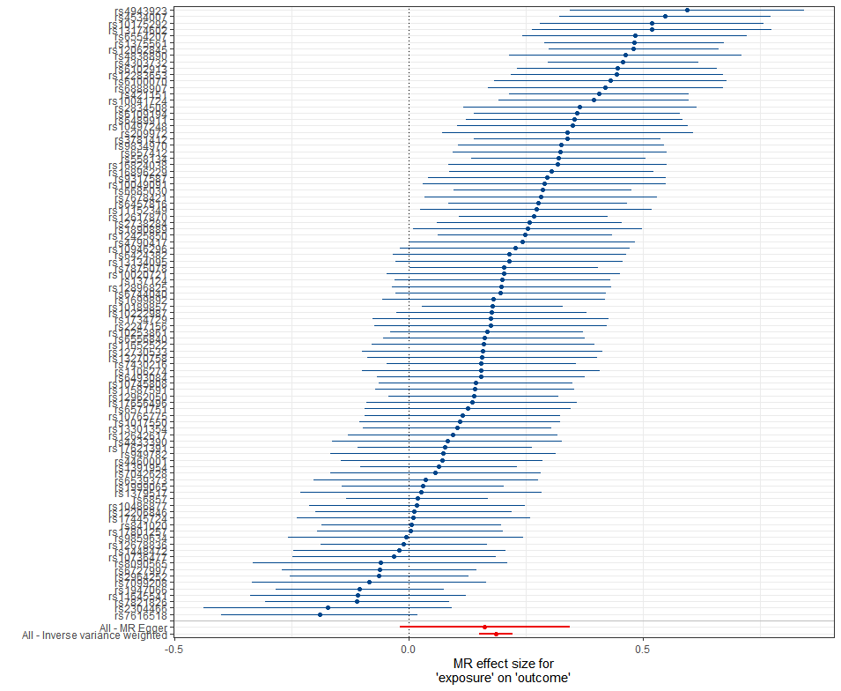
D.MVPA on metabolic syndrome E. smoking initiation on metabolic syndrome F. Coffee intake on metabolic syndrome
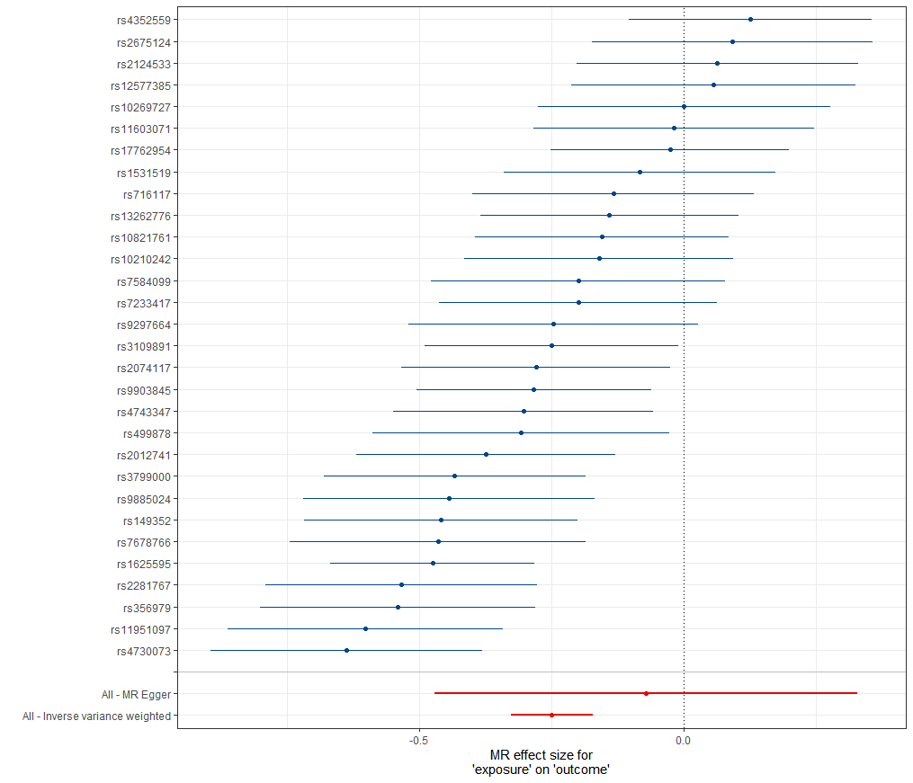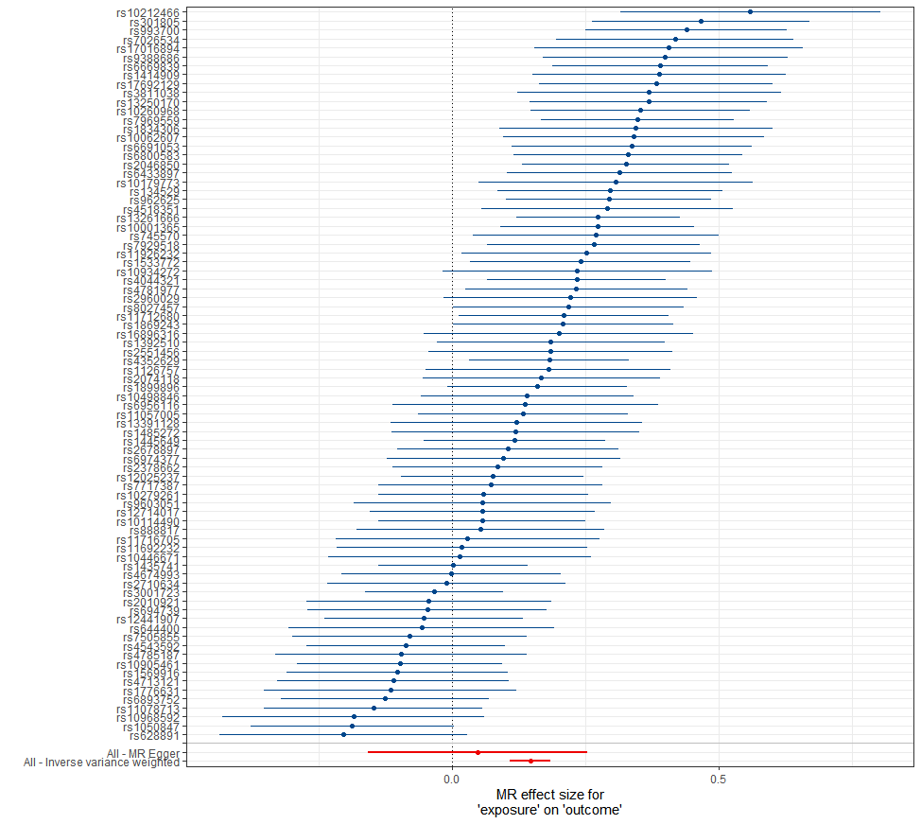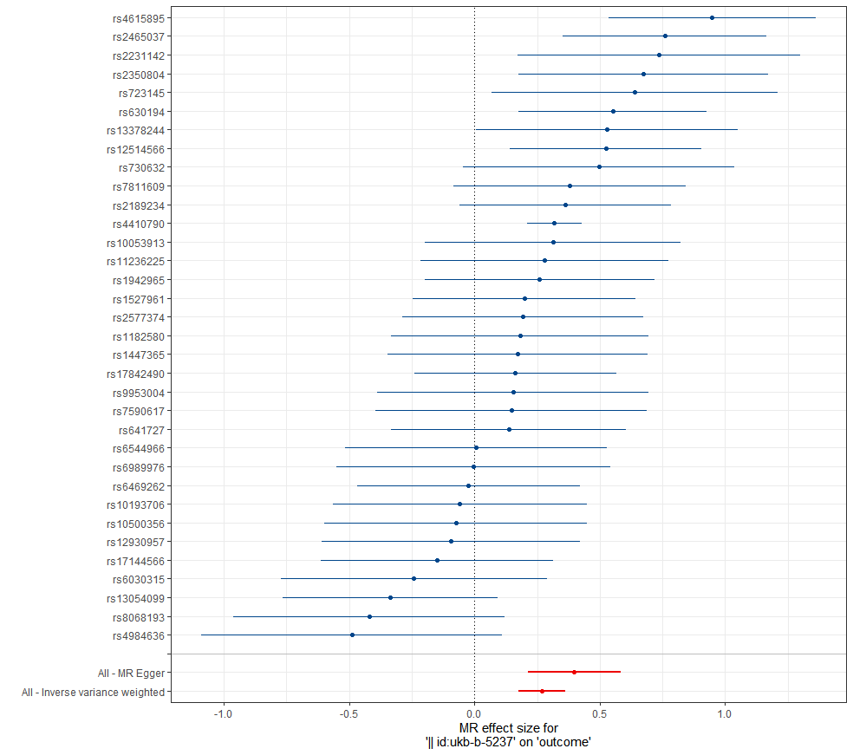
Figure S2. The forest plots of the identified associations between air pollutants and lifestyle factors with metabolic syndrome.

A.PM_{2.5} on metabolic syndrome B.NO_{X} on metabolic syndrome C. Leisure screen time on metabolic syndrome
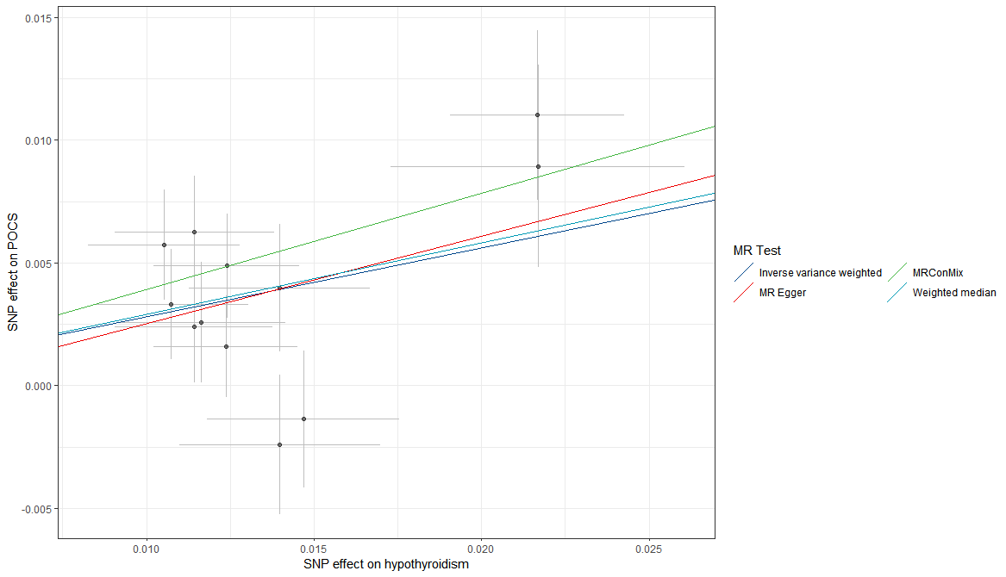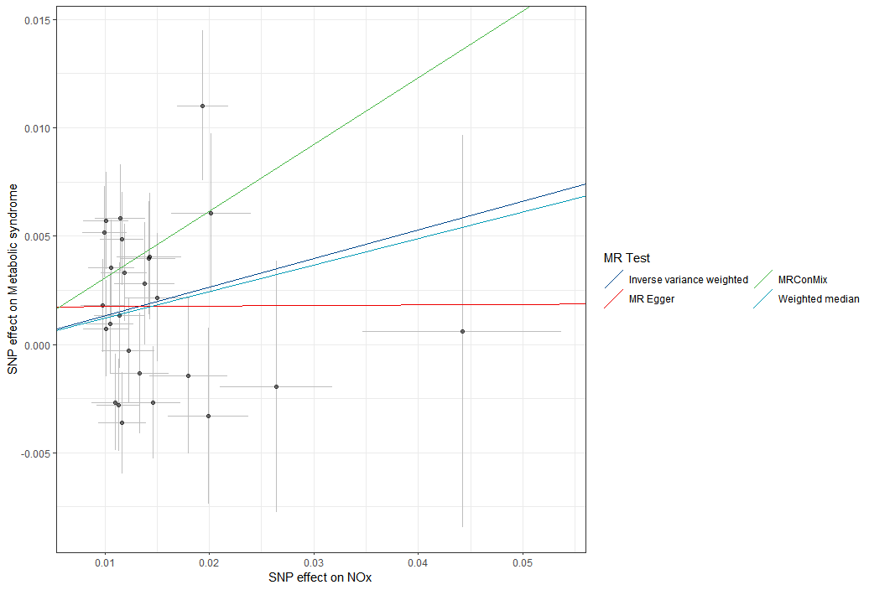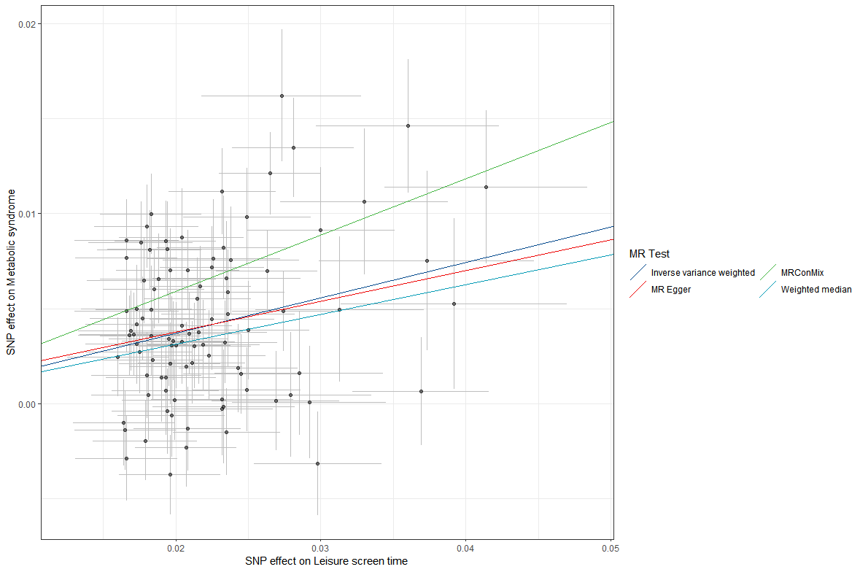

D.MVPA on metabolic syndrome E. smoking initiation on metabolic syndrome F. Coffee intake on metabolic syndrome
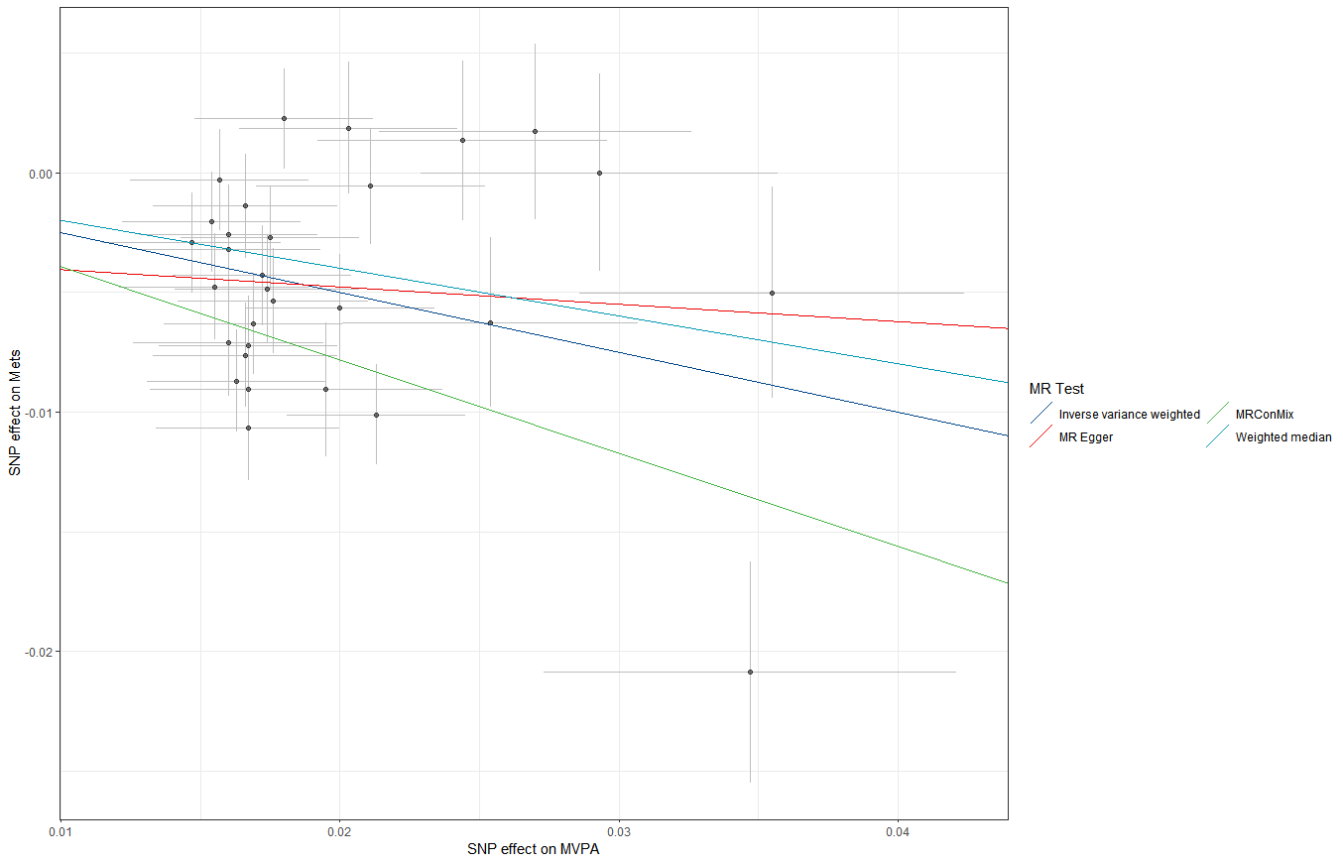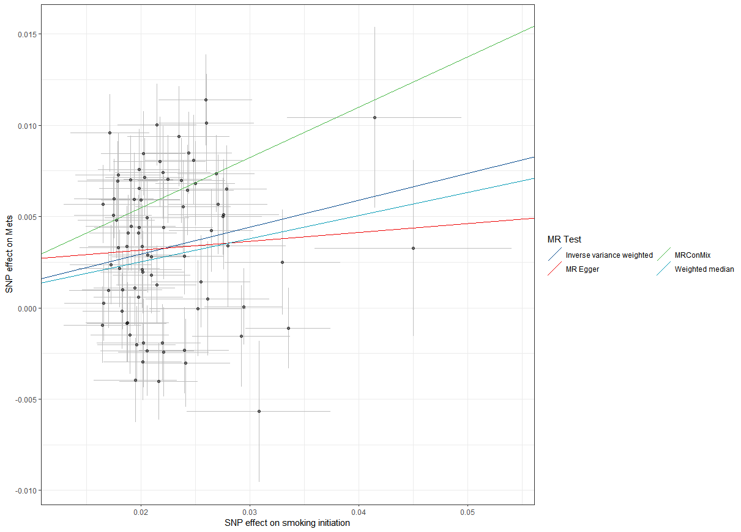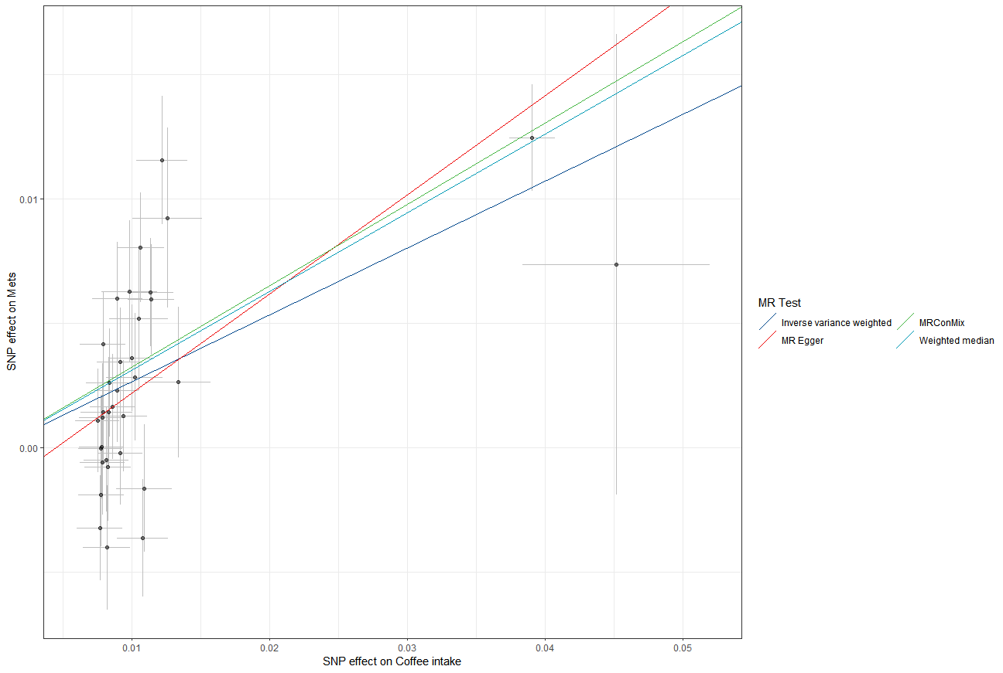

Figure S3. The scatter plots of the identified associations between air pollutants and lifestyle factors with metabolic syndrome.

A.PM_{2.5} on metabolic syndrome B.NO_{X} on metabolic syndrome C. Leisure screen time on metabolic syndrome
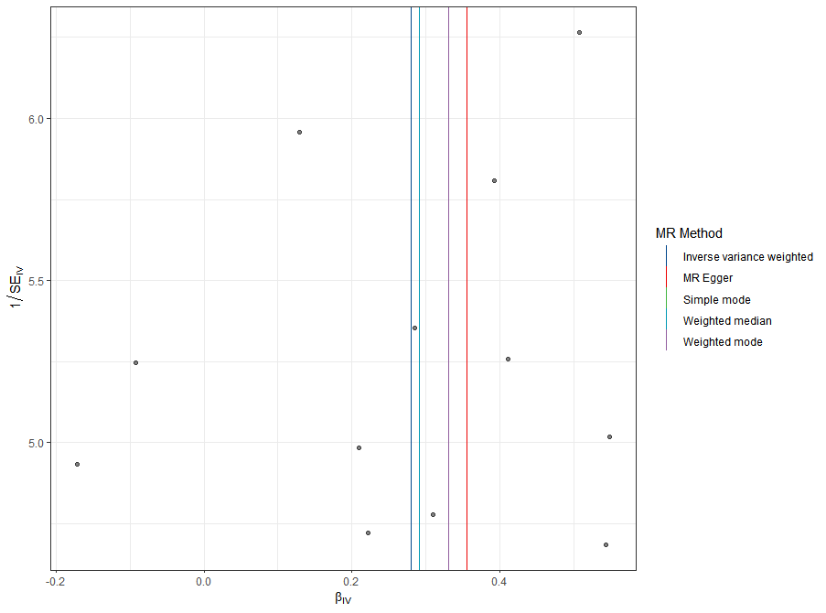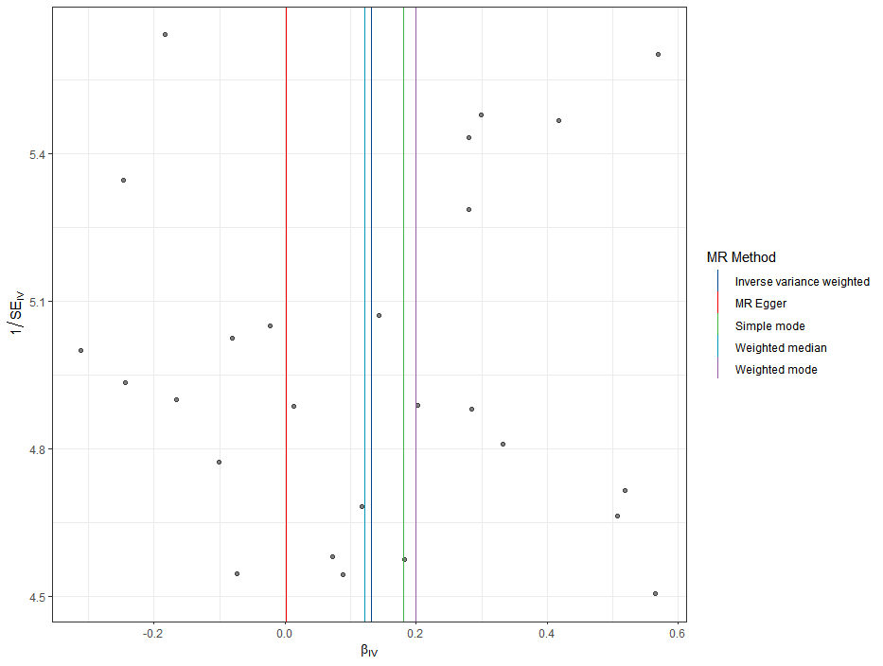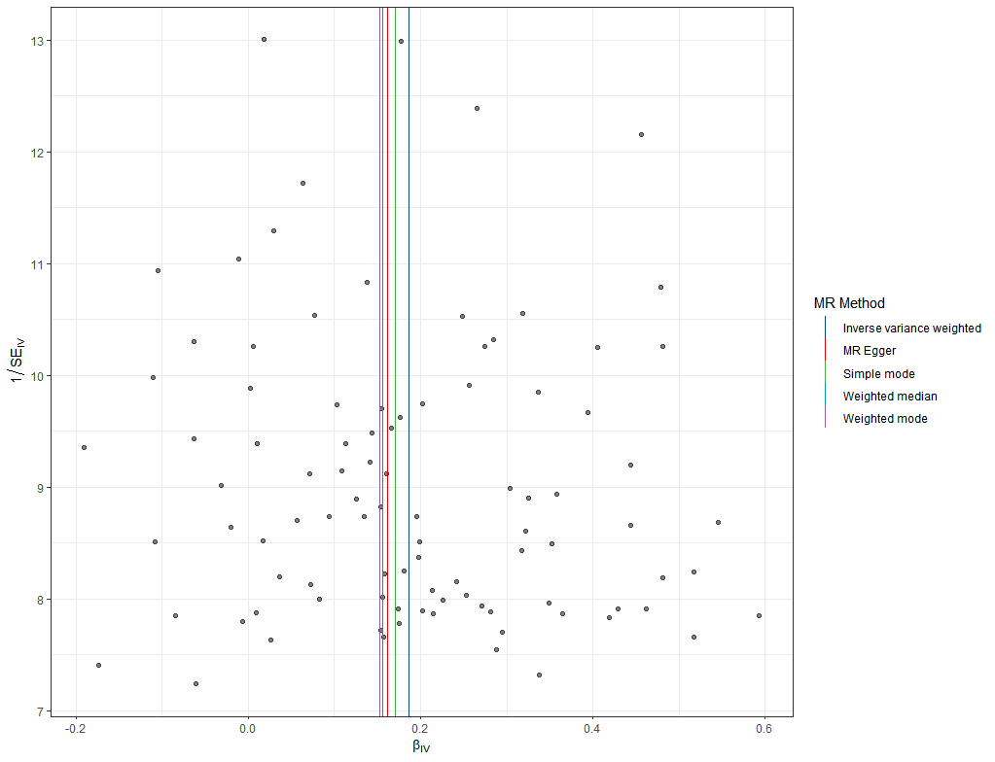
D.MVPA on metabolic syndrome E. smoking initiation on metabolic syndrome F. Coffee intake on metabolic syndrome
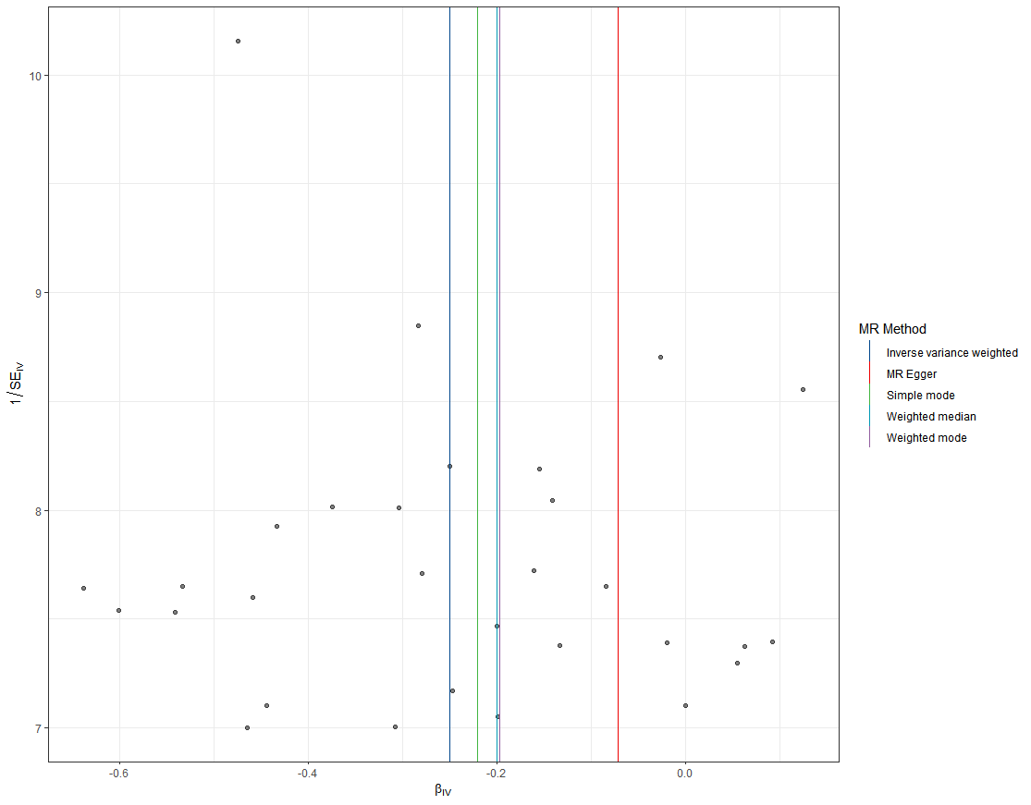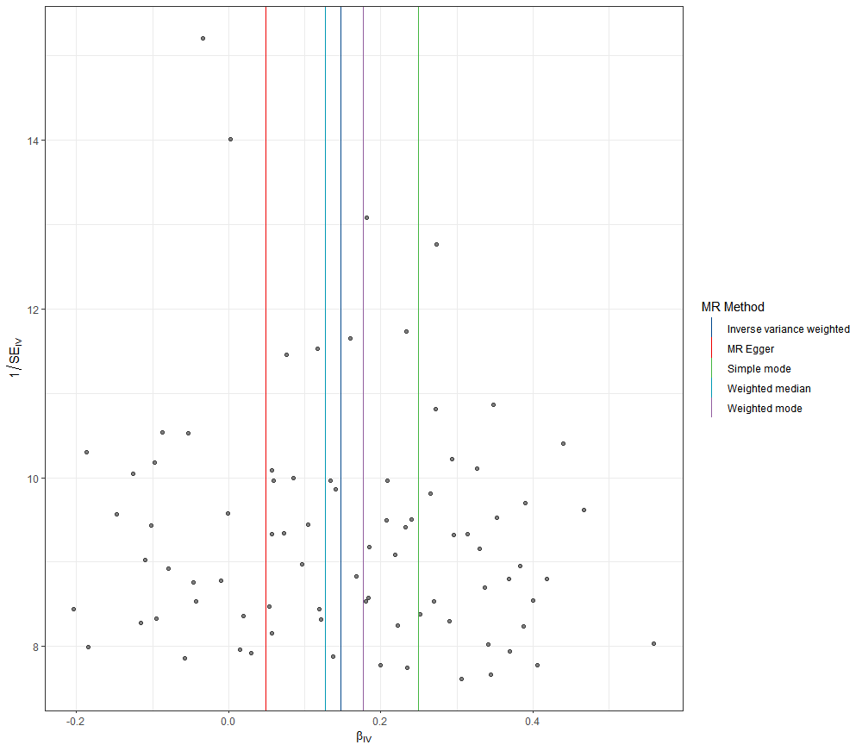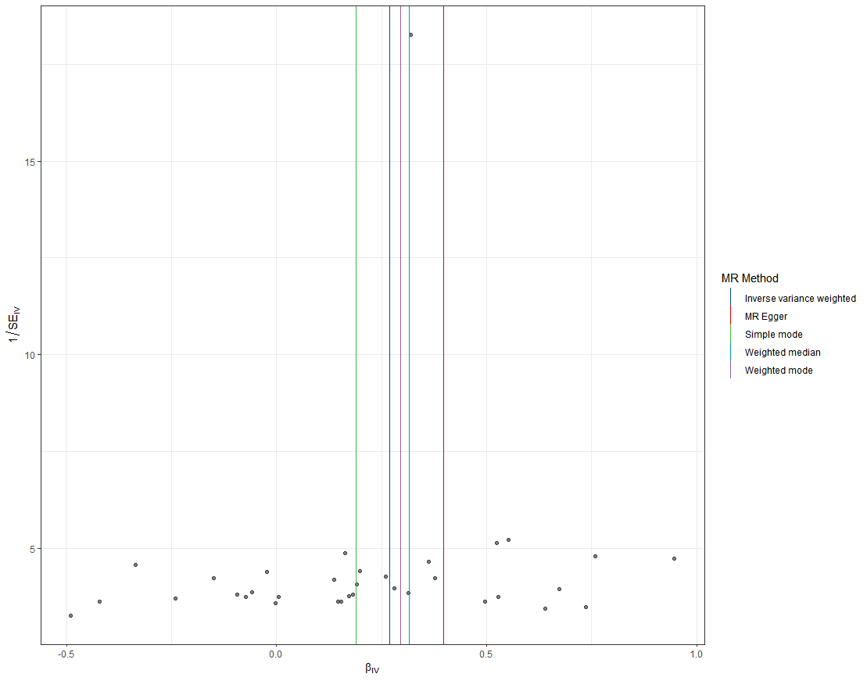
Figure S4. The funnel plots of the identified associations between air pollutants and lifestyle factors with metabolic syndrome.

A.PM_{2.5} on hypertension B. Leisure screen time on hypertension C. MVPA on hypertension D. smoking initiation on hypertension
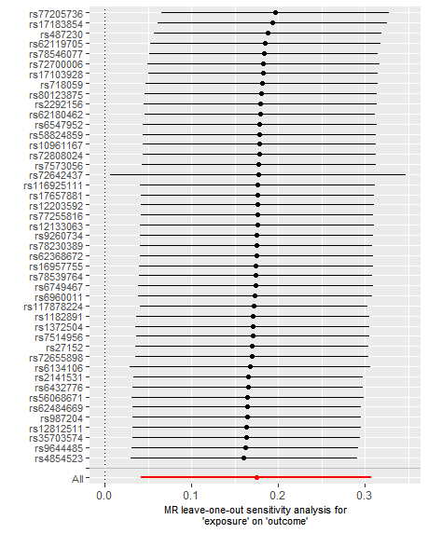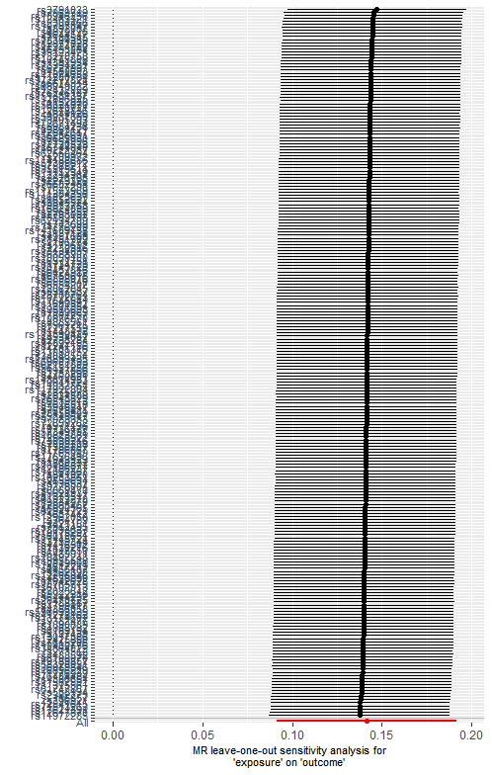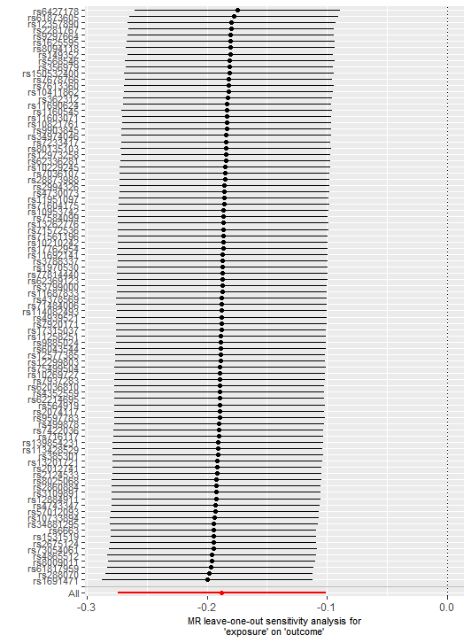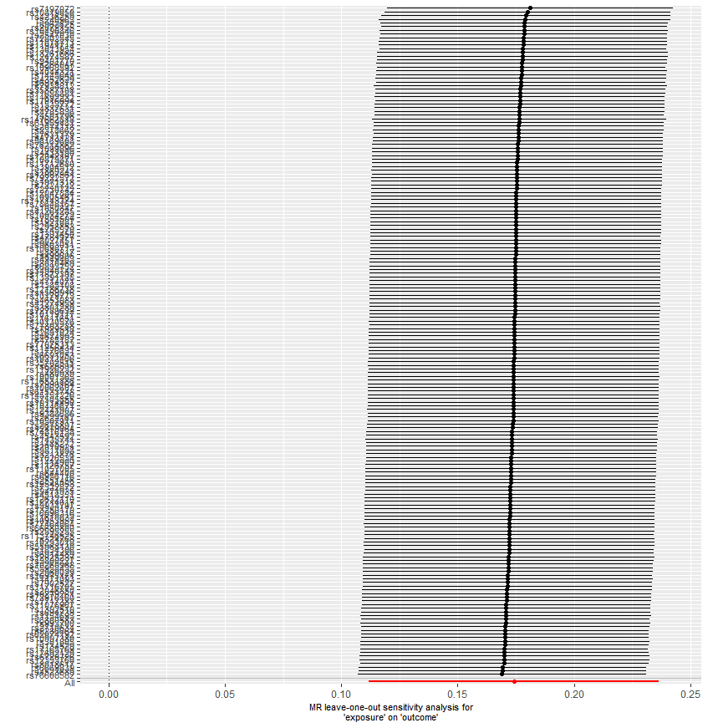
Figure S5. Leave-one-out analysis for identified associations between air pollutants and lifestyle factors with hypertension.

A.PM_{2.5} on hypertension B. Leisure screen time on hypertension
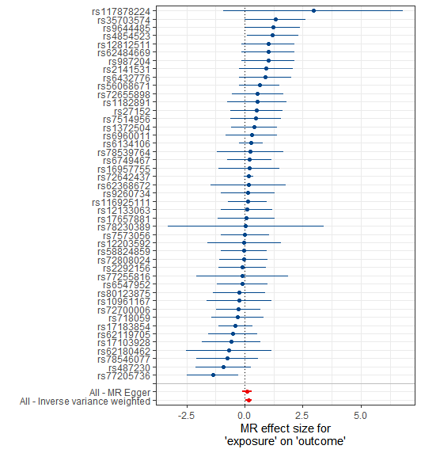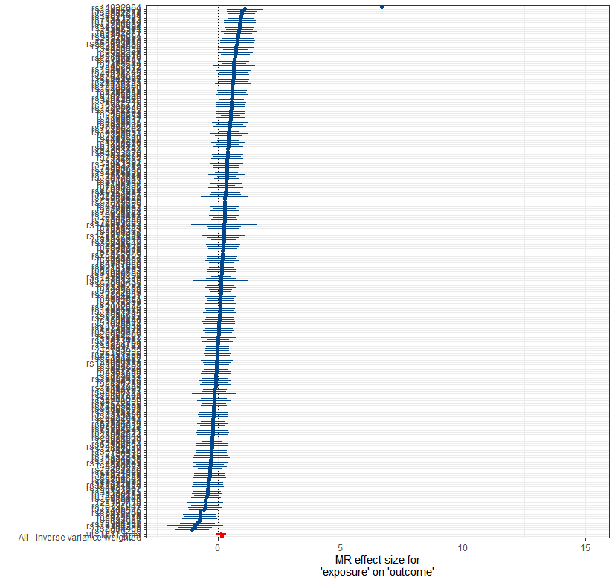
C.MVPA on hypertension D. smoking initiation on hypertension
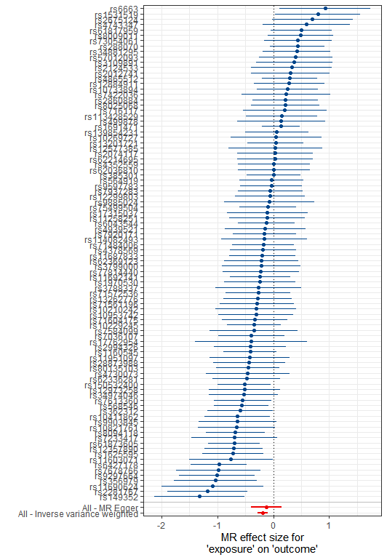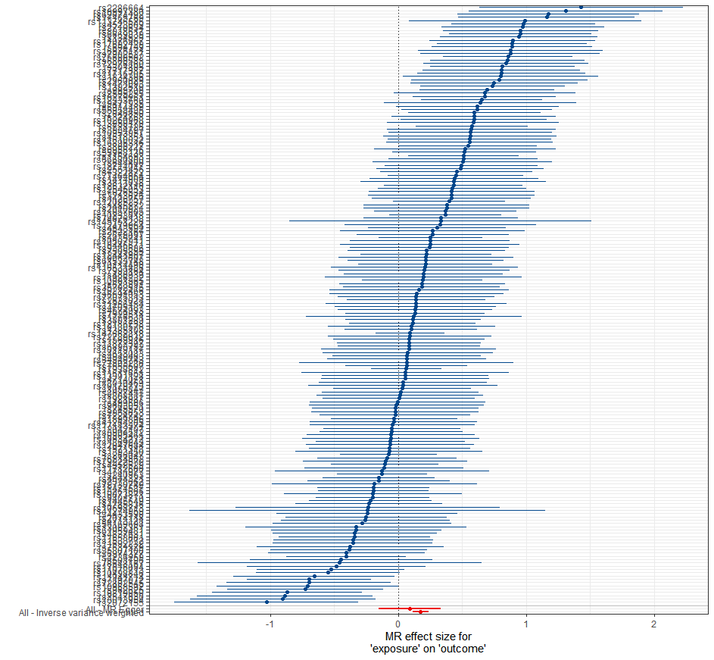
Figure S6. The forest plots for identified associations between air pollutants and lifestyle factors with hypertension.
A.PM_{2.5} on hypertension B. Leisure screen time on hypertension
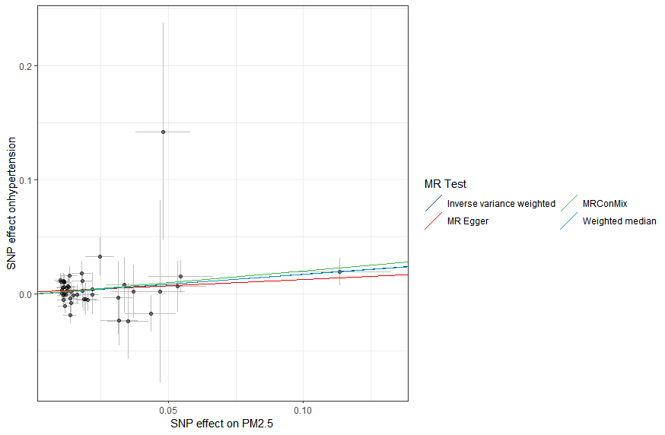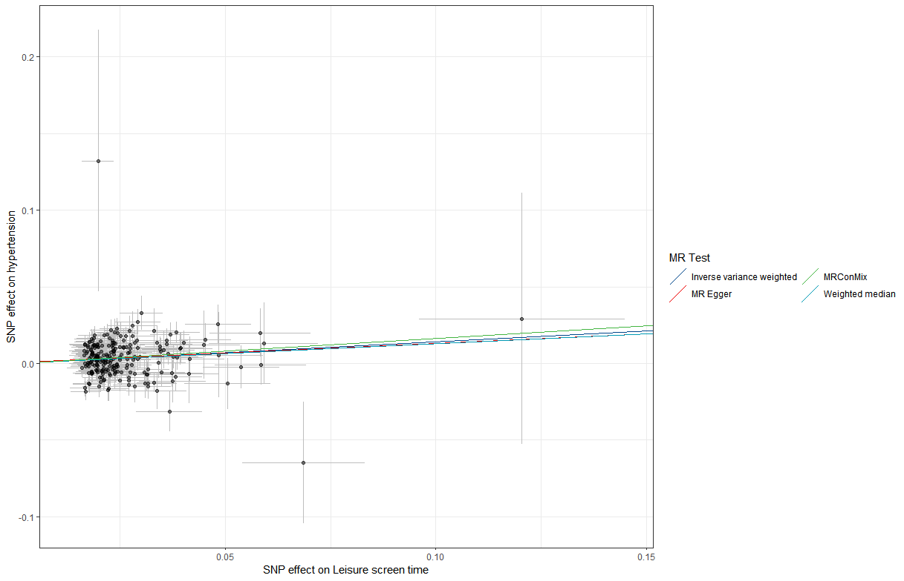
C.MVPA on hypertension D. smoking initiation on hypertension
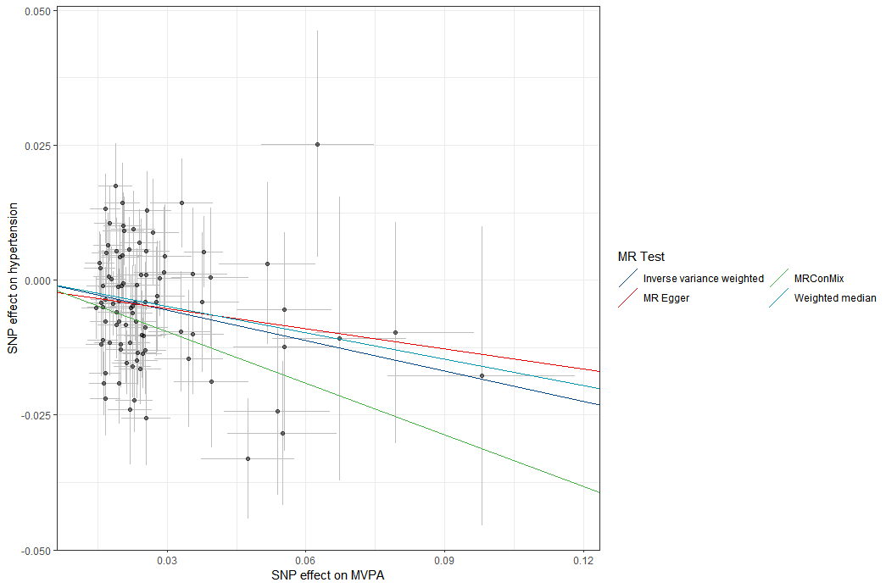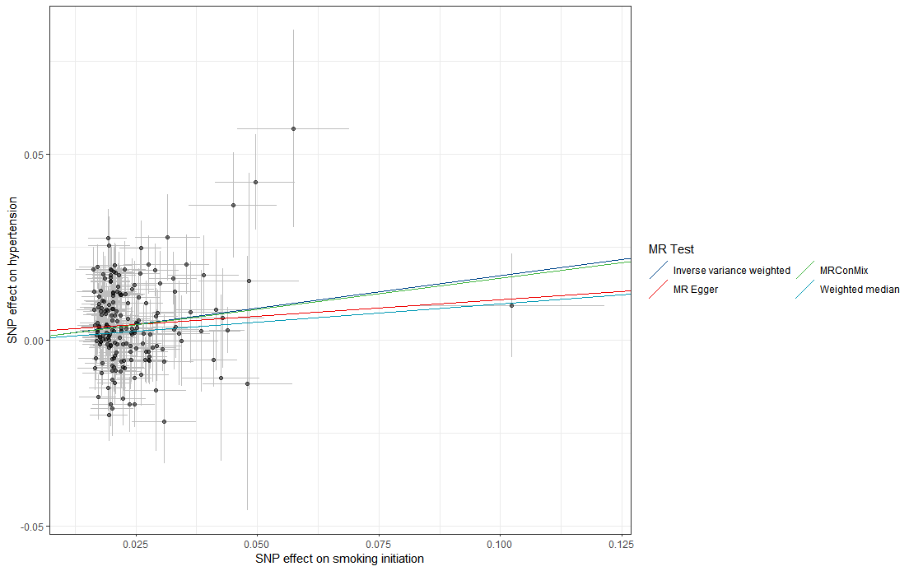
Figure S7. The scatter plots of the identified associations between air pollutants and lifestyle factors with hypertension.
A.PM_{2.5} on hypertension B. Leisure screen time on hypertension
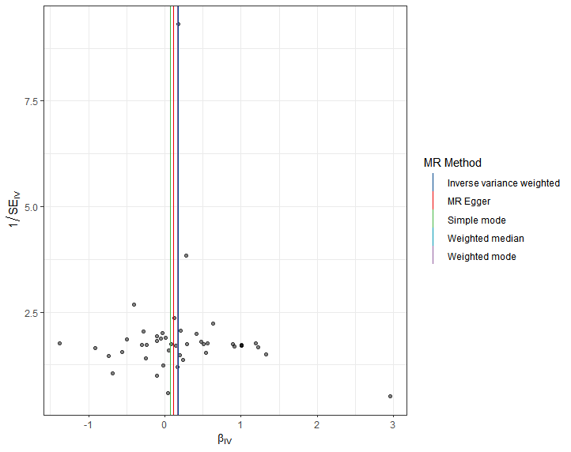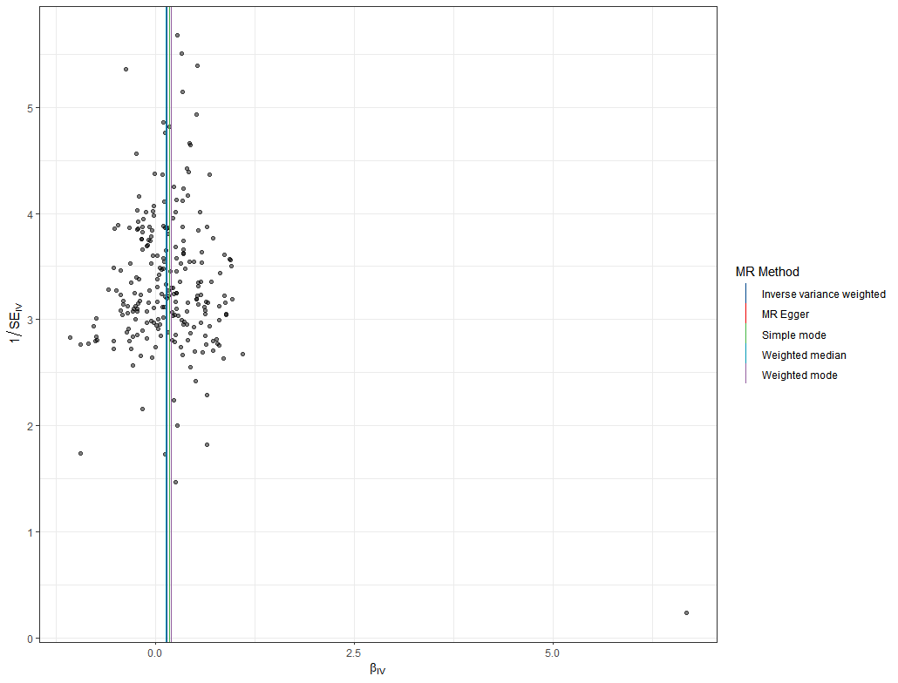
C.MVPA on hypertension D. smoking initiation on hypertension
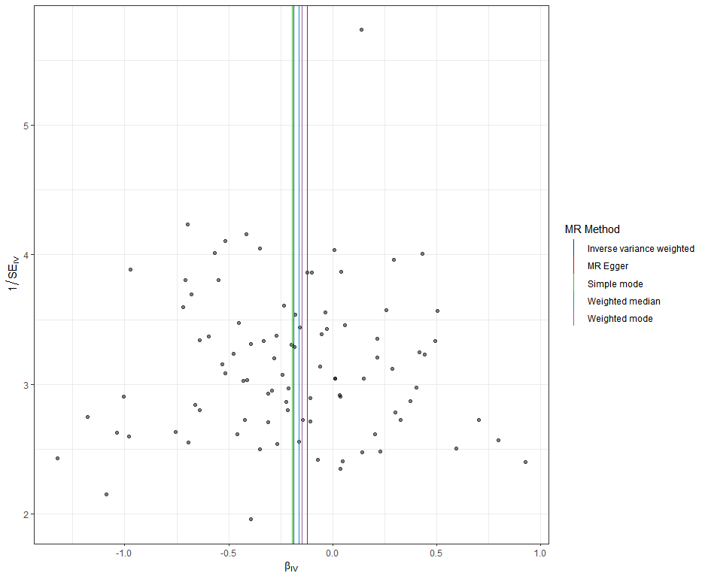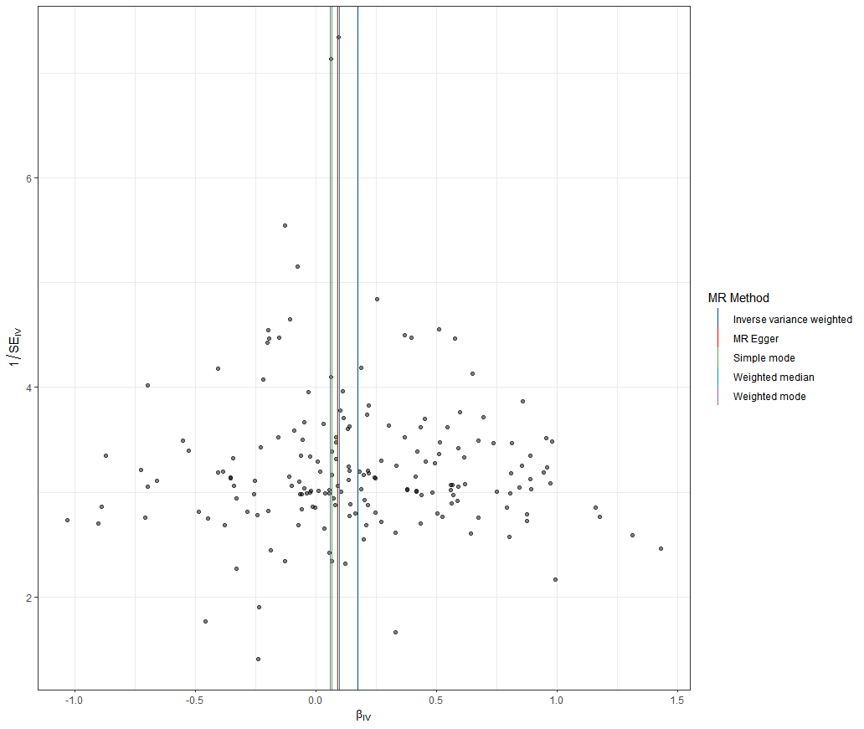
Figure S8. The funnel plots of the identified associations between air pollutants and lifestyle factors with hypertension.
A. NOx on waist circumference B. Leisure screen time on waist circumference C. MVPA on waist circumference
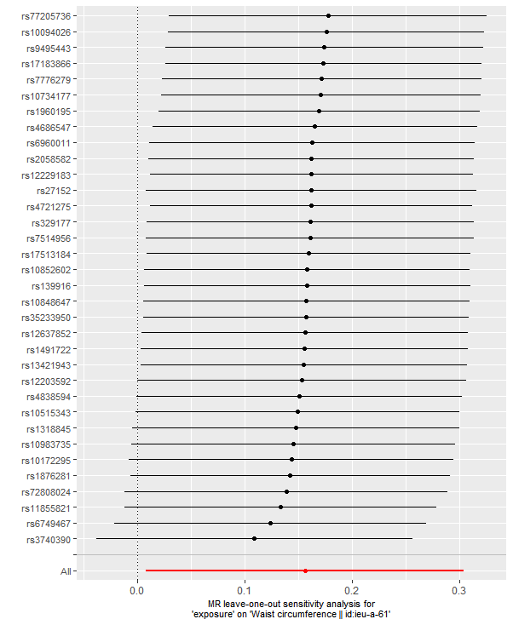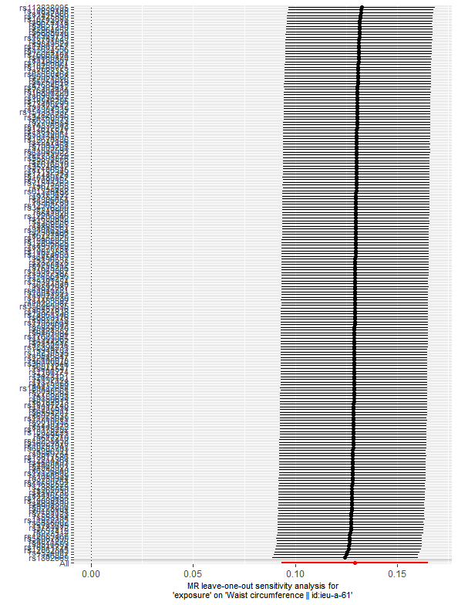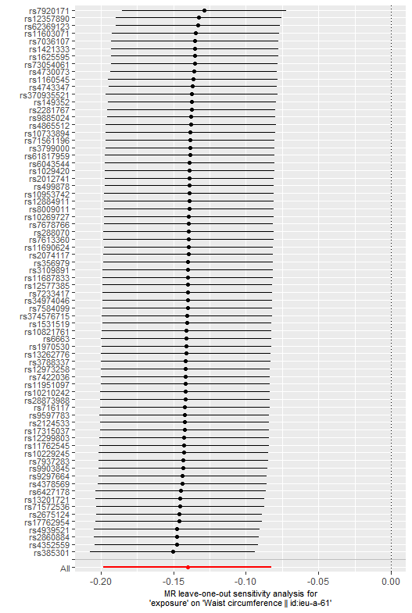
D. smoking initiation on waist circumference E. Coffee intake on waist circumference F. Relative carbohydrate intake on waist circumference
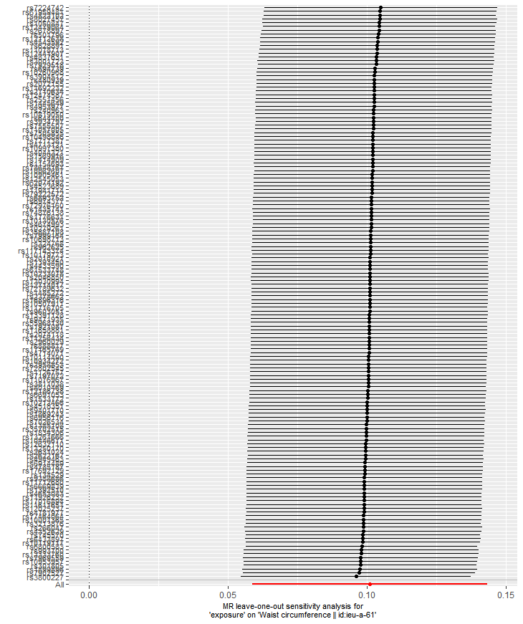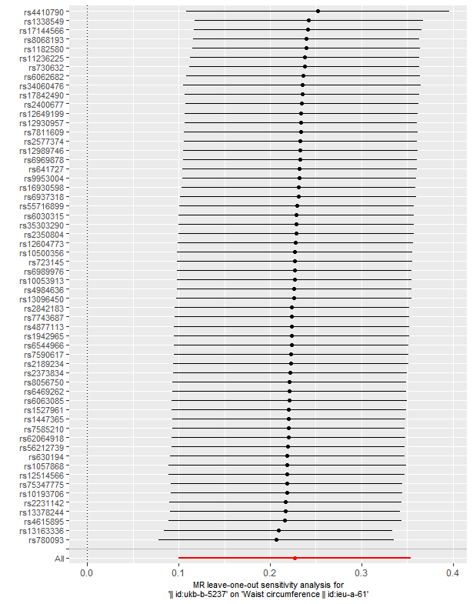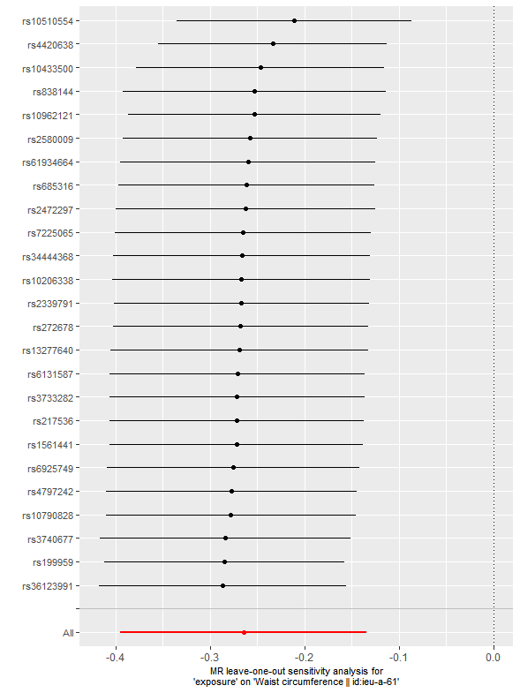
Figure S9. Leave-one-out analysis for identified associations between air pollutants and lifestyle factors with waist circumference.
- NOx on waist circumference B. Leisure screen time on waist circumference C. MVPA on waist circumference
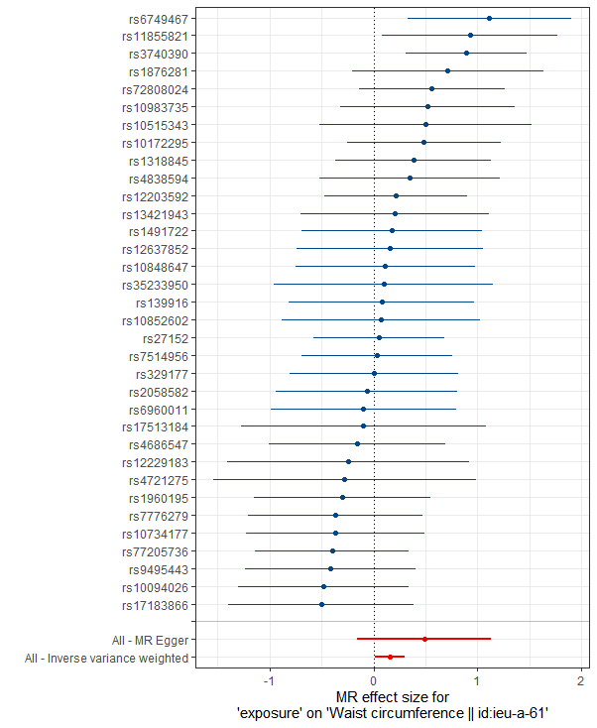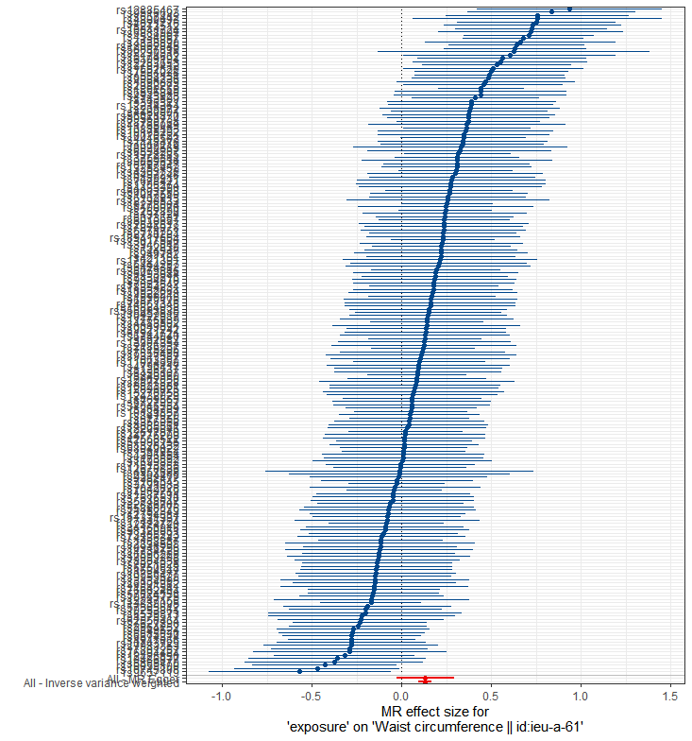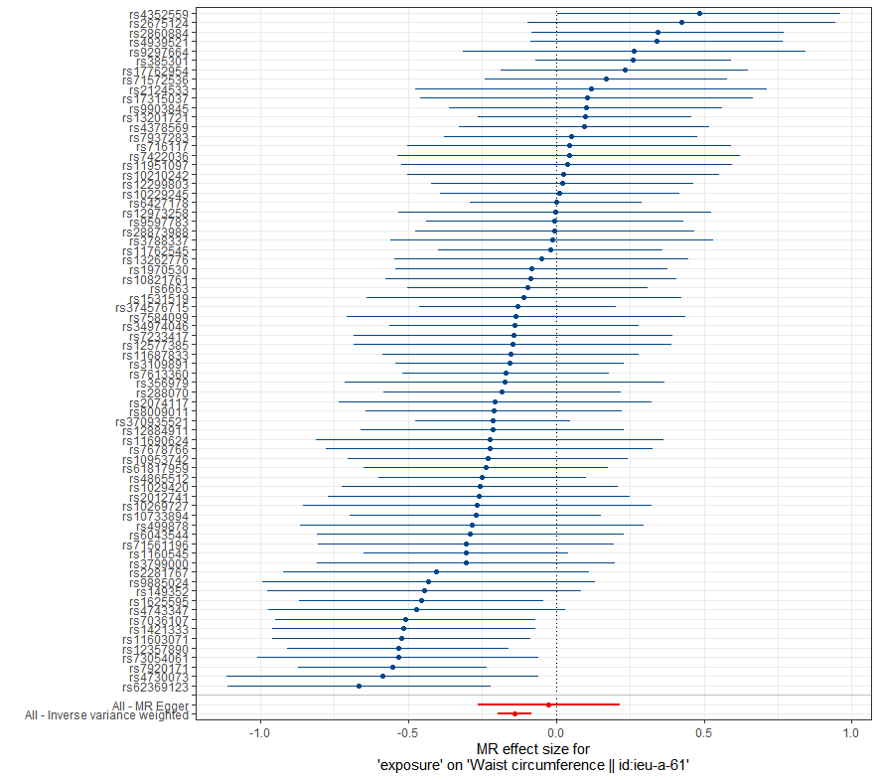
D. smoking initiation on waist circumference E. Coffee intake on waist circumference F. Relative carbohydrate intake on waist circumference
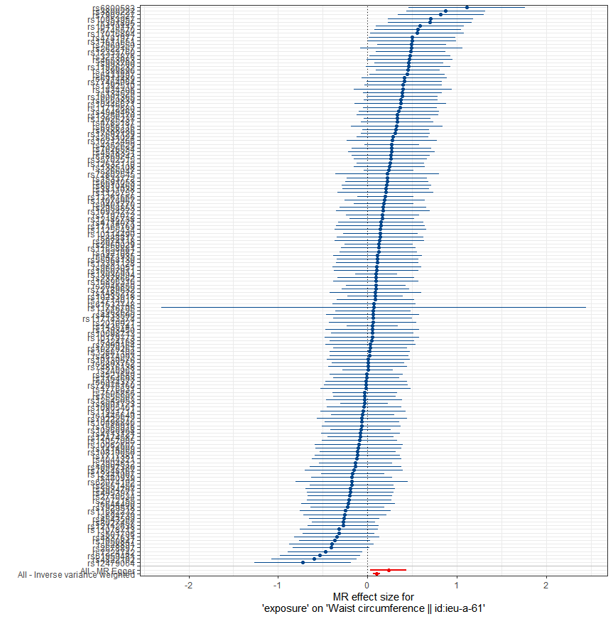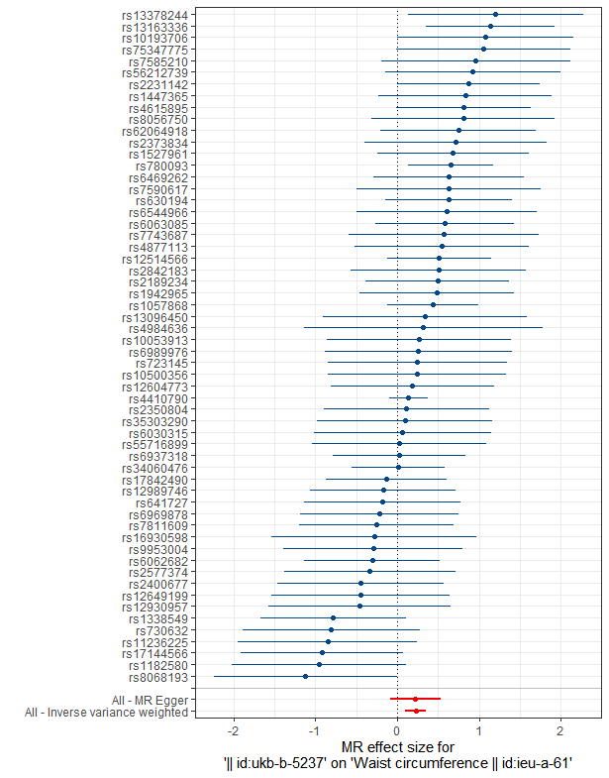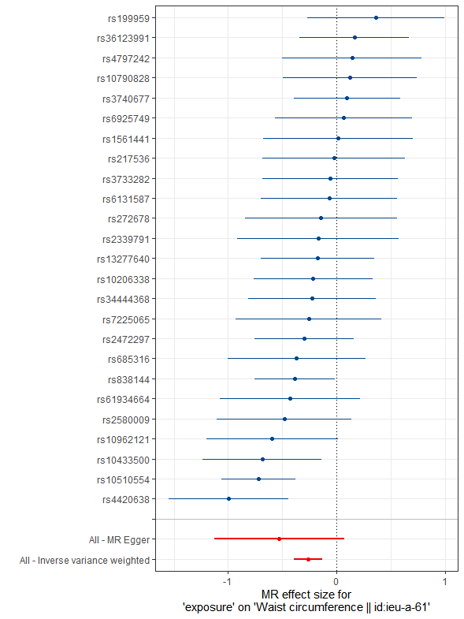
Figure S10. The forest plots for identified associations between air pollutants and lifestyle factors with waist circumference.
- NOx on waist circumference B. Leisure screen time on waist circumference C.MVPA on waist circumference
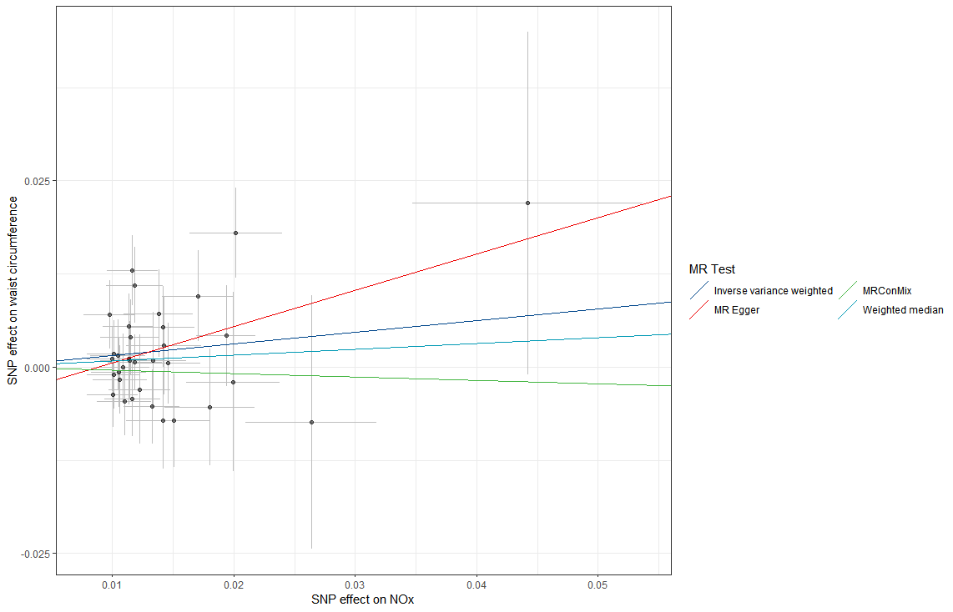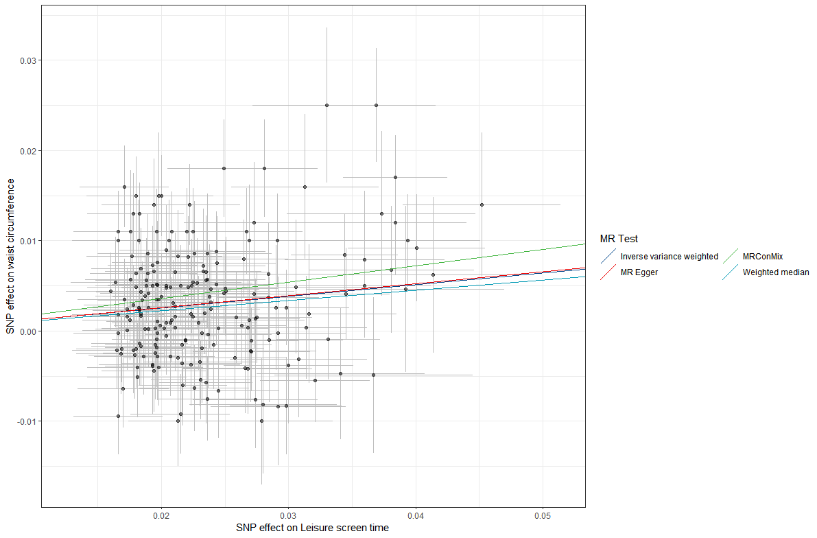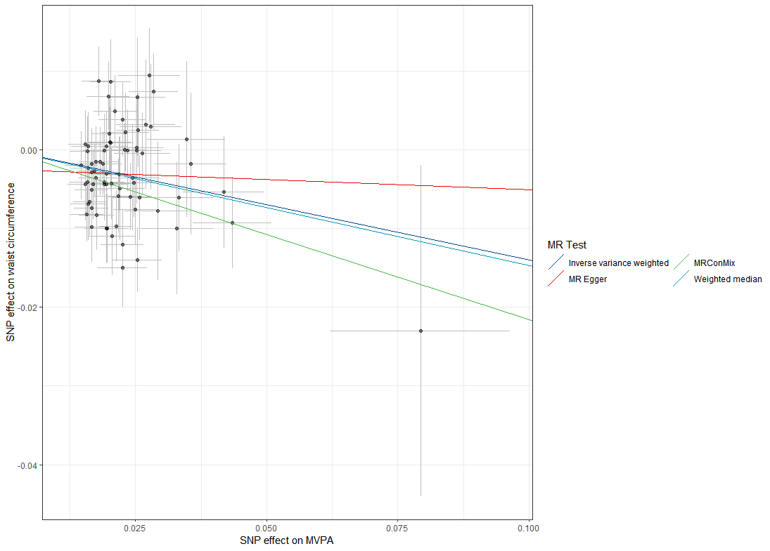

D. smoking initiation on waist circumference E. Coffee intake on waist circumference F. Relative carbohydrate intake on waist circumference
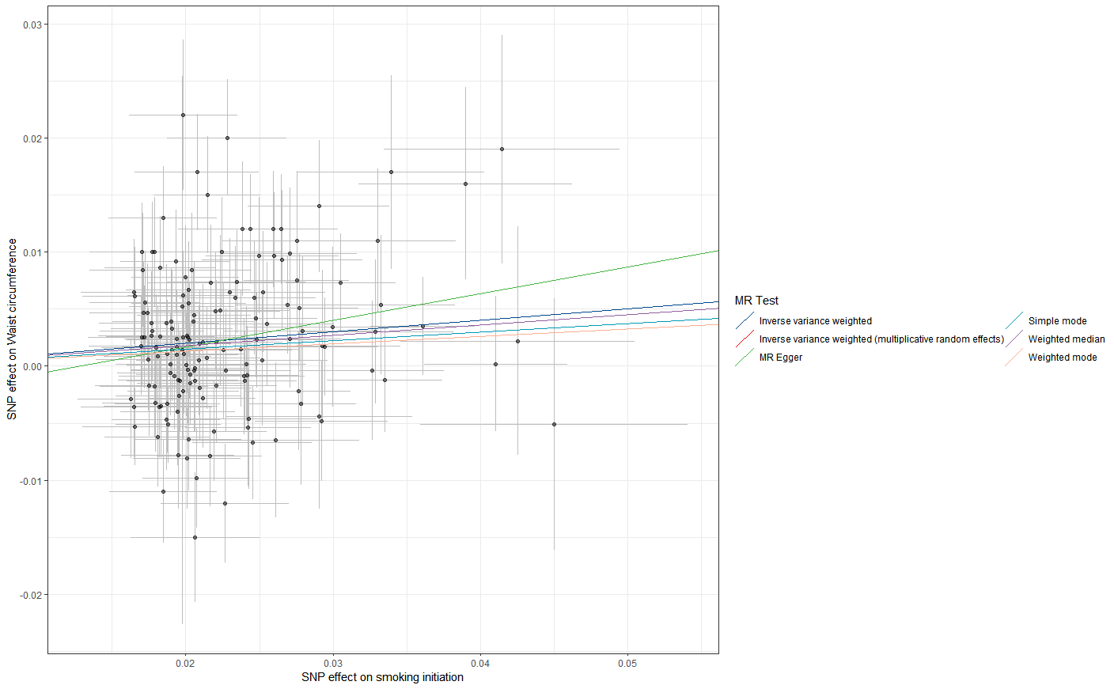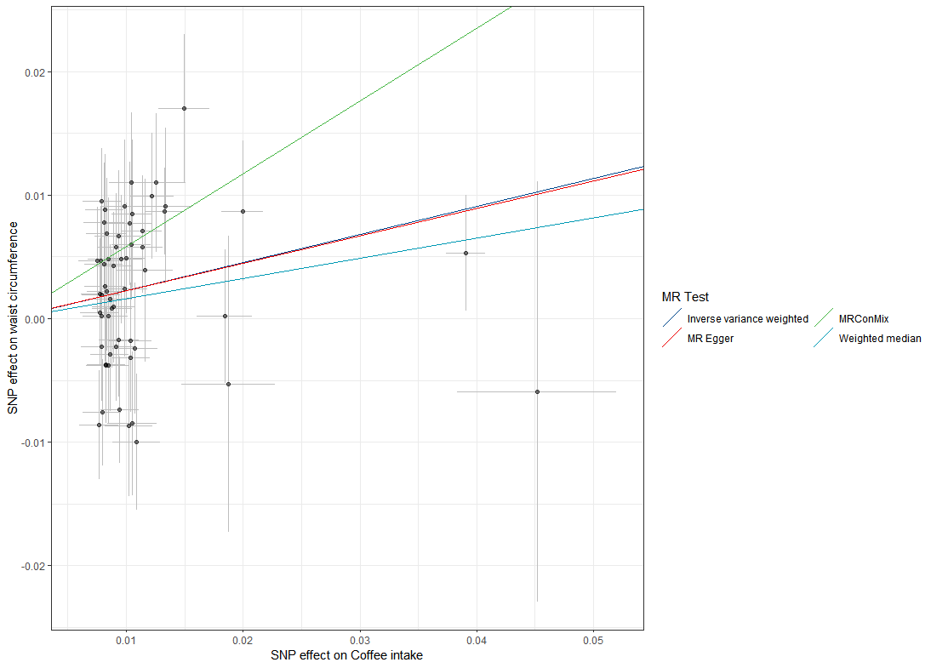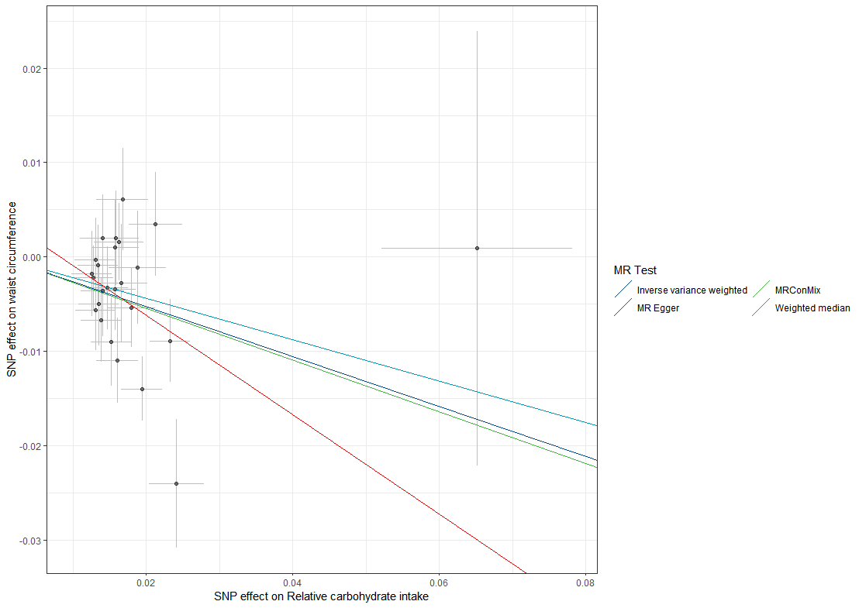
Figure S11. The scatter plots of the identified associations between air pollutants and lifestyle factors with waist circumference.

- NOx on waist circumference B. Leisure screen time on waist circumference C. MVPA on waist circumference
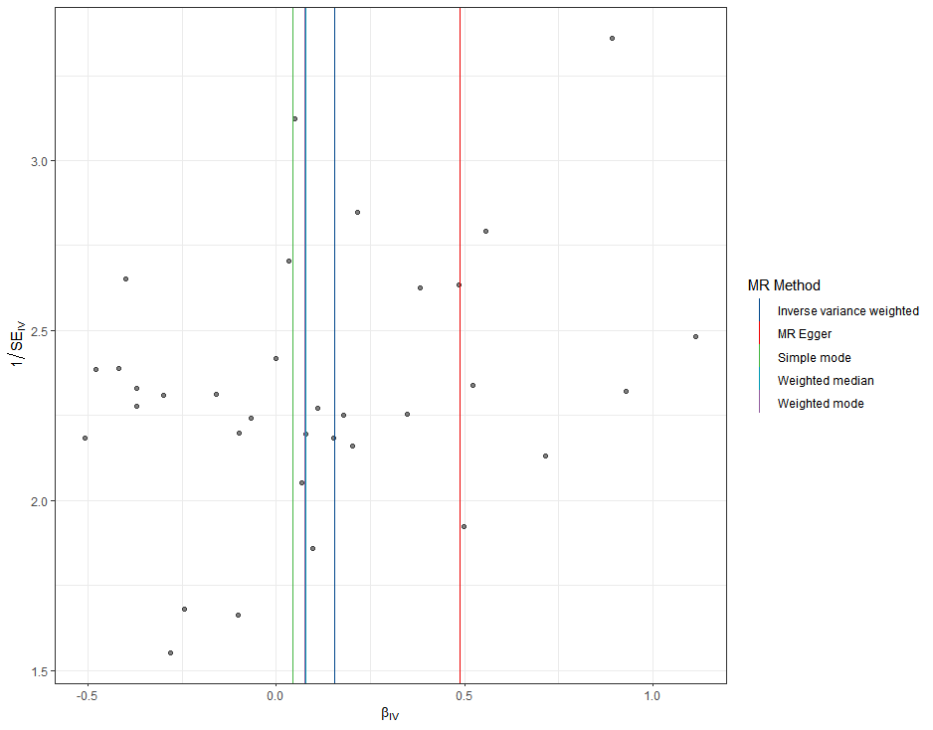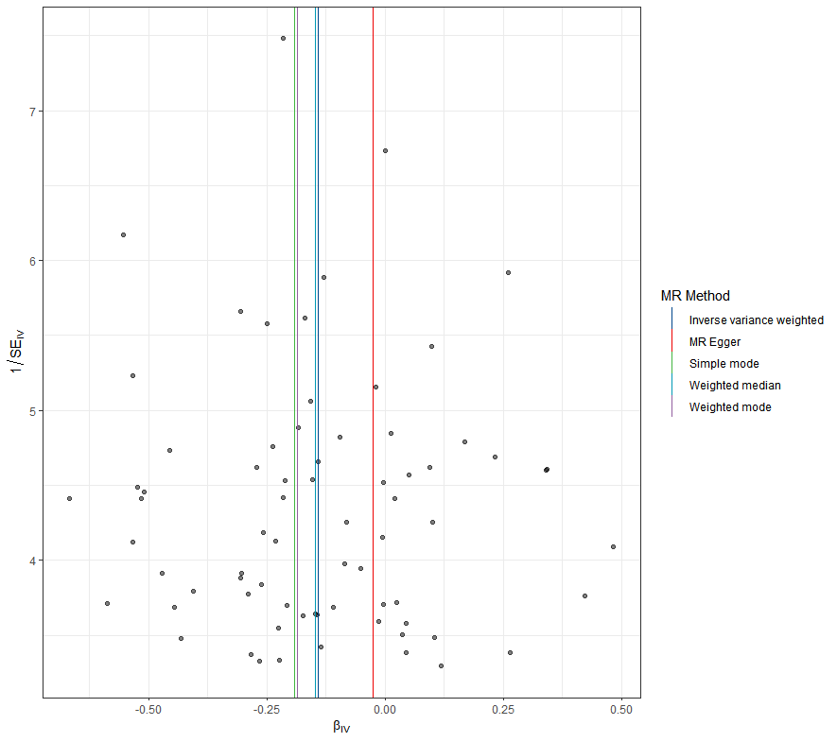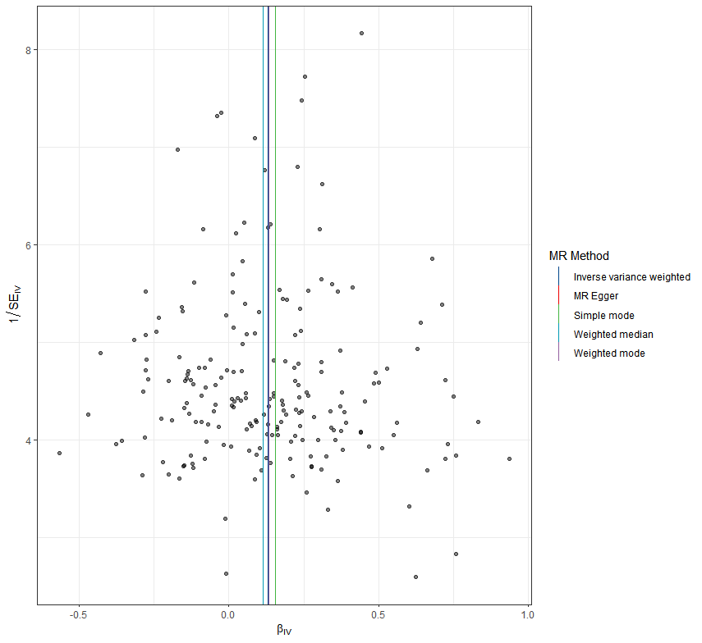
D. smoking initiation on waist circumference E. Coffee intake on waist circumference F. Relative carbohydrate intake on waist circumference
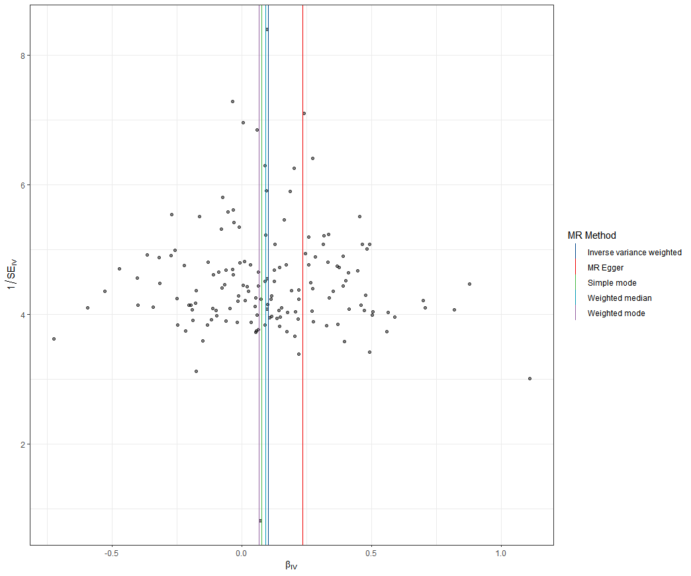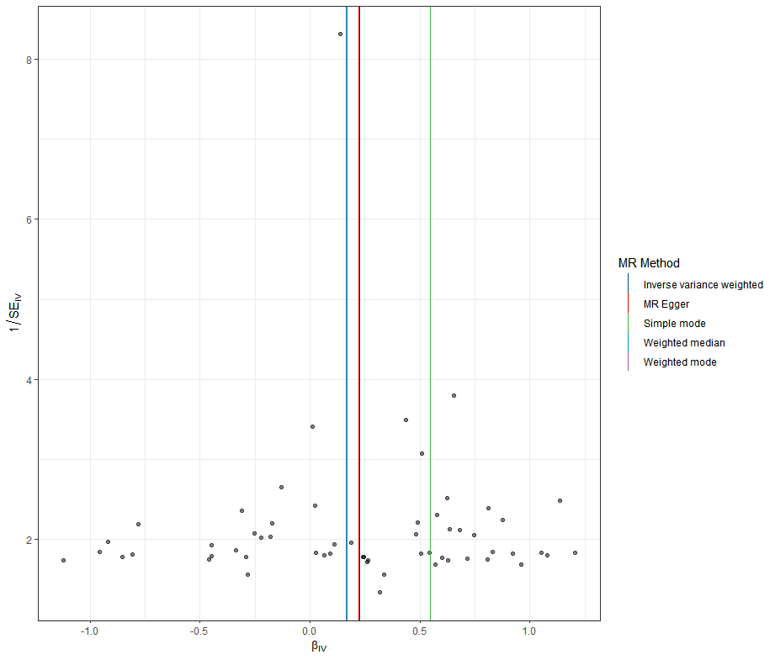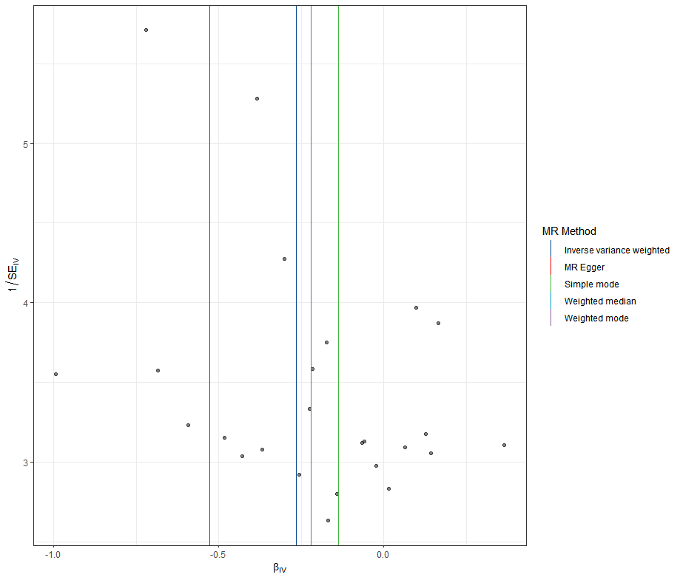
Figure S12. The funnel plots of the identified associations between air pollutants and lifestyle factors with waist circumference.

- Leisure screen time on HDL cholesterol B. MVPA on HDL cholesterol C. smoking initiation on HDL cholesterol
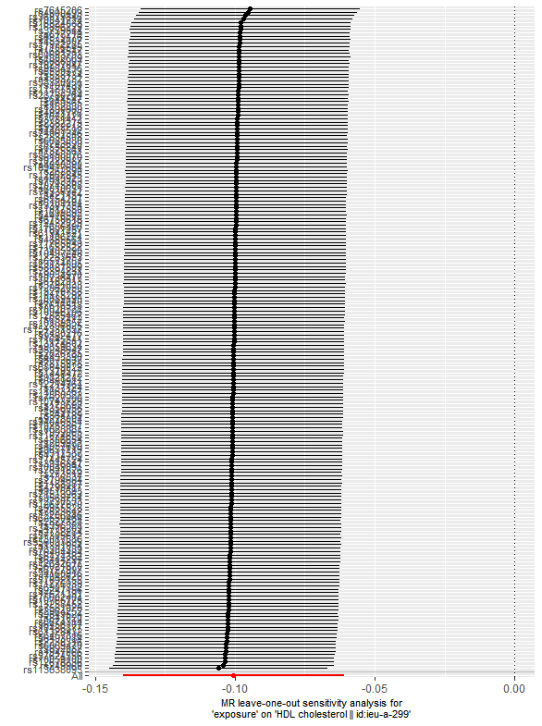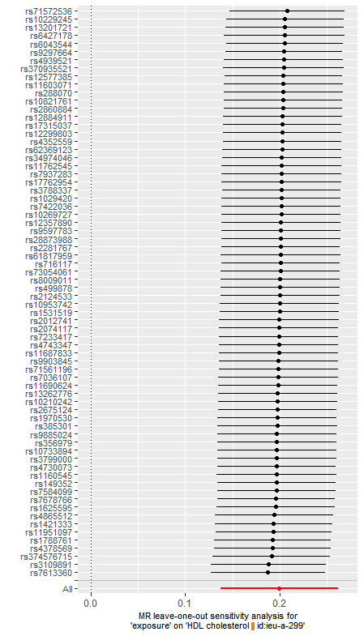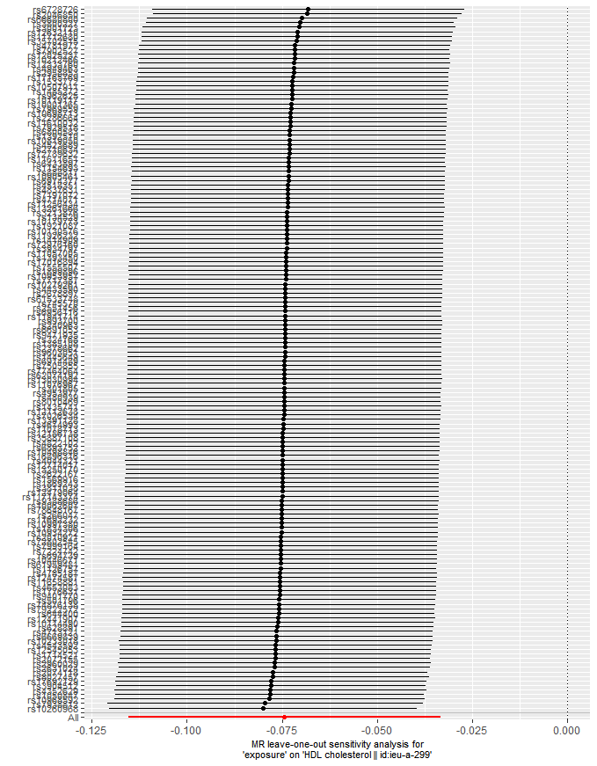
D. Alcoholic drinks per week on HDL cholesterol E. Relative protein intake on HDL cholesterol
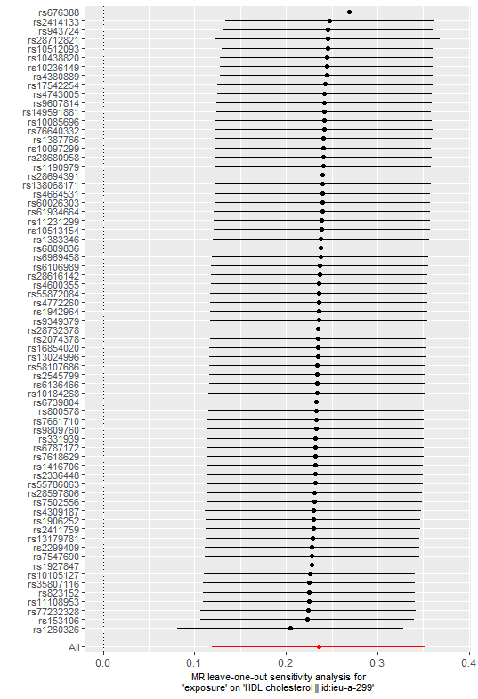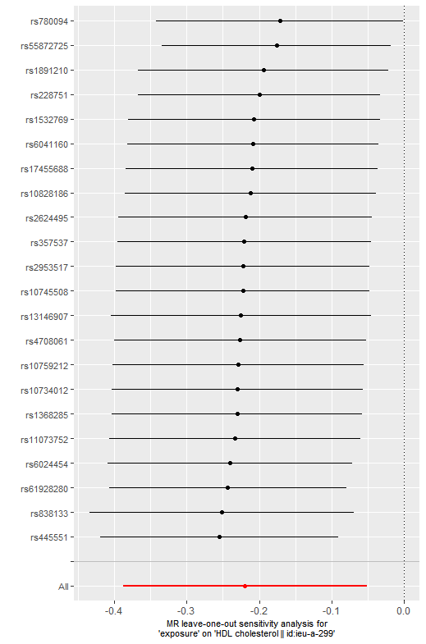
Figure S13. Leave-one-out analysis for identified associations between lifestyle factors and HDL cholesterol.
- Leisure screen time on HDL cholesterol B.MVPA on HDL cholesterol C. smoking initiation on HDL cholesterol
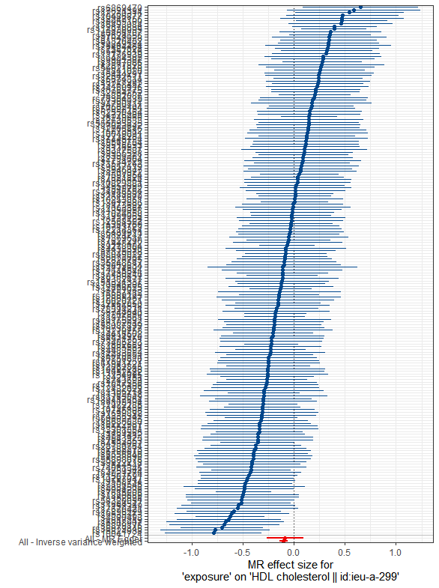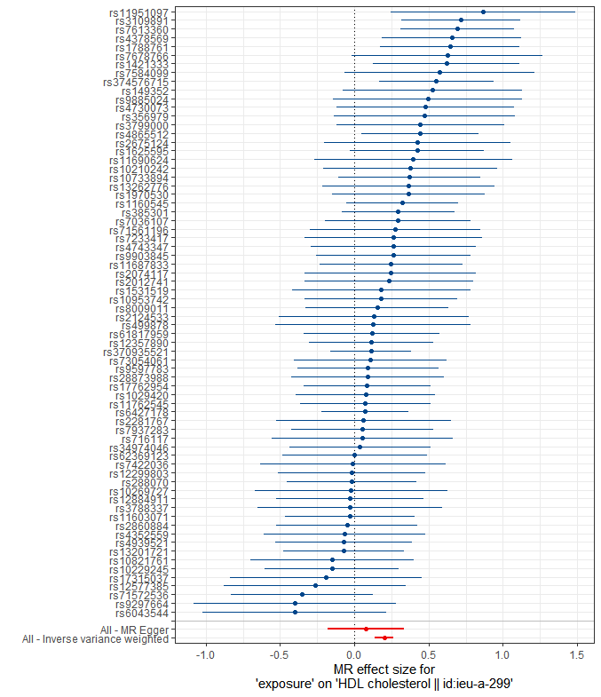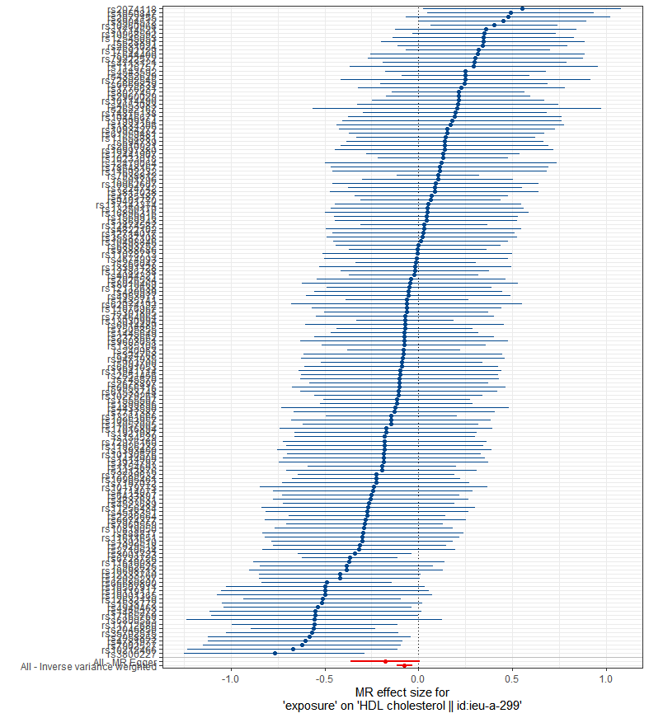
D. Alcoholic drinks per week on HDL cholesterol E. Relative protein intake on HDL cholesterol
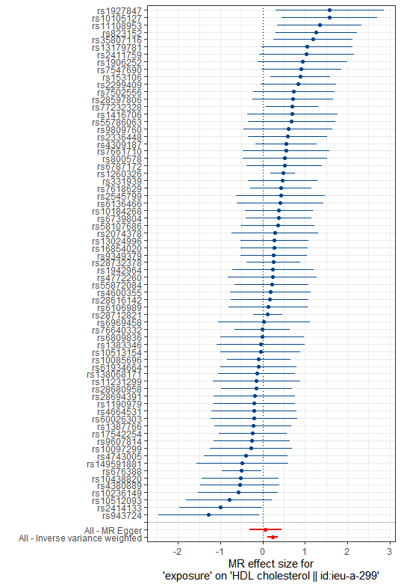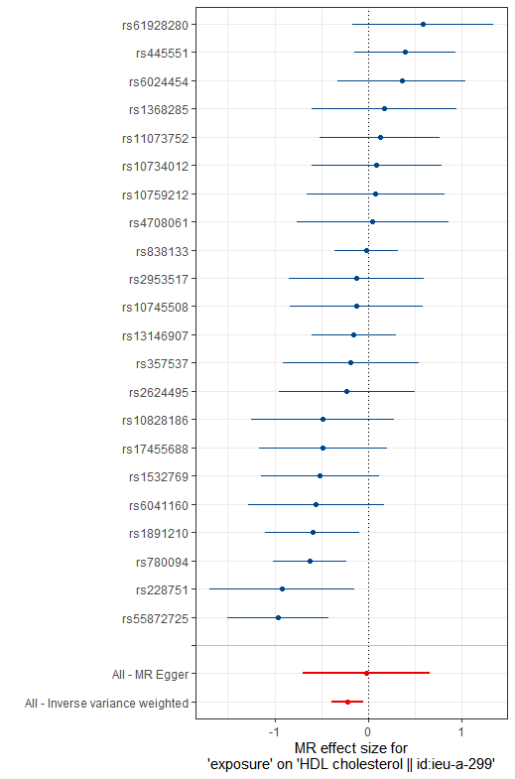
Figure S14. The forest plots for identified associations between lifestyle factors and HDL cholesterol.
A. Leisure screen time on HDL cholesterol B. MVPA on HDL cholesterol C. smoking initiation on HDL cholesterol
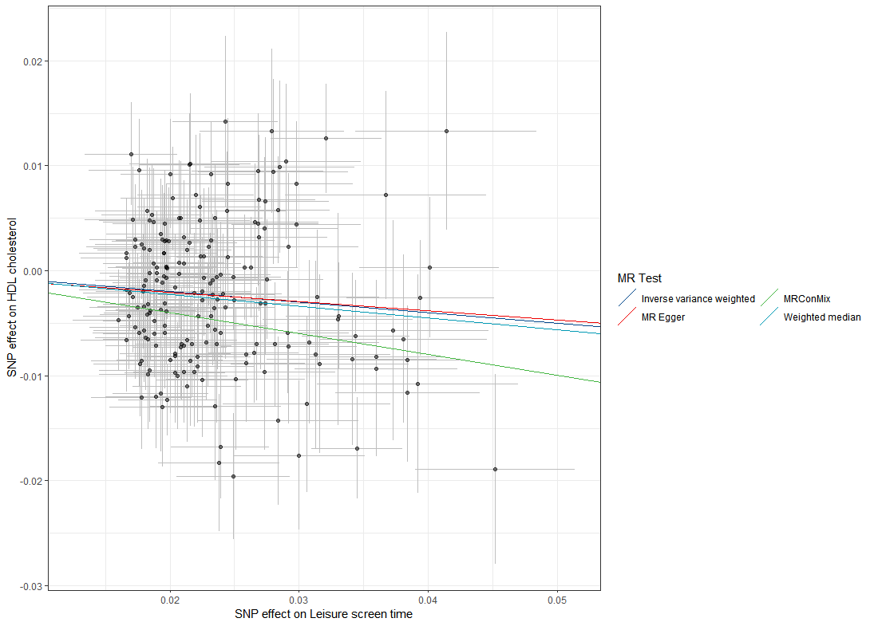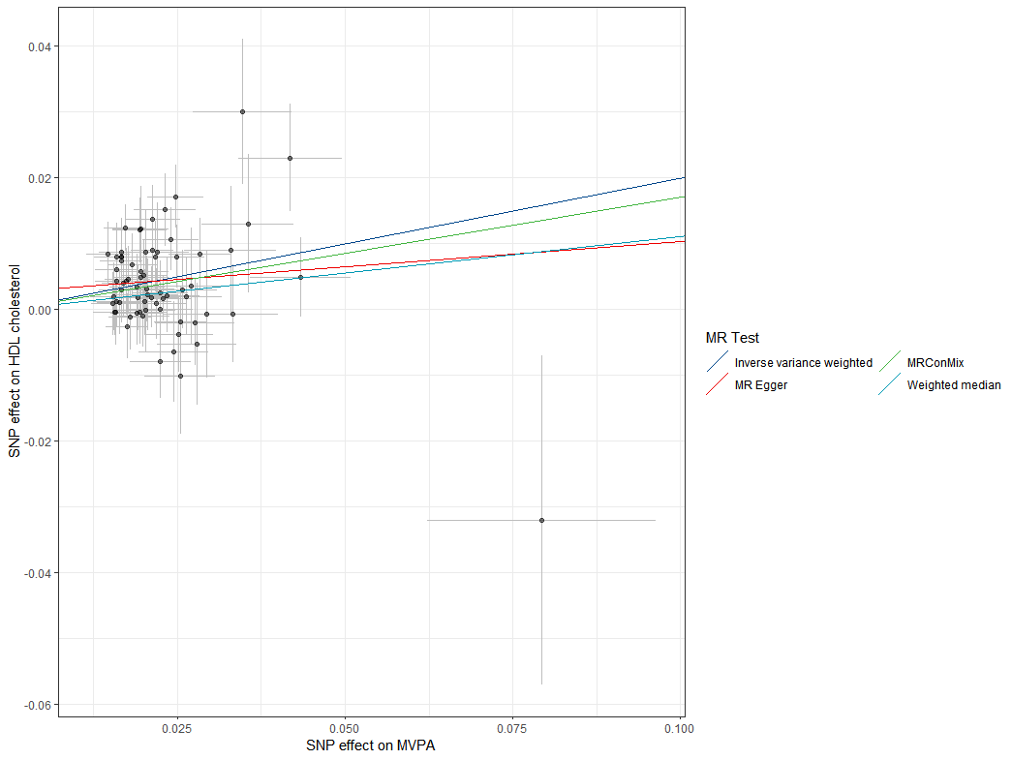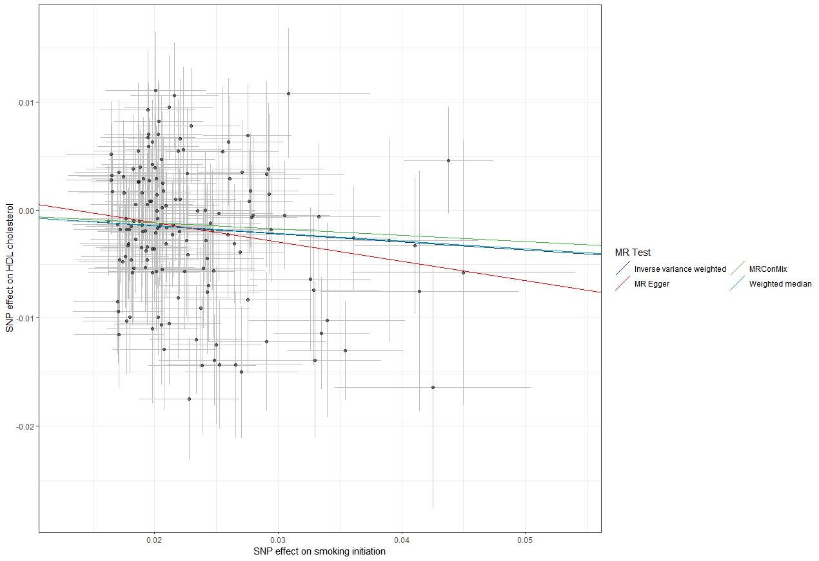

D. Alcoholic drinks per week on HDL cholesterol E. Relative protein intake on HDL cholesterol
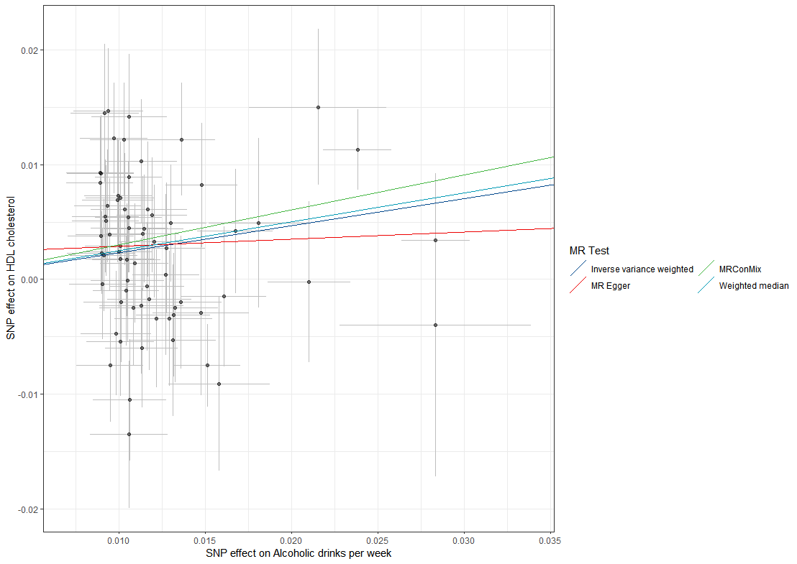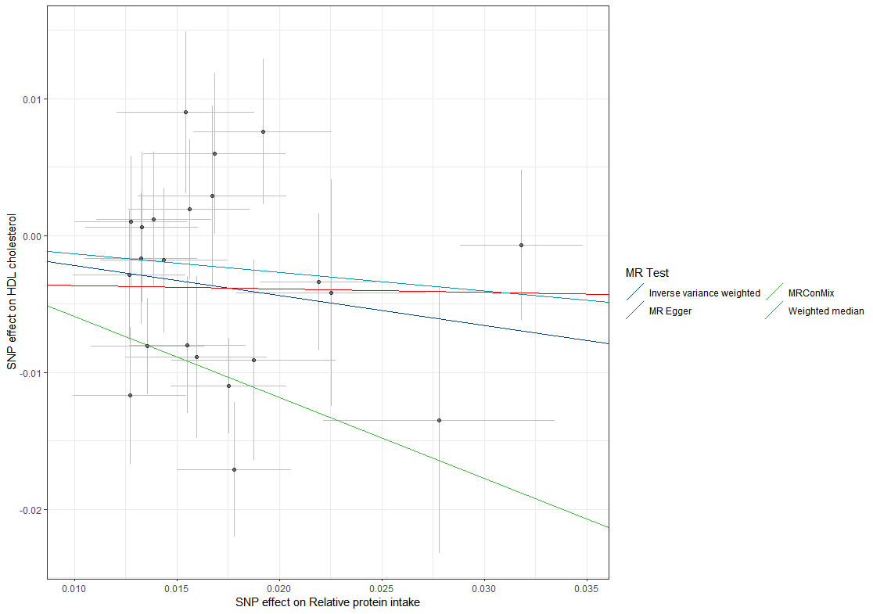
Figure S15. The scatter plots of the identified associations between lifestyle factors and HDL cholesterol.

- Leisure screen time on HDL cholesterol B.MVPA on HDL cholesterol C. smoking initiation on HDL cholesterol
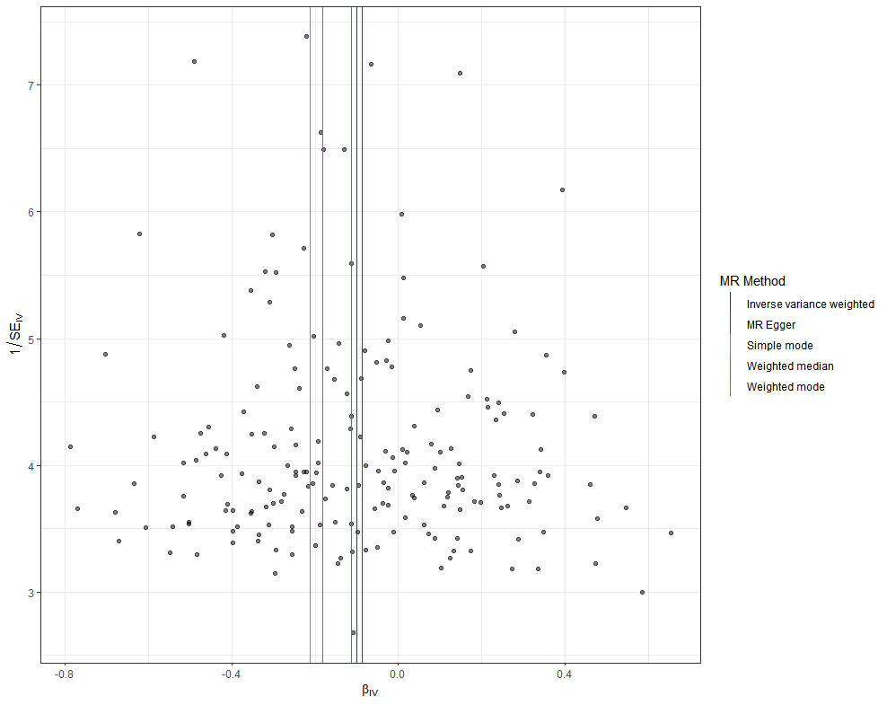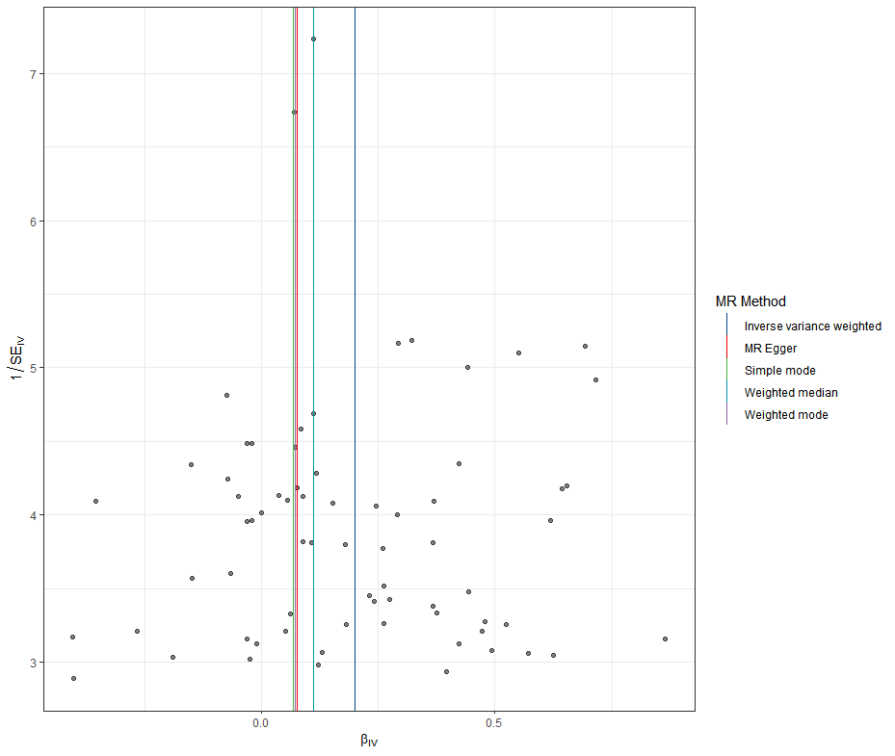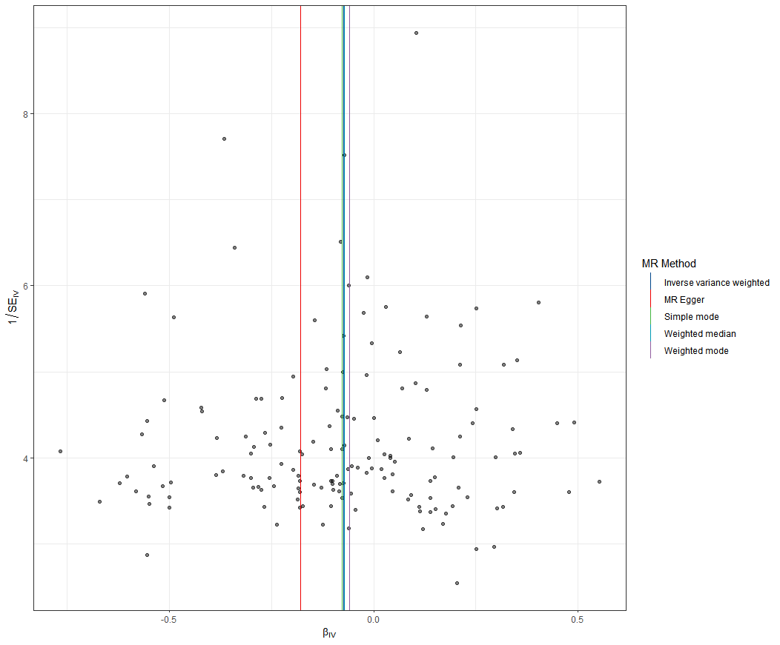
D. Alcoholic drinks per week on HDL cholesterol E. Relative protein intake on HDL cholesterol
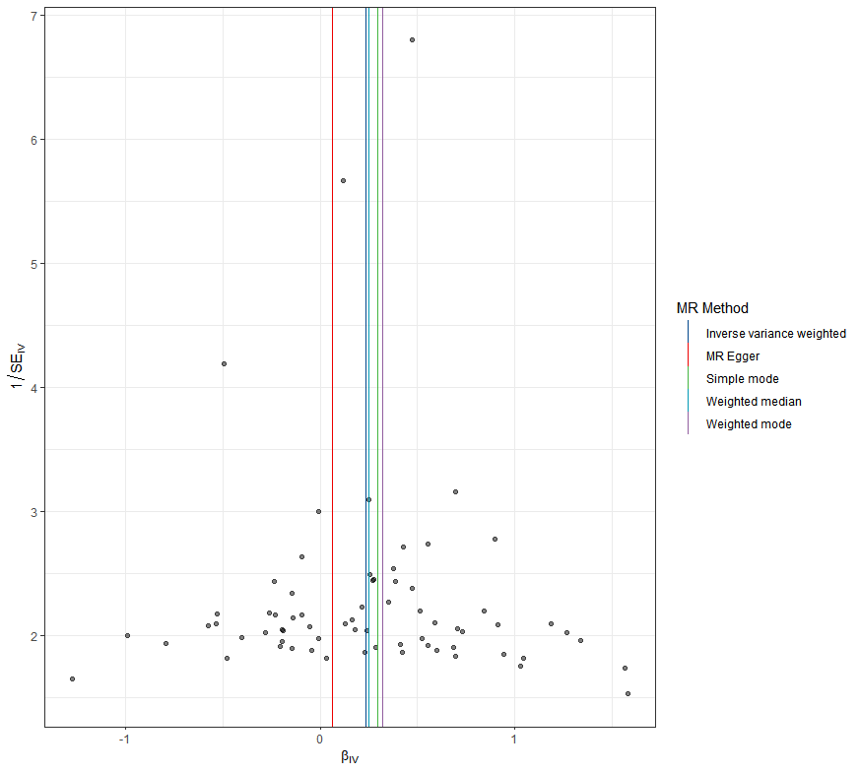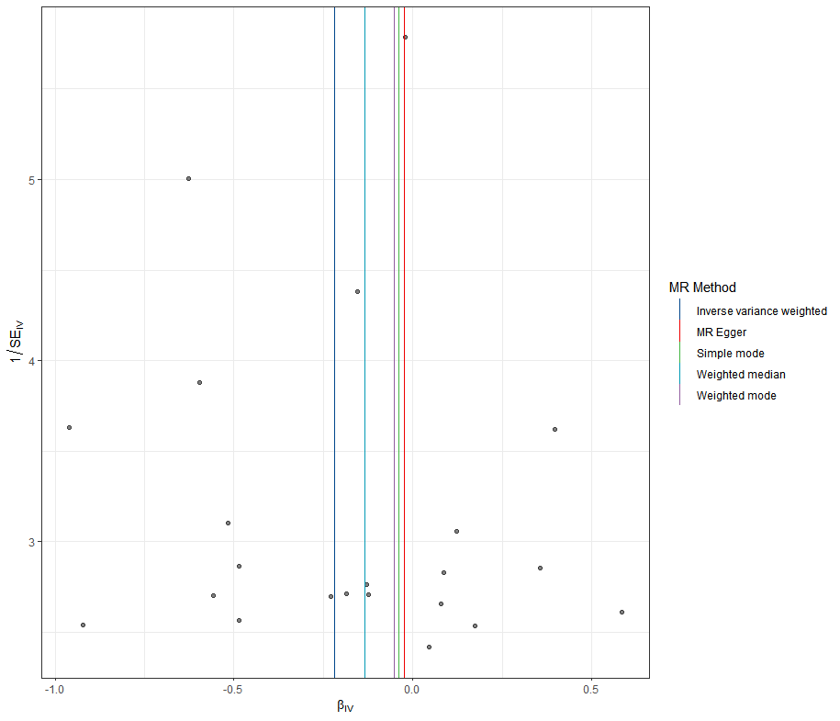
Figure S16. The funnel plots of the identified associations between lifestyle factors and HDL cholesterol.

- NOx on triglycerides B. Leisure screen time on triglycerides C.MVPA on triglycerides
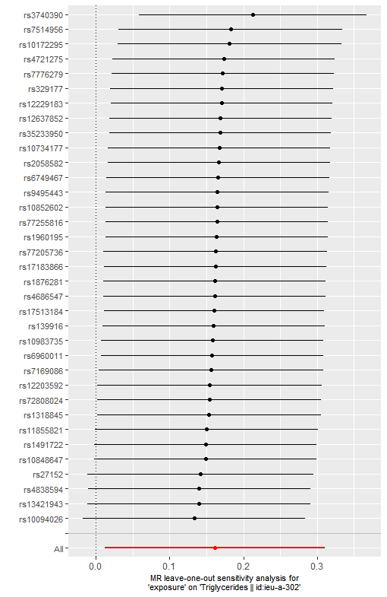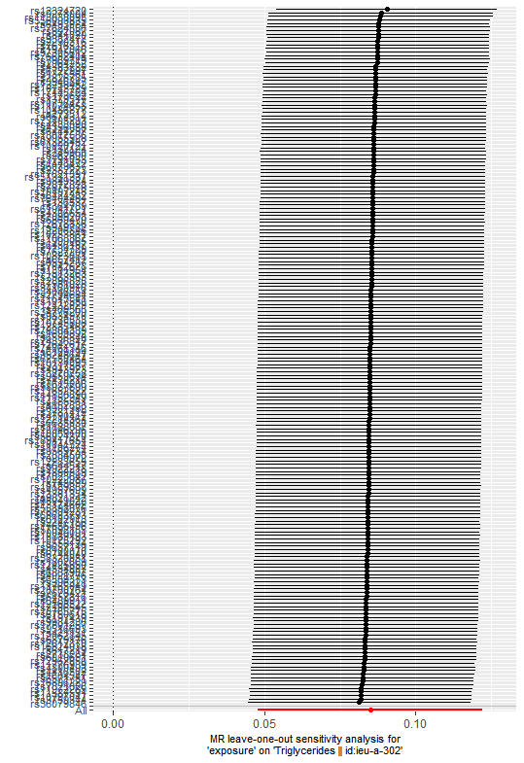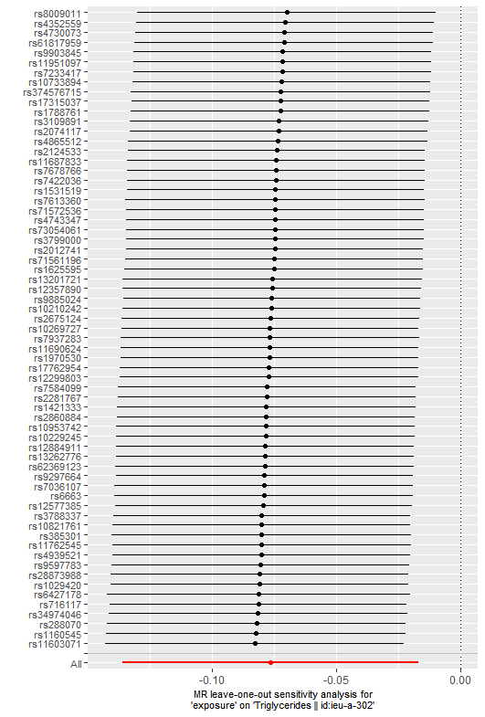
D. smoking initiation on triglycerides E. Relative carbohydrate intake on triglycerides
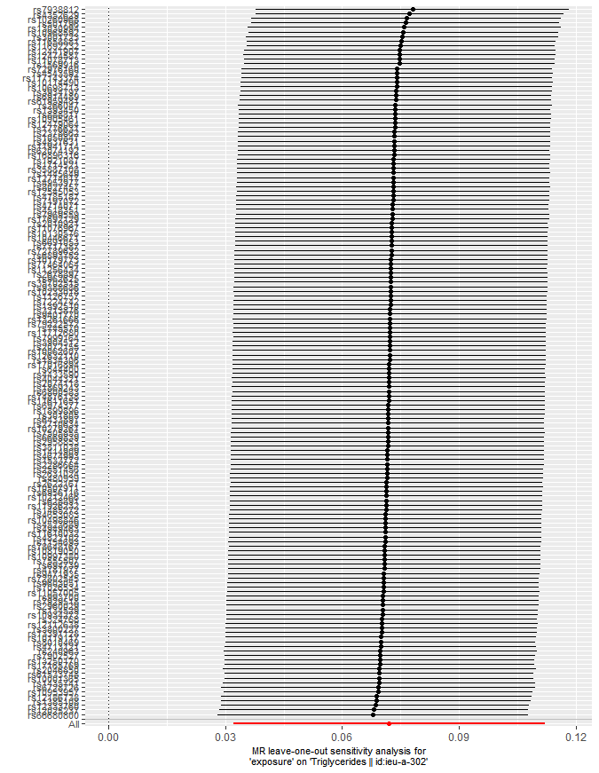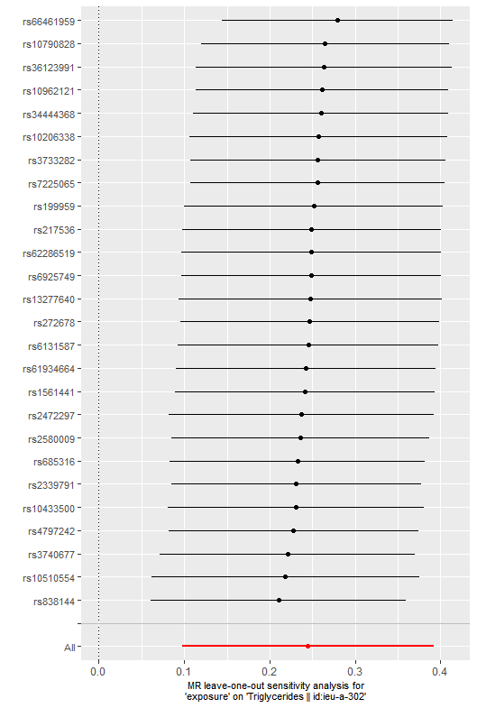
Figure S17. Leave-one-out analysis for identified associations between air pollutants and lifestyle factors with triglycerides.
- NOx on triglycerides B. Leisure screen time on triglycerides C. MVPA on triglycerides
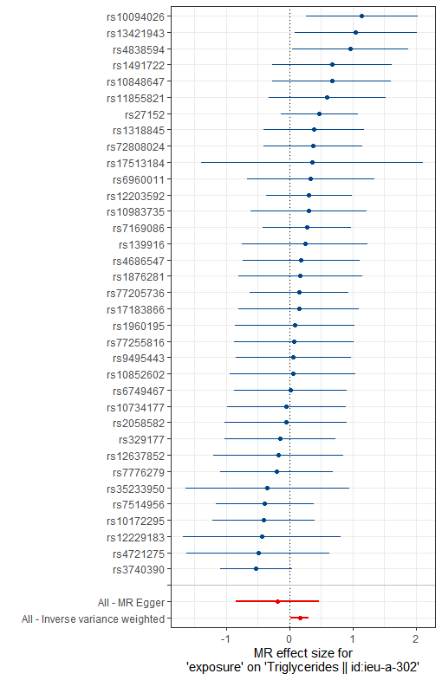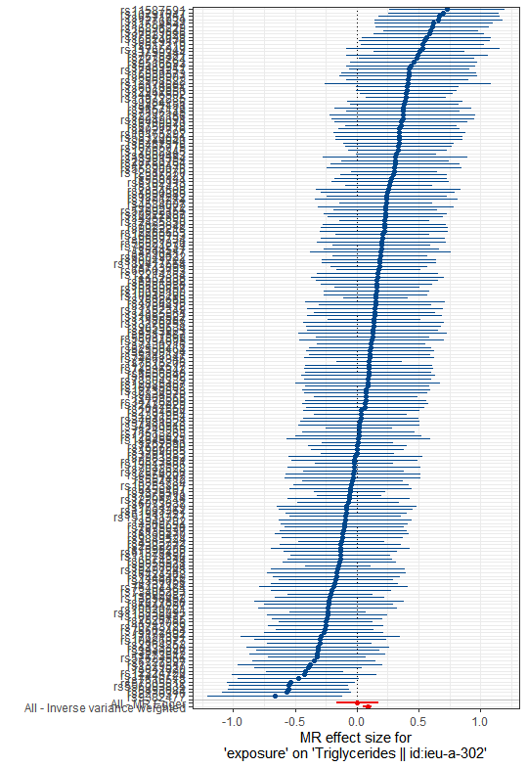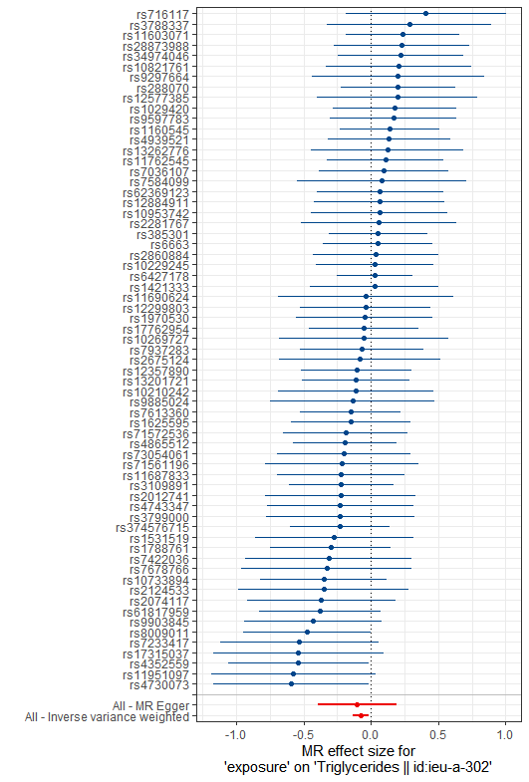
D. smoking initiation on triglycerides E. Relative carbohydrate intake on triglycerides
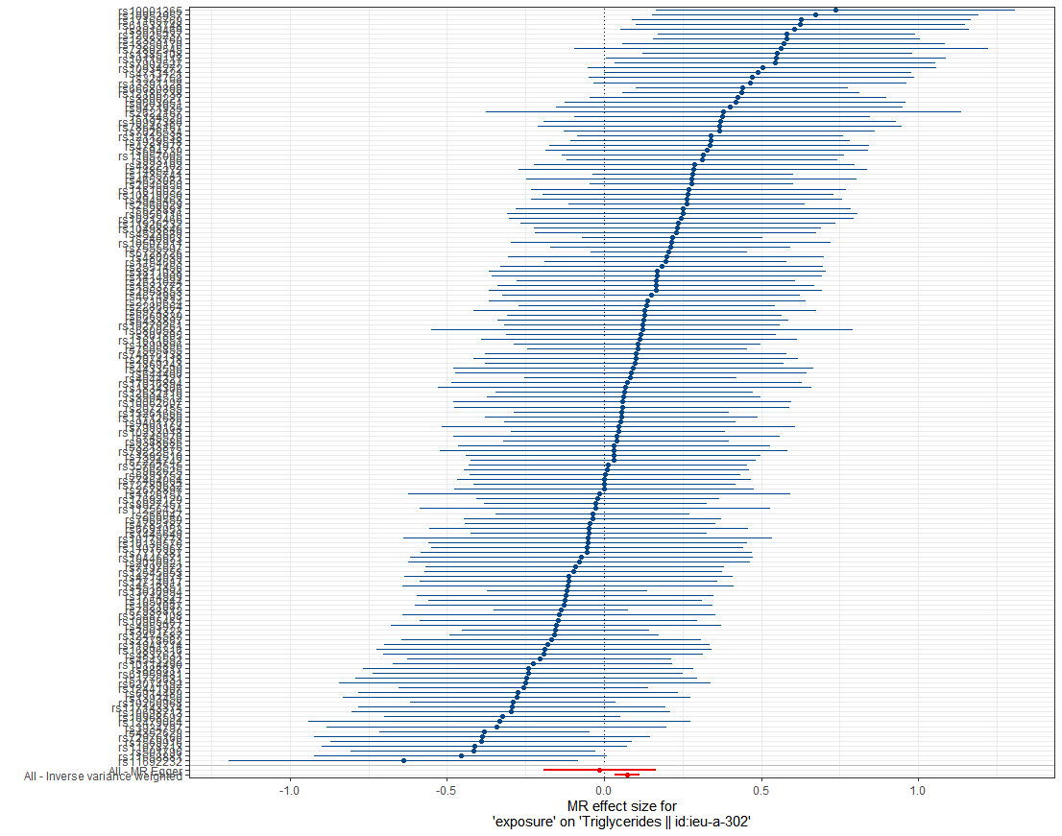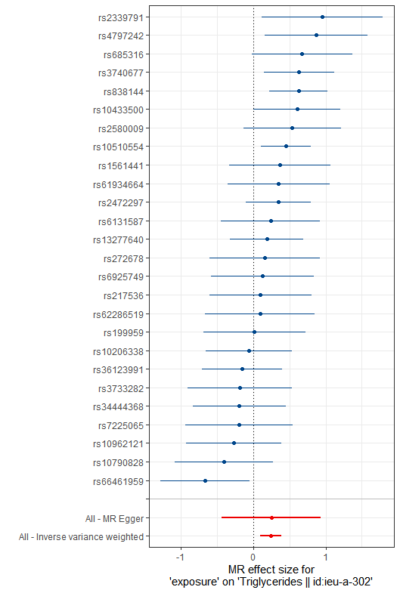
Figure S18. The forest plots for identified associations between air pollutants and lifestyle factors with triglycerides.
- NOx on triglycerides B. Leisure screen time on triglycerides C. MVPA on triglycerides
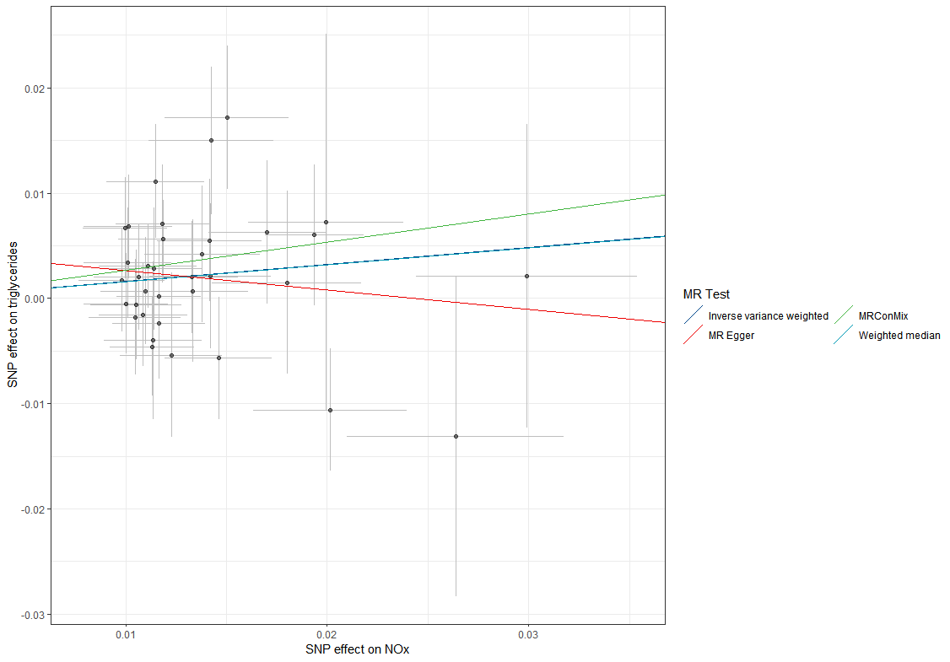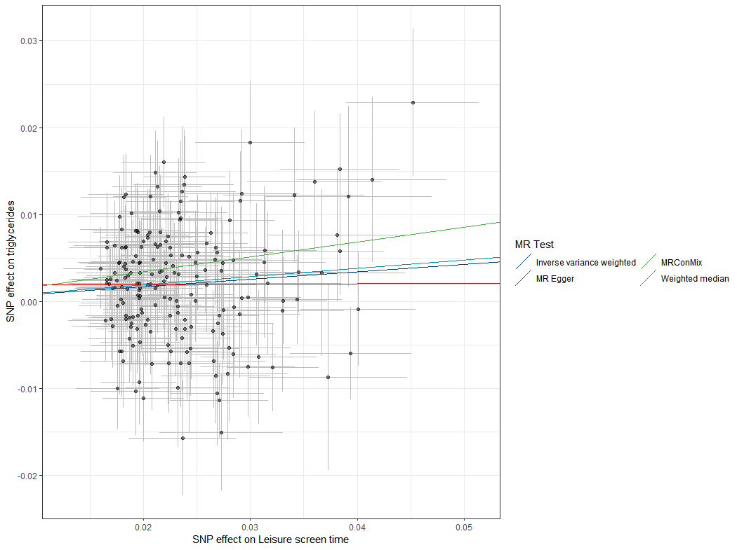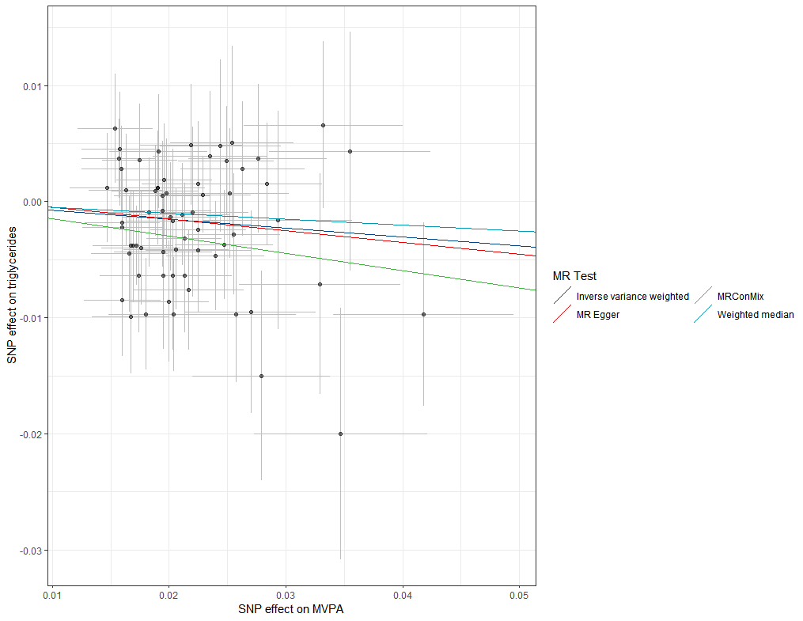

D. smoking initiation on triglycerides E. Relative carbohydrate intake on triglycerides
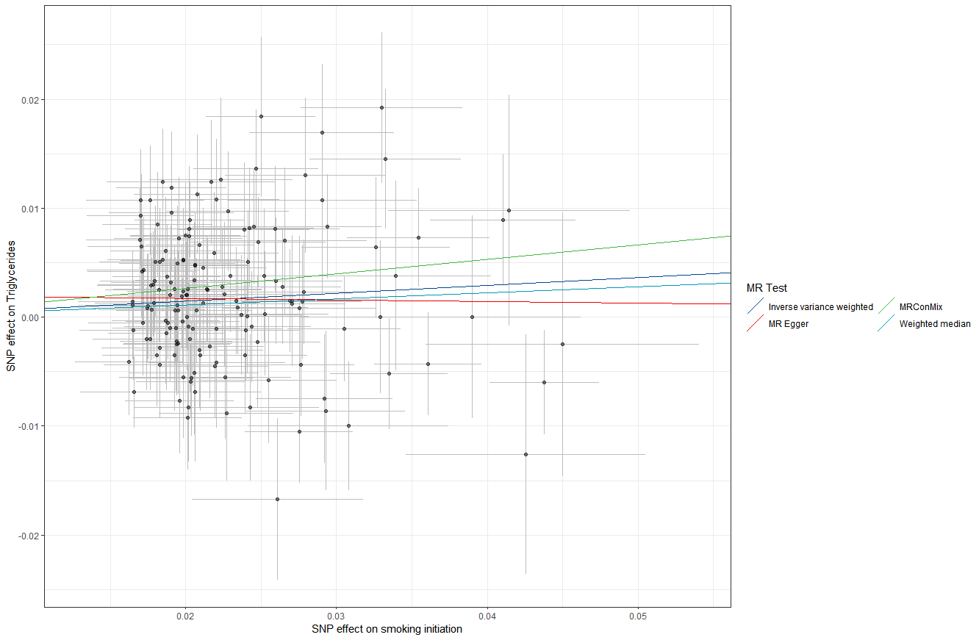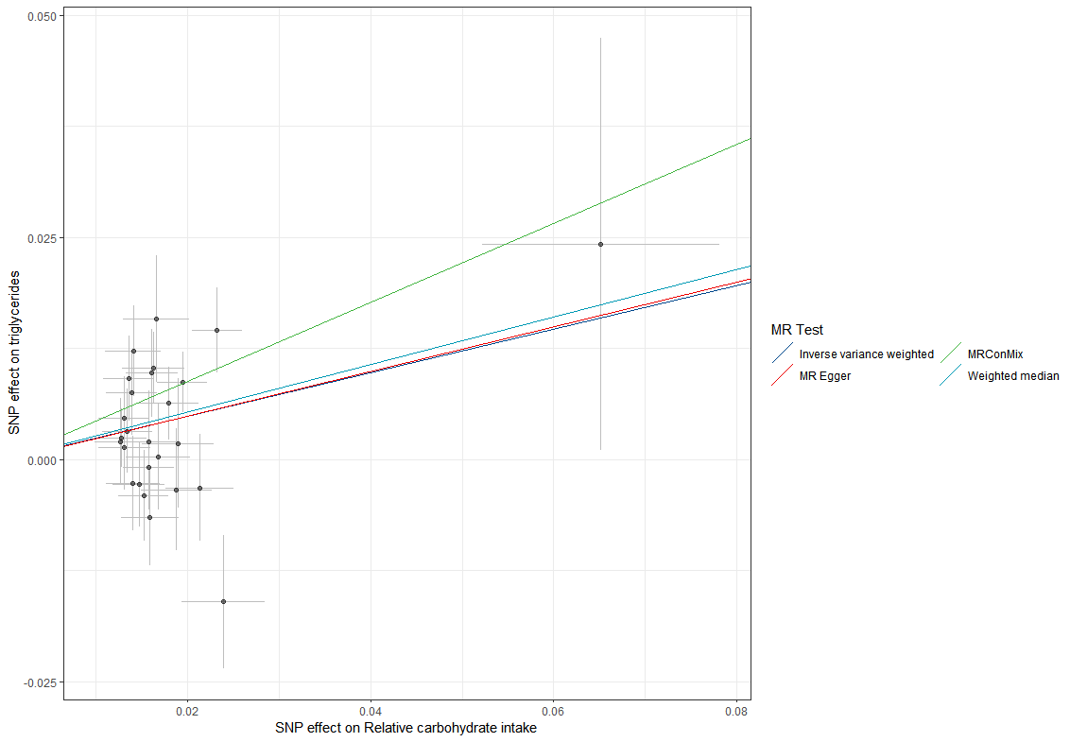
Figure S19. The scatter plots of the identified associations between air pollutants and lifestyle factors with triglycerides.

- NOx on triglycerides B. Leisure screen time on triglycerides C. MVPA on triglycerides
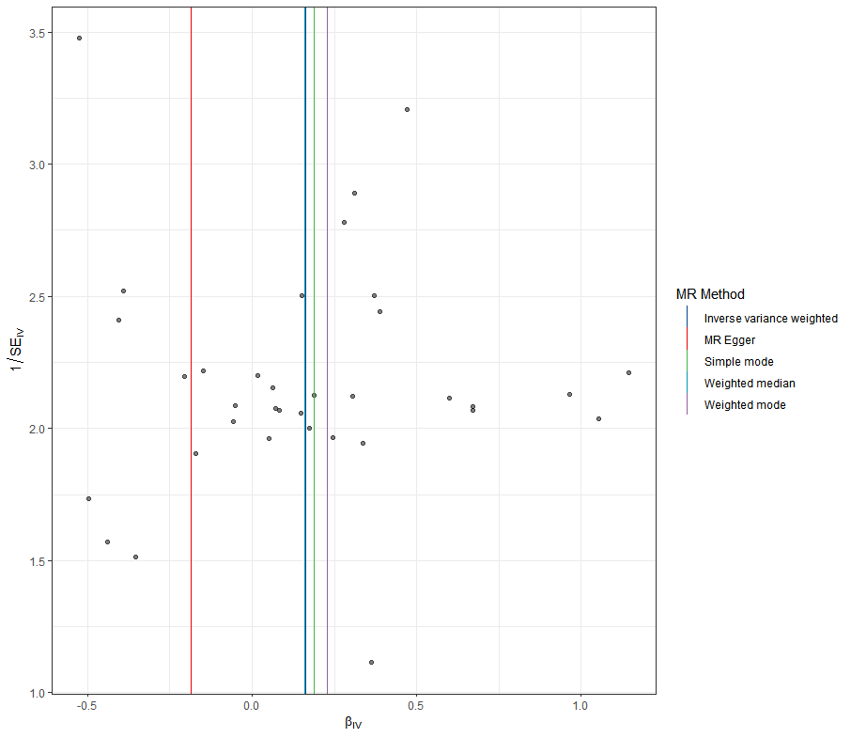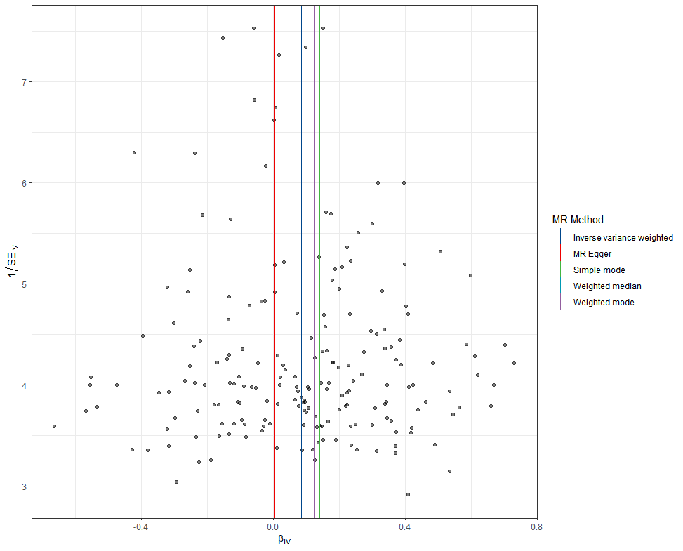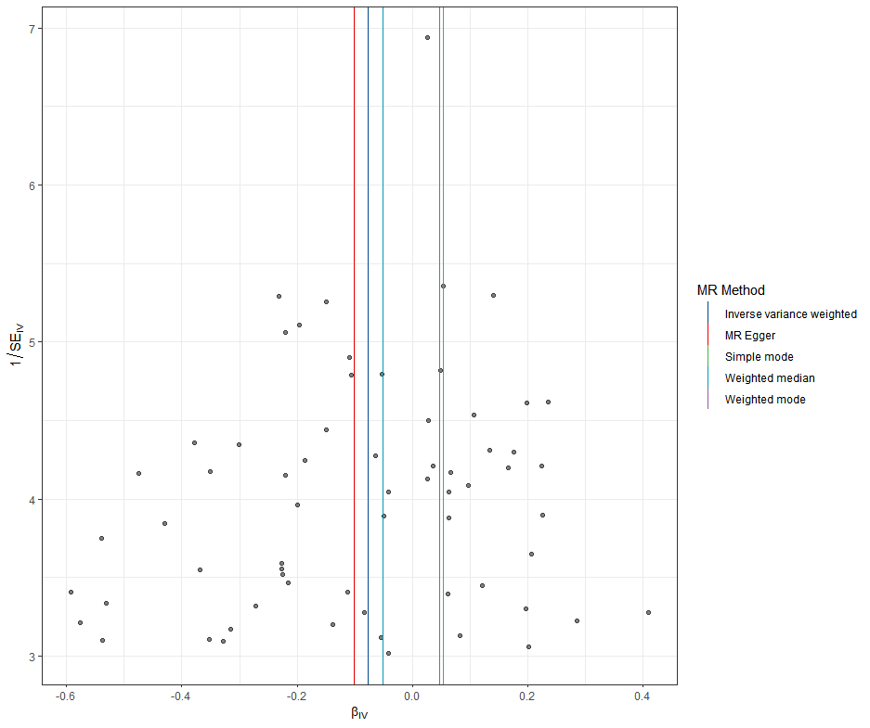
D. smoking initiation on triglycerides E. Relative carbohydrate intake on triglycerides
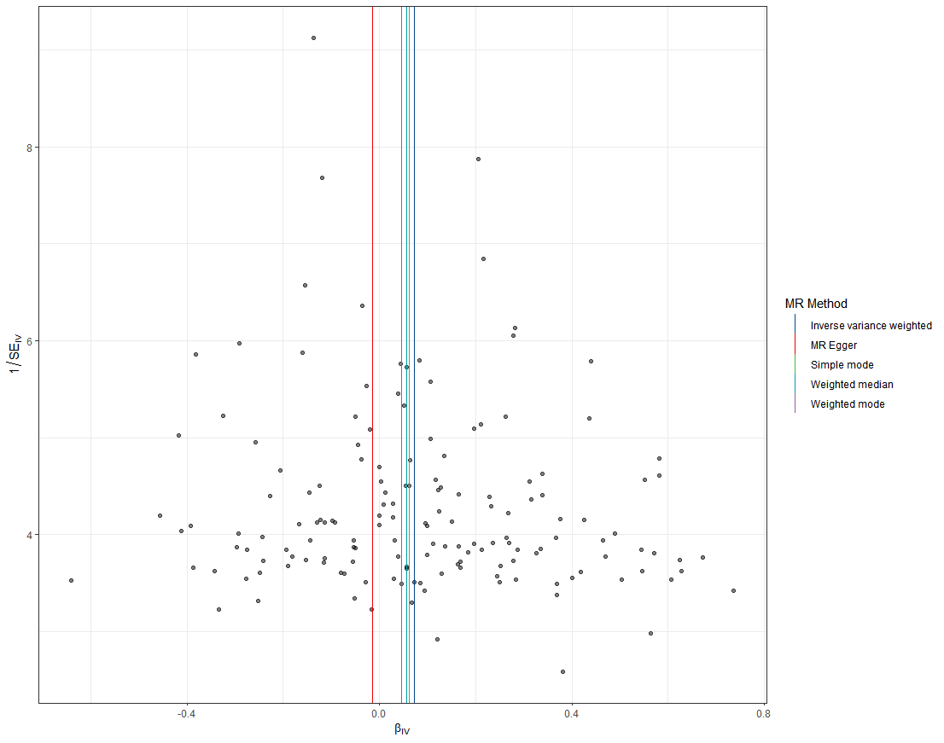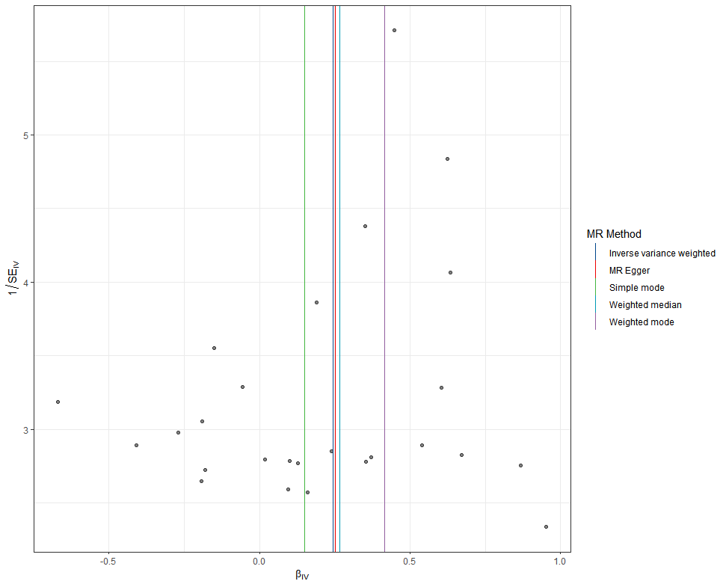
Figure S20. The funnel plots of the identified associations between air pollutants and lifestyle factors with triglycerides.

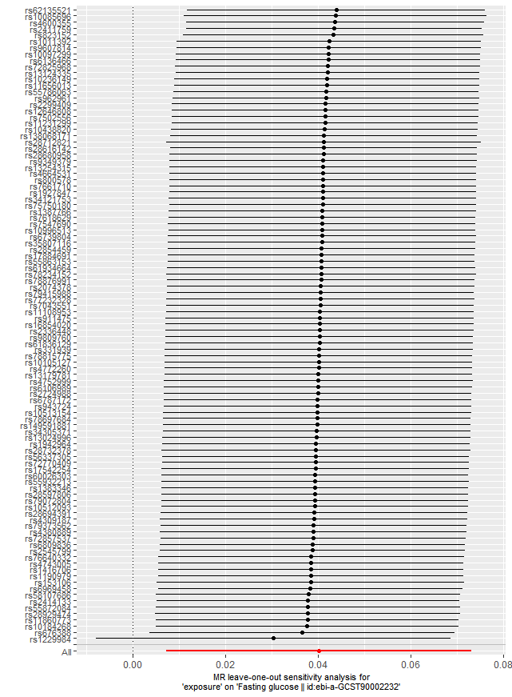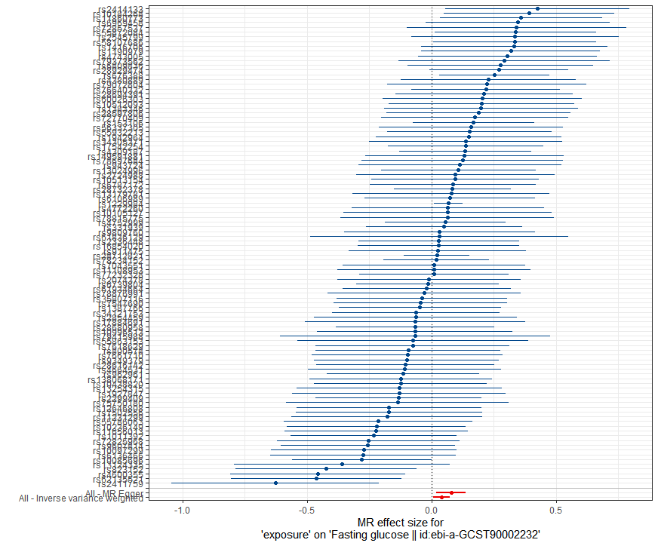
Figure S21. Leave-one-out analysis for identified associations Figure S22. The forest plots for identified associations
between alcoholic drinks per week and fasting glucose. between alcoholic drinks per week and fasting glucose.
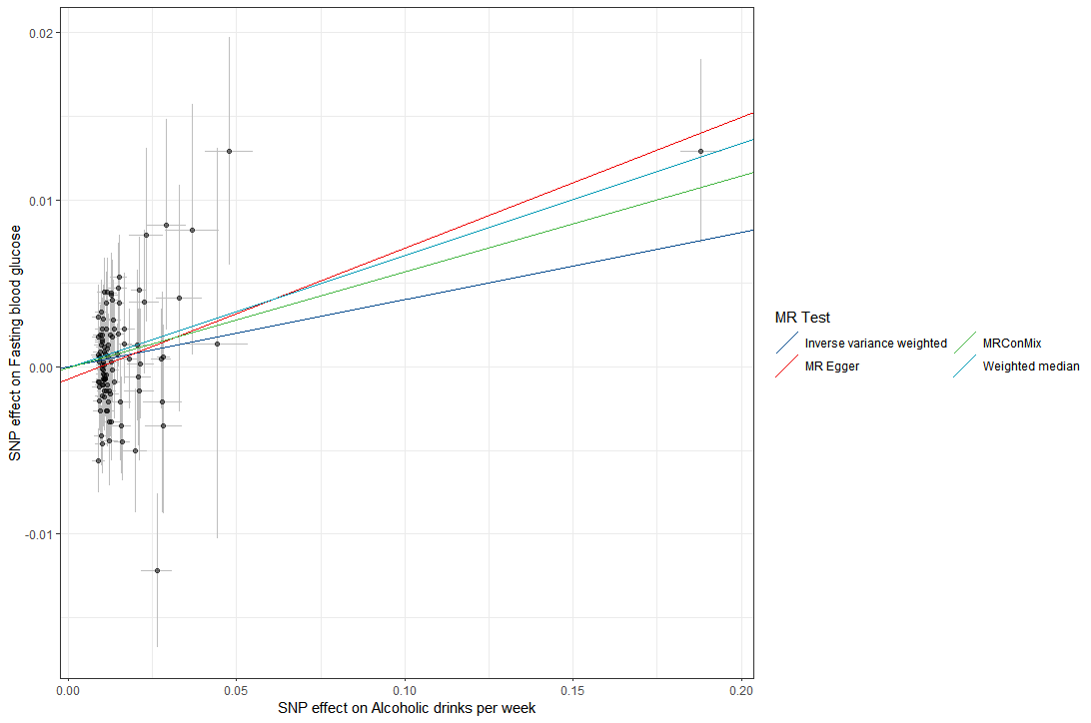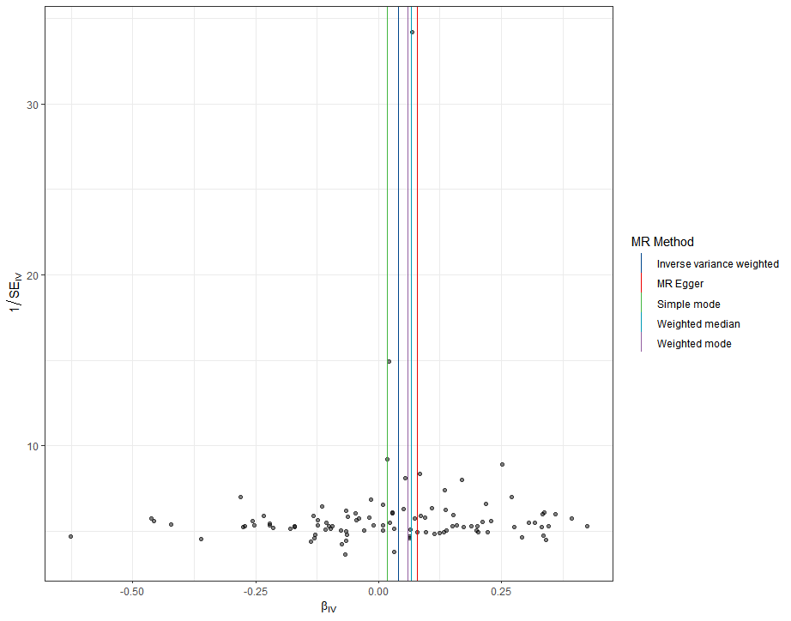
Figure S23. The scatter plots of the identified associations Figure S24. The funnel plots of the identified associations
between alcoholic drinks per week and fasting glucose. between alcoholic drinks per week and fasting glucose.

