APPENDIX A
Data Collection Form
Demographic and Clinical Information
Age |  | Sex |  |  | Handedness
Height |  | Weight
Comorbidities | [ ] Hypertension  [ ] Diabetes Mellitus  [ ] Heart Disease  [ ] Rheumatological disease  [ ] Pulmonary disease  [ ] Others (non-MSK) ____________________________
Pre-existing musculoskeletal (MSK) or pain conditions | [ ] Carpal tunnel syndrome  [ ] De Quervain’s tenosynovitis  [ ] Cervical spondylosis  [ ] Degenerative disease of the lumbar spine  [ ] Scoliosis  [ ] Ligamentous injuries of the extremities (e.g. ACL tear)  [ ] Osteoarthritis  [ ] Gouty arthritis  [ ] Rheumatoid arthritis  [ ] Others _________________________________________
History of MSK injury | [ ] No [ ] Yes (pls specify) ______________
Have you been operated on for an MSK condition? | [ ] No [ ] Yes (pls specify) ______________
Analgesic use | [ ] None [ ] Daily [ ] 1x/wk [ ] 1x/month [ ] others: ____
Baseline exercise | [ ] None [ ] 0.5-3 hrs/wk [ ] 4-7 hrs/wk [ ] >7 hrs/wk
Work Profile
I am a: | [ ] Consultant [ ] Resident;
Majority of my practice/training: | [ ] Private [ ] Government [ ] Both
Year Level (for residents): ___ | Years practicing (for consultants): ___
Estimated number of cases/year:
Average hours spent operating per day |  |  | Average days a week spent operating

Operating Profile
I am currently able to do the following operations (check all that apply):
[ ] Supratentorial craniotomy/craniectomy for trauma or stroke (including ICH)
[ ] Supratentorial craniotomy for tumor excision
[ ] Supratentorial craniotomy for clipping of aneurysm
[ ] Infratentorial craniotomy/craniectomy
[ ] Microscopic transsphenoidal excision of tumor (TSE)
[ ] Endoscopic transsphenoidal excision of tumor (TSE)
[ ] VP shunt insertion
[ ] Endoscopic third ventriculostomy (ETV)
[ ] Repair of spina bifida
[ ] Anterior cervical diskectomy with or without fusion and instrumentation (ACDF)
[ ] Laminectomy/laminotomy with or without fusion and instrumentation
[ ] Peripheral nerve neurosurgery
[ ] Deep brain stimulation (DBS)
[ ] Endovascular neurosurgery
I am currently able to regularly assist in the following operations (check all that apply):
[ ] Supratentorial craniotomy/craniectomy for trauma or stroke (including ICH)
[ ] Supratentorial craniotomy for tumor excision
[ ] Supratentorial craniotomy for clipping of aneurysm
[ ] Infratentorial craniotomy/craniectomy
[ ] Microscopic transsphenoidal excision of tumor (TSE)
[ ] Endoscopic transsphenoidal excision of tumor (TSE)
[ ] VP shunt insertion
[ ] Endoscopic third ventriculostomy (ETV)
[ ] Repair of spina bifida
[ ] Anterior cervical diskectomy with or without fusion and instrumentation (ACDF)
[ ] Laminectomy/laminotomy with or without fusion and instrumentation
[ ] Peripheral nerve neurosurgery
[ ] Deep brain stimulation (DBS)
[ ] Endovascular neurosurgery

In the following section, we will determine the areas of the body where pain is most felt after 5 representative neurosurgical procedures. Please use this figure as a reference for the location of the pain. This figure is from the Nordic Musculoskeletal Questionnaire [16]

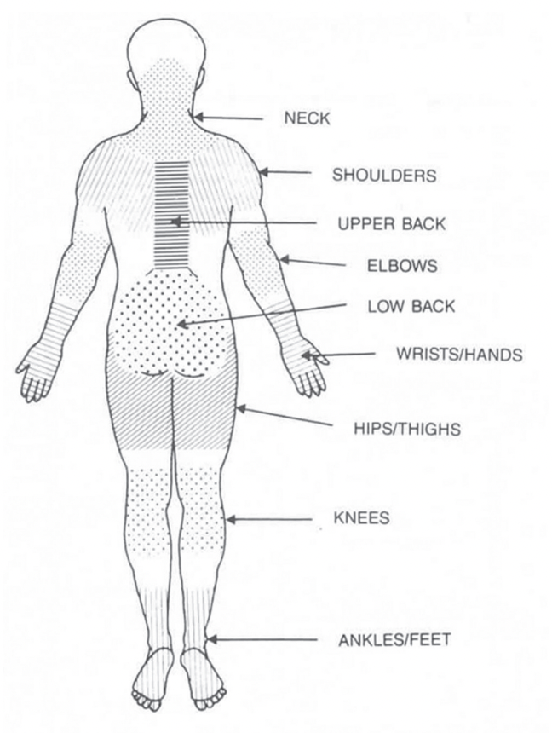

Please also use the subsequent rating scale (Borg 0-10) to approximate the pain you feel [17].
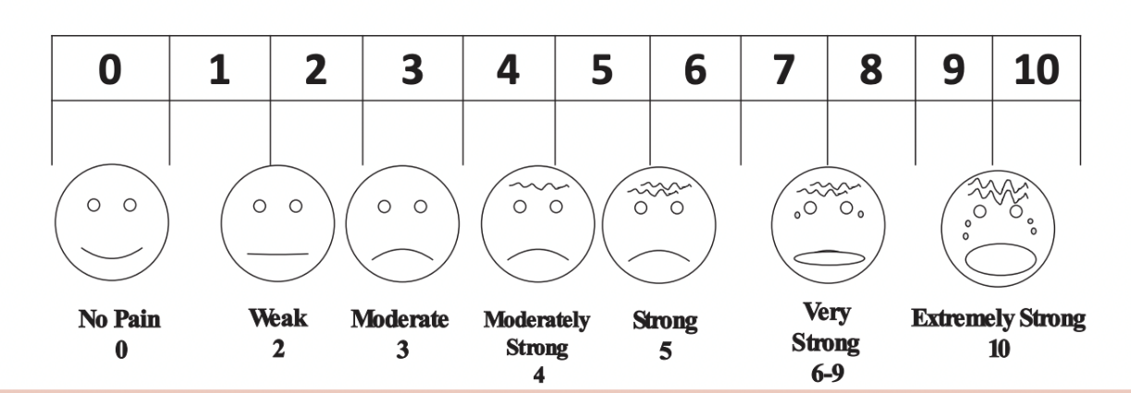

SUPRATENTORIAL CRANIOTOMY
Role:  [ ] Primary surgeon [ ] Assist | Predominant operating position:  [ ] Sitting [ ] Standing
Magnification (check all that apply)
[ ] None [ ] Glasses [ ] Contact lenses [ ] Loupes [ ] Microscope
I usually use
[ ] Craniotome
[ ] High speed drill (Midas, Elan, Stryker, NSK, etc.)
[ ] Hudson brace and Gigli wire
Please rate the pain you feel in the following areas from 1-10 after the procedure
Head _____
Eyes _____
Teeth _____
Neck _____
Shoulders _____
Upper back _____
Elbows _____
Wrist/hands _____
Low back _____
Hips/thighs _____
Knees _____
Ankles/feet _____
Others (please indicate) _____
______________________________________________________________________

INFRATENTORIAL CRANIOTOMY/CRANIECTOMY
Role:  [ ] Primary surgeon [ ] Assist | Predominant operating position:  [ ] Sitting [ ] Standing
Magnification (check all that apply)
[ ] None [ ] Glasses [ ] Contact lenses [ ] Loupes [ ] Microscope
I usually use
[ ] Craniotome
[ ] High speed drill (Midas, Elan, Stryker, NSK, etc.)
[ ] Hudson brace and gigli wire
Please rate the pain you feel in the following areas from 1-10 after the procedure
Head _____
Eyes _____
Teeth _____
Neck _____
Shoulders _____
Upper back _____
Elbows _____
Wrist/hands _____
Low back _____
Hips/thighs _____
Knees _____
Ankles/feet _____
Others (please indicate) _____
______________________________________________________________________

TRANSPHENOIDAL SURGERY
Role:  [ ] Primary surgeon [ ] Assist | Predominant operating position:  [ ] Sitting [ ] Standing
Type of TSE:  [ ] Microscopic [ ] Endoscopic [ ] Both | I usually use  [ ] Osteotome  [ ] High speed drill (Midas, Elan, Stryker, NSK, etc.)
Please rate the pain you feel in the following areas from 1-10 after the procedure
Head _____
Eyes _____
Teeth _____
Neck _____
Shoulders _____
Upper back _____
Elbows _____
Wrist/hands _____
Low back _____
Hips/thighs _____
Knees _____
Ankles/feet _____
Others (please indicate) _____
______________________________________________________________________

VP SHUNT INSERTION
Role:  [ ] Primary surgeon [ ] Assist | Predominant operating position (cranial part only):  [ ] Sitting [ ] Standing
Magnification (check all that apply)
[ ] None [ ] Glasses [ ] Contact lenses [ ] Loupes
I usually use
[ ] Craniotome perforator
[ ] High speed drill (Midas, Elan, Stryker, NSK, etc.)
[ ] Hudson brace
In general, I pass the shunt  [ ] Cranial to caudal [ ] caudal to cranial | I ask general surgery to open the abdomen  [ ] Yes [ ] No
Please rate the pain you feel in the following areas from 1-10 after the procedure
Head _____
Eyes _____
Teeth _____
Neck _____
Shoulders _____
Upper back _____
Elbows _____
Wrist/hands _____
Low back _____
Hips/thighs _____
Knees _____
Ankles/feet _____
Others (please indicate) _____
______________________________________________________________________

SPINE OPERATIONS
Role:  [ ] Primary surgeon [ ] Assist | Predominant operating position:  [ ] Sitting [ ] Standing
I wear a lead gown majority of my cases  [ ] Yes [ ] No | Most commonly used intraoperative navigation  [ ] None [ ] Xray [ ] Fluoroscopy/C-arm  [ ] Stereotaxy/IGS [ ] O-arm
Magnification (check all that apply)
[ ] None [ ] Glasses [ ] Contact lenses [ ] Loupes [ ] Microscope
I usually use  [ ] High speed drill (Midas, Elan, Stryker, NSK, etc.)  [ ] Bone rongeurs (Kerrison, Leksell) |  | I commonly perform fusion procedures  [ ] Yes [ ] No
Please rate the pain you feel in the following areas from 1-10 after the procedure
Head _____
Eyes _____
Teeth _____
Neck _____
Shoulders _____
Upper back _____
Elbows _____
Wrist/hands _____
Low back _____
Hips/thighs _____
Knees _____
Ankles/feet _____
Others (please indicate) _____
______________________________________________________________________

INTERVENTIONS
The most common approaches I do to alleviate my symptoms INTRAOPERATIVELY are:
[ ] Ignore it
[ ] Change body position: [ ] Stretch [ ] Walk around [ ] Sit down
[ ] Wear specialized footwear or supportive equipment
[ ] Wear compression stockings
[ ] Change height of surgical field
[ ] Change angulation of microscope
[ ] Change instruments (e.g. use a drill instead of a rongeur, etc.)
[ ] Adjust room temperature
[ ] Take analgesics pre- or intraoperatively
[ ] Use a special chair
[ ] Use an armrest
[ ] Take a break
[ ] Play music
[ ] Distract myself by talking to other people
[ ] Others___________________________________________________________________
Because of my pain, I have done the following (check all that apply)
[ ] Started to take pain medications
[ ] Sought medical consult for my pain
[ ] Experienced poorer sleep quality
[ ] Experienced poorer concentration
[ ] Increased irritability
[ ] Increased my surgical speed
[ ] Decreased my surgical speed
[ ] Decreased my patience with others
[ ] Decreased my mobility
[ ] Experienced tremors
[ ] Increased alcohol intake
[ ] Increased smoking/vaping
[ ] Exercised more
[ ] Undergone physical therapy
[ ] Consulted alternative forms of medicine (e.g. acupuncture, yoga, etc.)
[ ] Changed my diet
[ ] Increased my willingness to teach others
[ ] Decreased my willingness to teach others
[ ] Adjusted my OR schedule to allow rest
[ ] Changed my operative approach
[ ] Bought ergonomic equipment
[ ] Spent time away from neurosurgery (e.g. take a leave of absence or vacation leave)
[ ] Considered retiring from neurosurgery
[ ] Others:___________________________________________________________________

Please list the top three procedures that cause the most work-related pain (from most painful to least painful)
1.
2.
3.

