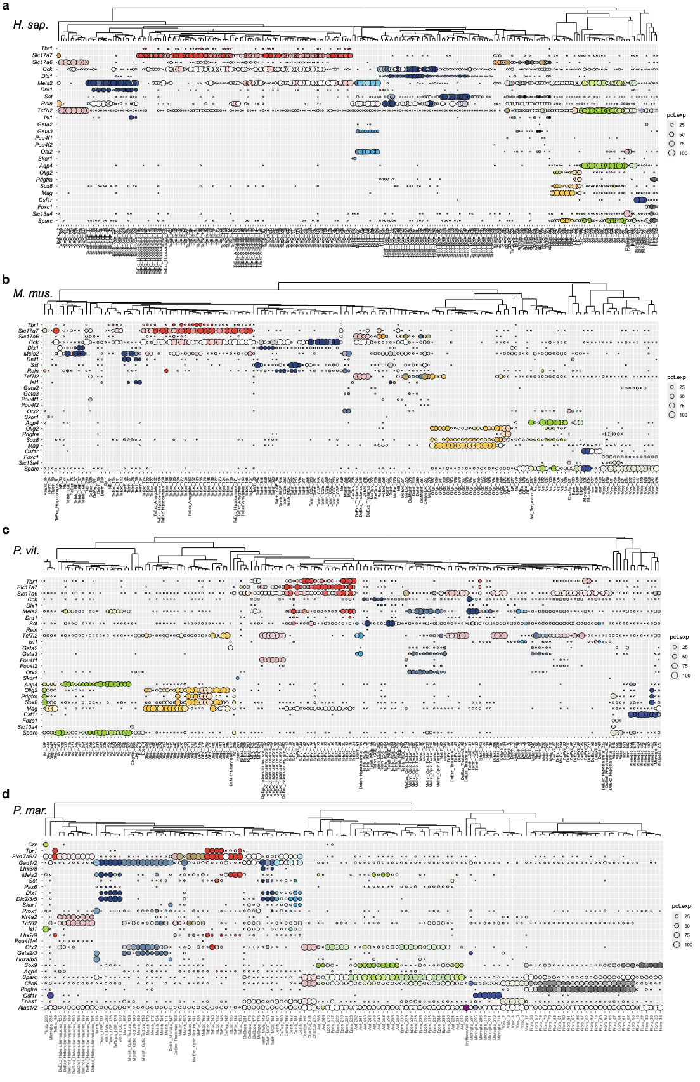
Extended Data Fig. 1 | Expression of markers and identification of clusters in vertebrates. a-d Dot plots showing canonical marker genes at the cluster level, generated from iterative clustering for four species: human (a), mouse (b), lizard (c), and lamprey (d). A subset of marker genes (see details in Supplementary Table 1) is shown. Dot size represents the percentages of cells within each cluster expressing that gene (pct. exp). The expression for each gene was scaled to -2 to 2 across all clusters and then assigned to gradient colours from white to the colour of each cell type family. Dots representing clusters with <1% of cells expressing the gene were omitted to reduce noise. The dendrogram was calculated with following approaches: (1) calculating the average unique molecular identifier (UMI) counts of marker genes at the cluster level; (2) removing the top and bottom 10% of highly and lowly expressed markers to reduce bias; and (3) constructing the tree using the pvclust¹ with 100 bootstrap (nboot=100) and parameters method.hclust = "average", method.dist = function(z){as.dist(1-cor(z,use="pa",method="spearman"). For gene families with multiple copies in lamprey, only the copy with the highest expression was shown. For example, among the three Tbr1 subfamily copies in lamprey, two were expressed in TeExc cells, but only MSTRG.6042 is displayed.

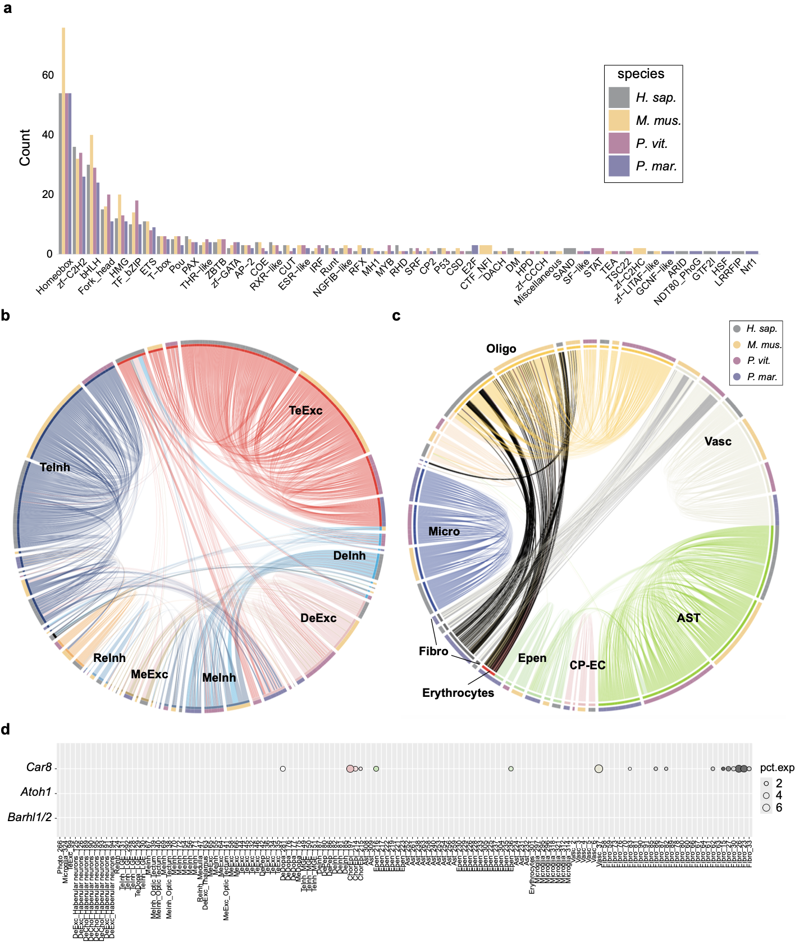

Extended Data Fig. 2 | Categories of shared TFs and cell type mapping across vertebrates. a, Bar plot shows the number of conserved TFs in major cell type families. TFs were classified based on the classification scheme which was downloaded from website (https://guolab.wchscu.cn/AnimalTFDB4//#/Family)². The colour of bar represents different species. The height of bar is the number of TFs classified as a certain type. b-c Chord plots displaying mappings within neuronal atlas and non-neuronal atlas across vertebrates, respectively. The outer coloured circle represents different species. The inner coloured circle denotes the colour of major cell type families. Major cell type families were also bold labelled as abbreviation, as same as Figure 1. False mappings from fibroblasts and lamprey erythrocytes to amniote oligodendrocytes were coloured as black lines. d, Dot plot of cerebellar markers in lamprey with dot size as the percentage of cells expressing that gene. The expression for each gene was scaled to -2 to 2 across all clusters and then assigned to gradient colours from white to the colour of each cell type family.

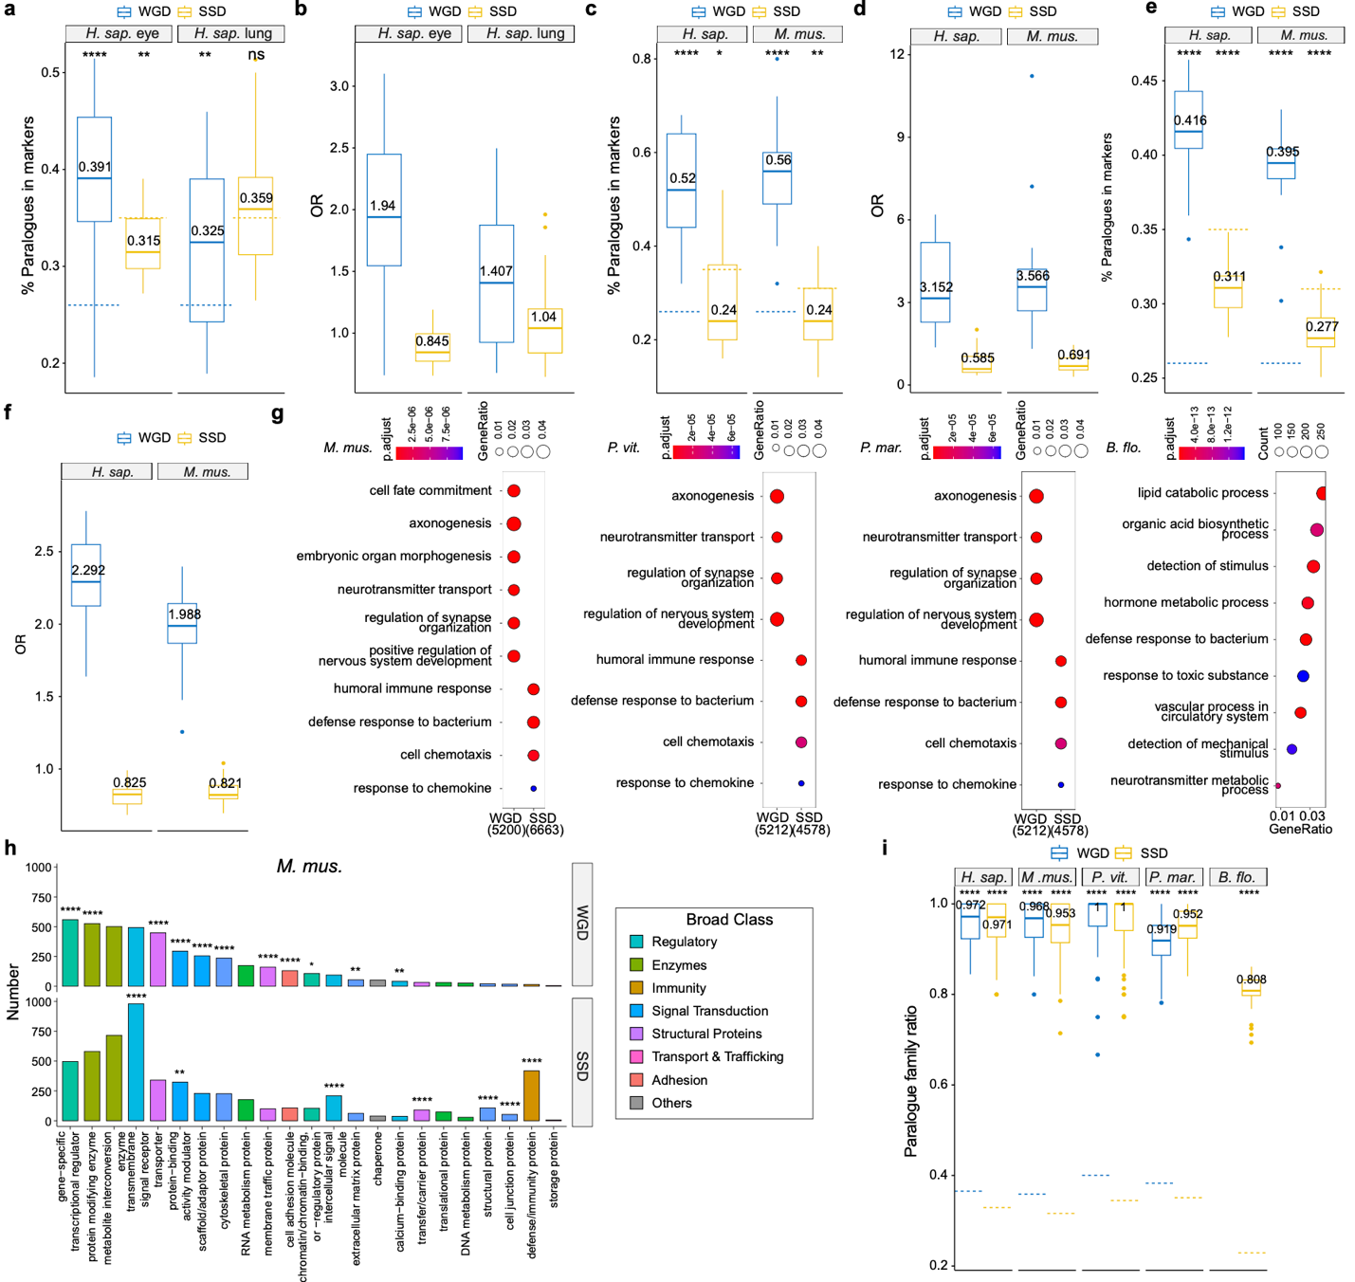

Extended Data Fig. 3 | Relationships between paralogues and cell type identity and diversity. a, Box plot showing the ratio of ohnologues (WGD, blue) and SSD paralogues (SSD, yellow) in cell type DEGs, respectively. The significance of differences between the ratio of paralogues as markers and their total percentage in all protein-coding genes was assessed using one-sample t-test. b, Odds ratio (OR) was calculated from Fisher’s exact test on ohnologues and SSD paralogues with cell type DEGs, respectively. The datasets for plots (a) and (b), eye and lung of human scRNA, were pre-processed by Human Cell Atlas and downloaded from following links (https://datasets.cellxgene.cziscience.com/64175889-d600-4b58-97ea-e74be80206e5.rds and https://datasets.cellxgene.cziscience.com/b351804c-293e-4aeb-9c4c-043db67f4540.rds)³. The DEGs were detected using Seurat FindAllMarkers⁴ on a subset of whole atlas with 3,000 cells per cell type and then filtered with FDR < 0.01. c,d The relationships between TFs from top 25 cell-type-specific regulons and paralogues in human and mice. (c) paralogue ratio in TFs for each cell type, (d) Odds ratio calculated from Fisher’s exact test on ohnologues and SSD paralogues with above TFs. e,f The relationships between target genes from top 25 cell-type-specific regulons and paralogues in human and mice. (e) paralogue ratio in target genes for each cell type, (f) Odds ratio calculated from Fisher’s exact test on ohnologues and SSD paralogues with above target genes. g, GO enrichment analysis on ohnologues and SSD paralogues in mice, lizards, and lamprey and paralogue enrichment in amphioxus. The colour represents FDR and dot size denotes gene ratio for vertebrates or gene count for amphioxus. h, Bar plot showing the number of different protein classes in WGD and SSD paralogues of mouse, respectively. Colour represents broad classifications. FDR values of overrepresented classes are shown as below whereas FDR in under-represented and non-significant classes are not shown. i, The ratio of the number of paralogue families (ohnologue families and SSD paralogue families) involved in markers to the number of paralogues in markers for each cell cluster. The number shown for each box represents the median value. The ratio denotes the number of paralogue families to number of paralogues and were represented by a blue (ohnologue) and a yellow (SSD paralogue) dotted line to be used as background for each species. The P-value and FDR are shown as following: ns (not significant); * (P < 0.05); ** (P < 0.01); *** (P < 0.001); **** (P < 0.0001).

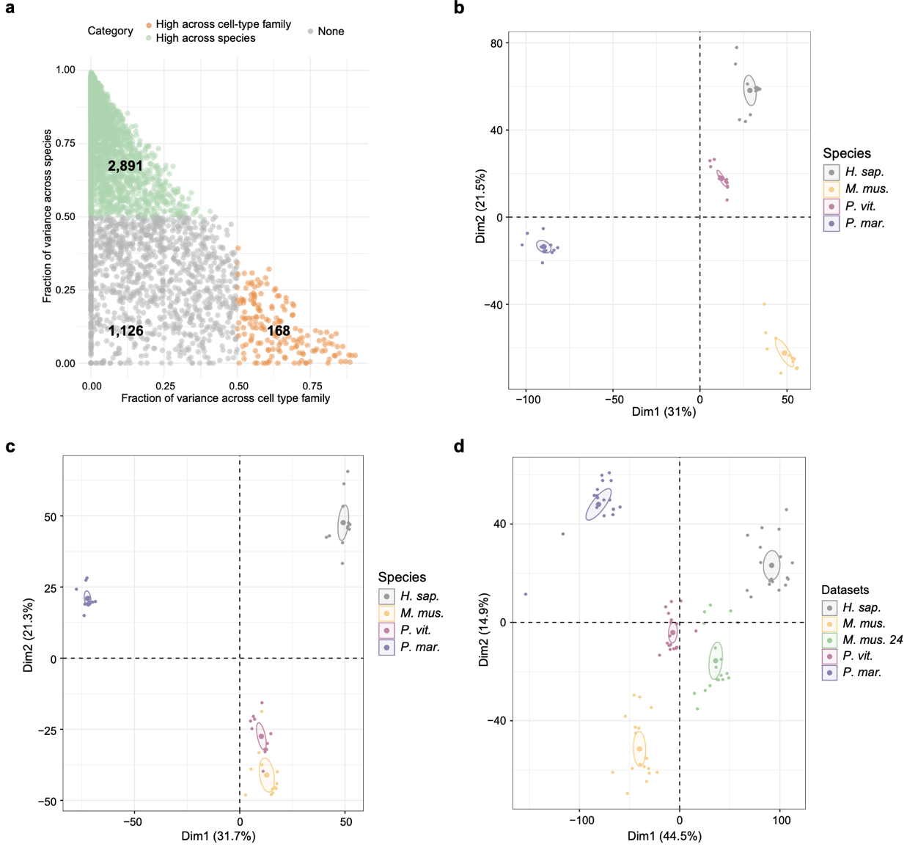
Extended Data Fig. 4 | Species/batch effects and variance decomposition. a, Variance decomposition of transcriptome estimates the relative contribution of cell type family and species/batch effects to the observed variance in gene expression for orthologues. Green dots indicate genes with higher contribution (> 50%) to species or batch effects, and genes with orange dots have higher (>50%) cell-type family contributions. Grey dots represent these genes are not highly contributing to the above two variables. The bold numbers in dots indicate the number of orthologues matching with above three categories. b,c, The first two Principal Components (PCs) of pseudobulk expression at metagene (b) and orthologue (c) level. Pseudobulk expression is normalized by DESeq2⁵ and top 2,000 genes with the highest variance were used to generate PCA plot. d, The first two PCs of pseudobulk expression (metagenes) with an additional neocortex dataset from mouse brain⁶. All datasets were subset to 10k cells. Each dot represents an integrated cluster by SAMap. Only integrated clusters containing five sources of datasets were retained and normalised by DESeq2. Top 2,000 genes with the highest variance were used to generate PCA plot.

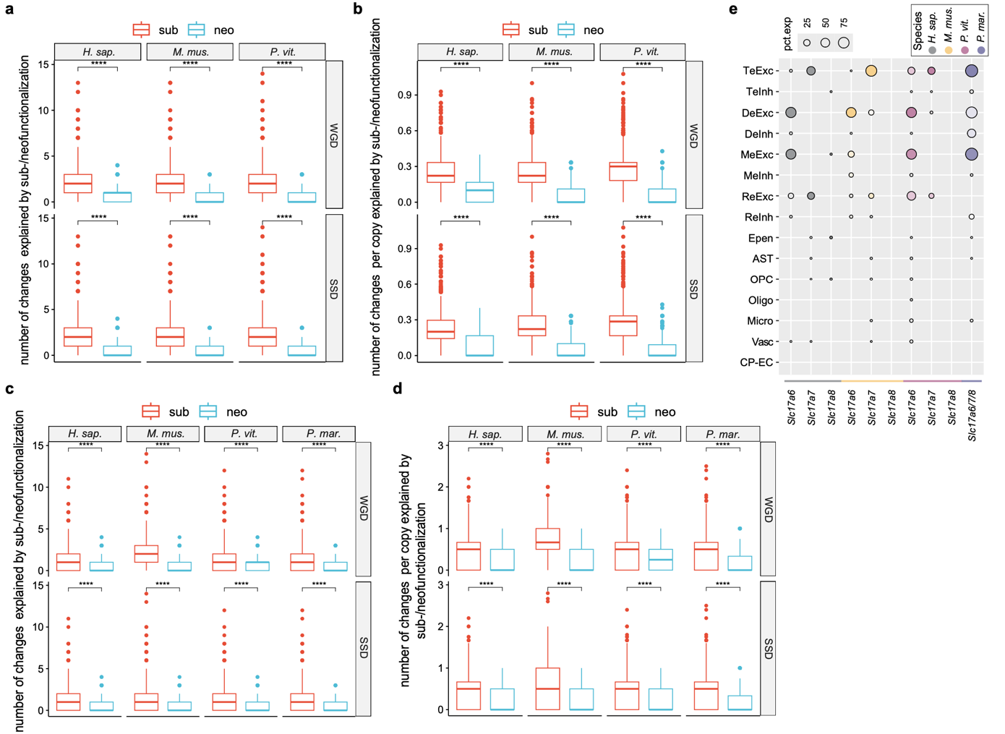
Extended Data Fig. 5 | Expression shifts of ohnologues and SSD paralogues. a,b, The number of changes (a) and changes per copy (b) explained by subfunctionalization and neofunctionalization for each ohnologue/SSD paralogue family in amniotes. Ancestral state was predicted based on three amniotes. Statistical significance was accessed by paired Wilcoxon signed-rank test. ns (not significant); * (P < 0.05); ** (P < 0.01); *** (P < 0.001); **** (P < 0.0001). c,d, The number of changes (c) and changes per copy (d) explained by subfunctionalization and neofunctionalization for each ohnologue/SSD paralogue family. Ancestral state was predicted based on Trinarization score binarized expression in vertebrates. The p-value was calculated and displayed as in (a). e, Dot plots showing the expression of Slc17a6/7/8 gene family. The size of dot represents the percentages of cells within each cluster expressing that gene. The gradient colours from white to species colour were scaled for each gene on individual species. Species of the gene is also shown as coloured line at the bottom of the plot.

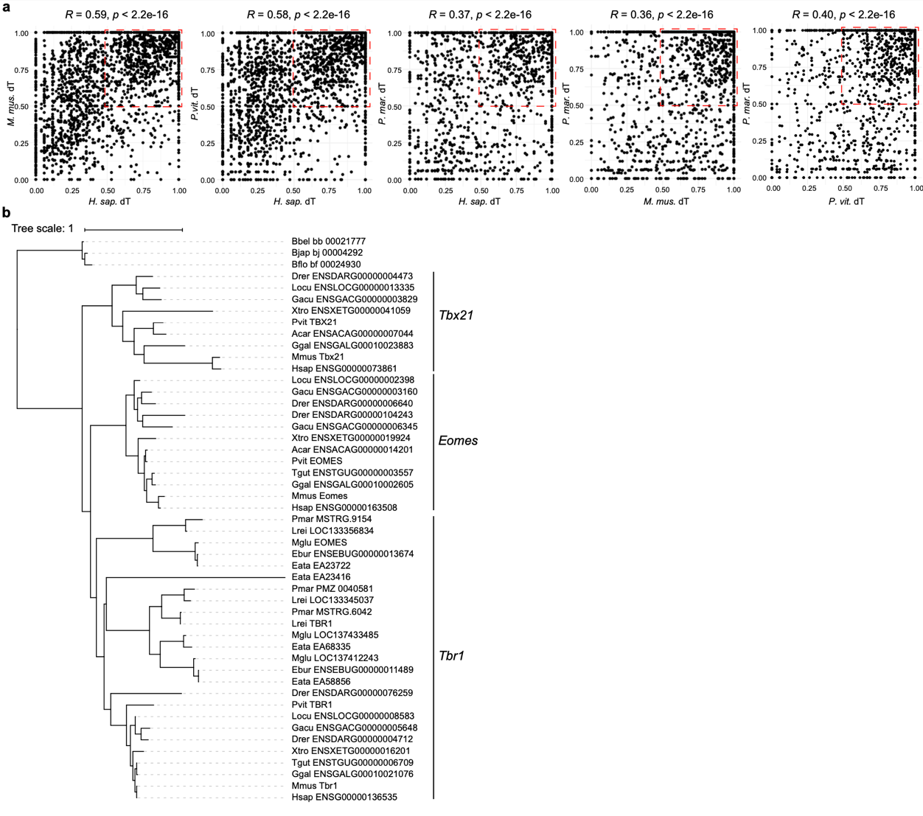
Extended Data Fig. 6 | Transcriptional divergence of paralogues across species. a, The average expression divergence (dT) of orthogroups compared in a pairwise manner. dT = 1 represents copies were not expressed in the same domain at all while dT=0 means all copies were expressed in the same domain. The correlation was calculated by Pearson with statical significance in all pairwise comparisons. The red dotted box highlights paralogous families exhibiting high expression divergence in both species. The amount of expression shifts toward mouse and lizard when compared with human, likely reflecting methodological differences between scRNA (mouse and lizard) and snRNA (human), where scRNA offers greater depth and snRNA-seq provides broader coverage. b, A rooted phylogenetic tree of the Tbr1 subfamily of T-box genes, generated by OrthoFinder. The tree scale represents a unit of evolutionary distance between gene sequences within an orthogroup. Three main genes in the Tbr1 subfamily were highlighted on the right of the tree.

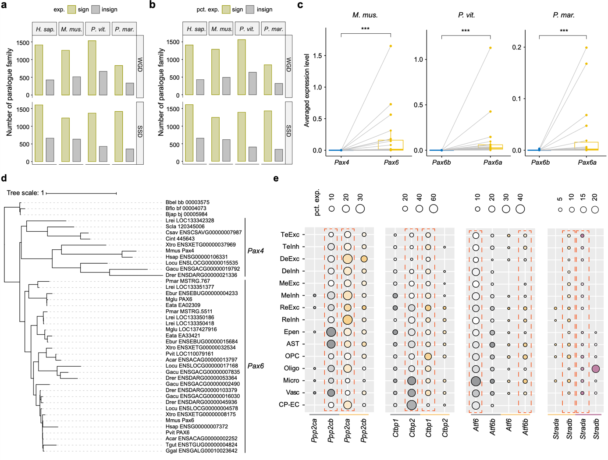
Extended Data Fig. 7 | Pan-expression differences within paralogue families. a,b. The number of ohnologue/SSD paralogue families that have at least one copy’s expression significantly differ from other copies. Ohnologue families and SSD paralogue families were labelled as WGD and SSD, respectively. (a) significance was evaluated at expression level with Friedman test. (b) significance was evaluated at percentage of cells expressing that gene (pct. exp.) level with Friedman test. c, Pseudobulk expression of Pax6-Pax4 family for mouse, lizard, and lamprey, respectively. Pseudobulk expression was calculated by the average of SAM normalised expression. Each dot represents a cell type family and the grey line between paralogues denotes the comparison of genes at the same cell type family. Significance was evaluated with paired Wilcoxon signed-rank test. ***, P < 0.001. d, A rooted phylogenetic tree of the Pax4/6 gene family, generated by OrthoFinder. The tree scale represents a unit of evolutionary distance between gene sequences within an orthogroup. Two main categories of the Pax4/6 were highlighted on the right of the tree. e, Dot plots showing some cases of paralogues are used differently by different species. The size of dot represents the percentages of cells within each cluster expressing that gene. The gradient colours from white to species colour were scaled for each gene on individual species. Species identity is also shown as coloured line at the bottom of the plot. The dotted orange boxes label the dominant copy.

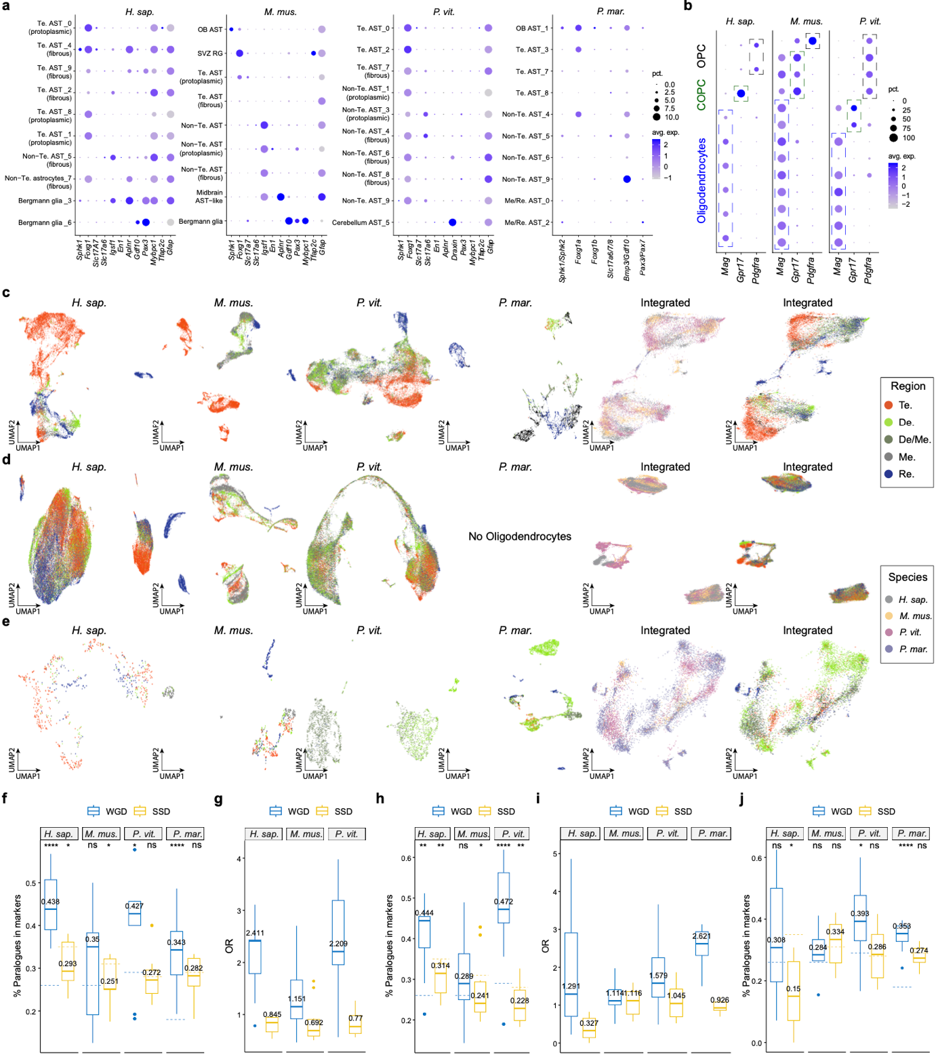

Extended Data Fig. 8 | Macroglia diversity and marker relationship with paralogues. a, Dot plot showing astrocyte marker expression across vertebrates. Colour indicates scaled average expression from -2 to 2, while dot size represents the percentage of expressing cells (capped at 10%). Abbreviations: OB, Olfactory bulb; SVZ, Subventricular zone; RG, Radial glia. b, Dot plot showing the expression of oligodendrocyte markers, with the same scaling and percentage representation as in (a) but not capped. Abbreviation: COPC, Committed oligodendrocyte precursor cells. c-e, UMAP plots of individual and integrated atlases for astrocytes (c), oligodendrocytes (d), and ependymal cells (e). Colours indicate dissection location and species, as detailed in the legend on the right. f,h,j, Proportion of ohnologues (WGD, blue) and SSD paralogues (SSD, yellow) among DEGs in the subtype of astrocytes (f), oligodendrocytes (h), and ependymal cells (j). Background proportions of ohnologues and SSD paralogues in expressed protein-coding genes are indicated by blue and yellow dotted lines, respectively. Significance was evaluated by one-sample t-test. ns (not significant); * (P < 0.05); ** (P < 0.01); *** (P < 0.001); **** (P < 0.0001). g,i, Odds ratios from Fisher’s exact test assessing enrichment of ohnologues and SSD paralogues among DEGs in oligodendrocytes (g) and ependymal cells (i).

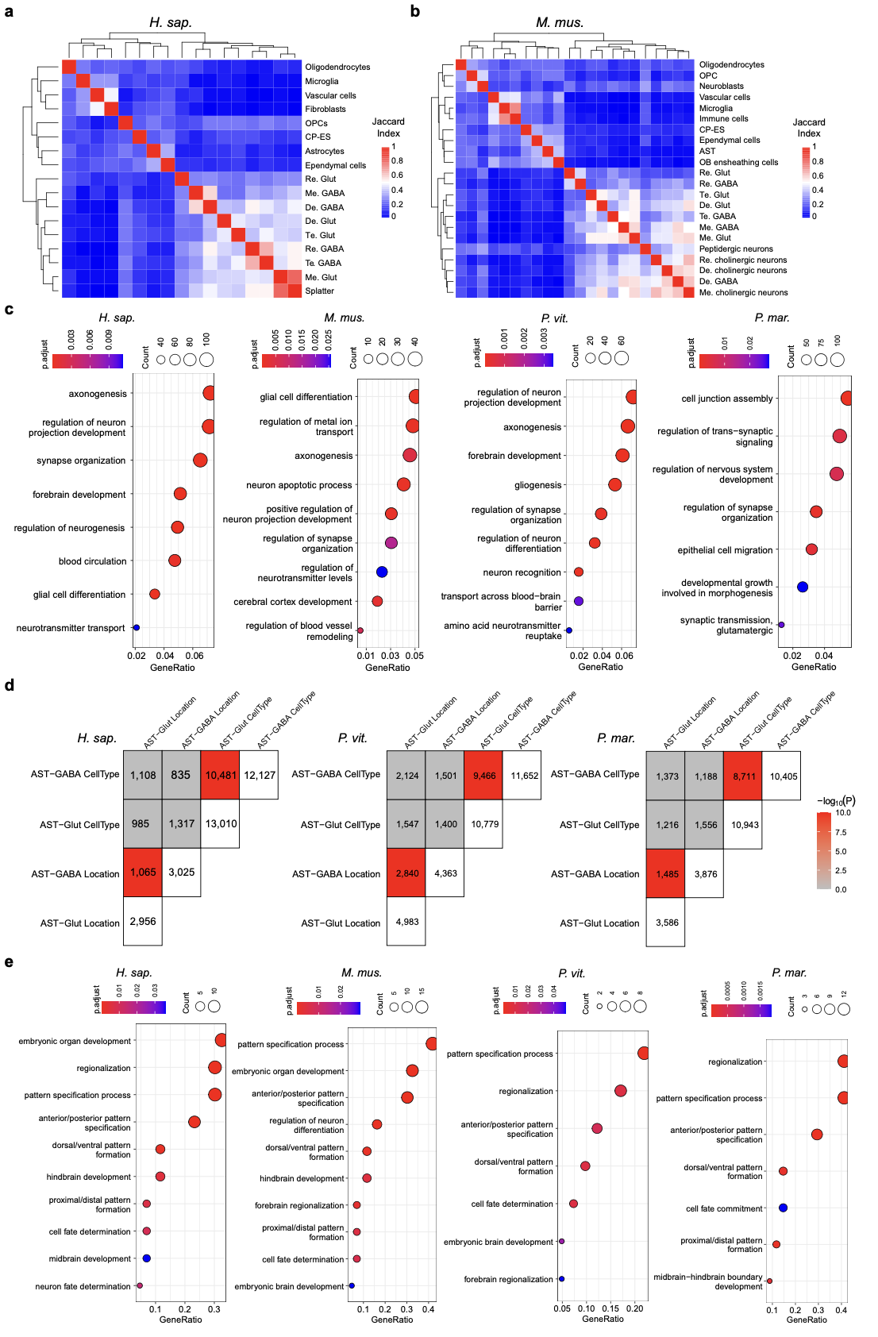
Extended Data Fig. 9 | Comparison and enrichment of regional-identity genes. a,b, Heatmap showing the Jaccard index of the TFs of top 100 regulons across cell type families in human (a) and mouse (b), respectively. The colour represents the value of Jaccard index, calculated by J(A,B)=∣A∪B∣/∣A∩B∣​. The total number of active regulons in human and mouse are 446 and 390, respectively. c, Dot plots showing GO enrichment of DEGs across astrocyte subtypes for each species. The colour represents FDR and dot size represents gene count. d, Heatmap showing the comparison matrix of potential regional-identity gene sets in Supp. Table 7. The colour is red if Fishers’ exact test shows significance with OR > 1. The gradient red colour represents -log₁₀(p-value). e, Dot plots showing GO enrichment of genes in conserved regionalisation orthogroups for each species. Genes in conserved regional orthogroups were identified if genes were highly contributing to regional identity and in the vertebrate conserved regionalisation orthogroups. The legend is same as (c).

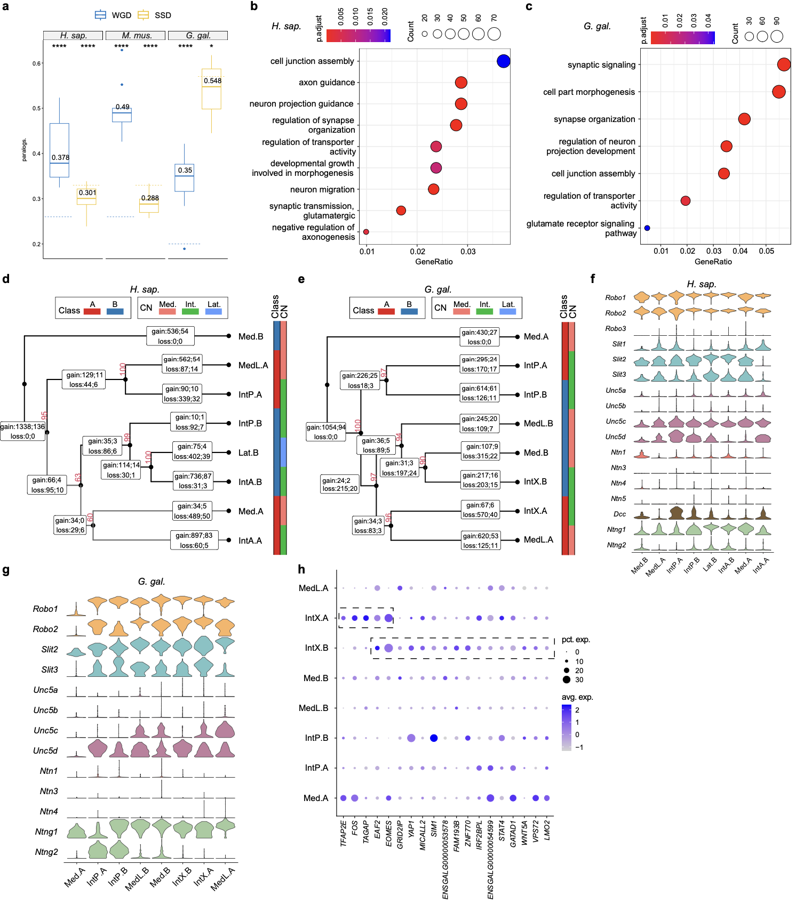

Extended Data Fig. 10 | Excitatory neurons in CN and genes important in subtype differences. a, Proportion of ohnologues (WGD, blue) and SSD paralogues (SSD, yellow) among DEGs in the subtype of cerebellar nuclei excitatory neurons. Background proportions of expressed protein-coding genes are indicated by blue and yellow dotted lines. Significance was evaluated by one-sample t-test. ns (not significant); * (P < 0.05); ** (P < 0.01); *** (P < 0.001); **** (P < 0.0001). b,c, GO enrichment of DEGs of CN excitatory neurons for human (b) and chicken (c). d,e, Dendrogram of excitatory neurons in CN and number of predicted genes with gain- and loss-of-function (expression domain) for human (d) and chicken (e). The left colour bar represents cell-type class and right bar represents location of CN. The red number near the node is Approximately Unbiased (AU) p-values, computed by pvclust with 100 times of multiscale bootstrap resampling. Rectangles in the branch contain the number of genes gain and loss in particular expression domain (CN or ancestral CN). The number following semicolon represents the number of TFs involved. f,g, Dot plots showing genes in axon guidance system are differentially expressed across CN in human (f) and chicken (g). h, Dot plot showing potentially important TFs in the evolution of IntX. The dotted boxes indicate up-regulated TFs for IntX.A and IntX.B compared to other subtypes.

References:
1. Ryota Suzuki <suzuki@ef-prime.com>, Yoshikazu Terada <terada@sigmath.es.osaka-u.ac.jp>, Hidetoshi Shimodaira <shimo@i.kyoto-u.ac.jp>. pvclust: Hierarchical Clustering with P-Values via Multiscale Bootstrap Resampling. 2.2–0 https://doi.org/10.32614/CRAN.package.pvclust (2005).
2. Shen, W.-K. et al. AnimalTFDB 4.0: a comprehensive animal transcription factor database updated with variation and expression annotations. Nucleic Acids Res 51, D39–D45 (2023).
3. Regev, A. et al. The Human Cell Atlas. eLife 6, e27041 (2017).
4. Hao, Y. et al. Dictionary learning for integrative, multimodal and scalable single-cell analysis. Nat Biotechnol (2023) doi:10.1038/s41587-023-01767-y.
5. Love, M. I., Huber, W. & Anders, S. Moderated estimation of fold change and dispersion for RNA-seq data with DESeq2. Genome Biol 15, 550 (2014).
6. Yao, Z. et al. A high-resolution transcriptomic and spatial atlas of cell types in the whole mouse brain. Nature 624, 317–332 (2023).

