Supplementary Information (S.I)

ANTIFUNGAL AND PHOTOCATALYTIC POTENTIALS OF ZINC OXIDE NANOPARTICLES SYNTHESIZED USING VARIOUS FRUIT PEEL AQUEOUS EXTRACTS

Dailami S.A Masokano^{1*}, Usman O.A Shuaibu¹, Jude E. Emurotu¹ and Pinkie Ntola²

- Department of Chemistry, Federal University Lokoja, PMB 1154 Lokoja-Nigeria
- Department of Chemistry, Faculty of Applied Sciences, Durban University of Technology, P.O Box 1334, Durban 4000, South Africa
*Corresponding email: dailami.adam@fulokoja.edu.ng; masokano09@gmail.com

 | 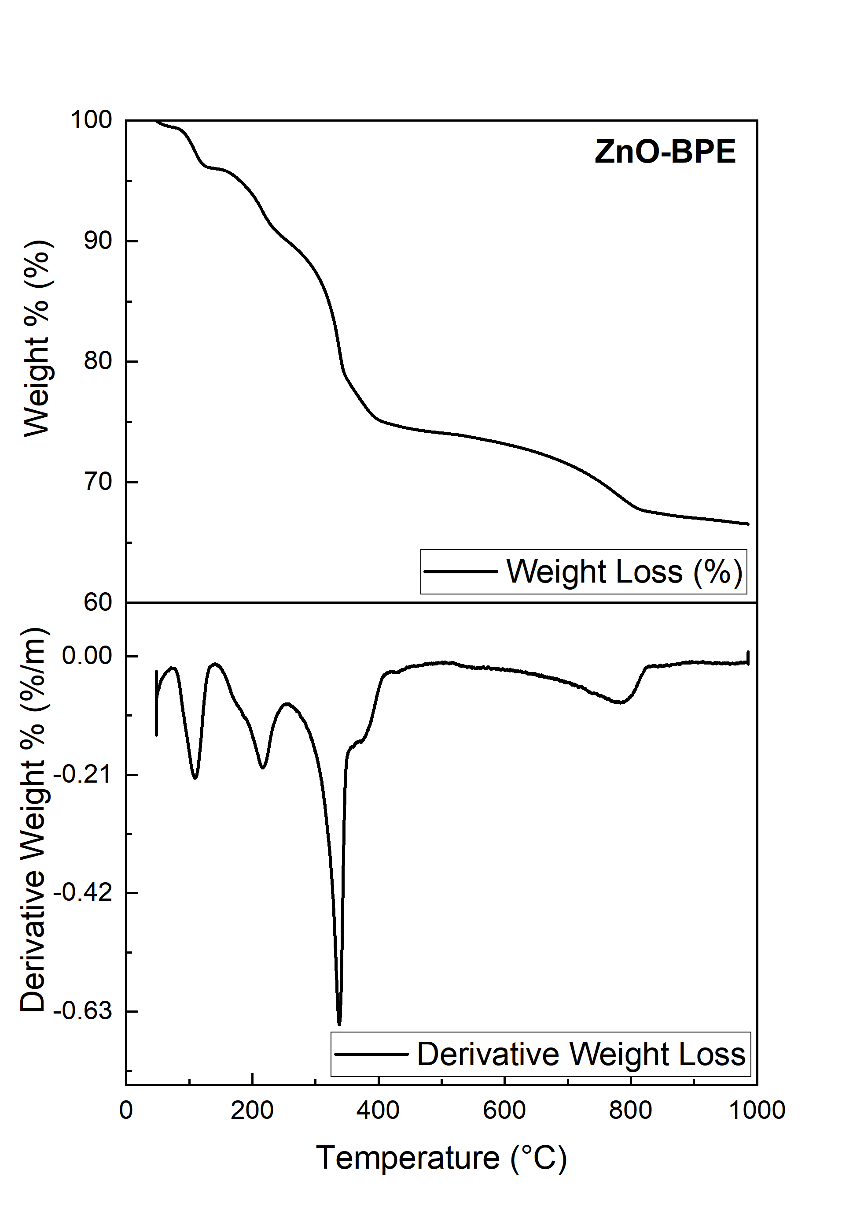
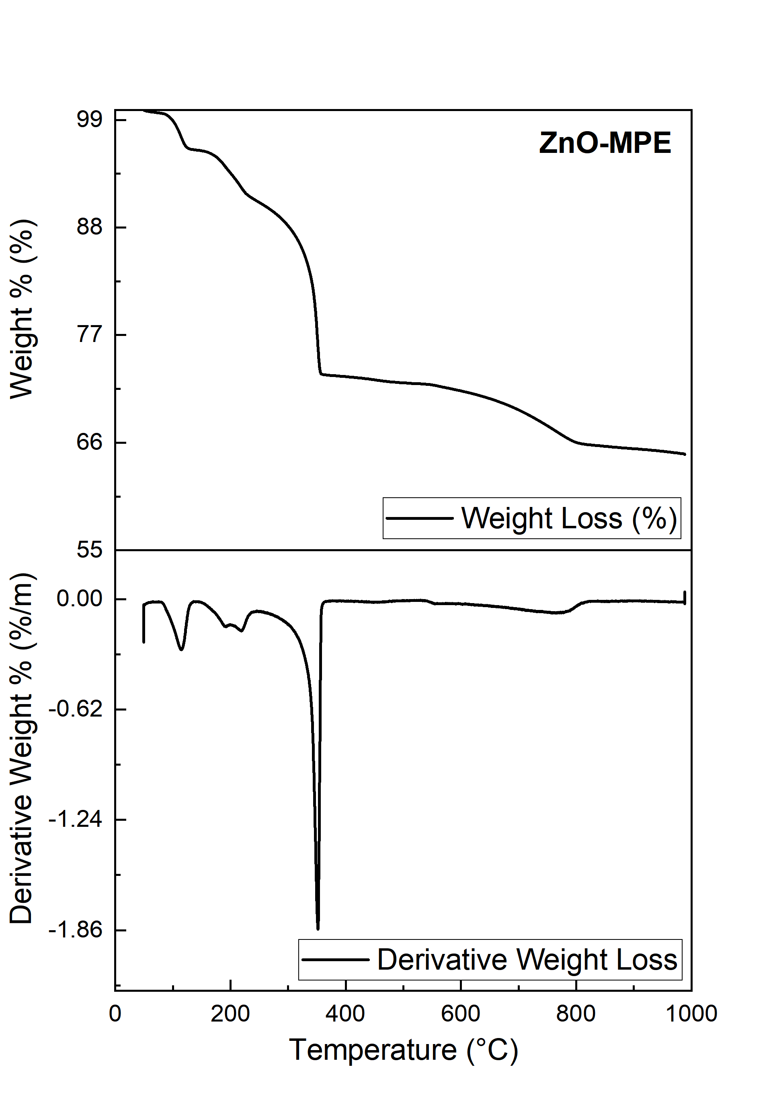 | 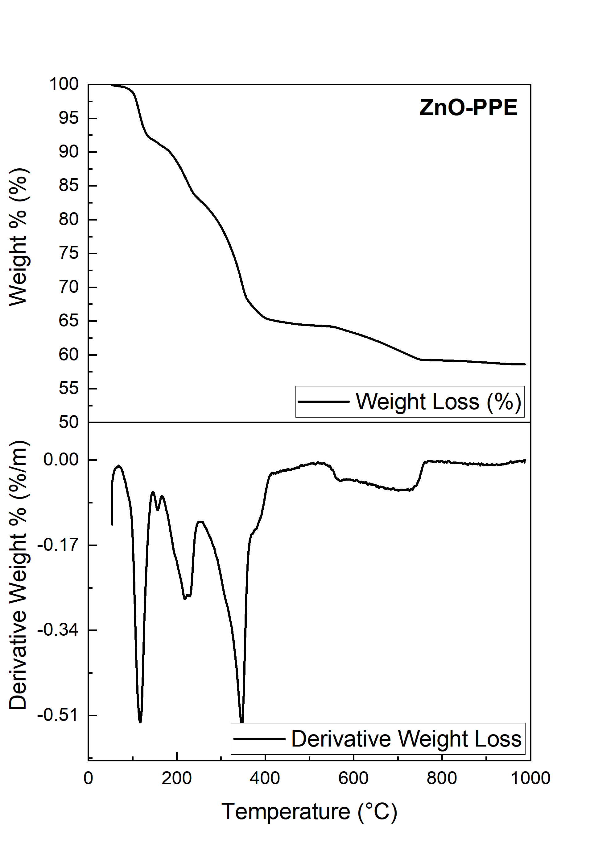

Figure S1: TGA and DTG analysis of the synthesized ZnONPs prior to calcination at 500 ºC

(a) | (b)
(c) | (d)

Figure S2: Tauc plot of indirect bandgap energy of the synthesized ZnONPs (a) ZnO-ppt (b) ZnO-BPE (c) ZnO-MPE and (d) ZnO-BPE

 | (b)
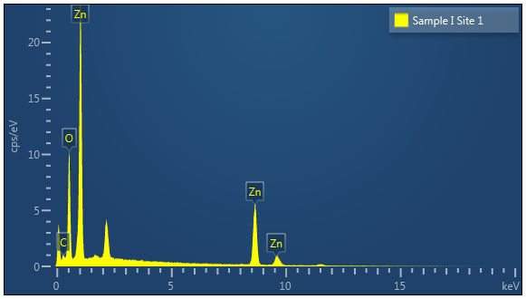  (c) | 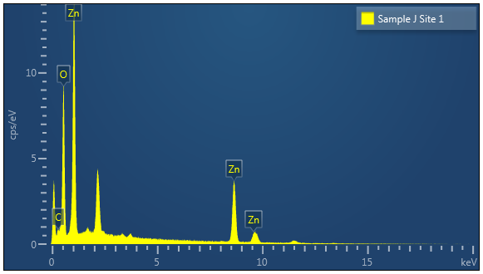  (d)
(a)
Figure S3: SEM images of (a) ZnO-ppt and (b) ZnO-MPE, and EDX spectra of (c) ZnO-ppt and (d) ZnO-MPE.

ZnO-ppt | ZnO-BPE
ZnO-MPE | ZnO-PPE

Figure S4: TEM images of the synthesized ZnONPs

Figure S5: TEM images of ZnO-ppt sample showing hexagonal structure of ZnO particles at magnification of 50 nm

(b)
(a)
(c) | (d)

Figure S6: (a) and (b) showing absorbance spectra of the MB dye degradation under UV light for ZnO-ppt and ZnO-MPE respectively, (c) and (d) showing percentage degradation of MB over ZnO-ppt and ZnO-MPE respectively, over 120 min reaction period

Figure S7: XRD of the used ZnO-MPE sample after three regeneration cycles.

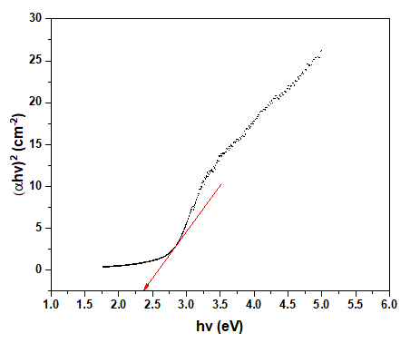
(a)
(b)

Figure S8: (a) UV-vis DRS and (b) bandgap energy (Tauc plot) of the used ZnO-MPE sample after three regeneration cycles.

