Supplementary Information
Unveiling the Uncertainty Bias in Bootstrap: Understanding the Paradoxical Efficiency of Bagging over Gaussian Processes based Active Learning for Materials Optimization
Zishuo Lan¹, Yiming Chen¹, Xiaobing Hu^{2*}, Junjie Li¹, Dezhen Xue^{3*}, Jincheng Wang^{1*}

¹State Key Laboratory of Solidification Processing, Northwestern Polytechnical University, Xi'an, 710072, China.
² School of Metallurgical Engineering, National and Local Joint Engineering Research Center for Functional Materials Processing, Xi’an University of Architecture and Technology, Xi’an, 710055, China.
³State Key Laboratory for Mechanical Behavior of Materials, Xi’an Jiaotong University, Xi’an, 710049, China.

Section S1: Material Datasets and Feature Engineering
We employed two computational datasets of perovskite oxide materials: thermodynamic phase stabilities (PS) and impurity diffusion activation energies (DAE). Due to the high dimensionality of these datasets, we implemented feature engineering methods as reported in the literature^{1,2}, including correlation screening, recursive elimination, and exhaustive screening. To further reduce dimensionality, Principal Component Analysis (PCA) was performed; we retained the components with a variance of more than 10% and made sure the accumulative variance was over 90%. For the two experimental datasets of BaTiO₃ ceramics focusing on energy storage density (ESD) and Curie temperature (CT), only PCA dimensionality reduction was applied. The complete feature engineering results are illustrated in Fig. S1a-f for the computational datasets and Fig. S1g-h for the experimental datasets. Table S1 summarizes the key information about all materials datasets used in this study.
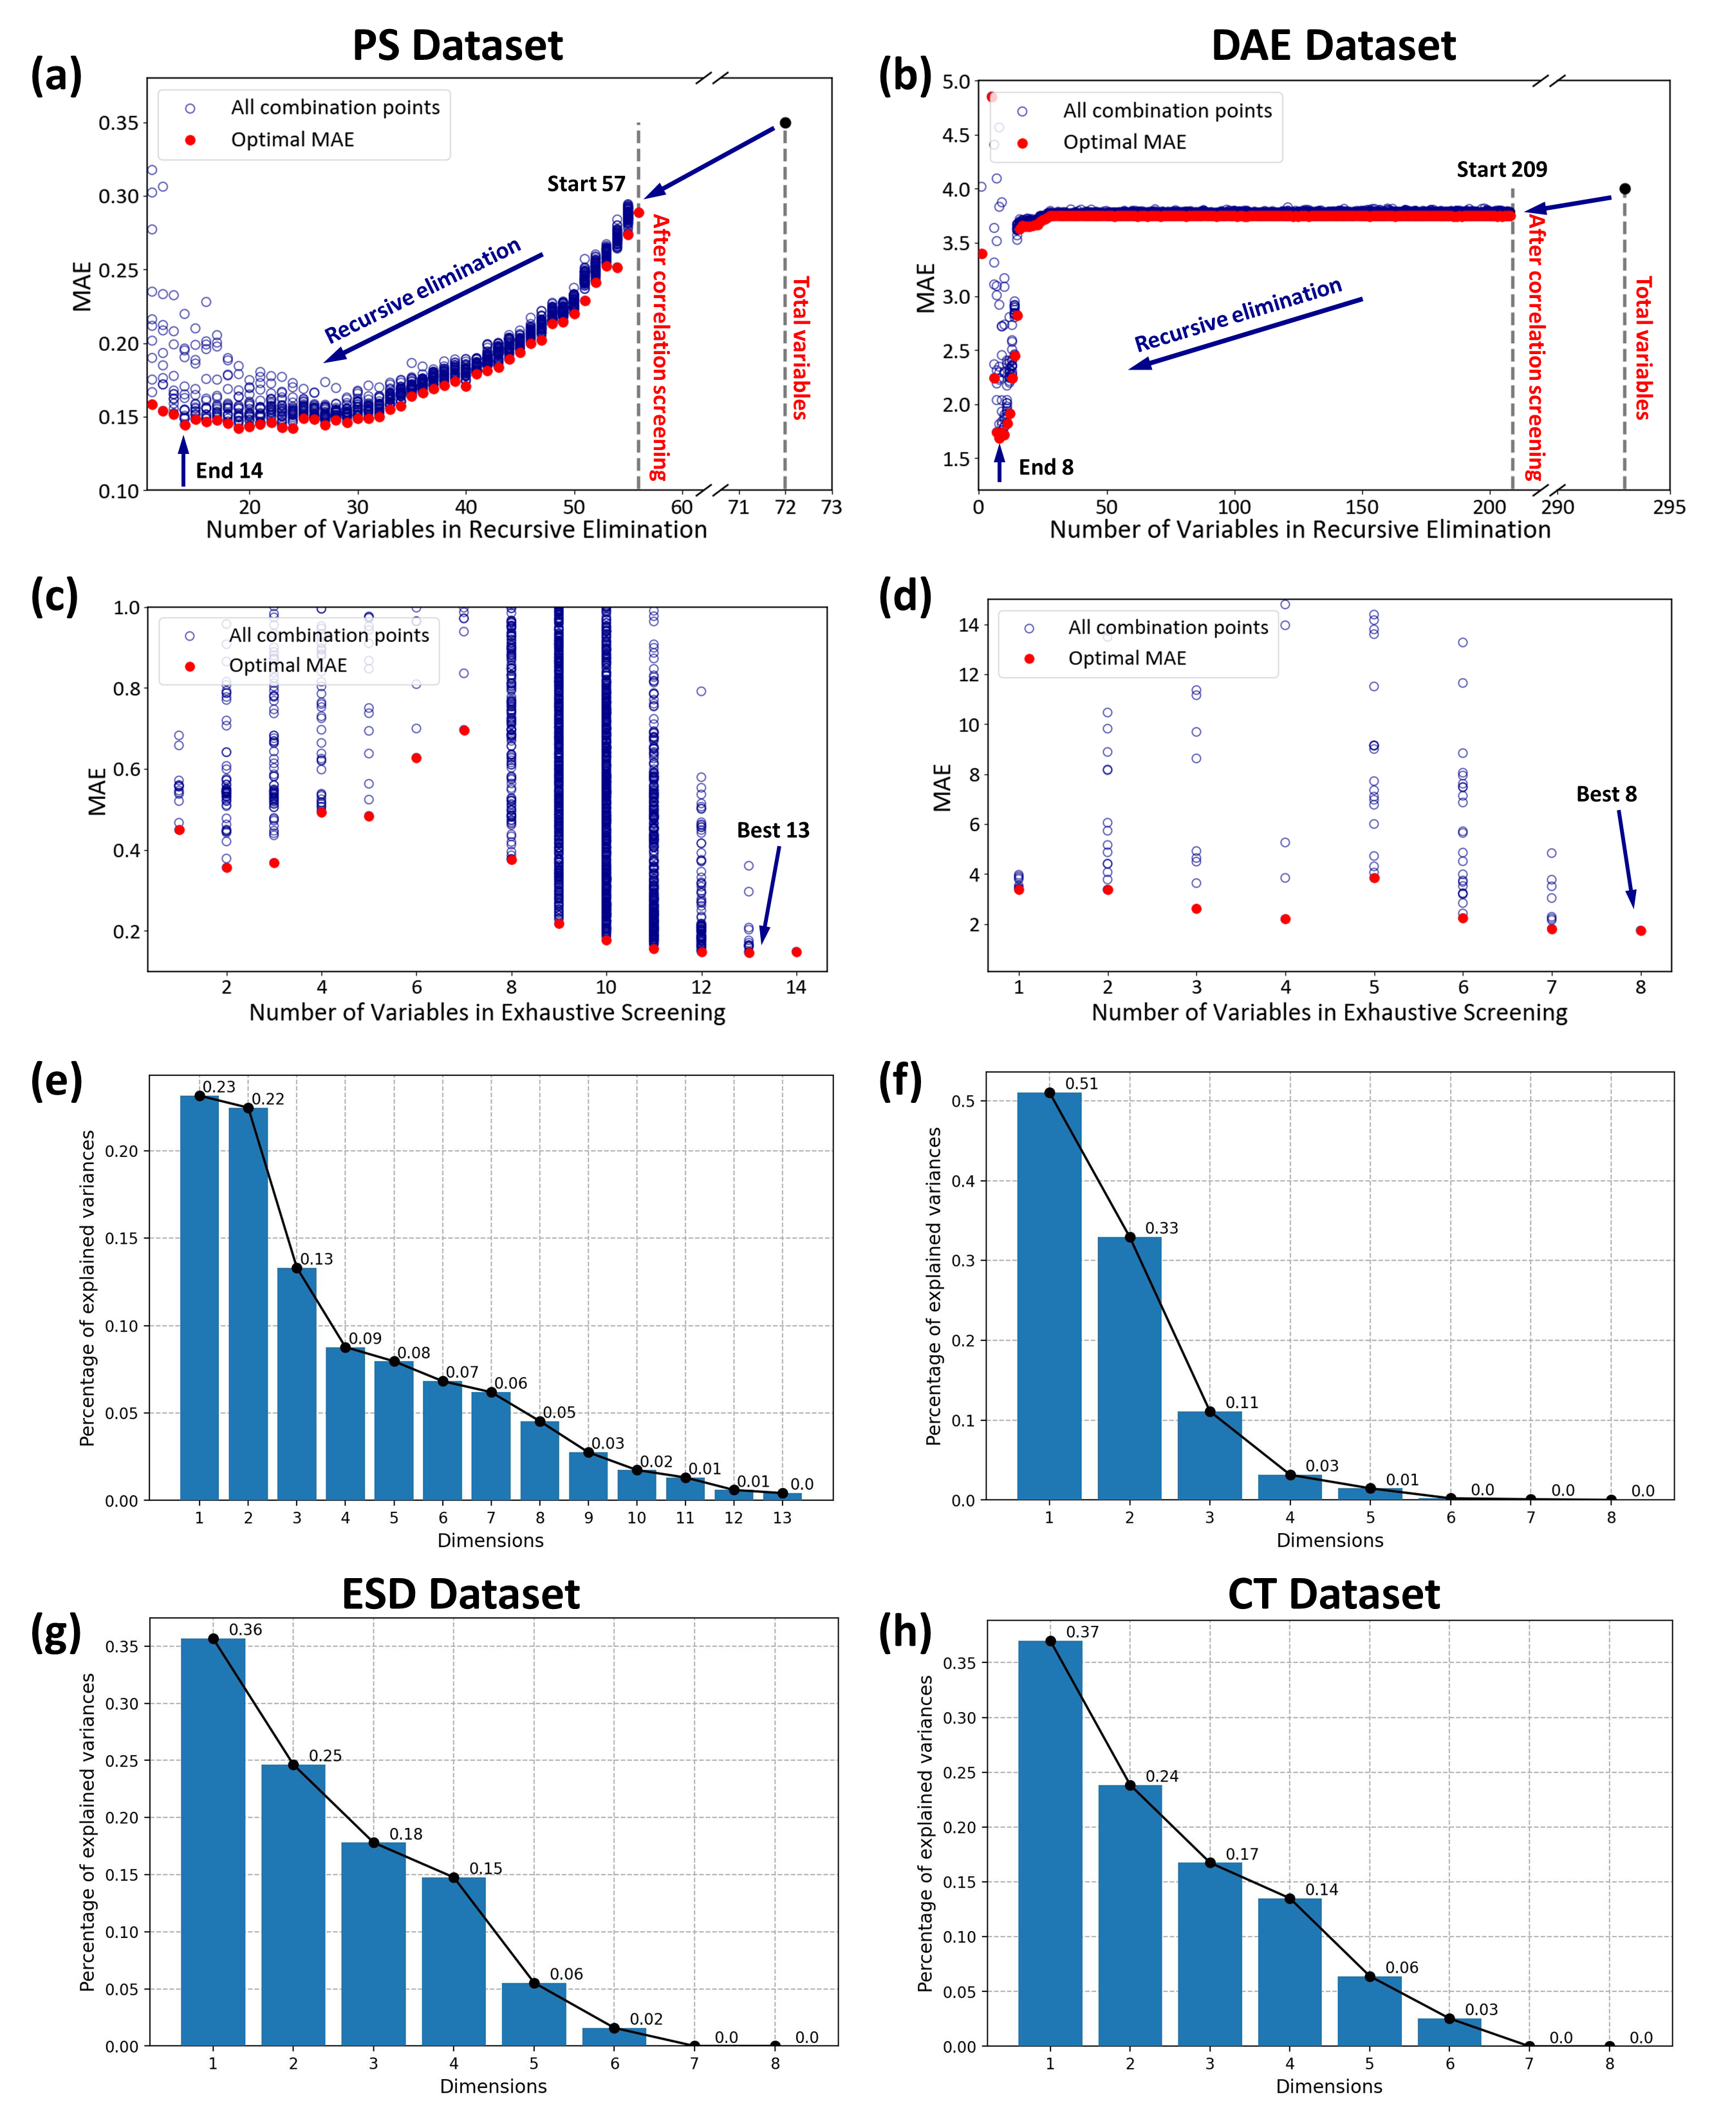
Fig. S1 | Feature engineering results for materials datasets. a-b Recursive elimination, c-d exhaustive screening and e-f PCA dimensionality reduction results for PS and DAE datasets. g-h PCA dimensionality reduction results for ESD and CT datasets.

Table S1. Summary of materials datasets used in this study.
Dataset | Sample size | Number of original features | Number of final features | optimization direction
PS | 1713 | 72 | 3 | maximization
DAE | 408 | 293 | 3 | maximization
ESD | 242 | 8 | 4 | maximization
CT | 182 | 8 | 4 | maximization

Section S2: Test Functions
The expression of the multi-peak one-dimensional function is provided as follows:
$$\begin{aligned}f\left(x\right)=1.5e^{-\frac{{\left(x-12\right)}^{2}}{5}}+0.75e^{-\frac{{\left(x-3\right)}^{2}}{5}}-\frac{1}{x^{2}+1}\end{aligned}$$
Six benchmark test functions were collected, including Peaks, Shubert, SinglePeak, SixHumpCamel, Hartmann3, and SumSquares. These functions exhibit diverse landscapes with varying complexity, as visualized in Fig. S2 The mathematical expressions and domain ranges for each test function are defined as follows:

- The Peaks function is defined as:
$$f\left(x\right)=3{(1-x_{1})}^{2}∙e^{(-x_{1}^{2}-(x_{2}+1)^{2})}-10\left(\frac{x_{1}}{5}-x_{1}^{3}-x_{2}^{5}\right)∙e^{\left(-x_{1}^{2}-x_{2}^{2}\right)}-\frac{1}{3}∙e^{(-(x_{1}+1)^{2}-x_{2}^{2})}$$
where $x=\left(x_{1},x_{2}\right)$ and $x_{1},x_{2}∈\left[-3, 3\right]$.

- The Shubert function is defined as:
$$f\left(x\right)=\sum_{i=1}^{5}{i∙\cos\left(\left(i+1\right)x_{1}+i\right)}∙\sum_{i=1}^{5}{i∙\cos\left(\left(i+1\right)x_{2}+i\right)}$$
where $x=\left(x_{1},x_{2}\right)$ and $x_{1},x_{2}∈\left[-2, 2\right]$.

- The SinglePeak function is defined as:
$$f\left(x\right)=0.5∙{(1-x_{1})}^{2}∙e^{(-x_{1}^{2}-{(x_{2}+1)}^{2})}$$
where $x=\left(x_{1},x_{2}\right)$ and $x_{1},x_{2}∈\left[-3, 3\right]$.

- The SixHumpCamel function is defined as:
$$f\left(x\right)=\left(4-2.1x_{1}^{2}+\frac{x_{1}^{4}}{3}\right)x_{1}^{2}+x_{1}x_{2}+(-4+4x_{2}^{2})x_{2}^{2}$$
where $x=\left(x_{1},x_{2}\right)$ and $x_{1},x_{2}∈\left[-1, 1\right]$.

- The Hartmann3 function is defined as:
$$f\left(x\right)=-\sum_{i=1}^{4}{α_{i}∙e^{\left(-\sum_{j=1}^{3}{A_{ij}{\left(x_{j}-P_{ij}\right)}^{2}}\right)}},$$
$$where α={(1.0, 1.2, 3.0, 3.2)}^{T}$$
$$A=\left(\begin{matrix}3.0 & 10 & 30 \\ 0.1 & 10 & 35 \\ 3.0 & 10 & 30 \\ 0.1 & 10 & 35\end{matrix}\right)$$
$$P={10}^{-4}\left(\begin{matrix}3689 & 1170 & 1673 \\ 4699 & 4387 & 7470 \\ 1091 & 8732 & 5547 \\ 381 & 5743 & 8828\end{matrix}\right)$$
where $x=\left(x_{1},x_{2},x_{3}\right)$ and $x_{1},x_{2},x_{3}∈\left[0, 1\right]$.

- The SumSquares function is defined as:
$$f\left(x\right)=\sum_{i=1}^{n}{x_{i}^{2}}$$
where $x=\left(x_{1},x_{2}\right)$ and $x_{1},x_{2}∈\left[-2, 2\right]$.

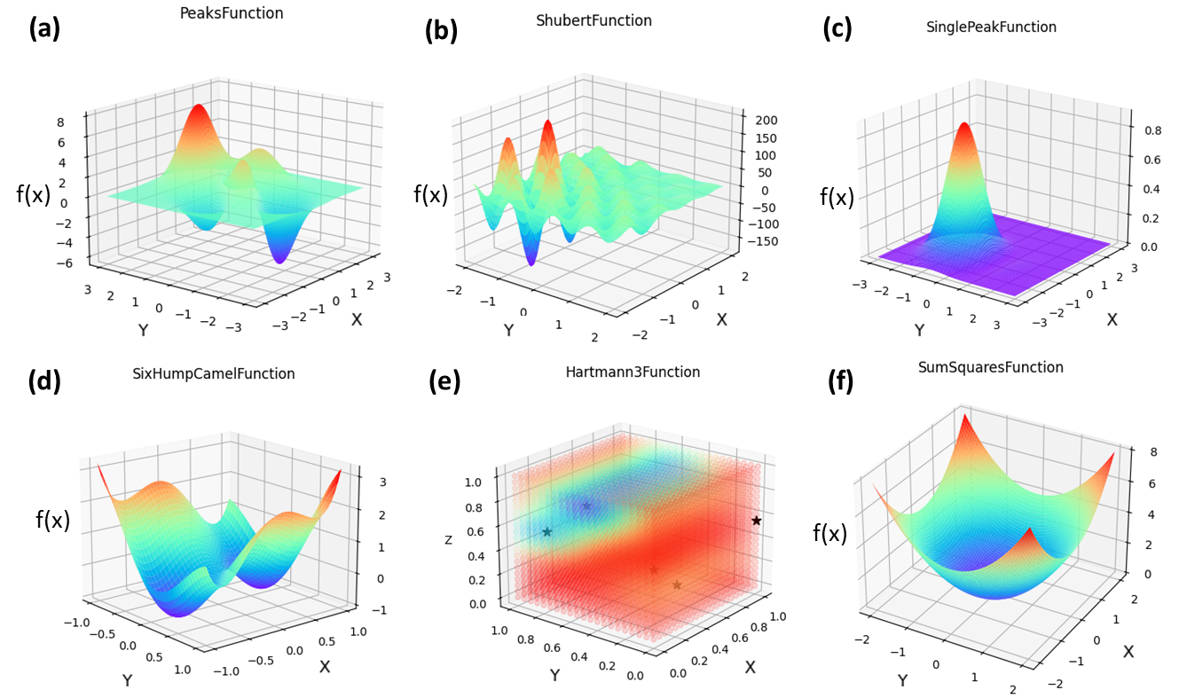
Fig. S2 | Landscapes of the six test functions used in this study: a Peaks, b Shubert, c SinglePeak, d SixHumpCamel, e Hartmann3, and f SumSquares. These functions exhibit diverse landscapes with single or multiple local extrema and varying complexity.

Section S3: Algorithm for Finding Peaks in Discrete Data
For discrete high-dimensional datasets, the definition and identification of peak samples present significant challenges due to the absence of continuous functions. To address this issue, we developed a methodology based on computational geometry principles to identify local extrema within discrete data spaces. We employed Delaunay triangulation to establish a topological structure among discrete data points, effectively creating a connectivity graph that approximates the underlying landscape. The Delaunay triangulation creates a set of simplices such that no data point is inside the circumspect of any simplex, providing an optimal neighborhood structure for subsequent analysis. The algorithm leverages the scipy package³ in Python to implement both Delaunay triangulation and convex hull construction.
Using the established Delaunay triangulation, we define the neighbor relationship between data points. A point is classified as a local maximum if its value is greater than all its nearest neighbors, while a local minimum is defined as a point with a value less than all its nearest neighbors. This approach effectively extends the concept of extrema from continuous functions to discrete datasets. Fig. S3a illustrates the construction of the convex hull and Delaunay triangulation for two-dimensional scattered points from the Peaks function, while Fig. S3b shows the identified local maxima and minima based on the neighbor relationships.
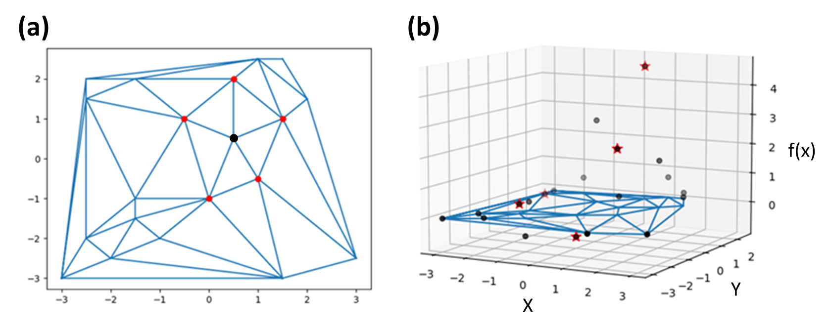
Fig. S3 | Peak identification in discrete datasets. a Illustration of Delaunay triangulation and convex hull construction for two-dimensional scattered points from Peaks function. The blue lines represent the Delaunay triangulation, establishing neighbor relationships between data points, while the red points indicate the nearest neighbors of the black points. b Identified local maxima and local minima (both marked as red stars) based on the neighbor relationships established through Delaunay triangulation.

Section S4: Correlation Analysis Results for Materials Datasets and Test Functions
Fig. S4a and S4b present the variation of correlation between UBG and other uncertainty estimators (UGP, RIpeaks, and KDE) as a function of sampling percentage for the DAE and PS datasets, respectively. For the six test functions, we conducted 50 trials by randomly sampling 10 initial points in each trial to establish a statistical distribution of correlations. Fig. S4c shows violin plots of the correlation distributions between UGP and UBG, RIpeaks and UBG, as well as KDE and UGP for all test functions. Fig. S4d-i provide a detailed correlation between UBG and other estimators (UGP, RIpeaks, and KDE) as a function of sample size for the six test functions. These results demonstrate how correlations evolve with increasing sample sizes across different function landscapes.
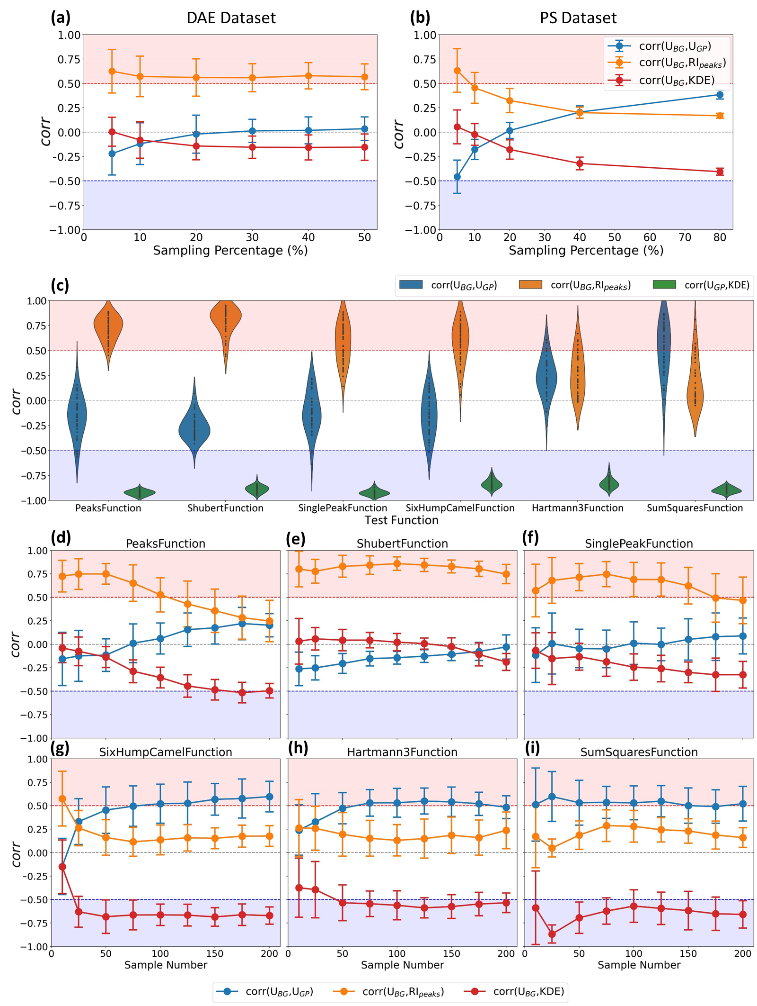
Fig. S4 | Correlation analysis between uncertainty estimators. a and b Correlation between UBG and others (UGP, RIpeaks, and KDE) with increasing sampling percentage for the DAE and PS datasets. c Violin plot for correlations between UGP and UBG, RIpeaks and UBG, as well as KDE and UGP across 50 trials with 10 random initial samples for all six test functions. d-i Error bar plots showing the correlation between UBG and other estimators as a function of sample size for the Peaks, Shubert, SinglePeak, SixHumpCamel, Hartmann3, and SumSquares functions, respectively.

Section S5: BGEI and BGEI-UGP Sampling Test Results
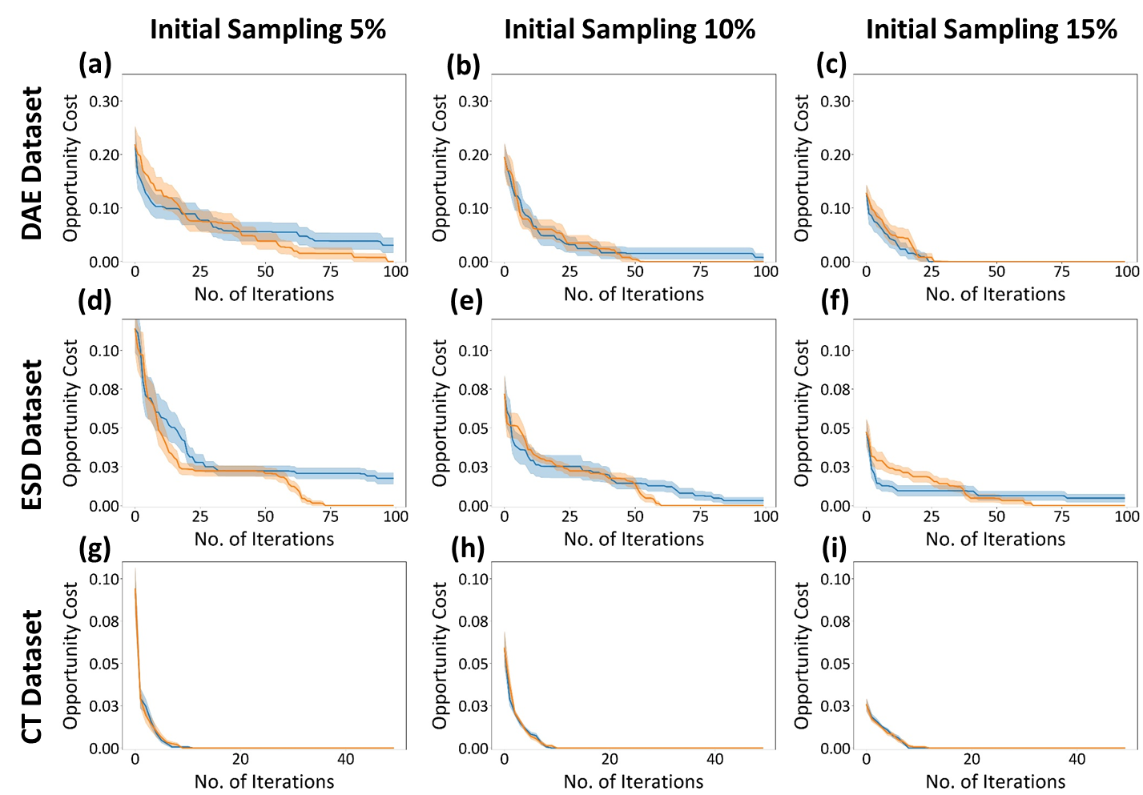
Fig. S5 | Optimization capability comparison between BGEI and BGEI-UGP. OC curves for BGEI and BGEI-UGP strategies on a-c DAE dataset, d-f ESD dataset, and g-i CT dataset are estimated with initial 5%, 10%, and 15% of training data.

1. Zhang, H., Fu, H., Zhu, S., Yong, W. & Xie, J. Machine learning assisted composition effective design for precipitation strengthened copper alloys. Acta Materialia 215, 117118 (2021).
2. Zhang, H. et al. Dramatically Enhanced Combination of Ultimate Tensile Strength and Electric Conductivity of Alloys via Machine Learning Screening. Acta Materialia 200, 803–810 (2020).
3. Virtanen, P. et al. SciPy 1.0: fundamental algorithms for scientific computing in Python. Nat Methods 17, 261–272 (2020).

