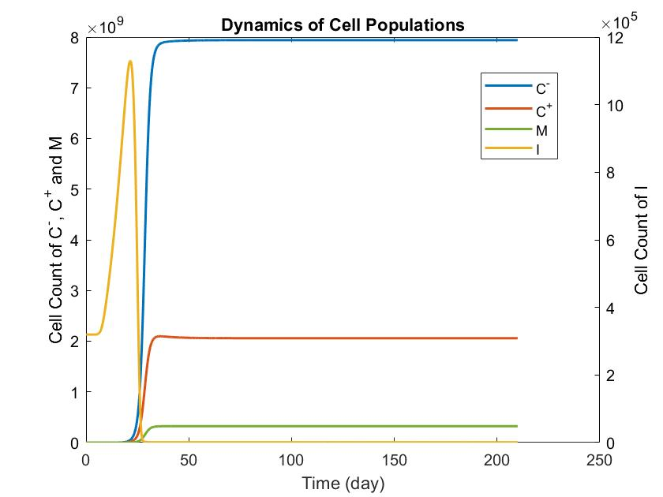
Supplemental Figures

Supplemental Figure 1: Dynamics of cell populations during monotherapy with RGX
Initial Conditions: Treatment begins on day 11, with τ set to 1.1 $×$ 10⁻⁷
The population of MDSCs is regulated by the treatment, but in the absence of an effective MTX-mediated cytotoxic effect, the C⁻ subpopulation becomes dominant.

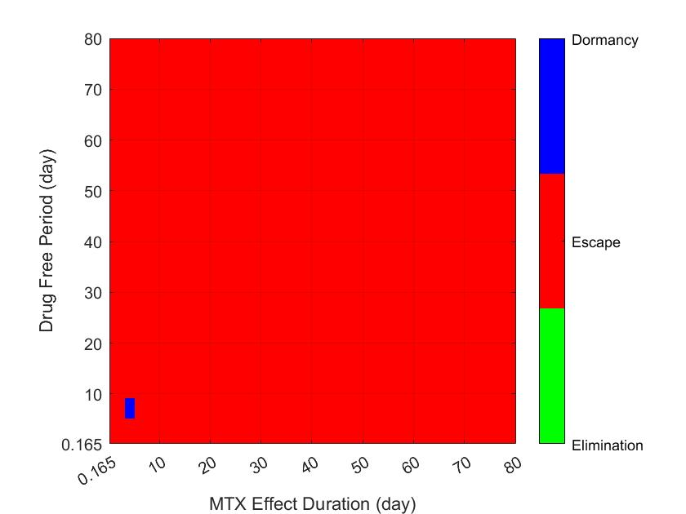
B
A
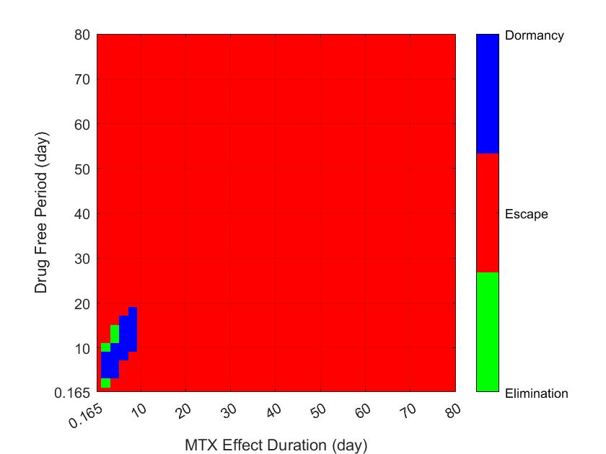

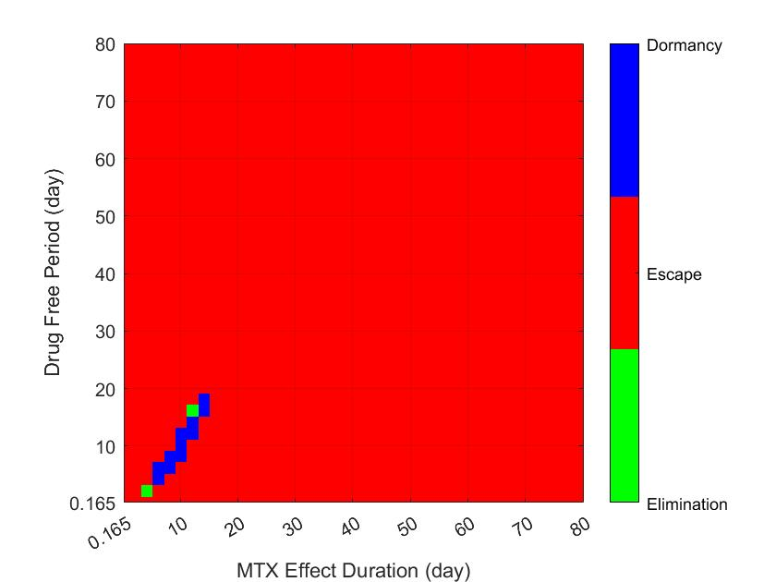
C

Supplemental Figure 2: Tumor fate following MTX monotherapy across different τ values and treatment initiation times
A) τ=1.6 $×$ 10⁻⁷, treatment initiated on day 11
B) τ=2.86 $×$ 10⁻⁷, treatment initiated on day 11
C) τ=1. 6 $×$ 10⁻⁷, treatment initiated on day 19

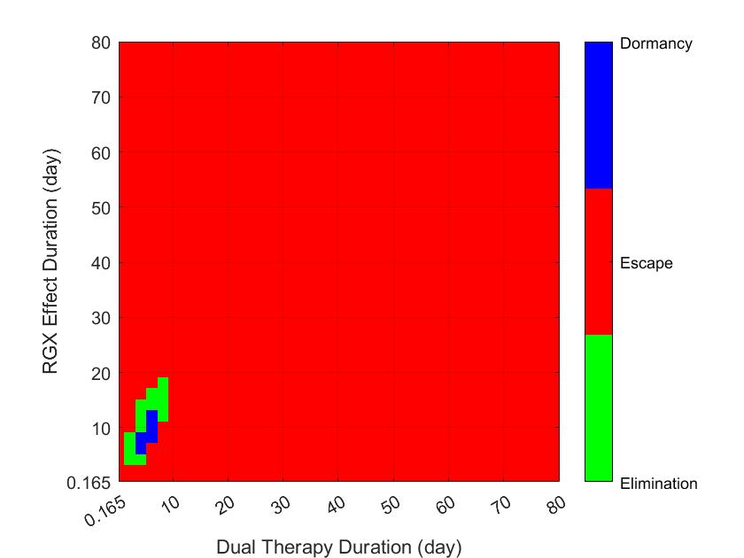
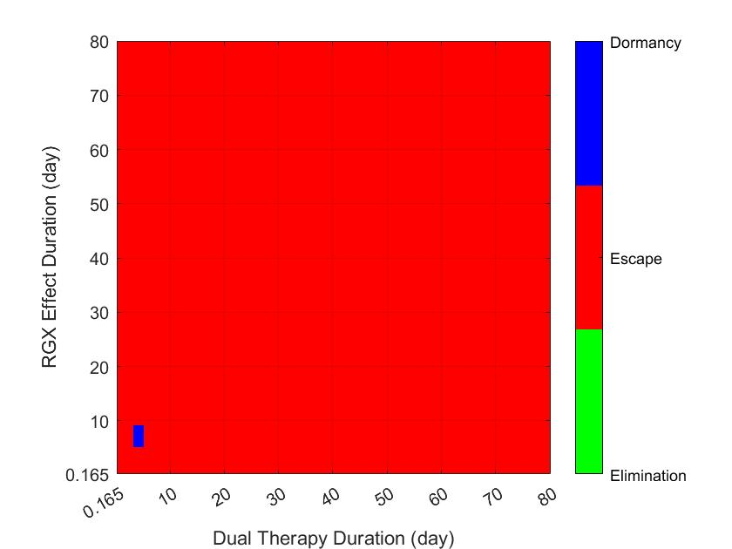
A
B

Supplemental Figure 3: Tumor fate following starting MTX-RGX dual-therapy on the day 11
A) τ=1.1 $×$ 10⁻⁷
B) τ=1.6 $×$ 10⁻⁷

