Supp. Fig. 1
Recording sites
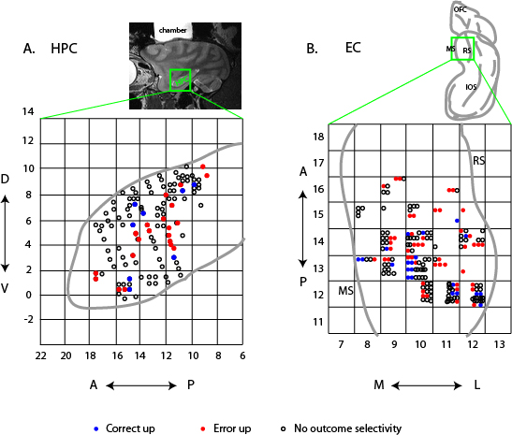

Supp. Fig. 1 Recording sites. A) Sagittal MRI image at the top of figure is of monkey El with the hippocampus (HPC) outlined by a green box and the location of the recording chamber indicated by the bright area dorsal to the brain. The graph at the bottom shows an expanded version of the same sagittal view of the HPC shown in the MRI image illustrating the anterior-posterior and dorsal ventral coordinates of the recording sites for monkeys A, B and El. Because we did not observe any clear topography, we compressed all the medial-lateral recording sites. The thick gray line illustrates the outline of the sagittal view of the anterior 2/3 of the HPC. The X- and Y- axes show the stereotaxic coordinates in mm from the crossing point of the interaural line and mid-sagittal line. Blue dots indicate the correct up cells, red dots indicate the error up cells and the open circles indicate the non-outcome selective cells. B) Line drawing at the top of the figure illustrates a ventral view of a monkey brain showing the location of the entorhinal cortex (green box). The graph below shows an expanded version of the EC illustrating the anterior-posterior and medial-lateral coordination of the recording sites in monkeys A and B. The same as in panel A, the X- and Y-axes of the graph indicate the stereotaxic coordinates in mm from the crossing point of the interaural line and mid-sagittal line. No clear topography was observed. Abbreviations: A: anterior; D: dorsal; L: lateral; M: medial; P: posterior; V: ventral. RS: rhinal sulcus; MS: medial side brain; OFC: orbitofrontal cortex; IOS: inferior occipital sulcus.

Supp. Fig. 2

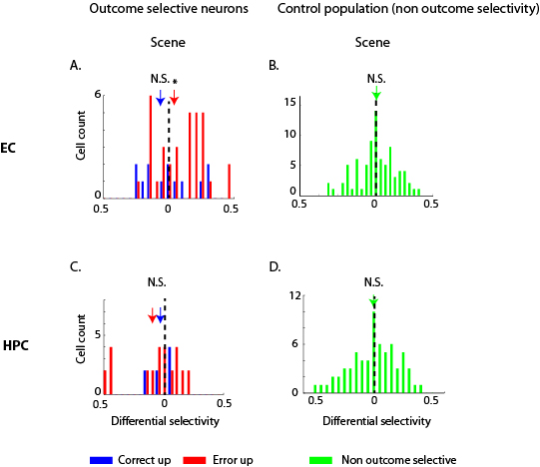

Supp. Fig. 2 Differential Selectivity indices (SI) during scene presentation period of LST. The differential selectivity indices of the correct-up and error-up cells in EC (A) and HPC (C) during scene period are plotted as fig. 4 for delay period. The differential selectivity indexes of the non-outcome selective cells in EC (B) and HPC (D) during scene period are also plotted here to show no significant selectivity shift after learning. *: p<0.05, N.S.: not significant.

Supp. Fig. 3
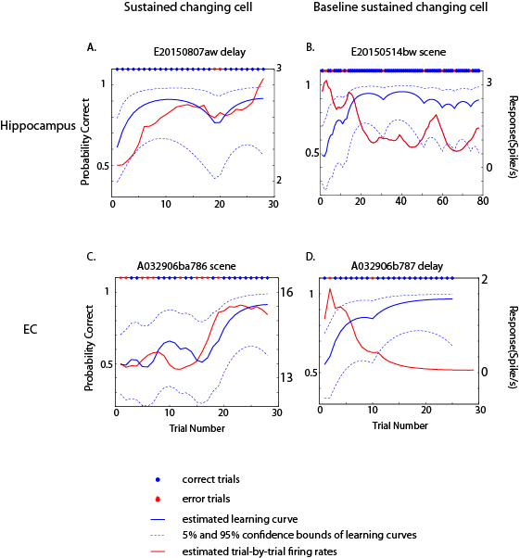

Supp. Fig. 3 Examples of newly recorded changing cells. The estimated trial-by-trial firing rates (red line) superimposed on estimated learning curves (blue line) of an example sustained changing cell in HPC was plotted in A, a baseline sustained changing cell in B, an example sustained changing cell in EC in C, and a baseline sustained changing cell in D. The blue filled circles on top of each subplots indicate correct trials and the red asterisks indicate the error trials. The 95% confidence bounds of estimated learning curves were plotted in blue dash lines. The trial-by-trial firing rates plotted here were estimated with the same state-space algorithm used to estimate behavioral performance ⁶⁷ to avoid the difficulty of recognizing the correlation between the firing rates and the behavior performances due to the noisy neural spiking with inherited variability.

Supp. Fig. 4
EC
Error up
Correct up
-500
0
500
1000
1500
2000
0
0.5
1
-500
0
500
1000
1500
2000
0
0.5
1
A.
B.
HPC
-500
0
500
1000
1500
2000
0
0.5
1
-500
0
500
1000
1500
2000
0
0.5
1
C.
D.
Time from saccade (ms)

Supp. Fig. 4 Averaged time courses of area under Receiver operating characteristic curves. The averaged time courses of the area under ROC curve of error-up (A) and correct-up cells (B) in entorhinal cortex (EC) and the error-up (C) and correct-up cells (D) in hippocampus (HPC) are plotted to show the strength of each category of outcome selective neurons in differentiating correct from error outcomes. The lighter lines indicate the standard error of the mean of the averaged time courses.

