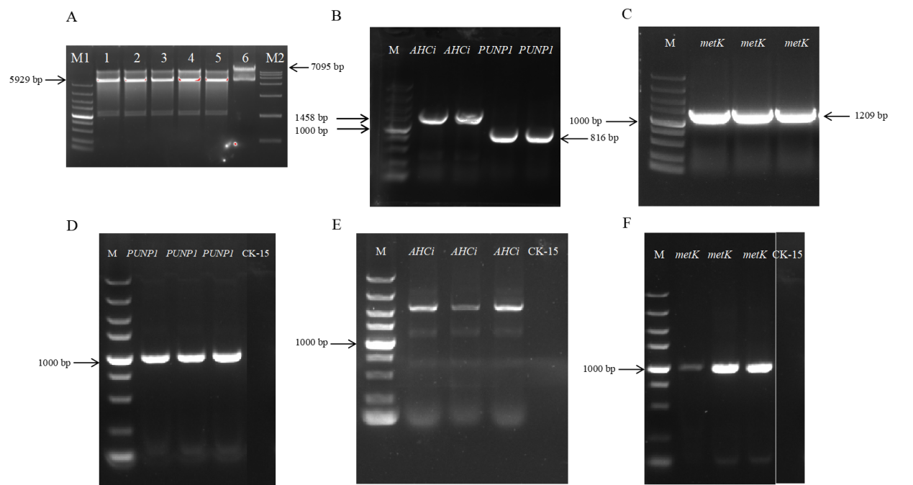
Fig S1.Construction and verification of overexpression vectors.
(A). Double digestion map of plasmid pLQ646. Lanes 1–5: Double digestion of plasmid with EcoRI and NdeI; Lane 6: Undigested pLQ646 plasmid; M1: DL5000 DNA marker; M2: DL15000 DNA marker. (B-C). PCR amplification of target gene fragments AHCi and PUNP1. AHCi: 1458 bp; PUNP1: 816 bp; metK: 1209 bp; M: DL5000 DNA marker. (D–F). Verification of overexpression strains for AHCi, metK, and PUNP1 in Streptomyces. M: DL5000 DNA marker; D: pLQ646-metK (1388 bp); E: pLQ646-AHCi (1637 bp); F: pLQ646-PUNP1 (995 bp).

Table S1 Strains and plasmids used in this study
Strain | Description | Source
S.nuorsei CK-15 | Glucocin-producing strain, wild-type strain | This laboratory
OE AHCi | CK-15 overexpression gene AHCi | This work
OE PNP | CK-15 overexpression gene PNP | This work
OE metK | CK-15 overexpression gene metK | This work
pLQ646 | Plasmid pSET152 modified, containing the kasO*p strong promoter plasmid shuttle vector for overexpression strain construction | Gift from Shenzhen Institute of Advanced Technology, Chinese Academy of Sciences

Table S2 Primer
Primer Name | Sequence 5'-3' | Product Size | Use
AHCi-L | TGAAGAGGTGACGTCCATATGATGACGACAGCAGCCACC | 1458 bp | Amplification of AHCi target sequence
AHCi-R | CTATGACATGATTACGAATTCTCAGTAGCGGTAGTGGTCGG | 1458 bp | Amplification of AHCi target sequence
PNP-L | TGAAGAGGTGACGTCCATATGGTGAACGCATCTGTTACCCC | 816 bp | Amplification of PNP target sequence
PNP-R | CTATGACATGATTACGAATTCCTAGATCTTGCTGAGGACCTGG | 816 bp | Amplification of PNP target sequence
152-Long-F | GATTAAGTTGGGTAACGCCA | 908 bp | Verification primers
152-Long-R | GGACAGGTATCCGGTAAGCG | 908 bp | Verification primers

Table S3 Time table
Time | A相：5mM乙酸铵水 | B相：乙腈 | 流速
0.00 | 10 | 90 | 0.3 mL/min
8.00 | 50 | 50 | 0.3 mL/min
10.00 | 50 | 50 | 0.3 mL/min
11.00 | 10 | 90 | 0.3 mL/min
17.00 | 10 | 90 | 0.3 mL/min

Table S4 ACQUITY UPLC BEH Amide Column Flushing Method
Time | 水 | 乙腈 | 流速
0.00 | 40 | 60 | 0.3 mL/min
0.00 | 40 | 60 | 0.3 mL/min
10.00 | 40 | 60 | 0.3 mL/min
11.00 | 10 | 90 | 0.3 mL/min
20.00 | 10 | 90 | 0.3 mL/min
21.00 | 40 | 60 | 0.3 mL/min
30.00 | 40 | 60 | 0.3 mL/min
31.00 | 10 | 90 | 0.3 mL/min
50.00 | 10 | 90 | 0.3 mL/min
51.00 | 40 | 60 | 0.3 mL/min
60.00 | 40 | 60 | 0.3 mL/min
61.00 | 10 | 90 | 0.3 mL/min
100.00 | 10 | 90 | 0.3 mL/min

Table S5 MRM Conditions
Compound Name | Precursor Ion | Product Ion | Dwell | Fragmentor | Collision Energy | Cell Accelerator Voltage | Polarity
gougerotin | 444.1 | 333 | 60 | 100 | 13 | 4 | Positive
gougerotin | 444.1 | 315.1 | 60 | 100 | 19 | 4 | Positive
gougerotin | 444.1 | 243.9 | 60 | 100 | 28 | 4 | Positive
gougerotin | 444.1 | 138.9 | 60 | 100 | 34 | 4 | Positive
gougerotin | 444.1 | 121.9 | 60 | 100 | 55 | 4 | Positive
gougerotin | 444.1 | 111.9 | 60 | 100 | 49 | 4 | Positive
gougerotin | 444.1 | 44 | 60 | 100 | 58 | 4 | Positive

Table S6 Significantly upregulated proteins in AHCi overexpression strain
Locus_tag | Funcation | Protein ID | Ratio
SE95_RS26160 | NAD(+) diphosphatase | WP_016576226.1 | 4.117937175
SE95_RS24610 | aldehyde dehydrogenase family protein | WP_016576230.1 | 3.389668631
SE95_RS08985 | cold-shock protein | WP_016575107.1 | 2.949599049
SE95_RS01465 | 5-formylfuran-3-yl)methyl phosphate synthase | WP_037635452.1 | 2.64338242
SE95_RS36825 | alkaline phosphatase family protein | WP_016573628.1 | 2.495529571
SE95_RS28640 | SpoIIE family protein phosphatase | WP_232817154.1 | 2.415290642
SE95_RS37760 | amidase domain-containing protein | WP_232817367.1 | 2.413964846
SE95_RS09005 | PTS fructose subfamily transporter subunit IIA | WP_016570410.1 | 2.333108207
SE95_RS22110 | M3 family metallopeptidase | WP_078948826.1 | 2.292163267
SE95_RS01340 | amidohydrolase family protein | WP_044371827.1 | 2.284837293
SE95_RS05775 | Wzz/FepE/Etk N-terminal domain-containing protein | WP_016575847.1 | 2.216948606
SE95_RS14950 | DUF742 domain-containing protein | WP_016575340.1 | 2.179455341
SE95_RS23915 | haloacid dehalogenase-like hydrolase | WP_016575640.1 | 2.174167873
SE95_RS15425 | amino acid permease | WP_016574030.1 | 2.163408982
SE95_RS09505 | hypothetical protein | WP_016571762.1 | 2.133112751
SE95_RS18920 | 50S ribosomal protein L33 | WP_016578602.1 | 2.020215495

Table S7 Significantly down regulated proteins in AHCi overexpression strain
Locus_tag | Funcation | Protein ID | Ratio
SE95_RS33070 | 7-cyano-7-deazaguanine synthase QueC | WP_016570258.1 | 0.452585492
SE95_RS14910 | transcriptional repressor | WP_016578370.1 | 0.41095287

Table S8 Significantly upregulated proteins in PNP overexpression strain
Locus_tag | Funcation | Protein ID | Ratio
SE95_RS39255 | Family 2 encapsulin nanocompartment cargo protein terpene cyclase | WP_038524797.1 | 6.152293218
SE95_RS31245 | Hypothetical protein | WP_044370483.1 | 4.138558457
SE95_RS26160 | NAD(+) diphosphatase | WP_016576226.1 | 3.548055627
SE95_RS29775 | Hypothetical protein | WP_038522302.1 | 3.184565634
SE95_RS07115 | HNH endonuclease family protein | WP_044372714.1 | 2.960054439
SE95_RS12540 | SidA/IucD/PvdA family monooxygenase | WP_020931373.1 | 2.829631444
SE95_RS25050 | Purine-nucleoside phosphorylase | WP_016575475.1 | 2.804936762
SE95_RS28880 | M1 family metallopeptidase | WP_016572962.1 | 2.716787514
SE95_RS28640 | SpoIIE family protein phosphatase | WP_232817154.1 | 2.51443785
SE95_RS10585 | ABC transporter permease/substrate binding protein | WP_016570850.1 | 2.483899531
SE95_RS09005 | PTS fructose subfamily transporter subunit IIA | WP_016570410.1 | 2.468718842
SE95_RS01340 | Amidohydrolase family protein | WP_044371827.1 | 2.348812777
SE95_RS11490 | DNA repair protein RecN | WP_044374729.1 | 2.307053388
SE95_RS23080 | DUF47 family protein | WP_016570948.1 | 2.274505718
SE95_RS09505 | Hypothetical protein | WP_016571762.1 | 2.271550407
SE95_RS30145 | Malto-oligosyltrehalose synthase | WP_020931396.1 | 2.211748705
SE95_RS23930 | 1,4-dihydroxy-6-naphthoate synthase | WP_020930878.1 | 2.134604814
SE95_RS36660 | TetR/AcrR family transcriptional reguLator | WP_044378094.1 | 2.11293237
SE95_RS03095 | Hypothetical protein | WP_044370696.1 | 2.07548541
SE95_RS14985 | Protealysin inhibitor emfourin | WP_016577594.1 | 2.055329713
SE95_RS28670 | CDP-diacylglycerol-glycerol-3-phosphate 3-phosphatidyltransferase | WP_016571082.1 | 2.055071874
SE95_RS14305 | HpcH/HpaI aldolase/citrate lyase family protein | WP_038519091.1 | 2.045855776

Table S9 Significantly down regulated proteins in the PNP overexpressing strain
Locus_tag | Funcation | Protein ID | Ratio
SE95_RS34150 | Phosphatidylinositol-specific phospholipase C domain-containing protein | WP_044373974.1 | 0.433993882
SE95_RS14910 | Transcriptional repressor | WP_016578370.1 | 0.392919542
SE95_RS12740 | Fumarate reductase/succinate dehydrogenase flavoprotein subunit | WP_016573055.1 | 0.210121609

Table S10 Significantly upregulated proteins in the metK overexpressing strain
Locus_tag | Funcation | Protein ID | Ratio
SE95_RS39250 | Family 2B encapsulin nanocompartment shell protein | WP_053164482.1 | 5.796071206
SE95_RS00210 | Alkyl suLfatase dimerization domain-containing protein | WP_198602790.1 | 5.625353514
SE95_RS39255 | Family 2 encapsulin nanocompartment cargo protein terpene cyclase | WP_038524797.1 | 4.671073528
SE95_RS31245 | Hypothetical protein | WP_044370483.1 | 4.157423097
SE95_RS03075 | Hypothetical protein | WP_044370704.1 | 3.867391437
SE95_RS29775 | Hypothetical protein | WP_038522302.1 | 3.727238571
SE95_RS07115 | HNH endonuclease family protein | WP_044372714.1 | 3.666533881
SE95_RS37135 | HutD family protein | WP_044380435.1 | 2.99517379
SE95_RS02355 | Peptidase S1 | WP_103377141.1 | 2.94272762
SE95_RS28880 | M1 family metallopeptidase | WP_016572962.1 | 2.744755138
SE95_RS37760 | Amidase domain-containing protein | WP_232817367.1 | 2.662666637
SE95_RS10585 | ABC transporter permease/substrate binding protein | WP_016570850.1 | 2.648804559
SE95_RS04110 | SH3 domain-containing protein | WP_016573302.1 | 2.596653061
SE95_RS24295 | DUF4239 domain-containing protein | WP_016576019.1 | 2.534627351
SE95_RS25645 | Exodeoxyribonuclease VII large subunit | WP_045788104.1 | 2.518856143
SE95_RS01340 | Amidohydrolase family protein | WP_044371827.1 | 2.514696567
SE95_RS09775 | RibuLose-phosphate 3-epimerase | WP_016570654.1 | 2.490568882
SE95_RS42080 | DUF6603 domain-containing protein | WP_157955253.1 | 2.460834572
SE95_RS23080 | DUF47 family protein | WP_016570948.1 | 2.455028273
SE95_RS15715 | Hypothetical protein | WP_044375297.1 | 2.428400358
SE95_RS09505 | Hypothetical protein | WP_016571762.1 | 2.364308859
SE95_RS09450 | Amidase | WP_053163764.1 | 2.343837622
SE95_RS19980 | DUF2617 family protein | WP_016578355.1 | 2.273238594
SE95_RS09515 | Oxygenase MpaB family protein | WP_232817053.1 | 2.246728032
SE95_RS40870 | Hypothetical protein | WP_157955255.1 | 2.203484193
SE95_RS21535 | SSI family serine proteinase inhibitor | WP_016571170.1 | 2.175771824
SE95_RS03095 | Hypothetical protein | WP_044370696.1 | 2.131388409
SE95_RS04760 | Endonuclease/exonuclease/phosphatase family protein | WP_103377162.1 | 2.075794926
SE95_RS10090 | CDP-alcohol phosphatidyltransferase family protein | WP_044373873.1 | 2.058003914
SE95_RS10900 | Chaplin | WP_037637058.1 | 2.046601922
SE95_RS36300 | Hypothetical protein | WP_016573949.1 | 2.040898899

Table S11 Significantly down regulated proteins in the metK overexpressing strain
Locus_tag | Funcation | Protein ID | Ratio
SE95_RS39575 | Acyl-CoA reductase | WP_038524881.1 | 0.131497367
SE95_RS39570 | Acyl-protein synthase | WP_053164405.1 | 0.181208882
SE95_RS35610 | Cytochrome P450 | WP_232817361.1 | 0.247914267
SE95_RS06330 | MbtH family NRPS accessory protein | WP_044372887.1 | 0.274162962
SE95_RS11390 | Lysophospholipid acyltransferase family protein | WP_016573450.1 | 0.30823013
SE95_RS31010 | Type I-E CRISPR-associated protein Cse1/CasA | WP_044377871.1 | 0.332896225
SE95_RS26345 | Mycothiol system anti-sigma-R factor | WP_016573167.1 | 0.353937856
SE95_RS09965 | DUF948 domain-containing protein | WP_174505055.1 | 0.36480767
SE95_RS38130 | Universal stress protein | WP_103377394.1 | 0.367428562
SE95_RS34580 | Cytochrome P450 | WP_198602915.1 | 0.404218943
SE95_RS31250 | Hypothetical protein | WP_103377348.1 | 0.443018011

Table 12. Names and Abbreviations of Metabolites Related to the Biosynthetic Pathway of gougerotin
Abbreviation | Metabolite
udpglcur | UDP-D-glucuronate
csn | cytosine
CGA | Cytosylglucuronic acid (Cytosylglucurate)
4cbCGA | 4-carbonyl-Cytosylglucuronic acid
ser__D | D-serine
serycoa | seryl-CoA
2amsald | 2-aminomalonate semialdehyde
4aCGA | 4-amino-CGA
serylCGA | seryl-CGA (compound 3)
glycylcoa | glycyl-CoA
amet | SAM
sarcslcoa | sarcosyl-CoA
ynmcn | yunnanmycin
goug | gougerotin

