Supplementary material
Table S1. Summary of the reviewed predictors for protein function annotation.
Tool | Year | Feature encoding scheme | Algorithm | Evaluation metrics
FunFams | 2015 | HMM | HCA | $$F_{max}$$
GOLabeler | 2017 | 3mer | LR, KNN | AUPRC, $F_{max}$, $S_{min}$
DeepGO | 2017 | word embedding | CNN | $F_{max}$, AvgPr, AvgRc
DeepGOPlus | 2019 | One-hot | CNN | AUPRC, $F_{max}$, $S_{min}$
NetGO | 2019 | 3mer | LR, KNN | AUPRC, $F_{max}$
DeepFRI | 2021 | Contact Map | GCN | AUPRC, $F_{max}$
TALE | 2021 | Sequence embedding | Transformer | AUPRC, $F_{max}$
PFmulDL | 2022 | One-hot | RNN, CNN | AUPRC, $F_{max}$, AUC
DeepGOZero | 2022 | EL Embeddings | MLP | AUPRC, $F_{max}$, $S_{min}$, AUC
PFresGO | 2023 | One-hot, ProtT5, Anc2vec | DNN | AUPRC, $F_{max}$, $S_{min}$, AUC
TAWFN | 2024 | One-hot, ESM-1b | CNN, GCN | AUPRC, $F_{max}$, $S_{min}$
1. Feature encoding scheme: HMM—hidden markov model; ESM—1b-Evolutionarily scaled model 1b.
2. Algorithm: HCA—Hierarchical clustering analysis; LR—Logistic regression; KNN—K-nearest neighbors; CNN—Convolutional neural network; GCN—Graph convolutional network; RNN—Recurrent neural network; MLP—Multi-layer perceptron; DNN—Deep neural network.
3. Evaluation metrics: AUPRC—Area under the precision-recall curve; AvgPr—Average precision; AvgRc—Average recall; $F_{max}$ —Maximum F-score; AUC—Area under the curve; $S_{min}$—Minimum semantic distance.

File S1. Design and analysis of more ablation experiments.
Analysis of Performance Differences Between Classifiers
In this study, we designed a protein function annotation model comprising three distinct feature channels, each capturing multidimensional representations from the perspectives of protein structure, sequence, and three-dimensional conformation. The features derived from these three sources are subsequently concatenated. To investigate the suitability of different classifier architectures for the function annotation task, we incorporated two types of classifiers after feature fusion: a simple linear classifier and a Transformer-based classifier with global modelling capabilities. As shown in Figure S2, under identical training configurations, the linear classifier consistently outperformed the Transformer classifier across multiple evaluation metrics.
In the linear classifier, the concatenated fusion feature vector serves as input to a two-layer fully connected neural network, which performs weighted integration of information from different sources and determines the decision boundaries. The fused feature representation already exhibits strong expressiveness, with the three types of features being semantically complementary and having undergone sufficient intra-channel modelling and contextual integration. As a result, additional complex structures for deep interaction modelling become unnecessary. In contrast, although the Transformer classifier possesses stronger nonlinear modelling capabilities, its advantages are typically realised in scenarios where input sequences or graphs exhibit significant contextual dependencies or higher-order interactions. Moreover, the Transformer architecture entails a larger number of parameters and higher computational complexity. Given the limited scale of the current training dataset and the inherent imbalance in the multi-label classification task, the Transformer classifier is more prone to overfitting, thereby compromising its generalisation ability. Consequently, under the specific task settings and feature design in this study, the simpler linear classifier is more effective in leveraging the extracted semantic features, resulting in more stable and accurate protein function annotation.
Analysis of the Impact of Different ESM Models on Annotation Performance
To gain deeper insights into the role of sequence features introduced in the third channel of our protein function annotation framework, we conducted a series of ablation experiments to compare the performance of sequence embeddings extracted from three ESM models with varying scales and architectures: ESM-2 650M, ESM-C 600M, and ESM-C 6B. All experiments were performed under identical settings, with the other two channels and training strategies held constant; only the source of the third-channel features was varied.
Figure S3 illustrates the model performance across the three principal GO categories: MF, BP, and CC, using $F_{max}$, AUC, and AUPRC as evaluation metrics. Overall, ESM-C 6B demonstrated superior performance across all metrics, particularly in the BP and CC categories, where it achieved significantly higher AUC and AUPRC values than the other two models. This suggests that ESM-C 6B exhibits a stronger ability to generalise by effectively capturing implicit structural semantics embedded in protein sequences, thereby enhancing the model’s capacity to infer and classify complex functional patterns. Moreover, the large parameter scale of ESM-C 6B may contribute to its ability to model intricate and high-order patterns related to protein function. In comparison, ESM-2 650M, a classical transformer-based language model, performed slightly better in $F_{max}$ and AUPRC within the MF category, reflecting its strength in tasks primarily driven by sequence information. However, its performance in the BP and CC categories was relatively unstable, indicating potential limitations when modelling functions with a higher dependency on structural context. On the other hand, ESM-C 600M, a medium-sized structure-aware language model, consistently underperformed across all categories and metrics. We attribute this to its limited model capacity, which likely hinders its ability to capture the complex, high-dimensional relationships between sequence and function, resulting in less discriminative feature representations. In summary, based on its robust and consistently superior performance, ESM-C 6B was ultimately selected as the sequence feature extractor for the third channel in our final model, enabling optimal accuracy in protein function annotation.
Impact of Different Sequence Features on the Performance of the Multi-Channel Model
To further validate the effectiveness of different sequence features in our proposed multi-channel fusion framework for protein function annotation, we conducted ablation experiments while keeping the EGNN-based structural channel and the ESM-C sequence feature channel unchanged. Specifically, we compared the performance of the 3Di token features provided by Foldseek with the sequence features derived from ProteinBERT. As shown in Figure S4, the incorporation of Foldseek’s 3Di token features led to more stable performance across all three GO categories: MF, BP, and CC. Notably, in the BP category, the AUPRC increased significantly from 0.2530 to 0.3709, with the AUC improving from 0.8664 to 0.8708, and $F_{max}$ increasing by approximately 6 percentage points, demonstrating a stronger ability to distinguish between positive and negative samples.
We attribute this performance improvement to the fundamental differences in information representation between 3Di token and ProteinBERT features. ProteinBERT, while pretrained on protein sequences, primarily models contextual dependencies along the linear amino acid chain and lacks explicit modelling of spatial structures or local 3D conformations. In contrast, Foldseek’s 3Di tokens are constructed based on the geometric and topological relationships between fragment pairs in actual protein structures, thus providing more informative representations of structural characteristics. Since precise 3D conformations and spatial interactions often determine protein function, 3Di token features can more directly capture local structural patterns relevant to function, thereby enhancing the model’s ability to make accurate functional predictions.
Furthermore, from the perspective of information redundancy, both ProteinBERT and ESM-C are sequence-based language models and likely share considerable representational overlap. In contrast, the 3Di tokens provide a structurally-drivelingpresentation that is independent of sequence language modelling, introduces complementary information into the feature space and enriches the overall representation after multi-channel fusion. In summary, the 3Di token features from Foldseek demonstrate stronger utility and biological relevance in protein function annotation tasks. Their ability to incorporate structural information effectively provides the downstream classifier with more discriminative input representations, thereby improving overall model performance and generalizability.
Model Impact of Different Sequence Features on the Performance of the Multi-Channel Model
To investigate the impact of different feature fusion strategies on the performance of protein function annotation models, we designed comparative experiments focused on the integration method of ESM-C sequence features. Given the strong semantic representation capabilities of ESM-C, we sought to determine whether incorporating it together with secondary structure features as node inputs to the EGNN channel could simplify the model architecture without compromising performance. To this end, we developed a modified architecture and compared it with the original three-channel model to evaluate the effect of sequence-structure feature fusion at different levels. Specifically, while retaining the Foldseek 3Di token feature channel, we removed the standalone ESM-C sequence feature channel. Instead, we concatenated ESM-C features with secondary structure features as node inputs to the EGNN channel. This modified strategy is denoted as “Secondary Structure + ESM-C (EGNN)” and was compared against the original three-channel model “Secondary Structure (EGNN)”. As shown in Figure S5, across the three GO categories (MF, BP, and CC), the “Secondary Structure + ESM-C (EGNN)” strategy exhibited various degrees of performance decline in $F_{max}$, AUC, and AUPRC metrics. Notably, in the BP category, $F_{max}$ decreased from 0.5684 to 0.5039, and AUPRC dropped by more than 0.12, indicating a significant degradation in the model’s classification ability within the biological process domain.
We attribute this performance drop to the disruption of the semantic continuity and contextual representation structure of ESM-C features when directly concatenated with secondary structure features at the node level, which may prevent full utilisation of their representational potential. In contrast, modelling sequence and structure features in separate channels helps maintain the independence of their respective feature spaces, while semantic complementarity can be better realised in the subsequent fusion stage. This strategy benefits both the discriminative power and generalization ability of the model. In summary, these experimental results further validate the rationality of our proposed three-channel architecture in terms of feature organization and information fusion. Preserving the independence of sequence language features and structural graph features through separate channels and performing feature-level fusion at the final stage effectively leverages the complementary strengths of multi-source information, thereby enhancing the overall performance of protein function annotation models.

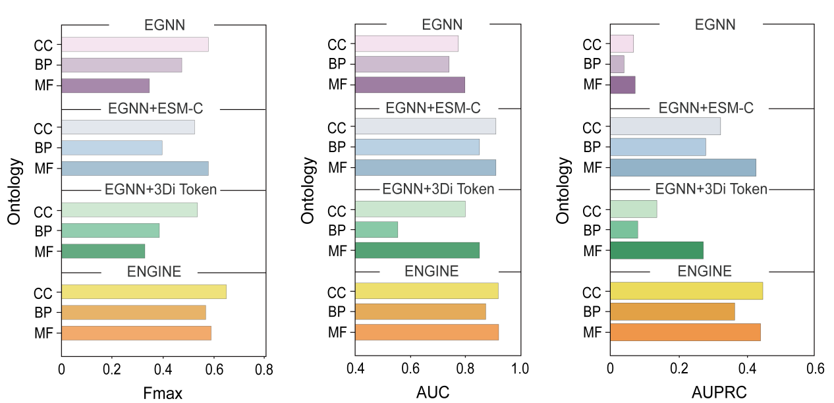Figure S1. Performance comparison of ENGINE variants with ablated input channels. The bar chart illustrates changes in protein function annotation performance upon removal of the structural channel, sequence channel (ESM-C), or 3Di sequence channel across MF, BP, and CC categories.

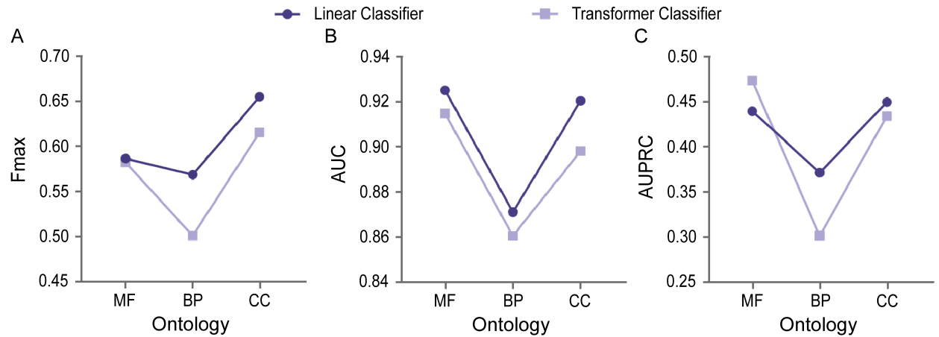
Figure S2. Performance comparison of different classifiers. Dark purple circles represent linear classifiers, while light purple squares represent Transformer-based classifiers. (A) Comparison of classifier performance in terms of $F_{max}$ scores across MF, BP, and CC categories. (B) Comparison of classifier performance in terms of AUC scores across MF, BP, and CC categories. (C) Comparison of classifier performance in terms of AUPRC scores across MF, BP, and CC categories.

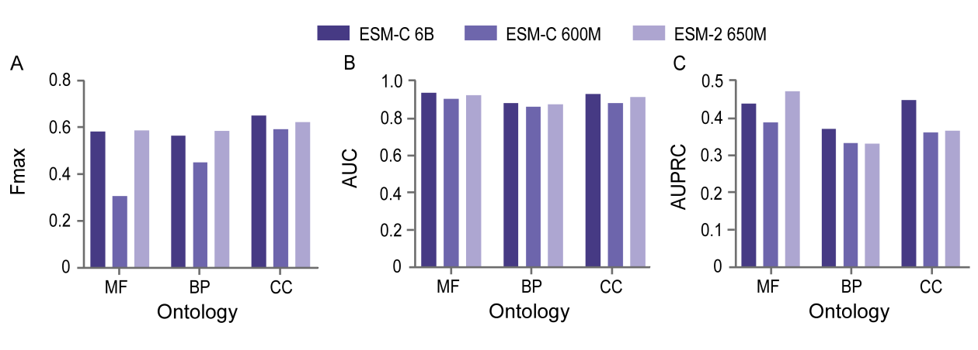
Figure S3. Performance comparison of different ESM models. The purple bars, from light to dark, represent ESM-2 650M, ESM-C 600M, and ESM-C 6B, respectively. (A) Comparison of performance based on $F_{max}$ scores using features extracted by ESM-2 650M, ESM-C 600M, and ESM-C 6B across the MF, BP, and CC categories. (B) Comparison of performance based on AUC scores using features extracted by ESM-2 650M, ESM-C 600M, and ESM-C 6B across MF, BP, and CC categories. (C) Comparison of performance based on AUPRC scores using features extracted by ESM-2 650M, ESM-C 600M, and ESM-C 6B across MF, BP, and CC categories.

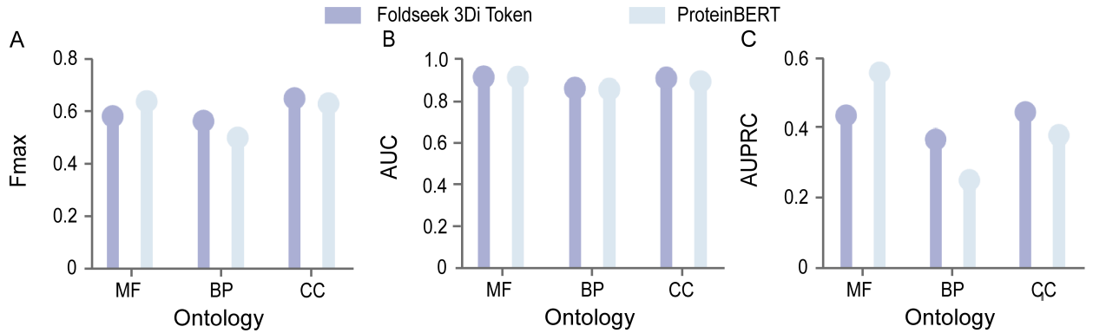
Figure S4. Performance comparison of different sequence features. The purple bars represent features extracted using 3Di tokens from Foldseek, while the blue bars represent features extracted using the pre-trained ProteinBERT model. (A) Comparison of performance based on $F_{max}$ scores using 3Di token features and ProteinBERT-derived features across the MF, BP, and CC categories. (B) Comparison of performance based on AUC scores using 3Di token features and ProteinBERT-derived features across MF, BP, and CC categories. (C) Comparison of performance based on AUPRC scores using 3Di token features and ProteinBERT-derived features across MF, BP, and CC categories.

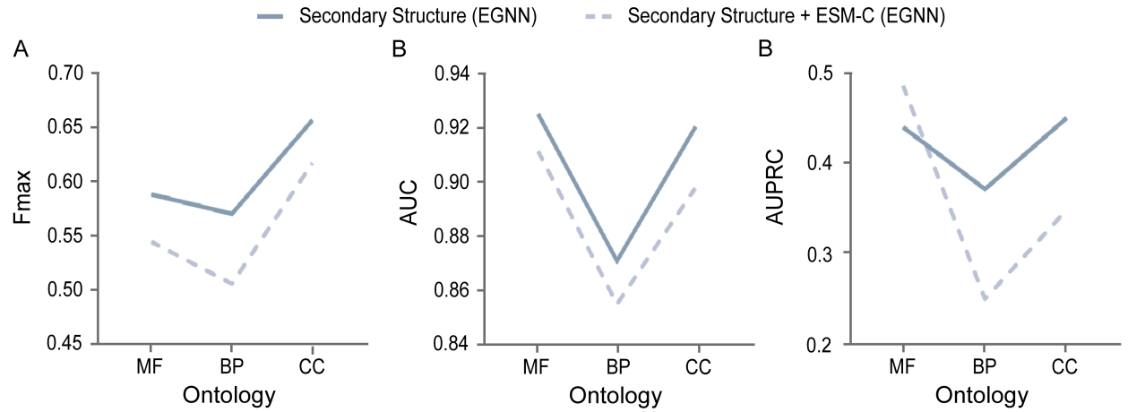
Figure S5. Comparison of two channel design strategies for incorporating ESM-C features. The dark blue solid line represents the ENGINE model, where ESM-C features are used as an independent channel. The light blue dashed line represents the strategy where ESM-C features are integrated into the node features. (A) Comparison of performance in terms of $F_{max}$ scores across the three GO categories using the two ESM-C feature integration strategies. (B) Comparison of performance in terms of AUC scores across the three GO categories using the two ESM-C feature integration strategies. (C) Comparison of performance in terms of AUPRC scores across the three GO categories using the two ESM-C feature integration strategies.

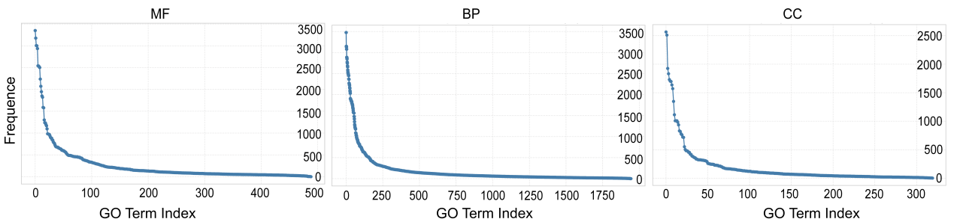

Figure S6. Distribution of GO term frequencies stratified by category in the training set. This figure shows the frequency distribution of GO terms in the MF, BP, and CC categories. It highlights the pronounced long-tailed nature of GO label occurrence in protein function annotation datasets. The x-axis represents the index of GO terms (sorted by frequency), while the y-axis indicates the number of proteins annotated with each GO term.

