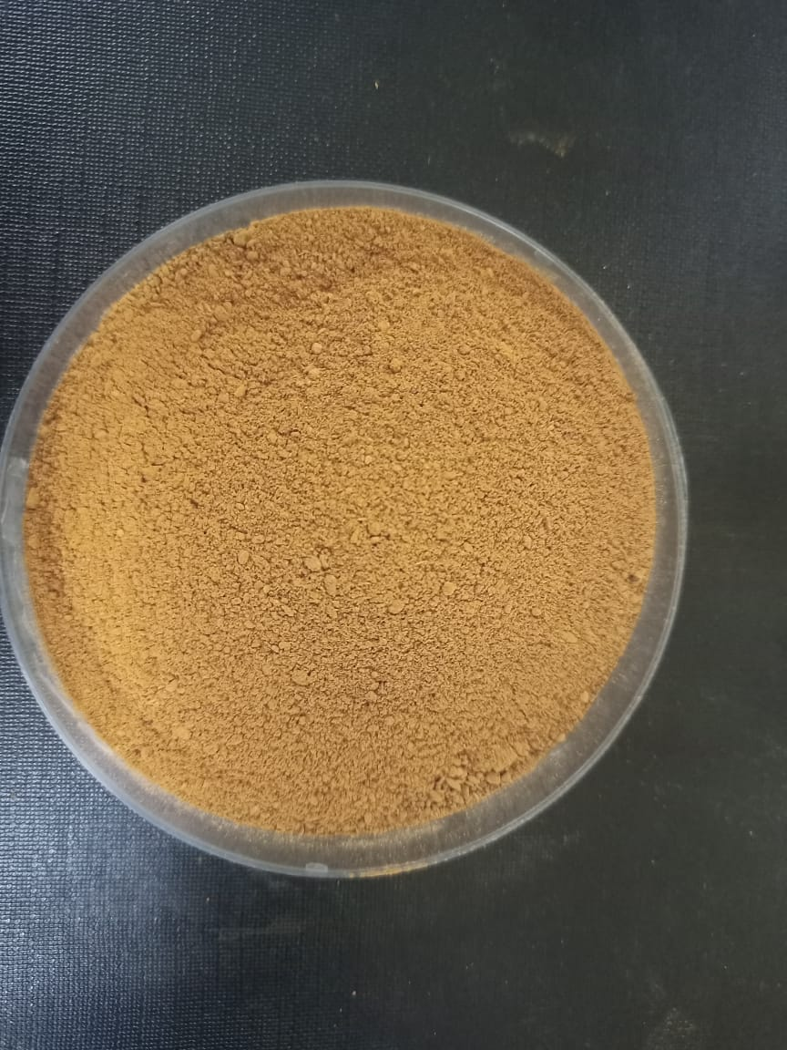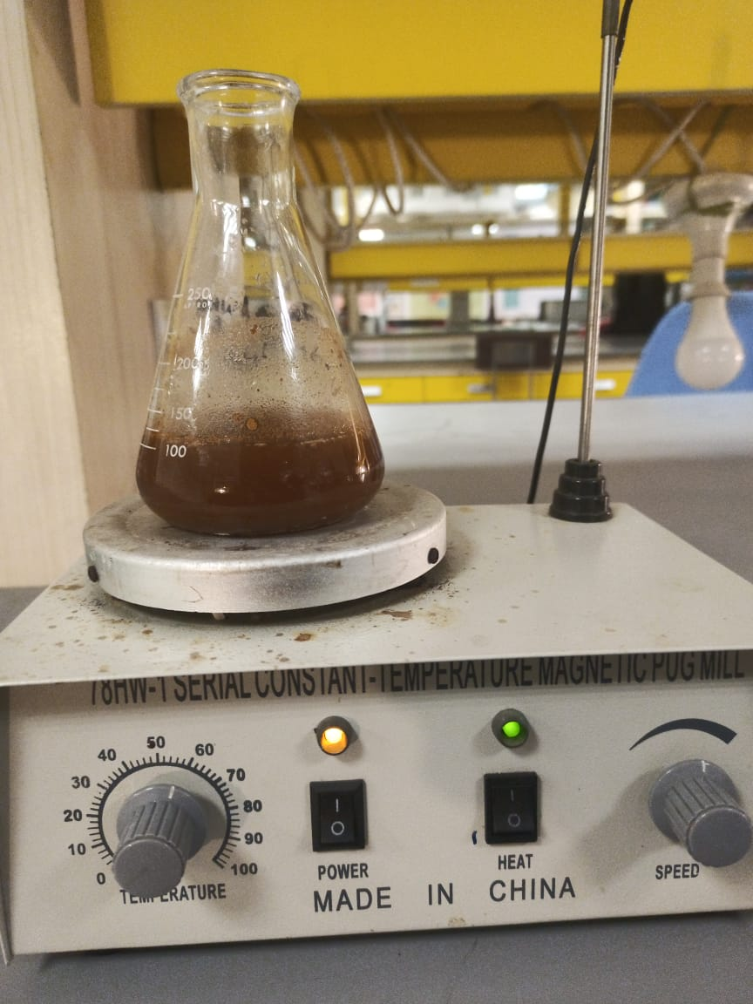
Figure 1 :Dried Powder of Cinnamon Verum barks (left) and preparation of plant extract (right). The dried bark powder is used as a starting material for the extraction process. The process involves soaking and heating to obtain the bioactive-rich plant extract necessary for the green synthesis of nanoparticles.

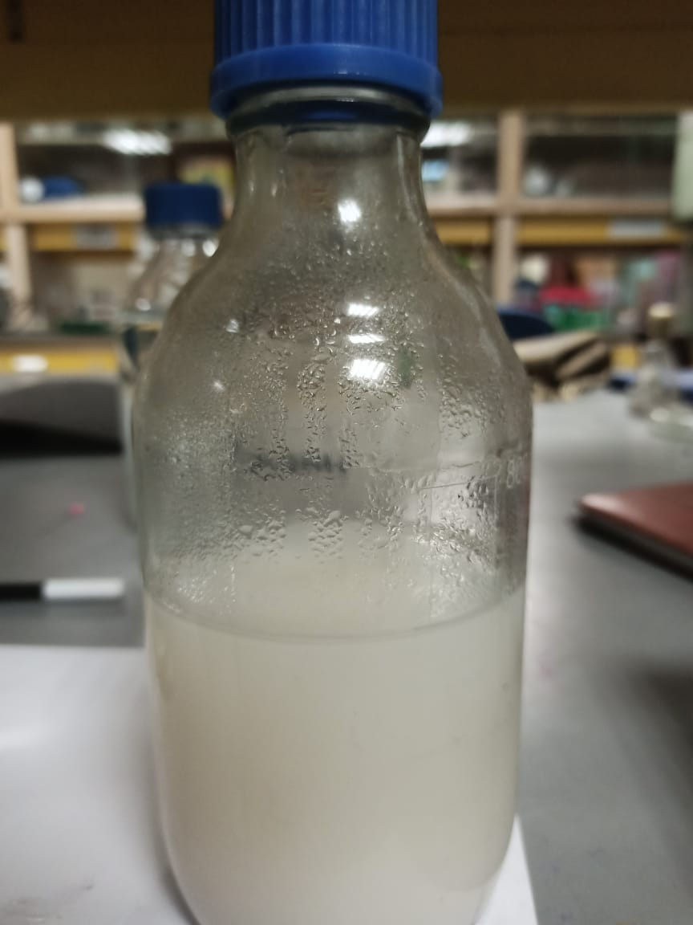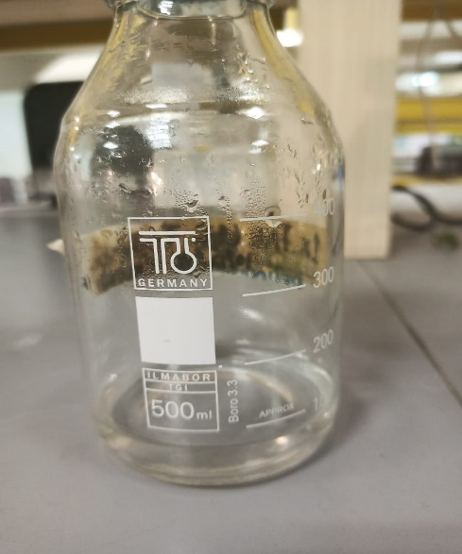
Figure 2: Stock solutions of titanium chloride (left) and zinc nitrate (right). These solutions serve as the precursors for the synthesis of TiO2 and ZnO nanoparticles, respectively, using the green synthesis method.

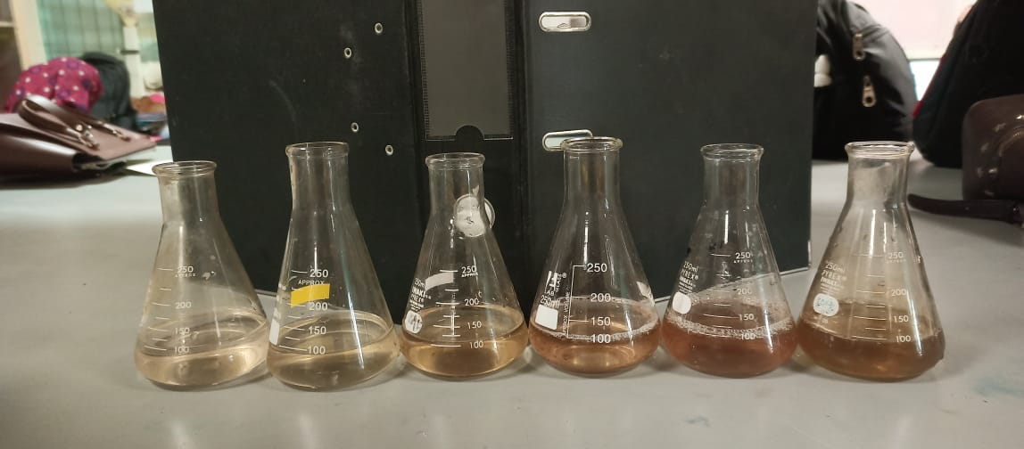
Figure 3: Six reactions performed for the optimization of ZnO NPs. This figure illustrates the various experimental conditions tested to determine the optimal parameters for synthesizing ZnO nanoparticles using Cinnamomum verum bark extract.

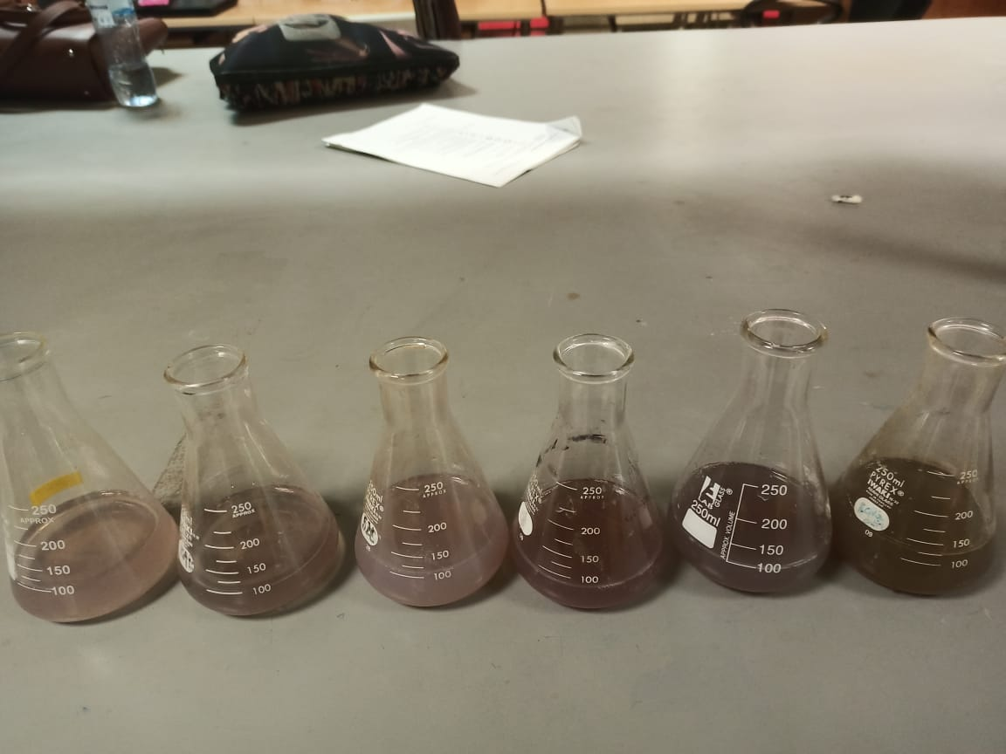
Figure 4: Six Reactions performed for the optimization of TiO₂ NPs. This figure shows the different conditions evaluated to optimize the synthesis process for TiO2 nanoparticles.

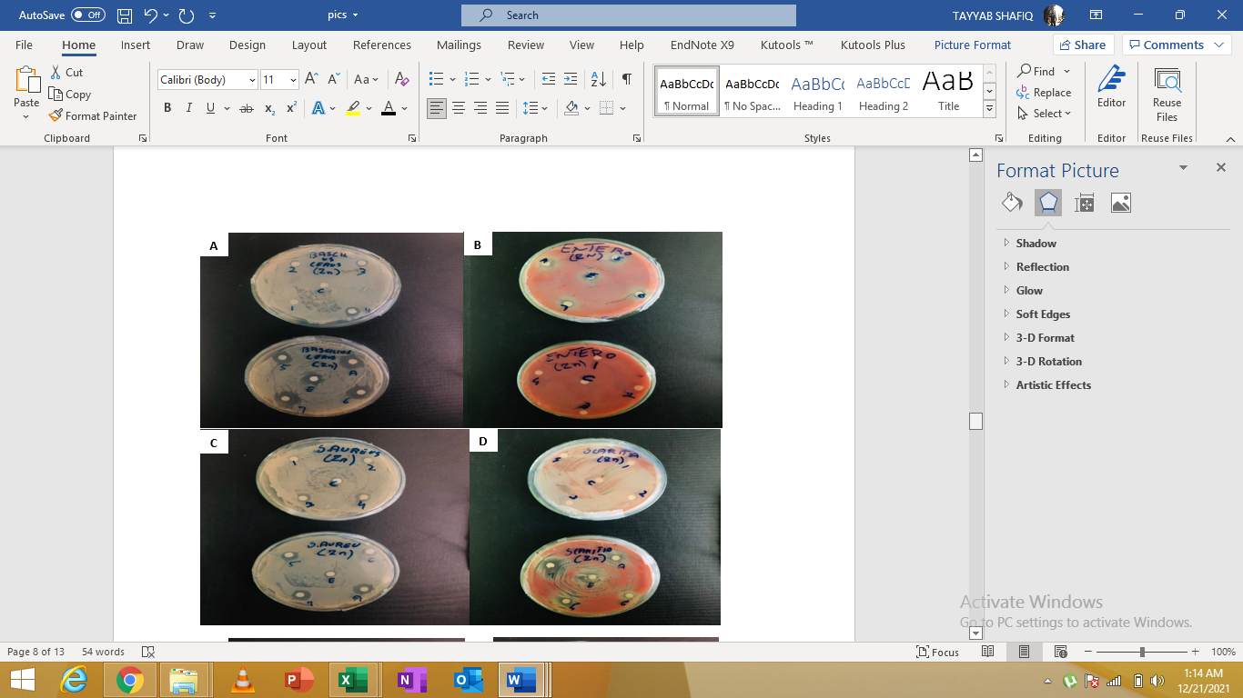
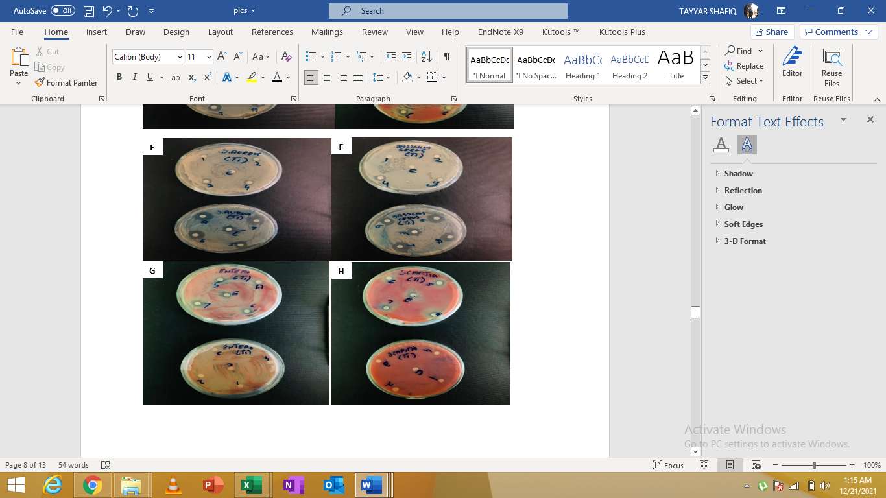
Figure 5: Antabacterial activity of ZnO nanoparticles (a, b, c, d) and TiO₂ nanoparticles (e, f, g, h) against different bacterial strains: Bacillus cereus (a, e), Staphylococcus aureus (b, f), Escherichia coli (c, g), and Enterobacter aerogenes (d, h). The figure demonstrates the antimicrobial efficacy of the synthesized nanoparticles, with zones of inhibition indicating their antagonistic effects against these pathogenic bacteria.

