Supplementary

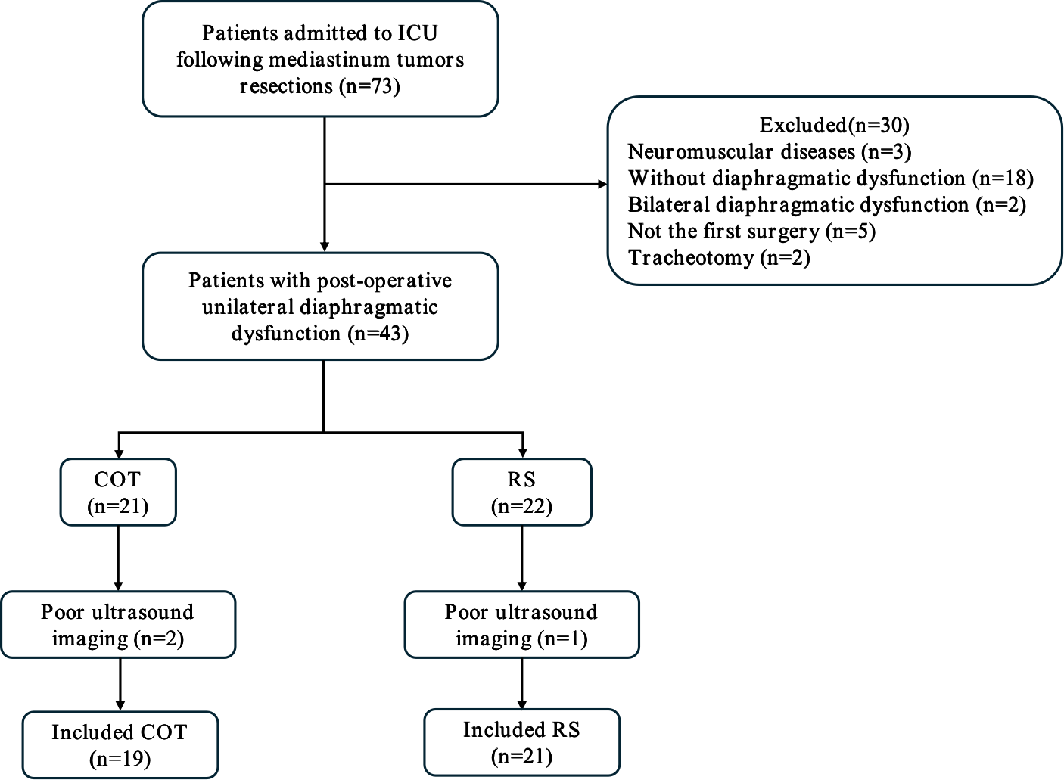

Figure1. Flowchart of the study. Throughout the study, a total of 73 patients with postoperative diaphragmatic dysfunction were initially evaluated. After applying the exclusion criteria (including 2 patients in myasthenic crisis, 1 with a history of Guillain-Barré syndrome, 18 without postoperative diaphragmatic dysfunction, 2 with bilateral diaphragmatic dysfunction, 5 non-first-time mediastinal tumor surgery patients, 2 who underwent tracheostomy due to intraoperative recurrent laryngeal nerve injury, and 3 with poor postoperative ultrasound imaging), 40 patients (23 males, average age 48.6 years) were ultimately included in the final analysis(Supplementary Figure 1). Within this cohort, 21 received respiratory support(RS) and 19 received conventional oxygen therapy (COT).

