Extended Data
Table EI. Summary of Al_{(1-x)}Sc_{x}N film thickness, refractive index and composition.
ScN:  AlN | Temp.  (°C) | Thick.  (nm) | Index  (633nm) | Al (at.%) | Sc (at.%) | N (at.%) | N:  Al+Sc | x | Cl (at.%) | C (at.%) | O (at.%)
0:1 | 215 | 39.2 ± 1.7% | 1.88 ± 1.2% | 52.4 ± 0.3 | 0.0 | 45.6 ± 0.4 | 0.87 ± 0.01 | 0.0 | 0.0 | 1.9 ± 0.5 | 0.2 ± 0.1
1:1 | 215 | 35.4 ± 1.2% | 2.04 ± 0.8% | 46.0 ± 0.3 | 7.5 ± 0.1 | 44.6 ± 0.3 | 0.84 ± 0.01 | 0.14 ± 0.01 | 0.9 ± 0.1 | 0.6 ± 0.2 | 0.4 ± 0.3
1.5:1 | 215 | 41.1 ± 1.7% | 2.12 ± 0.6% | 41.1 ± 0.4 | 11.2 ± 0.1 | 45.8 ± 0.2 | 0.88 ± 0.02 | 0.21 ± 0.01 | 1.2 ± 0.1 | 0.6 ± 0.3 | 0.2 ± 0.2
2:1 | 215 | 36.5 ± 3.0% | 2.12 ± 0.7% | 37.1 ± 0.7 | 15.4 ± 0.3 | 44.2 ± 0.5 | 0.84 ± 0.02 | 0.29 ± 0.01 | 1.9 ± 0.1 | 1.2 ± 0.7 | 0.3 ± 0.4
3:1 | 215 | 34.7 ± 2.5% | 2.19 ± 0.9% | 27.7 ± 0.3 | 23.0 ± 0.1 | 46.1 ± 0.4 | 0.91 ± 0.01 | 0.45 ± 0.01 | 2.3 ± 0.1 | 0.7 ± 0.2 | 0.2 ± 0.2
0:1 | 300 | 40.5 ± 2.7% | 1.99 ± 0.4% | 52.2 ± 0.1 | 0.0 | 47.1 ± 0.2 | 0.90 ± 0.01 | 0.0 | 0.0 | 0.7 ± 0.1 | 0.1 ± 0.1
1.5:1 | 300 | 36.4 ± 2.3% | 2.11 ± 0.6% | 47.6 ± 0.3 | 6.6 ± 0.3 | 45.3 ± 0.3 | 0.84 ± 0.01 | 0.12 ± 0.01 | 0.2 ± 0.1 | 0.0 | 0.4 ± 0.2
3:1 | 300 | 30.9 ± 6.4% | 2.16 ± 1.4% | 35.9 ± 0.6 | 15.3 ± 0.3 | 47.4 ± 0.3 | 0.93 ± 0.02 | 0.30 ± 0.01 | 0.6 ± 0.1 | 0.5 ± 0.3 | 0.3 ± 0.2

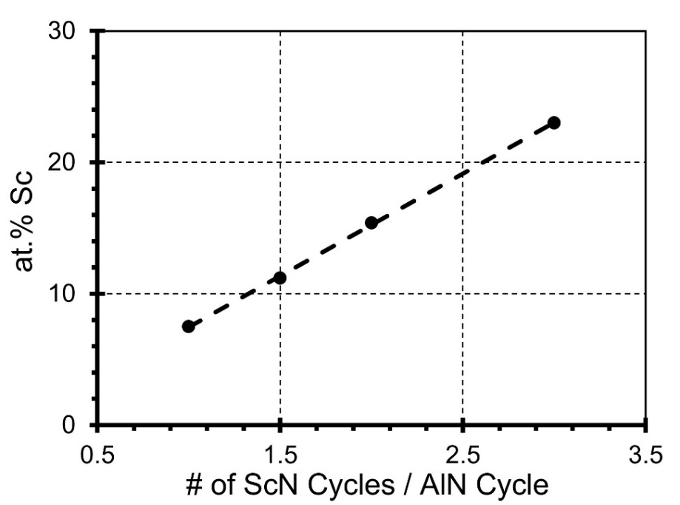
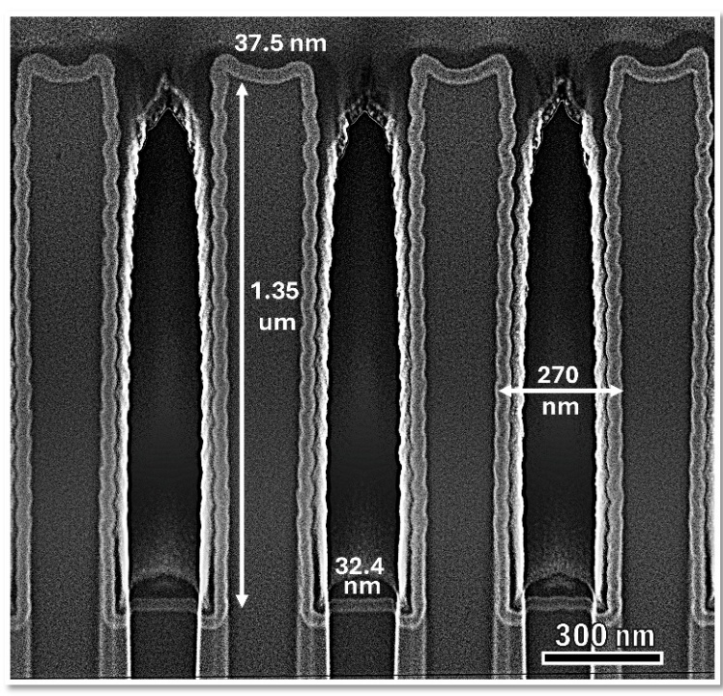
Fig. E1. Sc concentration versus # of ScN cycles per AlN cycle for Al_{(1-x)}Sc_{x}N PEALD on Si (100) at a 215°C substrate temperature.

Fig. E2. Al_{(1-x)}Sc_{x}N-coated trenches with a 5:1 aspect ratio imaged by FESEM showing a bottom-to-top thickness ratio of 86%.

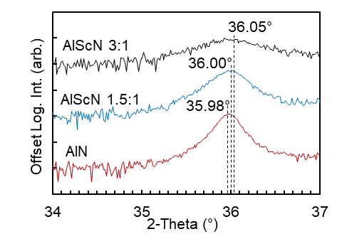
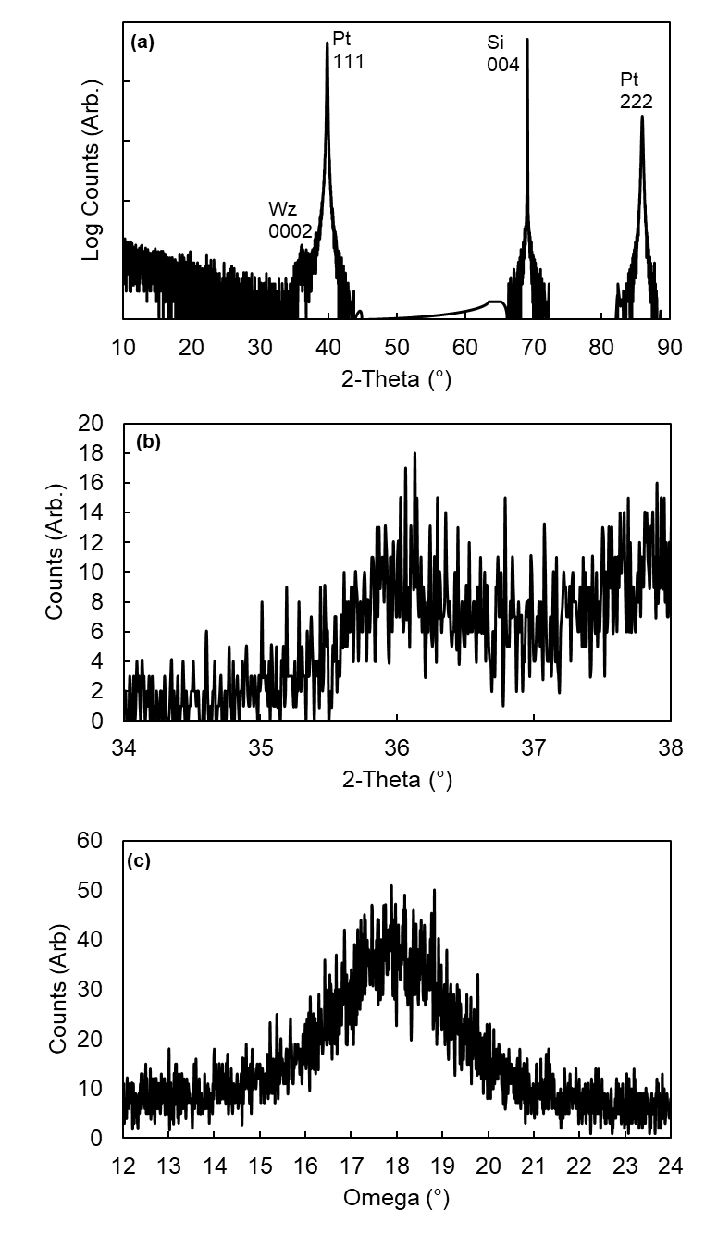
Fig. E3. Close-up of the Al_{(1-x)}Sc_{x}N Goniometer 2θ XRD scan of (0002) peaks shown in Fig. 4(a) with the fit peak center values (2-theta) labeled for convenience.

Fig. E4. XRD patterns of Al_{0.79}Sc_{0.21}N thin films grown with a ScN:AlN cycle ratio of 1.5:1 on {111}-oriented Pt substrates at a substrate temperature of 215° C. (a) Goniometer 2θ scan showing a very small (0002) Al_{0.79}Sc_{0.21}N peak, (b) a closeup of the same, and (c) omega rocking curve scan along the (0002) Al_{0.79}Sc_{0.21}N peak.
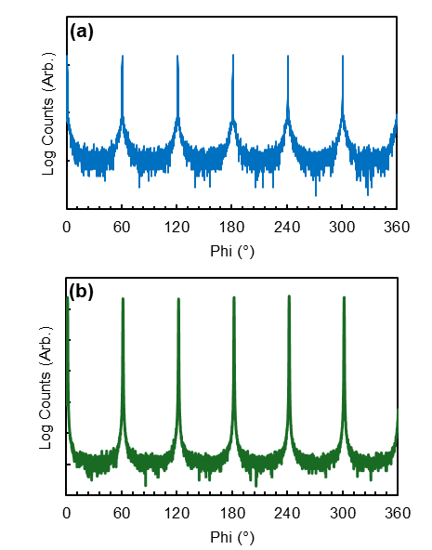
Fig. E5. Full-sized Phi scans aligned to the (103) plane of PEALD Al_{0.88}Sc_{0.12}N (40.2 nm-thick with a 5nm-thick AlN nucleation layer) (a) and epitaxial GaN (b) films on a c-plane sapphire substrate.

