Supplementary Information S2

Code saturation analysis
Figure S1 shows a sequential saturation curve using a 0% new information threshold, indicating that saturation was reached when no new codes emerged from additional interviews. This occurred at interview #12, where the black curve plateaus at 100, meaning all unique codes had been identified. Additionally, the figure shows that 80% and 90% of all unique codes were identified in 4 and 7 interviews, respectively. This suggests that a substantial portion of code content was captured early in data collection.
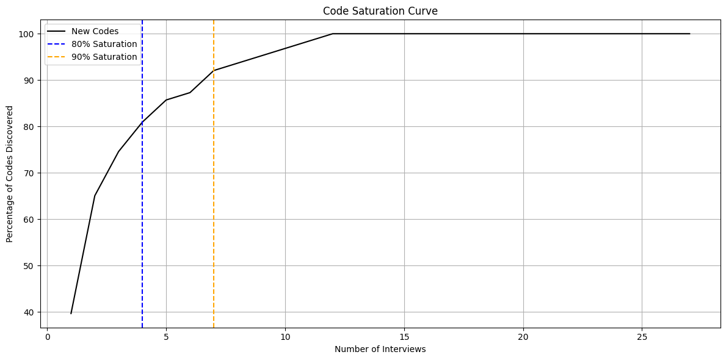
Figure S1. Sequential saturation curve showing the cumulative code emergence

Figure S2 compares the cumulative emergence of new codes in the actual interview order with a randomly ordered sequence. In the actual order, saturation was reached at interview #12 (consistent with the pattern observed in Figure S1), while the random order reached saturation at interview #19. Although saturation was reached later in the randomized order, the overall trajectory of code accumulation remained consistent. This suggests that the observed saturation point is relatively robust, though modestly influenced by interview order.
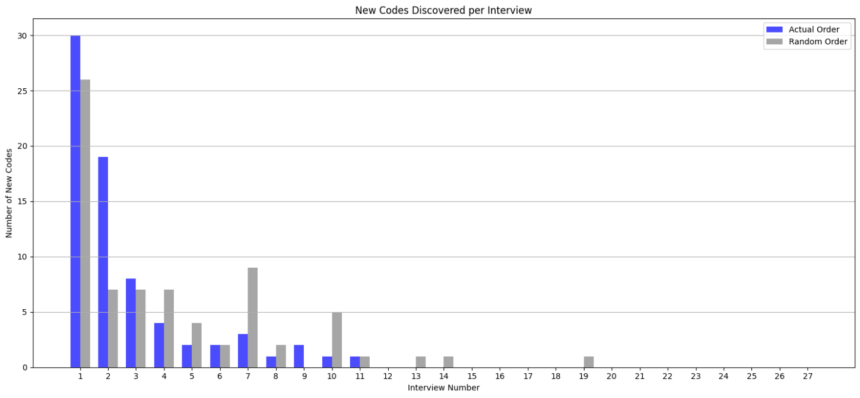
Figure S2. Comparison of code emergence in the actual interview sequence vs. randomized interview order

