Figure 1. Mitophagy- related genes expression. (A) Heatmap presenting the expression patterns of 29 MRGs, with rows representing individual MRGs and columns representing samples. The dataset includes 682 tumor samples and 101 normal samples, with colors ranging from blue to red, indicating low to high expression levels, respectively. (B) Correlation analysis of the 14 differentially expressed MRGs, with red indicating positive correlations and blue indicating negative correlations. The depth of color represents the magnitude of the correlation coefficients.

Figure 2. The quality control metrics and clustering analyses. (A) Violin plots illustrating the quality control metrics for GSM7910990 and GSM7910991, including the number of detected features (nFeature_RNA), number of RNA molecules (nCount_RNA), and the percentage of mitochondrial gene expression (pMT). (B) Principal Component Analysis (PCA) plot showing the distribution of cells from samples GSM7910990 (red) and GSM7910991 (blue) across the first two principal components (PC1 and PC2). (C) Scatter plot depicting the correlation between the number of features (nFeature_RNA) and the number of RNA molecules (nCount_RNA) for GSM7910990 (red) and GSM7910991 (blue). The correlation coefficient is 0.92. (D) Dot plot showing the marker genes across the identified clusters, highlighting key genes such as VIM, SPARC, IGFBP7, AIF1, and others. (E) Uniform Manifold Approximation and Projection (UMAP) plot showing the clustering of cells from both samples. Each cluster is color-coded and labeled, indicating distinct cell populations.

Figure 3. GSVA analysis and KEGG pathway. (A) Heatmap displaying the enrichment of different pathways identified through gene set variation analysis (GSVA) in different cell types. The color gradient, ranging from blue to red, indicates low to high expression levels, respectively. (B) Bar plot showcasing the pathways enriched with differentially expressed genes between the high and low-scoring groups of mitophagy-related genes. The blue color indicates a normalized enrichment score (NES) > 0, representing pathways associated with high expression, while the black color denotes pathways associated with low expression.

Figure 4. Protein expression. Immunohistochemistry (IHC) staining data for proteins corresponding to seven out of the nine feature genes were obtained from the Human Protein Atlas (HPA) dataset. However, protein expression data for MTERF3 and CSNK2A2 were not available in the HPA.

Figure 5. Enrichment analysis results of three mitophagy-related breast cancer subtypes. (A) Bar graph displaying the enrichment results of hub genes associated with the MEblue module, which exhibits the highest correlation with Cluster 1. The bars are colored according to their corresponding p-values. (B) Bar graph presenting the enrichment results of hub genes associated with the MEturquoise module, which demonstrates the highest correlation with Cluster 2. The bars are colored based on their respective p-values. (C) Bar graph illustrating the enrichment results of hub genes associated with the MEblack module, which shows the highest correlation with Cluster 3. The bars are colored according to their associated p-values.

Figure 6. Immune infiltration profiles and expression of checkpoint genes between clusters. (A) Box plot illustrating the immune infiltration profiles of three BC subtypes assessed using the CIBERSORT algorithm. (B) Box plot displaying the differential expression of immune checkpoint genes in three BC subtypes. (*P < 0.05, **P < 0.01, ***P < 0.001, ****P < 0.0001, P-values were estimated by the Kruskal-Wallis test)

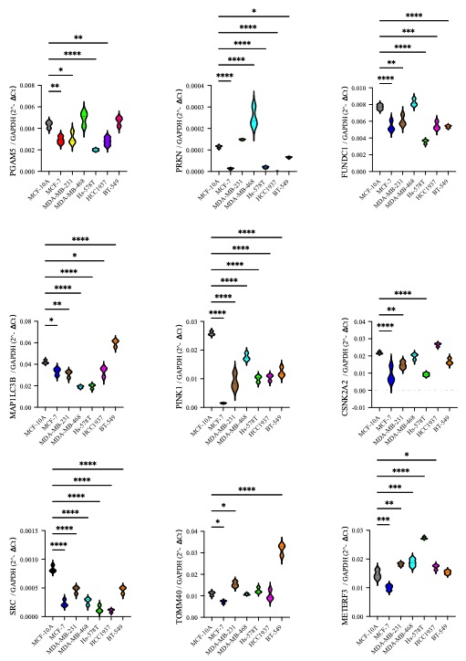
Figure 7. Relative mRNA expression levels of mitophagy-related genes in breast cell lines.
Quantitative real-time PCR (qPCR) analysis was performed to measure the expression levels of PGAM5, PRKN, TOMM40, FUNDC1, MAP1LC3B, PINK1, MTERF3, CSNK2A2, and SRC in breast cell lines, including the non-tumorigenic MCF-10A and tumorigenic lines (MCF-7, MDA-MB-231, MDA-MB-468, Hs-578T, HCC1937, and BT-549). Gene expression was normalized to GAPDH and presented as relative quantification (2^−ΔCt). Data are shown as mean values with error bars representing standard deviation.

Table s1. Primer sequences of genes.

PGAM5-F(homo) | CGGAAGAGGAACGTGGAATC
PGAM5-R(homo) | TGGTACTGGGAATGCCTGAT
PRKN-F(homo） | GTAGCTTTGCACCTGATCGC
PRKN-R(homo） | TAGCCAAGTTGAGGGTCGTG
TOMM40-F(homo) | CTCTTCAAAGGCTCTGTGGATAG
TOMM40-R(homo) | ACTTGTTCTTGCGGTGATTCA
FundC1-F(homo） | CCAGTGGTGGAATCGAGTGT
FundC1-R(homo） | AGAAATCCTGCACACCAGCC
MAP1LC3B-F(homo） | ACCCTGAGTCTTCTCTTCAGG
MAP1LC3B-R(homo） | AGTTTACAGTCAGGGCCGTT
PINK1-F(homo） | CCATCTGGTTCAACAGGGCA
PINK1-R(homo） | AAATCTGCGATCACCAGCCA
MTERF3-F(homo） | AGGCTGCTAACTGGAAGTCT
MTERF3-R(homo） | ACATCTTTGGGATTCTGGTGAT
CSNK2A2-F(homo） | TGTTCGTGTAGCCTCAAGGTA
CSNK2A2-R(homo） | GCTGGTCATAGTTGTCCTGTC
Src-F(homo） | AGCTGGTGCAGTTGTATGCT
Src-R(homo） | ACGTAGTTCATCCGCTCCAC
GAPDH-F(homo） | GGTGTGAACCATGAGAAGTATGA
GAPDH-R(homo） | GAGTCCTTCCACGATACCAAAG

