FOXM1 targeting alters AURKB activity and reshapes antitumor immunity to curb the progression of small cell lung cancer
Md Arafat Khan¹, Parvez Khan^{1*}, Mahek Fatima¹, Asad Ur Rehman¹, Laiba Anwar¹, Zahraa Wajih Alsafwani¹, Aatiya Ahmad¹, Mohammad Ali Abbas Zaidi¹, Jesse L. Cox², Areem Zahid¹, Sameer Mohiuddin¹, Sung Hoon Kim³, Juan A Santamaria-Barria⁴, Imayavaramban Lakshmanan¹, Benita S Katzenellenbogen⁵, John A. Katzenellenbogen³, Apar K Ganti^{6,7,} Surinder K Batra^{1,7,8}, Mohd Wasim Nasser^{1,7}*
¹Department of Biochemistry and Molecular Biology, University of Nebraska Medical Center, Omaha, Nebraska, USA.
²Department of Pathology, Microbiology and Immunology, University of Nebraska Medical Center, Omaha, Nebraska, USA.
³Department of Chemistry and Cancer Center, University of Illinois at Urbana-Champaign, Urbana, IL 61801, USA
⁴Department of Surgery, University of Nebraska Medical Center, Omaha, Nebraska, USA.
⁵Department of Molecular and Integrative Physiology and Cancer Center, University of Illinois at Urbana-Champaign, Urbana, IL 61801, USA
⁶Division of Oncology-Hematology, Department of Internal Medicine, VA-Nebraska Western Iowa Health Care System, and Division of Oncology-Hematology, Department of Internal Medicine, University of Nebraska Medical Center, Omaha, NE-68198, USA,
⁷Fred and Pamela Buffett Cancer Center, University of Nebraska Medical Center, Omaha, NE-68198, USA.
⁸Eppley Institute for Research in Cancer and Allied Diseases, University of Nebraska Medical Center, Omaha, NE-68198, USA.

*To whom all correspondence should be addressed:
Parvez Khan, Ph.D. or
Mohd Wasim Nasser, Ph.D.
Department of Biochemistry and Molecular Biology
University of Nebraska Medical Center,
Omaha, NE-68198, USA.
E-mails: parvez.khan@unmc.edu or wasim.nasser@unmc.edu
Phone: +1- 402-5592027

Material and Methods (Continued)
Cell Viability Assays
All the SCLC cell lines were cultured to an optimum concentration so that control cells could sustain their growth after treatment initiation. 1500-3000 cells were seeded in a 96-well plate and grown in the incubator at 37 °C with 5% CO₂. The next day, cells were treated with different drug concentrations. Control cells have a tendency to grow rapidly and tend to die due to contact inhibition. To mitigate contact inhibition, 5% serum-containing media was used to prepare drug treatments. In order to determine cell viability, 10μl MTT dye was added to each well of 96-well plates with a concentration of 5mg/ml. After three to four hours of incubation, the media was removed, and formazan formed from cellular metabolism was dissolved in 100 μls of DMSO. Subsequently, absorption values of different wells were measured using a UV-visible spectroscopy at 570 nm.
Colony Formation Assay
SCLC cells (adherent) were cultured in RPMI media supplemented with L-glutamine, sodium bicarbonate, sodium pyruvate, and 10% FBS. Once the cells reached a 70% confluency, they were trypsinized and seeded in 6-well plates at a density of 750-1000 cells per well. The cancer cells were allowed to adhere for 24 hours, and different concentrations of treatments were added including FOXM1 inhibitor FDI-6, NB-73, and doxycycline (for conditional knockdown/KD cells). The plated cells were allowed to form colonies. Once the colonies formed (approximately 6-9 days), they were fixed with methanol followed by staining with 0.5% crystal violet solution (dissolved in 80% water and 20% methanol). The plates were then carefully rinsed with water without dislodging the colonies and later air-dried. Once the plates were dry, they were cleaned and subsequently scanned. The subsequent images were then analyzed using ImageJ to count the colonies, and the colony counts were then plotted using GraphPad Prism with Student’s t-test data (analyzed with GraphPad Prism).
Trans-well Migration Assay
Adherent SCLC cells were cultured in RPMI Media (composition previously mentioned) and treated with FOXM1 inhibitors when they reached 50% confluency. After 48 hours of treatment, the cells were starved overnight in incomplete RPMI media (with the different drug treatments), which lacked FBS. The cells were then trypsinized, and 300 thousand cells were seeded in a six-well trans-well plate in incomplete media. The bottom of the trans-well plates had 20% FBS-containing media and the cancer cells were attracted to the high FBS media. The cells were allowed to migrate overnight. Afterwards, of the trans-well membranes were cleaned gently and fixed using methanol. The fixed cells were further stained with 0.5% crystal violet solution (previously mentioned), and the wells were rinsed with water to remove excess dye. The wells were imaged using a Leica ICC50 W microscope, and those images were later analyzed using ImageJ. The cell numbers were counted and plotted in GraphPad Prism with significance.
Three-Dimensional Spheroid Assay
SBC5 CisR, SBC5 conditional knockdown (KD) cells were seeded in a low attachment plate (24-well) at a density of 5000 cells per well in supplemented RPMI media, which is regularly used to culture these cells. After 72 hours of growth, the cells formed spheroids. Spheroid growth was monitored using a microscope. Once the spheroids were ready, the different treatments were initiated. In case of the conditional KD cells, doxycycline was added to induce the expression of FOXM1 shRNA, which eventually degrades FOXM1 mRNA. The spheroids were treated for a total of another 72 hours, and after the treatment, the spheroids were imaged. The total number of spheroids was counted for all the treatment groups, and data was analyzed using ImageJ. Eventually, the spheroid data was used to plot graphs in GraphPad Prism with subsequent t-tests.
Lentivirus production and transfection
The lentiviral particles used in this experiment were generated in HEK293T cells after co-transfection with Lipofectamine-2000. The third-generation packaging plasmids used in this experiment were bought from Addgene and they include- pMDLg/pRRE plasmid for HIV-1 GAG-POL (Addgene#12251), pRSV-Rev plasmid for Rev (Addgene#12253) and pMD2.G plasmid for the production of viral envelope protein (Addgene#12253). These three packaging plasmids were co-transfected with the luciferase plasmid (LP466-100, GeneCopoeia, MD, USA) for the generation of lentiviruses. To obtain the lentiviral particles, culture supernatant was collected at two timepoints after transfection- 48 hours and 72 hours. After collecting the supernatant, it was centrifuged at 1250 rpm for 3 minutes to remove the cell debris, and was later sterile filtered using 0.45-micron filters. Then the lentiviral particles were aliquoted in 1.5 ml Eppendorf tubes and stored at -80 °C for further use.
Generation of FOXM1 conditional knockdown cells
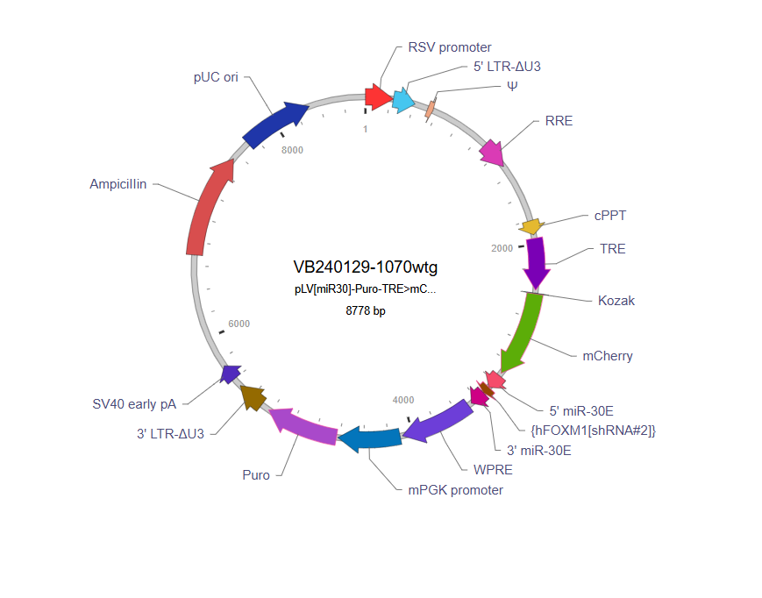
To generate conditional knockdown cells of SCLC, we have designed a knockdown (KD) vector that has FOXM1 shRNA under the regulation of TRE promoter and puromycin selection marker (the vectors were later produced by VectorBuilder) (Catalog #: Ecoli (VB240129-1070wtg). The bacterial stock was cultured with antibiotics, and the plasmid vector was isolated. To induce the expression of FOXM1 shRNA, rtTA and doxycycline were essential. Firstly, we prepared lentiviruses with FOXM1 conditional KD vector and third-generation packaging plasmids using HEK293T cells. Once the lentiviruses were formed, we transduced SBC3 and SBC5 cells with these lentiviruses (for FOXM1 KD). Then the cells were transduced with lentiviruses containing gene rtTA gene and selected with hygromycin. Once the KD cells were selected then doxycycline sensitivity was measured from a kill curve and doxycycline (5µg/ml) was found to induce expression of FOXM1 shRNA. The cells were treated with doxycycline (5µg/ml) for 72 h and then the cells were collected, and lysates were prepared. The FOXM1 vector map is shared below-

Figure: FOXM1 conditional KD vector containing FOXM1 shRNA (image- Vector Map obtained from VectorBuilder).
FOXM1 shRNA sequence: AAGGACCACTTTCCCTACTTTATAGTGAAGCCACAGATGTATAAAGTAGGGAAAGTGGTCCTC
Immunoblot analysis
Around 2 X 10⁶ cells were collected and washed with ice-cold PBS and processed for protein extraction using cell lysis buffer (50 mM Tris-HCl pH 7.5, 250 mM NaCl, 1% NP-40, 0.5% sodium deoxycholate, 0.1% sodium dodecyl sulfate) containing protease and phosphatase inhibitors (Roche, Cat #: 11836153001; Sigma, PhosSTOP Cat#: 4906837001). The isolated proteins were quantified using Bio-Rad D/C protein estimation kit. The selected protein samples were boiled in Laemmli’s sample buffer, and 40-60μg of protein was resolved by electrophoresis using 10% SDS-PAGE. The resolved proteins were transferred to PVDF, blocked in 5% non-fat milk in PBS with 0.1% Tween-20 (PBS-T) for 1 h, and incubated with the respective primary antibodies (Supplementary Table 1) overnight at 4°C. The next day, the membranes were washed thrice in PBS-T and further probed with appropriate HRP-conjugated secondary antibodies (Invitrogen, diluted at 1:3000-1:4000 in PBS-T with 3% non-fat milk) for 1 h at room temperature. The membranes were washed in PBS-T, and the blots were processed for the detection of chemiluminescence using luminol reagent (Thermo Fisher Scientific, Cat #: 1859698) on iBright imaging system (Thermo Fisher Scientific, Waltham, MA, USA).

Supplementary Table 1: Details of antibodies and reagents used in the study.
KEY RESOURCES
REAGENT | SOURCE | IDENTIFIER | RRID
Antibodies
FOXM1, WB- 1:1000, IHC-1:400, Chromatin IP-1:100 | Cell Signaling Technology | Cat#20459 | AB_2798842
ERK1/2, WB-1:1000 | Cell Signaling Technology | Cat#9102 | AB_330744
p-ERK (Thr-202/Tyr-204), WB:1:1000 | Cell Signaling Technology | Cat#4370 | AB_2315112
Cleaved Caspase 3  WB: 1:1000, IHC: 1:400 | Cell Signaling Technology | Cat#9661 | AB_2341188
Ki67, IHC-1:100 | Abcam | Cat#ab92742 | AB_10562976
CD31, IHC-1:200 | Cell Signaling Technology | Cat#77699 | AB_2722705
β-actin, WB-1:10,000 | Sigma | Cat#A1978 | AB_476692
CD8 IF-1:200 | Thermo Fisher Scientific | Cat# MA1-145 | AB_2536855
PDL1 IF- 1:200 | Thermo Fisher Scientific | Cat#14598285 | AB_467782
F4/80 (D2S9R) XP® 1:200 | Cell Signaling Technology | Cat#70076 | AB_2799771
Secondary Antibody IF- Anti Rat AF488 | Jackson ImmunoResearch Laboratories | Cat# 112-545-003 | AB_2338351
Brilliant Violet 785™ anti-human CD8 Antibody | Biolegend | Cat#344740 | AB_2566202
Pacific Blue™ anti-human CD69 Antibody | Biolegend | Cat#310920 | AB_493667
APC anti-human CD25 | Biolegend | Cat#985810 | AB_2904482
CD8α (D4W2Z) IHC 1:400 | Cell Signaling Technology | Cat##98941 | AB_2756376
Cell Lines
SBC-3 | Cell Bank- JCRB | JCRB0818 | CVCL_1678
SBC-5 | Cell Bank- JCRB | JCRB0819 | CVCL_1679
NCI-H-69 [H-69] | Cell Bank- ATCC | HTB-119 ™ | CVCL_8121
NCI-H82 [H82] | Cell Bank- ATCC | HTB-175 ™ | CVCL_1591
NCI-H526 [H526] | Cell Bank- ATCC | CRL-5811 ™ | CVCL_1569
NCI-H1688 [H1688] | Cell Bank- ATCC | CCL-257 ™ | CVCL_1487
DMS-273 | Cell Bank- ECACC | Sigma -  95062830-1VL | CVCL_1176
Colo-668 | Cell Bank- ECACC | Sigma | CVCL_1128
Kits and chemicals
Total RNA isolation kit mirVana™ | Invitrogen™, Thermo Scientific, USA | Cat#AM1561 | SCR_008452
ImmPRESS Universal Polymer kit, Peroxidase | Vector Laboratories | Cat#MP-7500 | SCR_000821
DAB Peroxidase (HRP) Substrate Kit (with Nickel), 3,3’-diaminobenzidine | Vector Laboratories | Cat#SK-4100 | SCR_000821
FDI-6 | Selleckchem | Cat#S9689 | SCR_003823
Cisplatin | Sigma | Cat#1134357 | N/A
LIVE/DEAD™ Fixable Blue Dead Cell Stain Kit, for UV excitation | Invitrogen | Cat#L34962 | N/A
Abcam High sensitivity ChIP Kit | Abcam | Cat#ab185913 | N/A
Primers | Integrated DNA Technologies (IDT) | N/A | SCR_025813
FOXM1 shRNA | VectorBuilder | VB240129-1070wtg | N/A
pMDLg/pRRE  -Lentiviral Packaging Plasmid | Addgene | Cat#12251 | Addgene_12251
pRSV-Rev  -Lentiviral Packaging Plasmid | Addgene | Cat#12253 | Addgene_12253
pMD2.G  -Lentiviral Packaging Plasmid | Addgene | Cat#12259 | Addgene_12259
Machines and Core Facilities

Countess 3 Automated Cell Counter | Invitrogen | Cat#AMQAX2000 | SCR_026963
Invitrogen iBright FL1500 Imaging System | Invitrogen | Cat#A44115 | SCR_026331
IVIS | PerkinElmer (Revvity) | N/A | SCR_018621
University of Nebraska Medical Center Bioimaging Core Facility | UNMC | N/A | SCR_022481
University of Nebraska Medical Center Tissue Sciences Core Facility | UNMC | N/A | SCR_012465
University of Nebraska Medical Center Advanced Microscopy Core Facility | UNMC | N/A | SCR_022467
Flow Cytometry Research Facility | UNMC | N/A | SCR_017736
Animals Used
NSG Mice | The Jackson Laboratory | Strain##005557 | IMSR_JAX:005557
C57BL/6J | The Jackson Laboratory | Strain##000664 | SCR_018361
Software
GraphPad Prism | Dotmatics | N/A | SCR_002798
Biorender | Biorender | N/A | SCR_018361
Gene Expression Atlas | European Bioinformatics Institute | N/A | SCR_007989

ChIP Primers
Aurora B Kin. F | GCA ACG AAA GGT CTA TTG GTG G
Aurora B Kin. R | TCT AAC TTC TCT GCC CGA TGG AG

Reference
- Ireland, A. S., Micinski, A. M., Kastner, D. W., Guo, B., Wait, S. J., Spainhower, K. B., . . . Oliver, T. G. (2020). MYC Drives Temporal Evolution of Small Cell Lung Cancer Subtypes by Reprogramming Neuroendocrine Fate. Cancer Cell, 38(1), 60-78 e12. doi:10.1016/j.ccell.2020.05.001
- Zeng, J., Xiao, X. Q., & Zhou, Z. Y. (2022). A Hypoxia-Induced SCFFBXL1 E3 Ligase Ubiquitinates and Degrades the MEN1 Tumor Suppressor to Promote Colorectal Cancer Tumorigenesis. Cancer Res Treat, 54(2), 525-540. doi:10.4143/crt.2021.373

