Appendix: Patterns of Emergence and Circulation of West Nile Virus in Algeria

Contents
Supplementary methods 2
Supplementary figures 4
Supplementary tables 6

Supplementary methods
Model equations. Models were run using an earlier version of the RSero package (prior to the 2025 publication in PloS Comp Biol https://doi.org/10.1371/journal.pcbi.1012777). The following corresponds to the model equations used in this analysis.
Constant model: the probability that an individual of age a is seropositive is $P=1-exp(-aλ),$ where λ is the force of infection (FOI).
Constant model with seroreversion: $P=\frac{λ}{λ+ρ}(1-e^{-a(λ+ρ)})$, where ρ is the seroreversion rate.
Outbreak model: the outbreak model is described as the sum of K Gaussian distributions, where K is the number of epidemics. The FOI in year i is $λ_{i}=\sum_{k=1}^{K}{{\overline{α}}_{k}exp⁡(-\frac{{(i-T_{k})}^{2}}{β_{k}^{2}})}$, where ${\overline{α}}_{k}=α_{k}\frac{1}{\sum_{i}{exp⁡(-\frac{{(i-T_{k})}^{2}}{β_{k}^{2}})}}$ . Here, T_{k} is the peak year of the focal epidemic, β_{k} is the duration of multi-year epidemics or the uncertainty in epidemic timing, and α_{k} is the attack rate of the epidemic. Note that in the new version of the package, this model has been re-parameterized and no longer includes the β.
Constant outbreak model: in this model, the FOI is constant, but one or more outbreaks can still occur. The FOI during year i is $λ_{i}=λ_{C}+\sum_{k=1}^{K}{α_{k}exp⁡(-\frac{{(i-T_{k})}^{2}}{β_{k}^{2}})}$, where λ_{C} is the constant component of the FOI.
Bayesian methods. For each model (except for the constant outbreak models in Oran and Biskra), we ran four chains of 20,000 iterations with a burn-in of 5,000. We saved every 50th sample from the posterior by setting “thin” to 50 and set adapt_delta to 0.99. For the two aforementioned models, we ran four chains of 50,000 iterations with a burn-in of 25,000 and thinning set to 1.

Prior distributions. We used Rsero’s default prior distributions for all parameters except for the outbreak timing parameter (T) in the outbreak and constant outbreak models. For T, we used a uniform prior distribution with a lower bound of 0 and an upper bound of 50 due to the small number of study participants over the age of 50 across all locations. In the previous version of the package, the default prior distributions for each of the parameters were:
- λ: uniform between 0 and 10
- ρ: exponential with rate of 2
- β: uniform between 0 and 1
- α: uniform between 0 and 5
- T: uniform between 1 and 100

Supplementary figures

Figure S1. Confirmed West Nile Neuroinvasive Disease cases in Algeria, 2015 – 2019 by sex and disease form. ME/E: meningo-encephalitis or encephalitis, MLC: aseptic meningitis.

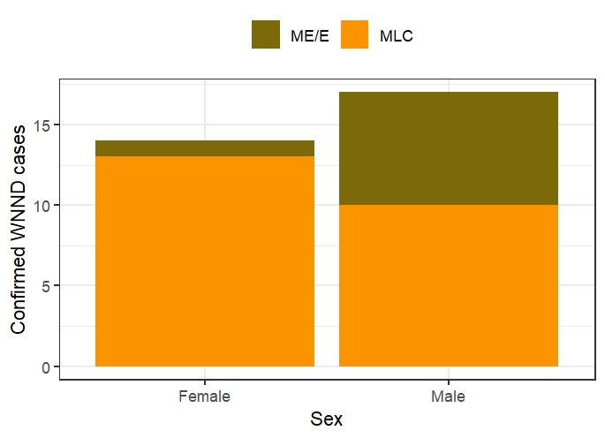

Figure S2. Seropositivity of West Nile virus by age in children across three northern Algerian provinces in 2017-2018. Pink color corresponds to the estimated outbreak time with the 95% credible intervals (CrI), which include 0 for Jijel and Tizi Ouzou. Estimated outbreak time was rounded to the nearest year. Sample sizes for children less than 13 years of age were 65, 97, and 39 for Jijel, Oran, and Tizi Ouzou, respectively.

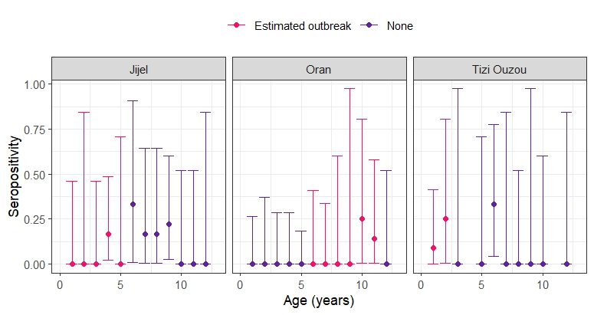

Supplementary tables

Table S1. Study locations based on the risk assessment of West Nile virus circulation using a tool developed by the European Centre for Disease Prevention and Control.

Province | Risk area type | Confirmed case | Seroprevalence study | Ecological factors | Risk assessment | Description
Oran | Predisposed | - | - | + | Low | Ecological conditions suitable for WNV circulation but no historical circulation of WNV
Tizi Ouzou | Predisposed | - | - | + | Low | Ecological conditions suitable for WNV circulation but no historical circulation of WNV
Biskra | Imperiled | - | + | + | Intermediate | Past evidence of WNV circulation
Jijel | Affected | + | - | + | High | Detection of at least one human case according to the European Union case definition.
Timimoun | Affected | + | + | + | High | Detection of at least one human case according to the European Union case definition.

Table S2. Deviance information criterion (DIC) and model diagnostic checks for serocatalytic models of West Nile virus in Algeria, 2017-2018. For DIC, lower values indicate better fit. We visually checked Markov chain Monte Carlo traces, and they were well mixed for all models. Warnings about divergent transitions and low effective sample sizes indicate that the model may be mis-specified and posterior means and medians may be unreliable, respectively. Bold indicates the best-fitting model for each province.

Province | Region | Model | Number of parameters | Deviance information criterion | Warnings about divergent transitions or low effective sample sizes
Tizi Ouzou | North | Constant | 1 | 100.1 | No
Tizi Ouzou | North | Constant with seroreversion | 2 | 86.8 | No
Tizi Ouzou | North | Constant outbreak | 4 | 84.9 | ~1100 divergent transitions after warm-up
Tizi Ouzou | North | One outbreak | 3 | 83.3 | ~1000 divergent transitions after warm-up
Oran | North | Constant | 1 | 196.8 | No
Oran | North | Constant with seroreversion | 2 | 196.4 | No
Oran | North | Constant outbreak | 4 | 194.3 | ~66,300 divergent transitions after warm-up
Oran | North | One outbreak | 3 | 189.9 | ~ 900 divergent transitions
Jijel | North | Constant | 1 | 208.3 | No
Jijel | North | Constant with seroreversion | 2 | 196.4 | No
Jijel | North | Constant outbreak | 4 | 196.9 | ~ 1000 divergent transitions after warm-up
Jijel | North | One outbreak | 3 | 195.9 | ~700 divergent transitions after warm-up
Timimoun | South | Constant | 1 | 144.7 | No
Timimoun | South | Constant with seroreversion | 2 | 146.6 | No
Timimoun | South | Constant outbreak | 4 | 145.1 | ~900 divergent transitions after warm-up
Timimoun | South | One outbreak | 3 | 161.0 | 900 divergent transitions after warm-up
Biskra | South | Constant | 1 | 287.4 | No
Biskra | South | Constant with seroreversion | 2 | 289.3 | No
Biskra | South | Constant outbreak | 4 | 288.0 | ~84,400 divergent transitions after warm-up
Biskra | South | One outbreak | 3 | 341.1 | ~1100 divergent transitions after warm-up

