SUPPLEMENTAL DATA

SUPPLEMENTAL TABLE 1. Clinical outcome: 3 out 67 patients with local disease at baseline had progressive disease during follow-up. Follow-up data of 18 months was available for 70 out of 74 patients.

 | Clinical outcome at the end of follow-up (n = 70)
Final stage at baseline | Stage at end of follow-up | Cured or stable disease  N (% of total) | Progressive disease  N (% of total) | Death caused by breast cancer  N (% of total) | Death due to other cause  N (% of total)
Local recurrence | M0 | 1 (1.4) | 0 (0.0) | 0 (0.0) | 1 (1.4)
Local recurrence | M1 | 0 (0.0) | 0 (0.0) | 0 (0.0) | 0 (0.0)
IIB | M0 | 31 (44.3) | 1 (1.4) | 0 (0.0) | 0 (0.0)
IIB | M1 | 0 (0.0) | 0 (0.0) | 0 (0.0) | 0 (0.0)
III | M0 | 25 (35.7) | 0 (0.0) | 0 (0.0) | 1 (1.4)
III | M1 | 0 (0.0) | 2 (2.9) | 1 (1.4) | 0 (0.0)
IV | M0 | 0 (0.0) | 0 (0.0) | 0 (0.0) | 0 (0.0)
IV | M1 | 3 (4.3) | 3 (4.3) | 1 (1.4) | 0 (0.0)

SUPPLEMENTAL TABLE 2. On a lesion-basis FDG PET incorrectly classified 24 of 287 pathologically verified lesions (A) and 43 of 204 lesions verified by follow up (B). Classification of lesions into 4 groups, based on the visual analysis using FDG PET imaging. Lesions have been pathologically verified (table A) or in case of absent/inconclusive pathology been verified by additional imaging and/or follow-up (table B). Outcomes of table A and B have been taken together in Table C.

A
FDG PET |  |  | Pathologically verified lesions
FDG PET |  |  | Malignant  (% of all total lesions) | Benign  (% of all total lesions) | Total
FDG PET | Uptake present and suspect
FDG PET |  | Breast | 72 | 1 | 73
FDG PET |  | Locoregional lymph nodes | 41 | 9 | 50
FDG PET |  | Distant | 2 | 7 | 9
FDG PET |  | Total | 115 (74.2) | 17 (11.0) | 132
FDG PET | No uptake and not suspect
FDG PET |  | Breast | 3 | 10 | 13
FDG PET |  | Locoregional lymph nodes | 3 | 5 | 8
FDG PET |  | Distant | 1 | 1 | 2
FDG PET |  | Total | 7 (4.5) | 16 (10.3) | 23
FDG PET |  | Total of all lesions | 122 | 33 | 155

B
FDG PET |  |  | Lesions verified with additional imaging  and/or follow-up
FDG PET |  |  | Malignant  (% of all total lesions) | Benign  (% of all total lesions) | Total
FDG PET | Uptake present and suspect
FDG PET |  | Breast | 4 | 0 | 4
FDG PET |  | Locoregional lymph nodes | 33 | 11 | 44
FDG PET |  | Distant lesions | 24 | 20 | 44
FDG PET |  | Total | 61 (54.5) | 31 (27.7) | 92
FDG PET | No uptake and not suspect
FDG PET |  | Breast | 0 | 1 | 1
FDG PET |  | Locoregional lymph nodes | 2 | 0 | 2
FDG PET |  | Distant lesions | 10 | 7 | 17
FDG PET |  | Total | 12 (10.8) | 8 (7.2) | 20
FDG PET |  | Total of all lesions | 73 | 39 | 112
C
FDG PET |  |  | Lesion verification through pathology report, additional imaging and/or follow-up
FDG PET |  |  | Malignant  (% of all total lesions) | Benign  (% of all total lesions) | Total
FDG PET | Uptake present and suspect
FDG PET |  | Breast | 76 | 1 | 77
FDG PET |  | Locoregional lymph nodes | 74 | 20 | 94
FDG PET |  | Distant | 26 | 27 | 53
FDG PET |  | Total | 176 | 48 | 224
FDG PET | No uptake and not suspect
FDG PET |  | Breast | 3 | 11 | 14
FDG PET |  | Locoregional lymph nodes | 5 | 5 | 10
FDG PET |  | Distant | 11 | 8 | 19
FDG PET |  | Total | 19 | 24 | 43
FDG PET |  | Total of all lesions | 195 | 72 | 267

Correctly identified by FDG PET
Incorrectly identified by FDG PET

SUPPLEMENTAL TABLE 3. Often incorrect identified lesions by FDG PET concerned axillary lymph nodes. Classification of lesions based on their location. All lesions have been verified with pathology, additional imaging and/or follow-up.

Location |  | Lesions verified with pathology, additional imaging and/or follow-up
Location |  | True negatives,  n (% of total) | False negatives,  n (% of total) | True positives,  n (% of total) | False positives,  n (% of total)
Location | Breast | 11 (4.1) | 3 (1.1) | 76 (28.5) | 1 (0.4)
Location | Axillary lymph nodes | 6 (2.2) | 3 (1.1) | 64 (24.0) | 23 (8.6)
Location | Other lymph nodes  - neck  - intramammary  - parasternal  - infraclavicular  - supraclavicular  - retropectoral  - mediastinal  - aorta  - hilus lung  - hilus liver  - inguinal | 0 (0.0)  0 (0.0)  0 (0.0)  0 (0.0)  0 (0.0)  0 (0.0)  0 (0.0)  0 (0.0)  0 (0.0)  0 (0.0)  0 (0.0) | 0 (0.0)  1 (0.4)  0 (0.0)  1 (0.4)  0 (0.0)  0 (0.0)  0 (0.0)  0 (0.0)  0 (0.0)  0 (0.0)  0 (0.0) | 0 (0.0)  0 (0.0)  3 (1.1)  5 (1.9)  2 (0.7)  0 (0.0)  9 (3.4)  0 (0.0)  1 (0.4)  0 (0.0)  0 (0.0) | 2 (0.7)  0 (0.0)  0 (0.0)  2 (0.7)  0 (0.0)  1 (0.4)  7 (2.6)  5 (1.9)  1 (0.4)  1 (0.4)  1 (0.4)
Location | Thyroid | 0 (0.0) | 0 (0.0) | 0 (0.0) | 1 (0.4)
Location | Lung | 7 (2.6) | 4 (1.5) | 0 (0.0) | 0 (0.0)
Location | Liver | 0 (0.0) | 0 (0.0) | 0 (0.0) | 2 (0.7)
Location | Bone | 0 (0.0) | 7 (2.6) | 16 (6.0) | 1 (0.4)
Location | Total analyzed lesions | 24 | 19 | 176 | 48

SUPPLEMENTAL TABLE 4. Conventional imaging incorrectly classified 33 out of 290 pathologically verified lesions (A) and 27 out of 184 lesions verified by follow up (B). Classification of lesions into 4 groups, based on the visual analysis using conventional imaging. Lesions have been pathologically verified (table A) or in case of absent/inconclusive pathology been verified by additional imaging and/or follow-up (table B).

A
Conventional imaging |  |  | Pathologically verified lesions
Conventional imaging |  |  | Malignant  (% of all total lesions) | Benign  (% of all total lesions) | Total
Conventional imaging | Suspect
Conventional imaging |  | Breast | 73 | 11 | 84
Conventional imaging |  | Locoregional lymph nodes | 41 | 11 | 52
Conventional imaging |  | Distant | 3 | 6 | 9
Conventional imaging |  | Total | 117 (74.5) | 28 (18.1) | 145
Conventional imaging | Not suspect
Conventional imaging |  | Breast | 2 | 0 | 2
Conventional imaging |  | Locoregional lymph nodes | 3 | 3 | 6
Conventional imaging |  | Distant | 0 | 2 | 2
Conventional imaging |  | Total | 5 (3.2) | 5 (3.2) | 10
Conventional imaging |  | Total of all lesions | 122 | 33 | 155

B
Conventional imaging |  |  | Lesions verified with additional imaging  and/or follow-up
Conventional imaging |  |  | Malignant  (% of all total lesions) | Benign  (% of all total lesions) | Total
Conventional imaging | Suspect
Conventional imaging |  | Breast | 4 | 1 | 5
Conventional imaging |  | Locoregional lymph nodes | 25 | 1 | 26
Conventional imaging |  | Distant lesions | 30 | 11 | 41
Conventional imaging |  | Total | 59 (52.7) | 13 (11.6) | 72
Conventional imaging | Not suspect
Conventional imaging |  | Breast | 0 | 0 | 0
Conventional imaging |  | Locoregional lymph nodes | 10 | 10 | 20
Conventional imaging |  | Distant lesions | 4 | 16 | 20
Conventional imaging |  | Total | 14 (12.5) | 26 (23.2) | 40
Conventional imaging |  | Total of all lesions | 73 | 39 | 112
Correctly identified by conventional imaging

Incorrectly identified by conventional imaging

SUPPLEMENTAL TABLE 5. Conventional imaging and FDG PET were concordant for 110 pathologically verified malignant lesions, were FDG PET identified 5 and conventional imaging 7 additional malignant lesions. Overview of pathologically verified lesions classified into 4 groups based on their outcomes on conventional and FDG PET imaging: not suspect-uptake, suspect-no uptake and suspect-uptake. There were no lesions with pathological verification for the group not suspect-no uptake.

Location of lesions | Pathologically verified lesions
Location of lesions | Malignant  (% of all total lesions) | Benign  (% of all total lesions)
Conventional imaging: not suspect
FDG PET: uptake
Breast | 2 | 0
Locoregional lymph nodes | 3 | 3
Distant | 0 | 2
Total | 5 (3.2) | 5 (3.2)
Conventional imaging: suspect
FDG PET: no uptake
Breast | 3 | 10
Locoregional lymph nodes | 3 | 5
Distant | 1 | 1
Total | 7 (4.5) | 16 (10.3)
Conventional imaging: suspect
FDG PET: uptake
Breast | 70 | 1
Locoregional lymph nodes | 38 | 6
Distant | 2 | 5
Total | 110 (71.0) | 12 (7.7)
Total of all lesions | 122 | 33

SUPPLEMENTAL TABLE 6. True and false positive lesions on FDG PET could not be discriminated based on SUV values. Semi-quantitative PET parameters for lesions classified into 3 groups, i.e. true positives, false positives and false negatives. Included lesions have either been pathologically verified (part A) or with additional imaging and/or follow-up (part B).

A
 | PET parameters
 | SUVmax* | SUVpeak* | SUVmean* | TLG*
False negatives  (n = 3) | 1.95 (1.71-1.98) | 1.68 (1.18-1.87) | 1.32 (1.22-1.43) | 1.64 (0.92-27.12)
False positives  (n = 17) | 3.07 (2.14-4.58) | 2.27 (1.62-3.71) | 2.04 (1.51-3.14) | 4.62 (3.80-7.69)
True positives  (n = 113) | 4.23 (2.54-6.37) | 3.01 (1.89-4.49) | 2.55 (1.54-3.42) | 12.15 (4.75-31.10)
* Median values with interquartile range

 | PET parameters
 | SUVmax* | SUVpeak* | SUVmean* | TLG*
False negatives  (n = 5) | 1.44 (0.90-1.52) | 1.14 (0.90-1.39) | 1.11 (0.84-1.23) | 0.33 (0.24-0.71)
False positives  (n =30) | 2.51 (1.68-3.85) | 1.83 (1.28-2.93) | 1.70 (1.23-2.78) | 3.19 (1.78-8.03)
True positives  (n = 60) | 3.00 (2.07-5.03) | 2.18 (1.32-3.76) | 2.11 (1.41-3.25) | 3.60 (2.05-15.22)
* Median values with interquartile range

SUPPLEMENTAL TABLE 7. Histological subtype is the most prominent pathological feature correlating with FDG uptake, with ductal BC having higher FDG uptake compared to lobular BC. Correlation between PET parameters and histopathological features of the primary breast lesions as assessed with mixed model analysis.

 | PET parameters
 | SUVmax* | SUVpeak* | SUVmean* | TLG* | Anatomic volume*
Histological subtype  Lobular  Ductal  Estimate (CI)  p-value | 3.20 (1.98-4.27)  5.18 (3.59-7.01)  2.99 (-0.13-6.10)  0.060 | 2.53 (1.63-2.75)  3.75 (2.70-5.53)  2.39 (0.02-4.76)  0.048 | 1.92 (1.12-2.35)  2.84 (2.14-4.05)  1.89 (0.10-3.68)  0.039 | 19.83 (7.52-31.10)  18.10 (10.44-35.85)  0.78 (-15.64-17.20)  0.923 | 13.12 (3.07-27.33)  7.87 (4.83-14.74)  -8.97 (-15.07- -2.87)  0.005
Grade  1  2  Estimate (CI)  p-value | 4.12 (3.82-4.71)  4.53 (3.13-6.85)  0.05 (-3.80-3.91)  0.977 | 2.89 (2.77-3.55)  3.30 (2.31-4.76)  0.95 (-1.58-3.48)  0.449 | 2.40 (1.87-2.66)  2.71 (1.96-3.65)  0.87 (-1.04-2.78)  0.359 | 8.83 (7.83-18.28)  19.29 (11.27-36.36)  8.19 (-9.35-25.73)  0.348 | 5.44 (4.03-8.87)  8.00 (4.53-18.94)  3.88 (-2.63-10.40)  0.233
ER positivity (%)  Estimate (CI)  p-value | 0.06 (-0.04-0.16)  0.231 | 0.04 (-0.10-0.18)  0.569 | 0.04 (-0.06-0.14)  0.450 | 0.96 (0.01-1.90)  0.048 | 0.08 (-0.28-0.43)  0.660
PR status  Negative  Positive  Estimate (CI)  p-value | 5.07 (4.08-7.67)  4.42 (3.13-6.42)  -1.37 (-4.43-1.68)  0.366 | 3.76 (2.72-6.11)  3.01 (2.24-4.75)  -1.00 (-3.41-1.40)  0.401 | 2.71 (2.50-4.76)  2.55 (1.88-3.55)  -0.83 (-2.64-0.98)  0.358 | 40.29 (23.19-111.52)  15.60 (9.37-32.92)  -13.26 (-29.91-3.40)  0.115 | 19.65 (8.06-83.90)  7.81 (4.10-14.39)  -2.83 (-9.02-3.35)  0.357
HER2neu status  Negative  Positive  Estimate (CI)  p-value | 4.23 (3.13-6.37)  5.74 (4.53-9.99)  1.34 (-3.05-5.73)  0.538 | 3.02 (2.31-4.47)  4.56 (2.68-7.34)  1.38 (-1.93-4.68)  0.402 | 2.55 (1.96-3.38)  3.32 (1.87-5.09)  0.74 (-1.75-3.23)  0.549 | 17.89 (9.52-35.33)  30.99 (20.87-72.72)  27.71 (4.81-50.60)  0.019 | 7.94 (4.10-15.81)  9.38 (7.90-23.49)  4.20 (-4.31-12.70)  0.321
Mitotic  activity index  Estimate (CI)  p-value | -0.15 (-0.44-0.14)  0.291 | -0.16 (-0.38-0.06)  0.143 | -0.12 (-0.28-0.05)  0.161 | -0.99 (-2.52-0.54)  0.198 | -0.075 (-0.64-0.49)  0.789
Tumor size  Estimate (CI)  p-value | -0.14 (-0.56-0.29)  0.518 | -0.18 (-0.71-0.36)  0.506 | -0.14 (-0.54-0.27)  0.495 | 4.29 (0.60-7.98)  0.024 | 1.66 (0.29-3.03)  0.019
* Median values with interquartile range

SUPPLEMENTAL TABLE 8. FDG PET imaging correctly identified 256 out of 346 axillary lymph nodes. Classification of axillary lymph nodes identified after surgical resection, based on the visual analysis comparing outcomes of FDG PET imaging with pathology outcomes. All included lymph nodes have been pathologically verified. Presence of malignant cells or pathological signs of complete response after neo-adjuvant therapy classified a node as malignant.

 | Pathologically verified lesions
FDG PET imaging | Benign  (% of all total lesions) | Malignant  (% of all total lesions)
Not suspect | 196 (56.6) | 83 (24.0)
Suspect | 7 (2.0) | 60 (17.3)
Total | 203 | 143

SUPPLEMENTAL TABLE 9. In 7 patients FDG PET imaging did not correctly identify the N-stage which could potentially affect treatment choices. Comparison of suspicious axillary lymph nodes present on FDG PET with affected axillary lymph nodes present in the pathology specimen.

FDG PET imaging  Number of nodes | Axillary lymph node dissection  Number of nodes | Number of patients
1 | 2-3 | 2
1-3 | ≥4 | 7
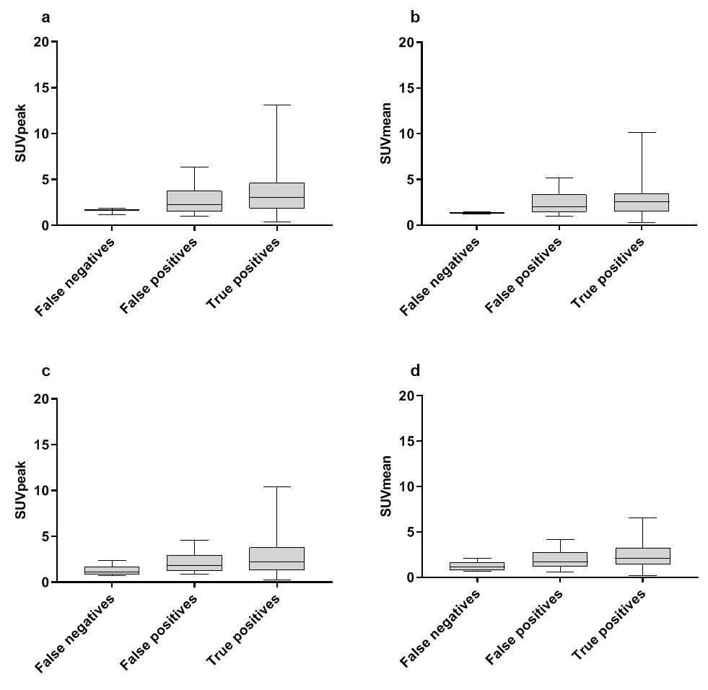
SUPPLEMENTAL FIGURE 1. Semi-quantitative PET parameters (SUV_{peak} and SUV_{mean}) for lesions classified into 3 groups, i.e. false negatives, false positives and true positives). Lesions have been verified pathologically (a/b) or by additional imaging and/or follow-up (c/d).
*P <0.05

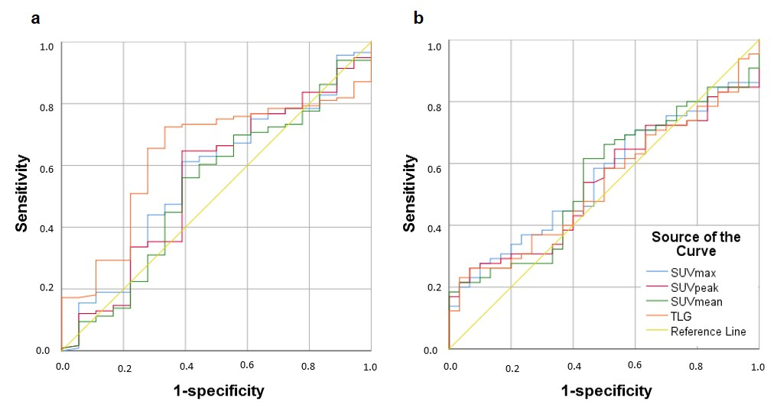

SUPPLEMENTAL FIGURE 2. Receiver operating characteristics (ROC) curves for differentiation between malignant and benign lesions using the semi-quantitative PET parameters. Included lesions have either been pathologically verified (a) or with additional imaging and/or follow-up (b).

