Galectin-1: a potential biomarker differentiating between early rheumatoid arthritis and spondyloarthritis
Ana Triguero-Martínez¹, ana6n92@gmail.com
Emilia Roy-Vallejo², eroyvallejo@gmail.com
Eva Gloria Tomero¹, tomeroeva@yahoo.es
Nuria Montes¹, nuria.montes.casado@gmail.com
Hortensia de la Fuente³, hortensiadelafuente@gmail.com
Ana María Ortiz¹, lanult@yahoo.es
Santos Castañeda¹, scastas@gmail.com
Amalia Lamana⁴*, amaliala@ucm.es Phone: 34-915202438. Fax: 34-915202374.
Isidoro González-Alvaro¹*, isidoro.ga@ser.es Phone: 34-915202438. Fax: 34-915202374.
¹Rheumatology Department, Hospital Universitario La Princesa, Instituto de Investigación Sanitaria La Princesa (IIS-IP), Madrid. Spain.
²Internal Medicine Department, Hospital Universitario La Princesa, Instituto de Investigación Sanitaria La Princesa (IIS-IP), Madrid. Spain
³Immunology Department, Hospital Universitario La Princesa, Instituto de Investigación Sanitaria La Princesa (IIS-IP), Madrid. Spain.
⁴Cell Biology Department, Facultad de Biología, Universidad Complutense de Madrid, Madrid, Spain.

* These authors share corresponding authorship

SUPPLEMENTARY MATERIAL

Supplementary figures

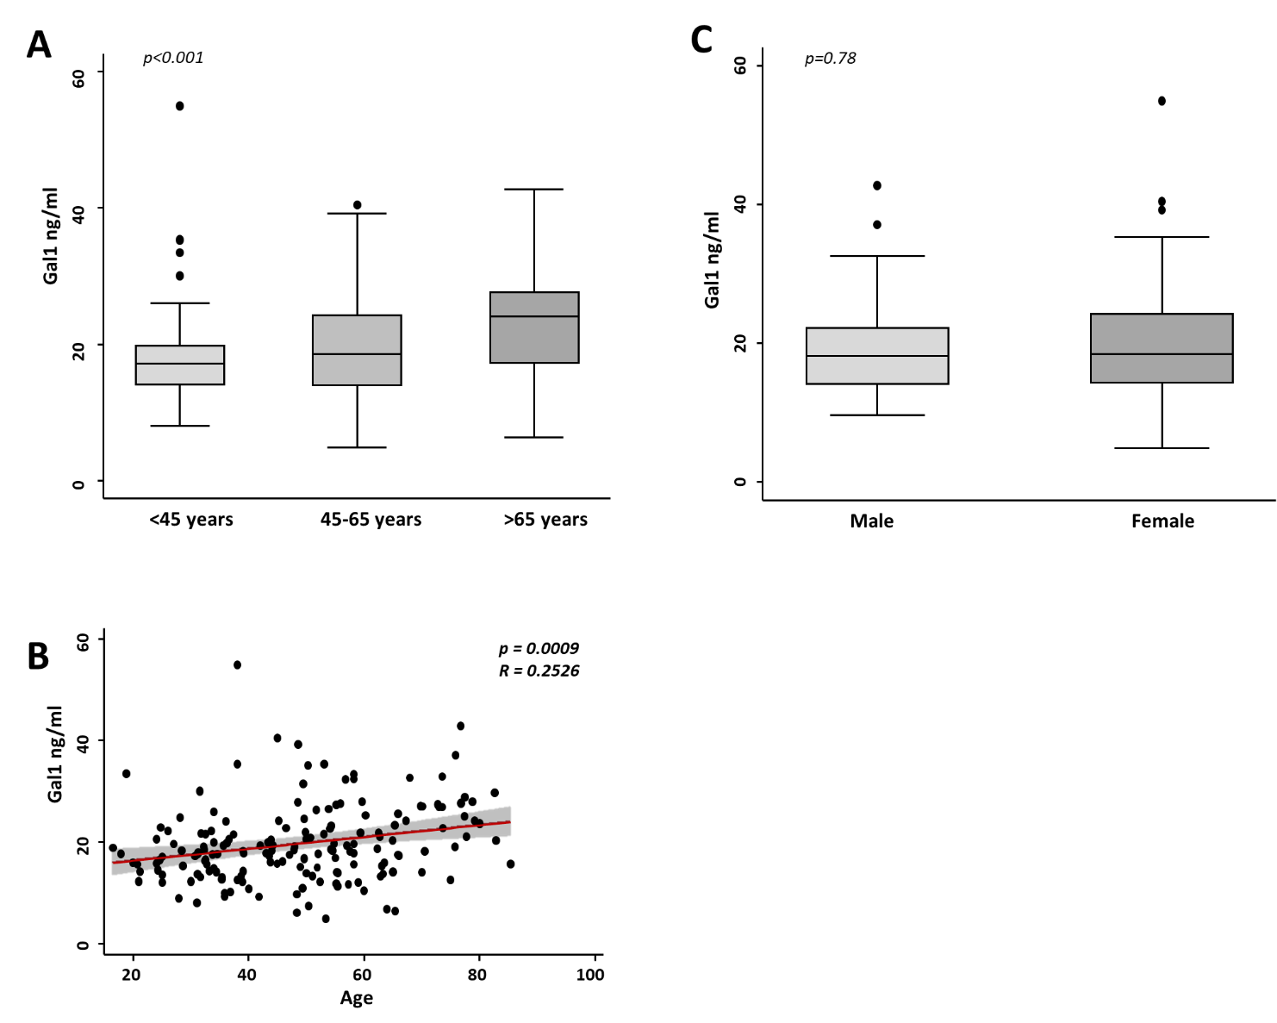
Supplemental Figure 1. Relationship between Gal1 serum levels and clinical characteristics
Determination of Gal1 serum levels by ELISA in all populations of study and age (A) or sex (C). Data shown as interquartile range (p75 upper edge of box, p25 lower edge, p50 midline) as well as the p95 (line above box) and p5 (line below). Dots represent outliers. Statistical significance was determined with ANOVA or Kruskal-Wallis test respectively. Significance threshold was set at p<0.05. Correlation of Gal1 serum levels with age in all populations of study (B). Data shown as dotplots and their fitted linear prediction with 95% confidence interval (grey shadow) using the twoway command of Stata with the lfitci option. Pearson correlation test was used to determine the level of significance.

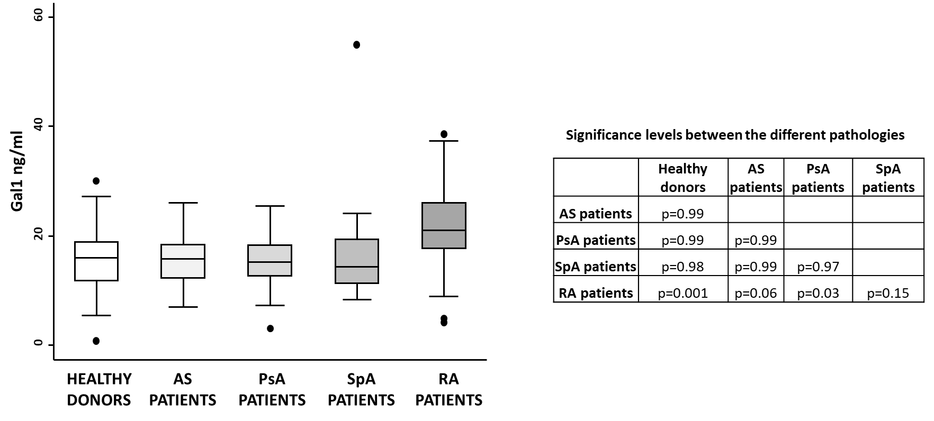

Supplemental Figure 2. Gal1 serum levels in different types of spondyloarthropathies in comparison with healthy donors and rheumatoid arthritis patients.
Determination of Gal1 serum levels by ELISA in healthy donors, ankylosing spondylitis (AS), psoriatic arthritis (PsA) early spondyloarthritis (SpA) and early rheumatoid arthritis (RA) patients. Gal1 serum levels were adjusted as describe in methods. Data are shown as interquartile range (p75 upper edge of box, p25 lower edge, p50 midline) as well as the p95 (line above box) and p5 (line below). Dots represent outliers. Statistical significance was determined with the Kruskal-Wallis test. Significance threshold was set at p<0.05.

Supplementary tables

Table supplementary 1: Baseline characteritics of spondyloarthropahies subpopulations
 | AS patients | Early SpA patients | psoriatic arthritis patients | p-value
 | (n = 21) | (n = 19) | (n=15)
Female; n (%) | 3 (14.29) | 12 (63.16) | 10 (66.67)
Age; p50 [p25-p75] | 53.88 [48.31 – 63.3] | 42 [36 – 45] | 49.45 [28.38 – 55.2] | 0.06
Disease duration (months); p50 [p25-p75] | 288 [264 – 360] | 18 [5 – 24] | 5.93 [2.43 – 13] | < 0.001
HLA-B27 positive; n (%) | 20 (95.24) | 16 (84.21) | 2 (13.33) | < 0.001
BASDAI; p50 [p25-p75] | 2.9 [1.9 – 3.6] | 4.4 [2.2 – 5.1] |  | 0.09
BASFI ; p50 [p25-p75] | 2.1 [1.5 – 2.8] | 1.6 [1.2–3.4] |  | 0.8
ASDAS ; p50 [p25-p75] | 2.2 [1.7 – 2.6] | 2.14 [1.35 – 3.30] |  | 0.64
DAPSA; p50 [p25-p75] |  |  | 8.2 [4.6 – 9.5]
n: number; p50: median or percentile 50; p25-p75: range between percentiles 25 and 75 or interquartile range; AS: ankylosing spondylitis ; SpA: spondyloarthritis; RA: rheumatoid arthritis; BASDAI: Bath Ankylosing Spondylitis Disease Activity Index; BASFI: Bath Ankylosing Spondylitis Functional Index; ASDAS: Ankylosing spondylitis disease activity index;DAS28: disease activity score estimated with 28 joint count; DAPSA: disease activity psoriatic

Table supplementary 2: Relationship between Gal1 (ng/ml) serum levels and diagnosis.
 | β Coeff. (95% CI) | p-value
Female gender | -1.06 (-3.66 to 1.52) | 0.416
Age (years)
< 45 | Reference
45-65 | 1.19 (-1.41 to 3.81) | 0.366
> 65 | 2.98 (-0.22 to 6.19) | 0.068
Diagnosis
Rheumatoid arthritis | Reference
Healthy donors | -6.96 (-9.93 to -3.98) | < 0.001
Ankylosing spondylitis | -6.51 (-10.59 to -2.43) | 0.002
Early spondyloarthritis | -5.89 (-9.78 to -2.00) | 0.003
Psoriatic arthritis | -7.35 (-11.50 to -3.20) | 0.001
Coeff. Coefficient ; CI. Confidence interval

Table supplementary 3: Baseline characteristics of the spondyloarthritis and mechanical low back pain patients population studied

 | Mechanical low back pain patients | SPA patients | p-value
 | (n = 24) | (n = 19)
Female; n (%) | 9 (37.5) | 12 (63.16) | 0.08
Age; p50 [p25-p75] | 36.5 [33 – 40.5] | 42 [36 – 45] | 0.06
Disease duration (months); p50 [p25-p75] |  | 18 [5 – 24]
HLA-B27 positive; n (%) |  | 16 (84.21)
BASDAI; p50 [p25-p75] |  | 4.4 [2.2 – 5.1]
BASFI ; p50 [p25-p75] |  | 1.60 [1.2 – 3.4]
HAQ; p50 [p25-p75] |  | 0.125 [0 – 0.625]
n: number; p50: median or percentile 50; p25-p75: range between percentiles 25 and 75 or interquartile range; SPA: spondyloarthritis; BASDAI: Bath Ankylosing Spondylitis Disease Activity Index; BASFI: Bath Ankylosing Spondylitis Functional Index HAQ: baseline health assessment questionnaire

