Supplementary Materials for:

Estimating Global, High-resolution Onsite Building Emissions

Paul J. Markakis^{1,2,4}, Trey M. Gowdy^{1,4}, Jordan M. Malof^{3,4}, Zion Sheng^{3,4}, Brittany Lancellotti^{1,4}, Leslie Collins², Aaron Davitt⁴, and Kyle Bradbury^{1,2,4}
1. Nicholas Institute for Energy, Environment & Sustainability, Duke University; 2. Dept. of Electrical & Computer Engineering, Duke University; 3. Dept. of Electrical Engineering and Computer Science, University of Missouri; 4. Climate TRACE

Contents
The supplementary materials are structured as follows. In Section S.1. we detail our method to compute building floor area. In Section S.2. we describe our approach for computing the Energy Use Intensity (EUI) parameter. We share additional comparison data results for both national-level comparison and municipality-level comparison in Section S.3. We provide additional global analysis results in Section S.4. Finally, we address known issues in Section S.5.

S.1. Building floor area

We observe that the GHSL volume data, when converted to total floor area of buildings (by assuming an average floor height of 3m per story) and combined with energy use intensity to compute energy consumption data, appears to overestimate energy consumption at the national level. Thus we apply a global scaling factor of 0.12 to the building floor area estimates based on a regression of our derived energy consumption estimates and national level energy consumption from IEA data. Since our goal is to estimate emissions, not energy consumption directly, what is most important is that the estimates of energy consumption are proportional to actual energy consumption and globally consistent.

S.2. Energy Use Intensity

The data sources used by the World Bank CURB Tool for these values are the ‘DOE Model’ and EDGE,’ model year(s) unknown. The CURB Tool was released in 2016. Using building stock information from the United States Energy Information Administration’s Commercial Building Energy Consumption Survey (CBECS) (U.S. Energy Information Administration 2023a) and Residential Energy Consumption Survey (RECS) (U.S. Energy Information Administration 2023b), we developed a proportional mix of values for residential vs. non-residential building categories based on floor area to create a weighted average of building EUI totals, as shown in Table S.1. This proportional mix is derived from U.S. data as it provides detailed information on building subtypes, and is used due to limited open data availability globally that match these categories. We then developed weighted averages across socioeconomic tiers for the residential sector (homes - houses and apartments/flats) to create a sole residential sector value for each location.

Table S.1. This table describes the weighted averages derived from U.S. Energy Information Administration (EIA) data to allocate floor area to the building types found in the World Bank CURB Tool for energy use intensity values. The EIA values originate from the Residential Energy Consumption Survey (RECS) and Commercial Building Energy Consumption Survey (CBECS).

Building Category | Percentages | Specific Building Type | Sq. Footage (US) - To inform percentage (Millions SF) | Percentages (based on US data) | Notes/Source
Residential | 71.12% | Home | 237,400.00 | 71.12% | RECS 2015 HC10.1 - includes all Single Family Homes, Apartment Units, and Mobile Homes.
Non-residential | 28.88% | Hospital | 4,018.00 | 1.20% | CBECS 2018 B12 - categories based recategorization of CBECS data categories to align with CURB Tool building types
Non-residential | 28.88% | Hotel | 6,976.00 | 2.09%
Non-residential | 28.88% | Office | 18,200.00 | 5.45%
Non-residential | 28.88% | Retail | 19,412.00 | 5.82%
Non-residential | 28.88% | Warehouse | 17,483.00 | 5.24%
Non-residential | 28.88% | Other | 30,333.00 | 9.09%

There are a few limitations with this process. The EUI values represent only a single point in time (the exact year for each location is unknown) and the values are associated primarily with major population centers only (potentially reducing accuracy for rural and suburban areas). Building-use percentages are based on a U.S. average, and then applied globally. Identifying more localized detailed building use percentage estimates that can be applied globally will improve accuracy. Further refinement of EUI values by recency and spatial resolution (more locations overall, including rural and suburban areas) provide opportunity for improvement to this model. These data are then converted from kilowatt hours (kWh)/square meter to megajoules (MJ)/square meter.

Prior to that conversion, we clip outlying data points. We clip all values to be between 50 and 400 kWh/m²/year to eliminate potential outliers, before then converting them MJ/m²/year.

S.3. Additional comparison data results

S.3.1. National-Level Comparisons

At the national level, because our method disaggregates EDGAR v8.0 data, when we aggregate our modeled emissions estimates by country, these estimates are the same as EDGAR v8.0 at the country level, which we have confirmed. To verify this and contextualize those values we compare them to both UNFCCC and the latest version of CAIT; the details of these emissions datasets were previously summarized in Table 1.

UNFCCC and CAIT both follow IPCC standards to account whether or not fossil fuels and biofuels are included within their building emissions data; emissions from biofuels are included for N₂O, and CH₄ but biofuels emissions from CO₂ are excluded. We follow this standard for the purposes of comparison at the national level. For these national-level comparisons, we aggregate modeled emissions estimates using country-level polygon boundaries for each country in UNFCCC and CAIT, respectively.
Figure S.1 maps the presence of building-related emissions data at the country level for UNFCCC and CAIT, respectively, in the year 2020, which is the most recent year available for these two data sources at the time of publication.
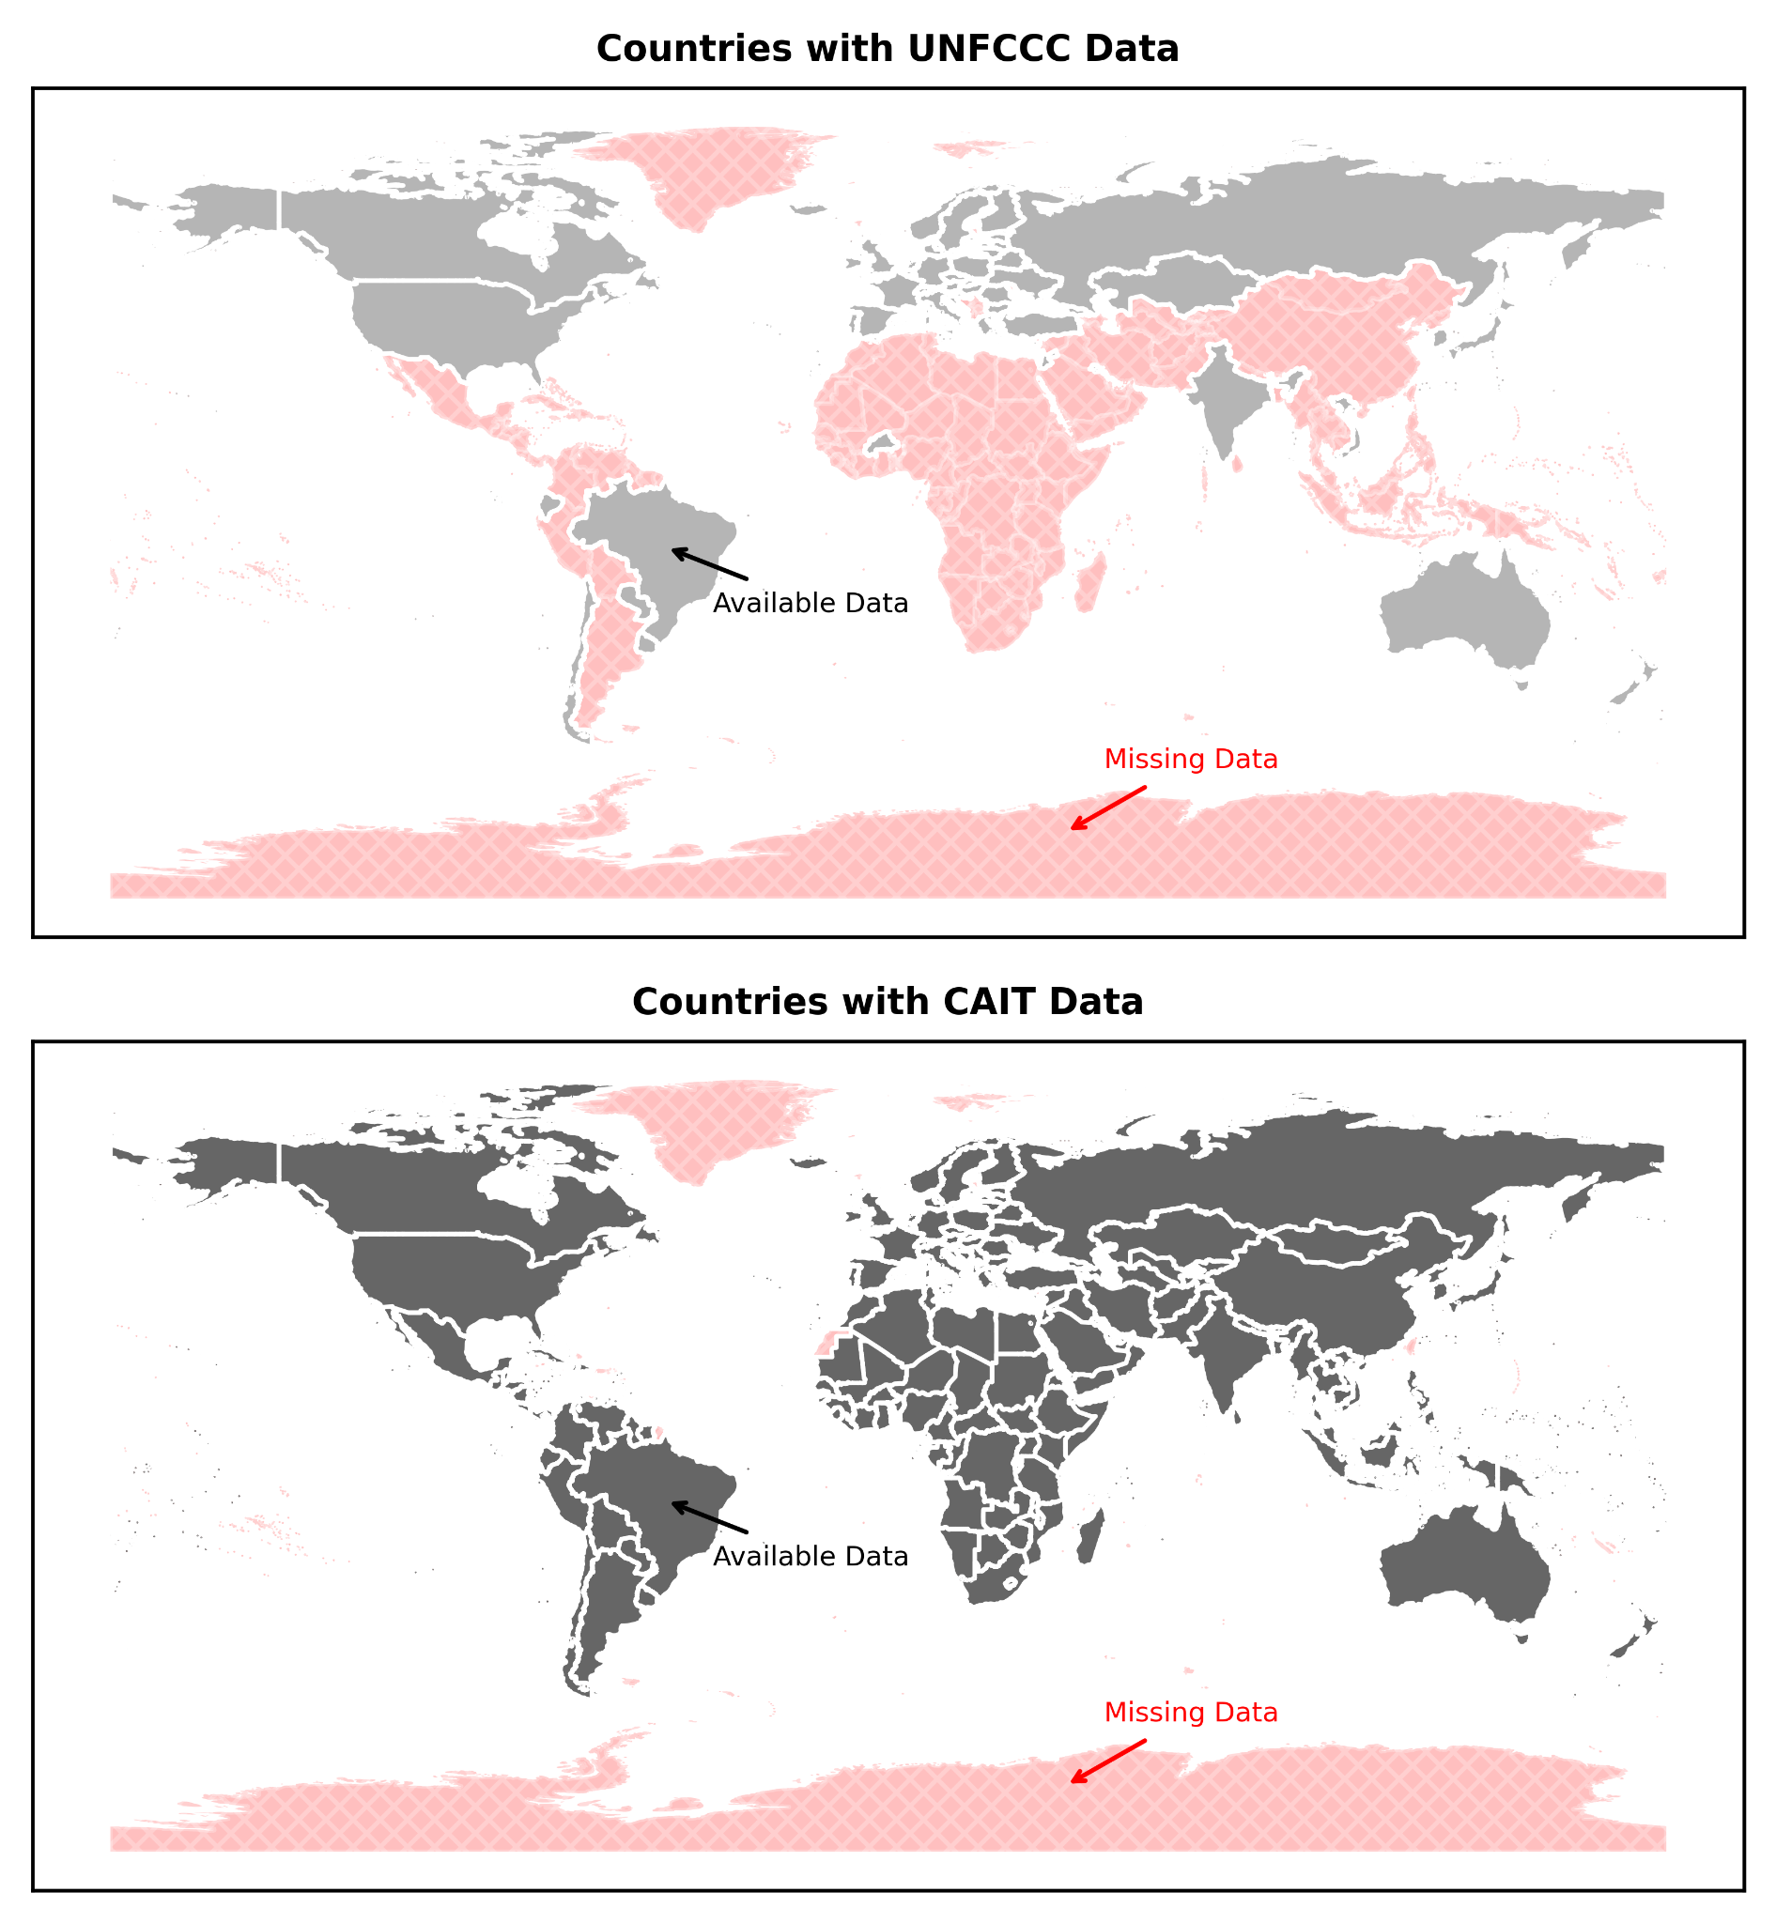
Figure S.1. The two maps above show the countries containing 2020 onsite direct building emissions data from UNFCCC (top) and CAIT (bottom). The countries included within each dataset are in gray, whereas the countries missing from each dataset are in red.
At the country level we compare our super-resolved EDGAR emissions against both UNFCCC and CAIT for “total” buildings (i.e., aggregated residential and non-residential buildings), as shown in Figure S.2 for CO₂ emissions. We here focus our initial comparison on CO₂ emissions as CO₂ is the dominant source of onsite direct building emissions as compared to CH₄ and N₂O. We show results for 2020, the most recent year for which all comparison datasets have published emissions data. While all emissions data sources are generally similar in country-level emissions magnitude, Figure S.2 shows that there exist differences across the two country-level inventories (UNFCCC and CAIT) as well as the GHG emissions data derived from EDGAR v8.0. Although not shown here, we independently confirmed that at the country-level level of aggregation, EDGAR v8.0 and our super-resolved EDGAR data are nearly-identical which provides verification that our super-resolution method expectedly matches country-level totals.

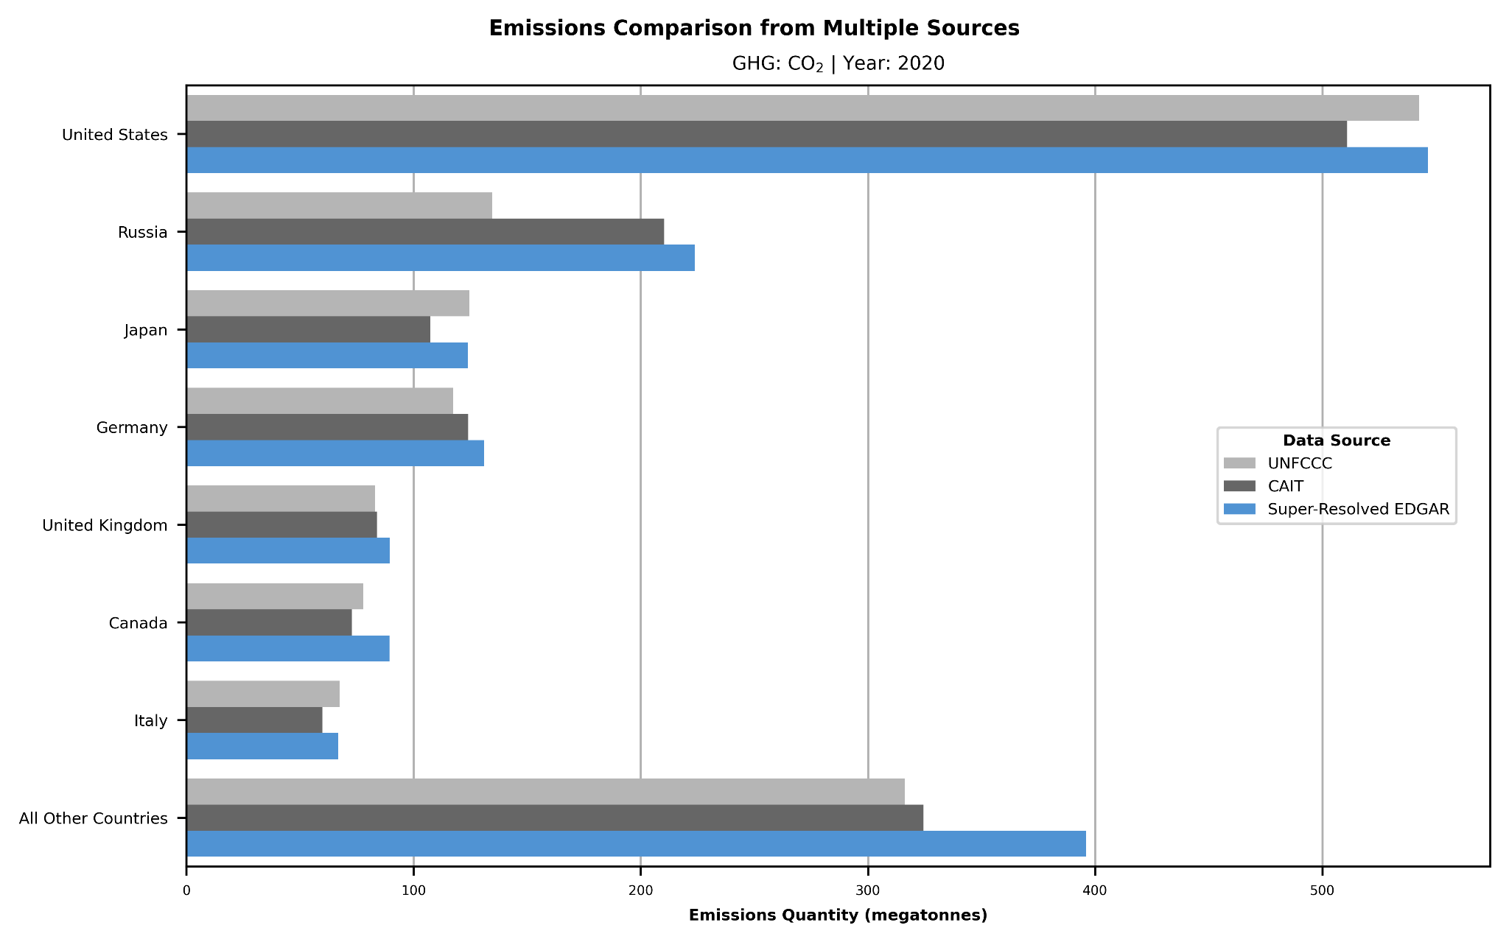
Figure S.2. We compare the quantity of direct onsite CO₂ building emissions (in megatonnes) across each of the countries included in the UNFCCC inventory for 2020. We include emissions inventory data from UNFCCC and CAIT for each such country, as well as emissions estimates from our super-resolved EDGAR. This plot delineates the countries representing the top 80% of CO₂ emissions in UNFCCC, with all other UNFCCC countries included in the “All Other Countries” category.

At the country level, we are able to expand the above analysis and provide per-country comparisons across all three primary GHGs (CO₂, N₂O, and CH₄) as well as for two different years (2015 and 2020). It is important to note that while the original EDGAR v8.0 and our super-resolved EDGAR data are generally identical at the country-level, there are some smaller countries (e.g., Monaco) for which the original EDGAR data appears missing when aggregated to the country-boundary; remedying this limitation is part of our ongoing work. These comparisons for 2015 and 2020 are shown in Figures S.3 and S.4, respectively.

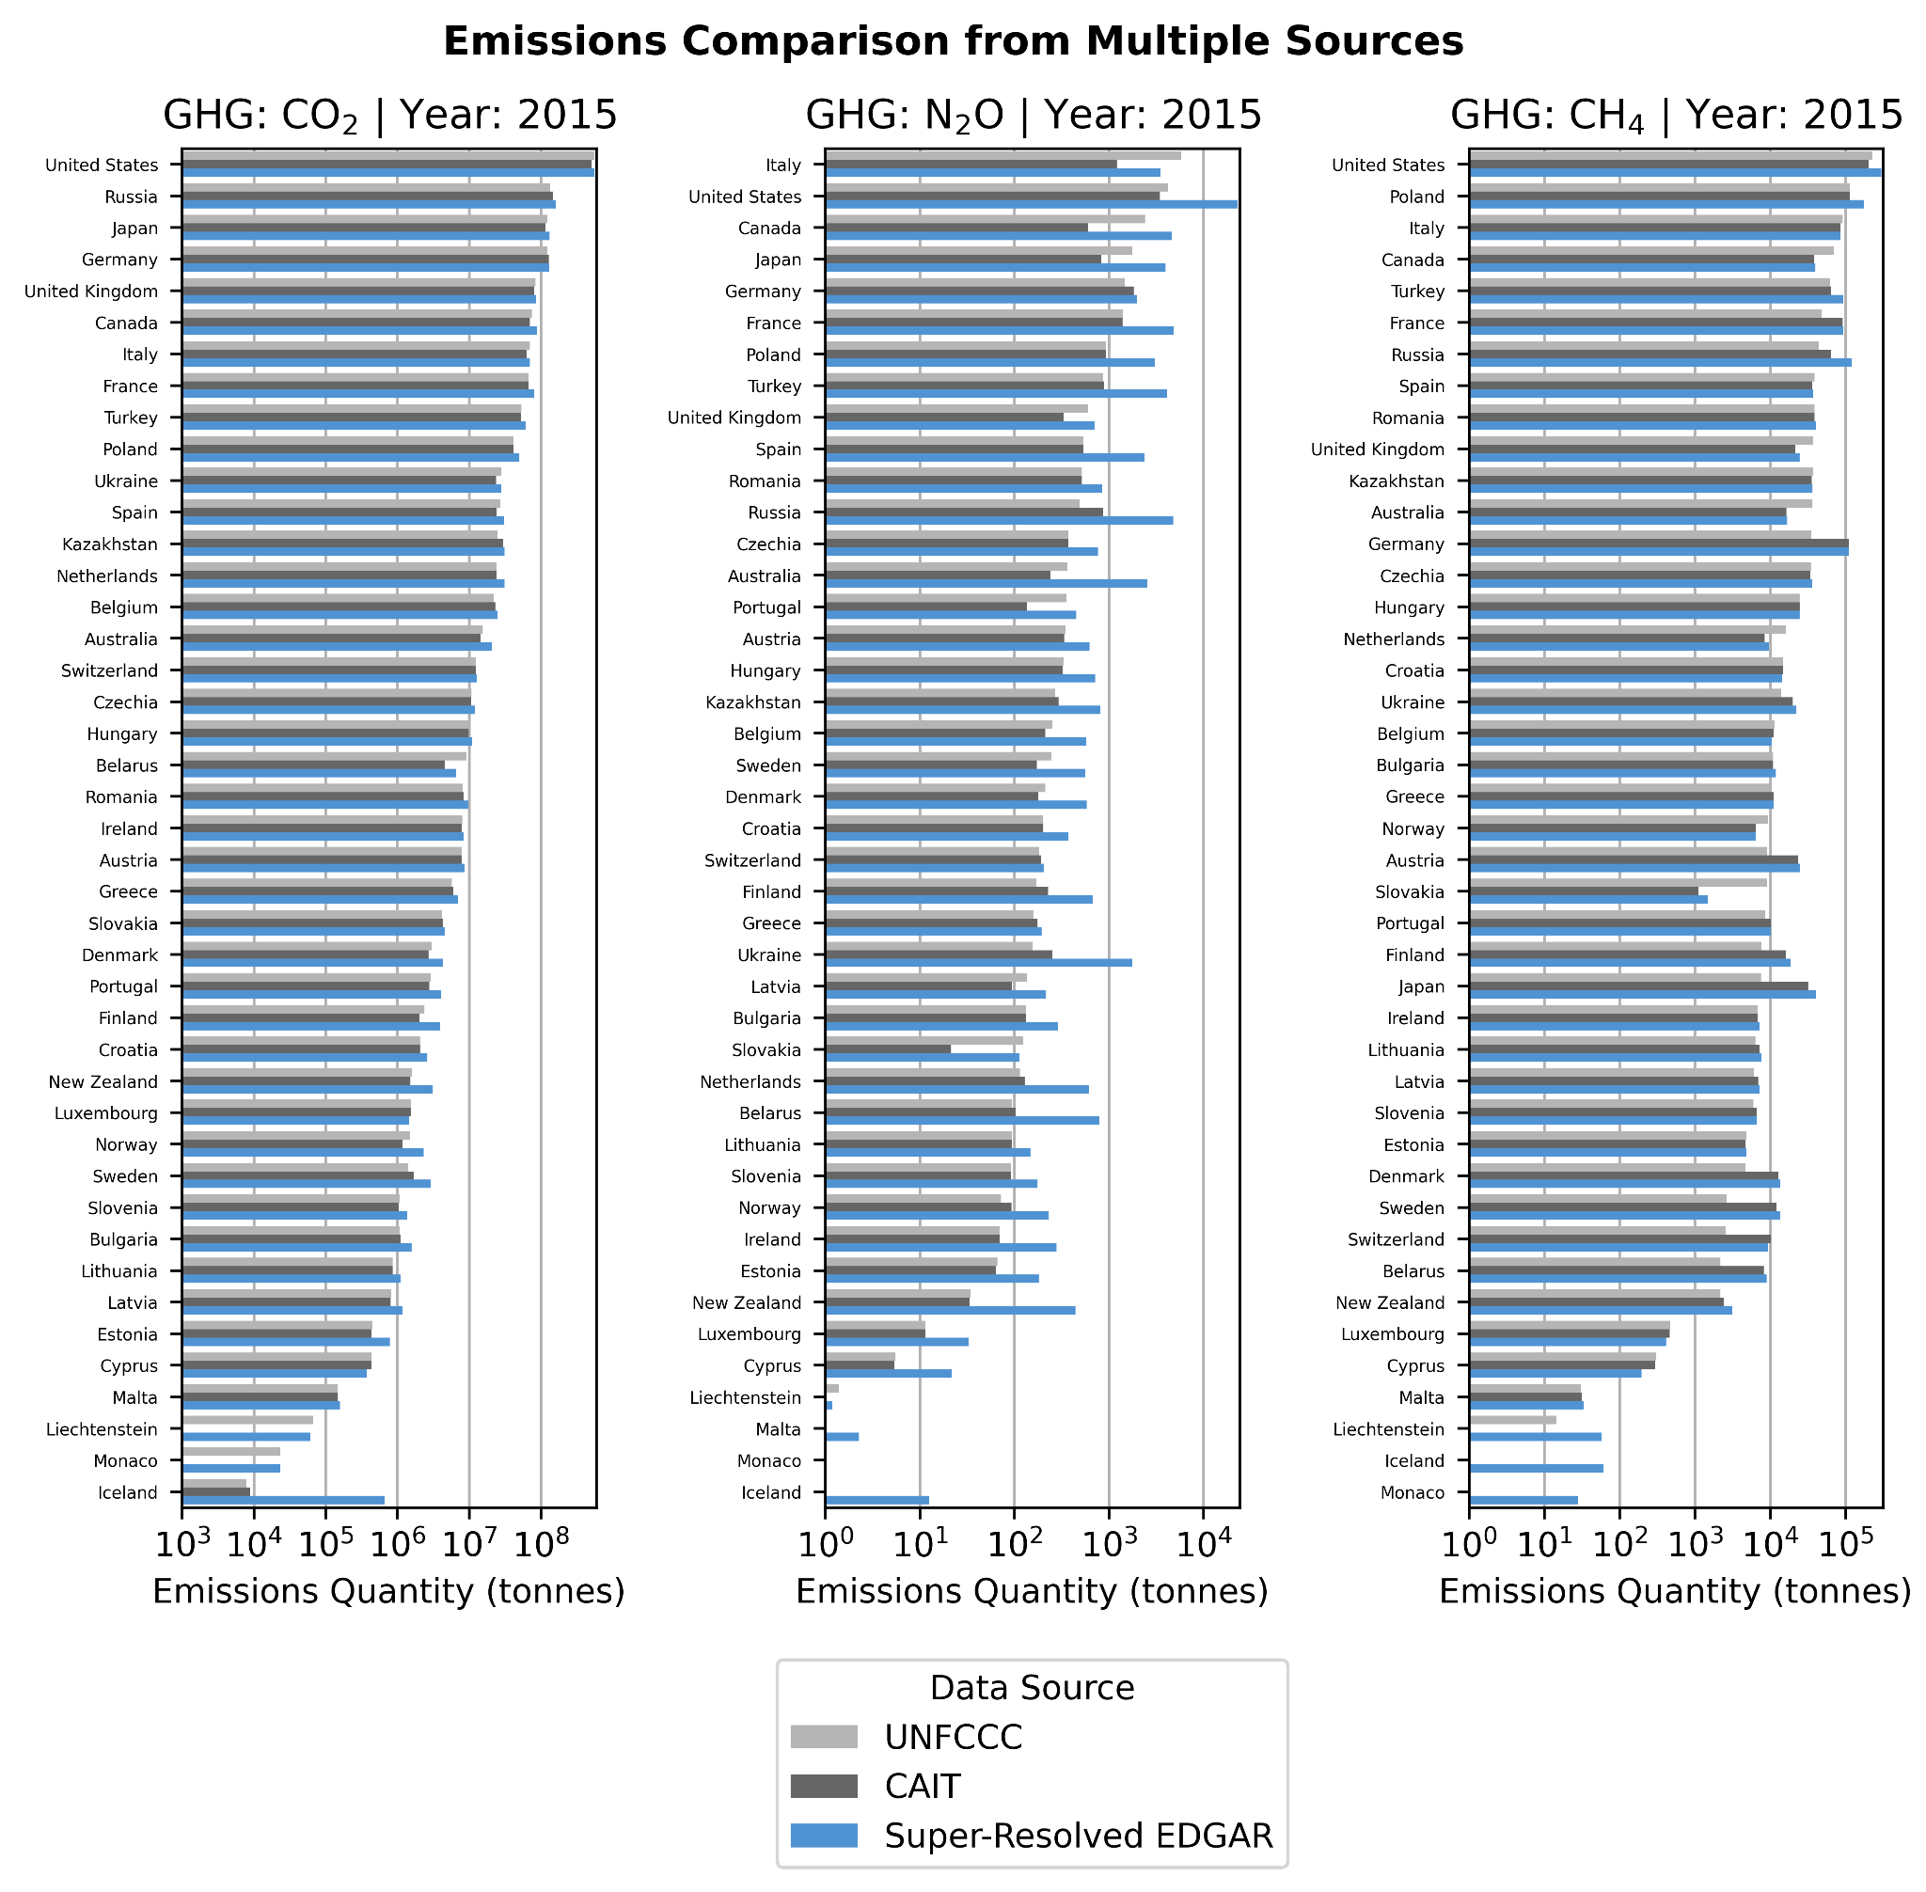
Figure S.3. We compare the quantity of direct onsite building emissions (in tonnes) across each of the countries included in the UNFCCC inventory for 2015. We include emissions inventory data from UNFCCC and CAIT for each such country, as well as emissions estimates from our model’s super-resolved version of EDGAR. We show this emissions comparison for CO₂, N₂O, and CH₄.

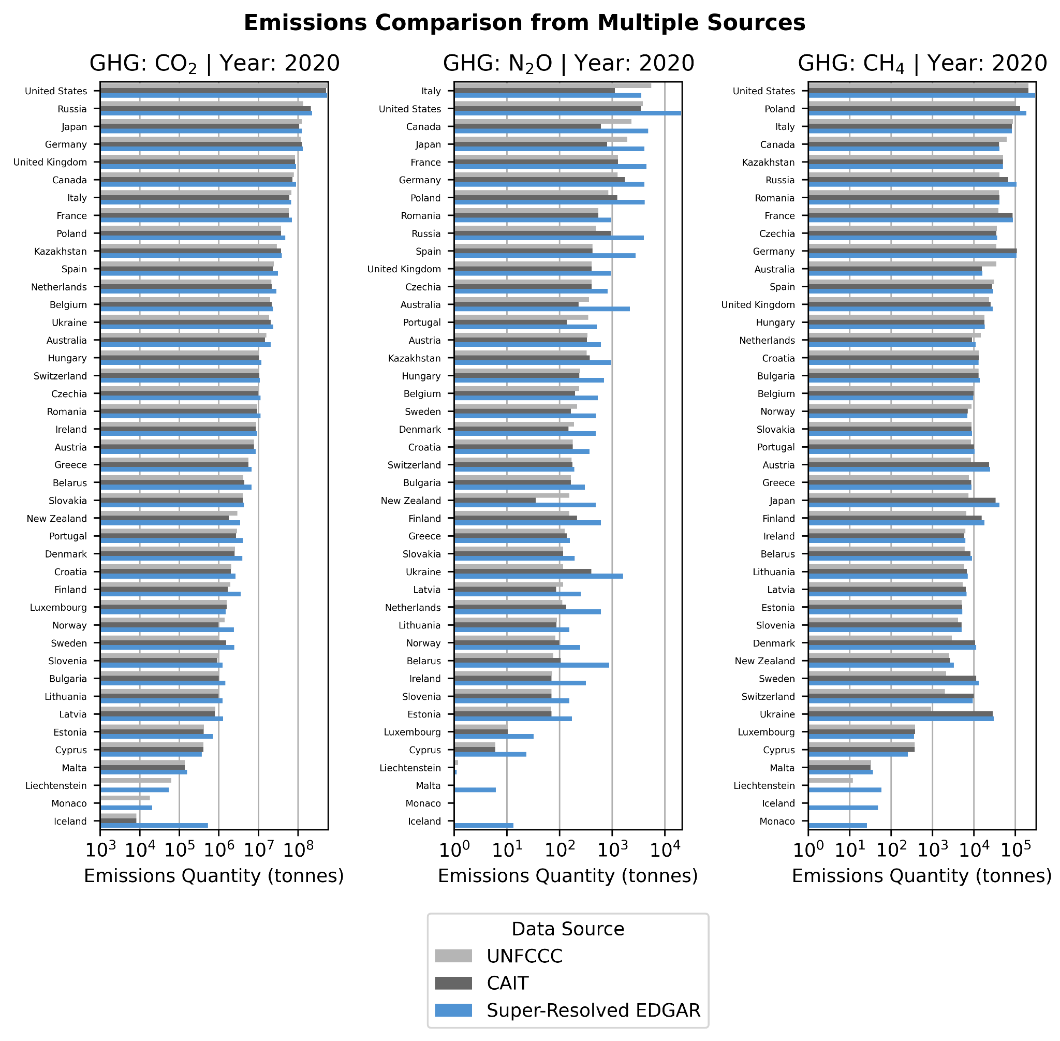
Figure S.4. We compare the quantity of direct onsite building emissions (in tonnes) across each of the countries included in the UNFCCC inventory for 2020. We include emissions inventory data from UNFCCC and CAIT for each such country, as well as emissions estimates from our model’s super-resolved version of EDGAR. We show this emissions comparison for CO₂, N₂O, and CH₄.

We consider a similar national-level comparison using energy consumption data from the IEA. These data exist only for a subset of countries around the world, and the comparison is limited to IEA and our super-resolved EDGAR model as we are unable to extract building-specific and subsector-specific energy consumption data from EDGAR v8.0. We specifically delineate countries that represent the top 80% of emissions in the IEA data for each sub-sector, aggregating all other countries into a common grouping – recognizing that these remaining countries collectively represent only 20% of all energy consumption in the IEA data. These comparisons are shown in Figures S.5 and S.6 for the years 2015 and 2020, respectively.

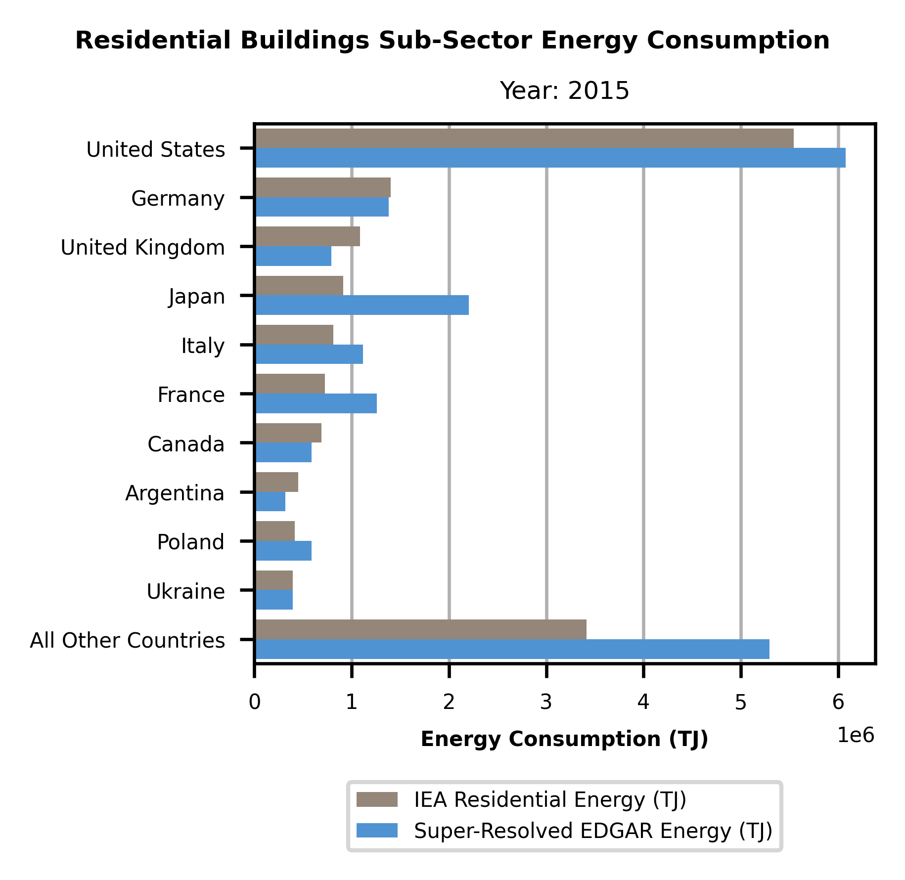 | 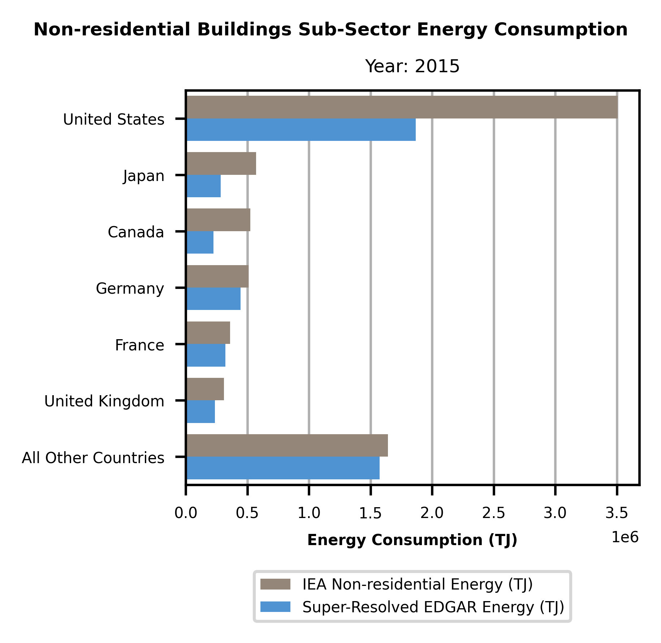
Figure S.5. We compare the 2015 country-level energy consumption from residential buildings (left) and non-residential buildings (right) provided by IEA against the country-level energy consumption data estimated by our super-resolved EDGAR model. There are clear differences between the two sources, in some countries showing the IEA estimates a greater magnitude of energy consumption and in other countries showing that the IEA estimates a lesser magnitude of energy consumption. Energy consumption is shown in units of terajoules.

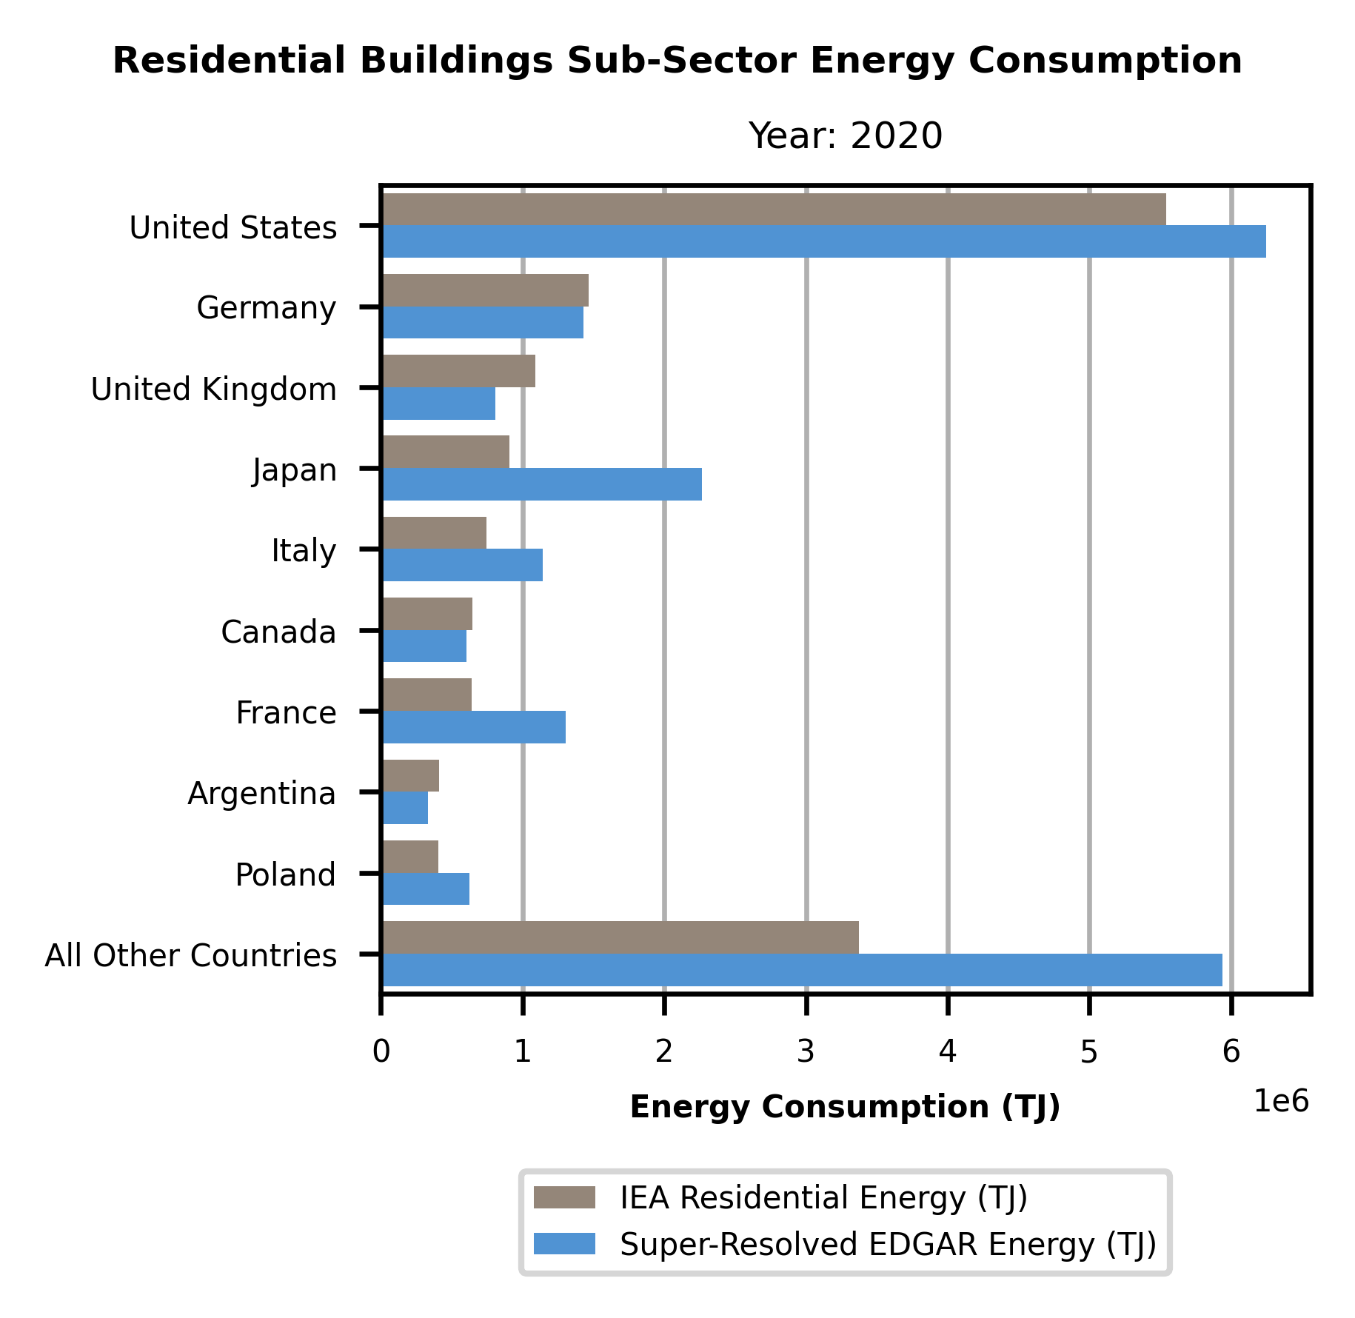 | 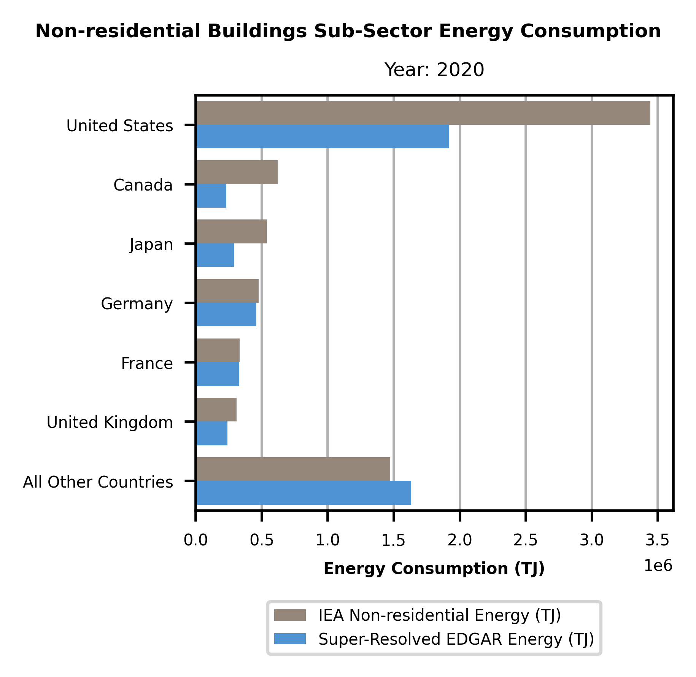
Figure S.6. We compare the 2020 country-level energy consumption from residential buildings (left) and non-residential buildings (right) provided by IEA against the country-level energy consumption data estimated by our super-resolved EDGAR model. There are clear differences between the two sources, in some countries showing the IEA estimates a greater magnitude of energy consumption and in other countries showing that the IEA estimates a lesser magnitude of energy consumption. Energy consumption is shown in units of terajoules.

S.3.2. Municipality-Level Comparisons
The DPFC emissions data for CO₂, N₂O, and CH₄ are disaggregated into residential and non-residential building sub-sectors, and each country’s data is associated with a corresponding year. (Note that India’s DPFC data are from 2013. We use 2015 data from EDGAR v8.0 and our model for DPFC validation, as 2015 data are the first that we consider as part of our current work.) DPFC data are also disaggregated into different contributing fuel types, so we can filter the data down to only include direct onsite fuel types and exclude sources such as electricity and district heating that are outside of the scope of our work. We further filter DPFC data to only include municipalities that contain both residential and non-residential emissions. Because the exact geographic boundaries used by DPFC for each municipality are not provided, we curate boundaries for each region and exclude any municipalities for which the inferred population differs greatly from the DPFC reported population. The resulting comparison data once all of this filtering is complete contains a total of 19,998 distinct municipalities across eight different countries (Canada, Chile, Costa Rica, Denmark, India, Japan, Mexico, and the United States). Because DPFC data are provided in units of CO₂e, we also use the latest conversion factors associated with the 100-year Global Warming Potential to convert CO₂e into tonnes of each corresponding GHG.

In addition to the stratified WAPE results provided in Section 3.2.2, we also provide stratified MAPE results below in Figure S.7. We first observe that proportional allocation of our super-resolved EDGAR data demonstrates consistently lower error than either allocation method applied to EDGAR v8.0 data. Although the MAPE increases as municipality size increases, this is attributable to limitations of the MAPE metric itself. One limitation of using MAPE as an evaluation metric is that a severe underestimate is strictly bounded at an absolute percentage error of 100%, whereas a severe overestimate has an unbounded absolute percentage error; thus, deciles dominated by severe underestimates would converge to an absolute percentage error of 100% whereas deciles dominated by overestimates would grow beyond that. We independently reviewed the distribution of estimation errors for each decile shown in Figure S.7 and confirmed that for smaller municipalities, there is a general trend to severely underestimate emissions when using EDGAR v8.0 with either allocation method, whereas there is a trend to overestimate emissions when using super-resolved EDGAR with either allocation method.

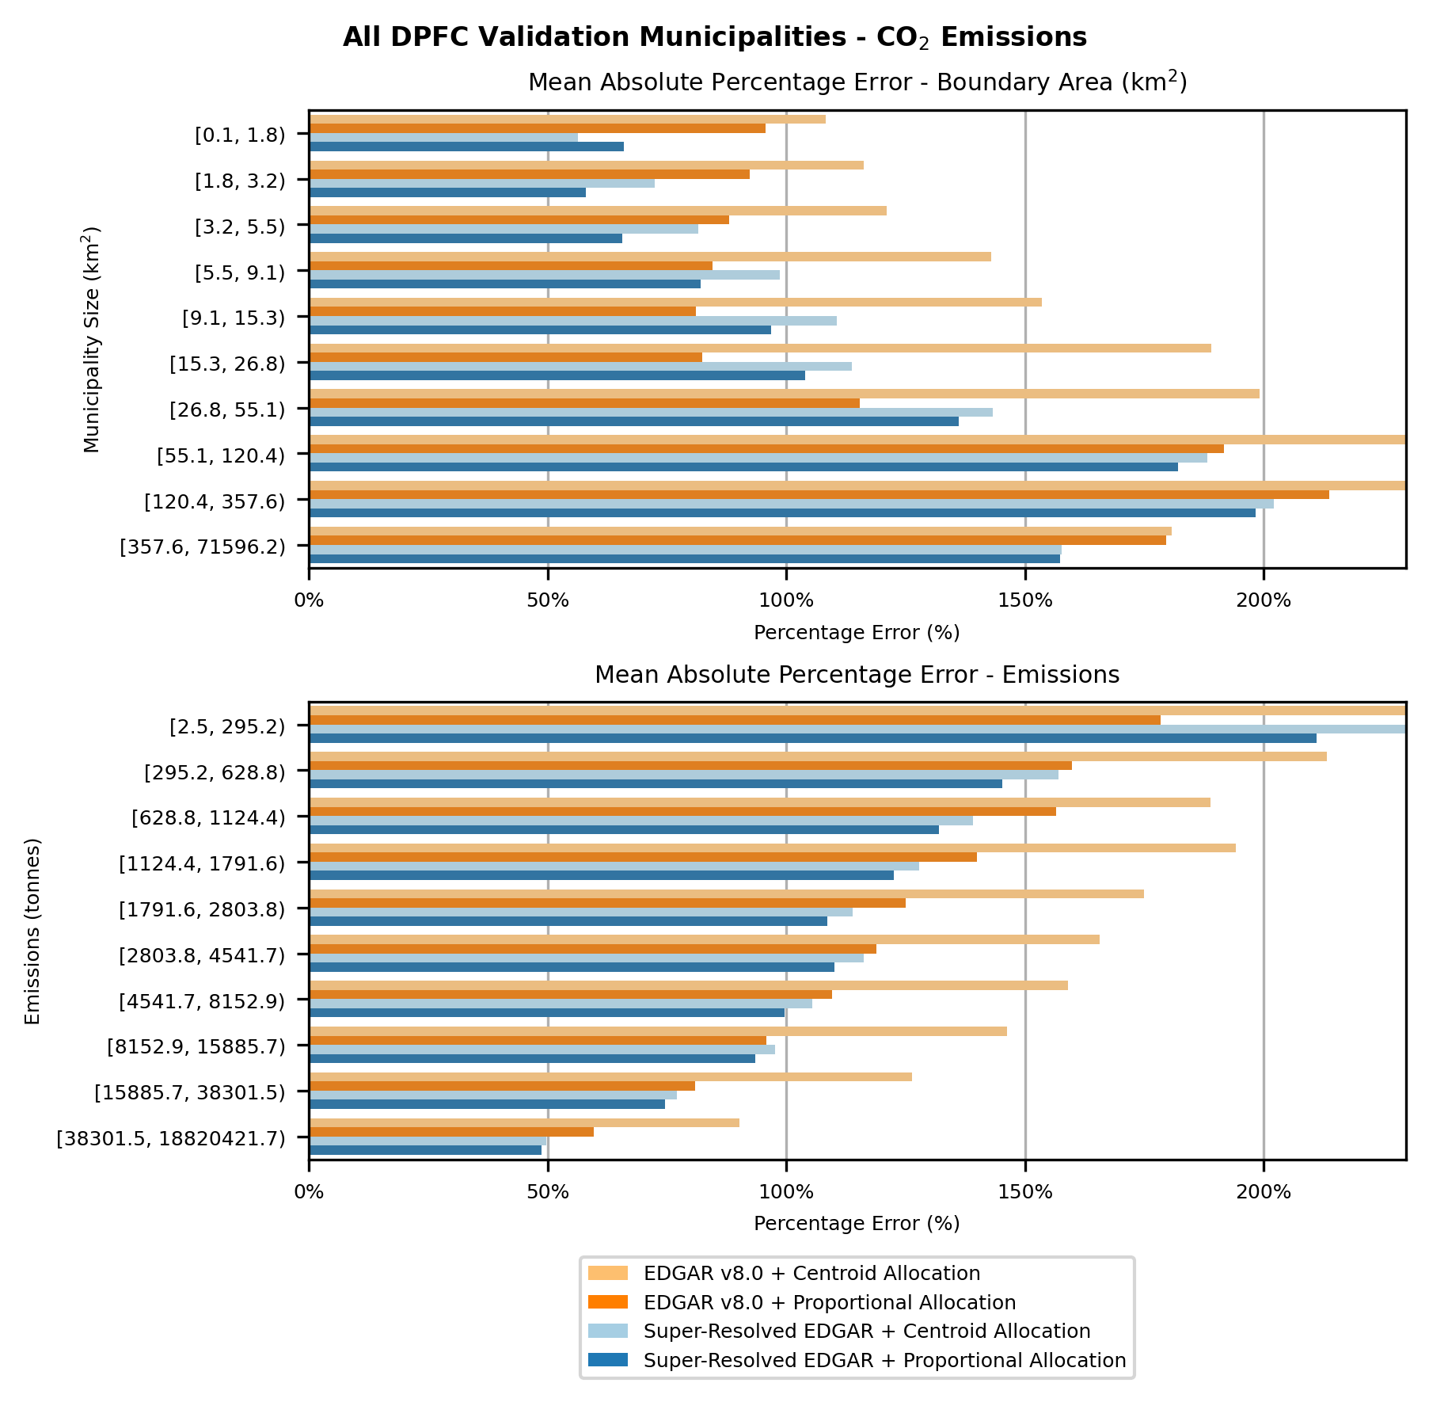
Figure S.7. We compare the Mean Absolute Percentage Error (MAPE) across all municipalities in DPFC. Our comparison focuses on both gridded emissions datasets under consideration (EDGAR v8.0 and our Super-Resolved EDGAR) as well as both gridded raster data allocation methods (Centroid and Proportional). The DPFC municipalities are binned into deciles based on their municipality size (in km²) and CO₂ emissions (in tonnes) and percentage error metrics are computed independently for each decile.

S.4. Additional global analysis
In addition to the exploration of building emissions from all onsite fuel sources (i.e., fossil fuels and biofuels) we also independently include summaries of emissions from only fossil fuels and from only biofuels.

S.4.1 Fossil Fuels Only
Here, we show summaries of onsite direct building emissions only from fossil fuel sources. We use the method described in Section S.3 to compute and isolate the building emissions exclusively from combusted on-site fossil fuel sources. We observe in Figure S.8 that the distribution of these emissions is different from the distribution when comparing all onsite fuel sources. We further observe in Figure S.9 that 10% of direct onsite fossil fuel building emissions are concentrated within 24 FUAs and 25% within 203 FUAs.

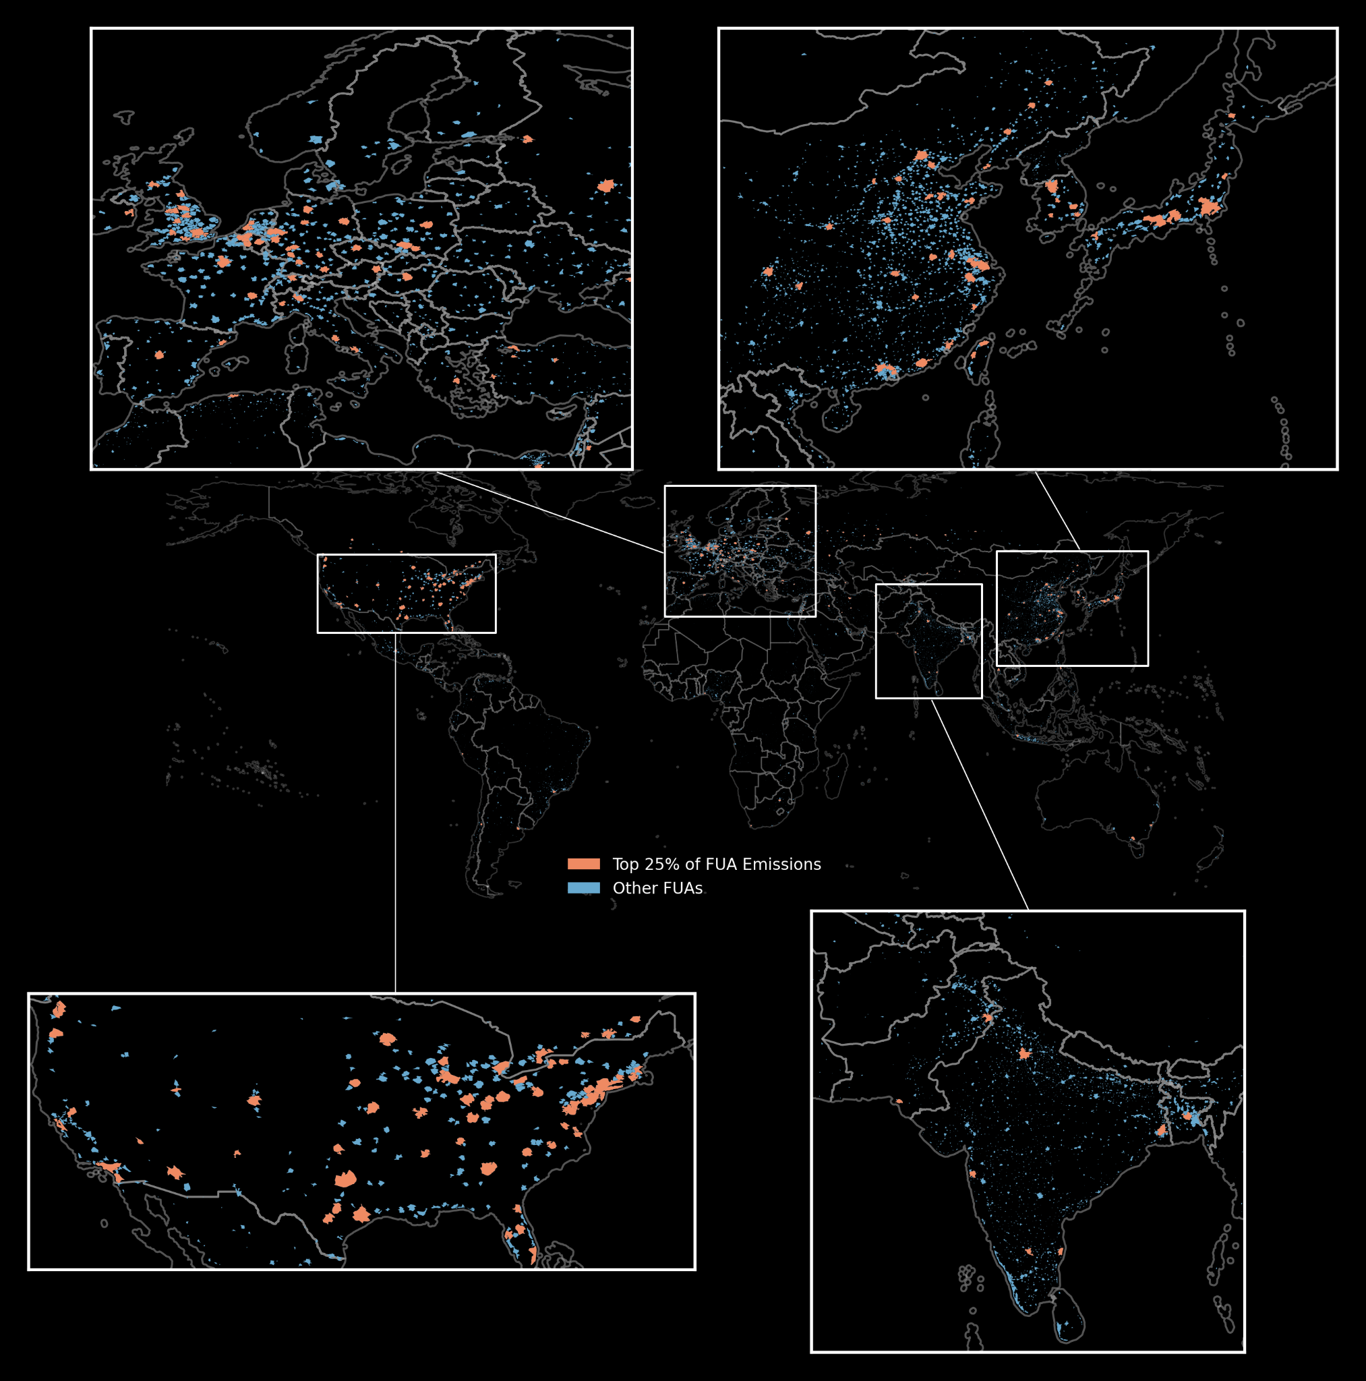
Figure S.8. Distribution of GHSL FUA boundaries across the globe. The FUAs representing the top 25% of CO2e-100yr direct onsite building fossil fuel emissions for the year 2023 are shown in orange and the remaining FUAs are shown in blue.

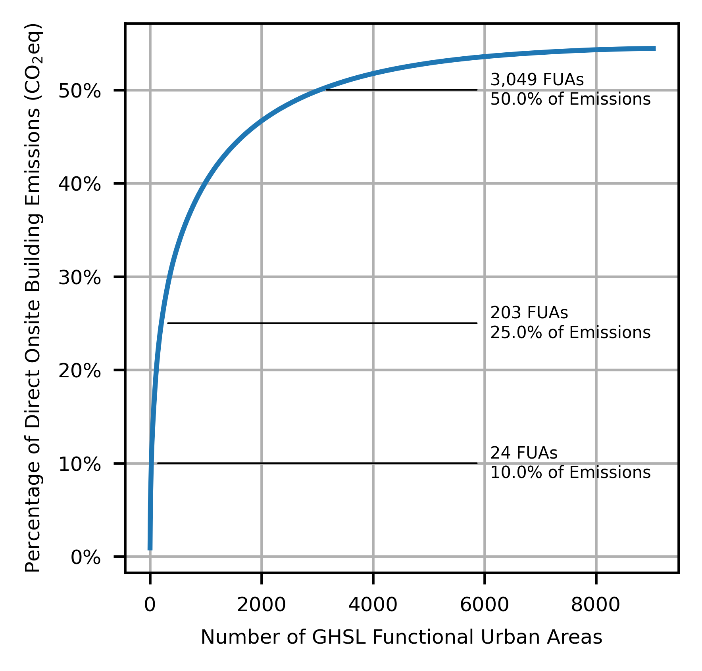
Figure S.9. For direct onsite building emissions from fossil fuels only, we explore the cumulative percentage of direct onsite CO2e-100yr building emissions from fossil fuels as compared to GHSL’s Functional Urban Areas boundaries for the year 2023.

S.4.2 Biofuels Only
We also consider summaries of onsite direct building emissions only from biofuel sources. We use the method described in Section S.3 in the supplementary materials to compute and isolate the building emissions exclusively from combusted on-site biofuel sources. We observe in Figure S.10 that the distribution of these emissions is different from the distribution when comparing all onsite fuel sources. We further observe in Figure S.11 that 10% of direct onsite biofuels-related emissions are concentrated with 25 FUAs and 25% within 203 FUAs.

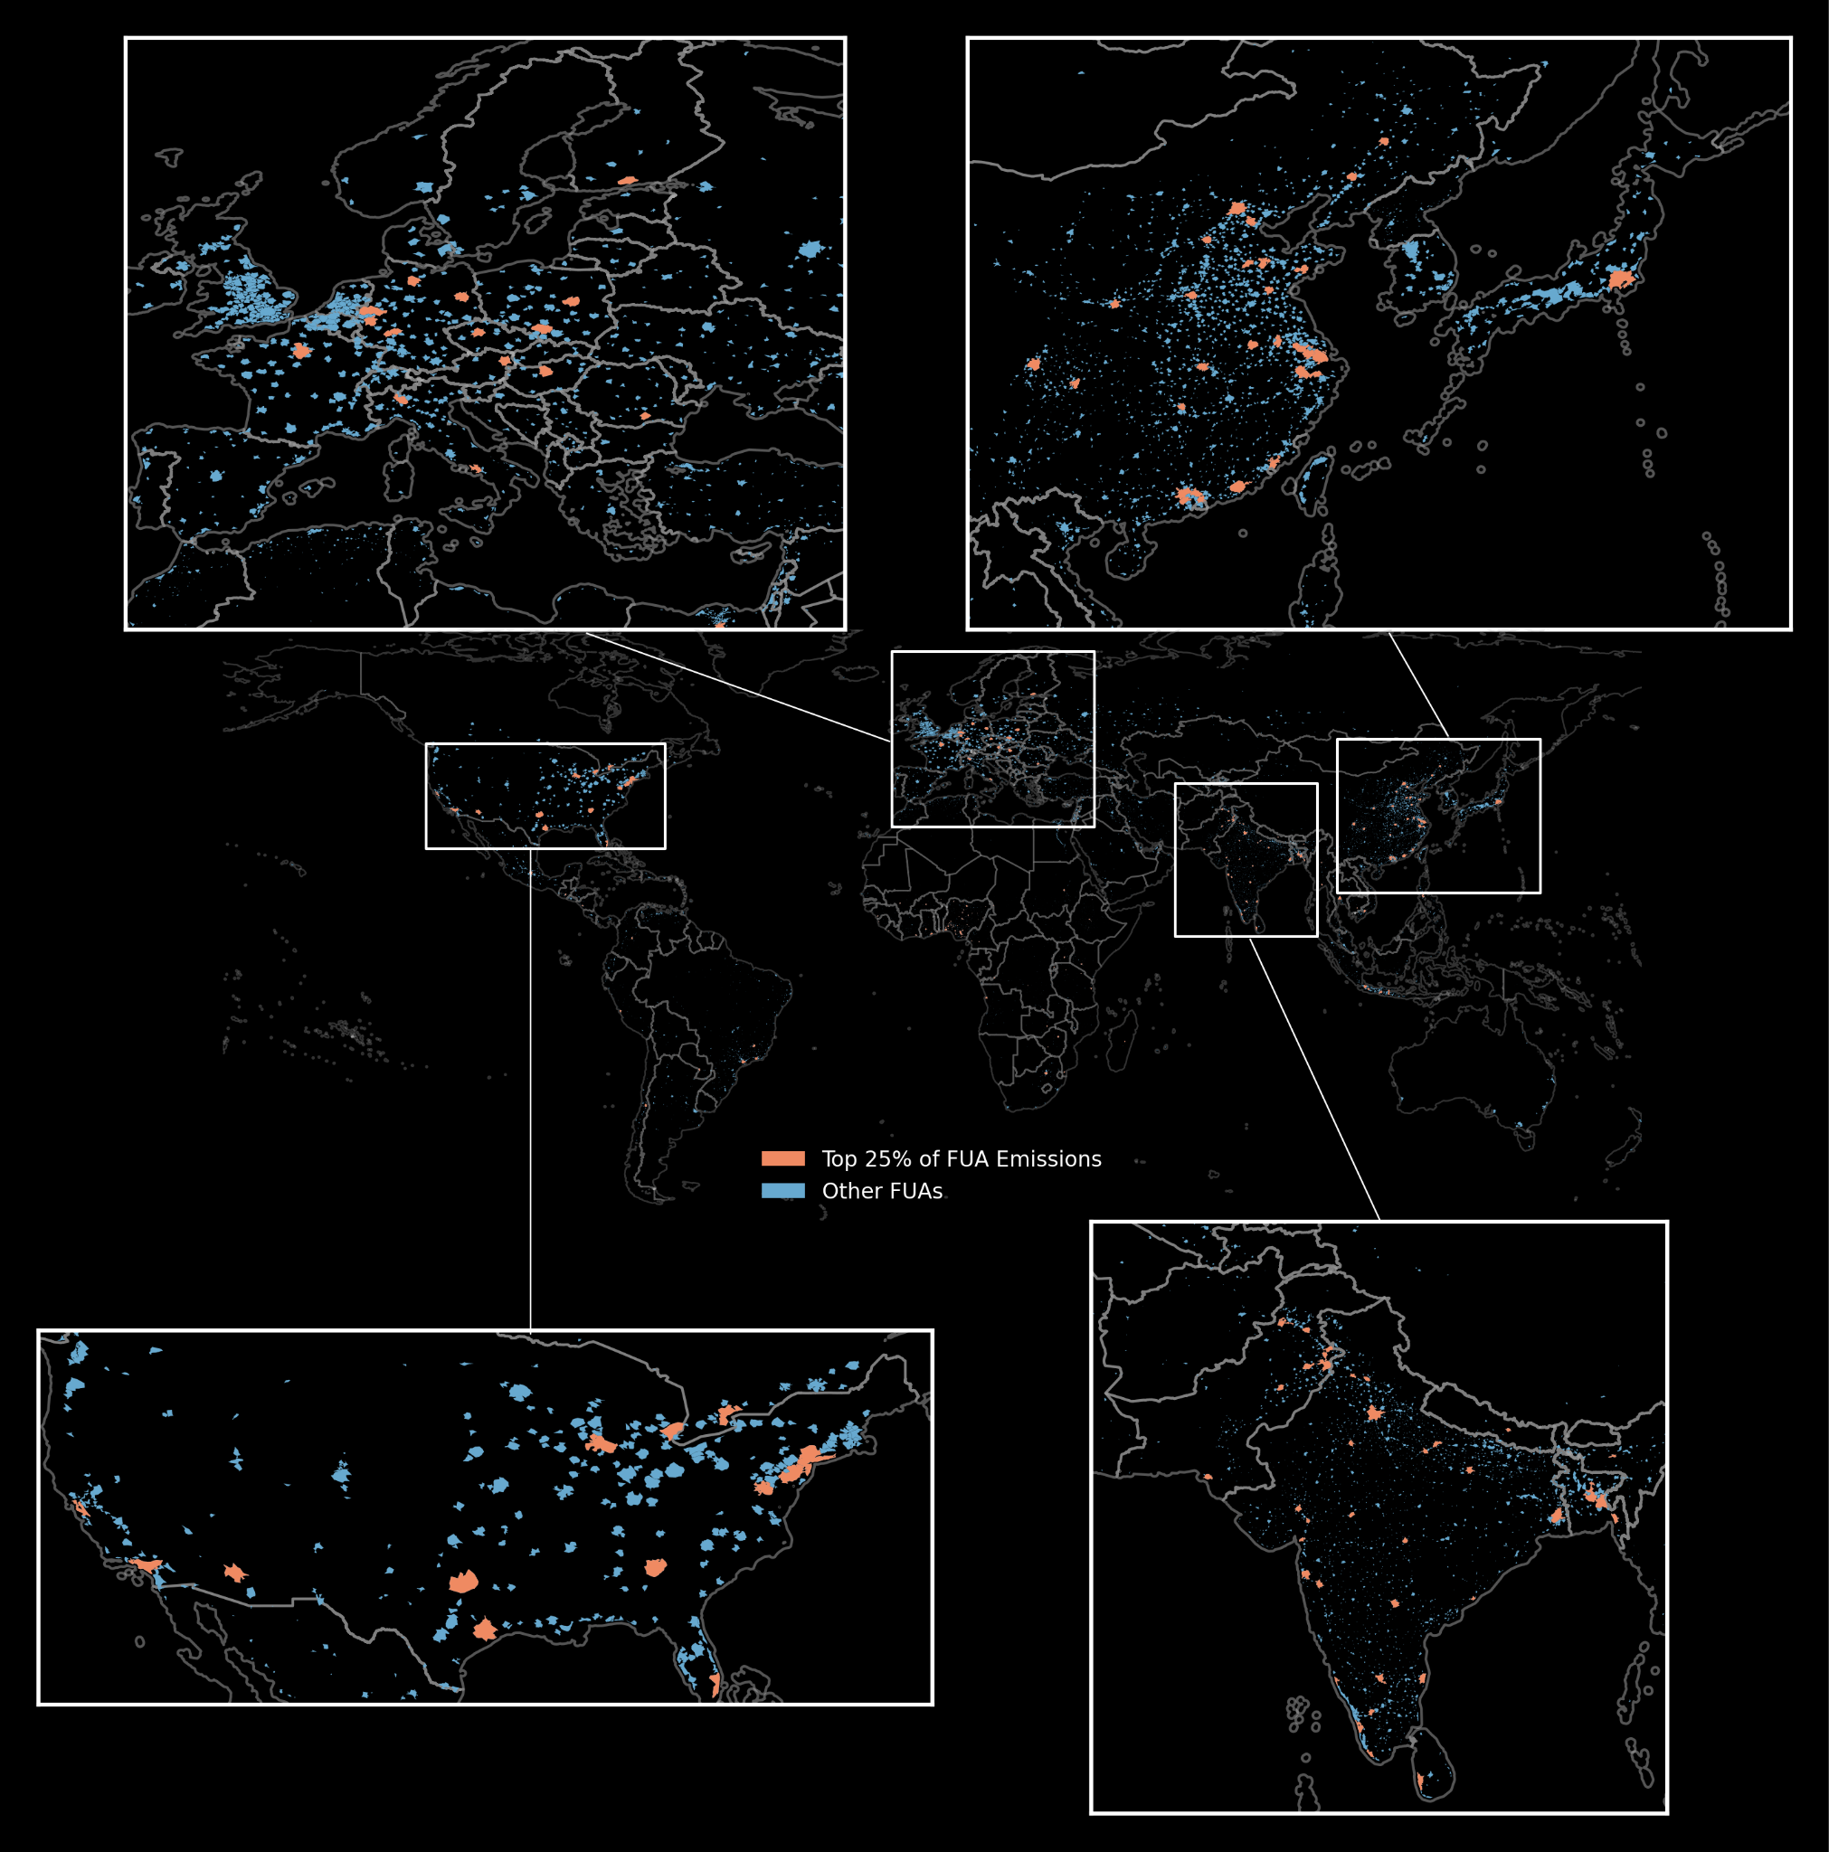
Figure S.10. Distribution of GHSL FUA boundaries across the globe. The FUAs representing the top 25% of CO2e-100yr direct onsite building biofuels emissions for the year 2023 are shown in orange and the remaining FUAs are shown in blue.

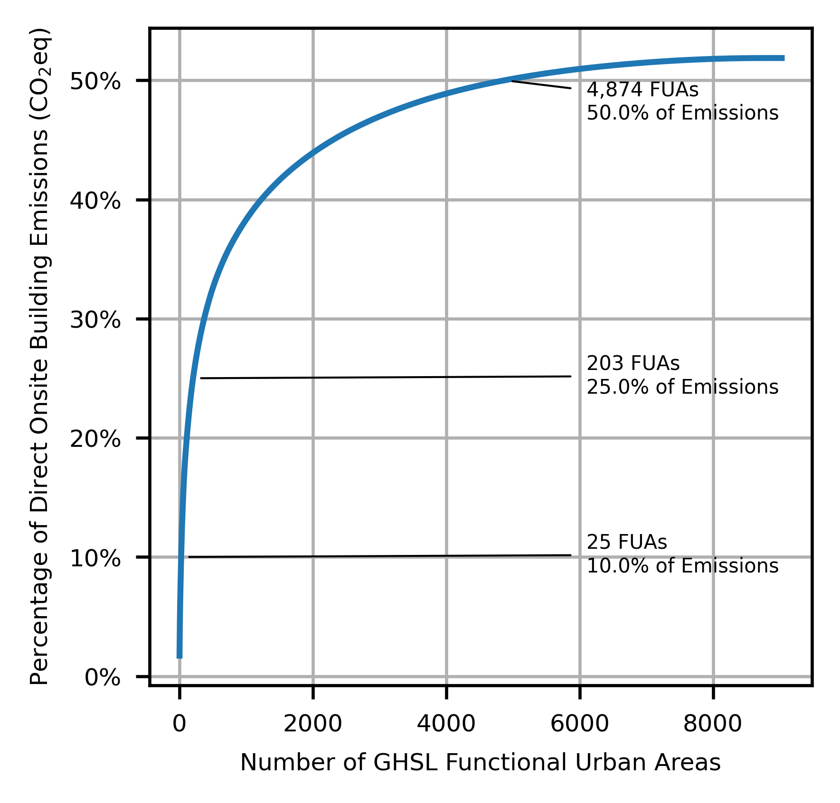
Figure S.11. For direct onsite building emissions from biofuels only, we explore the cumulative percentage of global direct CO2e-100yr building emissions as compared to GHSL’s Functional Urban Areas boundaries for the year 2023.

S.5. Known issues

S.5.1. Energy Use Intensity
To address identified challenges with the CURB Tool data, Agartala (India) was removed since there are no residential sector values in the original data, duplicate values for Juba (labeled “Sudan” for “South Sudan”) from CURB tool dataset were removed, and Panama City’s (Panama) data was removed as there was a likely error with the hotel EUI datapoint that impacted the non-residential data totals. Geospatial nearest neighbor values substitute for any removed EUI datapoints.

S.5.2. Final Estimates

In the Democratic Republic of the Congo, we are aware of possible missing data from the EDGAR data that impacts our estimates and may lead to underestimation in this location in the EDGAR super-resolved version of the model.

S.5.3. Inclusion/Exclusion of Biofuels

Biofuels (e.g., wood) are a fuel type used across the building energy sector and – particularly for N₂O and CH₄ – has a disproportionately large emissions factor as compared to other fuel types. However, biofuels are not consistently included (or excluded) by default in various inventories and emissions estimation models. IPCC standards (IPCC, 2019) dictate that for accounting purposes, CO₂ biofuel-related emissions from harvested wood biomass used directly as energy feedstocks, to include harvested wood biomass burnt directly as fuel wood on a residential, commercial, or industrial scale, as part of the Agriculture, Forestry, and Other Land Use (AFOLU) sector (IPCC, 2019) whereas N₂O and CH₄ biofuel-related emissions are accounted for within the Energy sector alongside fossil fuel-related emissions. As some sources (e.g., UNFCCC and CAIT) follow this IPCC convention in a non-separable way, we cannot choose to entirely exclude biofuels by default – nor can we add it to sources such as DPFC that contain no biofuels-related data. We thus use the following variations of our modeling approach to overcome differences across comparison data related to the inclusion or exclusion of biomass.

Where possible, we use the EDGAR v8.0 gridded data (with 0.1degree-by-0.1degree spatial resolution) as our source of EDGAR v8.0 data against which we apply our super-resolution method. However, to isolate the emissions contributions from onsite biofuels for N₂O and CH₄ we instead apply our super-resolution method to the EDGAR v8.0 country-level data; we thereafter compute the difference between the super-resolved gridded data reflecting all onsite combusted fuels and super-resolved country-level data reflecting onsite biofuels to reflect the emissions contributions from onsite fossil fuels. These data sources are shown in Table S.2.

Table S.2. Sources of EDGAR v8.0 data, by GHG and fuel type.
GHG | All Onsite Combusted Fuels | Onsite Fossil Fuels | Onsite Biofuels
CO₂ | EDGAR v8.0 Gridded Data (0.1degree-by-0.1degree) | EDGAR v8.0 Gridded Data (0.1degree-by-0.1degree) | EDGAR v8.0 Gridded Data (0.1degree-by-0.1degree)
N₂O | EDGAR v8.0 Gridded Data (0.1degree-by-0.1degree) | *Computed | EDGAR v8.0 Country Data
CH₄ | EDGAR v8.0 Gridded Data (0.1degree-by-0.1degree) | *Computed | EDGAR v8.0 Country Data
*Computed as the difference between super-resolved gridded data for all onsite combusted fuels and super-resolved country-level data for onsite country-level biofuels.

Our disaggregation from EDGAR v8.0 grid-cell level data was computed precisely as described in Section 2.3, to include using the 0.1-degree-by 0.1-degree gridded data as the “larger grid cell R” referenced in Figure 2. For our municipality-level analysis with comparison against DPFC data, we instead disaggregated EDGAR country-level data by using country polygons as the “larger grid cell R” referenced in Figure 2. The fundamental method is identical in either case: we use estimated energy consumption to proportionally allocate the single value associated with the larger grid cell R to smaller grid cells at 30-arcsecond spatial resolution.

S.5.4. Verifying modeled emissions estimates

EDGAR’s Energy for Buildings data includes not only residential and commercial buildings. As EDGAR’s Energy for Buildings data uses data from the IPCC’s 1996 (1A4) and 2006 codes (1A4+1A5) on ‘Other Sectors,’ this includes agricultural off-road vehicles (1.A.4.c.ii), fishing (1.A.4.c.iii), and marine vessels (1.A.5.b) that do not exactly align with our data estimates. From our review, these are small values that have a minor impact on estimates, but is key to note as we compare our model to EDGAR for validation.

S.5.5. Municipal-Level Validation Boundary Summary
For municipal-level validation, we discovered that there is not a consistent set of geographic boundaries from a common source at a corresponding municipality level. GADM is an open-source project that “wants to map the administrative areas of all countries, at all levels of sub-division” (GADM, 2024) and our primary source for country-level boundaries represented by GADM Level 0. While GADM tends to have near-complete global coverage within their data at the Level 0 administrative subdivision representing each nation, their data was not globally comprehensive at the municipality level. For example, the GADM Level 2 boundaries for the United States were not consistent with the size of each municipality contained within the United States DPFC data, and GADM does not contain municipality-level boundaries for the United States at a level corresponding to a more detailed subdivision.

To conduct our model validation at the municipal level, we identified distinct geospatial boundary files for each municipal region under consideration using authoritative data sources for each region. We found that GADM boundaries were sufficient for Chile, Canada, Costa Rica, and Denmark. For Mexico, Japan, and India, we identified corresponding municipality-level boundaries from the Humanitarian Data Exchange (The Humanitarian Data Exchange, 2024). In the United States, we were required to identify a boundary file independently for each of the 50 states in the country from authoritative state government websites. Table S.3 summarizes the source for each such set of boundaries.

Table S.3. Boundary Sources for Municipality-Level Validation
Country | Level for municipalities | Boundary Source
Mexico | Level 2 | Humanitarian Data Exchange
Japan | Level 2 | Humanitarian Data Exchange
Chile | Level 3 | GADM
Canada | Level 3 | GADM
Costa Rica | Level 2 | GADM
India | Level 5 | Humanitarian Data Exchange
Denmark | Level 2 | GADM
United States | N/A | State Government Boundaries

S.5.6 Mixed-Use Buildings
One challenge with the residential definition is that it will encompass some commercial building activity by including mixed-use and other building types that happen to exist within an area of predominantly residential buildings. This will lead to an overestimation of residential building emissions and an underestimation of non-residential emissions, which we do see in our data. Future versions of our work will seek to identify and leverage additional sources of data related to the distribution of building categories to enhance our analysis.

