Supplementary Material to

Decision processes in 3D structural MRI schizophrenia classification evaluated with saliency maps
Julia Jelitzki ¹², Alexandra Reichenbach ^{12*+}, and Alexander Windberger ³⁺

¹Center for Machine Learning, Heilbronn University, Heilbronn, Germany
²Medical Faculty Heidelberg, University of Heidelberg, Heidelberg, Germany
³Faculty of Informatics, Heilbronn University, Heilbronn, Germany
* corresponding author: alexandra.reichenbach@hs-heilbronn.de
⁺ these authors contributed equally to this work

Keywords: deep learning, schizophrenia, structural magnetic resonance imaging, explainable AI, Grad-CAM, saliency map

Images

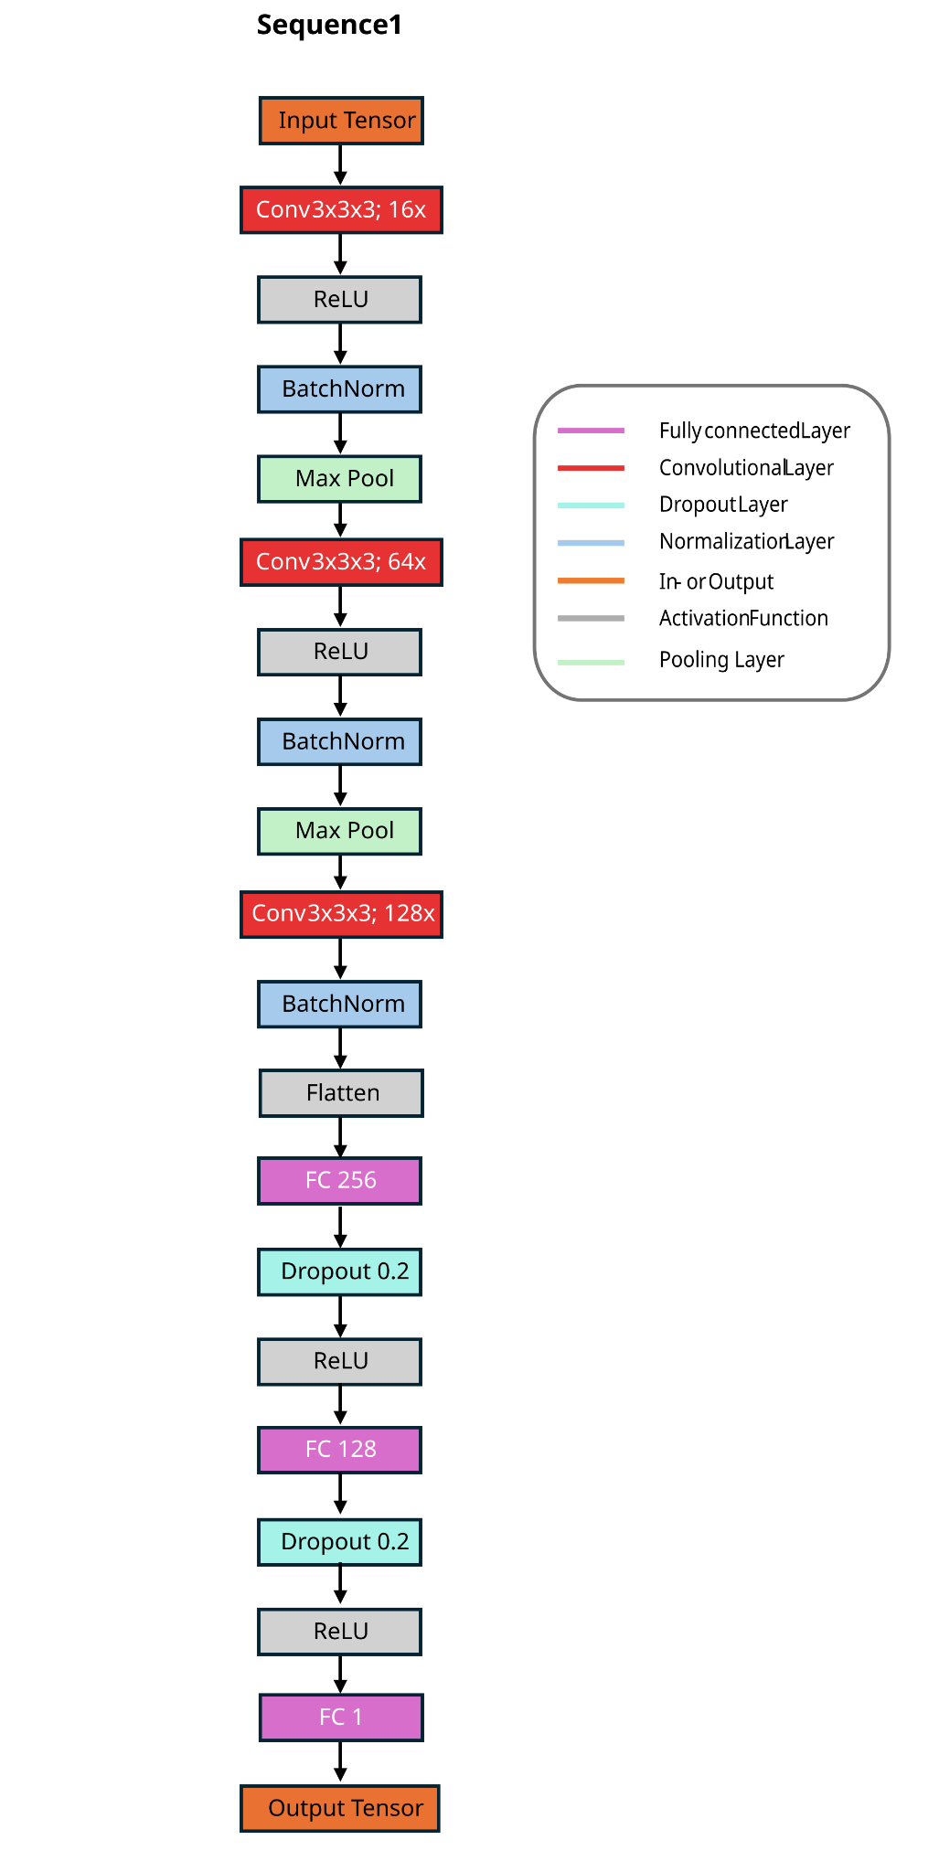

Supplemental Figure 1: Architecture depiction of Sequence 1 architecture.
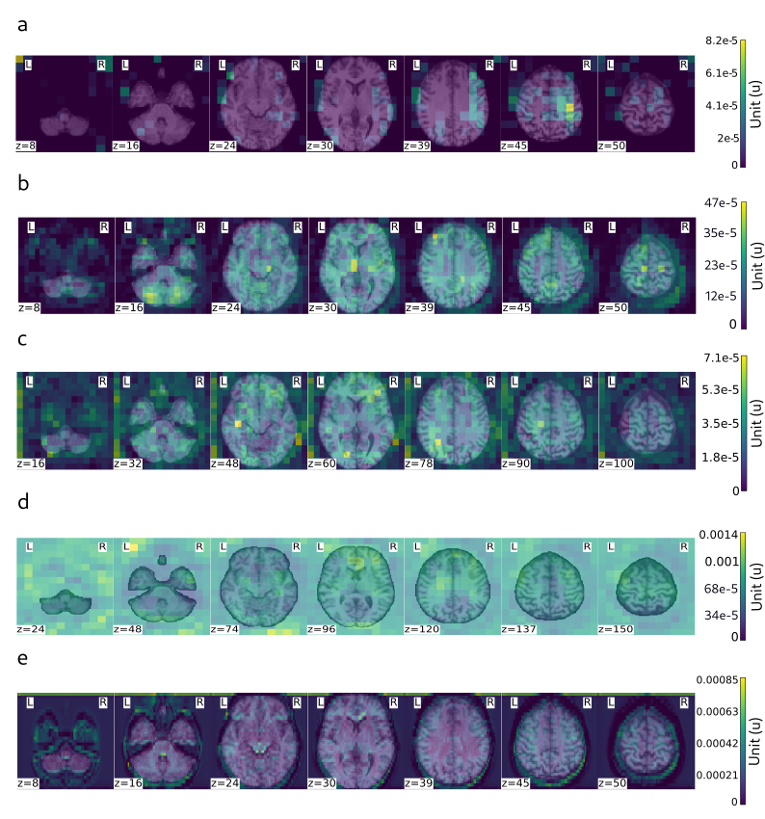
Supplemental Figure 2: Averaged saliency map of control class for the architecture types a) Sequence 1 b) OhNet c) Med3D d) RiekeNet e) MixedConv. Note that the architecture styles require different image resolutions.

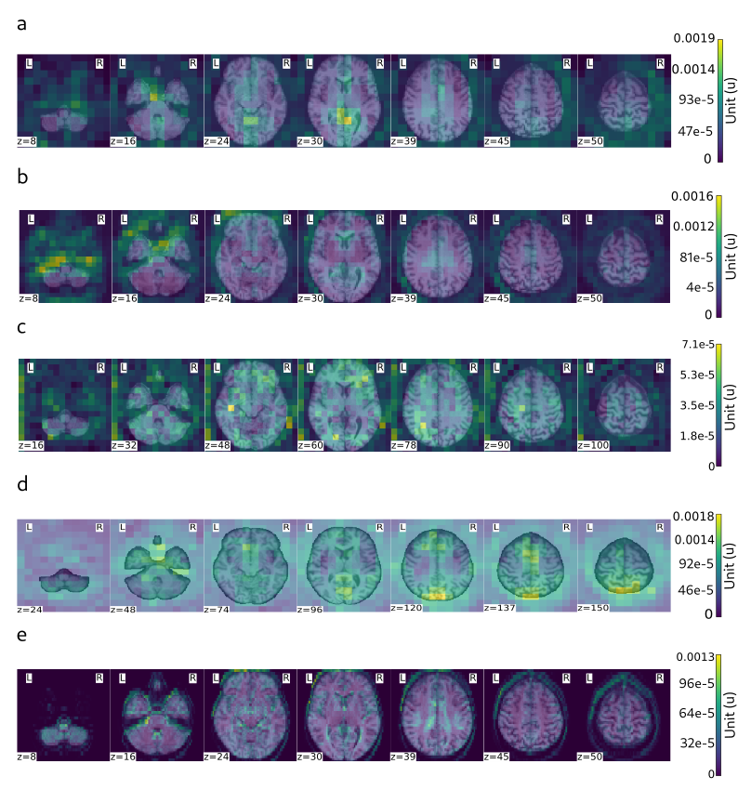
Supplemental Figure 3: Averaged saliency map of patient class for the architecture types a) Sequence 1 b) OhNet c) Med3D d) RiekeNet e) MixedConv. Note that the architecture styles require different image resolutions.

Tables

Network Name | Input Size | Preprocessing | Pretrained Weights
Sequence 1 | 64x64x64 | None | no
OhNet | 64x64x64 | None | no
Med3D10 | 128x128x128 | z-normalisation | yes
BrainID | 128x128x128 | rescale 0- 1 | yes
RiekeNet | 192x220x192 | z-normalisation | yes
Mixed Conv | 64x64x64 | rescale 0-1 z-normalisation | yes
ResNet18 | 64x64x64 | rescale 0-1 z-normalisation | yes

Supplementary Table 1. Training details and additional image pre-processing procedures for every network architecture. All images were additionally prepared(skullstripped, MNI space registration, ect.) as declared in the Data section.

Network Name | Lerningrate | Dropout | Weight Decay | Epochs | Pretrained Weights
Sequence 1 | 0.00015 | 0.2 | 0.00001 | 25 | no
OhNet | 0.00007 | 0.2 | 0.01 | 20 | no
Med3D10 | 0.000005 | 0.35 | 0.01 | 20 | yes
BrainID | 0.00002 | 0.6 | 0.05 | 30 | yes
RiekeNet | 0.0009 | 0.15 | 0.01 | 20 | yes
Mixed Conv | 0.009 | 0.3 | 0.5 | 30 | yes
ResNet18 | 0.00094 | 0.3 | 0.05 | 30 | yes

Supplementary Table 2. Overview of key network training parameters for all architecture types.

