Table 1: Tyrosine kinase inhibitor Structure
SR. No. | Name |  | Type of Inhibitor | Chemical Structure |  | Uses
1. | Imatinib (Gleevec) |  | Selective competitive tyrosine kinase inhibitor that targets BCR-ABL, c-KIT, and PDGFR. | 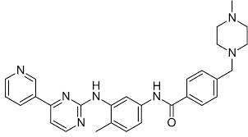 |  | Treat chronic myelogenous leukemia (CML).
2. | Nilotinib (Tasigna) |  | BCR-ABL tyrosine kinase inhibitor. | 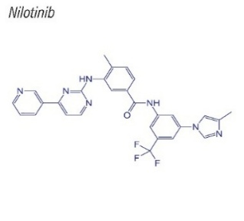 |  | Treat chronic myelogenous leukemia (CML).
3. | Sunitinib (Sutent) |  | Multi-targeted receptor tyrosine kinase (RTK) inhibitor. | 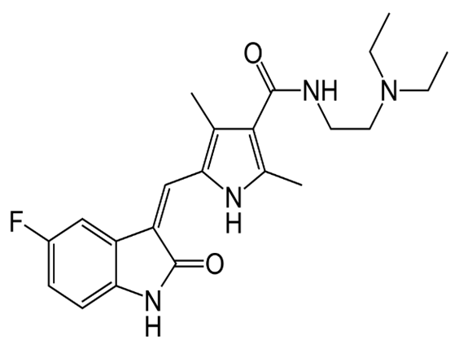 |  | Treat renal cell carcinoma (RCC).
4. | Gefitinib (Iressa) |  | EGFR (epidermal growth factor receptor) tyrosine kinase inhibitor. | 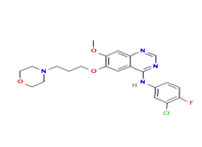 |  | Treat non-small cell lung cancer (NSCLC) with EGFR mutations.
5. | Lapatinib |  | Dual tyrosine kinase inhibitor of EGFR and HER2 receptors. | 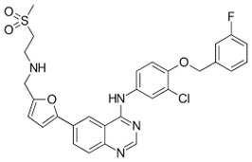 |  | Treat HER2-positive breast cancer.
6. | Erlotinib (Tarceva) |  | EGFR (epidermal growth factor receptor) tyrosine kinase inhibitor. | 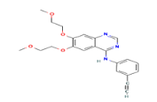 |  | Treat non-small cell lung cancer (NSCLC) with EGFR mutations.
7. | Dasatinib (Sprycel) |  | BCR-ABL and SRC family tyrosine kinase inhibitor. | 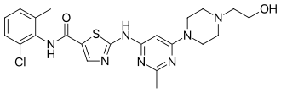 |  | Treat chronic myelogenous leukemia (CML).
8. | Axitinib (inlyta) |  | Selective vascular endothelial growth factor receptor (VEGFR) | 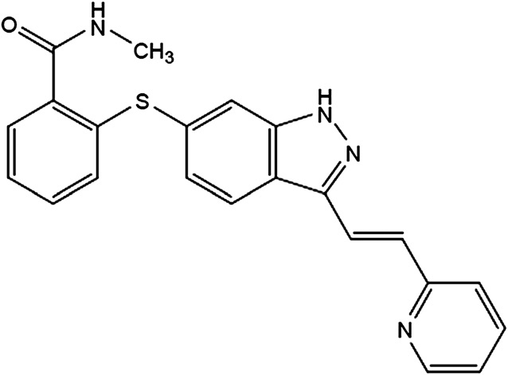 |  | Treat renal cell carcinoma (RCC).
9. | Osimertinib (Tagrisso) |  | EGFR tyrosine kinase inhibitor with activity against T790M mutation. | 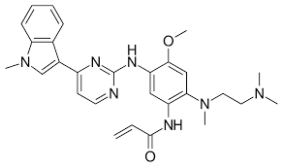 |  | Treat non-small cell lung cancer (NSCLC) with EGFR T790M mutations.
10. | Crizotinib (Xalkori) |  | ALK (anaplastic lymphoma kinase). | 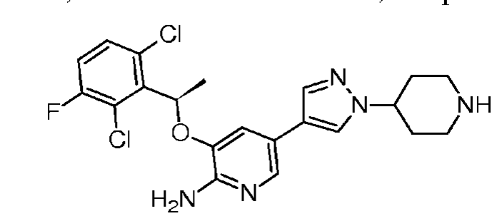 |  | Treat non-small cell lung cancer (NSCLC)
11. | Ponatinib (Iclusig) |  | BCR-ABL tyrosine kinase inhibitor with activity against the T315I mutation. | 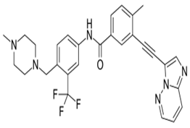 |  | Treat chronic myelogenous leukemia (CML).
12. | Sorafenib (Nexavar) |  | Multi-kinase inhibitor targeting RAF, VEGFR, and PDGFR. | 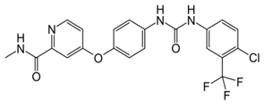 |  | Treat renal cell carcinoma (RCC).
13. | Regorafenib (Stivarga) |  | Multi-kinase inhibitor targeting VEGFR, FGFR, PDGFR, and other kinases. | 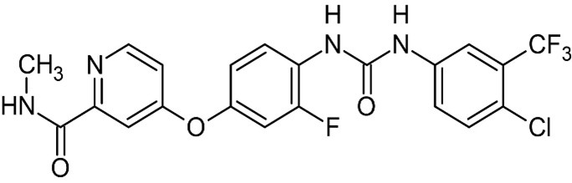 |  | Treat metastatic colorectal cancer (CRC).
14. | Tofacitinib (Xeljanz) |  | Janus kinase (JAK) inhibitor. | 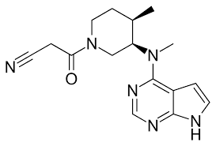 |  | Treat moderate to severe rheumatoid arthritis.
15. | Ruxolitinib (Jakafi) |  | Janus kinase (JAK) 1 and JAK2 inhibitor. | 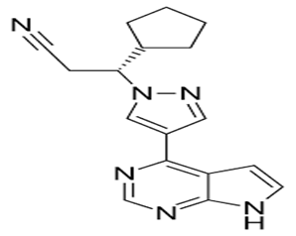 |  | Primarily used to treat myelofibrosis
16. | Vandetanib (Caprelsa) |  | multi-kinase inhibitor targeting VEGFR, EGFR, and RET. | 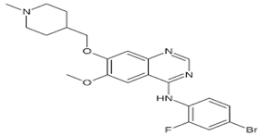 |  | Treat medullary thyroid cancer (MTC).
17. | Midostaurin (Rydapt) |  | Multi-kinase inhibitor targeting FLT3, KIT, and other kinases. | 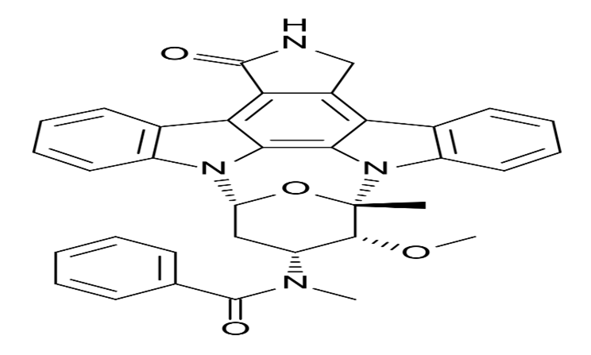 |  | Treat acute myeloid leukemia (AML) with FLT3 mutations.
18. | Pazopanib (Votrient) |  | Multi-kinase inhibitor targeting VEGFR, PDGFR, and c-kit. | 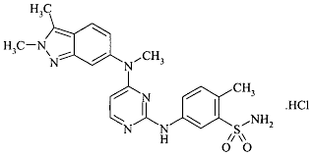 |  | Treat renal cell carcinoma (RCC).
19. | Alectinib (Alecensa) |  | ALK (anaplastic lymphoma kinase) tyrosine kinase inhibitor. | 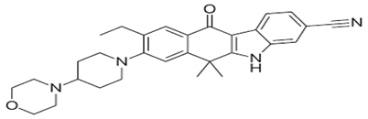 |  | Treat non-small cell lung cancer (NSCLC) with ALK gene mutations.
20. | Tivozanib (Fotivda) |  | Selective VEGFR (vascular endothelial growth factor receptor) tyrosine kinase inhibitor. | 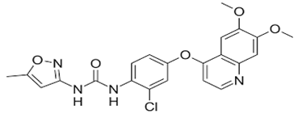 |  | Treat renal cell carcinoma (RCC).
21. | Cabozantinib |  | Multi-kinase inhibitor targeting VEGFR, MET, and AXL. | 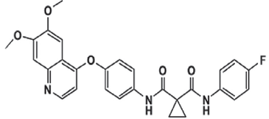 |  | Treat renal cell carcinoma (RCC).
22. | Neratinib |  | HER2/EGFR tyrosine kinase inhibitor. | 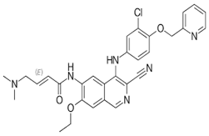 |  | Treat HER2-positive breast cancer.
23. | Brigatinib |  | ALK (anaplastic lymphoma kinase) tyrosine kinase inhibitor. | 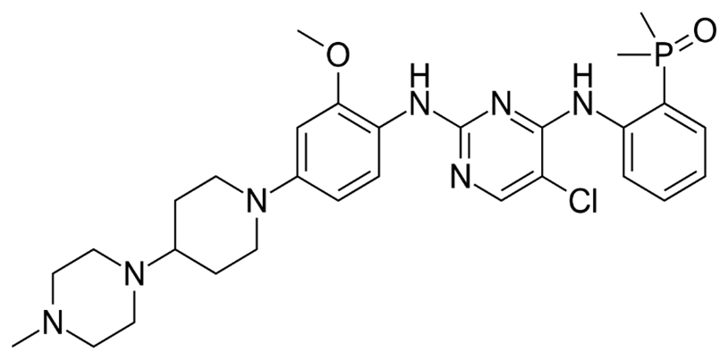 |  | Treat ALK-positive non-small cell lung cancer (NSCLC).
24. | Bosutinib |  | BCR-ABL and Src family tyrosine kinase inhibitor. | 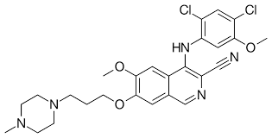 |  | Treat chronic myelogenous leukemia (CML).
25. | Zanubrutinib |  | Bruton's tyrosine kinase (BTK) inhibitor. | 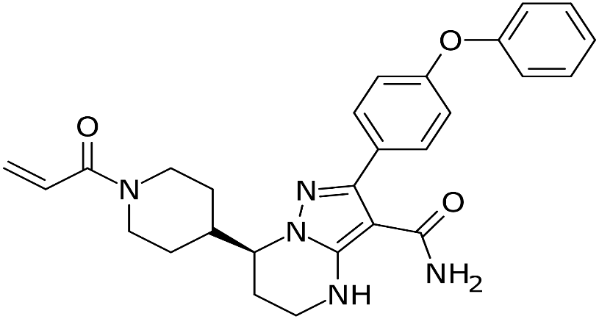 |  | Treat mantle cell lymphoma (MCL).
26. |  | Fedratinib | Fedratinib is a Janus kinase 2 (JAK2) inhibitor. | 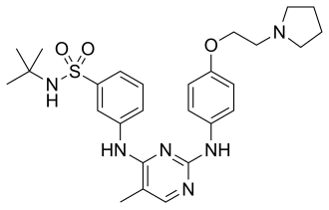 | Used for the treatment of myelofibrosis, which is a rare type of bone marrow cancer.

Table 2: structure of designed compounds with substitution
SR. No. | Compound Code | structure | Substitution
1. | S1 | 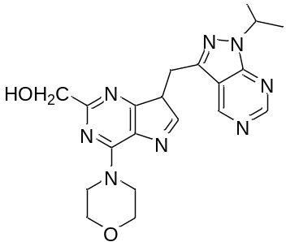 | Methanol
2. | S2 | 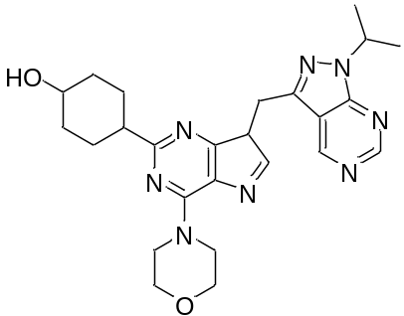 | Hydoxycyclohexyl
3. | S3 | 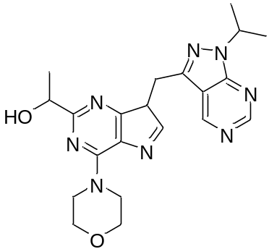 | 1-ethanol
4. | S4 | 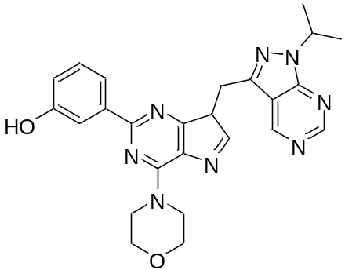 | m-hydroxyphenyl
5. | S5 | 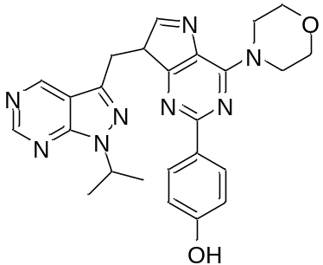 | p-hydroxyphenyl
6. | S6 | 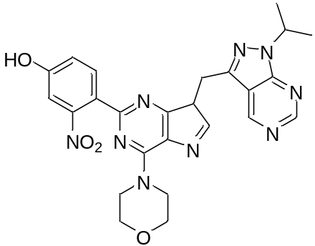 | o-nitro-p-hydroxy-phenyl

