Supplemental A: Search Strategy
Embase Classic+Embase <1947 to 2024 December 18>
Ovid MEDLINE(R) ALL <1946 to December 18, 2024>

1 (traumatic brain injury or TBI).mp. 167512
2 (traumatic brain injury or TBI).ab. 132776
3 exp traumatic brain injury/ 103680
4 (pneumonia or HAP or VAP or pulmonary infection).mp. 746955
5 (pneumonia or HAP or VAP or pulmonary infection).ab. 401928
6 exp pneumonia/ 842236
7 (predict* or model* or scor* or validat* or risk* or prognos* or associat* or factor*).ab. 31733508
8 1 or 2 or 3 177455
9 4 or 5 or 6 1029052
10 7 and 8 and 9 2173

Supplemental B: Forest Plots
Male vs Female Sex
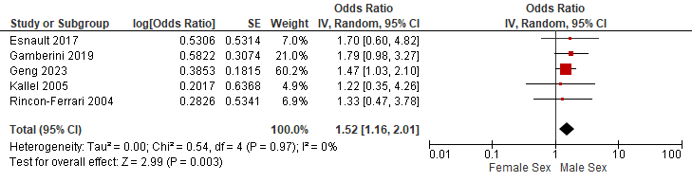
Increasing Age (Per 10 Years)
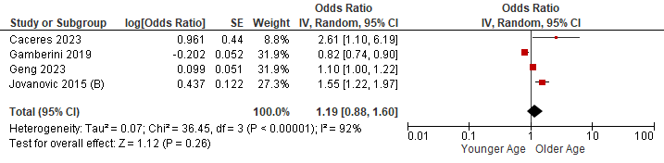
Injury Factors (Adjusted)
Higher vs Lower Chest AIS
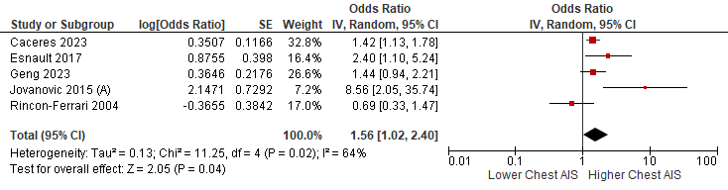
Increasing ISS (Per 10 Points)
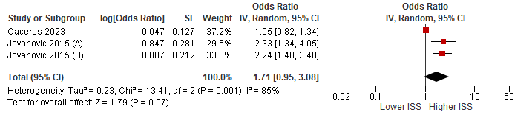
Lower vs Higher GCS
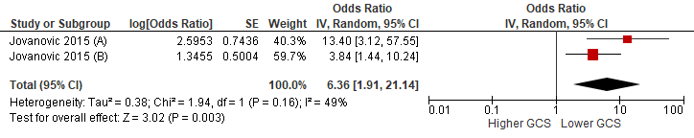
Treatment Factors
Mechanical Ventilation vs None
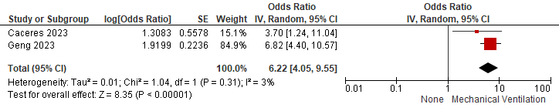
Barbiturate Use vs None
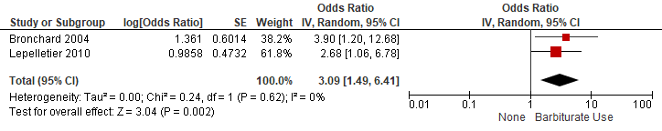
Early Antibiotics vs None
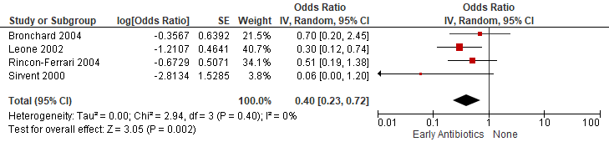

Supplemental C: Risk of Bias Assessments
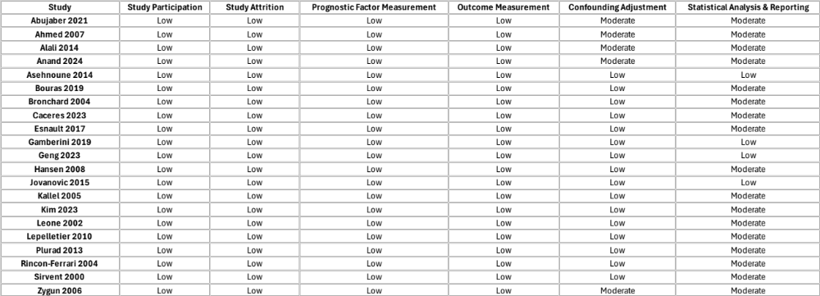

Supplemental D: GRADE Certainty Assessments
Question: What are the risk factors for pneumonia following traumatic brain injury?
№ of studies | Certainty assessment |  |  |  |  |  | impact | Certainty | Narrative Summary
№ of studies | Study design | Risk of bias | Inconsistency | Indirectness | Imprecision | Other considerations | impact | Certainty | Narrative Summary
Male Sex
5 | non-randomised studies | not serious | not serious | not serious | not serious | none | Pooled OR = 1.52 (95% CI 1.16 to 2.01) | ⨁⨁⨁⨁  High | Male sex is associated with increased risk of pneumonia following TBI.
Older Age
4 | non-randomised studies | not serious | serious^{b} | not serious | seriousª | none | Pooled OR = 1.19(95% CI 0.88 to 1.60) per each 10 years. | ⨁⨁◯◯  Low | Older age may be associated with increased risk of pneumonia following TBI.
Higher Injury Severity
3 | non-randomised studies | not serious | serious^{b} | not serious | seriousª | none | Pooled OR = 1.71 (95% CI 0.95 to 3.08) | ⨁⨁◯◯  Low | Higher injury severity may be probably associated with increased risk of pneumonia following TBI.
Lower vs Higher GCS
2 | non-randomised studies | not serious | not serious | not serious | not serious | Only two small studies^{c} | Pooled OR = 6.36 (95% CI 1.91 to 21.14) | ⨁⨁⨁◯  Moderate | Lower GCS is probably associated with increased risk of pneumonia following TBI.
Higher vs Lower Chest AIS
5 | non-randomised studies | not serious | Serious^{d} | not serious | Serious^{e} | none | Pooled OR = 1.56 (95% CI 1.02 to 2.40) | ⨁⨁⨁◯  Moderate^{f} | Higher Chest AIS is probably associated with increased risk of pneumonia following TBI.
Mechanical Ventilation
2 | non-randomised studies | Serious^{g} | not serious | not serious | Not serious | none | Pooled OR = 6.22 (95% CI 4.05 to 9.55) | ⨁⨁⨁◯  Moderate | Mechanical ventilation is probably associated with increased risk of pneumonia following TBI.
Early Antibiotics
4 | non-randomised studies | Serious^{g} | not serious | not serious | not serious | Intervention with potential confounding by indication^{g} | Pooled OR = 0.40 (95% CI 0.23 to 0.72) | ⨁⨁⨁◯  Moderate | Early antibiotics is probably associated with increased risk of pneumonia following TBI.
b
2 | non-randomised studies | Serious^{g} | not serious | not serious | not serious | Intervention with potential confounding by indication^{g} | Pooled OR = 3.09 (95% CI 1.49 to 6.41) | ⨁⨁⨁◯  Moderate | Barbiturate use is probably associated with increased risk of pneumonia following TBI.

Explanations
- Wide CI that contributes to imprecision
- High degree of statistical heterogeneity based on visual inspection and I-squared
- Only two small studies
- Borderline inconsistency
- Borderline imprecision
- Lowered once for borderline inconsistency and imprecision
- Intervention with potential confounding by indication or residual confounding

