Supplementary Information

- Trajectory convergence

RMSD and radius of gyration was used to test for convergence. The system was defined as converged once the RMSD and Rg remained within a stable range.

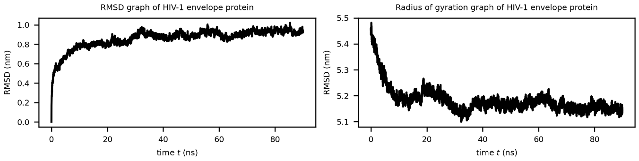
Supplementary Figure 1: RMSD and radius of gyration of HIV-1 envelope protein

- MDInteractions test suite
The MDInteractions python package was tested using a test suite (https://github.com/afowdar/MDInteractions/tests). The MDAnalysis repository (git clone https://github.com/MDAnalysis/mdanalysis.git) was cloned locally. The first five frames of the ten frame adk_oplsaa, adenosine kinase protein in the ‘testsuite/MDAnalysisTests/data’ was extracted.

An index file with two new groups was created using gmx make_ndx. The first group consisted of residues 1-4 and the second group consisted of residues 5-8. Each group was treated as a separate protein. The second group (given as group 11 in the index file) was used to manually compute the distances between amino acid residue pairs to infer intra-protein interacting residues (Supplementary Table 1) while both groups were used to infer inter-protein interacting residues for the first five frames (Supplementary Table 2).

The protein_interactions and mean_distance modules were executed on frames 1–5 using both the Python API and the command-line interface (CLI). These runs parsed the adk_oplsaa.gro, adk_oplsaa.xtc, and the associated index file, with parameter settings aligned with those described in the main text. The results produced by both approaches were consistent with the manually generated reference data presented in Supplementary Tables 1 and 2.

In addition, four supplementary Python test scripts were developed to validate specific interaction types: test_intra_pairs.py, test_inter_pairs.py, test_mean_intra.py and test_mean_inter.py. These scripts are designed to test the functionality and accuracy of the corresponding modules using the pytest framework. All tests implemented in the four scripts passed successfully, confirming the expected behaviour of the modules.

Supplementary Table 1: Manual computation of intra-protein distances and mean distance.
Intra-protein (group 11) |  |  |  |  |  |  |  |  |  | Frame 1 |  | Frame 2 | Frame 3 | Frame 4 | Frame 5
 |  |  |  |  |  |  |  |  |  | Distance (Aº) |  |  |  |  |  | Mean Distance (Aº) | Consistent pairs within 7 Aº
5 | LEU | CB |  | 6 |  | LEU |  | CB |  | 5.7677 | 5.7178 |  | 5.685 | 5.8499 | 5.7218 | 5.7484 | Yes
5 | LEU | CA |  | 7 |  | GLY |  | CA |  | 7.0383 | 7.1126 |  | 6.9905 | 7.1363 | 7.2972 | 7.115 | No
5 | LEU | CB |  | 8 |  | ALA |  | CB |  | 11.7281 | 11.6646 |  | 11.0836 | 11.7372 | 11.871 | 11.6169 | No
6 | LEU | CA |  | 7 |  | GLY |  | CA |  | 3.7627 | 3.91 |  | 3.8246 | 3.8199 | 3.8395 | 3.8313 | Yes
6 | LEU | CB |  | 8 |  | ALA |  | CB |  | 8.6193 | 8.7145 |  | 8.8477 | 8.2144 | 8.8296 | 8.6451 | No
7 | GLY | CA |  | 8 |  | ALA |  | CA |  | 3.8727 | 3.8676 |  | 3.8535 | 3.844 | 3.8512 | 3.8578 | Yes
Supplementary Table 2: Manual computation of inter-protein distances and mean distances.
Inter-protein (group 10 and 11) |  |  |  |  |  |  |  |  |  | Frame 1 |  | Frame 2 | Frame 3 | Frame 4 | Frame 5
 |  |  |  |  |  |  |  |  |  | Distance (Aº) |  |  |  |  |  | Mean Distance (Aº) | Consistent pairs within 15 Aº
1 | MET |  | CB |  | 5 |  | LEU |  | CB | 11.933 |  | 11.6663 | 13.0231 | 12.278 | 12.3419 | 12.2485 | Yes
1 | MET |  | CB |  | 6 |  | LEU |  | CB | 16.0299 |  | 15.3136 | 16.7158 | 16.7666 | 16.2732 | 16.2198 | No
1 | MET |  | CA |  | 7 |  | GLY |  | CA | 18.928 |  | 18.8765 | 18.881 | 18.3526 | 18.7274 | 18.7531 | No
1 | MET |  | CB |  | 8 |  | ALA |  | CB | 23.1146 |  | 22.6307 | 23.6499 | 23.4377 | 23.7902 | 23.3246 | No
2 | ARG |  | CB |  | 5 |  | LEU |  | CB | 10.5477 |  | 11.6620 | 11.7743 | 11.1459 | 11.2690 | 11.2798 | Yes
2 | ARG |  | CB |  | 6 |  | LEU |  | CB | 13.6674 |  | 14.4816 | 14.3259 | 14.5752 | 14.1958 | 14.2492 | Yes
2 | ARG |  | CA |  | 7 |  | GLY |  | CA | 16.4860 |  | 17.1317 | 17.0375 | 16.7145 | 17.2406 | 16.9221 | No
2 | ARG |  | CB |  | 8 |  | ALA |  | CB | 21.7394 |  | 22.7176 | 22.4065 | 22.3112 | 22.5457 | 22.3441 | No
3 | ILE |  | CB |  | 5 |  | LEU |  | CB | 6.0862 |  | 6.5222 | 6.6716 | 5.9940 | 6.3203 | 6.3189 | Yes
3 | ILE |  | CB |  | 6 |  | LEU |  | CB | 9.9028 |  | 10.0996 | 10.1672 | 10.1311 | 10.0293 | 10.066 | Yes
3 | ILE |  | CA |  | 7 |  | GLY |  | CA | 12.7121 |  | 13.3331 | 13.2662 | 12.8907 | 13.4853 | 13.1375 | Yes
3 | ILE |  | CB |  | 8 |  | ALA |  | CB | 17.1656 |  | 17.6709 | 17.3648 | 17.1650 | 17.7468 | 17.4226 | No
4 | ILE |  | CB |  | 5 |  | LEU |  | CB | 5.9568 |  | 5.8082 | 5.7985 | 5.8291 | 5.7792 | 5.8344 | Yes
4 | ILE |  | CB |  | 6 |  | LEU |  | CB | 6.4804 |  | 6.5824 | 6.4621 | 6.6103 | 6.3732 | 6.5017 | Yes
4 | ILE |  | CA |  | 7 |  | GLY |  | CA | 10.2365 |  | 10.4782 | 10.3563 | 10.3459 | 10.5716 | 10.3977 | Yes
4 | ILE |  | CB |  | 8 |  | ALA |  | CB | 14.9512 |  | 14.9943 | 14.8330 | 14.7195 | 14.9462 | 14.8888 | Yes

