Supplementary Material
Development of an Experimental Setup to Investigate Mirror Visual Feedback Effects on Cross-Education for an Intricate Finger Sequence Movement Task
Anurag Gupta¹* , Varadhan SKM¹
¹ Department of Applied Mechanics and Biomedical Engineering, IIT Madras, Chennai, India
*Corresponding author
Anurag Gupta
Department of Applied Mechanics and Biomedical Engineering
Indian Institute of Technology Madras
Chennai – 600036
Tamil Nadu
Email: tech.anurag01@gmail.com
ORCID: 0000-0002-9163-0870

1. Lockout Period Approach for Preventing False Detections
As described in Section 2.4.1: Background in the main text, for a phalanx copper patch, which functions as a key of the Text Input System (TIS), a key press or key release is followed by a period of voltage transitions between HIGH (3.3V) and LOW (0V) before settling at either HIGH (after a key release) or LOW (after a key press) (see Fig. 3 in main text). This period of voltage transitions is referred to as the bounce period. Transitions during the bounce period result in multiple false detections of key presses and key releases.
A simple and effective way to prevent false detections is to ignore any voltage transitions for a fixed duration immediately after detecting a key press or key release. This fixed duration is called the “lockout period” and needs to be greater than the expected bounce duration. Multiple tests were conducted to characterize the bounce periods for both key presses and key releases in the TIS. A lot of variability was observed in the bounce durations across trials. Based on observations from these tests, the lockout periods were empirically set to 25 ms after a key press and 50 ms after a key release.
The code was developed for key press and key release detection that incorporated these lockout periods. The code works as follows: The code monitors the digital input pins for a key press (3.3V to 0V transition). Once a key press is detected on a pin, any further voltage transitions on that pin are ignored for the next 25 ms. After this, the code monitors the pin for a key release (0V to 3.3V transition). Upon detecting a key release, it again ignores any voltage transitions for 50 ms. Following this, the code begins monitoring for the next key press, and the cycle repeats.
2. Limitations and Failure Scenarios of the Lockout Period Approach
Although the lockout period approach greatly reduced false detections, it did not eliminate them entirely. Upon investigation, two main reasons for the false detections were identified: (1) high variability in key press and release bounce durations (both across different keys and across time for the same key), and (2) random voltage transitions occurring during the press duration. This section details a few scenarios (out of many possible ones) that can lead to false detections.
The high variability in the key press and release bounce durations sometimes results in bounce durations that exceed their corresponding lockout durations, leading to false detections. Fig. S1 (a) illustrates a scenario where the key press bounce duration exceeds the key press lockout period of 25 ms. In this case, once the key press lockout period ends, the code begins monitoring for a key release. Since the key press bounce period is still ongoing, the first upward voltage transition immediately after the lockout period is falsely detected as a key release. The code now erroneously enters the key release lockout period. Following this, the code begins monitoring for a key press – when it should still be monitoring for a key release. This entire scenario results in the “key press duration” being wrongly calculated as 25 ms and the code becoming out of sync with the actual typing events, leading to further compounding errors.
Figure S1. Two scenarios in which the lockout period approach fails. (a) Illustration of a key press bounce duration greater than 25 ms, resulting in a false key release detection. (b) Illustration of an isolated voltage transition during the key press duration, resulting in a false key release detection. In both these scenarios, the false key release detection causes the code to become out of sync with the actual typing events, resulting in further false detections when the actual key release occurs.
When the actual key release occurs, the first downward transition during the key release bounce period is falsely detected as a key press, causing the code to erroneously enter the key press lockout period. If the bounce duration of the actual key release exceeds 25 ms, then the first upward transition immediately after the erroneous key press lockout period is falsely detected as a key release.
This entire scenario ensued due to the long key press bounce duration at the beginning, resulting in a false key release detection. While this problem could, in principle, be mitigated by increasing the key press lockout period, it was empirically observed that in some rare cases – particularly during very fast typing – the key press duration was as short as 30 ms. If the lockout period were increased to 30 ms or more, the actual key release instance would be missed by the code. For this reason, the key press lockout period was fixed at 25 ms during testing. Additionally, if we consider a separate scenario where the key release bounce duration exceeds 50 ms (which is the lockout duration for key release), then it will result in false detections during the key release bounce period for reasons similar to those described in the preceding scenario.
Another major cause for false detections is random voltage fluctuations during the key press duration. Fig. S1 (b) illustrates a scenario where an isolated voltage fluctuation during the key press duration results in false detections. Here, during the key press duration when the code is monitoring for a key release, an isolated voltage transition is falsely detected as a key release. The code then erroneously enters the key release lockout period of 50 ms. After this lockout period ends, the code begins monitoring for a key press instead of a key release and is out of sync with the actual typing events. This results in further false detections when the actual key release occurs, as illustrated in Fig. S1 (b).
Figure S2. Illustration of a scenario in which the lockout period approach fails due to persistent voltage transitions throughout the key press duration. These transitions result in multiple false key press and release detections.
A different scenario leading to multiple false detections arises when the entire press duration is noisy, i.e., the voltage transitions persist throughout the press duration. This can happen due to excessive physical sliding between the thumb and phalanx copper patches during typing. Fig. S2 illustrates this scenario. Here, immediately after the first key press lockout period ends, the code falsely detects a key release due to the ongoing noisy voltage transitions. The code then erroneously enters a key release lockout period. Immediately following this lockout period, the code falsely detects a key press – again due to noisy voltage transitions – and enters a key press lockout period. This cycle of false key press and release detections continues throughout the key press duration, as illustrated in Fig. S2.
3. Issues Related to the Stable Period Algorithm
During testing of the stable period algorithm (see Section 2.4.3: Stable Period Algorithm Working in the main text), occasional false detections of key presses and releases were observed. These false detections often caused the algorithm to become out of sync with the actual typing events, leading to errors in the detection of subsequent key events. Upon investigation, two primary causes were identified, and corresponding refinements were introduced to resolve them (see Section 2.5: Stable Period Algorithm Refined in the main text). This section describes the specific issues that disrupted the intended functioning of the stable period algorithm.
3.1 Issue: Entire Press Duration Noisy
In some cases, it was observed that voltage transitions persisted throughout the entire key press duration (see Fig. S3), possibly due to excessive physical sliding between copper patches during typing. In such a scenario, the expected key press stable period does not appear, and consequently, the algorithm mistakenly interprets the 15 ms stable period following the key release bounce as the key press stable period.
Figure S3. Illustration of a scenario in which the majority of the key press duration contains voltage transitions (noise). As a result, the stable period algorithm mistakenly interprets the 15 ms stable period following the key release bounce as the stable period associated with the key press. Consequently, the algorithm becomes out of sync with the actual typing events (highlighted in red).
As a result, the algorithm incorrectly begins monitoring for a key release when it should instead be monitoring for the next key press (see Fig. S3). This misalignment leads to a compounding error: when the same key is pressed again, the first upward transition during the new key press bounce period is incorrectly identified as a key release. The algorithm then erroneously starts monitoring for a key release stable period, having fallen out of sync with the actual typing events, leading to a series of subsequent false detections.
3.2 Issue: Random Voltage Fluctuations During the Key Press Duration
Figure S4. Illustration of a scenario in which an isolated voltage spike during the key press duration results in the stable period algorithm detecting a false key release and, subsequently, a false key press. False detections are highlighted in red. As a result, the algorithm becomes out of sync with the actual typing events.
Random voltage fluctuations during the key press duration were also found to cause false key press and release detections. Fig. S4 illustrates one such scenario (out of multiple possible scenarios). As depicted in the figure, a random voltage spike during the key press duration is falsely detected as a key release by the algorithm. Following this, the algorithm begins monitoring for a key release stable period of 50 ms.
If the remaining key press duration after the voltage spike exceeds 50 ms, then the algorithm detects a false key release stable period. It then begins monitoring for a key press. However, when the actual key release occurs, the first downward transition during the key release bounce period is falsely detected as a key press. This leads to compounding errors as the algorithm is out of sync with the actual typing events.
4. Data Output Format of the TIS
The TIS outputs various timing-related data for each key press–release event. This includes key press and release timestamps, press duration, key press and release bounce durations, timing information related to key press and release stable periods, etc. The data is output at different time instances as they are detected by the stable period algorithm. This section describes the TIS data and its output format.
4.1 TIS Data
For every key press–release event, the TIS outputs data sequentially in four distinct parts. Table S1 provides details of the information contained in each part. Apart from the key press and release timestamps, the rest of the data output by the TIS was crucial during the development, testing, and refinement of the stable period algorithm.
Table S1. Details of the four-part data output structure associated with a key press-release event. All durations and timestamps are in milliseconds.
Part Number | Data Output
1 | timestamp of key press
2 | timestamp at the end of the key press bounce period
2 | total key press bounce duration
2 | timestamp 15 ms into the stable period post key press
2 | voltage level of copper patch 15 ms into the stable period
3 | timestamp of key release
3 | press duration
4 | timestamp at the end of the key release bounce period
4 | total key release bounce duration
4 | timestamp 50 ms into the stable period post key release
4 | voltage level of copper patch 50 ms into the stable period
Common data in all four parts | character associated with the key
Common data in all four parts | count of the number of times the key is pressed
4.2 TIS Data Format
Each of the four data parts described in Table S1 is output in the format shown below (note: “ts” denotes timestamp).
1, character, count, ts: key press, @,
2, character, count, ts: end of key press bounce period, bounce duration of key press, ts: 15 ms into the stable period, voltage level 15 ms into the stable period, @,
3, character, count, ts: key release, press duration, @,
4, character, count, ts: end of key release bounce period, bounce duration of key release, ts: 50 ms into the stable period, voltage level 50 ms into the stable period, @,
A comma separates each data element, and each data part is separated by the ‘@’ character. The voltage levels of 3.3V and 0V are represented as 1 and 0, respectively. The first digit of each part indicates which of the four sub-parts it belongs to. The first three data elements of a part – part number, character, and press count – are critical in parsing the TIS data in post-processing. An example of actual data output by the TIS for a key press–release instance is as follows:
1,A,2,7620,@,2,A,2,7633,13,7648,0,@,3,A,2,7771,151,@,4,A,2,7773,2,7823,1,@
Here, A is the character typed, and the count is 2, indicating that this is the second instance of A being pressed. The time instances at which each of the four parts is output by the TIS during a key press–release event are highlighted in blue in Fig. 4 in the main text.
As per the refined algorithm, “part 3” data of a key press–release event can be sent multiple times, as illustrated in Fig. 4 in the main text. During post-processing, only the last “part 3” associated with a key press-release event is considered for analysis. Additionally, when the entire press duration is noisy (as illustrated in Fig. S3), only parts 1 and 4 are output by the TIS (see Refinement 1 in Section 2.5 in the main text for an explanation).
5. Thread-Based Real-Time Data Handling in Unity
This section explains how two 100 Hz data streams from the HKMS-TIS boards were simultaneously received and parsed in real time by the VR application, and how this data was passed to the main control loop for real-time utilization.
Unity provides a function called Update(), which is automatically called at regular intervals to execute the code within it repeatedly. Any changes in the VR environment – such as real-time virtual hand animation or updating the 3D word interface – must be implemented within this function. The frequency at which Update() is called depends on the computer’s system specifications; in our computer system, it averages approximately 70 calls per second (70 Hz) during VR application runtime.
However, the data frames sent by the HKMS-TIS boards of both hands arrive at the computer's serial ports at a higher frequency of 100 Hz. If data collection from the serial ports were performed using Update(), the slower collection rate (~70 Hz) would be insufficient to keep up with the 100 Hz data arrival rate. This discrepancy would prevent real-time utilization of HKMS-TIS data frames and lead to the accumulation of unprocessed data in the serial port buffer. Eventually, this buffer would become full, resulting in the loss of incoming data frames due to insufficient storage space.
To solve this issue, “threads” were used. In simple terms, threads are a way to execute tasks concurrently, and each thread executes code independently of other threads. Specifically, two separate threads were created, each dedicated to real-time data collection from one HKMS-TIS board. Each thread continuously collects incoming data frames from its respective serial port, parses these frames immediately upon arrival, and stores the parsed HKMS and TIS data in designated variables.
While the threads handle real-time collection and parsing of HKMS-TIS data frames, the Update() function is called concurrently at regular intervals. With each call, Update() accesses the “latest” parsed HKMS data from both threads and uses it to animate the virtual hands in real time. Given that Update() is called at approximately 70 Hz, it utilizes about 70 out of the 100 available HKMS data frames per second to achieve visually smooth hand animation.
Additionally, any typed character received in the HKMS-TIS data frames is placed into a queue by the corresponding thread. The Update() function retrieves these typed characters from this queue, in the order in which they were collected, and uses them to update the word interface of the typing task.
Since the Update() function and the threads access and/or modify shared variables independently, there is a possibility of data corruption due to simultaneous access and/or modification by multiple sources. To prevent this, appropriate thread-safety mechanisms were implemented to ensure synchronized access and modification of shared variables.
6. Measuring Hand Dimensions Using the Polhemus Patriot System
The Polhemus Patriot motion tracking system was used to measure the hand dimensions of the participants. This is an electromagnetic tracking system that provides the position and orientation of sensors relative to a source box (see Fig. S5). For hand measurements, a stylus equipped with a sensor at its tip was used (see Fig. S5). The system was configured to output the 3D position (x, y, z) in centimetres of the stylus tip relative to the source box whenever a button on the stylus was pressed. This section describes the methodology used to measure the dimensions of both hands using the Patriot system.
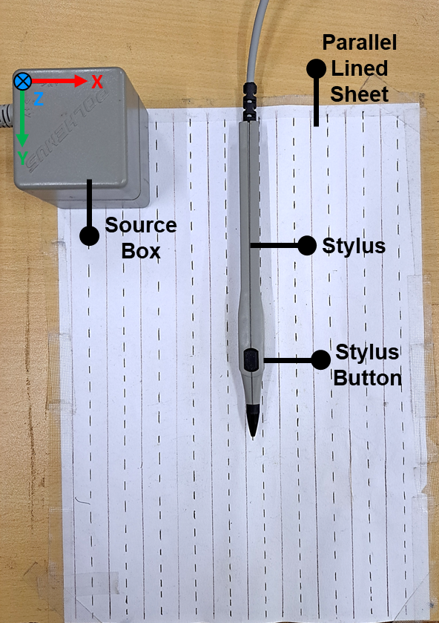
Figure S5. The Polhemus Patriot system’s source box and stylus. The source box’s reference frame and the location of the button on the stylus are also indicated. A sheet with parallel lines is affixed to the table, and the source box is placed on the sheet such that, when viewed from above, its +Y axis aligns with the parallel lines and points downward, its +X axis points to the right, and its +Z axis points into the plane of the table.
6.1 Pre-Measurement Preparation
Before taking the hand measurements, the following preparatory steps were done:
- Aligning the source box: A sheet with parallel lines was affixed to the experimental table (the same one used for sensor-to-segment alignment; see Section 3.3.1 in the main text). The Y-axis of the source box was carefully aligned with the parallel lines on the sheet (see Fig. S5). In this orientation, the positive X-axis pointed to the right, and the positive Z-axis pointed into the plane of the table.
- Marking the joints: The center of each joint on the participant's hand was marked using a pen. To do this, the participants were first asked to flex all four fingers at the distal interphalangeal (DIP) joints to make the joints more visible (see Fig. S6 (a)). In this position, the experimenter located the joint center using tactile examination and marked it with a “+” symbol. This was done for all the DIP joints. The same procedure was then repeated for the proximal interphalangeal (PIP) joints, metacarpophalangeal (MCP) joints, and the wrist joint (see Fig. S6 (b) and (c)). Additionally, a marking was made 2 cm below the MCP joint of the middle finger (see Fig. S6 (c)).
- Marking the thumb: Participants were instructed to touch the proximal phalanx of the little finger with the tip of the thumb. In this position, the PIP and DIP joint centers of the thumb were identified by the experimenter using tactile examination and marked with a “+” symbol. The base of the thumb metacarpal was then located and marked, and a straight line was drawn down the center of the thumb from the tip to the base of the metacarpal. A detailed description of this process is provided in Step 2 of Section 3.3.1: Sensor-To-Segment Alignment in the main text.
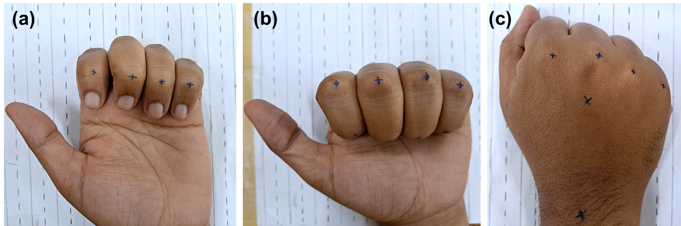
Figure S6. Markings on the hand for joint identification. (a) Markings on the DIP joints, (b) Markings on the PIP joints, and (c) Markings on the MCP joints, the wrist joint, and a point 2 cm below the MCP joint of the middle finger. Before each marking was made, participants were instructed to flex the finger at the relevant joint. This helped make the joint more prominent, as illustrated in the figure.
- Marking for finger width measurement: A horizontal line was drawn across the four fingers to serve as a reference for finger width measurement (see Fig. S7 (b)). To draw this line, the participant's middle finger was first aligned with one of the parallel lines on the sheet. Then, without moving the middle finger, the other fingers were adducted until no gaps remained between them (see Fig. S7 (b)). A transparent scale was then placed slightly above the MCP joint of the middle finger and aligned perpendicular to the parallel lines on the sheet by matching the scale’s markings with the parallel lines on the sheet (see Fig. S7 (a)). Finally, a straight line was drawn across the four fingers using a pen.
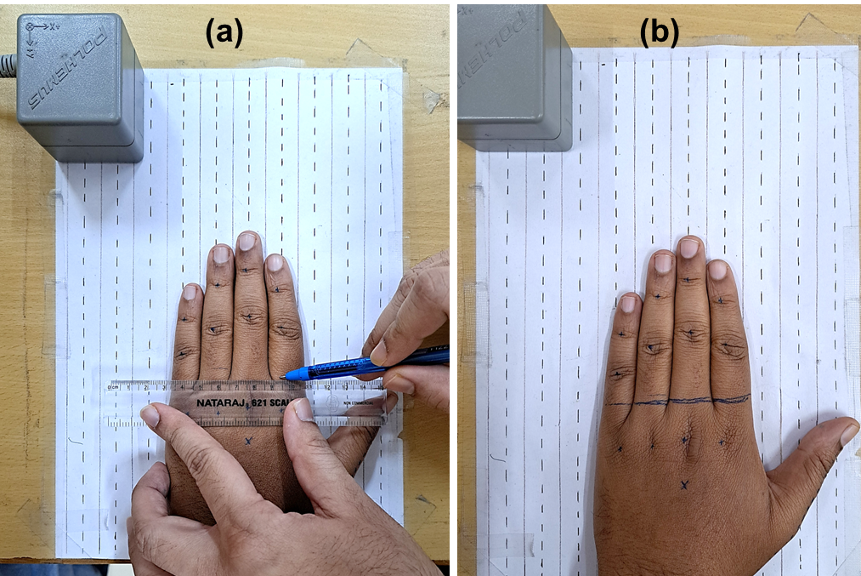
Figure S7. (a) Drawing a horizontal reference line across the four fingers using a transparent scale. The scale is aligned perpendicular to the parallel lines on the sheet by matching the scale’s markings with the parallel lines. (b) Hand placement on the parallel-lined sheet. The middle finger is aligned with one of the parallel lines, and the remaining fingers are adducted toward the middle finger such that there are no gaps between the fingers. A horizontal line is drawn across the four fingers. This line serves as a reference for subsequent finger width measurements.
6.2 Taking Hand Measurements
The hand was kept flat on the table, with the four fingers aligned along the Y-axis of the source box using the parallel lines as a guide (see Fig. S8 (a)). The tip of the stylus was then placed on each of the previously marked points on the hand, one at a time, and its (x, y, z) position relative to the source box was recorded. First, the positions of points 1 to 19 shown in Fig. S8 (a) were recorded. Next, the participants were instructed to adduct the fingers – without moving the middle finger – until no gaps remained between the fingers. Then, the positions of points 20 to 24, located along the previously drawn horizontal line, were recorded (see Fig. S8 (b)). Finally, the stylus tip was placed at an arbitrary point on the table surface (denoted as point 25 in Fig. S8 (b)), and its position was recorded. This position was used to calculate finger thickness (height), as explained in the next section.
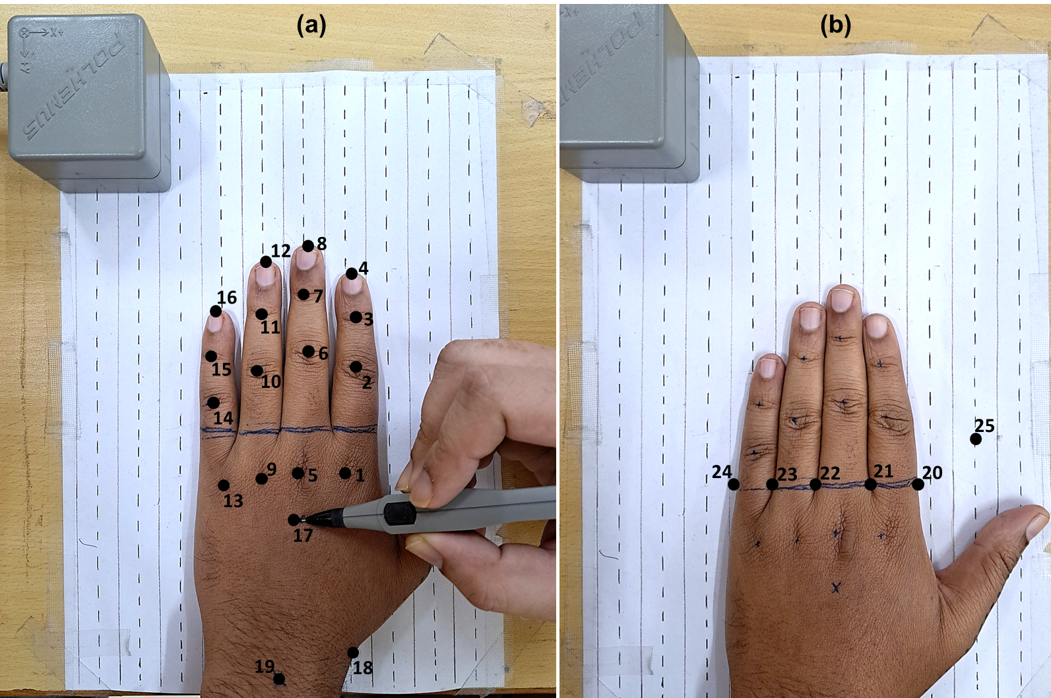
Figure S8. (a) Illustration of the hand placed flat on the table with the four fingers aligned with the Y-axis of the source box, by using the parallel-lined sheet as a visual guide. The black circles indicate the specific points on the hand where the 3D positions were recorded using the stylus. The numbers (1–19) denote the sequence in which these positions were recorded. At each point, the stylus tip was placed on the marking, and the stylus button was pressed to record the position relative to the source box. (b) In this posture, the position of the middle finger remains unchanged from (a), while the other fingers are adducted until there are no visible gaps between the fingers. Maintaining this posture, the remaining positions (20 to 25) were recorded using the stylus.
6.3 Calculating Hand Dimensions
Code was developed to calculate the hand dimensions using the 25 three-dimensional positions recorded using the Polhemus Patriot system. The calculations were performed as follows:
- Phalanx Lengths Calculation for the Four Fingers: Phalanx lengths were computed by calculating the Euclidean distance between appropriate position pairs, using only the x and y coordinates of the positions – i.e., on the horizontal XY plane. For example, the length of the proximal phalanx of the middle finger was calculated as the distance between positions 5 and 6 (see Fig. S8 (a)) using the formulae:
$$d=\sqrt{{(x_{6}-x_{5})}^{2}+{(y_{6}-y_{5})}^{2}}$$
where d is the Euclidean distance, and ${(x}_{5}, y_{5})$ and ${(x}_{6}, y_{6})$ are the coordinates of positions 5 and 6, respectively.
- Finger Thickness (Height) Calculation: The thickness of each finger was determined by computing the vertical distance (along the Z-axis) between the PIP joint of the finger and the surface of the table. For example, the thickness of the little finger was calculated as the difference between the z-coordinate of position 14 (PIP joint of the little finger) and position 25 (table surface). This single value computed for a finger was applied to all phalanges of the corresponding finger in the virtual hand model. Although actual finger phalanges vary in thickness, a uniform thickness value per finger was sufficient for our application.
- Finger Width Calculation: Finger widths were calculated using positions 20–24 (see Fig. S8 (b)). As an example, the width of the ring finger was computed as the Euclidean distance between positions 22 and 23 in the horizontal XY plane. As with thickness, the width value computed for a finger was uniformly applied to all phalanges of the corresponding finger in the virtual hand model.
- Relative Finger Locations Calculation: To compute the relative locations of the fingers, a local coordinate system was defined with position 17 (See Fig. S8 (a)) as the origin. In this system, the positive horizontal direction pointed rightward from position 17 along the +X axis of the source box, and the positive vertical direction pointed upward from position 17 along the –Y axis of the source box. The horizontal and vertical positions of the base of the four fingers (i.e., positions 1, 5, 9, and 13) and the base of the thumb’s metacarpal (position 18) were calculated relative to position 17, following the convention of this local coordinate system. All calculations were performed in the horizontal XY plane by using only the x and y coordinates of the relevant positions. In Blender, these computed distances were used to place the virtual fingers relative to the Blender origin, ensuring accurate spatial positioning of the fingers with respect to one another.
- Thumb Dimensions Calculation: Thumb dimensions were measured manually. Participants were instructed to touch the proximal phalanx of the little finger with the tip of the thumb. In this posture, the lengths of the thumb’s phalanges and metacarpal were measured using a scale, with the previously drawn center line on the thumb serving as a reference during the measurements. The measurements were taken in this posture because the length of each thumb segment increases when the thumb’s joints are flexed, and the maximum flexion of the thumb’s joints during the experimental task happens in this posture. Additionally, the width and thickness of the proximal phalanx were measured using a scale and applied uniformly to all thumb segments in the virtual hand model.
- Pivot Point Calculation for the Virtual Hand Model: To determine the pivot point for the virtual hand model, the vertical distance (along the Y-axis) between the MCP joint of the middle finger (position 5) and the wrist (position 19) was calculated using only the y-coordinate values. In the virtual hand model, the pivot point for the hand was placed this distance below the MCP of the middle finger. Specifically, when the orientation of the dorsal hand sensor is applied to the virtual hand’s root segment – a cuboid representing the four metacarpal bones and all carpal bones of the real hand – the cuboid rotates about this pivot point. Consequently, the entire virtual hand rotates about this same point. For further details on the structure of the virtual hand model, refer to Section 3.2: Virtual Hand Animation in the main text.
7. Preparations before Experimental Sessions
Several preparatory steps were carried out before each experimental session. This section provides details of those steps.
- The hand dimensions of both hands were measured for each participant in a separate session on a prior day. These measurements were then used to create participant-specific virtual hand models using the Blender software. The methodology for measuring hand dimensions is described in detail in Section 6.
- Rectangular copper patches of the required size and quantity were cut from a roll of copper tape. Thin, lightweight wires (28 AWG, Teflon-coated, multistrand) of the appropriate length were cut, soldered to these copper patches, and connected to the screw terminals on the HKMS-TIS board. These screw terminals were connected via the board to the digital input pins of the typing device’s microcontroller. Each of these digital input pins represented a character of the TIS.
- For efficient organization, the wires whose corresponding copper patches would be attached to a single finger were bundled together using a small tube (0.4 cm diameter, 2 cm length) (see Fig. 2 in the main text), and this tube was labelled with the name of the corresponding finger.
- Each copper patch was soldered to one of three color-coded wires: green for the distal phalanx, red for the middle phalanx, and blue for the proximal phalanx. Based on the labelled tube in which a wire was bundled and the wire colour, the other end of the wire was connected to the appropriate screw terminal ensuring that each copper patch represented the intended character according to the predefined phalanx–character map (see Fig. 1 in the main text). This system of labelled wire bundling and colour coding enabled quick, error-free attachment of wires to the correct screw terminals and copper patches to the appropriate finger phalanges.
- An appropriate amount of pre-cut double-sided tape was prepared for quick and easy use. Two sets were cut: one slightly larger than the IMU sensor base to ensure secure sensor attachment, and another slightly smaller than the copper patches to prevent the thumb patch from sticking to the exposed adhesive during typing.
8. Attachment of HKMS and TIS Devices to the Hand
This section details how the HKMS and TIS systems were attached to the participants’ hands.
- Hand Kinematics Measurement System Attachment: First, the bottom surface of the IMU sensors was affixed to the dorsal surface of the hand on the finger phalanges (and one on the metacarpal region two cm below the middle finger's MCP) using strongly adhesive double-sided tape. Then, another tape (3M Transpore Surgical Tape – 1.25 cm width) was applied over the sensor to reinforce sensor attachment further and minimise any displacement. This tape extended beyond the sensor’s edges and adhered to the sides of the finger phalanx, firmly anchoring the sensor in place.
- Text Input System Attachment: To ensure firm attachment of the copper patches for the duration of the experiment, a layer of 3M Transpore tape was first applied to the palmar surface of the relevant phalanges. Double-sided tape was then applied on top of this layer, followed by the copper patch on top of the double-sided tape. Since the copper patches were cut from copper tape, they came with an adhesive backing on one surface, which further enhanced the adhesion.
The first layer of Transpore tape was applied to address the issue of sweat affecting adhesion. During the experiment, some participants’ palms became sweaty, causing the double-sided tape to detach. The Transpore tape acted as a protective barrier, preventing direct contact between sweat and the double-sided tape.
To ensure its own adhesion, the Transpore tape was applied from one side of the phalanx, across the palmar surface, to the other side. It remained securely in place because the edges of the phalanx were relatively less sweaty than the palmar surface. Additionally, the sides of the phalanx already had a layer of Transpore tape, which had been used to secure the IMU on the dorsal surface. Together, these factors minimized the risk of detachment of the Transpore tape from the palmar surface.
Additional Note:
- Participants with excessively sweaty hands were excluded from the test, as even the Transpore tape on the palmar surface was prone to detachment in such cases.
- After the attachment of all the copper patches, a small portion of the bundled wires was secured to the dorsal surface of the hand with 3M Transpore tape (see Fig. 2 (c) in the main text). This prevented the wires from getting entangled with the fingers during typing. Sufficient slack was provided to the wires so that there were no unintended tugs on the copper patches during movement.
- After each test session, the copper patches were discarded, and a new batch was used for the next participant.

Supplementary Figure S9
Figure S9. The Calibration Status of all the IMU sensors from both hands is displayed on the screen for the experimenter to monitor. For further details on interpreting the calibration status of the BNO055, refer to our previously published work²⁸.

